EGI-Engage

Second release of the EGI Service Registry and Marketplace prototype
D3.13

Date | 26 April 2017
Activity | WP3
Lead Partner | SWING
Document Status | DRAFT
Document Link | https://documents.egi.eu/document/3028

Abstract

COPYRIGHT NOTICE
This work by Parties of the EGI-Engage Consortium is licensed under a Creative Commons Attribution 4.0 International License (http://creativecommons.org/licenses/by/4.0/). The EGI-Engage project is co-funded by the European Union Horizon 2020 programme under grant number 654142.
DELIVERY SLIP
 | Name | Partner/Activity | Date
From:
Moderated by:
Reviewed by
Approved by:

DOCUMENT LOG
Issue | Date | Comment | Author/Partner
v.1
...
...
v.n

TERMINOLOGY
A complete project glossary and acronyms are provided at the following pages:
- https://wiki.egi.eu/wiki/Glossary
- https://wiki.egi.eu/wiki/Acronyms

Contents
1 Introduction 5
2 Service architecture 5
2.1 High-Level Service architecture 6
2.1.1 Data Model 6
2.1.2 Workflows 8
2.1.3 Pay-for-Use support 13
2.1.4 Technology customisation 14
2.2 Integration and dependencies 15
3 Release notes 15
3.1 Requirements covered in the release 15
4 Prototypes evaluation 17
4.1 PrestaShop prototype 17
4.2 Open IRIS prototype 22
4.3 Outcome of the assessment 23
5 Feedback on satisfaction 23
6 Plan for Exploitation and Dissemination 24
7 Future plans 26
Appendix I. EGI Marketplace data model 27

Executive summary

Introduction

Tool name | EGI Marketplace
Tool url | PrestaShop based demonstrator: http://marketplace.egi.eu/  Open IRIS based demonstrator: http://egi.science-it.ch
Tool wiki page | N.A.
Description | The EGI Marketplace demonstrators show and promote EGI services. End users can discover the services and request access to them by specifying a set of options.
Value proposition | The EGI Marketplace will facilitate the discovery and the access to the EGI services.
Customer of the tool | EGI Foundation, NGIs, RIs, service providers, academic organizations.
User of the service | Prospective EGI users: research groups, individual researcher, site admins, academic organizations, SMEs, etc.
User Documentation | N.A.
Technical Documentation | N.A.
Product team | N.A.
License | N.A.
Source code | N.A.

Service architecture
The EGI marketplace prototype has been implemented adopting and customising technologies developed by third parties.
In particular, two demonstrators have been set up, one based on PrestaShop and the other based on Open IRIS.

High-Level Service architecture
The high-level service architecture of the two demonstrators is based on the underlying technologies. Please refer to the PrestaShop and Open IRIS documentation for more details.
This section focuses on the description of the data model and workflows that has been implemented into the two prototypes. Different alternatives to introduce the pay-for-use support in the marketplace are also depicted.
Finally, PrestaShop and Open IRIS customisations needed to fully implement the specifications are described.

Data Model
The data model of the marketplace reflects the EGI service catalogue structure (https://www.egi.eu/services & https://www.egi.eu/internal-services). It is made of a three-level hierarchy where the first level contains the EGI service areas (categories in the marketplace) and the second level maps to the EGI services (sub-categories in the marketplace). Furthermore, an additional level defines the EGI service options (products in the marketplace). The service options represents the products that the end user could access or purchase in the marketplace.
The marketplace data model has been already detailed in the D3.7 First release of the EGI Service Registry and Marketplace prototype. It has been updated and extended in this second release, defining service options for all the services in the EGI service catalogue.
The complete data model is described in Appendix I. In the following, data associated to a customer (customer/user profile) and to a service order are described.

Customer/User profile
Each customer/user of the EGI marketplace needs to be registered to submit service orders. Customers are forced to register during their first login into the marketplace, the registration allows the marketplace to gather enough information to create and store a customer profile in its internal database. Part of the data are retrieved by the EGI CheckIn service, which take cares of the user authentication. The remaining data are provided by the same customers filling in a form.
The following table shows the attributes that make the customer profile up, specifying the source of the information (CheckIn or the Marketplace) and if an attribute is mandatory or optional.

Attributes | From | Mandatory/Optional
Name | CheckIn service | Mandatory
Surname | CheckIn service | Mandatory
e-mail | CheckIn service | Mandatory
Display name | CheckIn service | Mandatory
EGI unique identifier | CheckIn service | Mandatory
Country | Marketplace | Mandatory
Institution | Marketplace | Mandatory
Department | Marketplace | Mandatory
Departmental web page | Marketplace | Optional
Linkedin profile | Marketplace | Optional
ResearchGate profile | Marketplace | Optional
Supervisor name | Marketplace | Optional
Supervisor profile | Marketplace | Optional

Service order profiling
The EGI marketplace associates to each service order a set of customer information, which are gathered during the Check-Out. Such information, complemented with the customer profile and the order details (the service options), enables the marketplace to implement a service order profiling, which allows an appropriate service order management, accordingly to the EGI Integrated Management System (IMS) processes and procedures.
The table below shows the customer information that are linked to a service order. Such information could be extended in the future according to possibly emerging needs.

Attributes | Value | Note
Customer typology | Single user or representing a research community/project or a private company
Reason to request access to the EGI services | free text
User group name (Only if the customer represents a research community/project or a private company) | text (see note) | It maps to the VO name. In the case the customers is already using the EGI infrastructure (VO list not empty), the VO name could be chosen from a drop down menu listing all the customer VOs (retrieved during the authentication) plus the option to specify a new VO.
Information on the project  (Only if the customer represents a research community/project or a private company) | Project name: text  Project web site: URL | To be expanded in the feature. It could be automatically filled in querying the operations portal if the project is already using the EGI infrastructure

Workflows
This section describes the procedures or workflows implemented in the two marketplace prototypes. For each procedure, the following information is provided:
- Overview: short description of the workflow.
- Trigger: events that start a workflow.
- Involved entities: all the entities that play a role in the workflow.
- Input: input data.
- Output: output data.
- Steps: step-by-step description of the workflow.
- Integration with other EGI tools: list of the EGI tools involved in the workflow and description of their interfaces with the marketplace.
The following workflows have been currently implemented:
- Authentication: the login procedure including the user registration during the first access.
- Discover and order services: finding and ordering services within the marketplace.
- Check-Out: submitting a service order together with a set of information to profile it.

Authentication and user enrolment
Overview:
The customer logs in the EGI marketplace through the CheckIn service.
Trigger:
- The customer decides to log in while he/she is visiting the marketplace.
- The customer starts the checkout process
Involved entities
- Customer
- Marketplace
- CheckIn service
Input
- No input
Output
- Personal customer information including the unique EGI identifier.
- Customer’s VO membership list.
Steps
Step | Conditions | Tool | Action
1 |  | Marketplace | Redirect the customers to the CheckIn service
2 |  | CheckIn service | Authenticate the customers and provide the Marketplace with personal customer information (including the unique EGI identifier) and VO membership list.
3 | Only during the first access (registration) | Marketplace | Complement the personal customer information already provided by the CheckIn service. The Marketplace asks the customer for filling a form with the following attributes:  - Country (mandatory), Institution (mandatory), Department (mandatory), Departmental web page (optional), Linkedin profile (optional), ResearchGate profile (optional), Supervisor name (optional), Supervisor mail (optional).  These additional attributes are stored in the Marketplace and the customer will not be asked to provide them in the future.  Customers can update their profile in any moment.
4 |  | Marketplace | After the customer is successfully logged in, the Marketplace shows his/her name in its web interface.

Integration with other EGI tools
Tool | Integration
CheckIn service | Perform the customer authentication on behalf of the marketplace and provide it with personal customer information (including the unique EGI identifier) and VO membership list.

Discover and order services
Overview:
The customer navigates on the service catalogue exposed in the EGI Marketplace and selects one or more services. The Marketplace exposes services following the service catalogue structure:
- First level: service categories
- Second level: services
- Third level: service options
Trigger:
- The customer accesses directly the marketplace or through the EGI web site.
Involved entities
- Customer
- Marketplace
Input
- No input
Output
- List of services including service options.
Steps
Step | Conditions | Tool | Action
1 |  | Marketplace | The customer navigates through the service catalogue published in the marketplace
2 |  | Marketplace | The customer selects one or more services specifying a set of service options

Integration with other EGI tools
There are no dependencies from the EGI tools.

Check-Out
Overview:
Define the customer profile and gather information on the research community/project/private company willing to exploit the EGI services and common options for the selected services. Forward all the information to a backed system that will take care of managing the service order.
Trigger:
- Customer starts the Check-Out process after he has selected one or more services.
Involved entities
- Customer
- Marketplace
- Check-In service
- Operations Portal
Input
- Personal customer information including the unique EGI identifier.
- Customer’s VO membership list.
- Service list including options selected by the customers
Output
- Personal customer information including the unique EGI identifier.
- Customer typology: representing a community or single user.
- Reason to request access to the EGI services.
- Only for customers representing a community:
  - Information on the project
  - VO information
    - New or existing
    - VO name
Steps
Step | Condition | Tool | Action
1 | Only if the customer is not already authenticated. | Marketplace  CheckIn | Automatically starts the authentication process redirecting the customers to the CheckIn service.
2 |  | Marketplace | Present to the customer his/her profile, as gathered during the authentication process, and request to fill in a form with the following fields:  - Customer typology:  - single user  - representing a research community/project  - representing a private company  - Reason to request access to the EGI services
3 v1 | Only if the customer represents a research community/project or a private company | Marketplace  Ops Portal | Request to the customer to fill in an additional form with the following fields:  - User group name: it maps to the VO name. In the case the customers is already using the EGI infrastructure (VO list not empty), the VO name could be chosen from a drop down menu listing all the customer VOs (retrieved during the authentication) plus the option to specify a new VO.  - Information on the project. Such field will be automatically filled in querying the operations portal if the customer select an existing VO in the User group name field.
3 v2 | Only if the customer is a single user | Marketplace | Check if the amount of resources requested by the customer is less than the threshold defined to access the Applications on demand platform:  - If yes, mark the customer as user eligible for the Applications on demand platform.  - If no, mark the customer as a normal user.
4 |  | Marketplace | Submit/record the service order and the customer profile to a backend system
5 |  | Marketplace | Send a confirmation e-mail to the customers: “your order is being processed…”

Integration with other EGI tools

Tool | Integration
CheckIn | Authenticate the customer if needed.
Operations Portal | Provide the marketplace with information related to already existing projects (VOs).
Marketplace backend | Receive the service request and the customer profile from the marketplace backend.

Pay-for-Use support
An analysis on how to implement the pay-for-use support in the Marketplace has been also done. As result, three different options has been defined.
- EGI acts as a broker / or individual provider offers listed separate, but aggregated on the service level: under service level, differentiate each option according to the access mode, for free or for pay. Then, e.g., for Cloud Compute service, the Marketplace will expose the options “General purpose instance” and “General purpose instance for pay”, etc.
- EGI acts as a broker: add the pay-for-use attributes directly in the service options (product in the marketplace). A flag “for pay” will be added as extra service option. If this option is selected the access policies will change accordingly.
- Direct contracts between customers and providers: an additional category, related to the pay-for-use providers, will be added in the first level of the data model hierarchy (service categories). Under this category, all the providers will be listed. Under each provider, all its products will be listed.
These three different options are currently in discussion within the Pay-for-Use working group. The Marketplace prototypes implemented the first one for demonstrative aims. They will be updated accordingly to the decision of the Pay-for-Use WG.

Technology customisation
In order to satisfy the requirements and the specifications above described, both PrestaShop and Open IRIS technologies needed customisations.
This section summarises the changes applied.

PrestaShop
The basic PrestaShop tool was enriched with the following plugins to extend its functionalities:
- Additional Product Attributes/Custom Product Fields Module. It allowed to add new fields on the product pages. It was essential to implement all the service options as specified in the data model.
- Custom Checkout and Customer and Address Fields manager Module. It allowed to easily add new fields on checkout pages and collect more data about the customers by adding extra fields to the registration form and customer account area. It was needed to implement both the customer and service order profiles.
- Dynamic Product Price Module. It allowed to define dynamic prices based on the values that customers defined for the service options. It was needed to implement the experimental pay-for-use support.
- Google Accounts login-in module for PrestaShop.
In addition, ad-hoc customisations were needed to implement the Authentication and user enrolment, and the Check-Out workflows. In particular, to retrieve customer information from the CheckIn service, to prevent the service order submission before the customer profile is completed and to profile the service orders. Minor changes were also requested to adjust the service options, the service list in the cart and the e-mail templates. All the changes were applied to both the PrestaShop basic code and the extra modules listed above.

Open IRIS
The main changes on Open IRIS were related to:
- Integration of the Open IRIS authentication mechanism with the EGI CheckIn service;
- Development of the user enrolment procedure according to the specifications;
- Development of a Cart allowing the submission of multiple service orders:
- Implementation of the service hierarchy as described in the specification.
In particular, last point was particularly complex to achieve considering that Open IRIS were designed to show services in a flat mode and categorise them via keywords. The concept of a service hierarchy did not exist in Open IRIS and its introduction requested relevant changes.

Integration and dependencies
Both prototypes have been integrated with the EGI CheckIn service and depends on it for the user authentication.

Release notes

Requirements covered in the release
- Authentication and user enrolment workflow.
  - Integration with the EGI CheckIn services to manage the user authentication.
  - Gathering of customer data from the CheckIn service.
  - Form to gather additional customer data during the registration.
- Discover and order services workflow.
  - Implementation of the three level hierarchy of the EGI service catalogue as specified in D3.7. See Appendix I for a full specification of the data model.
  - Implementation of a custom form for each service option.
  - Registration of the service providers in the system. Each provider is linked to a set of services and visible in the service pages.
- Check-Out workflow.
  - Customised cart allowing to gather additional information to profile the service orders.
- Basic pay-for-use support.
  - Implement the first option for experimental aims: under service level each option is differentiate according to the access mode (for free or for pay).

Prototypes evaluation
After the completion of the developments, the two prototypes were assessed to decide which technology to adopting for the EGI marketplace.
Both prototypes almost fully implemented the specifications demonstrating that both technologies are suitable, although customisation were needed. The unique lacking features are the retrieval of the customer’s VO membership list from the CheckIn, since it not supported yet, and the interface with the Operations Portal to automatically retrieve project information, which directly depends from the customer’s VO membership list.
The following two sessions shortly describe the two prototypes. Then, the outcome of the assessment is reported.

PrestaShop prototype

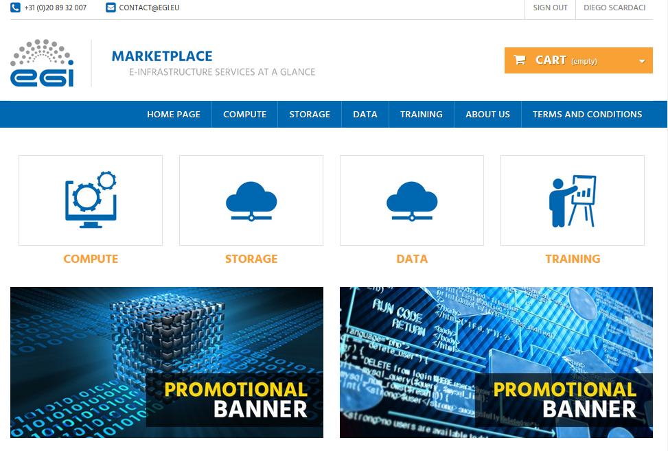
Figure 1. EGI Marketplace based on PrestaShop technology.

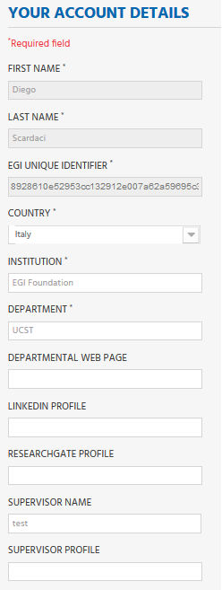
Figure 2. Form to gather the user profile. Fields in grey are filled in with values retrieved by the EGI CheckIn service and cannot be modified.

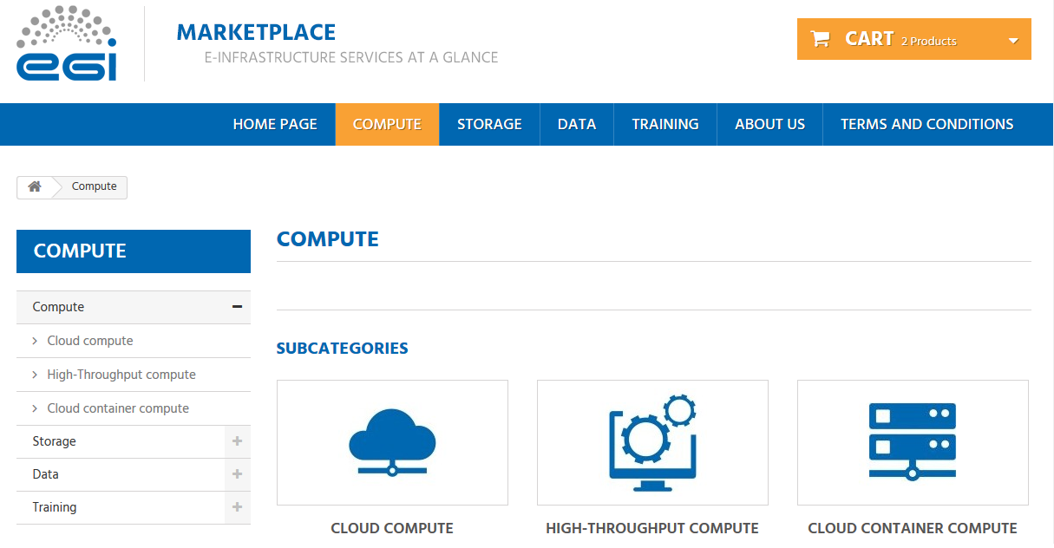
Figure 3. Service category view - Compute

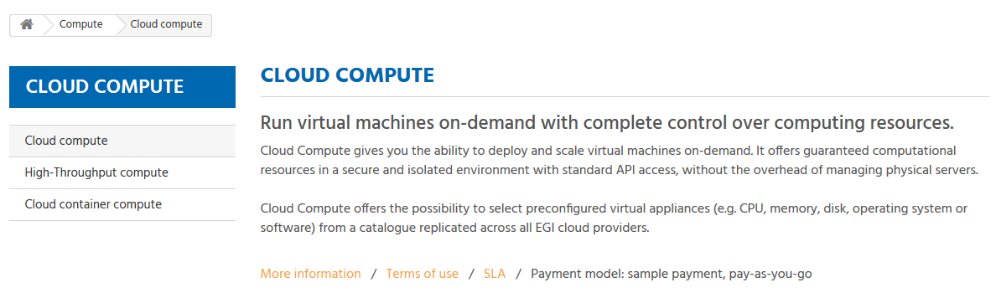
Figure 4. Service view - Cloud Compute

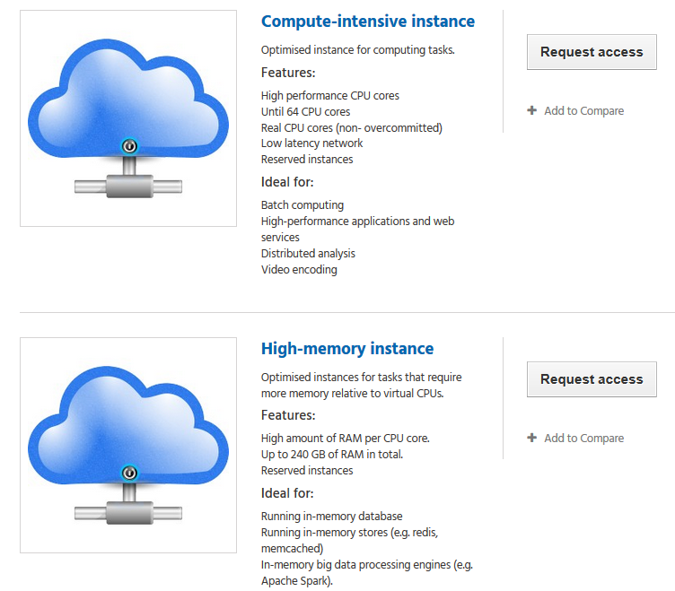
Figure 5. Example of service options - Cloud Compute

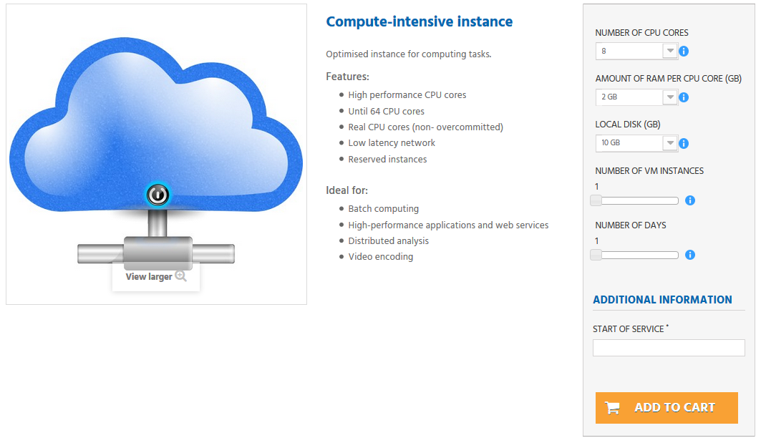
Figure 6. View to order a service. Compute-Intensive Instance in Cloud Compute service

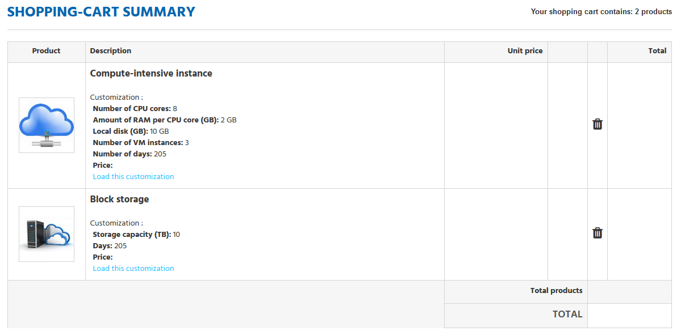
Figure 7. List of selected service options in the Cart

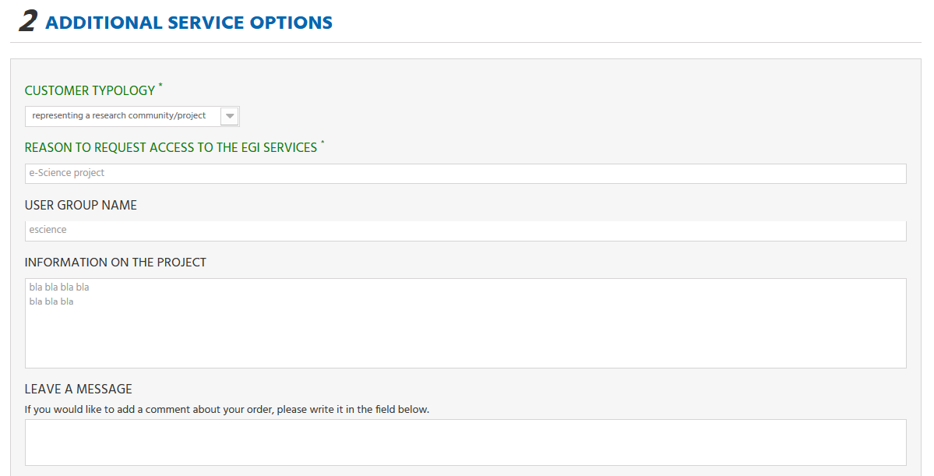
Figure 8. Service order profiling in the cart

Open IRIS prototype

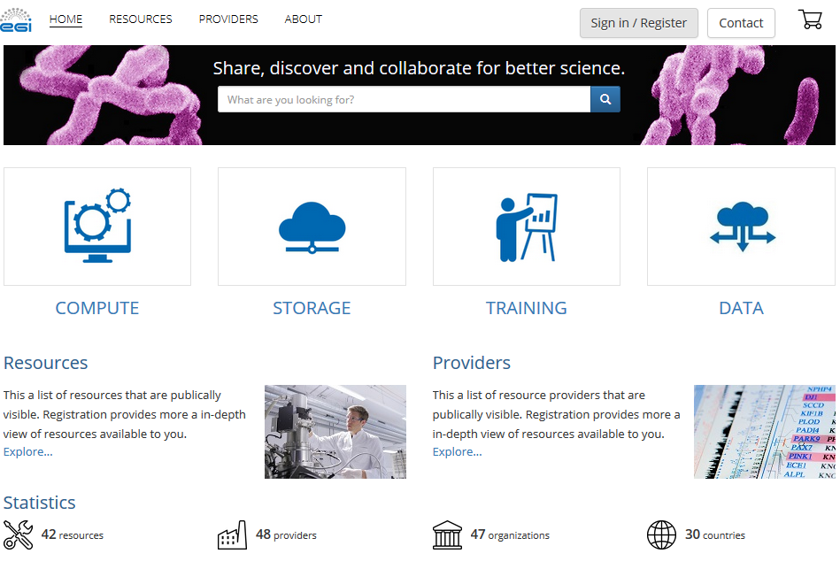
Figure 9. The EGI Marketplace based on Open IRIS technology.

Outcome of the assessment
The above mentioned workflows were evaluated in both systems. It was found that both systems adequately covered the current workflows as well as supported the data model. The final deision was taken for the following reasons:
- Widely used by other Internet web stores
- Easy to maintain as it has a wide community of developers
- Expertise within the EGI collaboration

Feedback on satisfaction
Who was involved in testing and what the outcome of the review was

Plan for Exploitation and Dissemination
This section should provide a plan for exploitation and dissemination (PEDR) of the project results documented in this deliverable. If a plan was already provided in an earlier deliverable, then this plan should provide an update. The content will be used to update the catalogue of project results (http://go.egi.eu/egi-engage-results) and to develop an overall PEDR for the whole project. You can create as many tables as the number of results being described.

Name of the result | Short name for the result (results generated under the project could be any tangible or intangible output, more particularly data, knowledge or information whatever its form or nature, whether it can be protected or not.)
DEFINITION
Category of result | - Technical input to standards: Technical specifications or extensions to standards adopted within the project  - Policy & Procedure developments: Technical procedures directed at users, service and infrastructure providers (for example to govern access and allocation to resources), policy reports and recommendations, and strategic analysis  - Software & service innovation: Software developments: (e.g.: workflows, Virtual Machines, applications), new software services deployed for the direct benefit of researchers (e.g.: web portals, gateways), e-Infrastructure Commons such as accounting, AAI, and the Federated Cloud platform and the Open Data platform, demonstrators and prototypes.  - Business model innovation: Business and sustainability-related outputs (the EGI Service Marketplace concept, the contribution to the Innovation space for the big data value chain, sustainability plans, pay-for-use models)  - Know-how: Includes all results from fact-finding activities (e.g. surveys, requirement gathering), but also the results from internal exercises (e.g. security challenges) and outputs that can be used for knowledge transfer as training materials.
Description of the result | Description of the result
EXPLOITATION
Target group(s) | Describe who will use those results. Es: RIs, international research collaborations and the long-tail of science, industry/SMEs, service providers, Funding agencies and decision/policy makers, Standardisation bodies"
Needs | What are the needs of the target groups that the results aims to fulfil?
How the target groups will use the result? | How the project result will be used? How are you going to achieve the best benefits from the project outcomes? How can you make sure the results they owned are used:  - in further research activities other than those covered by the project concerned  - in developing, creating and marketing a product or process  - in creating and providing a service  - in standardisation activities  Note: The exploitation does not need necessarily to be done by participants, who may prefer to ensure its use by another entity. Such indirect exploitation can be performed by licensing the results or assigning them to third parties, in accordance with the requirements established in the grant agreement "
Benefits | What are the expected benefits of the result when this will be used by the target groups?
How will you protect the results? | Protection of results is indeed essential in Horizon 2020, since an effective exploitation depends on it. Thus, participants must assess the possibility of protecting their results once these are generated. Please, describe what IP protection approach will you put in place for this result. This can range from simple attribution via open source license to full copyright for commercially exploitable results. (For more information you can read “How to manage IP in Horizon 2020: project implementation and conclusion” https://www.iprhelpdesk.eu/sites/default/files/newsdocuments/FS_IP_Management_h2020_implementation_0.pdf
Actions for exploitation | Please, describe the concrete actions that need to be executed to make the result reusable by the target group (e.g., for a software, this can include software packaging for distribution, documentation for the installation, etc). Once executed, the target groups should be able to use the results without barriers.
URL to project result | Link where the result will be made available
Success criteria | What are the success criteria in terms of adoption by the end of the project?
DISSEMINATION
Key messages | What messages will you tell to the target groups when informing about the results?
Channels | What channels will you use to deliver the messages to the target?  (e.g. Scientific publications, EGI web site, EGI newsletter, participation in conferences or trade fairs)
Actions for dissemination | Describe the concrete set of actions that will be put in place to disseminate this project output. When this result is ready, how will you reach to target group to ensure uptake of the result? (You can list the preliminary list of events where you plan to promote the results or material that will be produced or any other concrete actions that will be put in place during the project)
Cost | What is the expected cost of dissemination actions?
Evaluation | How will you evaluate the impact of the dissemination actions?

Future plans

- EGI Marketplace data model

https://www.prestashop.com/en/documentation
http://iris.science-it.ch
http://addons.prestashop.com/en/20201-additional-product-attributes-custom-product-fields.html
http://addons.prestashop.com/en/19736-custom-checkout-and-customer-and-address-fields-manager.html
http://addons.prestashop.com/en/19389-dynamic-product-price.html
The customer’s VO membership list cannot be retrieved from the CheckIn service yet.
The Check-Out workflow was entirely implemented except for the interface with the Operations Portal since the customer’s VO membership list cannot be retrieved from the CheckIn service yet.

