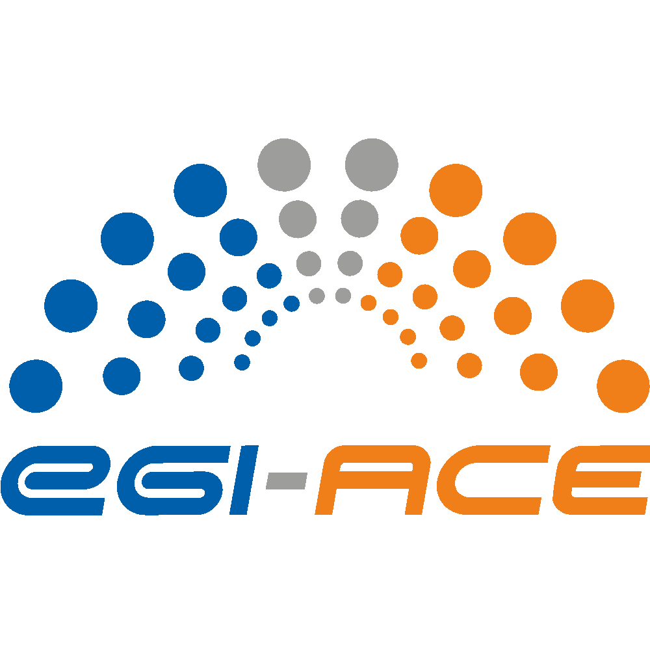
D1.7 Dissemination and Exploitation Plan

Lead partner: | EGI Foundation
Version: | 1
Status: | Under EC review
Dissemination Level: | PUBLIC
Keywords: | Dissemination, Exploitation
Document Link: | https://documents.egi.eu/document/3806

Deliverable Abstract
This document provides an update to the key exploitable results, including aspects such as the definition, value proposition, IP management, exploitation path and dissemination activities and adoption.

COPYRIGHT NOTICE
This work by parties of the EGI-ACE consortium is licensed under a Creative Commons Attribution 4.0 International License. (http://creativecommons.org/licenses/by/4.0/).
EGI-ACE receives funding from the European Union's Horizon 2020 research and innovation programme under grant agreement no. 101017567.

DELIVERY SLIP
 | Name | Partner/Activity
From: | Smitesh Jain  Magdalena Brus | EGI Foundation / WP1  EGI Foundation / WP1
Moderated by: | Sjomara Specht | EGI Foundation
Reviewed by: | Hien Bui  Gwen Frank | EGI Foundation  EGI Foundation

DOCUMENT LOG
Issue | Date | Comment | Author
v.0.1 | 08/06/2022 | Initial Version | S. Jain
v.0.2 | 13/06/2022 | Dissemination details | M. Brus
v.0.3 | 24/06/2022 | Updates with data space-related exploitation activities | S. Jain
v.1 | 25/06/2022 | Final | S. Jain

TERMINOLOGY
https://confluence.egi.eu/display/EGIG
Terminology/Acronym | Definition
EOSC | European Open Science Cloud
KER | Key Exploitable Results
OLA | Operational Level Agreement
UA | Underpinning Agreement
SDS | Service Delivery and Support Board
IP | Intellectual Property
IPR | Intellectual Property Rights
HTC | High Throughput Computing
HPC | High Performance Computing
RI | Research Infrastructure
SME | Small- or Medium-sized Enterprise
GOSC | Global Open Science Cloud
EOSC AG | EOSC Advisory Groups
EOSC TF | EOSC Task Forces
DoA | Description of Action
HRP | Horizon Results Platform

Contents
Executive summary 4
1 Introduction 5
1.1 Updates from D1.4 5
1.2 Relationship with other project deliverables and outputs 5
1.3 Exploitation and Dissemination Process 5
1.3.1 Identifying KERs 6
1.3.2 KER Champions 7
1.3.3 Exploitation 7
1.3.3.1 Mapping EGI-ACE stakeholder groups to the Horizon Results Platform User Groups 9
1.3.4 Dissemination 11
1.3.4.1 Dissemination Activities 12
2 The EOSC Compute Platform 18
3 Services enabling federated computing in EOSC 22
4 Research data spaces and processing tools for EOSC 25
5 Conclusions and Future Work 29
Appendix 1: EGI-ACE Stakeholder group definition 31
Appendix 2: Horizon Results Platform Template 33
Appendix 3: Radical Innovation Breakthroughs 39

Executive summary
The Dissemination and Exploitation plan deliverable establishes the link between EGI-ACE results and its dissemination and innovation management practices. The deliverable presents the Key Exploitable Results and presents a plan for promoting them and exploiting them by mapping them to the overall project dissemination presented in D2.6 Communications and Engagement Plan.
The first issue of this deliverable (D1.4 - Dissemination and Exploitation Plan) was published in July 2021.
During the first project period, EGI-ACE executed successfully the plan defined in D1.4. This second issue includes the following updates:
- An expanded exploitation and dissemination plan than the one presented in D1.4
- A plan to capture the direct and indirect innovation enabled by the project.
- A plan to capture the impact brought forth by the exploitation of the project results by researchers and by service providers.
- Identification of three new KERs and archival of the previously defined five KERs in the DoA and D1.4.
- Submission of the three KERs to the Horizon Results Platform.

This deliverable will serve as an input to the final periodic report and the D1.6 Quality, Risk and Innovation Management Plan, due in M30. The Key Exploitable Results (KERs) will also feature in the project outreach materials (presentations, flyers, EGI website and other similar materials).

Introduction
This deliverable presents the project’s Key Exploitable Results (KERs) and the process used in defining them, their value propositions and aspects related to dissemination and exploitation (including IPR-related issues) among other things. The deliverable will also include some updates to the analysis presented in the deliverable D1.4.

Updates from D1.4
As will be described in more detail in the document later, the five KERs as identified in the project proposal and included in D1.4 have been deprecated and replaced with three new KERs. Consequently, chapters 2-6 from D1.4 have been removed from the document and replaced with new chapters covering these new KERs.
Another major change from D1.4 is the removal of the section “1.2 KER-centric views of project’s dissemination and exploitation plans”. The content of this section is still present in essence but distributed across the subsections of the new section “1.3 Exploitation and Dissemination Process”. This section also expands greatly on the Dissemination activities and Exploitation plan.

Relationship with other project deliverables and outputs
This deliverable complements the Innovation Management section of the deliverables D1.1 and D1.3 (Quality, Risk, and Innovation Management Plan) by describing the process for capturing the project results and supporting their exploitation. This deliverable is also closely related to D2.6 “Communication and Engagement Plan” which defines the project’s engagement channels and dissemination activities. This deliverable will serve as an input to the final periodic report, due in M30. The Key Exploitable Results (KERs) will also feature in the project outreach materials (presentations, flyers, EGI website and other similar materials).

Exploitation and Dissemination Process
A project result is any output generated during the project implementation. Some examples of project results include know-how, experience, algorithms, prototypes, new products or services, policy recommendations, roadmaps, learnings, reports, publications, data, events, etc. However, not all these results can be exploited i.e., use and benefit from something often for commercial purposes or in public policymaking. A Key Exploitable Result (KER) is a project result or a group of similar project results with particularly high exploitation potential. The process of managing, exploiting and disseminating these KERs and the project results contained within them, in EGI-ACE, is represented in figure 1. The activities are grouped into four categories which are explained in detail in the following sections.

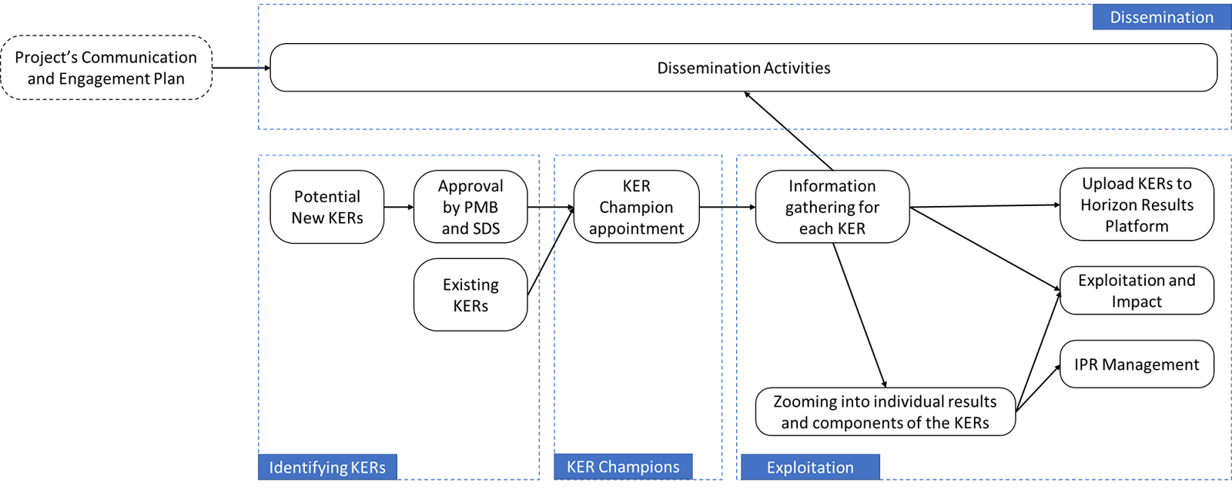

Figure 1: KER management, exploitation and dissemination process

Identifying KERs
The EGI-ACE project proposal identified the following five KERs in its Impact section:
- Free at point of use services, IT resources, data, and analytics via EOSC portal;
- Training, handbooks and consultancy;
- Improved Service Management and Tools;
- Interoperability Toolkit;
- Strategy and Recommendations.
However, during the course of the first year, it was identified that these five initial KERs do not fully reflect the results and impact of the project. The main objective of the EGI-ACE project is to deliver integrated computing, platforms, data spaces and tools as an integrated solution that is aligned with major European cloud federation projects and HPC initiatives. For this, the project delivers the EOSC Compute Platform and contributes to the EOSC Data Commons through a federation of Cloud compute and storage facilities, PaaS services and data spaces with analytics tools and federated access services. Keeping this in mind and to better reflect the objective and impacts of the project, a set of new KERs was defined with the support of the Project Coordinator, Technical Coordinator, Communications Manager, Project Manager and the Project Office. These KERs were also presented to the Project Management Board (PMB) and Service Delivery and Support Board (SDS) for feedback and approval. Taking into consideration the feedback provided, the following three KERs were identified,
- The EOSC Compute Platform;
- Services enabling federated computing in EOSC;
- Research data spaces and processing tools for EOSC.
It is possible that the project activities will identify additional KERs in the future. These KERs will be managed through the same process, such as being presented to the PMB and the SDS for feedback and approval. They will also get a KER champion assigned.

KER Champions
The SDS has, for each identified KER, assigned an individual in the role of a ‘KER Champion’. These KER Champions act as an Ambassador for the KER - a primary spokesperson within the project, helping to encourage uptake, exploitation and dissemination of the KER. They provide the relevant data for the Horizon Result Platform template for their respective KERs. They support the development and exploitation plan, pointing to the relevant contact persons for technical, IP and other exploitation plan aspects of the KER. KER champions take the lead in providing inputs on dissemination messaging. And finally, they also help bridge the gap between technical outputs and their practical implications by promoting the uptake.

Exploitation
As evident from the above discussions, the project takes a very KER-centric view toward exploitation. When considering any KER, the following mechanism will be used to ensure a consistent exploitation approach:
- Define the scope of the KER with the support of the PMB and the SDS;
- Capture the KER-related details (both pre-identified and potential new KERs identified during the project lifetime) with the support of the KER Champions, based on the Horizon Results Platform (HRP) template;
- Map KER development into project activities (often in a way that is not limited to a single work package);
- Monitor and update the KER details at periodic intervals.
Each of these KER is an umbrella under which similar or strongly related project results have been grouped together. To ensure a strong exploitation approach, project results under these KERs will be zoomed into. Templates have been created to capture information related to these individual project results.
For the three identified KERs, the expected users, benefits, and value propositions for using these results have been identified and are presented in the following chapters. Through discussions with the KER Champions, the Horizon Results Platform template for each of the KERs was filled and uploaded to the platform . The details for each of these KERs with selected fields from the HRP template can be found in the later chapters of this document.
These identified KERs for the EGI-ACE project could be either:
- Results that could and should be taken forward in the same application context the project works on, i.e., the EGI/EOSC ecosystem
- Results that could be taken up by anyone outside the specific context of the project.
When focusing on the first category of results, it is possible to make the following assumptions stemming from the EGI/EOSC environment:
- The services will be provided based on the ‘Free at the point of use’ model, based on commonly agreed rules of participation that provide basic sustainability or business model parameters;
- The primary use of the services will be processing varied research data sets that adhere to FAIR principles defined by the user community;
- The users are - at least in the immediate future - technically skilled, science-literate people capable of performing the tasks in a highly autonomous fashion.
The exploitation potential of the result is thus based on quite clear criteria: fitness for purposes of a particular research task, level of integration with the marketplaces (EGI, EOSC), and awareness of and attitudes towards the solution of the EGI and EOSC user communities. The openness of the platform and the technical skills of the user communities make the retention of users more challenging than in other IT service markets. The perceived ‘switching costs’ to another solution; providing better performance; are low.
The results belonging to the second category - results that could be taken up by anyone outside the specific context of the project - present a slightly more multifaceted challenge. A larger set of exploitation opportunities and stakeholder groups is balanced by the need to describe resources in a way that makes them relevant to a much broader range of stakeholders (also outside the project’s primary context). These results are typical candidates for inclusion in the EC Horizon Result Platform that is geared more towards investor groups ranging from private profit-oriented entities to public service and development-oriented organisations (including third-sector entities). This difference in orientation requires taking a broader set of aspects into account in capturing the results and a slightly different approach to disseminating them.
The role of joint ownership agreements is especially important for the KERs falling under this second category, as major project results are typically generated through the involvement of several organisations. The Horizon Results Platform requires assigning a partner or partners in the role of ‘Owner for exploitation’ and the joint ownership agreement needs to consider the fair distribution of a much broader range of benefits (investments, partnerships, consulting, paid service provision, among others) than is the case with pure academic use. A lot of this information is already captured in the OLAs, and UAs used by the Service Management System of the project. However, when the potential exploitation approaches go beyond the service provisioning in the EOSC Exchange context, it is important to review the exploitation roles of the partners involved in the development of the result.
All this is further complicated by the fact that the KERs are a group of individual results with each of them potentially having different access rights and IP protection mechanisms. So, zooming into the individual results contained within each of the KERs and collecting information around them and their protection is a key part of the exploitation plan.
Another aspect that the exploitation management should consider is developing a clear understanding of how the project enables innovative scientific research. One component of this is to explore writing publications related to the innovation built by the project especially focusing on innovative infrastructure for federated computing and the data spaces.
The other part is to understand the wider impact brought about by the project through the exploitation of its results by the users and service providers. A template will be developed to capture this information from all sources in a systematic manner. To capture this information, the following channels will be used,
- As part of the regular customer reviews carried out by task T2.3.
- User workshop which brings together users and shepherds to share updates on progress, achievements, impact
- Interviews with service providers
- Any other form of ad-hoc discussions as required

Mapping EGI-ACE stakeholder groups to the Horizon Results Platform User Groups
To better coordinate the exploitation and dissemination activities, this section aligns the EGI-ACE stakeholders as identified in D2.6 “Communication and Engagement Plan” with the Horizon Results Platform User Groups. The focus of deliverable D2.6 is on maximising the awareness of the key stakeholder groups during the project's lifetime. It defines the following stakeholder groups based on the type of interaction between the project and them:
- Users that demonstrate the project's positive impact by providing success stories. These include Researchers, International projects and Research Infrastructures (RIs), Industry/SMEs, Public sector;
- Service and content providers for research providing services that can be encouraged to integrate into the project. These include Academic HTC/Cloud providers, HPC providers, Data Space providers;
- EOSC Governance and Core need to be aware of the project and its potential to ensure the inclusion of EGI-ACE in the future EOSC technical and organisational structure. These include the EOSC Association, EOSC AGs/TFs, Providers of EOSC Core;
- Peer initiatives can be encouraged to align their approaches to increase the overall awareness of the solutions offered. These include INFRAEOSC-7 projects, GAIA-X, EOSC-like initiatives outside Europe (GOSC), and EOSC-Future Project.
In contrast, the Horizon Results Platform entry offers the following categorisation:
- Others/ No specific audience;
- Public or private funding institutions;
- EU and Member State Policy-makers;
- International Organisations (e.g., OECD, FAO, UN, etc.);
- Other Actors who can help us fulfil our market potential;
- Research and Technology Organisations;
- Academia/Universities;
- Private Investors.
Mapping between these two taxonomies is not straightforward. Table 1 maps the Horizon Results Platform categories to EGI-ACE stakeholder groups. In practice, each KER will have a subset of EGI-ACE categorisation entities and Horizon Results Platform audiences that is specific to that KER. This further underlines the importance of the KER Champion role. Without a deeper understanding of the situation and goals related to the result, it is impossible to determine which of the target groups are relevant for that KER.
Table 1 - Horizon Results Platform categories to EGI-ACE stakeholder groups
EGI-ACE stakeholder group | Entities in EGI-ACE categorisation | Potentially matching Horizon Results Platform entries
Users | - Researchers  - International projects and Research Infrastructures (RIs)  - Industry/SMEs  - Public sector | - EU and Member State Policymakers  - International Organisations (ex. OECD, FAO, UN, etc.)  - Other Actors who can help us fulfil our market potential  - Research and Technology Organisations  - Academia/ Universities
Service and content providers for research | - Academic HTC/Cloud providers, HPC providers, Data Space providers | - International Organisations (ex. OECD, FAO, UN, etc.)  - Research and Technology Organisations  - Academia/ Universities
EOSC Governance and Core | - EOSC Association  - EOSC AGs/TFs  - Providers of EOSC Core | - Public or private funding institutions  - EU and Member State Policymakers  - International Organizations  - Other Actors who can help us fulfil our market potential  - Research and Technology Organisations  - Academia/ Universities
Peer initiatives | - INFRAEOSC-7 projects  - GAIA-X  - EOSC-like initiatives outside Europe (GOSC)  - EOSC-Future Project | - Public or private funding institutions  - EU and Member State Policymakers  - International Organisations (ex. OECD, FAO, UN, etc.)  - Other Actors who can help us fulfil our market potential  - Research and Technology Organisations  - Academia/ Universities
Stakeholder categories mostly outside the ones defined in D2.6 |  | - International Organisations (ex. OECD, FAO, UN, etc.)  - Private Investor

As noted in table 1, the D2.6 stakeholder groups do not explicitly consider International Organisations or private investors. The former can be either a potential user of the services provided or a supplier of data and other resources that could be integrated into EGI-ACE supported workflows. Separating these two roles is crucial in the day-to-day operations of the project. However, the difference is less crucial when assessing the role of International Organisations as investors (funding or effort) in the exploitation phase.
When considering private investors, the expectations need to be tempered. As most of the project’s outputs are licensed under an Open-Source license or under Creative Commons, identifying IP and developing protection mechanisms (e.g., Trademark) and negotiating the details of the governance of the use of this IPR would require considerable up-front investments with very uncertain return. However, using the Horizon Results Platform template as the basis of the KER review with the Champions will ensure that feasibility of this option is assessed systematically.

Dissemination
The majority of the content in this section is derived from the D2.6 “Communications and Engagement Plan”. Dissemination activities for the stakeholders as identified in D2.6 and their relation with the KERs are included in the section below. D2.6 also discusses how to utilise the existing channels to not only disseminate but also engage with different target groups and create an environment and opportunities for two-way communications. That way, the KERs and the development process around them can be continuously consulted and aligned with the stakeholders' expectations.
The earlier phase of the project mainly focused on digital dissemination and engagement activities. As the global pandemic did not allow face-to-face events, online webinars and meetings were the main tools to ensure all target audiences and stakeholders stay up to date on the latest developments of the project. Pandemic or not, online communication channels play an important role in the dissemination of the project. Platforms and tools such as social media, newsletters, and websites are populated with case studies, call for use-cases, news items, explanatory videos and infographics. The project outcomes and results additionally benefit from publication in scientific journals, online events/webinars and training sessions, depending on the audience.

Dissemination Activities
The dissemination activities for each stakeholder category are displayed in table 2. The table includes examples, objectives and appropriate indicators to measure the impact.
Table 2 - Target audience 1 - stakeholder category: users
Communication activity | Related KER | Objective(s) | Dissemination output(s) and example(s) | Impact indicators | Notes
Promote call for use cases | KER1, KER3 | Inform users about the offering and how it supports their activities. This includes informing about the application process. | - Dedicated webpage on the call  - Newsletter items  - Programme  - Include/mention in relevant events, webinars, training sessions | # Of applicants gained through the dissemination outputs | In the second period of the project, onboarding of new communities is not anymore, a top priority.
Write use cases/ success stories to illustrate the service uptake | KER1, KER2, KER3 | Create awareness of the impact of the EGI-ACE services. | - Populate use cases section on website  - Newsletter items  - Social media posts  - Add to relevant scientific journals  - Presentations during relevant events | - Engagement statistics on online platforms  - # Times use case(s) used in presentations during relevant events  - # Of scientific journals use case(s) are included | In the second reporting period, the success stories will focus on promoting Integrated clouds to reach out to more cloud providers and users in the countries where the clouds are present.
Promote the added value of EGI-ACE and demonstrate how it supports research for EOSC | KER1, KER3 | Summarise the key use cases and demonstrate the added value for long tail of science, industry and data space providers | - Develop an extensive brochure / publication | - Number of views | Towards the end of the project
Promote webinars, training sessions and other events | KER1, KER2, KER3 | Inform and invite users to informative and interactive knowledge sharing events. | - Highlighted webpage on EGI-ACE events  - Newsletter items  - Social media posts  - Targeted emails to relevant mailing lists | - Engagement statistics on online platforms  - Click-through statistics to registration forms on online platforms  - # Of participants finding out about the event via the used channels (newsletter, social media, email, webpage) | In the second period, we will focus on more targeted promotion of the Webinar programme to specific audiences (e.g., through targeted email campaigns)
Publish specific impact reports of Data Spaces | KER3 | Inform, create awareness, share impact of EGI-ACE for the Data Spaces | - Brochure/leaflet on the project’s impact for each Data Space available online and for print  - Social media posts  - Targeted emails to relevant mailing lists | - # Of clicks and downloads  - # Printed versions collected during events
Promote services | KER1, KER2 | Inform, create awareness, highlight benefits of our service offering | - Website  - Social media  - video | - increased usage of the services | In the second part of the project, we will focus on Promotion of HPC services as soon as they are available (most likely in July 2022)
Promote the underused services | KER1, KER2 | Inform, create awareness, highlight benefits of services that are not being used enough | - Promotional campaign highlighting the benefits of specific services  - the campaign will include short videos shared through Social Media platforms highlighting the functionalities of different services  - Persons responsible for different services will be contacted by Task 2.4 to find the optimal way to communicate each specific service | - increased usage of the services | In the second period, we will focus on the promotion of those services that are not used as widely as other services. Examples include: RUCIO, FTS, DODAS, DEEP, PaaS Orchestrator and MasterPortal
Promote EOSC Compute Platform | KER1 | Inform, create awareness of the value for users | - Digital version, to be shared through communications channels  - Printed version; to be distributed at physical events | - # Of clicks and downloads  - # Printed versions collected during events

Table 3 - Target audience 2 - stakeholder category: service and content providers for research
Communication activity | Related KERs | Objective(s) | Dissemination output(s) and example(s) | Impact indicators
Create guidelines on how to join the EOSC Compute Platform | KER1, KER2 | Get information across on how to join the EOSC Compute Platform | - Infographic style quick guide available online and for print  - Targeted emails to relevant mailing lists | - # Of clicks and downloads  - # Of printed versions collected during events  - interactions after targeted emails sent
Demonstrate (HPC) integration in EOSC | KER1 | Show the impact of EGI-ACE as means of integration in EOSC | - Use cases available online  - Newsletter item  - Targeted emails to relevant mailing lists | - # Of page visits and other relevant page statistics  - requests to partner with the project or use guidelines
Setting up and operating Data Spaces | KER3 | Focus on explaining:  - what are the data spaces and what they bring to different target groups  - How are they useful  - Step-by-step introduction of how to set up a data space | - Brochure | - # Of views

Table 4 - Target audience 3 - stakeholder category: EOSC Governance and Core
Communication activity | Related KERs | Objective(s) | Dissemination output(s) and example(s) | Impact indicators
Vocalise and visualise the project’s contributions to EOSC in various communication materials | KER1, KER3 | Show the impact and importance of EGI-ACE to EOSC and the association | - Use cases available online  - Data Spaces impact reports available online and offline  - Social media posts directly targeting the EOSC Association  - Presentations during relevant events  - Posts on EOSC Liaison platform  - Posts on the Horizon Results platform  - Promotion of the EGI-ACE quarterly impact report  - Infographics  - Video  - Participation and organisation of events | - Page statistics  - # Of printed versions collected  - Social media engagement statistics  - Engagement after presentations
Inform relevant EOSC task forces about activities, results, engagement possibilities | KER1, KER3 | Proposing synergies and collaborations between the relevant EOSC task forces | - Targeted emails to specific mailing lists  - Posts on EOSC Liaison platform | - #Of joint presentations or booth attendances  - # Engagement activities leading to collaborative activities
Interact with providers of EOSC Core | KER1, KER2 | Contribute to development and improvement process of EOSC Core services | - Direct communication | Implementation of feedback

Table 5 - Target audience 4 - stakeholder category: peer initiatives
Communication activity | Related KERs | Objective(s) | Dissemination output(s) and example(s) | Impact indicators
Reach out to INFRA-EOSC07 projects and EOSC Future | KER1, KER3 | Keep projects informed and engaged to cross-promote relevant content | - All relevant communication/dissemination material that showcase results, calls, highlighted activities  - Cooperation through cross-project and collaboration board meetings | - # Materials/posts shared via communication channels of projects  - # Responses to relevant communication material
Continuously communicate and engage with initiatives such as GAIA-X and GOSC to share and align approaches and lessons learned | KER1, KER2, KER3 | Contribute to and from similar approaches to Open Science | - Direct communication  - Presentations at relevant events | - # Meetings and/or joint activities organised to exchange and align approaches
Document the best practices and lessons learned | KER1, KER2, KER3 | To communicate e.g., the set-up of Data Spaces and Innovation management | - Scientific papers | - # Downloads  - # Views

The Dissemination activities carried out related to each of the KERs are included in the chapters 2, 3 and 4.

The EOSC Compute Platform
Figure 2 provides a representation of the EOSC Compute Platform as overlaid on the EOSC Architecture diagram. The right side of the figure also presents the various components of the EOSC Compute Platform.
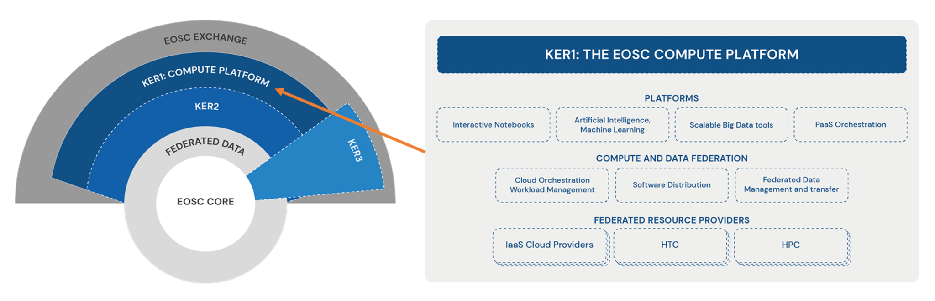
Figure 2: KER 1 - The EOSC Compute Platform

KER Champion | Enol Fernandez (EGI Foundation)
Result Description | The EOSC Compute Platform, delivered by EGI-ACE, is a free at the point of use, distributed computing environment. The Platform federates compute, storage and high-level services from research performing organisations and commercial entities. The Platform supports diverse, distributed data processing and analysis use cases.  The Platform is built on a hybrid infrastructure composed of cloud computing resources, High-throughput computing (HTC) sites and High-Performance Computing (HPC) centres. The Platform includes higher-level services which support Hybrid Cloud Orchestration (deploy custom virtual machines over multiple clouds), Workload Management (schedule, execute jobs), Artificial Intelligence/Machine Learning, Interactive Computing, Coordinated deployment/staging of applications and data. The Platform includes user support and training for researchers and scientific projects. The Platform is integrated with the EOSC Exchange, allowing other EOSC services to tap into its capabilities and resources.
Result Type | Services
Geographical Market | Global
Number of Customers | >1000 (7700+)
Types of Customers | - Individuals  - SMEs  - Academia  - Research and Technology Organisations  - Public Institutions and Authorities
Value Proposition | Researchers/Users  - Having a broad and growing spectrum of types of compute resources behind a single interface (EGI-ACE Open Call) and single allocation process.  - Streamlined support and communication through the use case shepherds and with access to experts for consultancy to select the most suitable types and combination of compute and related platform/data services to realise a use case.  - Build partnership with national providers for long-term usage of their compute resources.  - Free-at-point-of-use access to national and relevant international capacity.  - The distributed setup allows for computation to happen where the data is removing the need to move large amounts of data and any privacy concerns.  - Reusing software across providers with the use of AppDB removes the hurdle of installing software at every provider.  Providers  - Providers who join the EOSC Compute Platform benefit from the simplified integration with EOSC  - Co-funding by the EC to deliver relevant services across national borders.  EOSC  - The Platform allows the efficient use of European Commission and national funds, by integrating cross-border with national access mechanisms, maximising the return of investment for all stakeholders.  - Computing infrastructure is completely integrated with the EOSC ecosystem making EOSC an end-2-end destination.
Result Maturity | TRL7
Current Stage and Next Steps | Current Status  Number of providers  - HTC: 220  - Cloud: 27  - HPC: 4 pilot centers (not yet reached maturity)  Resource Allocated  - 20 million CPU hours (Additional 20M delivered via local funding and 2M externally funded)  - 29,213 GPU hours  - 5536 TB/month storage.  Next Steps  - To onboard HPC resources into the EOSC Compute platform.  - Improve integration and interoperability between services  - Monitor VA consumption  - Reassessment of communities requests (ongoing) to ensure services uptake  - Redistribution of load to ensure fair distribution among providers  - Targeted dissemination activities: DODAS for ESCAPE users, DEEP for AI/ML use cases  - Engage with communities testing RUCIO and FTS on premises (e.g., EISCAT_3D, LOFAR), then switch to the available WP6 installations for their production activities  - FTS as Data Transfer pilot for EOSC-Future  - Boost MasterPortal usage via DIRAC integration (soon in production)
IPR Approach | - Open Source license for software  - CC-BY license for documentation
Scalable Business Model | The Platform integrates capacities pre-paid by national governments and by the European Commission to provide IT services for science. Whenever possible we provide our users access to capacities in their national scope, minimizing dependency on cross-national usage. This lowers the overhead costs related to international usage which would be paid by the European Commission funds. The approach increases the scalability and sustainability of compute service delivery. There is a dedicated procurement action planned for sustaining the EOSC Compute Platform beyond the lifetime of the project.
Replicability | As the EOSC Compute Platform uses open-source components and detailed guidelines and documentation of the processes and procedures followed are available, it is possible to replicate the result.
Sustainability | There is a dedicated procurement action planned for sustaining the operation of the EOSC Compute Platform beyond the lifetime of the project. The procurement is expected to fund the central activities of the project (such as central Operation oversight, Resource Allocation, Training and Support teams), as well as offer some level of international service delivery. A major part of delivery will continue to rely on national funds, and the resource allocation process will continue to 'bring users to national resources' and enable the migration of applications and data to those resources as much as possible.
Important Links | - EGI-ACE Compute Platform Handbook.  - Technical specifications for computing common services report describes the different layers of the EGI-ACE technical architecture and details each of the services that compose those layers, covering the central services that enable the federation, resource providers delivering access to the actual computing and storage infrastructure, and higher-level Platform and Software as Service layers that provide compute and data orchestration alongside tools to facilitate the execution of workloads in the distributed infrastructure.
Dissemination | 12 Webinars - 370 participants  - 3 on Federated Resources layer  - 5 on Check-in & Compute and Data Federation layer  - 4 on Platforms layer  17 presentations at conferences and workshops – estimated reach +900 attendees  - EGI Conference 2021  - EGI-ACE Communities Workshops (one in 2021, one in 2022)  - EOSC Future Ask me anything sessions (3 events)
Exploitation | - 7700+ users  - 84 research communities  - 102 countries reached  - 4000+ logins per month

Services enabling federated computing in EOSC
Figure 3 provides a representation of this KER as overlaid on the EOSC Architecture diagram. The right side of the figure also presents the various technical and support services that are provided as part of this KER.
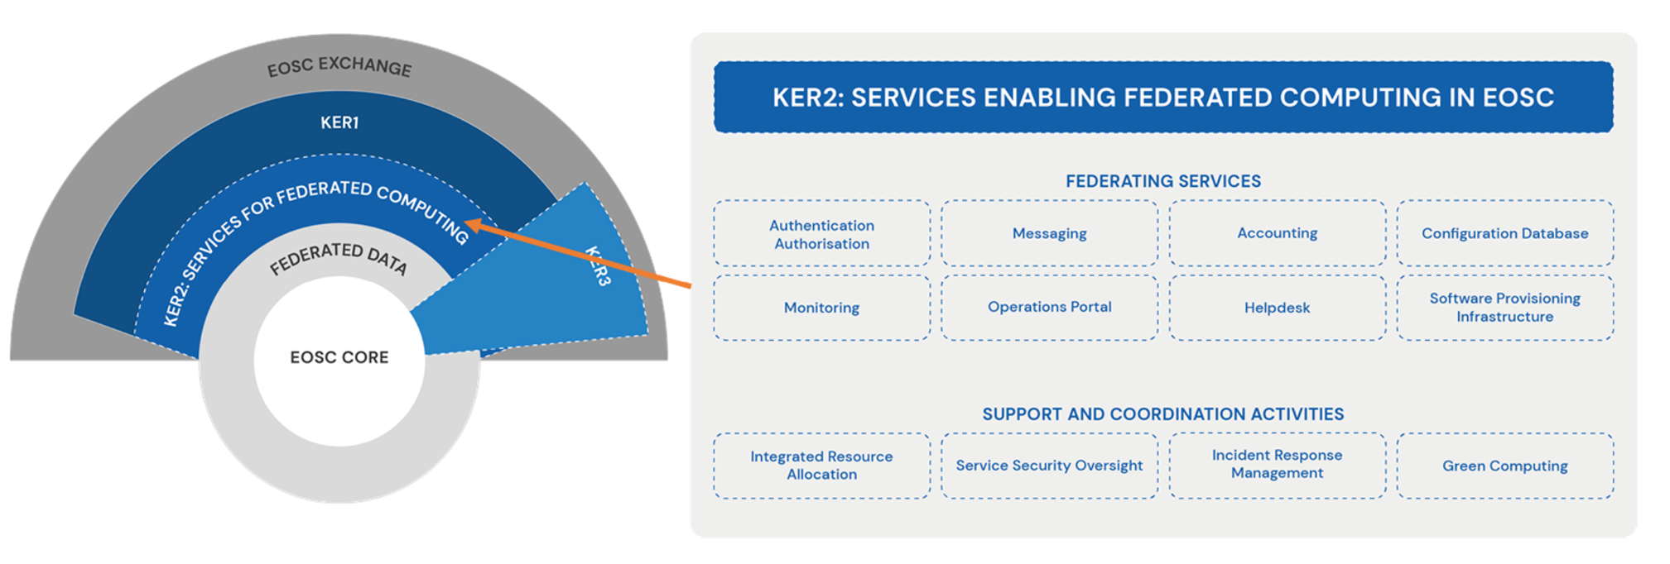
Figure 3: KER 2 - Services enabling federated computing in EOSC

KER Champion | Alessandro Paolini (EGI Foundation)
Result Description | EGI-ACE delivers various services that ensure the efficient management of the EOSC Compute Platform as a federated environment. These enabling services include technical elements (Check-in, Configuration Database, Monitoring service, Usage Accounting system, and Helpdesk), as well as non-technical elements and coordination activities, such as an IT Management System, service security oversight, incident response team, and resource allocation team.  For providers, these services ensure a simplified and seamless integration into the Compute Platform and, therefore, with EOSC. For users, this provides a scalable resource allocation approach that considers local and European policies and the needs of national and international research communities. The project also develops a knowledge catalogue with best practices and training materials to help providers of the EOSC Compute Platform improve energy efficiency at data centres.
Result Type | Services
Geographical Market | Global
Number of Customers | 6-30
Types of Customers | - SMEs  - Research and Technology Organisations
Value Proposition | For Providers  - The result enables standardised ‘access to market’ mechanism to service providers with built-in mechanisms to ensure fairness across the group of providers.  - Simplified order handling and customer relationship management (thanks to the first line CRM team that pre-analyses and brokers orders to best fitting providers, and the shepherd who liaises with the use cases).  - Being part of a computing community that advises each other on topics of shared interest (e.g., containers, green computing).  - Working with like-minded compute centres on harmonised policies, protocols, approaches for service operation, architecture and funding.
Result Maturity | TRL7
Current Stage and Next Steps | Current Status  The Service Management Tools – Technical Plan presents a brief functional description for each service, reports the requirements that have been implemented over the first year of EGI-ACE, and provides a technical development roadmap for the next period.  Next Steps  - Continue to collect and work on requirements for the Service Management tools according to EGI-ACE needs  - Deploy Keycloak as a new technology for EGI Check-in  - Implementation of the Storage and GPU Accounting  - New infrastructure for the middleware repository  - Creation of Green Computing best practices  - Increase the maturity of the service suppliers in IT standards  - All the staff involved in the operation of the services is trained to an adequate level of FitSM  - Providing guidelines to the suppliers to self-assess the status of their own SMS, with a particular focus on the interfaces with the EGI SMS.  - Regular update and evolution of the security policies and procedures  - Involving HPC providers
IPR Approach | - Open Source license for software  - CC-BY license for documentation
Scalable Business Model | Yes. These services are sustained through the funds collected through the membership fees of the EGI Federation. The number and capacity of these services depend on the budget and overall requirements gathered from the members of the Federation.
Replicability | It can be replicated by other Federations with some modifications depending on the context.
Sustainability | The result is connected and supported by the existing legal entity - EGI Foundation.
Important Links | - Guidelines for technical interoperability, service management alignment from INFRAEOSC03 and in coordination with other INFRAEOSC07 projects, and the status of the EGI-ACE service portfolio. Includes report of FAIR maturity level assessment of EGI-ACE data spaces and recommendations.  - Technical Roadmap for service management tools
Dissemination | Green Computing  - Survey circulated to all EGI-ACE participants (Jul 2021)  - 52 questions  - Information about the current status over lowering the impact of the energy consumption on the environment and future plans  - Response from 16 organisations  Workshops - estimated reach +1000 attendees  - 1 HPC integration workshop at EGI Conference 2021  - 1 Cloud and HTC integration workshop at EGI Conference 2021  - Security Workshop - ISGC 2022  2 Webinars (70+ participants)  - Monitoring services with ARGO  - How Green Is My Infrastructure?
Exploitation | Providers in the EOSC Compute Platform and Thematic Service Providers are using the Service Management Tools enabling the federated computing and supporting the operations activities.  - HTC, Cloud, HPC providers (WP3, WP7)  - IaaS Federation Services (WP3)  - Platform Services (WP4)  - Federated Data Spaces (WP5)  - Federated Data Access and Federated Compute Access Services (WP6)

Research data spaces and processing tools for EOSC
Figure 4 provides a representation of this KER as overlaid on the EOSC Architecture diagram. The right side of the figure also presents the scientific domains in which the data spaces of the project are a part of.
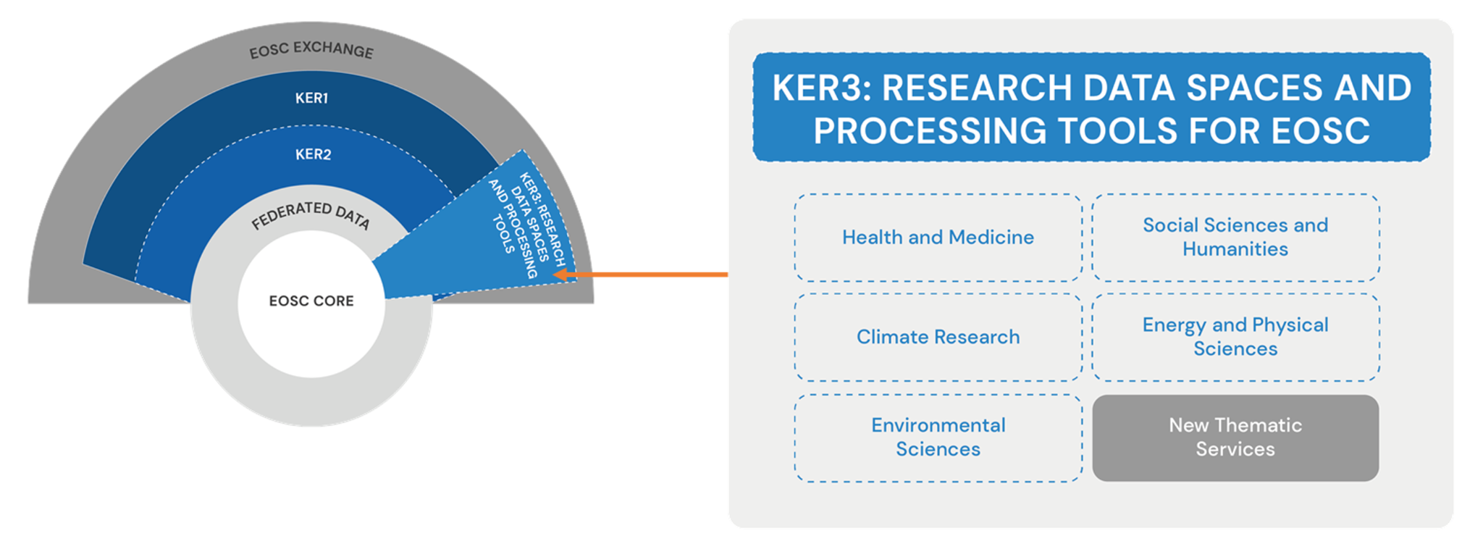
Figure 4: KER 3 - Research data spaces and processing tools for EOSC

KER Champion | Giuseppe La Rocca (EGI Foundation)
Result Description | Leveraging the EOSC Compute Platform, the EGI-ACE project has set up and provisions a thriving collection of Research Data Spaces and data processing tools.  Data Spaces are thematic services that host and integrate both datasets and scientific tools in a single unit, enabling scalable, online analysis of big datasets. The Data spaces federate data from multiple providers and host this data on the EOSC Compute Platform together with applications that read and can process the data. Both Data Spaces and the processing tools are integrated in the EOSC Portal and Marketplace as Thematic services to facilitate user access.  There are 13 dataspaces in the project,  - Health and Medicine: WeNMR, Virtual Imaging Platform, OpenRiskNet/NanoCommons, UseGalaxy.eu  - Climate Research: OpenCoastS, ENES  - Energy and Physical Sciences: PROMINENCE/Fusion, LOFAR  - Environmental Sciences: SeaDataNet, EMSO ERIC, GBIF, Disaster Mitigation and Agriculture  - Social Sciences and Humanities: OPERAS.  The project supports the setup and operation of additional Data Spaces, with the intention of contributing to the EOSC Exchange and Data Commons.
Result Type | Services
Geographical Market | Global
Number of Customers | >1000 (49000+)
Types of Customers | - Individuals  - SMEs  - Academia  - Research and Technology Organisations
Value Proposition | For Scientific Communities  - Streamlined support and communication through the use case shepherds and with access to experts for consultancy to select the most suitable types and combination of compute and related platform/data services to realise a use case.  - Build partnership with national providers for long-term usage of their compute resources.  - Free-at-point-of-use access to national and relevant international capacity.  - Increase user base and reusability of their services  - Development of sustainability plans for operation beyond the lifetime of the project.  EOSC  - Contribution to the EOSC Data Commons through the setup and provisioning of ‘Data Spaces’  - Contributions to multiple EOSC strategic objectives as defined by the PPP/SRIA.  - Development of guidelines and best practice approaches on how to set up and operate data spaces.
Result Maturity | TRL9
Current Stage and Next Steps | Current Status  During the first fifteen months of activity, the EOSC Compute Platform was instrumental in maintaining the operational level of many domain-specific thematic services such as: WeNMR and VIP. These Thematic Services are serving structural biologists and the medical imaging community providing them user-friendly access to complex computational workflows, tasks and resources. For the EMSO-ERIC Data Space, the Platform actively contributed to help the installation reach the pre-production level in 2021. New installations including the ENES Data Space, the GBIF Cloud data space, and the LOFAR Science Products rolled out their first releases in Q3 2021 and they are now on-boarded in the EOSC Portal.  Next Steps  - Complete the integration of the SeaDataNet, OpenRiskNet Data Spaces and Disaster Mitigation and Agriculture Thematic Service in the EOSC Compute Platform.  - Increase outreach and dissemination activities to promote the services uptake.  - Ensure long term support for user facing activities  - EOSC procurement, Lot 4 as possible funding source
IPR Approach | - Open Source license for software  - CC-BY license for documentation
Replicability | Guidelines have been created describing how to support the data spaces and use cases along with established processes that can be followed easily, making it easier to establish and onboard new data spaces and processing tools in EOSC.
Sustainability | The project will contribute to the development of a data space reference model and support the definition of related financial and sustainability models. The most successful data spaces can access new funding opportunities after the end of EGI-ACE. The EGI-ACE expertise and reference model is used beyond the project for the building of Data spaces.
Important Links | Links to services in EOSC Marketplace  - WeNMR  - The Virtual Imaging Platform (VIP)  - The European Galaxy server  - OPENCoastS  - The ENES Data Space  - PROMINENCE  - LOFAR  - EMSO ERIC Data Portal  - GBIF Spain Images portal and web services application  - PRISM: Peer Review Information Service for Monographs (DOAB) service  Documentation  - D2.4 Technical, Policy and Service Management Integration Report
Dissemination | 28 training events were organized by the WP5 partners, with focus on  domain researchers:  - 9 by WeNMR,  - 7 by EISCAT_3D,  - 4 by OpenCoastS,  - 3 by LOFAR,  - 3 by Virtual Imaging Platform,  - 1 by ENES, and  - 1 by EMSO-ERIC.  2 webinars were organized:  - Virtual Imaging Platform  - The ENES Data Space  1,703 participants in total
Exploitation | - 49000+ users  - 33% of the users from outside Europe

Conclusions and Future Work
At the midpoint of the project, the list of three KERs can be considered stabilised. However, there remains a small possibility that additional KERs may still be identified emerging from the early adopters and the use cases. This will be continuously monitored with the support of the SDS. The existing KERs will be monitored for the rest of the project at periodic intervals and the information in the HRP will be updated as required.
As discussed earlier, there is a need to zoom into the individual components and results contained within the identified KERs. These project results have their own access rights and protection mechanisms and understanding them is key to ensuring good exploitation of the KERs. For KER1 and KER2, an innovation developed during the project in the individual services included as part of these KERs will be documented along with other information such as license, and maturity level, among other things.
Furthermore, these individual project results may form their own autonomic innovation and dissemination systems, especially the Data Spaces included in KER3 which are linked to a certain research community with their own dissemination and exploitation strategies and tools. To continue getting a better understanding of how the results of the project are being exploited by the relevant users and communities and the impact they are creating, discussions will be arranged with selected use cases and communities as part of their periodic customer review or user workshops or on an ad-hoc basis.
For the next period, the project will also explore the possibility of writing publications based on the innovation being developed in the project. For this, a special discussion will be arranged in the SDS to identify potential topics for publication. The focus will be on the areas of innovative infrastructure being built for federated computing and data spaces. Currently, a paper is being drafted which will discuss the mature data spaces and the value provided by the project to these data spaces and their respective communities.
The project will also explore the possibility of registering its data spaces use cases as part of the International Data Spaces Association’s (IDSA) Data Space Radar. The radar covers use cases of different degrees of maturity from the phase of creating a business case to real data spaces. From planned to pilot to fully operational, across industries and functional domains — the use cases that align with your business goals are on the radar. This Data Space Radar presents a unique exploitation opportunity for these data spaces as it will allow all of them to realise the full value of their data through equal access to secure and sovereign data exchange among trusted partners. The use cases will feed into the building blocks catalogues initiatives that will establish the foundations to build the European Data Spaces.
The Federated Data Layer of EGI-ACE enables access to third-party data relevant to research projects. Aligning and contributing to the Data Space architecture will allow the data layer to facilitate data discovery and access to distributed datasets in the cloud. The project should also explore the strategic positioning, business models and governance of this federated data layer.
Support, where required, will also be provided to the activities described in the Communication and Engagement Plan to promote underused services, promoting HPC services and outreach to new communities. The results of all these activities will be presented in the final periodic report.

Appendix 1: EGI-ACE Stakeholder group definition
Stakeholder category: Users
Stakeholder group | Main motivation for engagement with the project
Researchers | This group wants to access services provided by the project for short term use (< 1 year).
International projects | This group wants to access services provided by the project for mid-term use (<3 years).
Research Infrastructures (RIs) | This group is interested in the service offerings of the project for long term, customised use (>3 years).
Industry/SMEs | The group wants to use the EOSC Compute platform for prototyping applications, and to receive technical support for the integration of applications/platforms with EOSC Compute continuum.
Public sector | This group is an early adopter of academic compute services and could use the project to access services in the EOSC Compute platform and to receive technical assistance for architecting and implementing compute-setups.
Stakeholder category: Service and content providers for research
Academic HTC/Cloud providers | This group will make use of the project’s wider reach to ensure their services are used across borders.
HPC providers | This group will be interested to learn about the project’s HPC integration and guidelines and follow them to become providers in EOSC.
Data Space providers | This group will be interested in how to interact with the services offered by the project to offer data spaces (i.e. scientific datasets and applications all integrated on scalable compute platforms.)
Stakeholder category: EOSC Governance and Core
EOSC Association | This group will benefit from the contributions of the project to the EOSC and will be interested in learning about the results, impact and development of the EOSC Compute Platform also with respect to competing/complementing solutions ‘out there’.
EOSC AGs/TFs | This group will be interested in receiving expertise from the project for specific topics to collaborate seamlessly on EOSC matters.
Providers of EOSC Core | This group will be eager to receive feedback and requirements on the services to continuously develop them.
Stakeholder category: Peer initiatives
INFRAEOSC-07 projects | This group will benefit from the joined activities, promotion and collaboration to further serve the EOSC mission and raise awareness.
GAIA-X | This group will be interested in learning about approaches to similar activities.
EOSC-like initiatives outside Europe (GOSC) | This group will be interested in learning about practices and technical solutions used/delivered by EGI-ACE to adopt those for the support of computing for Open Science.
EOSC-Future Project | This group will share a similar motivation as the ‘INFRAEOSC-7 projects’ and is interested in integrating their activities with that of the project where relevant

Appendix 2: Horizon Results Platform Template
The platform is available at the following link,
https://ec.europa.eu/info/funding-tenders/opportunities/portal/screen/opportunities/horizon-results-platform
Any H2020 or FP7 beneficiary can (and is encouraged) to submit project results by clicking the link Publish my Result (requires access to an account that is defined as a participant contact).
Result Title, Target Audiences and Needs | Instructions, suggestions | Answers
Title of result (120 characters) | Ideally a punchy name that makes sense to someone who hasn’t heard about EOSC, e-Infrastructures or Cloud technologies. Writing acronyms (like EOSC) out might be a good idea.
Message/ Teaser to potential user (1000 characters) | From the help text:  ” Please state what your result is, what it is for, what makes it special in terms of adding value or knowledge, what is your purpose of making it public, and what is your target audience.”  Essentially a 5W summary of the result: https://en.wikipedia.org/wiki/Five_Ws
Video/ image section | Upload an image (primary goal: visually attractive item to draw attention and trigger curiosity) or add a link to a YouTube/Vimeo video.
Result Type | Dropdown list with a few options.
Target Audience | Select max three from the list; somewhat start-up-oriented list, but includes e.g. policy makers and  other.
Our needs are | Another dropdown list, max three choices. Heavily geared towards investors/funding sources and entrepreneurship-related training.
We specifically need/ are looking for (600 words) | Freeform description of what the result owners are looking for (more specifically than the selection from the list) from the members of the target audiences selected.  Ideally it would be possible to present engagement as something that is in the self-interest of the target audience members.
ABOUT US
Main project | EC-funded project that was the main contributor
Other related projects | Optional – won’t be visible in the entry
Result Contributors | The partners that contributed to the result. Dropdown list with full partner names (may need GA to map short names to long ones)
Owners for exploitation | Partners that will serve as contact points for further exploitation. Less important for open EOSC services (in which case entries would probably imply a commitment to user onboarding and support). In case the business model is based on licensing of IPR, this needs more care (either single owner or parties to a joint ownership agreement)
Start-up created for further exploitation? | Yes/no
Logo | Not applicable unless there’s a start-up in the works
TESTIMONIALS/ REFERENCES
Title | Title of the success story collection (should at least contain material that is not created by the contributors or owners).  You can add several entries on this section (click Add information)
Link | URL
FIND US ON
Description | No help text, but this could be e.g., homepage or EOSC marketplace entry.  As with testimonials, it is possible to add more than one line: homepage + marketplace entry ideal solution.
Link | URL
RESULTS DESCRIPTION AND INFLUENCE
Result description (1200 characters) | More detailed description of the result, freeform.  N.B. The form seems to calculate characters in bulleted lists wrong (effective character limit seems to be lower with formatting than without it).
Business Sector(s)/ Policy Area(s) | Dropdown list, several options, select max 3.
Tags/ Keywords | From the help text:  We would recommend that you use keywords to describe the technology, science, sector, content or nature of the result and very importantly, keywords to denote potential uses or applications of your result. Please note that, by default, you will see in your submission form all keywords linked to the main project you had chosen for declaring this result. This is to help you get started. Feel free to remove those keywords irrelevant to this result.
YOUR RESULT'S CONTRIBUTION TO SUSTAINABLE DEVELOPMENT
Contribution to UN Sustainable Development Goals | Dropdown list with the goals listed (compulsory, includes not applicable as one of the answers. Max three  For background, see: https://www.un.org/sustainabledevelopment/sustainable-development-goals/
Radical Innovation Breakthrough? (optional) | Refers to a specific list of Radical Innovation Breakthroughs (RIBs) defined by the Commission based on a study. Details can be found at https://www.researchgate.net/publication/335661904_100_Radical_Innovation_Breakthroughs_for_the_future  - list of RIBs copied to Appendix 4
Are you a member of the 'World Alliance for 1000 Solutions'? | Yes/no – the alliance homepage is at https://solarimpulse.com/world-alliance
YOUR RESULT'S INFLUENCE ON POLICY
Has your result had, or you expect it to have significant influence on policy-making? | Yes/no – e.g. I would imagine results related to natural hazards would automatically have at least a moderate impact on policy. Error in the helpdesk, so exact definition is a bit unclear
OTHER INFORMATION/ DATA TO SHARE
Title (optional, one or more links to further information) | Open access publications, presentations
Link | URL
RESULT AND BUSINESS MATURITY AND EXPLOITATION OUTLOOK
Result Maturity | TRL (https://en.wikipedia.org/wiki/Technology_readiness_level) rating market deployment or not applicable. Anything onboarded on EOSC marketplace should be at least TRL 8-9.
Current Stage and Next Steps | More details/justification of the maturity. Investor perspective noted in the help text.
Do you already have customers for this result? | Yes/no. If yes, see next:
Number of existing customers | Categories (1-5, 6-30, 31-50, 51-100, 101-500, 501-1000, >1000)
What type of customers/ users do you have? | Different types of for-profit/public sector entities + individuals (number of choices doesn’t seem to be limited)
Which Business Sectors do your customers mainly come from? | Many categories; allows more than three options.
Unique value proposition | Help text suggests mapping this to the teaser (consistency). The Wikipedia page on the topic might offer some food for thought and help to get from scientific communications mode to shameless self-promotion: https://en.wikipedia.org/wiki/Unique_selling_proposition
Do you have a scalable business model? | The help text offers some help, but as a rule of thumb: for a business model to be scalable, staffing requirements should grow in a strongly sublinear fashion and/or the revenue per customer (or end-user) should remain relatively stable.  Grant-based sustainability is usually not scalable, nor is consulting. Franchising, licensing and platform business models can be.
Is your result replicable? | Judgement call, some help from the instructions available.  Possible rule of thumb: if you can move all the staff members involved in the result to a new project with only a minor dip in customer/client satisfaction, the result is replicable. Web-based self-service solutions can be replicable, training probably not.
Please elaborate on the Replicability | Justification for a claim for replicability
Is your result and your business model sustainable in the long-term? | The help text doesn’t make much sense – the site linked to it talks about sustainability in the ecological sense, but I would interpret this in the economic sense.  Rule of thumb might be a weaker version of scalability: if you assume you can generate revenue to cover the costs, you are probably sustainable. Even grants- or donations-based revenue models can be sustainable, but would probably need elaboration (e.g. plan on creating a brand, goodwill to overcome donor apathy – Oxfam/Wikipedia sustainability model)
Please elaborate on Sustainability | Justification to claim the solution is sustainable.
Are you targeting geographical markets? | Market areas, can also be global
INVESTORS CORNER
What level of investment (EUR) are you currently looking for? | Levels of funding sought: if a € sum is chosen, additional tick boxes explaining what potential investors would receive

Appendix 3: Radical Innovation Breakthroughs
From the report, 100 Radical Innovation Breakthroughs for the Future, published at Horizon scanning study: Future Radical Innovation Breakthroughs.
(Areas of high potential relevance to EOSC-related activities in bold)
2D Materials | Bioluminescence | Energy Harvesting | Lab-On-A-Chip
3D Printing of Food | Bionics (medicine) | Epigenetic Change Technologies | Marine and Tidal Power Technologies
3D Printing of Glass | Bioplastic | Exoskeleton | Metamaterials
3D Printing of Large Objects | Bioprinting (of human parts) | Flexible Electronics | Microbial Fuel Cells
4D Printing | Blockchain | Flying Car | Microbiome
Airborne Wind Turbine | Brain Functional Mapping | Gene editing | Molecular Recognition
Aluminium-based Energy | Brain Machine Interface (BMI) | Gene Therapy | Molten Salt Reactor
Antibiotic Susceptibility Testing | Carbon Capture and Sequestration | Genomic Vaccines | Nano-LEDs
Artificial Intelligence | Carbon Nanotubes | Geoengineering and Climate Engineering | Nanowires
Artificial Photosynthesis | Chatbots | Graphene Transistors | Neuromorphic Chip
Artificial Synapse/ Brain | Computational Creativity | High-precision Clock | Neuroscience of Creativity and Imagination
Asteroid Mining | Computing Memory | Harvesting Methane Hydrate | Optoelectronics
Augmented Reality | Control of Gene Expression | Holograms | Plant Communication
Automated Indoor Farming | Desalination | Humanoids | Plastic-Eating Bugs
Biodegradable Sensors | Driverless | Hydrogels | Precision Farming
Bioelectronics | Drug Delivery | Hydrogen Fuel | Quantum Computers
Bioinformatics | Emotion Recognition | Hyperloop | Quantum Cryptography
Bioluminescence | Energy Harvesting | Hyperspectral Imaging | Regenerative Medicine
Bionics (medicine) | Epigenetic Change Technologies | Lab-On-A-Chip | Reprogrammed Human Cells
Bioplastic | Exoskeleton | Marine and Tidal Power Technologies | Self-healing Materials
Bioprinting (of human parts) | Flexible Electronics | Metamaterials | Smart Tattoos
Blockchain | Flying Car | Microbial Fuel Cells | Smart Windows
Brain Functional Mapping | Gene editing | Microbiome | Soft Robot
Brain Machine Interface (BMI) | Gene Therapy | Molecular Recognition | Speech Recognition
Carbon Capture and Sequestration | Genomic Vaccines | Molten Salt Reactor | Spintronics
Carbon Nanotubes | Geoengineering and Climate Engineering | Nano-LEDs | Splitting Carbon Dioxide
Chatbots | Graphene Transistors | Nanowires | Swarm Intelligence for undertaking practical tasks
Regenerative Medicine | Spintronics | Touchless Gesture Recognition | Neuroscience of Creativity and Imagination
Reprogrammed Human Cells | Splitting Carbon Dioxide | Underwater Living | Technologies for Disaster Preparedness
Self-healing Materials | Swarm Intelligence for undertaking practical tasks | Warfare Drones | Targeting Cell Death Pathways
Smart Tattoos | Targeting Cell Death Pathways | Wastewater Nutrient Recovery | Neuromorphic Chip
Smart Windows | Technologies for Disaster Preparedness | Water Splitting | High-precision Clock
Soft Robot | Thermoelectric Paint | Computing Memory | Computational Creativity
Speech Recognition | Harvesting Methane Hydrate

The following categories are not available on the Participant Portal; however, they are listed here for completeness' sake – they could be good keywords and topics for the policy impact.
List of Radical Social Innovation Breakthroughs (RSBs)
Access/Commons-Based Economy | Life Caching | Car-free City | Owning and Sharing Health Data
Alternative Currencies | Local Food Circles | Collaborative Innovation Spaces | Read/Write Culture: diversifying information gatekeepers
Basic Income | New Journalist Networks | Gamification | Reinventing Education
Body 2.0 and the Quantified Self

List of Global Value Networks (GVNs)
Carbon retention for climate change mitigation | Individualised manufacturing close to the customer | Smart transport | Sustainable use of materials
Decent and meaningful life for elderly people | Peer to peer-based consumption decisions | Space as a global commons | Sustainable use of water systems and resources
Enabling mechanisms for self-organising communities | Planning and infrastructure for liveable human settlements | Sustainable energy solutions | User data markets
Global Capacity for Social Innovation | Pro-active health and self-care approaches | Sustainable food for all | Valid information and knowledge co-creation
Human and social security | Remote interaction with people and machines | Sustainable housing | Virtual citizen interaction for entertainment
Individualised manufacturing close to the customer | Security network against military and criminal attacks | Sustainable tourism | Art and culture
Peer to peer-based consumption decisions | Smart transport | Sustainable use of materials

KER1 https://ec.europa.eu/info/funding-tenders/opportunities/portal/screen/opportunities/horizon-results-platform/41512
KER2 https://ec.europa.eu/info/funding-tenders/opportunities/portal/screen/opportunities/horizon-results-platform/41519
KER3 https://ec.europa.eu/info/funding-tenders/opportunities/portal/screen/opportunities/horizon-results-platform/39783
https://ec.europa.eu/info/funding-tenders/opportunities/portal/screen/opportunities/horizon-results-platform
Solutions for a sustainable EOSC (report from the EOSC Sustainability WG)
Solutions for a sustainable EOSC (report from the EOSC Sustainability WG)
Solutions for a sustainable EOSC (report from the EOSC Sustainability WG)
Options: Policy Related Results, Scientific or Technological R&D results (including HW), ICT Software Digital Solution, Other Intangible Results, Services, Other
Options: Others/ No specific audience, Public or private funding institutions, EU and Member State Policymakers, International Organisations (ex. OECD, FAO, UN, etc.), Other Actors who can help us fulfil our market potential, Research and Technology Organisations, Academia/ Universities, Private Investors
Options: Business partners - SMEs, Entrepreneurs, Large Corporations; Incubators / Accelerators; Marketing Mentoring or Coaching; Financing Expertise; Technology Transfer Expertise; Legal / IPR advise; I/we wish to transfer my/our IPR to an interested party; Investor readiness training; Investor introductions; Business plan development; Expanding to more markets /finding new customers; Executive Training; Business Angels; Venture Capital; Crowd-funding Equity; Other type of Investment
Options: Agriculture and rural development; Banking and financial services; Borders and security; Budget; Business and industry; Climate action; Competition; Consumers; Culture and media; Customs; Digital economy and society; Economy, finance and the euro; Education and training; Employment and social affairs; Energy; Environment; EU enlargement; European neighbourhood policy; Food safety; Foreign affairs and security policy; Fraud prevention; Home affairs; Humanitarian aid and civil protection; Institutional affairs; International cooperation and development; Justice and fundamental rights; Maritime affairs and fisheries; Migration and asylum; Public health; Regional policy; Research and innovation; Single market; Sport; Statistics; Taxation; Trade; Transport; Youth
Options: Individuals; SMEs; Big corporations; Academia; R&T organisations; Public Institutions and Authorities; Governments; Commerce; Manufacturers
Agriculture and rural development; Banking and financial services; Borders and security; Budget; Business and industry; Climate action; Competition; Consumers; Culture and media; Customs; Digital economy and society; Economy, finance and the euro; Education and training; Employment and social affairs; Energy; Environment; EU enlargement; European neighbourhood policy; Food safety; Foreign affairs and security policy; Fraud prevention; Home affairs; Humanitarian aid and civil protection; Institutional affairs; International cooperation and development; Justice and fundamental rights; Maritime affairs and fisheries; Migration and asylum; Public health; Regional policy; Research and innovation; Single market; Sport; Statistics; Taxation; Trade; Transport; Youth
https://ec.europa.eu/info/sites/info/files/research_and_innovation/knowledge_publications_tools_and_data/documents/ec_rtd_radical-innovation-breakthrough_052019.pdf
https://www.researchgate.net/publication/335661904_100_Radical_Innovation_Breakthroughs_for_the_future

