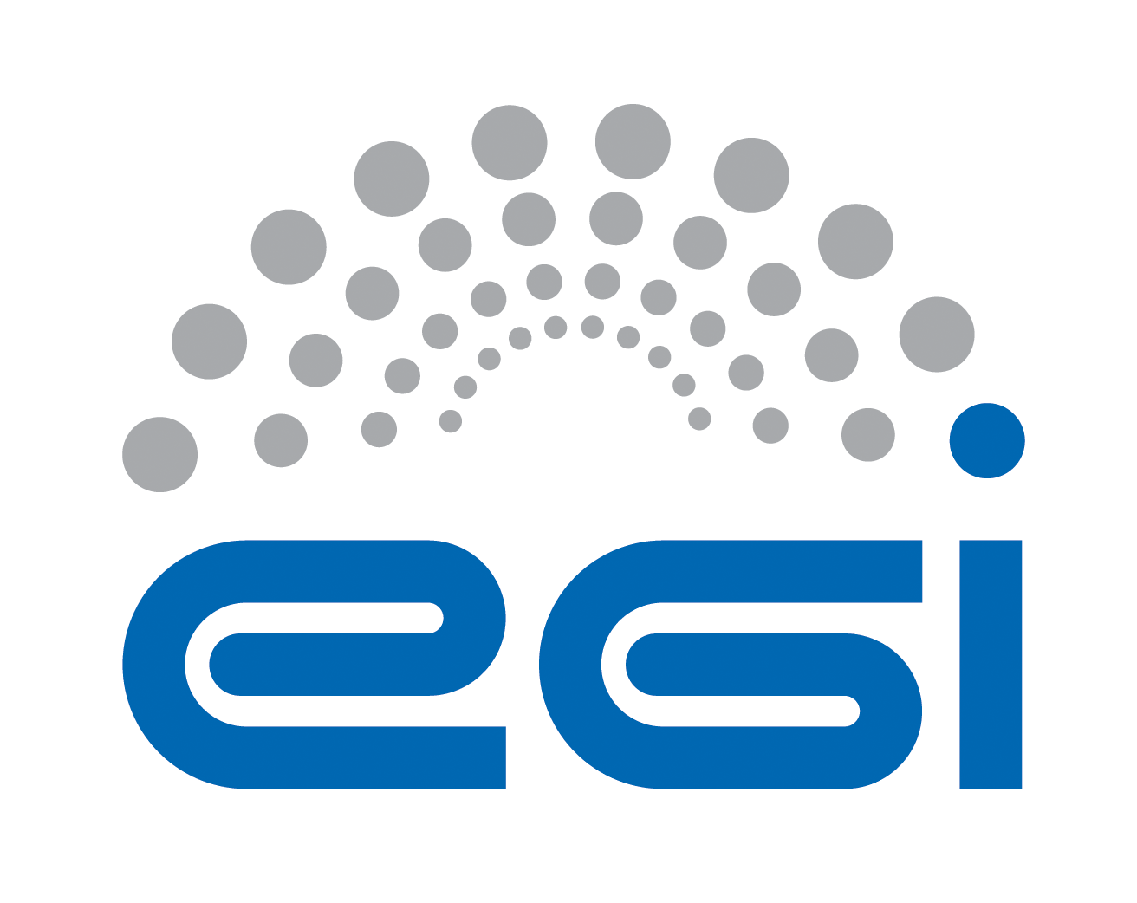
Acceptable Use Policy and Conditions of Use
of the EGI Platform for the Long-tail of Science

Document Link | https://documents.egi.eu/document/2635
Last Modified | 05/11/2015
Approved by | Members of project that developed the EGI Platform for the long tail of science
Contact Person | Gergely Sipos / EGI.eu, MTA SZTAKI

COPYRIGHT NOTICE
This work by EGI.eu is licensed under a Creative Commons Attribution 4.0 International License (http://creativecommons.org/licenses/by/4.0/).
TERMINOLOGY
A complete project glossary is provided at the following page: http://www.egi.eu/about/glossary/

This acceptable Use Policy and Conditions of Use applies to all the users of the ‘EGI Platform for the long-tail of science’, hereafter referred to as the Platform. EGI.eu (www.egi.eu) owns and gives authority to this policy.

The goal of the Platform is to offer user-friendly access to e-infrastructure services for members of the long-tail of science, i.e. for individual researchers and small research teams who do not belong to any of the established EGI Virtual Organisation communities.

By registering in the Platform as a user you declare that you have read, understood and will abide by the following conditions of use:
- You can use the services and resources of the Platform only for activities that relate to the work that you described in the registration form when you applied for access.
- Your registration will be suspended when you exceed the resources that were allocated for you during membership approval, or when your membership expires. (Membership is initially 6 months and can be extended for another 6 months.)
- You shall provide appropriate acknowledgement of support for your use of the resources/services provided. The following acknowledgement text can be used for this purpose (e.g. in scientific publications): This work used the EGI Infrastructure which is co-funded by the EGI-Engage project (Horizon 2020) under Grant number 654142.
- You shall not use the resources/services for any purpose that is unlawful and not (attempt to) breach or circumvent any administrative or security controls.
- You shall respect intellectual property and confidentiality agreements.
- You shall protect your access credentials (e.g. usernames and passwords).
- You shall keep all your registered information correct and up to date.
- You shall immediately report any known or suspected security breach or misuse of the resources/services or access credentials to the specified incident reporting locations and to the relevant credential issuing authorities.
- You use the resources/services at your own risk. There is no guarantee that the resources/services will be available at any time or that their integrity or confidentiality will be preserved or that they will suit any purpose.
- You agree that logged information, including personal data provided by you for registration purposes, may be used for administrative, operational, accounting, monitoring and security purposes. You agree that this logged information may be disclosed to other authorised participants via secured mechanisms, only for the same purposes and only as far as necessary to provide the services.
- You agree that the body or bodies granting you access and resource/service providers are entitled to regulate, suspend or terminate your access without prior notice and without compensation, within their domain of authority, and you shall immediately comply with their instructions.
- You are liable for the consequences of your violation of any of these conditions of use, which may include but are not limited to the reporting of your violation to your home institute and, if the activities are thought to be illegal, to appropriate law enforcement agencies.

https://wiki.egi.eu/wiki/Long-tail_of_science_project

