e-ScienceTalk

Dissemination Plan

EU DELIVERABLE: D4.1

Document identifier: | e-ScienceTalk_D4.1_DisseminationPlan_v0.1
Date: | 21/10/2010
Work package: | WP4
Lead Partner: | EGI.eu
Document Status: | FINAL
Dissemination Level: | PUBLIC
Document Link: | https://documents.egi.eu/document/232

Abstract
The document describes the dissemination and outreach plan for e-ScienceTalk, including audiences, messages, critical success factors and the products of the project: GridCafe, GridCast, GridGuide, the GridBriefings and International Science Grid This Week/The Digital Scientist.

- Copyright notice
Copyright © Members of the e-ScienceTalk collaboration, 2010. See www.e-sciencetalk.eu for details of the e-ScienceTalk project and the collaboration. E-ScienceTalk is a project co-funded by the European Commission as an Support Action within the 7th Framework Programme. E-ScienceTalk began in September 2010 and will run for 33 months. This work is licensed under the Creative Commons Attribution-Noncommercial 3.0 License. To view a copy of this license, visit http://creativecommons.org/licenses/by-nc/3.0/ or send a letter to Creative Commons, 171 Second Street, Suite 300, San Francisco, California, 94105, and USA. The work must be attributed by attaching the following reference to the copied elements: “Copyright © Members of the e-ScienceTalk Collaboration, 2010. See www.e-sciencetalk.eu for details of the e-ScienceTalk project and the collaboration”. Using this document in a way and/or for purposes not foreseen in the licence, requires the prior written permission of the copyright holders. The information contained in this document represents the views of the copyright holders as of the date such views are published.
- Delivery Slip
 | Name | Partner/Activity | Date
From | Catherine Gater | EGI.eu/WP4 | 21/10/2010
Reviewed by | Reviewers:
Approved by | PMB
- Document Log
Issue | Date | Comment | Author/Partner
1 | 21/20/10 | First draft | C Gater/EGi.eu
2
3
- Application area
This document is a formal deliverable for the European Commission, applicable to all members of the e-ScienceTalk project and its beneficiaries and collaborating projects.

- Document amendment procedure
Amendments, comments and suggestions should be sent to the authors.
- PROJECT SUMMARY

Over the last 10 years, the European Commission and governments have invested substantial funds in distributed computing infrastructures. Scientists have access to state-of-the-art computational and data resources located around the world, putting European research into a leading position to address the greatest challenges facing us today, such as climate change, pandemics and sustainable energy. The advent of the European Grid Infrastructure, combined with the blurring of boundaries between grids, clouds, supercomputing networks and volunteer grids, means that a clear consistent source of information aimed at non-experts is now more important than ever, through dissemination projects such as e-ScienceTalk, that cross national boundaries.

Objectives:

- e-ScienceTalk will build on the achievements of the GridTalk project in bringing the success stories of Europe’s e-Infrastructure to policy makers in government and business, to the scientific community and to the general public.

- e-ScienceTalk will work with EGI-InSPIRE and other collaborating projects to expand the scope of the existing GridTalk outputs, and to report on the interactions of grids with e-Infrastructures such as cloud computing and supercomputing.

- The project will explore options for the sustainability of e-ScienceTalk’s products.

- e-ScienceTalk will produce a series of reports aimed at policy makers to disseminate key policy issues underpinning grid and e-Infrastructure development in Europe. The project will also coordinate e-concertation activities.

- The GridCafé, GridCast and GridGuide suite of websites will cover new topics and explore novel web technologies; they will integrate closely with GridPP’s Real Time Monitor, combining live views of grid activity with the human aspects of computing.

- The growing weekly publication, International Science Grid This Week (iSGTW) will bring news and events to the existing and potential e-Science community under a new name of The Digital Scientist.

- EXECUTIVE SUMMARY
The aim of e-ScienceTalk is to build on the significant achievements of the “GridTalk: co-ordinating grid reporting across Europe” project in bringing the success stories of Europe’s e-Infrastructure to policy makers in government and business, to the broader scientific community and to the general public. The key challenges will be to work with the emerging European Grid Infrastructure (EGI) ecosystem as it becomes established, to maintain and enhance the high quality of the existing GridTalk outputs, to report on the interactions of grid computing with other e-Infrastructures, such as cloud computing and supercomputing and to explore the long-term sustainability of e-ScienceTalk’s products.

E-ScienceTalk’s output will consist of four principal products. Firstly, e-ScienceTalk will produce a series of GridBriefings aimed at policy makers in order to disseminate key policy reports and issues underpinning grid and e-Infrastructure development in Europe. As part of these activities, e-ScienceTalk will also coordinate annual concertation meetings and activities for the e-infrastructures area. The GridCafé, GridCast and GridGuide suite of interactive websites will expand in content to cover new developments and players in the changing arena of EGI, National Grid Initiatives (NGIs), European Middleware Initiative (EMI) and other e-Infrastructure projects. These websites will be enhanced by a closer interaction with the Real Time Monitor of GridPP, the UK Grid for Particle Physics, combining live views of grid activity with the human aspects of grid computing. Finally, the growing online weekly publication, International Science Grid This Week (iSGTW), will be relaunched as The Digital Scientist, and will communicate directly with the existing and potential grid and high performance/high throughput computing user community.

This document reviews dissemination prior to e-ScienceTalk through the GridTalk project and introduces the partners involved in the project and their responsibilities. Also outlined are ways in which e-ScienceTalk will collaborate with other projects, such as EGI-InSPIRE, EMI, SIENA and infrastructures outside Europe such as REUNA and ALICE2. The Dissemination Plan also includes success factors in the areas of establishing an effective team, coordinating their efforts, maintaining audience share and using new technologies.

E-ScienceTalk will target four specific audiences: Policy makers in European science and business; members of the public in Europe and worldwide; European scientists in a position to develop or exploit grid computing and e-Infrastructures and university and final year high school students. This document summarises the principal messages that will be disseminated to those audiences through e-ScienceTalk’s channels.

The Dissemination Plan discusses these channels in detail and also the means by which they will be implemented throughout the project – the GridBriefings, GridCafé, GridGuide, GridCasts, the Real Time Monitor and international Science Grid This Week/The Digital Scientist. The quality metrics that will be used to monitor the progress of each work package are also summarised.

In conclusion, the outputs of the project will be reviewed through the annual feedback and metrics reports, culminating in a guide to dissemination for EC projects. The impact and sustainability of the e-ScienceTalk products will also be assessed through annual reports, that will outline plans and options for their long term sustainability beyond the lifetime of the project.

TABLE OF CONTENTS
1 Introduction 6
1.1 Dissemination prior to e-ScienceTalk 7
1.2 Partners and responsibilities 7
1.3 Working with collaborating projects 8
1.4 Success factors 9
2 Target audiences 11
2.1 Policy makers 11
2.2 Media and general public 11
2.3 Scientists and e-Infrastructure users 11
2.4 University and final year high school students 11
3 messages 13
4 means for dissemination 14
4.1 Policy, impact and sustainability 14
4.2 GridCafé, GridGuide, GridCast 16
4.3 iSGTW/The Digital Scientist 19
4.4 Social media 20
5 implementation 21
5.1 Policy, impact and sustainability 21
5.2 GridCafé, GridGuide, GridCast 22
5.3 iSGTW/The Digital Scientist 23
6 quality metrics 25
6.1 Policy, impact and sustainability 25
6.2 GridCafe, GridGuide, GridCast 25
6.3 iSGTW/The Digital Scientist 25
7 conclusion 26
8 References 27

Introduction
The aim of e-ScienceTalk is to build on the significant achievements of the “GridTalk: co-ordinating grid reporting across Europe” project in bringing the success stories of Europe’s e-Infrastructure to policy makers in government and business, to the broader scientific community and to the general public.

The key challenges will be to work with the emerging European Grid Infrastructure (EGI) ecosystem as it becomes established, to maintain and enhance the high quality of the existing GridTalk outputs, to report on the interactions of grid computing with other e-Infrastructures, such as cloud computing and supercomputing and to explore the long-term sustainability of e-ScienceTalk’s products.

Background to the project

Over the last 10 years, the European Commission and governments across Europe have invested hundreds of millions of Euros in scientific grid computing and e-Infrastructures. European scientists now have access to state-of-the-art computational and data resources located around the globe, putting European research into a world-leading position. These grid and interacting e-Infrastructures allow Europe to benefit from research that addresses the greatest challenges facing the planet today, such as climate change, pandemics and sustainable energy.

Grid infrastructures are now moving towards a sustainable and more user-centric model through the European Grid Infrastructure, which will integrate national operations at a European level. During this transition, it is essential to keep the achievements and impact of grid, distributed and high performance computing at the forefront of people’s minds, through dissemination projects that cross national and even international boundaries. While the first phase of GridTalk focused principally on communicating the benefits, success stories and challenges of grid computing, e-ScienceTalk will expand its focus outwards from a central core of grid computing to cover the interactions and offerings from other e-Infrastructures, such as cloud computing, the supercomputing networks of DEISA and PRACE and the networking layer of GÉANT. This blurring of boundaries is being increasingly driven by the needs of users, such as the life sciences and fusion communities, and the future users represented by the European Strategy Forum for Research Infrastructures (ESFRI) projects. By broadening its approach in this way, e-ScienceTalk will increase its relevance to the general public, policy makers and the broader scientific community, helping to ensure continued public support for the European e-Infrastructures activities, as outlined by the EC in the Digital Agenda for 2020 and beyond.

Dissemination Outputs

E-ScienceTalk’s output will consist of four principal products. First, e-ScienceTalk will produce a series of GridBriefings aimed at policy makers in order to disseminate key policy reports and issues underpinning grid and e-Infrastructure development in Europe, seeking to expand the audience for these reports to new areas, such as the US. As part of these activities, e-ScienceTalk will also coordinate annual concertation meetings and activities for the e-infrastructures area.

Secondly, the GridCafé, GridCast and GridGuide suite of interactive websites will expand in content to cover new developments and players in the changing arena of EGI, National Grid Initiatives (NGIs), European Middleware Initiative (EMI) and other e-Infrastructure projects.

Thirdly, these websites will be enhanced by a closer interaction with the Real Time Monitor of GridPP, the UK Grid for Particle Physics, combining live views of grid activity with the human aspects of grid computing. Finally, the growing online weekly publication, International Science Grid This Week (iSGTW), will be relaunched as The Digital Scientist, and will communicate directly with the existing and potential grid and high performance/high throughput computing user community. The impact and sustainability of the e-ScienceTalk products will be assessed by the work package producing the GridBriefings, who will produce reports on the impact of these products on their audiences, but also outline plans and options for their sustainability at regular intervals throughout the project. Each of the work packages will provide input into these status reports, which will lead to a final report covering the sustainability of all the e-ScienceTalk products: the GridBriefings, the videos, blogs, user generated content, images, graphics, documents, the websites for GridCafé, GridCast and GridGuide and the weekly publication iSGTW and its archives. These products will all be made available as open access materials, freely accessible to European-funded projects and beyond.

Dissemination prior to e-ScienceTalk
Prior to e-ScienceTalk, the GridTalk project brought together and enhanced the communication channels that will be further developed during e-ScienceTalk. GridTalk was funded under FP7: Coordination Action for the Research Infrastructure Initiative to run from 1 May 2008 to 31 August 2010. GridTalk reached an extensive worldwide audience, as a result of its engaging and successful design-led products, qualified journalism professionals, high quality content, media contacts and extensive project networks. The GridBriefings reflected the work of over xx projects in the course of their first year, including non-European projects such as Open Science Grid and the Open Grid Forum, and international projects and initiatives such as the WorldWide Large Hadron Collider Computing Grid, the Green Grid and the fusion facility, ITER. The GridGuide was launched during GridTalk and now features over xx sites, including sites in Europe, South America and the US. During GridTalk, iSGTW reached readers from nearly 200 countries, speaking 115 different languages and produced articles covering projects in Europe, the US and around the world. An entirely new version of the GridCafé website was launched in November 2008 using a 3-D format, keeping the site at the cutting edge of web design and attracting more than xxx,000 visits from nearly xx,000 visitors since its launch. GridTalk held xx GridCast events, filming more than xx podcasts with more than xxx views on videosharing website YouTube alone, and visits from more than xx countries to the blog itself.

Partners and responsibilities

The e-ScienceTalk consortium members provide complementary areas of expertise, which are reflected in their tasks within the project.

  - EGI.eu coordinates pan-European distributed computing activity within Europe on behalf of its stakeholders, NGIs, EIROs, and others. It is independent of any particular institute or application community and will participate in a wide range of collaborations within Europe and beyond.

- QMUL is responsible for dissemination for GridPP, the UK’s particle physics grid. In this role it has developed an award-winning website, overseen the production of successful demonstrations, produced widely-reported press releases and held stands at many grid and computing events. In the policy area, QMUL has produced the series of GridBriefings published during GridTalk, a guide to GridPP for UK policy makers and provided speakers to policy conferences and in Parliament.

- APO’s experience of web and print design and new media will be crucial in further developing the GridCafé website and interactive content. As the site’s original designer, APO is in a unique position to build on its strengths and add new and innovative content, as well as to develop the GridCast and GridGuide sites. APO’s print design experience is also essential for producing eye-catching and engaging GridBriefings and marketing materials for iSGTW and the e-ScienceTalk project itself.

- Imperial College designed and built the Real Time Monitor for GridPP and will bring essential technical expertise to the consortium. The RTM demonstrates the global reach of grid computing in a highly visual and engaging way. Imperial College will enhance the co-development of the Real Time Monitor and the GridGuide. Imperial College is also a major centre for grid dissemination and e-Science in the UK in its own right.

- CERN is a well-known centre for grid communications and has hosted the editor of iSGTW since the publication’s launch. CERN has also managed the Enabling Grids for E-sciencE’s dissemination activities throughout all three phases of the project. CERN’s position at the hub of many grid projects, including the WorldWide LHC Computing Grid, puts it in an excellent position to source and share contacts, dissemination materials and success stories, which is vital for the continued success of iSGTW as well as the other e-ScienceTalk products. CERN also attracts high profile visitors from governments, business, funding agencies and international projects who will be exposed to presentations, events and materials from e-ScienceTalk.

Working with collaborating projects
In addition, the e-ScienceTalk consortium will work in collaboration with numerous grid and e-Infrastructure projects throughout Europe and beyond − without this close collaboration there would be no possibility of delivering the work programme.
E-ScienceTalk will work closely with the key projects shaping the current and future e-Infrastructures, including GÉANT, DEISA / PRACE, EGI, and EMI. These future collaborations will help e-ScienceTalk to achieve its aims to communicate the developments in the European e-Infrastructures clearly and authoritatively at a time of great change, when users and funders of the infrastructures will be closely tuned to progress in these areas. Working NGIs such as NGS in the UK, as well as local dissemination hubs such as EUAsiaGrid, ASGC and GridPP will also make an important contribution to these aims and the ultimate success of the e-ScienceTalk project.
REUNA will work with the project team to extend the reach of e-ScienceTalk to Latin America, particularly through collaborations with the ALICE2 project and CLARA. REUNA will also help e-ScienceTalk to disseminate the lessons learnt documents and reports widely, by translating them into Spanish. REUNA will also aim to translate GridBriefings and GridCafé content into Spanish on a regular basis, and host mirror sites where possible on the REUNA website in the e-Science section. The REUNA, GridCafé and GridGuide sites will also host mutual web links. REUNA will publicise e-ScienceTalk events and GridCasts, and iSGTW will advertise events and announcements from REUNA. In these and other ways, REUNA and e-ScienceTalk will support each other to disseminate grid and e-Science success stories and activities.
E-ScienceTalk has also agreed to work with projects such as The Lost Sounds Orchestra, WeNMR, neuGRID and enviroGRIDS to disseminate the results of their work in the fields of musical instrument reconstruction, grid-enabled nuclear magnetic resonance, neuroscience and environmental studies via e-ScienceTalk channels, enriching the content available across e-ScienceTalk’s products. As during GridTalk, e-ScienceTalk will work with many projects of this kind.
E-ScienceTalk will also aim to work with standards bodies and projects such as OGF and SIENA for policy engagement. GridTalk and OGF-Europe signed a mutual collaboration agreement outlining principal areas of collaboration in early 2008 and OGF-Europe went on to contribute to the GridBriefing PERT team, provide content for iSGTW, publish extracts from GridTalk content in OGF-Europe monthly eAnnouncements and contribute to the GridCasts. SIENA, the successor to OGF-Europe, has agreed to collaborate on communication and outreach activities and each project will identify relevant ways to maximise outreach.
E-ScienceTalk will also aim to work with other projects in a similar way, both at a national and European level, as well as with countries and regions outside Europe. Examples of the ways in which e-ScienceTalk will collaborate with these projects include:

- using case studies in GridBriefings, iSGTW articles and as examples on the GridCafé website;
- inviting projects to use resources from the GridCafé website to communicate with the public;
- displaying infrastructure sites on the GridGuide and through the Real Time Monitor;
- writing articles for iSGTW and contributing source materials and quotes to GridBriefings;
- circulating e-ScienceTalk’s products through their dissemination channels;
- asking project members to contribute to GridCasts, and aggregating blogs from the project;
- hosting joint booths at policy-related events;
- running policy-related events in their field or geographical area;
- listing events and announcements in iSGTW;
- coverage of events hosted by collaborating projects in iSGTW and GridCast;
- media sponsorship of events by iSGTW and GridCast.

Success factors
The success factors for the project are related to the risk areas identified in the Description of Work [R1].

Success Factor | Risk area | Measures of success
1. Establishment of an effective dissemination team | Dependency on a limited number of individuals | - Recruitment and retention of experienced dissemination professionals  - Cross training between individuals  - Establish strong links between work packages, with individuals working across several tasks
2. Maintaining audience share and growth in visitor figures | Maintaining the audience | - Metrics used to monitor audience numbers  - Regular user surveys once a year to assess impact  - Collaboration with other projects to maximise outreach channels  - High quality content
3. Keeping e-ScienceTalk products at the cutting edge of online technology | Failure in chosen technologies ie become obsolete or are unreliable | - Use partners’ expertise in new media  - Regularly review the channels used  - New technologies backed up by tried and tested solutions for other products
4. Effective coordination | Information flow between partners | - Regular meetings by phone, email and face to face  - Effective communication channels between partners established  - Quality plan implemented and monitored

Target audiences

E-ScienceTalk aims to increase awareness of the scientific impact of European grid and e-Infrastructure projects by providing interesting, useful and insightful material aimed at four main audiences.

- Policy makers in European science and business.

- Members of the public in Europe and worldwide.

- European scientists in a position to develop or exploit grid computing and e-Infrastructures.

- University and final year high school students.

Policy makers
Policy makers will be informed and updated with the achievements and potential of e-Infrastructures through the policy summary reports, the GridBriefings. These publications summarise in non-technical language the key reports and issues and emphasise the need for sustainable methods of communication surrounding these topics. Policy makers will also be targeted through attendance at events by the e-ScienceTalk team, through booths, posters, materials and presentations.

Media and general public
This audience will be engaged via the well-established GridCafé website, which explains computing grids to a non-expert audience, with additional materials about other e-Infrastructures. The website’s scope and appeal has also been expanded through new media channels during the first phase of GridTalk, to include blogs, podcasts, and social media sites. This reach will be expanded in e-ScienceTalk to cover interactive online environments. The GridGuide complements the GridCafé by providing a more in-depth guide to institutions across the globe that are involved in grids and distributed computing. In turn, the GridGuide will become increasingly interactive and accessible through co-development with the Real Time Monitor, which shows traffic on the worldwide grid in real time.

Scientists and e-Infrastructure users
These are targeted by the weekly electronic newsletter International Science Grid This Week, produced in collaboration with Open Science Grid and with over 6600 subscribers worldwide. E-ScienceTalk will aim to increase iSGTW subscribers by at least 30% from the start of the project. The publication will be relaunched as The Digital Scientist in November 2010.

University and final year high school students
These students are the future users and drivers of Europe’s e-Infrastructures. They will be introduced to grid computing and its associated technologies through the GridCafé and GridGuide websites. Content and links will be developed aimed at this audience for each of the themed areas of the websites ie grid computing, cloud computing, supercomputing and so on.

messages
The principal messages to be communicated through e-ScienceTalk’s channels are:

- Grids and e-Infrastructures are enabling scientists in Europe and around the world to achieve results and discoveries that would otherwise be impossible.

- Computing grids and e-Infrastructures are a daily part of the lives of scientists. Europe is in a leading position to exploit these infrastructures in disciplines from life sciences, to social sciences, to high energy physics.

- Use of e-Infrastructures is growing, with tens of thousands of users depending on grid computing projects in Europe alone and new projects proliferating across the globe.

- Funding for grid computing and e-Infrastructures has been, and remains, a worthwhile investment for Europe in order to support the European Research Area.

- The technologies and infrastructure developed for distributed computing infrastructures have varied applications in business, innovation and government and Europe is benefiting from these.

- Grid computing and e-Infrastructures have, and will continue to have, an important and positive impact on the lives of the general public, enabling scientific breakthroughs in areas such as understanding climate change, improving health and novel IT services.

means for dissemination

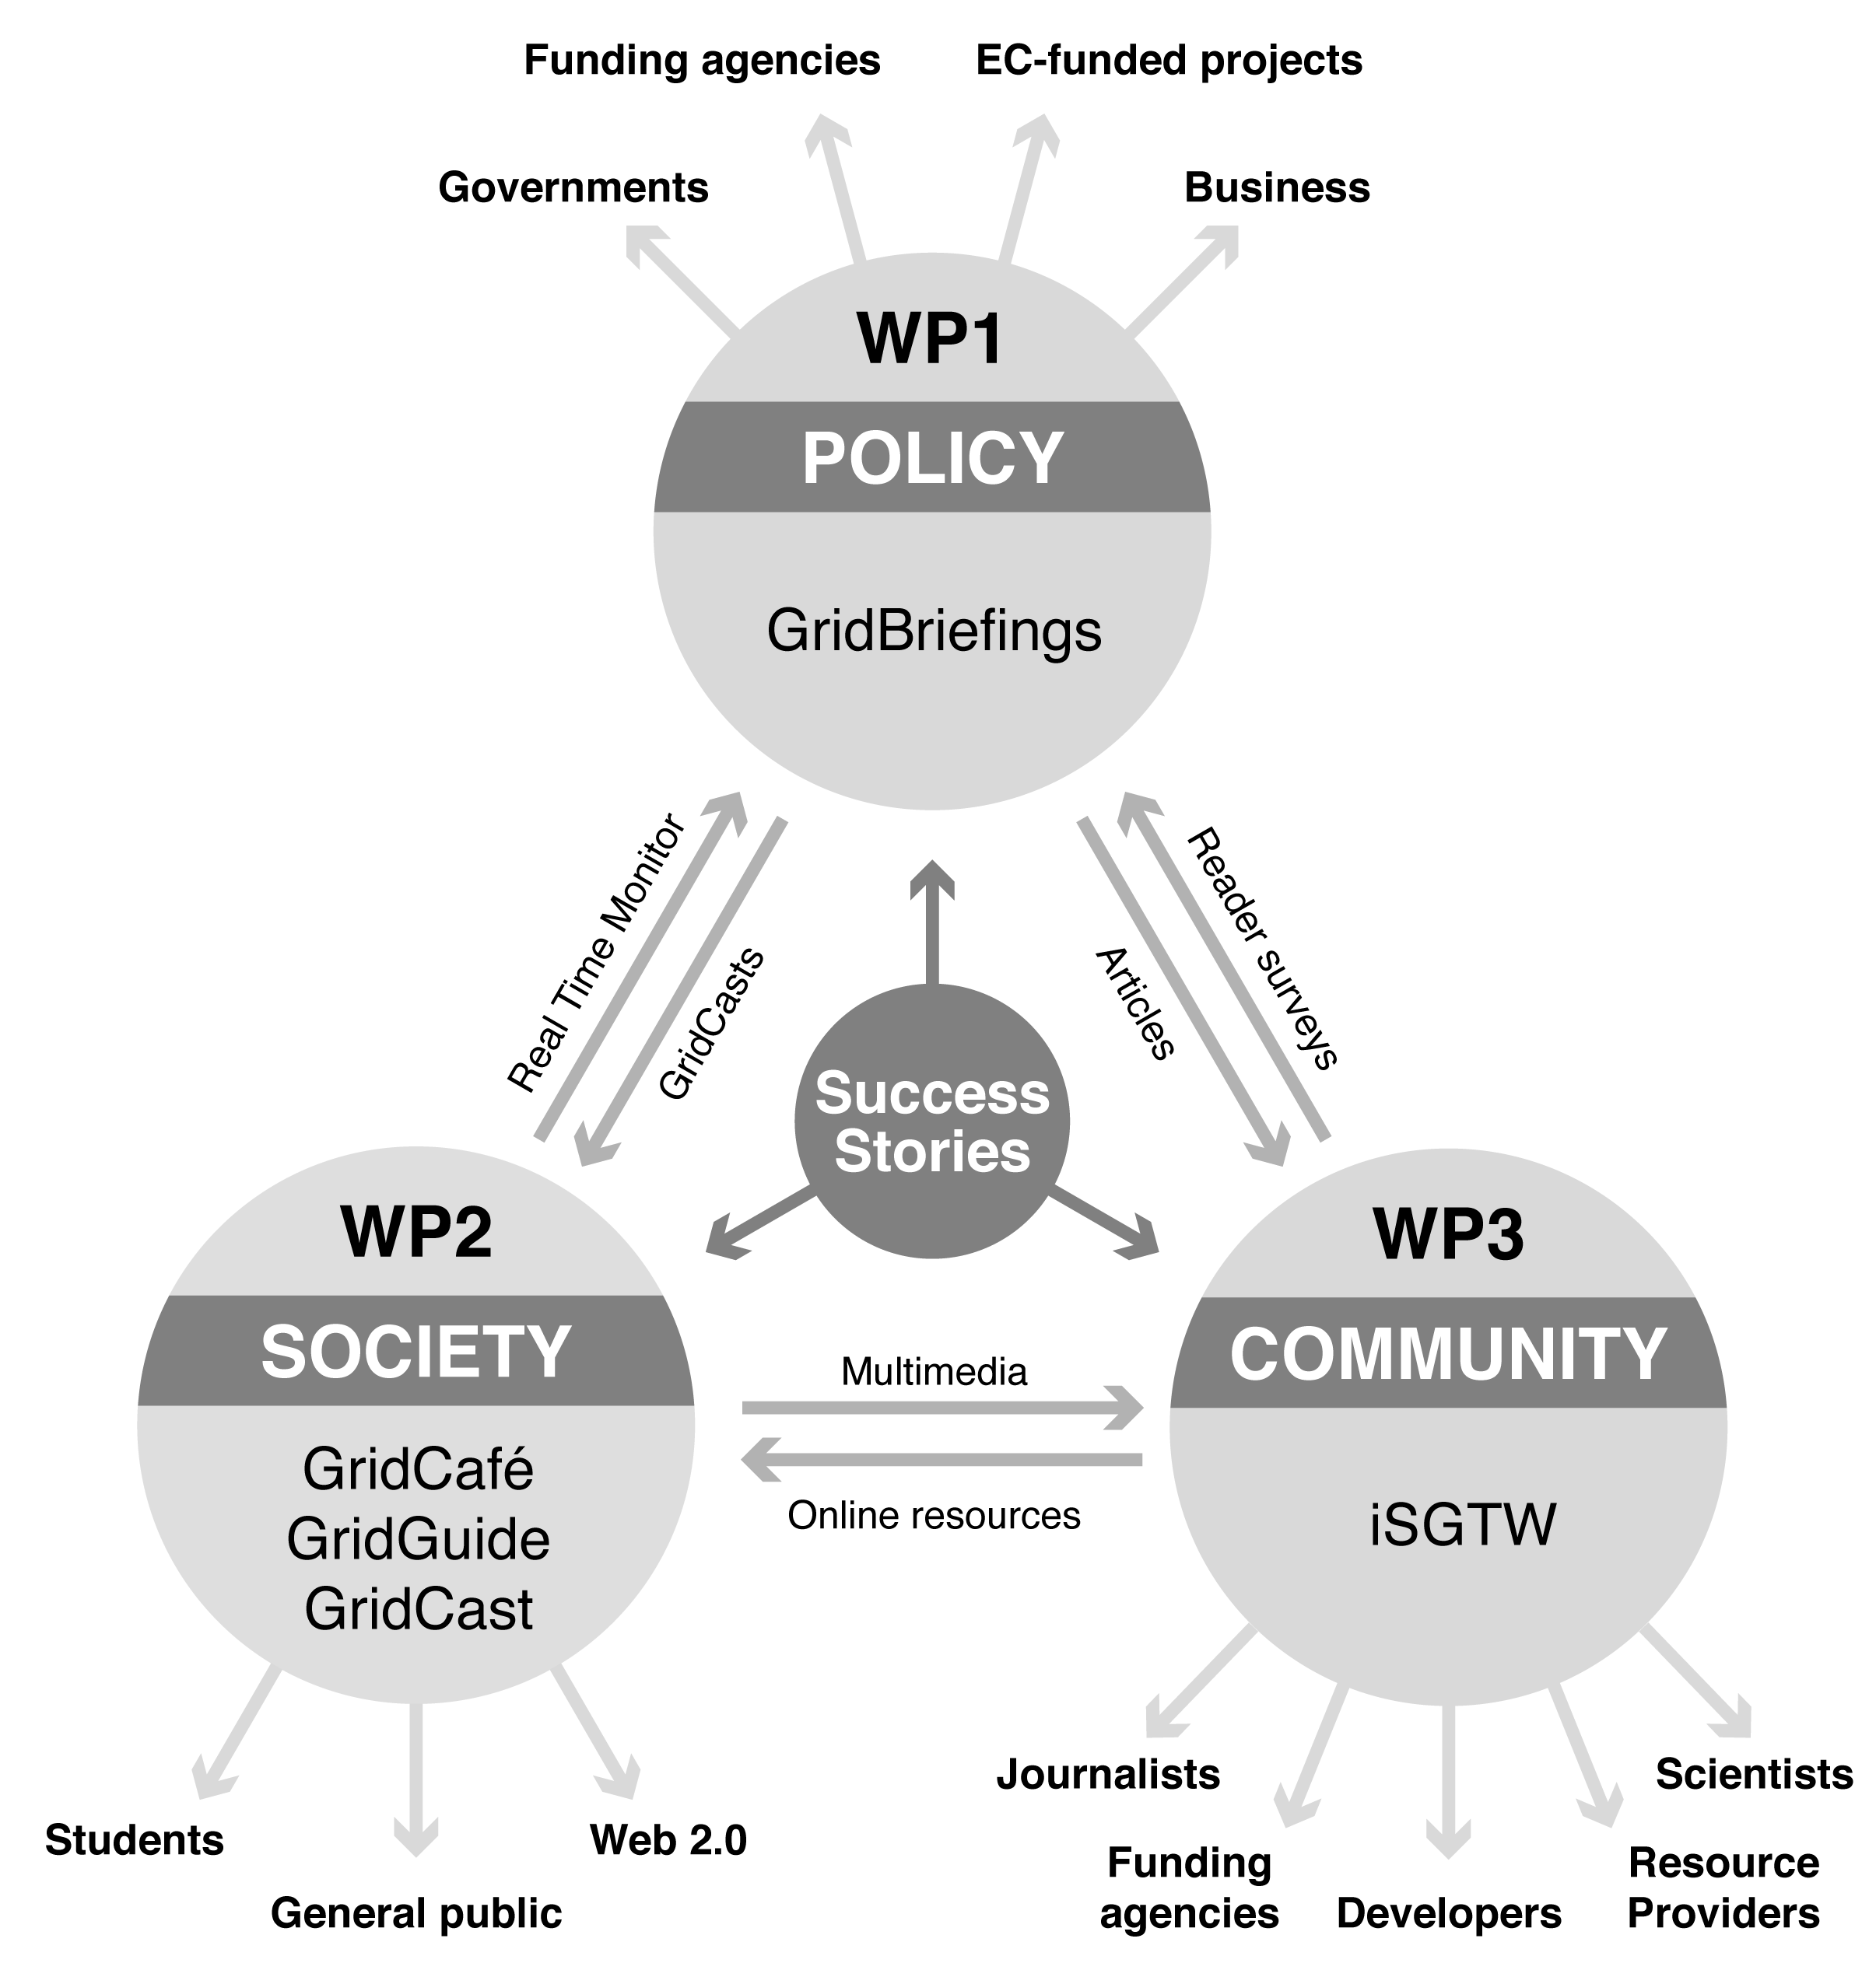

Policy, impact and sustainability
Although scientific results produced using grid computing, supercomputing networks and volunteer computing grids are reported in the press and elsewhere, information about the e-Infrastructures that are used to produce these results is less widely disseminated. As grid and high performance computing have become more ubiquitous, the infrastructure itself becomes increasingly secondary to the science that is enabled. While this is desirable in many ways, it leaves a potential gap in the understanding of policy makers and funders as to the role that e-Infrastructures are playing. By pulling together high profile examples, and making their use of e-Infrastructures explicit, e-ScienceTalk will fill this gap.
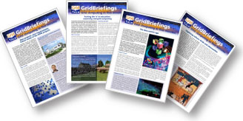
WP1 will produce a regular series of publications aimed at policy makers, setting out the achievements and challenges of grid computing and e-Infrastructures, following on from the successful series produced during GridTalk. These GridBriefings will be written in accessible language that is appropriate to the audience, drawing together information from case studies, analyses, reports, policy statements, concertation meeting outcomes and articles and will consist of:

- Short, full colour GridBriefings (four per year), to be produced approximately every three months and linked to key events, policy document releases, policy announcements or other triggers. These will be aimed at policy makers of all types in parliament, government and industry. In addition to providing an overview of the impacts of grid and e-Infrastructure on society, each GridBriefing will also have a theme – for example, a geographical region, or a topic such as ‘future Internet’– to be approved by the Project Management Board.

- Final report, produced at the end of the project. This will consolidate together the short briefings and include a foreword by a key policy figure to put the work into the context of EC policy.

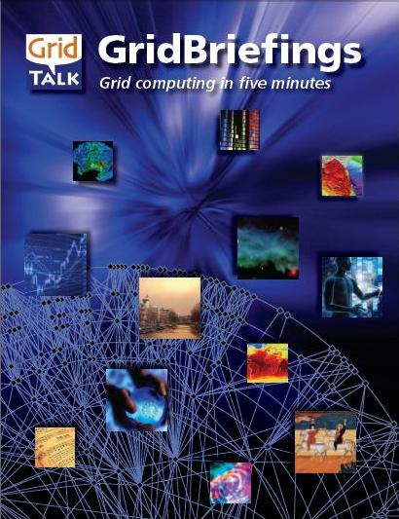
Content for these grid impact publications will be produced in collaboration with European and, in some cases, worldwide e-Infrastructure projects, as for GridTalk. WP1 will also work closely with policy-oriented e-Infrastructure groups such as e-IRG, e-IRGSP2/3, EGI, SIENA and ESFRI, setting up a policy response panel to ensure its publications meet the needs of these groups and report their activities successfully.

As well as the publications above, WP1 will examine alternative means for engaging policy makers in all layers of government (European, national and regional) and in business. One of the early deliverables in this work package is an analysis of possible routes, building on the work of GridTalk, including:

- Attending two to three policy-related conferences and events per year, to give talks and host stands at exhibitions, such as future EC presidency events which will be attended in collaboration with other projects where possible.
- Holding in-person briefings or discussion sessions for policy makers, potentially in collaboration with bodies such as parliamentary committees, government bodies or learned societies.
- Working with business groups and trade organisations to hold events or publish briefings.
- Arranging tours for policy makers to sites in their region, or to major European laboratories, such as CERN.

In addition to producing the GridBriefings, this work package will also assess the impact of longer running products such as iSGTW and GridCafé, and explore possibilities for the sustainability of all e-ScienceTalk’s products beyond the close of the project. The work package will analyse the metrics and feedback gathered during both phases of the project in order to formulate a series of annual reports that will make recommendations on future directions for each work package and highlight the lessons learnt that can benefit other EC-funded projects. These reports will help to form the basis for the year-on-year strategy for each work package, moving towards sustainability and outlining concrete proposals on how to share best practices and ensure that all e-ScienceTalk’s products continue to act as a resource in the long term.

This work package will assume a key leading and coordinating role in the concertation activities and meetings related to the e-Infrastructures area. WP1 will coordinate about one annual e-concertation meeting per year, commencing with the 8th e-Infrastructure Concertation meeting at CERN on 4-5 November 2010. WP1 will coordinate reporting of the event, working with other projects where possible, webcasting the event and leading the use of a discussion and comment facility provided by WP2.

In addition, WP1 will integrate closely with WP2 and WP3. Case studies developed for GridBriefings will be used in iSGTW and vice versa, short discussions of the GridBriefing topics will be included in the ‘In Debate’ section of the GridCafé website and in the Nature Networks forum. WP1 will lead the production of the policy engagement strategy, and will also plan associated dissemination at policy events, such as the eChallenges event in Warsaw in November 2010, organising and hosting e-ScienceTalk booths and writing and filming blogs from the events. WP1 will also contribute content on the achievements of grids and e-Infrastructures to WP2 and WP3.

GridCafé, GridGuide, GridCast

Since its launch by CERN in 2003, the GridCafé website has become an authoritative source of accessible, engaging information about grid computing across Europe and beyond. WP2 will manage both the upkeep and regular refreshment of the GridCafé web interface as well as updating its content to continue to reflect the massive advances in grid computing since the site’s launch. Content will be expanded not only to cover the new EGI and European Middleware Initiative ecosystems, but will also extend to other forms of e-Infrastructure, networking and distributed computing. Grid developments outside Europe will also be covered. Semantic search tools will be explored, as well as adding links to interactive content such as demos, videos and online interactive tools.

In the era of Web 2.0, with Web 3.0 on the horizon, modern web technologies are essential to keep a website alive and interesting. WP2 will develop the websites to ensure that they are easy to use and navigate and have maximum impact, using new web tools where they facilitate this aim. WP2 will research expanding the GridCafé brand into other interactive environments, such as OpenSim. The functionality offered by 3-D environments could help to communicate the concepts of grid computing and its results in a highly intuitive way that is likely to be appealing to a younger audience. Visitors to a 3-D online space could, for example, spend time watching GridCast videos, chat with experts and try out interactive demos, such as the Globe 3D Protein Viewer.

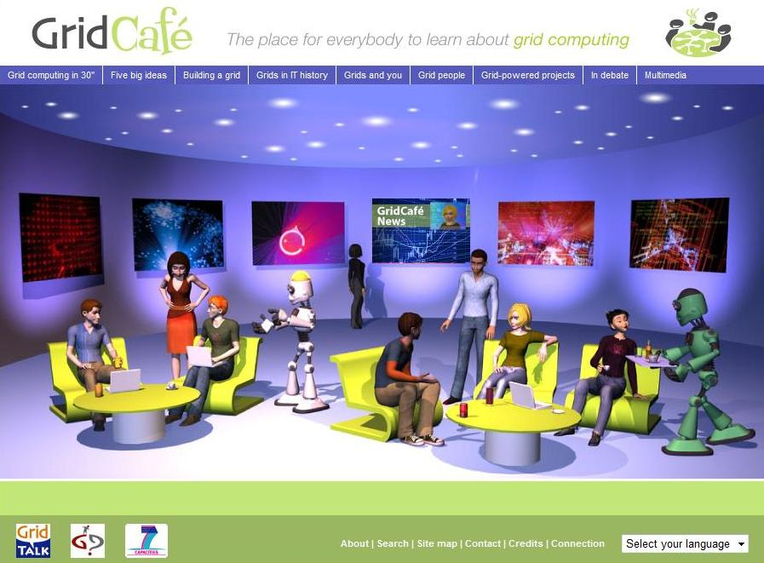
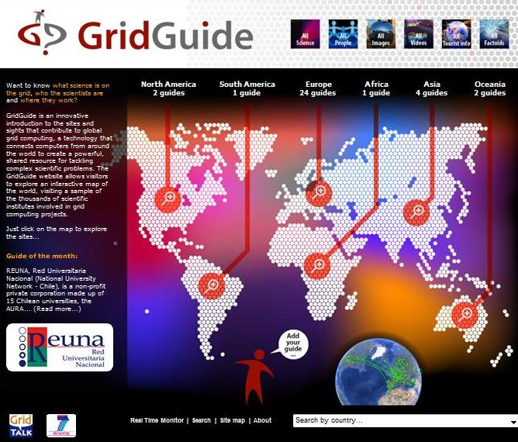

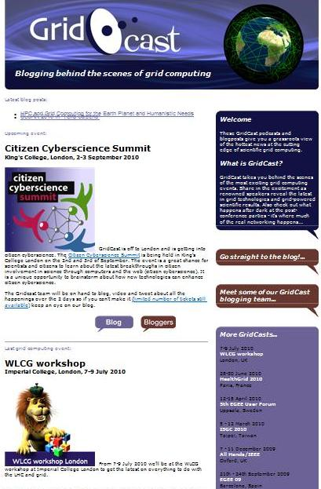
The GridCast activity is a further facet of this more personal, interactive type of website. GridCasts combine blogs, videos and interviews from major grid computing and e-Infrastructure conferences, including policy related events. WP2 will produce at least three GridCasts each year, publicised and distributed through GridCafé and iSGTW. They will also work with DEISA, GÉANT, EGI.eu, PRACE and DANTE to create a high profile for the GridCasts, advertising widely and enhancing the news content, including breaking more live news. GridCast will also seek to invite celebrity bloggers to either blog for the site, or to link to the blog. The work package will also investigate combining GridCast with the micro-blogging site, Twitter and live coverage tools, such as CoverItLive, which help to coordinate all the various social media channels available during an event from one interface.

The GridGuide interface allows users to click on grid sites worldwide, see images from the site, find out about the work in progress and read interviews with researchers. As well as giving a visual overview of current grid work, GridGuide enables users to drill down to more detail about an individual scientist’s work and how the grid has produced results. For these reasons, the GridGuide is useful for engaging with policy makers who are able to find out more detail about work going in their local regions or areas of responsibility, as well as the general public and other scientists. This work package will expand the number of sites included in GridGuide, including a higher proportion of sites outside Europe, but without increasing the maintenance or administrative burden on the GridTalk team. GridGuide will work with EGI in order to include the NGI sites.

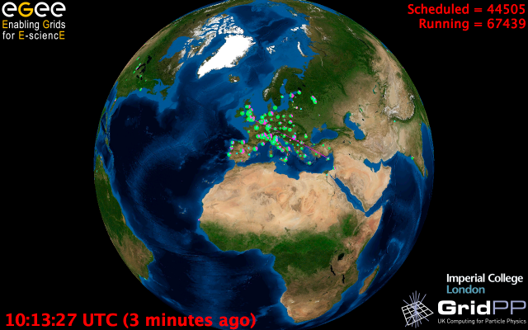
For e-ScienceTalk, the work package include development of the Real Time Monitor in order to build more strongly on the work that was achieved during GridTalk. The Real Time Monitor shows a live version of the job traffic on the grid, and the current integration with GridGuide allows a visitor to click on a site and view both the technical statistics as well as the human face of the grid. By developing the two products in tandem, they will have greater compatibility on a wider range of platforms, combining to create a very powerful and popular tool for demonstrating the capabilities and scope of the grid. Bringing Imperial College onboard as a partner for e-ScienceTalk will not only bring their expertise in the RTM within the project, enabling closer integration with GridGuide, but will also foster close links with GridPP, using their dissemination networks to promote the GridGuide itself.

WP2 will work with WP1 to support the annual e-concertation meetings, providing an online blog with a facility for feedback, discussion and comments and event websites. WP2 will also investigate ensuring continued access to the existing contents of the BELIEF Digital Library.

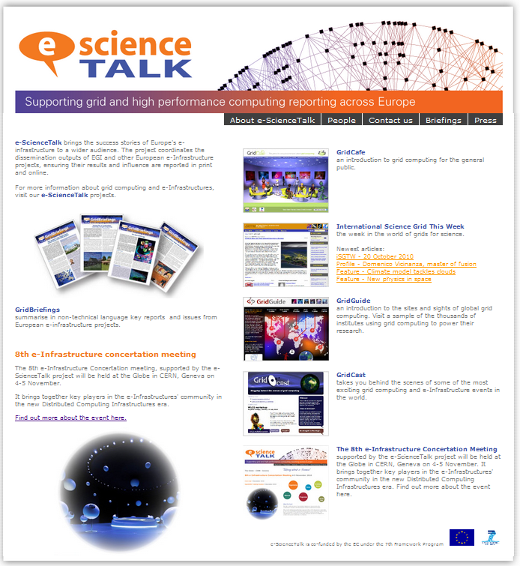
This work package will also refresh and update the overall e-ScienceTalk project website, which will include information about the project and the project team, links to the e-ScienceTalk websites, downloads and press materials, as well as news feeds from the other e-ScienceTalk websites such as iSGTW. New logos and document templates will also be created for the new project, evolving the original GridTalk branding to reflect the expanded scope.

iSGTW/The Digital Scientist
The contribution that iSGTW is making to the international grid community is apparent in its growing popularity and increased appeal, as shown by a readership that grew 65% in under two years, drawing its readers from nearly 200 countries. ISGTW is ranked 8 out of 10 on Google’s Page Ranking system and in GridTalk’s first year the website saw 235,000 page views and over 9,900,000 file downloads.

The goal will be to expand the coverage of the publication beyond grid computing alone, to include technologies such as supercomputing, distributed computing, networks, data and cloud computing and their impact on grid development. The publication will continue to strive to show that these computing resources go beyond the world of physical sciences to encompass much of modern science and research. To do so, longer, more in-depth, more multi-source stories will be produced. To reflect iSGTW’s increased scope, the publication will be relaunched in November 2010 as The Digital Scientist, accompanied by a major redesign of the website. The relaunch will introduce new interactive features, such as the facility for readers to comment on and rate stories, to share them with other websites and social media sites, and to take part in polls and surveys.

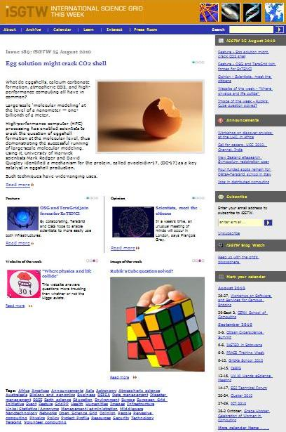
The European editor based at CERN and the US based editor alternate the task of publishing iSGTW each week, both contributing content to every issue. The editors will continue to be responsible for locating stories, researching, interviewing, writing, fact-checking, locating illustrations, editing and proofreading the original content for each issue of iSGTW, as well as acting as day-to-day webmasters. The European editor will draw up a marketing strategy and oversee its implementation, using channels such as social networking sites, for example, Nature Networks, specialist sites such as Slashdot and BoingBoing, and blogs to promote iSGTW stories and raise the profile of the publication. The European editor will seek to leverage the mailing lists of other e-Infrastructure projects where possible. The European editor will also be responsible – with the help of APO – for the production of small quantities of printed promotional matter for distribution at conferences, such as posters, postcards and similar items, which proved extremely effective during GridTalk at growing the readership. During GridTalk, iSGTW acted as media sponsor for key conferences such as the EGEE events EGEE’08, EGEE’09, and the 4th and 5th User Forums. This enabled iSGTW to report direct from the event, but also to offer free subscription to all registered delegates. ISGTW will seek similar partnership deals during e-ScienceTalk, particularly with EGI, TERENA and PRACE.

The editor will also gather statistics on how the publication is being read, including the number of visitors to the site, time spent on the site and on individual articles and take a snapshot of reader comments. The editor will coordinate an annual readership survey to be sent out to all readers in order to gather feedback on the types and breadth of stories being covered, the quality of the publication and to understand the profile of the readership.

To maximise the impact of the high quality professional writing skills available to iSGTW, opportunities will be actively sought to publicise features and articles more widely, with the aim of having these ‘picked up’ by the general media and rebroadcast to their own readers. During GridTalk, this was successfully achieved by a number of stories written by iSGTW’s professional writers, such as a feature about the resurrection of an ancient Greek instrument, the epigonion and another that covered tracking down modern day pirates using the grid. In e-ScienceTalk, individual stories will be promoted using press releases posted on AlphaGalileo, the European science news service which is used by thousands of journalists and the publication itself will be promoted by the editor’s attendance at meetings such as the International Science Journalism conference. By pursuing these promotional activities, iSGTW will potentially reach well beyond its current readership.

The iSGTW calendar will feature events from across the grid and e-Infrastructure spectrum, including a wider range of EC events such as information days, workshops and concertation meetings. The calendar will be particularly useful for the EGI projects and NGIs, helping them to coordinate their events programme and avoid clashes with other major events. Using the tagging system for articles, other projects such as GÉANT and PRACE will also be able to pull out stories relating to their work for reprint in brochures and booklets.

As well as editing iSGTW, the European editor will manage the human aspects of iSGTW by maintaining contact with projects and content providers, drawing stories from a wider geographic area than in GridTalk. In particular, the European editor will act as the main point of contact between the European and US teams, liaising with the US editor to ensure a smooth and timely publication process each week. The European editor will also work with the US editor to coordinate communications with the iSGTW Advisory Board, which consists of members based at CERN and Fermilab, including convening the quarterly meetings of the Advisory Board.

The iSGTW work package will work closely with WP2 and WP1, providing content, and creating publicity for the policy reports of WP1 through the publication of articles and announcements. The editor will also travel to major grid-related and e-Infrastructure events, such as EGI conferences and User Forums and e-concertation events, in order to conduct interviews and generate stories. One or more student interns will also be sought during the lifetime of the project, to spend up to 3 months writing with iSGTW and advancing the marketing and new media plan, based at CERN, Imperial or QMUL.

Social media
During e-ScienceTalk, the project will also investigate using social media channels such as the micro-blogging site Twitter, photo sharing sites such as Flickr and video sharing sites such as YouTube and Vimeo in order to distribute the dissemination materials and messages from all the work packages. ISGTW already features on Nature Networks and Facebook, and WP3 will explore ways in which these tools can be built into the marketing strategy for The Digital Scientist.

implementation

Policy, impact and sustainability

The work described above in WP1 will be distributed across three sub-tasks T1.1 Production and distribution of grid policy articles and reports, T1.2 Impact and sustainability of iSGTW and GridCafé and T1.3 Events attendance and media impact event organisation.

Task 1.1 Production and distribution of grid policy articles and reports
- GridBriefings will be expanded to cover more topics than grid computing, including e-Infrastructures, supercomputing, networks, cloud computing and more.
- Formalise agreements with e-IRG to advise on GridBriefings – replacing the previous GridTalk PERT team.
- Formalise agreements with e-IRG_SP2/3 and e-IRG for dissemination of our policy material and working together on events.
- Create an additional wider team to complement the e-IRG board who can provide additional comment, drawn from projects such as EGI-InSPIRE and EMI.
- Consider rebranding the GridBriefings to e-ScienceBriefings, with updated templates.
- Investigate different forms for disseminating policy materials, such as audio podcasts.
- Work with OSG to increase the circulation of the GridBriefings to OSG contacts.
- Collaborate with projects such as REUNA to translate GridBriefings into other languages, such as French and Spanish.
- Investigate other projects that could provide translations of GridBriefings.
- Expand into new geographical areas eg US, Asia, South America and Africa both through expanded content covering projects in these areas and wider distribution through collaborations with projects such as EUAsiaGrid and ALICE2.
- Cooperate with networking projects to distribute the GridBriefings to regions outside Europe.
- Work closely with GridCafé and iSGTW to produce policy related articles, podcasts and interviews.
- Create a ‘how to get started on the grid’ downloadable primer.

Task 1.2 Impact and sustainability of iSGTW and GridCafé
- Establish and gather a set of metrics that reflect the quality of e-ScienceTalk’s products eg quotes, distribution numbers, web statistics.
- Produce reports summarising these metrics and the lessons learnt, and explore mechanisms to make these available to other European projects, including through the BELIEF Digital Library.
- Explore the possibilities for funding iSGTW, GridCafé and other products sustainably beyond e-ScienceTalk and make recommendations regarding the available options.

Task 1.3 Events attendance and media impact event organisation
- Identify and attend events aimed at policy makers such as eChallenges in Warsaw, November 2010 in order to distribute the GridBriefings and communicate the issues, collaborating with projects such as EGI.eu and DANTE to host joint booths, liaising with WP2 to produce branded giveaway items such as caps and mugs.
- Target media meetings such as the International Science Journalism conference to build a network of media contacts, as reaching out through the media is an effective way to communicate with policy makers, as well as the general public.
- Coordinate annual e-concertation meetings and activities in e-Infrastructure areas, including reporting on the event, coordinating discussion on the online forum and producing a GridBriefing based on the outcomes from the event.

GridCafé, GridGuide, GridCast

The work of WP2 will be carried out by three sub-tasks T2.1 GridCafé, T2.2 Real Time Monitor and GridGuide and T2.3 GridCast.

Task 2.1 GridCafé
- Update the site content, removing references to closed projects and introducing newly funded initiatives.
- Explore adding a semantic search engine to the websites.
- Add more links to demos, videos and online interactive tools such as the ASTRA project’s (Ancient Instrument Sounds/Timbre Reconstruction Application) online application to play ancient Greek instruments resurrected by the grid.
- Evaluate the 3-D technical solutions available, such as OpenSim, based on pilot work carried out during GridTalk.
- Add content covering the areas of supercomputing, cloud, networks and data and review the content of the whole site.
- Develop more translations in addition to the Spanish and French sites, including Chinese.

Task 2.2 Real Time Monitor and GridGuide
- Add more sites to the GridGuide, covering a wider geographical area, including outside Europe.
- Add sites to the GridGuide that are involved in supercomputing, cloud and networking research projects.
- Develop further interactive functionality with the Real Time Monitor to make navigating the site more intuitive.
- Issue annual releases of the RTM with updated release notes and a two month new version support period. These releases will enhance integration with the GridGuide, to allow the new information added to the GridGuide to be easily accessible from the RTM and vice versa.
- Add further sources of information into the RTM, such as file movement around the grid, which would also then be available from within the GridGuide. This would show a real time picture of the load placed on the grid from within both the Real Time Monitor and the GridGuide.
- Explore the possibility of launching the RTM from a site included within the GridGuide as an application, such as an applet, that would run on a wide range of platforms, including handheld computers and smart phones.
- Add news elements to the home page of the GridGuide.
- Aim to make GridGuide the definitive source to find out what sites are working on within the EGI infrastructure, such as the NGIs.
- Explore continuity of access to the contents of the BELIEF Digital Library.

Task 2.3 GridCast
- Aim to run three major GridCasts per year, including at least one non-European event, covering major EGI and e-Infrastructure events.
- Focus on producing slightly longer, higher quality videocasts in different formats eg spotlight on a particular project, ‘a day in the life’ of a delegate, a reportage/overview of a complete event
- Focus the management of the blogging team, including providing guides for bloggers and refreshing the list of bloggers, including people with a mix of technical backgrounds and perspectives.
- Work with DEISA, GÉANT and EGI to publicise GridCasts. Market the upcoming GridCasts in advance via the EGI.eu and NGI dissemination channels, working closely with the dissemination teams to recruit bloggers and advertise the GridCasts.
- Host and create video content and a discussion and comment facility for the e-concertation events as well as the event websites.
- GridCast is important for community building within the grid and e-Science community, but it could also have a wider reach. Build up the brand by inviting high profile guest bloggers to contribute.
- Enhance the news content of the GridCast site by breaking more live news.
- Investigate combining GridCast with Twitter and live coverage tools such as CoverItLive.
- Refresh and update the e-ScienceTalk website for the start of the new project, including updating logos and document templates.

iSGTW/The Digital Scientist

The work of producing the iSGTW/ The Digital Scientist will be carried out through two sub-tasks T3.1 Weekly publication and T3.2 New media outlets

Task 3.1 Weekly publication
- Produce the weekly publication in a timely and efficient manner, liaising with the US editor to ensure the smooth running of the publication and an uninterrupted publishing schedule, outside major holidays.
- Relaunch the publication with a new name, a new content management system and increased functionality, such as the ability to comment on stories, rate them, and participate in polls of the week, in order to build a community around the publication.
- Liaise with the US editor and Xenomedia regarding technical issues with the website.
- Work with the US editor to achieve consensus on goals and directions of editorial material, communicate with the Advisory Board and convene the Advisory Board meetings.
- Expand the iSGTW resources section, including the glossary and the image bank. The image bank will encourage other publications to pick up iSGTW stories and offer a further incentive for contributions from scientists – their images will have a potential circulation beyond iSGTW.
- Contribute to the publications of other e-infrastructure projects as opportunities arise.
- Coordinate the iSGTW calendar, featuring events from across the grid and e-Infrastructure spectrum to aid with the scheduling of events by the projects and include EC events such as workshops and info days.
- Coordinate annual readership surveys to gather feedback on the publication and build up a profile of the readership.
- Seek media partnership deals with projects such as EGI-InSPIRE and other e-Infrastructure projects in order to sponsor key conferences and increase subscription rates to iSGTW from delegates, as well as leveraging their existing mailing lists.

Task 3.2 New media outlets eg Twitter, Nature Networks
- Build on the work already started in marketing iSGTW during GridTalk to expand readership through social networking tools such as Twitter, Nature Networks and Facebook.
- Draw up a marketing plan using these tools and assess the effectiveness of the plans at regular intervals.
- Assess the possibilities for commercial exploitation of the publication, including models for self-funding.
- Seek to recruit one or more student interns to write for iSGTW and to advance the marketing of iSGTW via new media outlets.

quality metrics

A number of quality metrics will be monitored during the course of the project to track progress of the work packages. Quality issues will also be addressed in the deliverable D4.2 Quality Assurance Guide. An annual report on feedback and metrics will also be produced (deliverables D4.3, D4.4 and D4.5).

Policy, impact and sustainability

Metrics used to track these impacts will include:
- number of projects covered (target: 20 per year)
- number of reports and briefings circulated (target: 1000 per year)
- number of countries where reports and/or briefings are distributed (target: 30)

GridCafe, GridGuide, GridCast

Metrics used to track the progress of this work package will include:
- number of sites on the GridGuide (target: 100 in total)
- number of grid and e-Infrastructure projects linking to the GridCafé website (target: 40)
- number of bloggers contributing to GridCasts (target: 5 for each GridCast)
- number of GridCasts each year (target: 2 in Europe per year and 1 outside Europe)

iSGTW/The Digital Scientist

Metrics used to track the iSGTW work package will include:
- number of iSGTW subscribers (target: increase by 30% by close of project)
- number of articles in iSGTW on European projects (target: 50 per year)
- number of projects in the iSGTW/GridCafé resources section (target: 100 by close of project)
- number of iSGTW printed materials distributed to European projects (target: 1000 by close of project)

conclusion

This dissemination plan outlines the plans for e-ScienceTalk to reach out to its four main audiences: policy makers, the general public, the scientific community and university students. Progress against the success factors outlined above will be monitored through the annual reports on feedback and metrics that will also be produced in Project Months 12, 24 and 32 (Deliverables D4.3, D4.4 and D4.5). These reports will culminate in a final deliverable D4.6 Guide to Dissemination for EC Projects in PM33, which will summarise the lessons learnt during both e-ScienceTalk and its first phase, GridTalk.

The impact and sustainability of the e-ScienceTalk products will also be assessed through the Annual Impact and Sustainability Reports in Project Months 11, 23 and 31 (Deliverables D1.3, D1.4 and D1.5). Each of the work packages will provide input into these status reports, which will lead to a final report covering the sustainability of all the e-ScienceTalk products beyond the lifetime of the project: the GridBriefings, the videos, blogs, user generated content, images, graphics, documents, the websites for GridCafé, GridCast and GridGuide and the weekly publication iSGTW and its archives.

References
R 1 | Description of Work
R 2
R 3
R 4
R 5

http://www.e-sciencetalk.org/briefings.php
www.e-sciencetalk.org/e-concertation/
www.gridcafe.org
http://gridcast.web.cern.ch/Gridcast/
www.gridguide.org
http://rtm.hep.ph.ic.ac.uk/
www.e-sciencetalk.eu
www.isgtw.org
www.thedigitalscientist.org
www.alphagalileo.org

