EGI-Engage

Risk analysis and risk response for Period 1
D1.2

Date | 15 October 2015
Activity | NA1
Lead Partner | EGI.eu
Document Status | DRAFT
Document Link | https://documents.egi.eu/document/XXX

Abstract
This document provides guidelines how risk management (identification, analysis, response and control) will be conducted in EGI-Engage project. It also provides result of first re-assessment of the probability and impact of risks identified during project proposal phase and proposed response, as well as result of new risk identification.

COPYRIGHT NOTICE
This work by Parties of the EGI-Engage Consortium is licensed under a Creative Commons Attribution 4.0 International License (http://creativecommons.org/licenses/by/4.0/). The EGI-Engage project is co-funded by the European Union Horizon 2020 programme under grant number 654142.
DELIVERY SLIP
 | Name | Partner/Activity | Date
From: | Małgorzata Krakowian | EGI.eu | 8.10.2015
Moderated by:
Reviewed by
Approved by:

DOCUMENT LOG
Issue | Date | Comment | Author/Partner
v.1 | 1.10.2015 | First draft | Małgorzata Krakowian/EGI.eu
v.2 | 8.10.2015 | Version after internal review | Małgorzata Krakowian/EGI.eu

TERMINOLOGY
A complete project glossary is provided at the following page: http://www.egi.eu/about/glossary/

Following definitions are used in EGI-Engage Risk management process:
Risk: a risk is defined as an uncertain event or condition that if it occurs, has a negative (threads) or positive (opportunities) effect on a Project's Objectives. (Source: PMBOK) In EGI-Engage risk management process the scope has been limited to threads.
Risk Registry: a database of identified risks with recorded their analysis and response planning as well risk occurrence with history of treatment.

Contents
1. Introduction 4
2. Risk management team 5
3. Timing 6
4. Risk management process 7
1.1 Risk identification 8
1.2 Risk analysis 9
1.2.1 Risk likelihood descriptors 9
1.2.2 Risk impact descriptors 10
1.2.3 Risk likelihood and impact matrix (risk level) 10
1.3 Risk response 10
1.4 Risk control 12
5. Risk analysis 13

Introduction
Project Risk management process includes conducting risk management planning, identification, analysis, response planning and control. The objective is to detect threads and decrease its likelihood and impact by proper treatment as well as collect lessons learned from risks occurrence to better manage the project.
Benefits of a risk management include:
- Increase focus and attention on risks
- Proactive approach for preventing risks from becoming issues
- Provide a consistent approach for analyzing, prioritizing, communicating and managing risks
- Provide an approach to efficiently and effectively mitigate risks
- Save cost and time by identifying, prioritizing, and managing risks
Risk management process in EGI-Engage is conducted on the basis of expert judgement technique. A Risk management team has been established in a way to involve Project management and Technical coordination level of the project structure. The membership is described in Section 2 with a clear description of responsibilities. Risk management is a subject of Project Management Board and Activity Management Board attention.
Section 3 describes when and how often the risk management processes will be performed during the project life cycle.
In section 4 each of the sub processes are described with a clear definition of what are the inputs, outputs and actions performed, as well as supporting materials.
Section 5 provides the outcome from the first re-assessment of the probability and impact of risks identified during project proposal phase and proposed response, as well as the result of new risk identifications.
The Risk registry has been reviewed by Work Package leaders and Project Management Board. It is kept confidential, with access restriction to PMB and AMB members, and is attached as appendix in the EC portal to the deliverable.

Risk management team
Risk management team is formed from project team members who take part in risk management process. Team members have clearly assigned roles and responsibilities, which are defined as follow:
Quality and Risk Manager
Responsible for:
- coordinating project risk management activity
- defining and keeping up to date risk management plan
- helping Work Package leaders in risk analysis and response
- performing risk registry reviews
- reporting to Project Management Board risk management status
Technical Coordinator
Responsible for:
- coordinating with Work Package leaders implementation of risk response plan
- performing risk analysis and coordinating contingency planning tasks within the project
Work Package leaders
Responsible for:
- identifying and defining new risks
- reviewing identified risks during risk registry review
- implementing risk response plan
- reporting on risk status and its occurrence
Project Management Board
Responsible for:
- approving risk response for risks level high and extreme
- supporting Technical Coordinator

Timing
This section describes when and how often the risk management processes will be performed during the project life cycle.
Risk management process timing is as follow:
- On daily basis (whenever necessary)
  - Work Package Leaders are
    - applying risks response
    - reporting on risk occurrence
    - reporting on new risks identified
- On monthly basis
  - Quality and Risk Manager is
    - reporting to PMB risk occurrences and newly identified risks which require PMB attention.
- Every 3 months
  - Quality and Risk Manager are conducting risk registry review with Work Package leaders, including:
    - identifying deprecated risks
    - reassessment of impact and probability of existing risks
    - reviewing of risk response
    - identification of new risks
  - Quality and Risk Manager is reporting to PMB outcome of the review.

Risk management process

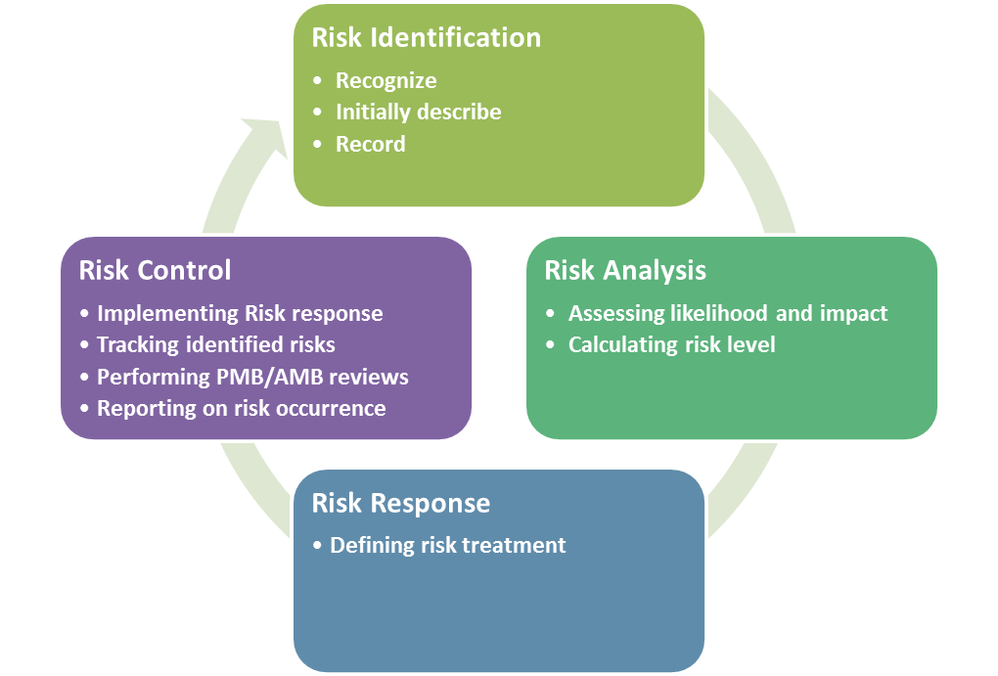
Risk management process contains four sub processes:
Risk identification
- goal: determining which risk can affect the project and documenting it in Risk registry
- description: a process that is used to find, recognize, and describe the risks that could affect the achievement of objectives.
Risk analysis
- goal: assessing likelihood and impact , calculate risk level
- description: a process that is used to understand the nature, sources, and causes of the risks that you have identified and to estimate the level of risk. It is also used to study impacts and consequences and to examine the controls that currently exist.
Risk response
- goal: defining risk response plan for each risk
- description: a process of developing options and actions to reduce threats to project objectives
Risk control
- goal: improve efficiency of risk approach through continuously monitoring and adjustment
- description: a process of implementing risk response plan, tracking identified risks, performing risk reviews

In following sections each of the sub process is described with clear definition of what are the inputs, outputs and actions performed.

Risk identification
Input: Project team members’ expertise
Output: Initial risk entry in risk registry
Risk identification is a process that involves finding, recognizing, and describing the risks that could affect the achievement of the project objectives. It is used to identify possible sources of risk in addition to the events and circumstances that could affect the achievement of objectives. It also includes the identification of potential consequences.
Risks are identified:
- Periodically:
  - During Risk registry review through interviews and brainstorming conducted by Quality and Risk manager with Work Package leaders
- On daily basis (whenever necessary):
  - Work Package leaders are expected to inform Quality and Risk manager in case of new risk identified or risk occurrence.

Each risk is supposed to be described in following way:
- Risk no – (mandatory) unique risk identifier
- Risk - (mandatory) one sentence description of the risk
- Likelihood - (mandatory) Likelihood (probability) is the chance that something might happen
  - Options: Unlikely, Possible, Likely, Almost Certain
- Impact - (mandatory) A consequence (impact) is the outcome of an event and has an effect on objectives
  - Options: Minor/Moderate/Major/Catastrophic
- Risk level - (mandatory) The level of risk is its magnitude. It is estimated by considering and combining consequences and likelihoods. A consequence is the outcome of an event and has an effect on objectives. Likelihood is the chance that something might happen.
  - Options: Low/Medium/High/Extreme (automatically calculated based on Risk likelihood and consequences matrix)
- Consequences – (mandatory) description of impact risk will have in case of occurrence
- Deliverables – Deliverables which might me impacted in case of occurrence
- KPIs – Impacted KPIs
- Objective – Impacted Objective
- WP1-WP6 – (mandatory) Impacted WPs
- Treatment – (mandatory) description of possible treatment of the risk
- Owner – (mandatory) A risk owner is WP that has been given the authority to manage a particular risk and is accountable for doing so.
- Trend – (mandatory) Indication of risk trend comparing to previous risk review period
  - Options: Stable, Improving, Degrading, New, Depreciated
- Comment for PMB - additional comments for PMB after AMB review

Risk analysis
Input: risk entry in risk registry
Output: Prioritized list of risks (list of risks that pose the greatest threat), risk trends
During risk analysis the level of likelihood and impact for each risk is evaluated during the interviews with Work Package leaders performed by Quality and Risk manager.
Risk rating (level) is calculated according to likelihood and impact matrix.

Risk likelihood descriptors
The following table is containing Risk Likelihood Descriptors:
Rating | Description | Likelihood of occurrence
1 | Unlikely | - Not expected, but there's a slight possibility it may occur at some time.
2 | Possible | - The event may occur at some time.
3 | Likely | - There is a strong possibility the event will occur
4 | Almost Certain | - Very likely. The event is expected to occur in most circumstances

Risk impact descriptors
Rating | Description | Project Objectives impact
1 | Minor | - Any risks which will have just a mild impact on the project, still these must be addressed in time.  - Quality degradation barely noticeable.
2 | Moderate | - Risks which will cause some problems, but nothing too significant. Quality reduction requires approval.
3 | Major | - Risks which can significantly jeopardize some aspects of the project, but which will not compromise the success of the whole project.  - Quality reduction unacceptable.
4 | Catastrophic | - A risk that can prove detrimental for the whole project.

Risk likelihood and impact matrix (risk level)
The risk likelihood and impact matrix is a grid for mapping likelihood of each risk occurrence and its impact to the project objectives if that risk occurs. This actually describes the risk level of an event to occur. Risks are prioritized according to their potential implications on project objectives.

Likelihood | Impact
 | Minor | Moderate | Major | Catastrophic
Unlikely | Low | Low | Medium | Medium
Possible | Low | Medium | High | High
Likely | Medium | High | High | Extreme
Almost Certain | Medium | High | Extreme | Extreme

Risk response
Input: Risk registry
Output: Risk response plan for each risk
Within this process risk owner, who is responsible for given risk and its risk response, must be identified. Risk response should be appropriate for the significance of the risk (risk level), cost-effective, realistic and agreed by involved parties.
Following table presents for each Risk impact level suggested response to be defined:
Risk Impact level | Response
Minor | - Accept  - Define recovery activities  - Managed by routine procedures  - Monitor and review
Moderate | - Mitigate  - Define and implement mitigation activities  - Managed by monitoring or response procedures
Major | - Mitigate  - Define and implement  - controls  - mitigation activities  - recovery activities  - Project Management Board attention needed and management responsibility specified
Catastrophic | - Avoid or mitigate  - Define and implement  - controls  - contingency plan  - recovery activities  - mitigation activities  - Must be managed by Project Management Board with a detailed treatment plan.

Following table presents for each Risk level suggested involvement of Risk management team members:
Risk level | Involvement
 | Quality and Risk Manager | Technical Coordinator | Work Package leader | Project Management Board
Low | Informed | Informed | Active engagement | Informed
Medium | Consulted | Consulted | Active engagement | Informed
High | Consulted | Active engagement | Active engagement | Consulted
Extreme | Active engagement | Active engagement | Active engagement | Active engagement

Risk control
Input: Risk registry
Output: Improved efficiency of risk approach
Risk control is a process which goal is to improve efficiency of risk approach through continuously monitoring and adjustment. It is implementing risk response plan, tracking identified risks, performing risk reviews.
Activities planned as part of risk control:
- On daily basis (whenever necessary)
  - Work Package Leaders are
    - applying risks response
    - reporting on risk occurrence
    - reporting on new risks identified
- On monthly basis
  - Quality and Risk Manager is
    - reporting to PMB risk occurrences and newly identified risks which require PMB attention.
- Every 3 months
  - Quality and Risk Manager is conducting risk registry review with Work Package leaders, including:
    - identifying depreciated risks
    - reassessment of impact and probability of existing risks
    - reviewing of risk response
    - identification of new risks
  - Quality and Risk Manager is reporting to PMB outcome of the review.

Risk analysis
Risk analysis has been performed by AMB members with support of Quality and Risk Manager.
All foreseen risks identified during project proposal phase have been reviewed:
- Are risks still relevant to the project?
- Have risk impact and likelihood levels changed?
- Is response proposed still valid and being applied?
- Are consequences of the risk occurrence still valid?
In addition to each of the risk has been assigned risk owner – Work Package leader responsible for coordinating treatment application, and also indicated trend for each risk in comparison to risk level proposed during project proposal phase.
Each Work package leader has been also responsible, based on 6 month experience, to identify new risks (unforeseen) and record risks materialized.
As result of the review:
- 11 foreseen risks have been identified as deprecated
  - 4 – Risks duplicated by other risks
  - 4 – Risks not valid any more
  - 3 – Risks not related to the project but EGI Infrastructure
- 9 foreseen risks have been identified as still relevant
  - Risk level
    - 2 – high
    - 2 – medium
    - 5 – low
  - Risk trend
    - 3 – stable – risk level has not change
    - 6 – improving – risk level has been decreased
- 31 unforeseen risks have been identified
  - Risk level
    - 15 – high
    - 10 – medium
    - 6 – low
- 5 Risks occurrences related to 3 risks
  - Risk occurrences’ status
    - 3 – improving
    - 2 – stable
- None of the risks have been identified as requiring contingency plan to be created.

Conclusions and consequences from this review:
- ...
- ...

Next steps and implementation procedure for this plan

