EGI-InSPIRE

Evolving the EGI Business Model

EU DELIVERABLE: D2.18

Document identifier: | EGI-D2.18-1040-V8.docx
Date: | 08/05/2012
Activity: | NA2
Lead Partner: | EGI.eu
Document Status: | FINAL
Dissemination Level: | PUBLIC
Document Link: | https://documents.egi.eu/document/1040

Abstract
EGI’s main contribution to the digital European Research Area is to deliver a world-class e-infrastructure built as an open ecosystem that offers the opportunity for different actors to provide their own uniquely valuable tools and services for the benefits of researchers. In order for the whole EGI ecosystem to provide value sustainably, each actor needs to properly identify the most appropriate business model for it to operate with. This report addresses this need by bringing together the information produced from a number of activities over the last year and providing a framework for discussing and generating business models for the actors within the EGI ecosystem. Concrete proposals and plans for the next two years are also provided.
- Copyright notice
Copyright © Members of the EGI-InSPIRE Collaboration, 2010-2014. See www.egi.eu for details of the EGI-InSPIRE project and the collaboration. EGI-InSPIRE (“European Grid Initiative: Integrated Sustainable Pan-European Infrastructure for Researchers in Europe”) is a project co-funded by the European Commission as an Integrated Infrastructure Initiative within the 7th Framework Programme. EGI-InSPIRE began in May 2010 and will run for 4 years. This work is licensed under the Creative Commons Attribution-Non-commercial 3.0 License. To view a copy of this license, visit http://creativecommons.org/licenses/by-nc/3.0/ or send a letter to Creative Commons, 171 Second Street, Suite 300, San Francisco, California, 94105, and USA. The work must be attributed by attaching the following reference to the copied elements: “Copyright © Members of the EGI-InSPIRE Collaboration, 2010-2014. See www.egi.eu for details of the EGI-InSPIRE project and the collaboration”. Using this document in a way and/or for purposes not foreseen in the license requires the prior written permission of the copyright holders. The information contained in this document represents the views of the copyright holders as of the date such views are published.
- Delivery Slip
 | Name | Partner/Activity | Date
From | Steven Newhouse | EGI.eu/NA2 | 17/04/2012
Reviewed by | Moderator: Morris Riedel  Reviewers: Owen Appleton  Torsten Antoni | EMI  ETH  KIT | 08/05/2012
Approved by | AMB & PMB
- Document Log
Issue | Date | Comment | Author/Partner
ToC | 06/03/2012 | Table of Contents | Sergio Andreozzi, Sy Holsinger, Steven Newhouse/EGI.eu
1 | 12/03/2012 | First draft of content | Sy Holsinger/EGI.eu
2 | 02/04/2012 | Second draft following EGI CF’12 for internal review | Sy Holsinger/EGI.eu
3 | 09/04/2012 | Comments and edits from internal review | Steven Newhouse/EGI.eu
4 | 10/04/2012 | Revisions for second round of comments | Sy Holsinger/EGI.eu
5 | 17/04/2012 | Revised version for external review | Sergio Andreozzi, Sy Holsinger, Steven Newhouse/EGI.eu
6 | 17/04/2012 | Final revised version for external review | Sergio Andreozzi, Sy Holsinger, Steven Newhouse/EGI.eu
7 | 07/05/2012 | Revised version according to external reviews | Sergio Andreozzi/EGI.eu, Steven Newhouse/EGI.eu
8 | 08/05/2012 | Final changes, document ready for PMB review | Sergio Andreozzi/EGI.eu
- Application area
This document is a formal deliverable for the European Commission, applicable to all members of the EGI-InSPIRE project, beneficiaries and JRU members, as well as its collaborating projects.
- Document amendment procedure
Amendments, comments and suggestions should be sent to the authors. The procedures documented in the EGI-InSPIRE “Document Management Procedure” will be followed:
https://wiki.egi.eu/wiki/Procedures
- Terminology
A complete project glossary is provided at the following page: http://www.egi.eu/about/glossary/.

EGI: European Grid Infrastructure: a federation of shared computing, storage and data resources from national and intergovernmental resource providers that delivers sustainable, integrated and secure distributed computing services to European researchers and their international partners

EGI.eu: a non-profit organisation based in Amsterdam established to coordinate and manage the infrastructure (EGI) on behalf of its participants: National Grid Initiatives (NGIs) and European Intergovernmental Research Organisations (EIROs)

EGI-InSPIRE: A four-year project, co-funded by the European Commission’s 7th Framework Programme (contract number: RI-261323), helping to establish a sustainable, reliable e-Infrastructure that can support researchers’ needs for large-scale data analysis

- PROJECT SUMMARY
To support science and innovation, a lasting operational model for e-Science is needed − both for coordinating the infrastructure and for delivering integrated services that cross national borders. The EGI-InSPIRE project will support the transition from a project-based system to a sustainable pan-European e-Infrastructure, by supporting ‘grids’ of high-performance computing (HPC) and high-throughput computing (HTC) resources. EGI-InSPIRE will also be ideally placed to integrate new Distributed Computing Infrastructures (DCIs) such as clouds, supercomputing networks and desktop grids, to benefit user communities within the European Research Area.

EGI-InSPIRE will collect user requirements and provide support for the current and potential new user communities, for example within the ESFRI projects. Additional support will also be given to the current heavy users of the infrastructure, such as high energy physics, computational chemistry and life sciences, as they move their critical services and tools from a centralised support model to one driven by their own individual communities.

The objectives of the project are:

- The continued operation and expansion of today’s production infrastructure by transitioning to a governance model and operational infrastructure that can be increasingly sustained outside of specific project funding.
- The continued support of researchers within Europe and their international collaborators that are using the current production infrastructure.
- The support for current heavy users of the infrastructure in earth science, astronomy and astrophysics, fusion, computational chemistry and materials science technology, life sciences and high energy physics as they move to sustainable support models for their own communities.
- Interfaces that expand access to new user communities including new potential heavy users of the infrastructure from the ESFRI projects.
- Mechanisms to integrate existing infrastructure providers in Europe and around the world into the production infrastructure, so as to provide transparent access to all authorised users.
- Establish processes and procedures to allow the integration of new DCI technologies (e.g. clouds, volunteer desktop grids) and heterogeneous resources (e.g. HTC and HPC) into a seamless production infrastructure as they mature and demonstrate value to the EGI community.

The EGI community is a federation of independent national and community resource providers, whose resources support specific research communities and international collaborators both within Europe and worldwide. EGI.eu, coordinator of EGI-InSPIRE, brings together partner institutions established within the community to provide a set of essential human and technical services that enable secure integrated access to distributed resources on behalf of the community. The production infrastructure supports Virtual Research Communities (VRCs) − structured international user communities − that are grouped into specific research domains. VRCs are formally represented within EGI at both a technical and strategic level.

- EXECUTIVE SUMMARY
To ensure a sustainable, open infrastructure for decades to come, EGI must continue to evolve to fully flourish as open ICT ecosystem. As described throughout this report, this can ultimately be achieved through a combination of a variety of different roles, services, capabilities, and values that are independently delivered across the EGI ecosystem.
As EGI targets the whole digital European Research Area (ERA) and its diverse research communities, it is critical that researchers are able to use EGI’s core infrastructure services, collaboration tools and platforms to customise their individual virtual research environments. This increased flexibility and personalisation of the virtual research environment available to them will ultimately result in broadening EGI’s supported research base and contribute to its long-term sustainability.
In early 2011, an EGI Sustainability Plan was produced introducing the concept of business models within the context of EGI. That report proposed an initial formulation of the EGI ecosystem and the services provided by each role. It also investigated the possible revenue streams that could be considered for the various services and defined a number of recommendations to support them. The discussion later evolved in a number of activities such as: value creation analysis of the EGI ecosystem to understand the unique value of each role; a sustainability workshop at the EGI Technical Forum 2011 to discuss business models for concrete organisations such as a large VRC, a large NGI and a technology provider; a user sustainability workshop to understand the priorities of the various communities in terms of services to be sustained and responsibilities; a sustainability and business model session at the EGI Community Forum 2012 to continue the discussion on the matter and align it with the strategy.
This report builds on the strategy and business development discussions that have taken place over the last year to provide a complete picture of how EGI is evolving and where and how its stakeholders can play a role in ensuring the sustainability of the infrastructure. It provides an overview of the overall value proposition, strategy and vision of EGI. It also links to the planned architectural evolution towards a platform model and the changes to the EGI ecosystem such a move will mean. After the overview, the report sets out the context for business model generation by defining a framework for discussion based on the Lean canvas tool that provides a concise and easy way to discuss and visualise the core nine elements of a business plan into a single page. This framework coupled with a SWOT analysis for each role of the EGI ecosystem is then used to elaborate concrete business models by matching strengths to opportunities or evaluating how to convert weaknesses or threats into potential new options. Within the business space that technology providers and resource providers operate in, it is expected that they will develop their own personalised business models. The EGI-InSPIRE project can act as a facilitator by providing a common framework and forums for discussion. The report ends with a list of next steps to evolve the discussion over the next two years in alignment with the strategy, platform and technology plans.
TABLE OF CONTENTS
1 Introduction 8
2 EGI Value Proposition & Strategy 9
3 Evolving the EGI Architecture and Ecosystem 11
3.1 Platforms Orientation 11
3.2 Ecosystem Overview 12
4 Generating Business Models 15
4.1 Structuring a Business Model 15
4.2 EGI Business Model 16
4.3 EGI.eu Business Model 18
4.4 Business space for resource providers 20
4.5 Business space for technology providers 24
5 Conclusions and Next Steps 27
6 References 28
7 Annex A: SWOT Analysis for Other EGI Ecosystem Actors 29
7.1 Researchers 29
7.2 Funding 31
8 Annex B: Business Model Examples 32
8.1 Contrail 32
8.1.1 As a Technology Provider 32
8.1.2 As a Platform Integrator 33
8.1.3 As a Platform Operator 33
8.2 EMI and IGE 34
8.2.1 As a Technology Provider 34
8.2.2 As a Platform Integrator 35
8.3 NGI X 35
8.3.1 As a National Coordination Body 36
8.3.2 As an Infrastructure Provider 37
8.3.3 As a Platform Operator 37

LIST OF Figures
Figure 1 - EGI Platform Model 11
Figure 2 - EGI Ecosystem Overview 13
Figure 3 - Relationships between roles of the EGI Ecosystem and the Platform Model 14
Figure 4 - Contrail within the EGI ecosystem 32
Figure 5 - Contrail services within the EGI platforms 33
Figure 6 - EMI and IGE within the EGI ecosystem 34
Figure 7 - EMI and IGE services within the EGI platforms 35
Figure 8 - NGI X within the EGI ecosystem 36
Figure 9 - NGI X services within the EGI platforms 36

LIST OF TABLES
Table 1 - Lean Canvas Template 15
Table 2 - SWOT Analysis for EGI from the perspective of a consuming researcher or research collaboration 17
Table 3 - Integrated Business Model for EGI 18
Table 4 - SWOT Analysis for EGI.eu 19
Table 5 - EGI.eu Business Model 19
Table 6 - SWOT Analysis for a Resource Centre 20
Table 7 - SWOT Analysis for a Resource Infrastructure Provider 21
Table 8 - SWOT Analysis for a National Coordinating Body 21
Table 9 – An example business model for an organisation acting as a National Coordinating Body and Resource Infrastructure Provider 22
Table 10 - SWOT for a Platform Operator 23
Table 11 – An example business model for a Platform Operator 23
Table 12 - SWOT for a Generic Technology Provider 24
Table 13 - SWOT for a Community-specific Technology Provider 25
Table 14 – An example business model for Community-specific Technology Provider 25
Table 15 - SWOT for a Platform Integrator 26
Table 16 – An example business model for a Platform Integrator 26
Table 17 - SWOT for Individual Researchers 29
Table 18 - SWOT for Research Collaborations 30
Table 19 - SWOT for Virtual Research Communities 30
Table 20 - SWOT for National Funding Bodies 31
Table 21 - SWOT for European Funding Bodies 31
Table 22 - SWOT for Commercial Funders 31
Table 23 - SWOT for Community Funders 31

Introduction
The European Grid Infrastructure (EGI) has been evolving over the last decade towards an open ecosystem to better meet the needs of the diverse research communities it needs to support and to become sustainable for the decades to come. As described throughout this report, this can ultimately be achieved through a combination of a variety of different roles, services, capabilities, and values that are independently delivered across the EGI ecosystem.
In early 2011, an EGI Sustainability Plan was produced [R2], which introduced various business models that could be applied within the EGI ecosystem, proposed an initial formulation of the actors in the EGI ecosystem and the services provided by each actor. It also investigated the possible revenue streams that could be considered for the various services and defined a number of recommendations to support them. The discussion triggered a number of activities such as: value creation analysis of the EGI ecosystem to understand the unique value of each role [R8]; a sustainability workshop at the EGI Technical Forum in Vilnius [R3] to discuss business models for concrete organisations such as a large VRC, a large NGI and a technology provider; a 3-day user sustainability workshop in Amsterdam [R5] to understand the priorities of the various communities in terms of services to be sustained and responsibilities; a sustainability and business model session at the EGI Community Forum 2012 in Munich [R6] to continue the discussion on the matter by assembling the many pieces together with the strategy. EGI has also developed a long-term strategy plan [R1] with links to the Europe 2020 priorities elaborated thanks also to the participation of socio-economic impact studies. This report builds on these strategy and business development discussions that have taken place over the last year to provide a complete picture of how EGI is evolving and where and how its stakeholders can play a role in ensuring the sustainability of the infrastructure.
As the move towards a digital European Research Area continues, the mechanisms that support it, such as e-Infrastructures, need to evolve as well. This means that if EGI is to play a pivotal role in bringing the digital ERA online, then the services it offers needs to provide the flexibility that satisfies a wider user base. It is not enough to just create new governance structures and invest in equipment and resources, it is about changing the policy and culture of a community by moving towards an open ecosystem that will allow researchers to use EGI’s services more flexibility and thereby broaden their uptake across the ERA.
This report is structured as follows: Section 2 defines the overall value proposition of EGI as the main underpinning driver of the infrastructure and links this to the long-term vision and strategy; Section 3 summarises the platform-oriented architectural evolution and highlights the implied changes to the EGI ecosystem; Section 4 defines a framework to discuss business models based on the Lean Canvas [R18], presents concrete examples for many roles and identifies the business space for resource and technology providers; Section 5 draws up the conclusions and identifies a number of next steps to continue the discussion for the coming year and beyond.
Overall, this report provides a framework from which any organisation, either directly or indirectly involved in EGI, can define how to create, deliver, and capture value sustainably (i.e., a business model).

EGI Value Proposition & Strategy
EGI provides uniform access to large scale computing, storage and data resources across Europe through a federation of national resource providers that allows scientists from all fields of research to make the most out of the latest computing technologies for the benefit of their activities. Through EGI, scientists and researchers can share information securely, collaborate with colleagues worldwide and manipulate and analyse complex data faster and more efficiently in ways otherwise not possible. The research supported by EGI covers areas such as the Large Hadron Collider particle accelerator in CERN attempting to find the Higg’s boson, medical researchers finding innovative cures for diseases such as Alzheimer’s, malaria and avian flu as well as the creation of complex simulations to model climate change, among many others. Each of these examples has a direct impact on society at large while employing thousands of scientists and researchers across Europe and beyond. Benefits of EGI include:
- Ensuring the uniform and reliable availability of resources to researchers at a local, national and European scale, by having consistent monitored access to services wherever they are located;
- Enabling faster scientific results to be produced through collaboration across organisational and national boundaries due to the federation of national resource provider for the seamless uniform access to services for researchers in Europe and internationally;
- Promoting open science through the availability, accessibility and reuse of scientific data & results, use of web-based tools that facilitate scientific collaboration and ensuring public access to research;
- Allowing researchers to focus on their research rather than managing their e-Infrastructure needs;
- Providing effective utilisation of resources in different administrative domains to ensure the most effective return on infrastructure investments;
- Facilitating the innovation and sharing of solutions by building a thriving ecosystem through community events and other collaborative services.
Having understood the areas where EGI may deliver value, a plan needs to be defined so that these areas can be developed and made easily accessible to those that need them. At the core of its strategy EGI has defined its mission, values and vision to inspire stakeholders, to guide decisions and to align actions of each individual participant:
- Vision: To support the digital European Research Area through a pan-European research infrastructure based on an open federation of reliable services that provide uniform access to national computing, storage and data resources
- Mission: To connect researchers from all disciplines with the reliable and innovative ICT services they need to undertake their collaborative world-class and world-spanning research
- Core Values:
  - Leadership: EGI is a leading pan-European infrastructure, integrating worldwide computing, storage and data resources to support an ecosystem built on innovation and knowledge transfer.
  - Openness: EGI operates collaboratively with a transparent governance structure that integrates the views and the requirements of all stakeholders, from research communities to resource providers.
  - Reliability: EGI provides a reliable infrastructure that research communities can depend on to collaborate with their peers and deliver innovation.
  - Innovation: EGI will continue to meet the needs of research communities operating at unparalleled geographic and technical scale by partnering to bringing new technologies into production
The EGI Strategic Plan [R1] identifies three main areas of investment to realise the vision and evolve EGI to meet the needs of new research communities, improve the experience of the current research communities and open the infrastructure to different resource providers and technology providers to support the ERA. These are:
- Community and Coordination: promote competitive cooperation, collaboration and interaction at local, national and European levels for increased visibility and results. This includes targeted outreach, support, organisation and marketing of events
- Operational Infrastructure: EGI federates an operational infrastructure comprising over 350 resource centres that has been proven to work at a large-scale. This should be re-used and adapted to maintain the current services, integrate domain-specific services and institutional private clouds into a uniform infrastructure.
- Virtual Research Environments: a key aspect to wider scale adoption of e-Infrastructures is the ability for the individual researcher and research collaborations to personalise their environments and to run the software environments and services they want to use when they want to do so.

Evolving the EGI Architecture and Ecosystem
EGI currently federates an operational infrastructure comprising over 350 resource centres that has been proven to work at a large-scale across more than 50 countries. Over the last decade, the focus has been on developing the services to operate the infrastructure and the functional services to access the resources.
In order to succeed in fulfilling the needs of different diverse research communities, EGI needs to improve the adaptability and personalisation of the infrastructure. As it is not foreseeable to successfully scale the activities and services to meet the needs across all the different scientific communities within the ERA, EGI must establish an ecosystem that allows researchers (or those acting on their behalf) to provide a personalised e-Infrastructure for their use. For this reason, an evolution towards a horizontal platform architecture has been envisioned to help achieving greater flexibility and efficiency in both provisioning and accessing EGI’s distributed computing resources (see MS510 EGI Platform Roadmap [R9]). Individual platforms are scoped to satisfy the major concerns of the relevant stakeholder. Section 3.1 presents a brief on the new platform decomposition envisioned for the future EGI, while section 3.2 depicts the roles for actors to play in the new EGI ecosystem.

Platforms Orientation
The EGI Platform Model (described in more detail in the MS510 EGI Platform Roadmap [R9] and sketched in Figure 1) allows distinct and different ‘products’ to be defined and marketed to different consumers, e.g., research infrastructures, platform operators or research communities. Such a platform architecture will help EGI establish defined services and their APIs for each platform allowing it to become more neutral and impartial in its support for those communities that consume and compose EGI’s platform offerings alongside their own activities. Therefore, the platforms provided are designed to foster choice and flexibility, allowing for innovation and value-added services being built on top of it. They lead to technology isolation that enables upgrades on the individual layers, improve manageability of code, reusability of components and better testability.
The EGI Technical Roadmap [R21] provides more details on the further development, particularly the EGI Infrastructure Platform, and where possible, for the EGI Collaboration Platform, to provide a roadmap of activities taking place within EGI-InSPIRE and related projects. A fundamental design aspect of the EGI Platform model is to allow the concurrent deployment of the current middleware services on to physical hardware next to the deployment and operation of community platforms (as part of a research community’s virtual research environment) on a federated cloud platform managed by the NGIs within EGI.

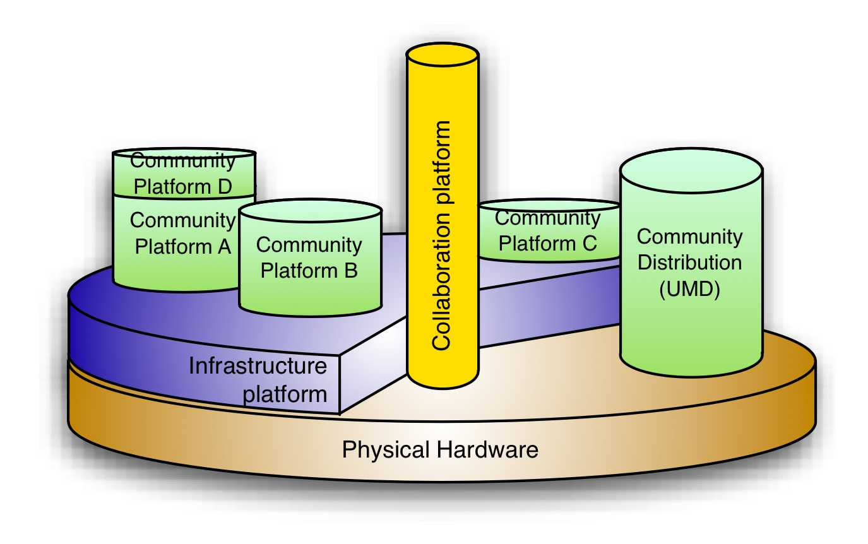
Figure 1 - EGI Platform Model

The EGI Core Infrastructure Platform is used to ensure that services operating in different resource centres belonging to different administrative domains are federated together to provide a uniform service offering. Uniformity includes consistency in their deployment, ensuring their availability and reliability through service monitoring, and accounting for the activity of the service in different administrative domains. The EGI Core Infrastructure Platform is primarily targeted at resource providers (either working on a geographical/national or research community basis) who need to federate their affiliated resource centres together or to those operating community platforms integrated with EGI’s Core Infrastructure Platform on behalf of particular research communities. Examples services could include: federated AAI for managing the infrastructure, resource management services, messaging, monitoring, accounting, and information discovery.
The primary purpose of the EGI Collaboration Platform is to provide services that enable the collaboration between research communities that are using technology deployed alongside or using the EGI Core Infrastructure Platform. It builds upon some of the services that already exist in the EGI production infrastructure but over time will provide a distinct platform for EGI’s research communities and technology providers to be adopted.
The EGI Collaboration Platform comprises services and technology that are (or expected to be) used across many if not all EGI research communities irrespective of their scientific domain. The EGI Collaboration Platform therefore is supplemental to the EGI’s Core Infrastructure Platform but is targeted towards research communities, individual researchers and those integrating Community Platforms on their behalf. Examples services include: federated AAI for accessing collaborative platform services, data movement, VM image sharing, research group membership, service desk, meeting planning, training platform.
EGI Community Platforms are sets of services designed to meet the needs of their respective research communities. As a consequence, it is difficult to describe EGI Community Platforms in a generic way similar to the EGI Core Infrastructure Platform (providing the means to help the distributed operation of a community platform), or the EGI Collaboration Platform (providing generic services that help different research communities collaborate with each other). There may be considerable overlap and reuse in deployed services and applications between different EGI Community Platforms. The research community itself defines the scope of their community platform, and therefore its composition is subject to the community’s choice of software products need to deliver the required capability.
While it may be obvious in such a situation to engage in collaborative inter-platform software development, the community platform model ensures that the involvement and impact of the research community in the services they use directly can be kept independent from the maintenance and operation of the EGI Core Infrastructure Platform. Such collaborative activities are already being supported through EGI’s Application Database, the Virtual Machine Image Marketplace (an implementation of a ‘Platform Store’ which has come out of the StratusLab project which EGI now deploys) and initiatives for software discovery and exchange (such as EMI’s ScienceSoft proposal [R10, R12]). Examples of such Community Platforms could include: brokered HPC, classic HPC, data-intensive HTC, pilot-job HTC, EGI basic (simple access to Compute and Storage resources).

Ecosystem Overview
The ecosystem on which EGI started to build upon has developed over the last decade provides minimal distinction between the roles of different actors and the values they provide. As a result, EGI is frequently seen as a monolithic and closed ecosystem with which it is difficult to interact and collaborate with. In defining the EGI strategic plan [R1], a consistent analysis of the various actors in the ecosystem has been performed to examine the current structures that are in place, the values being exchanged while mapping these actors to the strategic activities, roles and services that are being defined and developed.
This analysis has led to a new decomposition of the EGI ecosystem, which has evolved to provide a clearer separation between the roles within the NGIs and Technology Providers as well as the creation of specific roles called Platform Integrators and Platform Operators in line with the EGI Platform Roadmap.
It was important to decouple these roles that for the most part sit within the national infrastructures and technology providers so that they can be delivered by additional organisations in order to scale out EGI’s ability to interact with different research communities. Platform Operators have the technical expertise to deploy and operate products and services to meet the needs of particular researchers, while Platform Integrators are able to respond to specific needs by integrating independent software components into a coherent software stack to enable fully functional services based on a researcher’s individual needs. The following sections provide more detail to these roles.
Figure 2 provides a high-level view of the refined ecosystem as a result of this analysis. This moves the current monolithic ecosystem towards one that has increased openness that would provide a structure where others can replace existing actors without damaging the ecosystem as a whole, thus ensuring a persistent and sustainable e-Infrastructure for years to come.

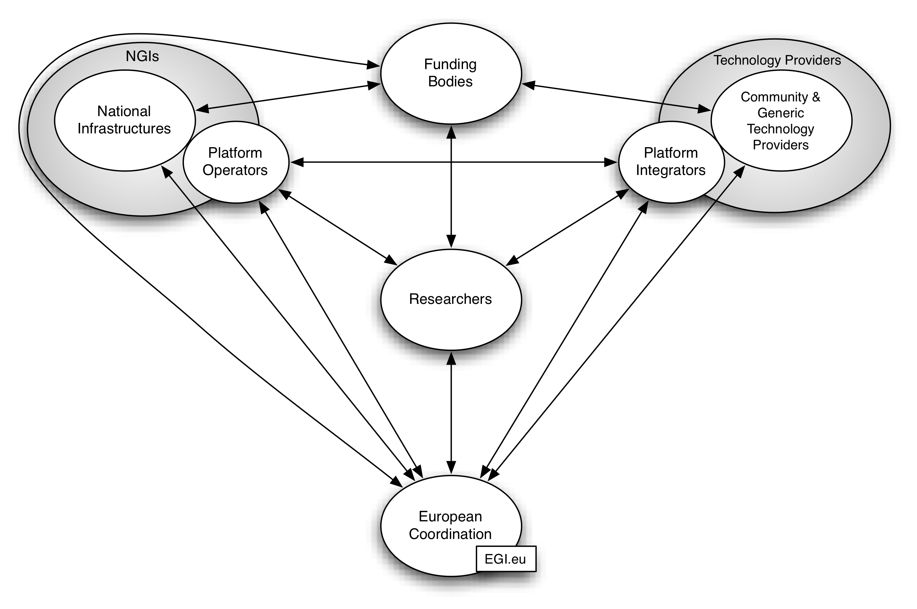
Figure 2 - EGI Ecosystem Overview

- Researchers: consumers of e-Science services that are supported by e-Infrastructures to perform their digital research; they are interested in services that can rapidly adapt and integrate with their workflows to conduct their research, achieve faster results, publish first and gain the recognition of their peers. They can be organised in research collaborations or Virtual Research Communities (VRCs) [R22].
- Technology Providers: the technology area within the EGI ecosystem is built upon open-source or commercial software coming from technology providers within the EGI community and generic technology providers outside of it that are put together by platform integrators to meet the needs of particular research communities.
- National Infrastructures: these include the NGIs that represent national activities within EGI and undertake national coordination duties through the resource infrastructure provider role. They have the responsibility to manage and deliver the operational infrastructure coming from the individual ‘resource centres’ within the country. They may also have the responsibility to act as platform operators for particular research communities ensuring that any research community specific services provided by the resource centres are operating effectively.
- European Coordination: for EGI, the EGI.eu organisation provides the vehicle for community coordination, policy, governance, outreach, operation and interaction within the EGI ecosystem and with similar peer bodies in other e-Infrastructures in Europe and around the world.
- Funding Bodies: EC, national research councils or other organisations that define policies and funding schemes to support the digital research.

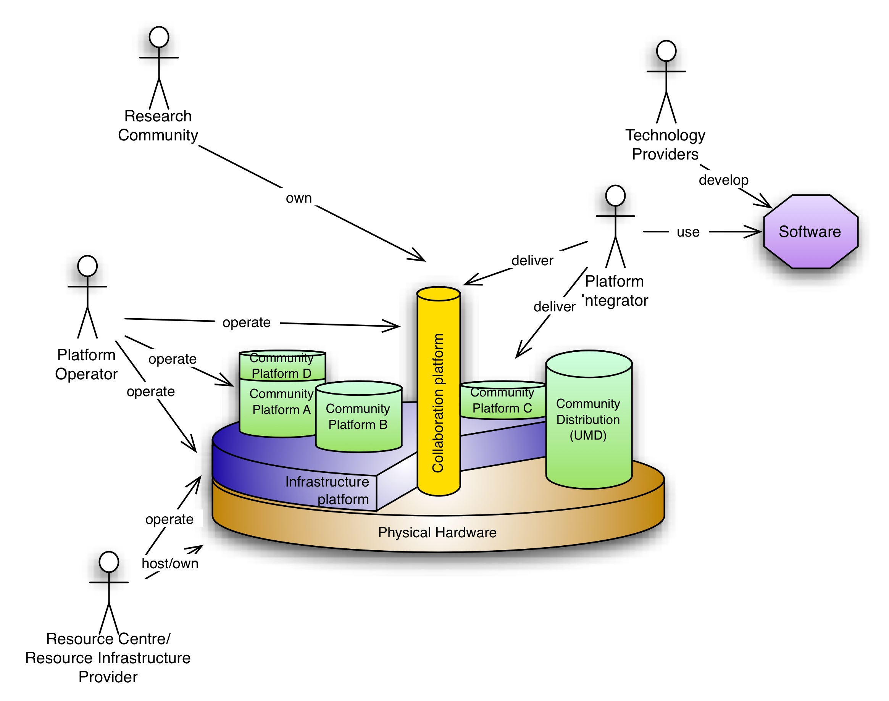
Figure 3 - Relationships between roles of the EGI Ecosystem and the Platform Model

Generating Business Models
In the previous sections, the value, vision and strategy of EGI have been presented, the architectural evolution into a platform-layered infrastructure has been highlighted and the evolved EGI ecosystem has been depicted. The next stage is to provide a framework for business model generation for the various actors that can play a role in contributing to the overall EGI integrated service delivery. The approach is to firstly perform a SWOT analysis to identify Strengths, Weaknesses, Opportunities and Threats for the role of the ecosystem under examination. This analysis helps in finding a competitive advantage by matching the strengths to opportunities, while it can suggest conversion strategies to convert weaknesses or threats into strengths or opportunities. After the SWOT analysis, a business model is suggested by adopting a format presented in the next section.

Structuring a Business Model
A common misconception throughout the research and academic world has been that a business model is how to generate revenue or conduct commercial activities. For the most part, anything related to business or enterprise terminology is generally discounted by the academic community, but at a very simple level a business model is simple statement staying what you do, why you do it and for whom.
While any organisation that creates and delivers value must be able to generate enough revenue to cover its expenses, a business model is much more than that. A business model is the rationale or description of how an organisation creates, delivers, and captures value sustainably. In fact, revenue generation is just one aspect of a business model formulation.
The following concepts serve as a pragmatic way to start defining a business strategy using a common framework from which to build. The proposed canvas in Table 1 proposes specific nine distinct subparts that enable to deconstruct a business model. They are a tested decomposition proved to work in many different real-world use cases [R18]. They can be individually completed for/by the various entities of the EGI ecosystem and the simple format helps a conversation among the interested parties by keeping it focused on the core elements who lead the success of a business instead of getting lost in complex business plan documents.

Table 1 - Lean Canvas Template
Problem  Top 3 problems | Solution  Top 3 features | Unique Value Proposition  Single, clear, compelling message that states why you are different and worth paying attention |  | Unfair Advantage  Can’t be easily copied or bought | Customer Segments  Target customers
 | Key Metrics  Key activities you measure |  |  | Channels  Path to customers
Cost Structure  What are the most important costs inherent in the business model?  Which Key Resources are most expensive?  Which Key Activities are most expensive? |  |  | Revenue Streams  For what value are our customers or funders really willing to pay?  For what do they currently pay?  How are they currently paying?  How would they prefer to pay?  How much does each Revenue Stream contribute to overall revenues?

The nine elements of the lean canvas mean:
  - Problem: Identify the top three problems to be addressed. This is the first, principle feature, as any organisation needs to understand that it cannot do everything for everyone. Not only will this allow for the definition of specific and targeted services that are provided but it will also avoid wasted time, money and effort in the wrong areas. Finally, this element considers that customers do not care about the proposed solution, but mainly about their problem being solved.
  - Customer Segments: List the customer(s) that potential solutions could and should satisfy. Analyse them to see if they can be broken down into further segments for more targeted activities.
  - Unique Value Proposition: Short, clear, compelling message that turns an unaware visitor into an interested prospect. This should be the primary reason for adopting the solution.
  - Solution: Any identified problem should have a corresponding solution for the customer.
  - Channels: List the path to reach and interact with the customers. This is not only marketing and communication, but also how to deal with the customers once obtained.
  - Cost Structure: List fixed and variable costs associated with offering this solution. One of the biggest mistakes it trying to offer a solution for which the organisation does not have the resources for, or for which cost recovery is impossible. This is why the importance of knowing the costs of services and then to analyse what is needed in order to recuperate costs.
  - Revenue Streams: Identify the sources of revenue that cover the costs. Even non-profits need to recuperate running costs. The only difference between a non-profit and fully commercial organisation is the amount that is obtained over operational costs, but the principle remains the same: offering a service that people need and needing to ensure that the costs in providing it are recovered, if not, everything becomes unsustainable. In the research and academic world, this could be through the identification of a wide variety of funding streams that are more streamlined, targeted and rationalised, leading to a more sustainable provision of services. It is important to note that the person paying for a service is often not the user of the service. While perhaps seen as a feature of academia this also occurs in the commercial sector.
  - Key Metrics: List the key numbers that will measure progress/success. The worst thing for any organisation is to continue in one direction and not realising that it was the wrong direction until too late. Periodic progress checks are essential in evaluating the work that is on-going in order to refine activities or change course as necessary. Identifying what areas along the process needs to be monitored and attach specific metrics to measure it will be crucial.
  - Unfair Advantage: Identify what cannot be easily copied or bought. Examples of competitive advantage are: a dream team, personal authority, large network effects, community, existing customers, SEO ranking, the right “expert” endorsement.

EGI Business Model
According to the delivery model strategy defined in ITIL [R24], EGI follows a partnership or multi-source model where a number of service providers have made an agreement to work together to provide an integrated set of services. Therefore, EGI is seen from a researcher’s perspective as a single point of access to a powerful ICT infrastructure to support digital research and collaboration. The various organisations contributing to the EGI ecosystem have their own autonomy and independence, each of them with an individual business model. Nevertheless, it is useful to consider them as a virtual service provider and perform an overall SWOT analysis to derive an integrated business model. Table 2 presents a SWOT analysis of EGI as a whole from the perspective of a researcher or research collaboration given an integrated service delivery between NGIs & their resource centres, EIROs, and EGI.eu.
Table 2 - SWOT Analysis for EGI from the perspective of a consuming researcher or research collaboration
Strengths  - Access to computing resources beyond which they would have locally to enable researchers to achieve faster scientific results  - Seamless and uniform access to distributed services for researchers in Europe wherever the research or the service are located  - Provision of services to facilitate and support collaboration between research communities (e.g. application marketplace, training marketplace) | Weaknesses  - Current services are tailored to only a few research communities  - Resource allocation process for new resources dependent on the resources accessible to that research community  - Not ideal for the individual researchers or small collaborations  - Lack of a shared vision and management structure across partners may slow down decision making process
Opportunities  - Provide a set of services that can be used by more research communities  - Facilitate the deployment of easy to use virtual research environments for individual research communities that integrates access to distributed ICT resources  - Actively contribute to the implementation of the "Digital Agenda for Europe" and “Innovation Union” to enable the digital ERA  - Generate a "network effect" in the digital research community | Threats  - Slow evolution to a more generic infrastructure can lead potential new research communities to build their own solutions or move to commercial providers  - Economic crisis may impact on stability of partners thus endangering the whole initiative

Given the provided analysis, based on the identified strengths and opportunities, the integrated business model for EGI is provided in Table 3. The internal weakness of being tailored only to specific research communities and the external threat of other research communities building their own infrastructures and thus making inefficient use of public resources has been carefully considered. EGI is addressing it with the move towards a platform model that allows individual research communities to deploy their own community platforms and research infrastructures to either integrate their resources alongside EGI’s or reuse EGI’s Core Infrastructure Platform to manage their distributed research infrastructure.
The lack of a common vision amongst all EGI’s partners is mitigated through strategic planning activities within EGI.eu that have produced an analysis of the value creation in the EGI ecosystem [R8], the EGI Strategy [R1], the EGI Platforms Roadmap [R6], and this report. EGI.eu has also established an annual process to gather strategic data from the participating NGIs and organise them into an EGI Compendium [R23]. The process has been established through the mechanism of the Virtual Team Projects to define the set of questions and the first iteration of the data collection mechanism has been completed in April 2012.
For EGI to support the digital ERA and the diverse scientific disciplines within it, it is essential to provide an operational model that allows different research communities to deploy the virtual research environment that they need, where and when they need in order to run their workflows to access the available resources or share their data.
The proposed model recognises that research communities have funding models that do not allow for ‘pay-per-use’; instead they expect a ‘free’ access or co-funded services through provision of in-kind resources. Therefore, the direct funding of the infrastructure by the different EU Member States and EC is seen as the most effective and optimal use of public spending that will also reduce the likelihood of fragmentation and disjointed policy actions and reduce the duplicate expenditure on similar infrastructures.
Table 3 - Integrated Business Model for EGI
Problem  - Hard to use and un-integrated tools and services slow down the digital researcher  - Multi-disciplinary grand challenges cannot be solved without distributed collaboration and use of distributed resources  - Difficult to discover/share useful problem solving tools and experiences | Solution  - Deployment of customised virtual research environments to meet the needs of individual research communities  - Platform model to access federated ICT resources that meet different needs  - Collaboration tools to share solutions and events to connect people | Unique Value Proposition  Empowering digital research and research collaboration |  | Unfair Advantage  European scale expertise in the technology and community built over a decade, collection of expertise across hundreds of European research organisations and individuals | Customer Segments  Individual researchers  Research collaborations  VRCs
 | Key Metrics  - Number of supported communities and disciplines  - Installed capacity  - Reliability and availability  - Scientific papers |  |  | Channels  Helpdesk, champions, events, social media
Cost Structure  Staff, IT infrastructures, operational costs, dissemination material |  |  | Revenue Streams  Direct: in-kind ICT resources  Indirect: EU funding for innovation, national funding for operations and maintenance, recurring budget line item from local governments

EGI.eu Business Model
As already mentioned in the ecosystem overview, EGI.eu is the legal entity established by the European Grid Infrastructure community to provide coordination across different national infrastructures and community building by driving forward the strategic direction of service delivery, attracting new research communities, exploring collaborations with both the public and commercial sector and promoting EGI’s role within Europe (e.g. DAE, ERA). Table 4 presents the SWOT analysis for EGI.eu.
Table 4 - SWOT Analysis for EGI.eu
Strengths  - International coordination, visibility, branding and management of services  - Strategy, policies and planning for European resource federation  - Negotiation on behalf of research and resource provider stakeholders  - Interaction with international research communities at European level | Weaknesses  - Dependent on external partners for providing technical services  - Demonstrating added value of coordination activity is complex
Opportunities  - Coordinate service delivery for individual researchers, research collaborations and VRCs  - Coordinating EGI’s role in DAE, IU and ERA  - Drive the evolution of EGI to attract new research communities  - Explore collaborations with commercial sector  - Drive innovation through strategic partnerships and participation in key projects | Threats  - Fragmentation between European e-Infrastructure organisations  - Failure of national grid infrastructures  - Unable to open the ecosystem and infrastructure to enable wider adoption  - Inability to prove European added value  - Strategy and business models of the NGIs become unsustainable
Table 5 presents the business model for the EGI.eu organisation. This is focused on the primary customers that are NGIs and EIROs that partially fund the organisation and strategically lead it through a direct representation in the EGI Council.
Table 5 - EGI.eu Business Model
Problem  - Coordinating the delivery of services across distributed independent resource providers  - Building and integrating a large, growing, diverse, evolving federated community with many partners  - Attracting new European research communities to using EGI’s distributed services | Solution  - Cost-effective consensus driven coordination of service delivery  - Marketing and events that outreach to new research communities  - Provide European wide representation to EC, governments and other strategic partners | Unique Value Proposition  Supporting the effective integration of e-infrastructures for digital research and collaborations at the EU level and beyond |  | Unfair Advantage  Resource provider community part of the governance  An expert team | Customer Segments  NGIs  EIROs  European Research Infrastructures  EC
 | Key Metrics  - New research communities  - Integration of infrastructures, technologies and resources  - Reliability of the coordinated services  - Publications and technical outreach activities  - Contributions to EU and national priorities |  |  | Channels  Personal relationships, management and coordination bodies, reports, promotional material, community events, social media
Cost Structure  Staff  Office space and materials |  |  | Revenue Streams  Direct: membership fees from members for core services  Indirect: EC funding for European-wide objectives (e.g. EU2020 Strategy) and new innovations

Business space for resource providers
As already explained, the ICT resources federated together to form EGI are owned by independent institutions (or hosted/managed by them on behalf of their research communities). These institutions vary considerably from a small department of a University that has received a grant to provision resources for its local researchers that are involved in a large distributed collaboration, up to a very large research institute supporting thousands of affiliated researchers that offers a huge local ICT infrastructure (e.g., CERN). EGI has adopted a governance model for pan-European e-infrastructures inspired by the experience of the research and education networks where each country has created a national coordination body to harmonise investments with the national policies, and possibly consolidate services that can be more efficiently provided at a central European level.
As highlighted in the ecosystem overview, the evolution of the national infrastructures has evolved into identifying three main roles that can be played by a local institution:
- Resource centres (RC) that provide compute, storage and other resources exposed through locally deployed services to meet the needs of particular research communities;
- Resource infrastructure providers (RP) that manage on a geographical basis (generally through national borders) the aggregation of the services provided by individual resource centres and manage the operational delivery of the coordination services under their management;
- National coordination bodies that have a defined governance role within their national borders as being the designated representative for their country’s activities internally and internationally.
Table 6, Table 7, and Table 8 show the SWOT analysis for the resource centre, resource infrastructure provider and national coordination body respectively.

Table 6 - SWOT Analysis for a Resource Centre
Strengths  - Operate services to access local physical resources  - Source of local technical expertise and consultancy | Weaknesses  - Unreliable service offering due to unreliable software or hardware  - Limited available technical effort for software deployment and operation leading an unresponsive and inflexible service
Opportunities  - Expand and optimise usage of resources across different research groups  - Ability to provide potential high-value customisation for specific research groups | Threats  - Increase of low cost commercial providers offering more flexible cost-effective resources
Table 7 - SWOT Analysis for a Resource Infrastructure Provider
Strengths  - Coordination of operations across their federated resource centres  - Provision of general ICT services for their federated resource centres | Weaknesses  - Reluctance in changing the current operation model and opening up to new technologies from different communities  - Inability to move quickly due to the complexity of the infrastructure
Opportunities  - Consolidate activities to achieve economy of scale  - Source of expertise for consultancy  - Highlight national excellence | Threats  - Inability to prove added value to resource centres  - Resources centres not delivering services to agreed quality
Table 8 - SWOT Analysis for a National Coordinating Body
Strengths  - National single point of contact for government, research communities and resource centres as regards ICT services for e-science | Weaknesses  - Lack of effective strategies to outreach new research communities at the national level  - No direct control of resources, so slow allocation of new resources  - Low visibility within research communities
Opportunities  - Become an authoritative voice for influencing scientific computing activities, DAE & IU & ERA at the national level  - Increase impact of scientific computing by broadening uptake in research communities | Threats  - Limited relevance and role may endanger sustainability  - Weak engagement with government and resource centre

Given the three identified roles, for each country we can envision one national coordination body, one resource infrastructure provider and one or more resource centres. Each national grid community is different and several configurations of the governance are being followed. For instance, one country may decide to have a lightweight legal entity to coordinate e-infrastructures of any kind (e.g., Grid, high-end computing, network) while delegating the central operations to another entity. Another country may decide to have a heavyweight legal entity that provides national grid coordination, central operations and a big resource centres. Yet another example can envision the lack of a legal entity for the national coordination with functions distributed among the partners aggregated as a kind of association. Therefore, it is not possible to provide a single concrete business model that could be adopted by all national infrastructures, nevertheless it is worth to define the business space where organisations can operate and decide the most appropriate governance and coordination model that best suit their national policies and needs.
Table 9 presents a possible business model for the case of an organisation performing the role of national coordinating body and resource infrastructure provider. To succeed, such an organisation needs to gain government endorsement to represent the national computing resources for science at the national and international level. Such recognition would first lead to a competitive advantage and also easier access to funding of activities that can harmonise the national spending on ICT resources for science in line with the national priorities.
As a resource infrastructure provider, the organisation should work on recruiting high-quality staff that can organise and run the central operational services while supporting small and new resource centres and helping them to integrate their services into the national and international infrastructures. This organisation should also be able to attract new research communities at the national level by championing the available services at campus or community-specific events.
Table 9 – An example business model for an organisation acting as a National Coordinating Body and Resource Infrastructure Provider
Problem  - Costs of provide coordination services and operational interoperability  - Attract new users and resources for optimizing public money spending on e-infrastructures and enable reusability and network effect  - Difficult to improve visibility and importance at nationally | Solution  - Cost-effective coordination of service delivery at the national level through international partnerships  - Marketing and events to outreach new research communities  - Act as single voice to national government, research communities and other national infrastructures | Unique Value Proposition  Supporting the effective integration of e-infrastructures for digital research and collaborations at the national level and beyond |  | Unfair Advantage  Resource centres representatives are part of the governance  Endorsement and recognition by the national governmental | Customer Segments  Resource Centres  National Research Infrastructures
 | Key Metrics  Usage, Resources, Resource Centres, Technologies integrated, Scientific domains |  |  | Channels  Helpdesk, Online media, direct consultancy, campus & community champions
Cost Structure  Staff, IT infrastructure  Office space and materials |  |  | Revenue Streams  Direct: membership from resource centres, paid support for training and consultancy  Indirect: national funded research projects, fixed budget line item in local government, structural funds, EC funded projects

The EGI evolution towards a platform-oriented architecture is opening up a new business opportunity for organisations as a platform operator. The purpose of this role is to ensure that the services deployed as part of an infrastructure or community platform are operating effectively on the distributed resources for their consuming research community. Staff with expertise in the software that makes up the various platforms will operate these platforms on behalf of the research communities in order to allow them to focus on their research. Table 10 presents the SWOT analysis for this new role.

Table 10 - SWOT for a Platform Operator
Strengths  - Technical expertise to operate domain-specific platforms on behalf of research communities  - Source of platform-related support and consultancy | Weaknesses  - Dependent on resource centres and resource infrastructure provider delivering the required platform infrastructure
Opportunities  - Able to deploy and operate products and services to meet the needs of particular researchers | Threats  - Inability to maintain reliable services due to lack of documentation or reliable software components  - The reliability of the underlying infrastructure that is out of their direct control

Table 11 presents a possible business model for a platform operator. Clearly, the business opportunity is in providing a specialised consultation for the needs of a specific research community in the area of operating a platform through EGI’s services. The main value to be provided and message to be delivered is to free researchers from the burden of operating technical services so that they can concentrate on their core business of doing research. The platform operator can act as interface to the platform integrator to provide the necessary feedback to improve the services.

Table 11 – An example business model for a Platform Operator
Problem  - Heavy burden to the research community or researcher of operating a distributed community platform  - Lack of technical skills to operate the platform within the research community | Solution  - Operate the community platform chosen by the researcher or research community to the specified SLA  - Specialised consultancy to the research community to evolve the offered service | Unique Value Proposition  Removing the burden from the researcher of operating the distributed services that they need to conduct their digital research |  | Unfair Advantage  Personalised service  Expert knowledge in the specific domain  Excellent track record on service operation | Customer Segments  Research collaborations  VRCs
 | Key Metrics  Ticket time to solve ratio, Scientific domains, service availability & reliability |  |  | Channels  Helpdesk, forums, website, wiki, knowledge base, social media
Cost Structure  Staff, IT infrastructure  Office space and materials |  |  | Revenue Streams  Direct: paid support, training, consultancy, usage  Indirect: national funded research projects, fixed budget line item in local government, structural funds, EC funded projects

Business space for technology providers
The technology area within the EGI ecosystem is built upon open-source or commercial software coming from community and generic technology providers that is put together by platform integrators to meet the needs of particular groups – researchers or operations staff. For instance, the EMI project [R16] integrates a platform for high-throughput computing from software that is developed within the project primarily for the EGI community (i.e., community technology providers) or to meet particular use cases coming from target research communities (e.g., WLCG [R13]). Software developed outside the EGI community (i.e., generic technology providers) such as Apache [R14] is used for cross-community and infrastructure wise purposes.
EGI-InSPIRE has only a limited software development activity that is restricted to the operational tools and to a limited number of collaboration tools. The functional services deployed within EGI are produced in partnership with independent community technology providers to meet the needs of researchers to solve their distributed data analysis problems. These virtual research environments need to be integrated, hosted and operated to meet the individual needs of the research community. There is therefore a role for organisations offering software development, software integration and software platform services to these research communities. The EGI ecosystem, identifies a business space for two main types of technology providers:
- Generic technology providers: open-source software collaborations or commercial software providers that deliver technology that can span multiple user communities or domains for general infrastructure purposes
- Community-specific technology providers: organisations or projects that develop or deliver software for use for specific user communities or customisation for specific requirements.
It is important to differentiate these two types of technology providers that will allow for more targeted activities in specific areas and clarity in defining requirements and channels for establishing agreements. Clearly, an organisation can play both roles. Table 12 presents a SWOT analysis for a generic technology provider while Table 13 presents the SWOT analysis for a community-specific technology provider.

Table 12 - SWOT for a Generic Technology Provider
Strengths  - Offer of free/inexpensive generic software components  - SLA for software and support services on a professional basis with mature community or paid support  - Strong and trusted brand name across multiple user groups | Weaknesses  - Inability or unwillingness to react to the needs of small user groups
Opportunities  - Provides a technology source with maintenance and development shared across many communities | Threats  - Technical failures can endanger adoption or retention  - Pressure to maintain or expand features may lead to reduced quality  - Communities may adopt domain-specific solutions
Table 13 - SWOT for a Community-specific Technology Provider
Strengths  - Development of community-specific open source software components  - SLA for software and support services supplements close relationship with consumers.  - Technical expertise from within the community. | Weaknesses  - Lack of critical developer mass for true open-source model  - Relatively small community bears maintenance costs  - Immature support around software components
Opportunities  - Able to respond to and engage with specific community needs  - Expand market shares and improve reuse by improving quality & functionality | Threats  - Specific community needs may evolve faster than available development effort  - Technical failures can endanger adoption or retention  - Commoditisation of other software components leading to competition

An example business model is provided for a community-specific technology provider. These have been vital over the last decade in providing customised domain specific solutions mainly supported through EC-funded projects.

Table 14 – An example business model for Community-specific Technology Provider
Problem  - Need for custom software components to meet the need of specific research communities  - Timely support for bug and security problems | Solution  - Develop high-quality software components to meet specific consumer needs  - SLA for software support | Unique Value Proposition  The specialist in building software solutions for digital research |  | Unfair Advantage  Community  Domain-specific expertise  A dream team | Customer Segments  Platform Integrator
 | Key Metrics  Community supported, reduction in tickets or time solved |  |  | Channels  Helpdesk, bug trucker, website, wiki, knowledge base, social media
Cost Structure  Staff, IT infrastructure for development and testing, documentation, office space and materials |  |  | Revenue Streams  Direct: paid support service based on SLA  Indirect: innovation projects (National/European), hybrid with in-kind development effort coming from the customer community

Given the diversity of software technology that makes up the typical virtual research environment needed by a research community, the specific role of platform integrator is needed for those that will integrate this software for deployment on the infrastructure. A platform integrator is responsible for bringing together components from different technology providers to meet the needs of a particular consuming community (e.g., individual researcher, research group, virtual research community, research infrastructure or physical infrastructure provider). Currently, this role is coupled within the community technology provider (e.g., EMI and IGE [R12, R15]). As EGI evolves to include a wider variety of technologies from different sources, a dedicated function where a business model can be created to deliver this service is necessary. The rationale behind the platform integrators is that they have the understanding the researchers’ requirements, are able to identify where existing software can be reused and can identify where new software development is needed. Table 15 presents the SWOT analysis for a platform integrator, while Table 16 presents an example business model.

Table 15 - SWOT for a Platform Integrator
Strengths  - Integration of independent software components into a coherent software stack to enable fully functional services based on user needs  - Offer an SLA for integrated software and support services  - Technical expertise across an integrated solution | Weaknesses  - Inability to provide consistent and up-to-date documentation due to external software sources  - Dependency on external sources for the quality of software components
Opportunities  - Able to respond to specific needs by adapting or sourcing required software components | Threats  - Inability to find suitable software components for integration  - Incompatibility of independent software components.

Table 16 – An example business model for a Platform Integrator
Problem  - To find, integrate and maintain software components into a coherent platform to support a research activity requires time/expertise not available to most researchers | Solution  -Integrate/certify software platforms to meet the user needs  -SLA for platform support | Unique Value Proposition  The specialist in platform integrations for the digital research domain |  | Unfair Advantage  Community  Existing customers  A dream team  No ‘vendor lock in’ | Customer Segments  Individual researchers  Research collaborations  VRCs  Infrastructure Providers
 | Key Metrics  Reduced integration effort, number of satisfied requirements, reduction in tickets or time solved, supported technologies/ domains,reuse and adaptation of existing software solutions and appliances |  |  | Channels  Helpdesk, bug trucker, website, wiki, knowledge base, social media
Cost Structure  Staff, IT infrastructure for development and testing, documentation, office space and materials |  |  | Revenue Streams  Direct: paid support service based on SLA  Indirect: innovation projects (National/European), in-kind development effort from customers

Conclusions and Next Steps
To ensure a sustainable infrastructure to support open science for decades to come, EGI must continue to evolve from a monolithic project structure to fully flourish as an open ICT ecosystem. As described throughout this report, this can ultimately be achieved through a combination of a variety of different roles, services, capabilities, and values that are delivered across the EGI ecosystem.
As EGI targets the whole digital European Research Area, it will be critical to allow researchers to personalise their EGI services and customise their virtual research on top of a strong reliable infrastructure platform that can provide a foundation for their activities. This increased flexibility and customisation will ultimately result in broadening of EGI’s supported research base and contribute to its long-term sustainability.
This report built on top of previous activities and addresses the complex theme of bringing together value proposition, strategy and architecture evolution to identify the business space for the various roles of the EGI ecosystem. A framework for business model generation has been set and concrete examples have been provided for EGI and EGI.eu. For other actors such as NGIs, resource infrastructure providers, technology providers, platform operators and platform integrators exemplar business models have been provided for development by the individual organisations that fulfil these roles within the EGI ecosystem. Further activities include:
- EGI-InSPIRE will continue to facilitate these organisations in developing their own concrete business models through workshops at the EGI Forums and other events;
- In June 2012, the EGI Council will hold a meeting to review the EGI Strategy (http://go.egi.eu/EGI2020);
- In September 2012, during the EGI Technical Forum a full day session on the EGI sustainability is planned with focused sessions on the technology and resource providers sustainability strategies and business models; during the event, results from the cost analysis carried out by the e-FISCAL project and the EGI compendium survey will be presented to enrich the discussion;
- Following the start of the EC-funded FedSM project, EGI will benefit from consultancy to support the development of business model and service strategy;
- A service portfolio will be defined in line with the IT service management best practices with consultancy provided by the gSLM project and in the future the FedSM project where EGI.eu will participate as “client” of service management experts;
- In the long-term, revisions of the strategy plan, platform roadmap, technical roadmap and business models will be provided (April 2013, April 2014).
The final goal is that by the end of EGI-InSPIRE, the defined strategy and its technical implementation coupled with the developed business models will provide plans that will allow EGI to continue to sustainably deliver its value to the European Research Area.

References
R 1 | D2.30 EGI Strategic Plan - https://documents.egi.eu/document/960
R 2 | D2.7 EGI Sustainability Plan - https://documents.egi.eu/document/313
R 3 | EGI UF’11 Policy Session - http://go.egi.eu/policy-session-egiuf2011
R 4 | EGI TF’11 Sustainability and Business Models Workshop - http://go.egi.eu/yaqzs
R 5 | EGI User Virtualisation Workshop - http://go.egi.eu/uvw1
R 6 | EGI CF'12 Sustaining the EGI ecosystem Workshop - http://go.egi.eu/bfmxj
R 7 | Sustainability & Business Models Survey Analysis - https://documents.egi.eu/document/797
R 8 | Value Creation in the EGI Ecosystem - https://documents.egi.eu/document/987 -
R 9 | MS510 EGI Platform Roadmap - https://documents.egi.eu/document/970
R 10 | ScienceSoft - http://sciencesoft.web.cern.ch/
R 11 | WeNMR Project - http://www.wenmr.eu/
R 12 | European Middleware Initiative (EMI) - http://www.eu-emi.eu/
R 13 | Worldwide LHC Computing Grid (WLCG) - http://lcg.web.cern.ch/lcg/
R 14 | Apache - http://www.apache.org/
R 15 | Initiative for Globus in Europe (IGE) - http://www.ige-project.eu/
R 16 | PRACE - http://www.prace-project.eu/
R 17 | Business Model Canvas - http://www.businessmodelgeneration.com/
R 18 | A. Maurya, Running Lean: Iterate from Plan A to a Plan That Works, O'Reilly Media, Second Edition, March 2012, ISBN-13: 978-1449305178
R 19 | Contrail - http://contrail-project.eu/
R 20 | Roadmap for Open ICT Ecosystems - http://cyber.law.harvard.edu/epolicy/roadmap.pdf
R 21 | EGI Technical Roadmap - https://documents.egi.eu/document/1094
R 22 | EGI Glossary - https://wiki.egi.eu/wiki/Glossary
R 23 | EGI Compendium - https://wiki.egi.eu/wiki/VT_EGI_Compendium
R 24 | ITIL 2011 Service Design - http://www.best-management-practice.com/officialsite.asp?FO=1253138&ProductID=9780113313112&Action=Book

Annex A: SWOT Analysis for Other EGI Ecosystem Actors
This section presents the SWOT analysis performed from the viewpoint of researchers and funders.

Researchers
Researchers: Users or consumers of e-Science services that are supported by e-Infrastructures to run their own research analysis. They are interested in using whatever they can rapidly adapt or integrate to meet their individual research needs in order to conduct their research, publish first and gain the recognition of their peers.
A large fraction of the individual scientists group together in collaboration, but the single scientist working alone on a problem that needs massive computing or data resources is not negligible. As researchers use a wide range of software and tools, helping them to personalise their use of generic EGI services through domain specific virtual research environments coupled with offering platforms that support them will be critical for expanding the user base by allowing any researcher to run what they want, when they want it.

Table 17 - SWOT for Individual Researchers
Strengths  - Source of innovative research ideas  - Generator of scientific data, information, knowledge and expertise | Weaknesses  - Lack of easy access to large-scale data management and processing facilities  - Unlikely to have resources for significant software development so dependent on available external solutions  - Lack of influence in the specification of external e-Infrastructures services
Opportunities  - Greater benefit and use of e-Infrastructures through lowered technical barriers & increased flexibility for faster & better results  - Focusing on research rather than managing their e-Infrastructures needs | Threats  - Unable to analyse data to extract knowledge and produce innovations  - International & local publicly funded e-Infrastructures do not meet their needs  - Commercial offerings drive up the cost of their research and may not meet technical requirements

Research Collaborations: A group of scientists and researchers from institutes and/or universities working together for a common goal either on a National or European level.
While composed of individual researchers, research collaborations have sufficient critical mass and coordination to contribute to and to a limited extent sustain their own community around shared resource goals needed to tackle societal challenges.

Table 18 - SWOT for Research Collaborations
Strengths  - Collaborative generator of ideas, data and innovation  - Able to access ICT expertise to breach technical barriers within their local organisation or through the collaboration | Weaknesses  - Distributed community makes it harder to achieve critical mass  - Organisational borders may provide barriers to data access, analysis and resulting innovation  - Ad-hoc solutions can lead to inefficiencies or inability to conduct research and a longer time to achieve results
Opportunities  - Easier collaboration across organisational boundaries through e-infrastructures  - Focusing on research rather than their e-Infrastructures needs | Threats  - Unable to analyse data to extract knowledge and produce innovations  - International & local publicly funded e-Infrastructures do not meet their needs  - Commercial offerings drive up the cost of their research and may not meet technical requirements

Virtual Research Communities: Structured European research communities such as EIROForum labs or European wide research collaborations that have end-users who wish to systematically access distributed resources provided by their own community across Europe.
Table 19 - SWOT for Virtual Research Communities
Strengths  - Collaborative generator of ideas, data and innovation  - Able to access ICT expertise to breach technical barriers local within their local organisation or through the collaboration  - International critical mass as recognised science mission  - Structured governance (formal or informal) | Weaknesses  - Distributed community makes it harder to achieve critical mass  - Organisational borders may provide barriers to data access, analysis and resulting innovation  - Ad-hoc solutions can lead to inefficiencies or inability to conduct research and longer time to achieve results  - The need to share and manage increasing amount of digital data is mission critical
Opportunities  - Easier collaboration across organisational boundaries through e-Infrastructures  - Focusing on research rather than managing their e-Infrastructures needs | Threats  - International & local publicly funded e-Infrastructures do not appear to meet their needs.  - With no suitable public e-Infrastructure, they will need to develop their own solution as commercial solutions unlikely to support extreme requirements

VRCs are composed of researchers that potentially span different disciplines in different organisations across different countries that have structured themselves to tackle a ‘grand challenge’ within their own scientific community (e.g., WeNMR [R11]). VRCs have the opportunity to directly influence developments through participation within the User Community Board (UCB), where requirements are prioritised and fed into the Technology Coordination Board (TCB).

Funding
National Funding Bodies: Provide a source of funds to support e-Infrastructure activities and user communities according to national priorities.
European Funding Bodies: Provide a source of funds primarily focused around aligning the EU towards the priorities set by the EC.
EGI is currently supported through a mix of national based funding along side European funding to achieve its goals. However, as described, each funding body invests in EGI for varying motivations. It is important for EGI, as it moves towards a more open ecosystem, to also better analyse the services that are offered and how they each correlate to the funding body’s buy-in. As different business models are being explored, it is important to keep in mind why these funding bodies invest in EGI.
NGIs and their resource centres benefit directly from centralised technical services and support that help coordinate and integrate EGI’s operational activities. Therefore, national based funding bodies should be the primary contributor to these services. The establishment and promotion of EGI as a service to enable the digital European Research Area is in line with the EC priorities and goals within Europe 2020 and they should be the primary investor in this activity.
Table 20 - SWOT for National Funding Bodies
Strengths  - Funding for national interests and effort | Weaknesses  - Short-term funding  - Difficulty to invest in non-national activity
Opportunities  - Facilitate research and development aligned with national strategies | Threats  - Funding results do not meet local success criteria
Table 21 - SWOT for European Funding Bodies
Strengths  - Funding for innovation done within international teams  - Long-term vision for e-Infrastructures in society | Weaknesses  - EC project model imposes administrative constraints
Opportunities  - Provide e-Infrastructure to support ERA, DAE and other EC initiatives | Threats  - Disconnect between vision and needs  - Unable to deliver within constraints of EC model
Table 22 - SWOT for Commercial Funders
Strengths  - Provides direct links to market  - Business experiences and efficient processes | Weaknesses  - Potential lack of transparency and openness
Opportunities  - Enable development and operation costs to be shared  - Enable access to new markets and Customers.  - Diversify income sources | Threats  - Limited source of funds so must target key functions
Table 23 - SWOT for Community Funders
Strengths  - Can directly support community needs | Weaknesses  - Subject to the available of funds
Opportunities  - Direct link of value received to value delivered | Threats  - Low return on Investment would jeopardise funding

Annex B: Business Model Examples

Contrail
An example of how an EC project could contribute to the EGI ecosystem and the business models that could be used to sustain its activities is provided through the Contrail project [R19]. The Contrail project is developing cloud services, which it could contribute as a Technology Provider, Platform Integrator and Platform Operator. Although the business model needs further development, this initial draft illustrates that other organisations and projects beyond EGI.eu and the NGIs can contribute to the EGI ecosystem. Given the uptake of user communities, the EGI business model provides an incubation framework for solving the sustainability of this and many other European and national research projects including data and technologies that eventually will be picked up again after a given period after the project lifetime.
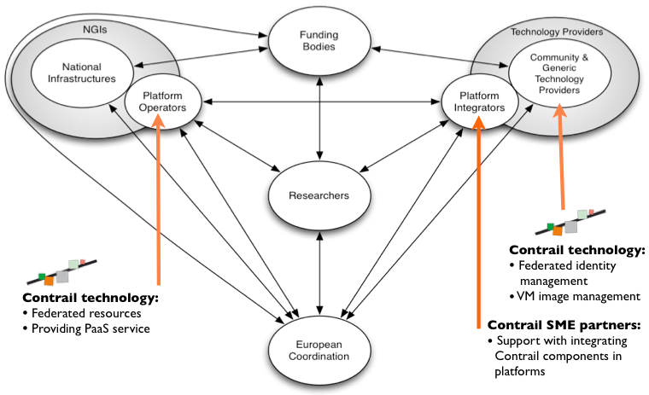
Figure 4 - Contrail within the EGI ecosystem

As a Technology Provider
Relationship: B2B
Problem: Services needed to build an IaaS federated cloud.
Customer segments: EGI.eu and Platform Integrators.
Value proposition: Allows open access to shared computing resources; the vision of the Contrail Project is that any organisation should be able to be both a Cloud provider when its IT infrastructure is not used at its maximal capacity, and a Cloud customer in periods of peak activity. Resources that belong to different operators will be integrated into a single homogeneous Federated Cloud that users can access seamlessly.
Solution: Provide services related to federated identity management and VM image management based on Contrail SAML/XAML based identity management and Contrail OVF based Virtual Execution platform.

As a Platform Integrator
Relationship: B2B
Problem: Integrating services needed to provide an IaaS federated cloud platform.
Customer segments: Delivery of a Federated Cloud Infrastructure Platform to EGI.eu on behalf of its affiliated resource providers.
Value proposition: Provide and support an integrated software solution to meet the needs of EGI.eu and its affiliated resource providers.
Solution: A software solution that integrates with EGI’s existing Core Infrastructure Platform.
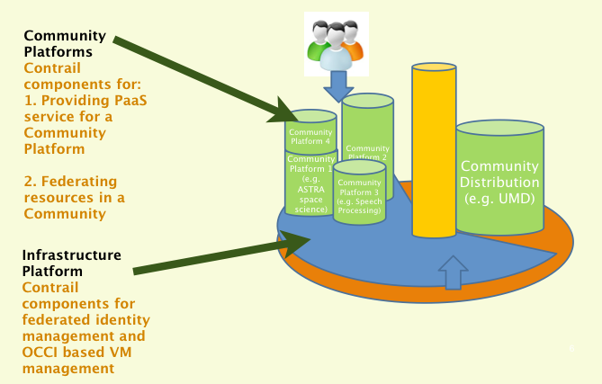
Figure 5 - Contrail services within the EGI platforms

As a Platform Operator

Providing PaaS service for a Community
Relationship: B2B
Problem: Ability to easily deploy and combine sets of services that can scale automatically.
Customer segments: Platform Operators; Platform Integrators.
Value proposition: Providing a platform working on top of an integrated with the community federation and the EGI infrastructure federation.
Solution: Offer an easy extensible PaaS platform provided by Contrail with a number of preinstalled applications (Java, PHP, SQL, NoSQL, and Hadoop) for a community of users.

Federating resources in a Community
Relationship: B2B
Problem: To combine cloud resources from different community members into a coherent federation, with automatic scheduling in the Community federation.
Customer segments: Platform operators; Platform integrators.
Value proposition: An SLA based Cloud federation.
Solution: Contrail SLA-based federation of clouds, with federated identity management on top of EGI

EMI and IGE
EMI is a collaboration of four major European middleware providers: ARC, dCache, gLite and UNICORE. The initiative delivers a consolidated set of middleware components for deployment in EGI, as part of the Unified Middleware Distribution (UMD). EMI also provides middleware to PRACE [R16] and other distributed computing infrastructures.
The IGE project serves European e-Infrastructures by providing development, customisation, provisioning, support (including training), and maintenance of components of the Globus Toolkit. IGE has worked in close collaboration with EGI, as well as other distributed computing infrastructure projects, and standard development organisations.
Both projects have been two of EGI’s main technology providers over the last two years. The following diagrams and sections provide an overview of where each sit with the EGI ecosystem and the value they provide.
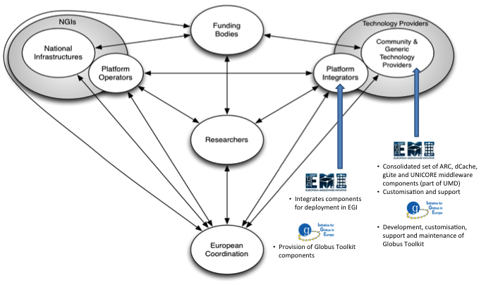
Figure 6 - EMI and IGE within the EGI ecosystem

As a Technology Provider
Relationship: B2B
Problem: Researchers require user-centric services and support for incidents and requests.
Customer segments: EGI.eu, Platform Integrators.
Value proposition: Established experts in distributed computing and e-Infrastructures providing the key technologies required by any research community.
Solution: EMI - Deliver a consolidated set of middleware components for deployment in EGI; Extend the interoperability and integration with emerging computing models; Strengthen the reliability and manageability of the services and establish a sustainable model to support; harmonise and evolve the middleware, ensuring it responds effectively to the requirements of the scientific communities relying on it.
IGE - Adapt Globus to better fulfil European requirements through coordinating European input from users, developers, and infrastructure providers; Deliver tailored software development, operation, support, training, and documentation services to the European communities; Act as a central hub for Globus within Europe.

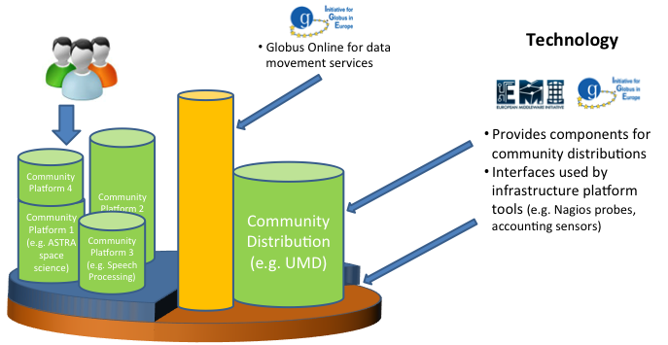
Figure 7 - EMI and IGE services within the EGI platforms

As a Platform Integrator
Relationship: B2B
Problem: Management of large amounts data; efficient interfaces between infrastructures and platforms.
Customer segments: Researchers and research groups.
Value proposition: Stable integrated distribution of compute and data management services that delivers a broad suite of technologies for deployment in distributed computing infrastructures in Europe and beyond.
Solution: Integration of Globus Online for data movement services, a variety of components for community distributions and interfaces used by infrastructure platform tools.

NGI X
As mentioned, the National Grid Infrastructures (NGIs) are EGI’s main stakeholders, together with EIROs CERN and EMBL. It is expected that the business strategies resulting from each NGI will vary greatly, depending on the size and scope of activities and individual expertise. The following scenario is a high-level description serving as a starting point for national infrastructures to further detail their specific business plan. Therefore, they are intended to provide an overview of just some of the many possible options described throughout this report. Each organisation is free to choose any combination of services to provide and roles and functions to fulfil.
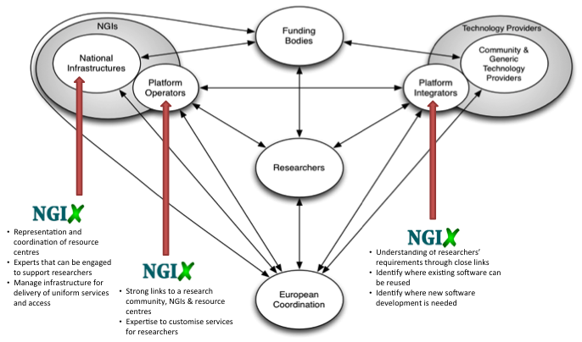
Figure 8 - NGI X within the EGI ecosystem

As a National Coordination Body
Relationship: B2B
Problem: Delivery of uniform ICT services and infrastructure access across multiple resources centres into an integrated national infrastructure requires central coordination and management.
Customer segments: Resource Infrastructure Providers; Resource Centres.
Value proposition: Central coordination provides a single point of contact for government, research communities and resource centres and influences scientific computing activities, DAE & ERA at the national level, ultimately increasing the impact of scientific computing and broadening uptake across research communities.
Solution: Provide representation and cost-effective coordination of national for delivery of uniform services and access; Interface with EGI.eu and other bodies for national priorities and requirements.
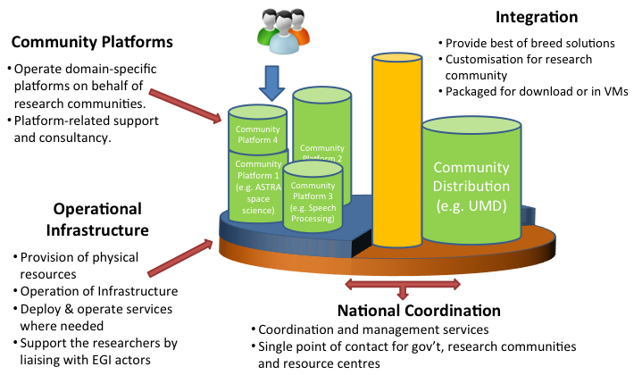
Figure 9 - NGI X services within the EGI platforms

As an Infrastructure Provider
Relationship: B2B
Problem: General lack of easy integrated uniform access to large-scale data management and processing facilities needed to conduct innovative collaborative research. Larger research collaborations experience barriers to data access, analysis and resulting innovation outside of organisational borders.
Customer segments: Resource Centres; Researchers and Research Groups.
Value proposition: Ensuring quality of service across a federation of resource centres for the provision of uniform ICT services for the benefit of researchers and research groups.
Solution: Provision of physical resources; Operation of infrastructure; Support

As a Platform Operator
Relationship: B2C
Problem: Current operational model is either closed or inflexible around allowing new technologies to be deployed from different communities. Many currently rely on ad-hoc solutions that lead to inefficiencies or inability to conduct research and longer time to achieve results.
Customer segments: Researchers and research groups.
Value proposition: Strong links to a research community, NGIs & resource centres with expertise to customise and operate services for researchers.
Solution: Operate domain-specific platforms on behalf of research communities; Provide platform-related support and consultancy.

As a Platform Integrator
Relationship: B2B
Problem: The overall complexity of the infrastructure is slow or unable to meet the rapid changes in researcher needs. Many researchers lack the internal resources for significant software development; therefore they are dependent on available external solutions.
Customer segments: Researchers and research groups.
Value proposition: Technical expertise and comprehensive understanding of researchers’ requirements through established links thus able to identify where existing software can be reused or new software development as needed.
Solution: Provide best of breed solutions selected from a wide variety of technology providers based on specific requirements; Customisation services tailored to specific research community requirements; Packaged solutions rendered available for download or as virtual machines.

An ICT ecosystem as open when it is capable of incorporating and sustaining interoperability, collaborative development and transparency, while increasing capacities to create flexible, service-oriented ICT applications that can be taken apart and recombined to meet changing needs more efficiently and effectively [R20].

