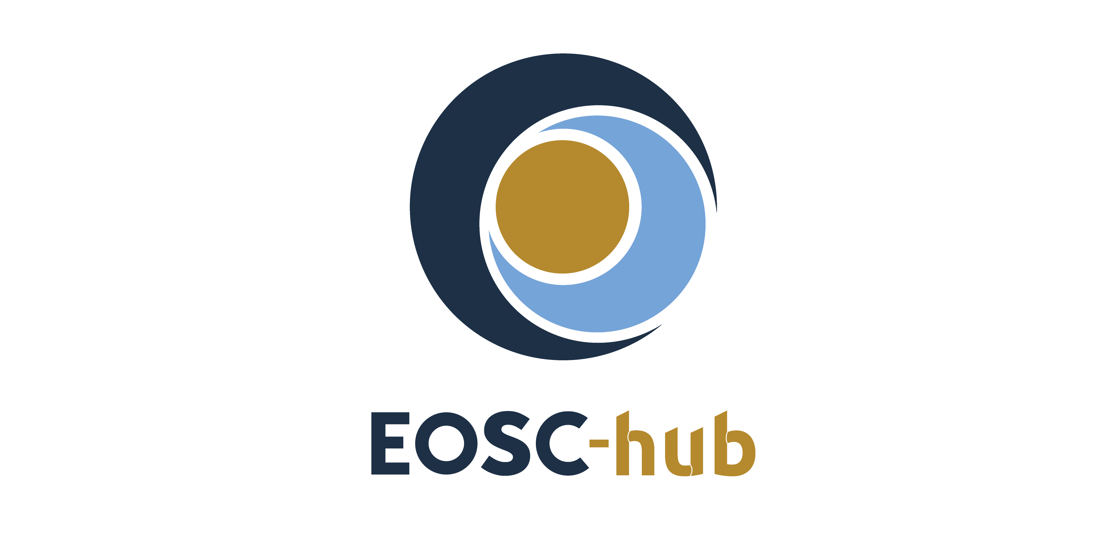

D3.5 Communication & Stakeholder Engagement: Final Report
Lead Partner: | EGI Foundation
Version: | 1
Status: | Under EC review
Dissemination Level: | Public
Document Link: | https://documents.egi.eu/document/3635

Deliverable Abstract
The EOSC-hub project involves infrastructure providers from the EGI Federation and EUDAT CDI, and technology providers from INDIGO-DataCloud, with the purpose of offering services, software and data repositories to support research and innovation. These resources are offered via the integration and management system of the European Open Science Cloud Hub, acting as a single-entry point for all stakeholders. This report provides a summary of the communication and stakeholder engagement activities executed over the 36-month project lifetime, detailing the performed actions and their impact assessment based on the KPIs and metrics that have been defined at the beginning of the project. The report covers Communication activities, Events, Visitor/user/provider engagement in the EOSC Portal, Research Infrastructure and project engagement, Business engagement, EOSC Working groups.

COPYRIGHT NOTICE
This work by Parties of the EOSC-hub Consortium is licensed under a Creative Commons Attribution 4.0 International License (http://creativecommons.org/licenses/by/4.0/). The EOSC-hub project is co-funded by the European Union Horizon 2020 programme under grant number 777536.
DELIVERY SLIP
Date | Name | Partner/Activity | Date
From: | Gergely Sipos | EGI Foundation/WP3 | 06/04/2021
Moderated by: | Malgorzata Krakowian | EGI Foundation/WP1
Reviewed by: | Sara Garavelli  Iryna Kuchma  Anca Hienola | CSC / EOSC-Future  EIFL / OpenAIRE  FMI / ENVRI-FAIR | 23/03/2021
Approved by: | AMB

DOCUMENT LOG
Issue | Date | Comment | Author
v.0.1 | 11/02/2021 | Table of content | Gergely Sipos
v.0.2 | 18/04/2021 | Full draft for external review | Gergely Sipos (EGI Foundation),  Iulia Popescu (EGI Foundation),  Rob Carrillo (Trust-IT),  Giuseppe La Rocca (EGI Foundation), Debora Testi (CINECA),  Marcin Plociennik (PSNC),  Sy Holsinger (EGI Foundation),  Mark van de Sanden (SURF),  Owen Appleton (EGI Foundation),  Sergio Andreozzi (EGI Foundation)
v.0.3 | 23/03/2021 | External review | Sara Garavelli  Iryna Kuchma  Anca Hienola
v.1 | 06/04/2021 | Final | Several authors (see v.0.2)

TERMINOLOGY
https://wiki.eosc-hub.eu/display/EOSC/EOSC-hub+Glossary

Contents
1 Introduction to EOSC-hub Stakeholder Engagement 5
2 Communication activities 7
2.1 Communications channels 7
2.2 Other communication 10
3 Events 11
3.1 EOSC-hub Flagship Event: EOSC-hub Week 11
3.2 Co-organised flagship events 11
3.3 EOSC-hub trainings and webinars 12
4 EOSC Portal engagement 14
4.1 Visitor analysis 14
4.2 User analysis 15
4.3 Provider analysis 18
5 Research Infrastructure and project engagement 22
5.1 Thematic Services, Competence Centres and Early Adopters 22
5.2 Other engagement activities 23
6 Business engagement activities 25
7 EOSC Working groups 28
7.1 EOSC Architecture Working Group 28
7.2 EOSC Rules of Participation Working Group 31
7.3 EOSC Sustainability Working Group 32
7.4 Skills and Training Working Group 33
8 Conclusions 34

Executive summary
The EOSC-hub project aimed to become the single contact point for researchers and innovators to discover, access, use and reuse a broad spectrum of resources for advanced data-driven research. Stakeholder engagement was tasked to identify and engage with key members on the recently established EOSC landscape to promote EOSC-hub services, achievements, opportunities to them, and overall to increase the use of the EOSC Portal and its services.
The stakeholder engagement activity was coordinated by Task 3.2, and integrated efforts from other work packages of the project. The distributed teams worked with service providers, scientific communities, members of the commercial sector, EOSC policymakers and the general public.
Stakeholder engagement activities included communication (website, social media, brochures/publications), organisation of events (conferences, workshops, webinars), attending external events, signing up providers and serving users via the EOSC Portal, providing 1-on-1 consultancy to EOSC-related projects and research infrastructures, running business pilots, contributing to relevant EOSC Working groups.
During its 3 year the project
- Doubled the annual number of visitors on its website, reached 2,200 subscribers with its project magazine, reached 3,000 followers on social media, published 25 brochures/leaflets.
- Organised annual conference with 800 participants (per event), and co-organised conference that reached 700 participants. Organised an online conference with 4,000 visitors.
- Run more than 200 training events with 5,200 attendees, and a webinar program with 7 events and over 110 participants.
- Established and operated the EOSC Portal that reached 1,500 visitors per month, served 415 user access requests (in total), onboarded 126 new services.
- Engaged with and performed technical integration activities with 9 Thematic Services, 9 Research Infrastructure Competence Centres, 13 Research community Early adopters.
- Run 18 Business pilots with SMEs.
- Contributed to 4 (out of the 6) EOSC Working Groups.

Introduction to EOSC-hub Stakeholder Engagement
The EOSC-hub project aimed to become the single contact point for researchers and innovators to discover, access, use and reuse a broad spectrum of resources for advanced data-driven research. This vision was implemented through the EOSC Portal and Marketplace which have been opened in November 2018. Through the Portal the project made available a catalogue of services from the EGI Federation, EUDAT CDI, INDIGO-DataCloud and major research e-Infrastructures.
The project built on mature processes, policies and tools from the leading European federated e-Infrastructures to cover the whole life cycle of services, from planning to delivery. EOSC-hub brought this knowledge into the operation of the EOSC Portal and other elements of the current EOSC Core (for example the monitor, accounting, helpdesk).
During its 39 months the project captured its key outputs into 9 ‘Key Exploitable Results’:
- EOSC Portal and Marketplace
- EOSC Service Management System
- EOSC Rules of Participation
- Internal Services in the Hub Portfolio
- External services in the EOSC Service Portfolio
- EOSC Digital Innovation Hub (DIH)
- Business and Sustainability models
- Interoperability and Integration guidelines
- Training Courses and Material
Given this landscape the main objectives of the EOSC-hub Stakeholder Engagement were to
- Promote the EOSC Portal to new providers.
- Promote the catalogued services to new users and user groups.
- Promote the enabling services (e.g. helpdesk, usage accounting, service monitor) to providers and promote continuation within the future EOSC Core after EOSC-hub.
- Increase collaboration with the commercial sector.
Stakeholder engagement was coordinated by Task 3.2, with the involvement of 4 institutes: CINECA, CSIC (coordinated the task until month 18, then left the task), EGI.eu (coordinated the task from month 18), TUBITAK (joint the task from month 18). The group strongly relied on other WPs and focused on coordinating/aligning their activities towards maximal efficiency and performed activities that felt outside the scope of those other WPs but were important for successful engagement.

Because of the strong relationship with the other WPs this deliverable pulls content from several other tasks and WPs to report about the overall picture of Stakeholder Engagement.
- Section 2 Communication activities (main contributor: WP3)
- Section 3 Events (main contributor WP3)
- Section 4 EOSC Portal engagement (main contributor WP4)
- Section 5 Research Infrastructure and project engagement (main contributor T3.2)
- Section 6 Business engagement activities (main contributor WP9)
- Section 7 EOSC Working groups (main contributor WP4)
Each section reports about achievements mentioning also the KPIs that were defined in ‘D3.1 Communications and Stakeholder Engagement Plan’.

Communication activities

Communications channels

EOSC-hub website and EOSC Portal
The EOSC-hub website was designed as the main communication channel of the project and serves as the main source of information for researchers, policy makers, the business community, the project team and the general public.
The website was continuously improved throughout the duration of the project with new sections to highlight EOSC-hub’s activities and results: from dedicated pages to research communities such as the Competence Centres, the EOSC Early Adopter Programme, to a distinct space for the EOSC Digital Innovation Hub, a vastly improved training section, and finally a Key Exploitable Results-focused section and navigation area, allowing visitors to immediately find the most relevant project results.
The viewership figures of the website have increased significantly from the 1st year of the project from 80,663 total page views and 11,363 users in 2018 to 120,064 page views and 21,354 users by the end of 2020.
The EOSC Portal was launched at the end of 2018 as a main communication channel and entry point of the European Open Science Cloud. EOSC-hub, OpenAIRE and eInfraCentral developed the EOSC Portal and provided continuous update and maintenance to content: adding new sections, case studies, service descriptions, a dedicated EOSC Portal brochure and dedicated videos.
The viewership figures of the EOSC Portal have also increased significantly from the 1st year of the project from 118,753 total page views and 2,289 average monthly users in 2019 to 228,065 page views and 4,745 average monthly users by the end of 2020.
The EOSC-hub website will continue to be maintained for at least two years after the project concludes while EOSC Portal will continue its operations under EOSC Enhance, EOSC-Future and other projects that will be represented in the EOSC Portal Editorial Board.

EOSC-hub internal newsletter
The internal newsletter was set up to keep the EOSC-hub consortium informed of ongoing activities, plans, news, achievements and updates from Work Package leaders and other information of note. The newsletter was sent via email from the Mailchimp application. A total of 14 internal newsletter were sent to the project consortium over the duration of EOSC-hub reaching over 2200 subscribers.

EOSC-hub Magazine
The EOSC-hub Magazine is a key project communication channel, created as a tool for engagement, dissemination and brand building. The EOSC-hub Magazine features stories about use cases, technical developments, project achievements and news, results and guidelines commissioned within the wider EOSC landscape (i.e., from within the project, but also from outside). A total of 7 issues of the EOSC-hub Magazine were produced, in both online and print format as per original plan.

Publications
The EOSC-hub project produced over 25 publications to give in-depth information conveying the added values of services, research communities and industry, KERs and general achievements. Significant publications were the following:
WHAT | TITLE | AUDIENCE
Leaflet | EOSC-hub Generic Leaflet | Research Communities, Industry, Service Providers  + General Public
Leaflet | EOSC-DIH Generic Leaflet | Industry
Leaflet | EOSC-hub Competence Centres | Research Communities
Leaflet | EOSC-hub Thematic Services | Research Communities
Leaflet | 5 Ways of Working with EOSC-hub | Research Communities, Service providers
Leaflet | OPENCoastS Thematic Service | Research Communities
Leaflet | DARIAH Thematic Service | Research Communities
Brochure | EOSC-hub Magazine (7 editions) | Research Communities, Service providers, Industry, Decision Makers  + General Public
Brochure | EOSC-DIH Success Stories | Industry
Brochure | EOSC Early Adopter Programme | Research Communities, Service providers, Industry, Decision Makers
Brochure | EOSC-hub Key Exploitable Results | Research Communities, Service providers, Industry, Decision Makers  + General Public
Poster | EOSC-hub Contributions to EOSC | Research Communities, Service providers, Industry, Decision makers, EOSC community
Poster | EOSC-hub Portal Poster | Research Communities, Service providers, Industry, Decision makers, EOSC community
Poster | EOSC-hub & The Marine Research Competence Centres | Marine Research Community
Poster | EOSC-hub & Ocean Science | EO Community
Poster | EOSC-hub & Digital Humanities | Humanities Community
Poster | EOSC-hub Poster for DI4R 2018: the project in a nutshell | Research Communities, Service providers, Industry, Decision makers, EOSC community
Technical report | EOSC-hub Integration Report | Research Communities, Service providers, Industry, Decision makers
Technical report | Evaluation of the EOSC-hub Community | Research Communities

Social media
Social media was deployed as a communication channel to promote the project's activities, broadcast EOSC-hub news, engage with project stakeholders and research communities and support other communications channels. The project was focused on Twitter and LinkedIn tools, both networks having visible buttons published on the website.
Twitter:
- Handle: @EOSC_eu
- Number of followers: 2910
LinkedIn:
- Link: linkedin.com/company/eosc-hub
- Number of followers: 189

Other communication

Use cases
Use cases were written to demonstrate practical works of EOSC-hub's services and key exploitable results. They represent powerful tools to showcase what has been achieved during the project.
Within EOSC-hub, use cases and success stories were dedicated to the EOSC-hub Competence Centres, the EOSC Early Adopter Programme and the EOSC Digital Innovation Hub.
They were embedded in web sections onto the EOSC-hub website, the EOSC Portal and edited into 2 dedicated publications: the Early Adopter Programme brochure (13 research use cases ) and the EOSC-DIH Success Stories (7 business use cases) brochure.
The use cases have been also submitted to the EOSC Use Case collection campaign that was organised by the EOSC Researcher Engagement and Use cases Interest Group coordinated by the EOSCsecretriat project.

Events

EOSC-hub Flagship Event: EOSC-hub Week
The EOSC-hub Week was the major gathering point for all the EOSC-hub stakeholders. This two/three-day event focused on showcasing the EOSC-hub results to the complete stakeholder landscape, interacting with the EOSC-hub community, engaging new users and service providers, and creating awareness on the EOSC-hub offer. The EOSC-hub flagship events offered different visibility opportunities to achieve these objectives through keynote and parallel presentations, lightning talks, training courses, poster and demo areas, networking.
The 1st EOSC-hub week was held in Malaga from the 16-20 April 2018. Gathering over 170 stakeholders, the week revolved around two major events: a public day and an EOSC-hub “all hands” meeting. The public day, sponsored by the EGI Foundation, the EUDAT CDI and the XDC project, welcomed the participation of service providers, representatives of the research communities and policy makers engaged in the establishment of the European Open Science Cloud. The "all hands" meeting was the first opportunity for the over 100 EOSC-hub partners to gather together and discuss the progress and the early achievements of the project.
The 2nd EOSC-hub week was held in Prague from the 10 to the 12 of April 2019. The event brought together over 310 stakeholders, increasing by a 40% the attendance rate and confirming the EOSC-hub week as one of key events for the EOSC community. The event saw the active involvement from the ESFRI communities, the HPC Centers of Excellence and the regional INFRAEOSC-05b projects.
The 3rd EOSC-hub Week, held in May 2020, was the last of the series. From the first event which gathered 170 attendees, the latest EOSC-hub Week 2020 gathered 800 participants. Originally planned to be held as a face-to-face event in Karlsruhe, the event was instead organised online due to the rise of the worldwide pandemic. The event was a major success and potentially one of the largest for the entire EOSC community.

Co-organised flagship events
The 2018 edition of the Digital Infrastructures for Research (DI4R) jointly organised with GEANT, OpenAIRE, and PRACE saw the participation of over 330 participants.
Together with RDA Europe, FAIRsFAIR, OpenAIRE and FREYA the EOSC-hub project organised three workshops in 2019 that gathered and prioritised community feedback on the current challenges and priorities for services to support FAIR data. The results of these workshops have been published in Patterns in an article entitled ‘Recommendations for Services in a FAIR data ecosystem’.
In November 2020, the project co-organised a final virtual EOSC-hub event with SSHOC and FREYA, called “Releasing the EOSC”. The event included a virtual exhibition component - the EOSC Projects EXPO that saw 33 exhibitors from across the EOSC community. The event gathered up to 700 participants from 45 countries, with the exhibition booths accumulating almost 4,000 visits from the participants, 900 video views and 1500 document views.

EOSC-hub trainings and webinars
To support the training needs of the two main groups of stakeholders (e.g.: scientist communities and simple researchers across various countries and scientific disciplines, and service providers), the project organized specialized training activities. Overall, the sound training programme supported by the project contributed to creating awareness about the EOSC services and resources, augmenting skills and adapting organisational practices for a full participation in the EOSC ecosystem. Over the last three years the project organized a total of 203 training events which were attended by more than 5200 participants (!). The breakdown of the training events organized per categories is shown in Fig. 1. Further details about the training activities supported by the project are reported in D11.5.
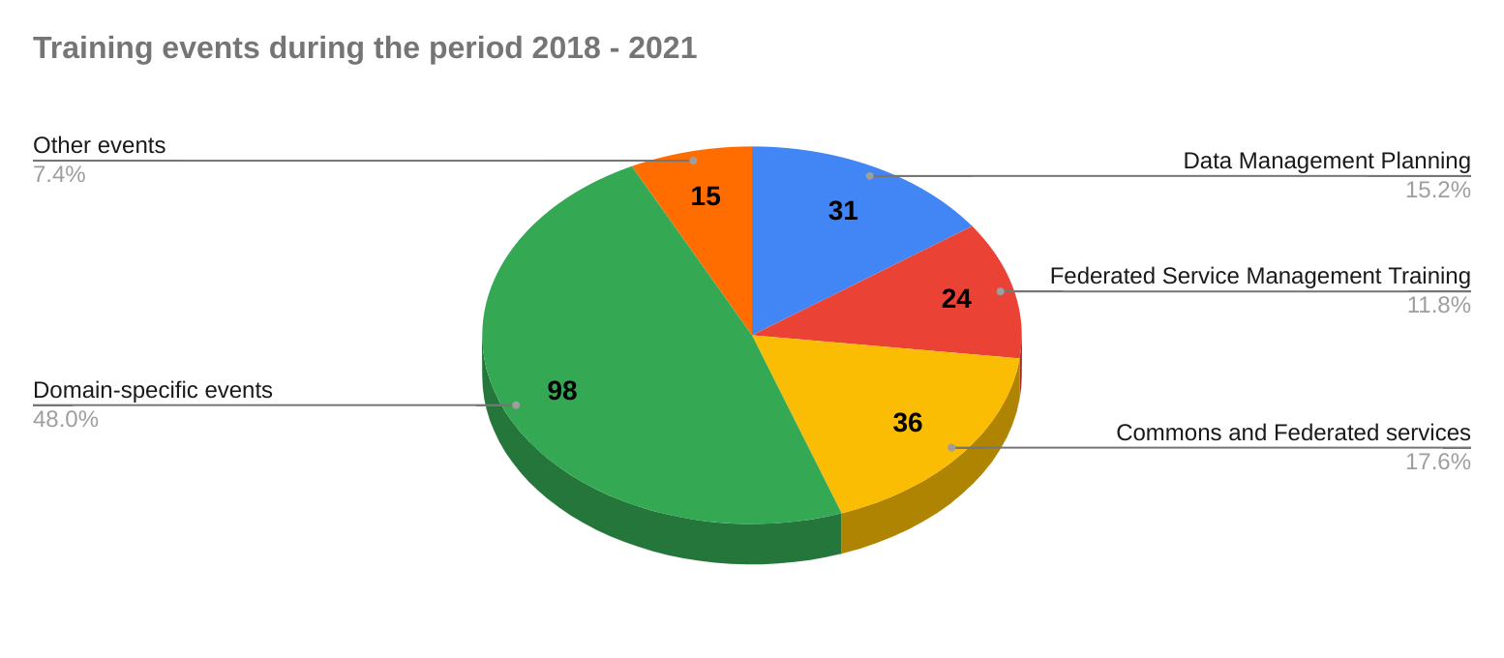Fig. 1: Training events organized by topic in EOSC-hub WP11

Towards the last period of the project, EOSC-hub organised a set of seven webinars to showcase some of the results of the project in a number of topics. (Fig. 2)
The webinars were promoted and broadcasted live and were later packaged to be consumed on-demand allowing busy prospective viewers from still registering and gaining access to the recordings and slides even after the live broadcast has passed.
As of 8 March 2021, at least 115 unique individuals from at least 70 organisations including academia/research, data center/providers, government/public administration, IT consultancies, library/publishers, non-profit organisations, and small & medium enterprises from 24 different countries consumed both the live and on-demand webinars. The webinars will continue to be available after the project’s conclusion.
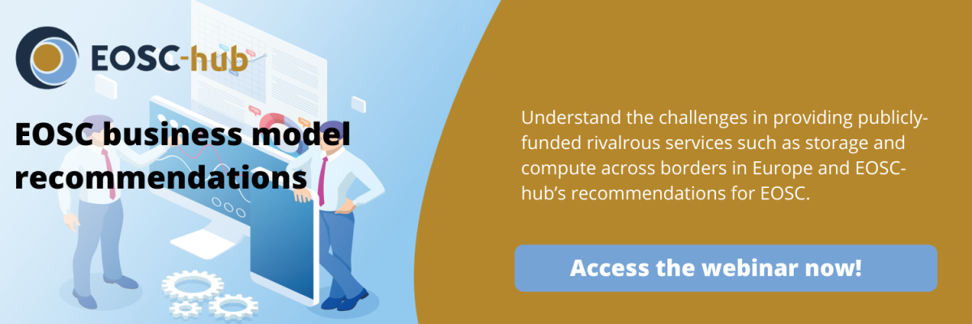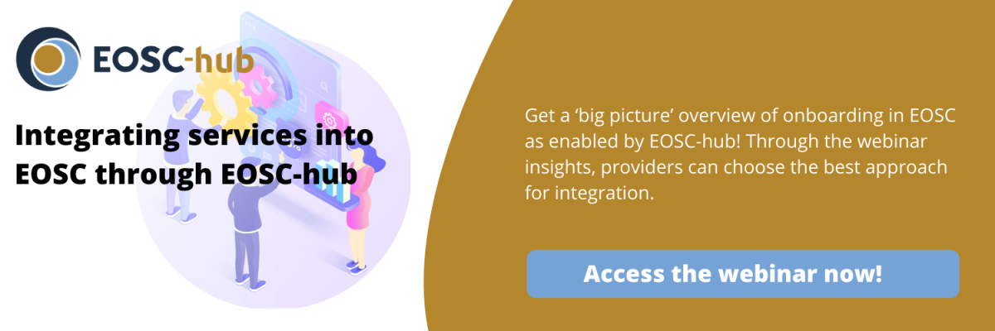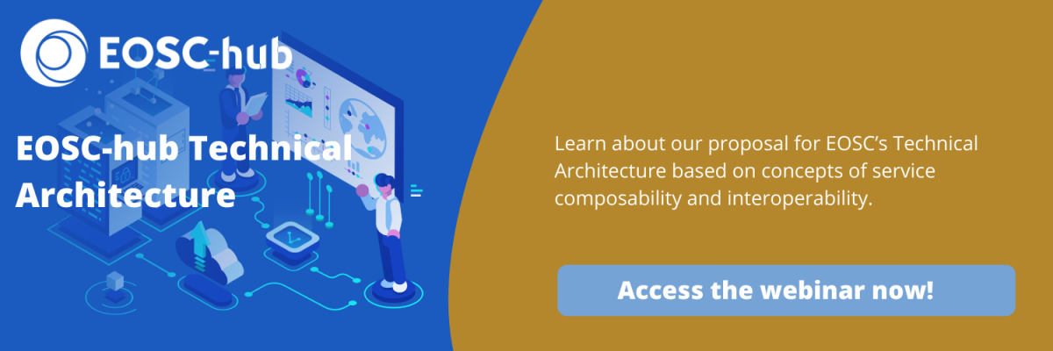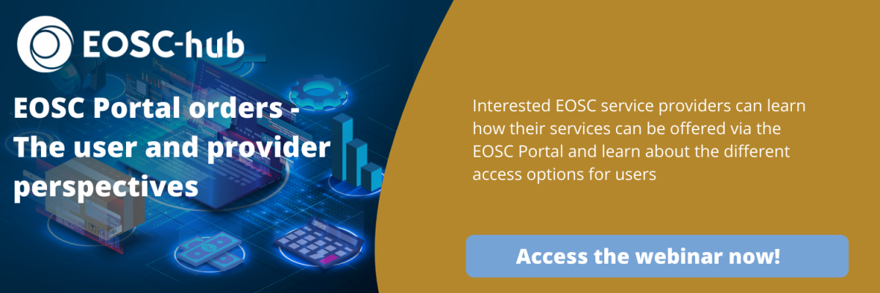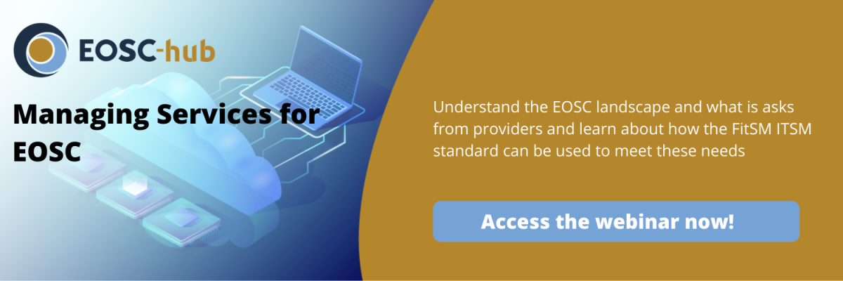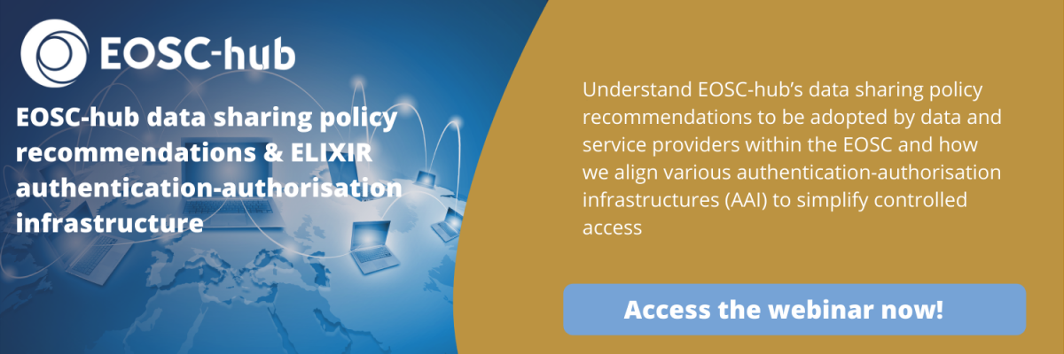
Fig. 2: EOSC-hub Final Webinar Series

EOSC Portal engagement
The most tangible output of the EOSC-hub project is the EOSC Portal (https://www.eosc-portal.eu/), together with all its components and teams that make it work for providers and users (the rules of participation, order handling tools and processes, helpdesk and user support teams, etc.). The EOSC Portal was opened in November 2018 and since that time EOSC-hub is the main operator and provides teams to onboard new providers and their services and to handle service access requests from users.
Other Marketplaces gradually came online in the second half of 2020, but connection/federation of these and the central EOSC Portal is still not yet available, so the EOSC Portal remained in the focus of the EOSC-hub Stakeholder engagement team.
Both provider onboarding and user order handling were performed by WP4 teams in EOSC-hub. The Stakeholder Engagement team periodically performed analysis of the onboarded providers and of the served users. The first analysis was done internally in February 2020, the second publicly in June 2020. The below section provides the third analysis based on data collected between November 2018 and the end of January 2021.

Visitor analysis
Our first analysis looks at the number of new visitors in the EOSC Portal (https://www.eosc-portal.eu/) and EOSC Marketplace (http://marketplace.eosc-portal.eu/). Figure 3 shows the monthly numbers with blue and red, respectively. The visits started with a rapid increase accountable to the excitement of opening.
After this the visits normalised at around 1,500 per month, with a slight increasing trend and with peaks around Oct 2019, May 2020, October 2020 when the major EOSC-hub events and EOSC Symposiums were organised.
The more significant increase (~33%) can be seen in December 2020 and January 2021, which is very probably thanks to the EOSC Portal introduction webinars that EOSC-Enhance organised.
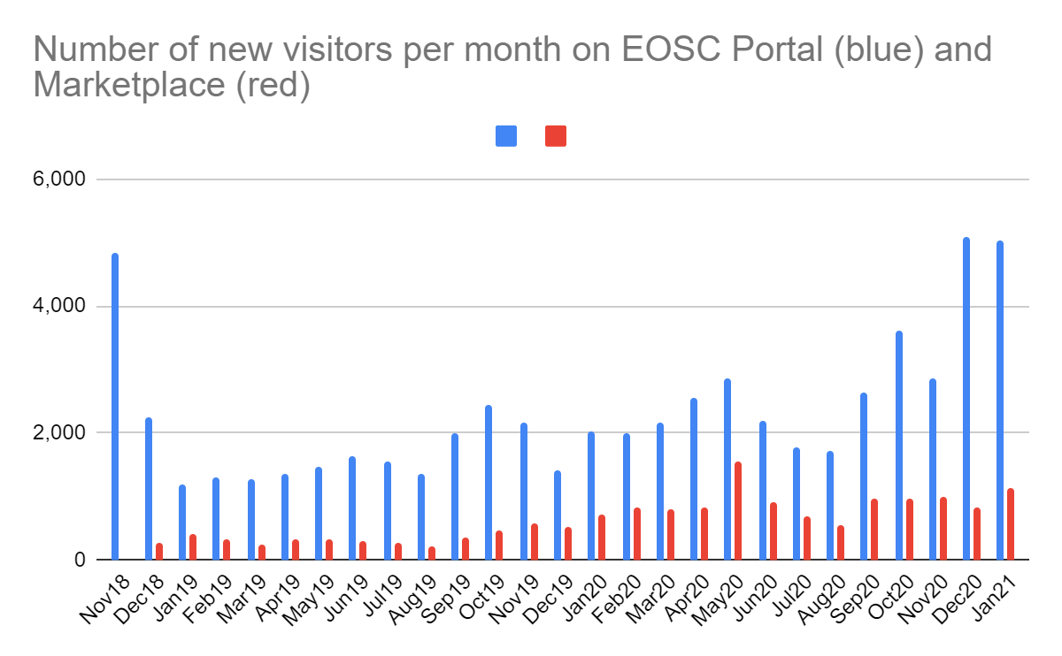
Fig. 3: Number of new visitors per month in the EOSC Portal (https://www.eosc-portal.eu/) - BLUE
and in the EOSC Marketplace (http://marketplace.eosc-portal.eu/) - RED

User analysis
By the time of writing 399 access orders have been served through the EOSC-hub Project in the EOSC Portal. These orders requested access to 415 services. Note that the majority of the cataloged services do not require ordering from the users and can be openly accessed. We do not have firm data about how many users these open access services really attracted.
Our first diagram (Fig. 1.) shows the received number of service orders per month. There is no particular trend in the number of orders, but an annual increase is visible. The relatively big increase between Jan-April 2020 is because of the Early Adopter Pilots that became active in those months and were requested to request services formally through the Marketplace. (See the explanation of the Early Adopter Pilots in Section 5.1 later.)

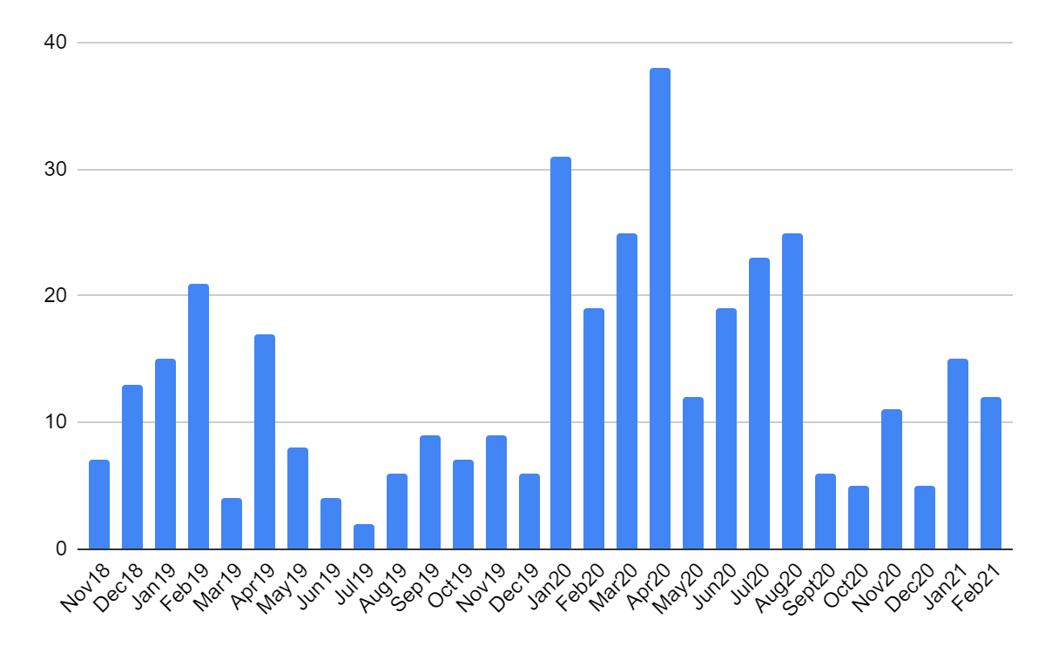
Fig. 4: Number of services requested for access per month in the EOSC Marketplace (total: 415)
331 out of the 399 access orders include ‘country’ information about the user. The spread of these users across countries are indicated in Figure 5. The numbers are roughly proportional to the size of the different countries. Bosnia-Herzegovina, Cyprus, Montenegro, FYR of Macedonia, Serbia and Turkey are European countries without any confirmed order yet. Bulgaria, Croatia and Romania did not have any orders until June 2020 (when the last similar analysis was done). Having them with orders now is a sign of the growing uptake of the EOSC Portal.

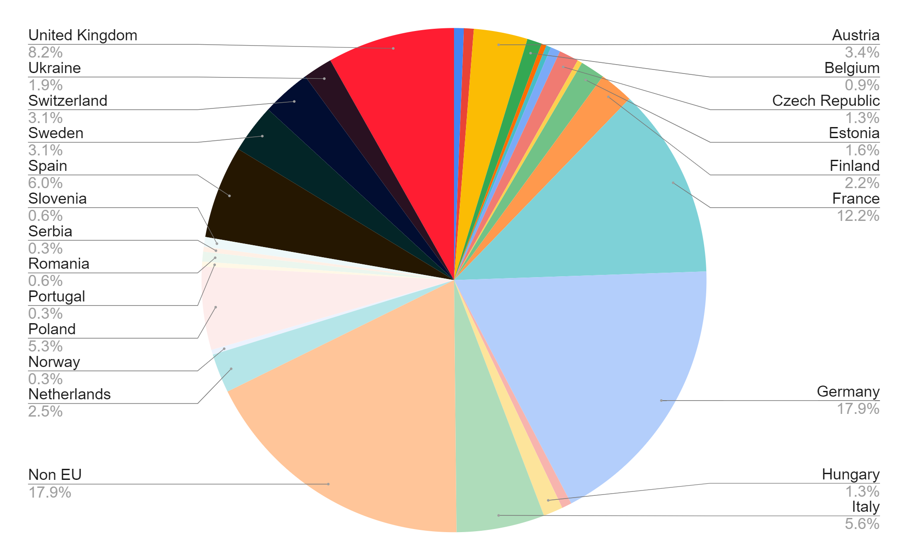
Fig. 5: Distribution of user who submitted orders through the EOSC Portal and whose ‘country’ field is complete (total: 331)
Out of the 399 orders, 277 include information about the user’s discipline. The disciplinary spread of these 277 orders is shown in Figure 6. As can be seen, Information/Computational sciences category leads (23%), followed by Engineering (14%). Biological/Life sciences, Earth sciences and Physical sciences follow each with ~10-13%. Humanities and social sciences are lagging behind with approx. 2% in total. The rest is spread across other disciplines, including Chemistry, Astrophysics, Mathematics, etc. Interdisciplinary research is mentioned in 6.6% of the orders.

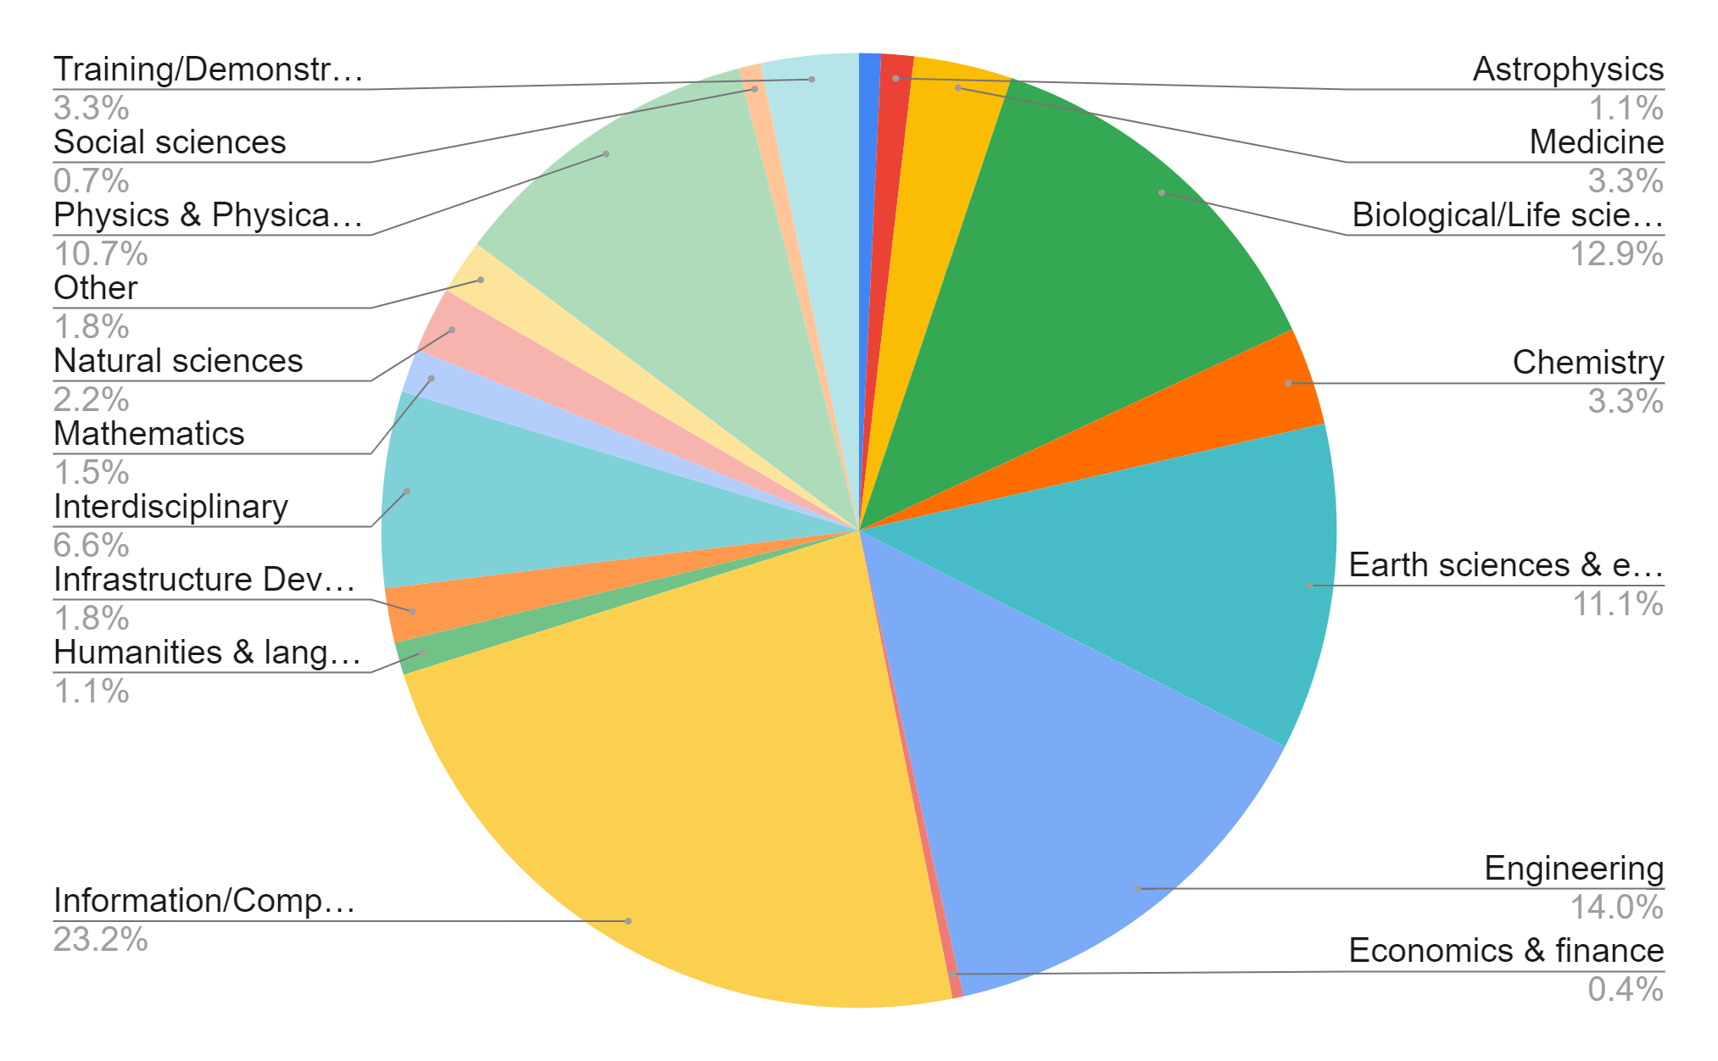
Fig. 6: Distribution of users who submitted orders through the EOSC Portal and whose ‘discipline’ field is complete (total: 277)

Provider analysis
The project onboarded 126 services from 82 providers through the Onboarding channel of the EOSC Portal. Our first analysis looks at the geographical footprint of providers, using the following categories (Fig. 7):
- Global: The provider organisation has members from Europe and elsewhere
- European: The provider has a dominant presence in Europe. (ESFRIs are typical examples.)
- Multi-national: The provider has presence in several European countries, but without a major goal to expand its footprint.
- National: The provider is present in one country.
The data confirms the focus of EOSC-hub (and EOSC) on international/multi-national communities, however there is a slightly growing share of national providers (their share grew from 35% to 39% since June).

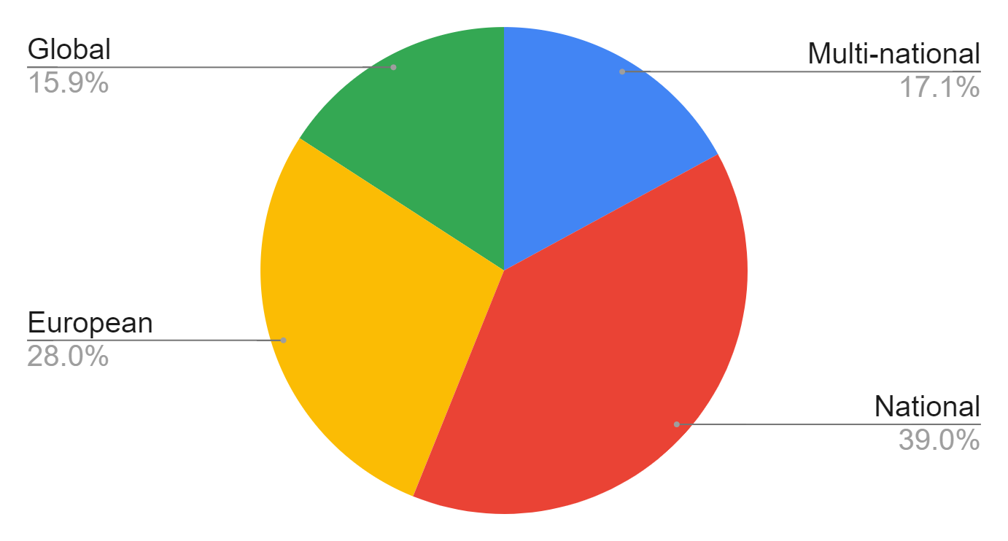
Fig. 7: Geographical footprint of the onboarded providers. (total 82)
Concerning the disciplinary distribution of providers (Fig 8) we can observe that:
- The ‘engineering and technology’ domain has a big share (42%): This is because generic services (such as HTC, cloud, data management) best fit into this category within the Frascati classification that we used, and because such generic services dominate in EOSC so far. Another reason is that several disciplinary providers, such as ESFRI clusters build/built their own portals/marketplaces that are not yet interoperable with the EOSC Portal, so the services catalogued there are not visible in the central EOSC Portal.
- Natural sciences dominate: This is due to the fact that the Frascati classification we used to pull physical, chemical, earth, biological sciences under this single top-level class. We zoom into this slice in Figure 9.
- ‘Medical and Health’ have ‘only’ 4.8%. This is because under the ‘Natural sciences’ there is also a ‘Biological sciences’ subdiscipline with additional entries, so these two should be considered together (See subdisciplines of Natural sciences in Fig. 9).
- Social sciences and humanities have 13.5% together.

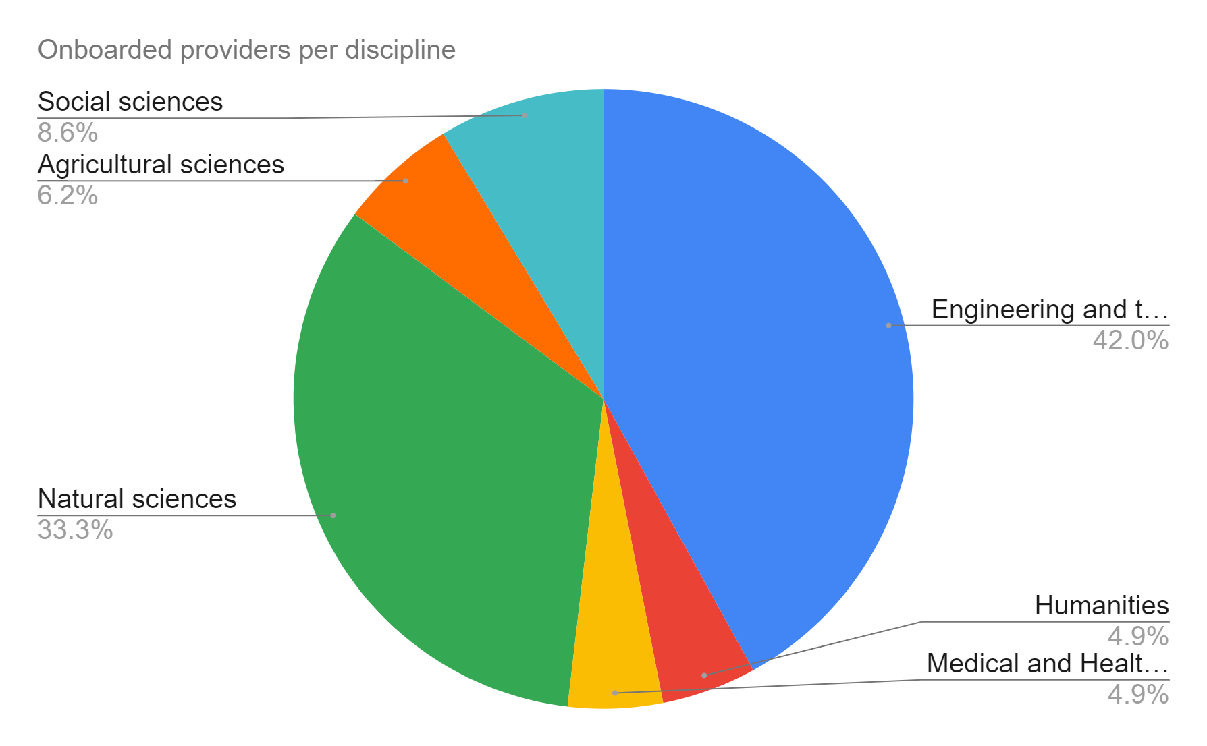
Fig. 8: Disciplinary distribution of onboarded providers (total 82).
Our next analysis (Fig. 9) goes into the break-down of the Natural sciences discipline. From this break-down we can observe:
- A big dominance of earth science providers (42%) is due to the fact that the Thematic Services and Competence Centres have a very high number of providers from this domain. Only a smaller segment joined later as service provider via the EOSC Portal.
- A significant presence of physics science communities (19.4%) is partly because of Physics providers in the consortium (e.g. in the Fusion Competence Centre) and partly because of the strong relationship of EGI with physics communities.
- ‘Biological sciences’ communities here together with the Medical and Health communities from Fig. 8 mean 13.5% of all the providers are from these domains.
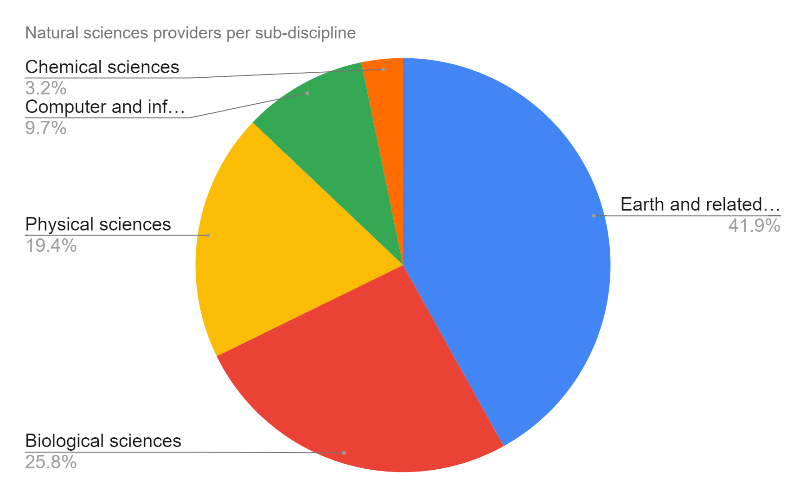
Fig. 9: Sub-disciplinary distribution of onboarded providers within Natural Sciences (total 33).

Research Infrastructure and project engagement

Thematic Services, Competence Centres and Early Adopters
The EOSC-hub consortium built upon national e-Infrastructures, data centers, research e-Infrastructures and European Intergovernmental Scientific Research Organizations (EIROs). The EGI partnership brings 22 national e-Infrastructures (NGIs), while the EUDAT CDI brings a network of nodes that provide a range of services for data lifecycle management.
The project stimulated engagement from the start via large research collaborations and research infrastructures via
- 9 Thematic Services (TSs) in WP7:
  - Linguistics (CLARIN), physical sciences (DODAS: Dynamic On Demand Analysis Service), climate change (ECAS: ENES Climate Analytics Service), environmental sciences (GEOSS: Global Earth Observation System of Systems and OPENCoastS: On-demand oPEratioNal Coastal circulation forecast Services and EO Pillar: a set of services related to Earth Observation (EO) domain), life sciences (WeNMR: Worldwide e-Infrastructure for NMR and structural biology), social sciences (DARIAH: Digital Research Infrastructure for the Arts and Humanities), biodiversity sciences (LifeWatch: a set of services related to Biodiversity and Ecosystem).
- 8 Competence Centres (CCs) in WP8:
  - life science (ELIXIR RI), physical sciences (Eurofusion and ITER), marine sciences (IFREMER), radio astronomy (LOFAR), seismology (EPOS and the EIDA data infrastructure), atmospheric/environmental sciences (ICOS and eLTER), disaster mitigation (DMCC+).
In 2019 WP8 was expanded with a new task, WP8.9, called Early Adopter Pilots (EaPs). The task was populated with 13 new scientific communities who requested services and assistance to integrate with the generic e-infrastructure services offered by EOSC-hub, OCRE, OpenAIRE and GÉANT. The 13 communities were selected through 2 open calls:
- Environmental sciences
  - Planetary sciences: Virtual European Solar and Planetary Access cloud
  - Ocean sciences: EMSO ERIC Data Management Platform
  - Human impact on life on Earth: STARS4ALL Light Pollution Analysis Platform for Citizens
  - Multi-disciplinary env. sciences: DevOps framework and virtual infrastructure for ENVRI-FAIR common FAIR data services
  - Biodiversity sciences: OpenBioMaps data management service for biological sciences and biodiversity conservation pilot
- Social sciences
  - Mapping the sensitivity of mitigation scenarios to societal choices
- Agriculture
  - Towards an e-infrastructure for plant phenotyping
  - AGINFRA+: Virtual Research Environments to Support Agriculture and Food Research Communities
  - Big Data Analytics for agricultural monitoring using Copernicus Sentinels and EU open data sets
- Life sciences
  - Supporting FAIR data discoverability in clinical research: providing a global metadata repository (MDR) of clinical study object
  - Integration of toxicology and risk assessment services into the EOSC marketplace
- Material sciences
  - Open AiiDA lab platform for cloud computing in Materials Science
- Multi-disciplinary
  - Towards a Global Federated Framework For Open Science Cloud
TSs and CCs were selected during proposal preparation time, while the EaPs during the project in 2019. For all of them a selection criterion was the link to international scientific communities, Research Infrastructures on the ESFRI roadmap, or to international projects funded in the Horizon-2020 programme. The project in this way could reach and engage with many ESFRI infrastructures that were ready and willing to engage with EOSC through EOSC-hub.
The achievements of the Thematic Services are reported in D7.5. The achievements of the Competence Centres are reported in D8.2. The achievements of the Early Adopter Pilots are reported in separate documents.

Other engagement activities
TSs, CCs, EaPs served as the main, but not the only engagement instrument to work with research infrastructures and large-scale European projects. Task 3.2 sought for additional opportunities from the start to engage with and establish collaboration with international communities that are interested/relevant to engage with EOSC. The work was challenging because EOSC significantly evolved during the lifetime of the project, and there was (still is) different vision within the main stakeholders about what EOSC is and should be. EOSC-hub, as a very practical service delivery entity therefore had to be presented and communicated to external entities in various ways during the past 3 years.
In 2019, before the COVID pandemic, the main instrument of engagement with new research infrastructures and projects was attending their events, establishing face-to-face connection and then following up with them remotely using the best EOSC channel (e.g. become user/provider in the EOSC Portal, Getting technical support for service integration). The T3.2 engagement team continuously monitored the landscape of events, and the disciplinary landscape of EOSC Portal usage (see the June 2020 analysis) and identified events where relevant stakeholders can be met.
The pandemic forced us to change this engagement practice in 2020. Face to face events stopped, and the number of events, where we could meet relevant stakeholders, was significantly reduced. We launched the EOSC-hub Webinar programme (see Section 3.3) to provide external stakeholders to engage with us, and sent invitations to ESFRI Clusters, EOSC projects and other stakeholders directly, and via the EOSC Liaison Platform. We also joined the EOSC Project Interest Groups (IGs) that have been launched by the EOSCsecretariat after November 2019. The IGs run with different intensity, and the outcomes and impact of them are unfortunately rather unclear to us.

Business engagement activities
The EOSC Digital Innovation Hub (EOSC DIH) was set up by WP9 and was being marketed as the mechanism for business organisations (e.g. start-ups, SMEs, large enterprises) to directly engage with the European Open Science Cloud. EOSC-hub WP9 defined specific service offers to facilitate establishing business partnerships and business pilots to increase exploitation potential of commercially viable research data and other existing e-Infrastructure services while providing both human and technical services to commercial organisations to increase digitization capabilities and move new products or services into the market. The final report of the DIH activities is presented in D9.4, below we provide an overview of the business pilots related achievements.
The long-term strategy of the DIH is to live beyond the life of the project and to be the featured mechanism for industry to engage with the European Open Science Cloud. Therefore, the DIH has been branded as the EOSC Digital Innovation Hub (instead of EOSC-hub Digital Innovation Hub) with all online and promotional material reflecting this: dedicated service offers; package of EOSC DIH logos; own url (eosc-dih.eu) and social media accounts (Twitter; LinkedIn); brochures; poster; reusable slide decks; video; entry to the EC DIH Catalogue, etc.
The initial demonstrators of the EOSC DIH were the 6 business pilots selected via an open call during the project preparation phase. The pilots represented different domains and had different technical requirements, while introducing added value services and clear exploitation and long-term business plans. Activities comprised:
- Enabling access to e-Infrastructure services by maximising the use of provided resources
- Providing first level support and monitoring progress
- Defining pre-commercial agreements and IPR
- Assessing and validating results
After these 6 initial pilots, an additional 12 business pilots ran experiments in the DIH, 5 of them selected from the DIH Open Call that was launched in Spring 2020. As the project did not have cascade funding available, selected pilots got a voucher for services to support their pilots.
With a total of 18 pilots ran, 16 of which successfully concluded by the project end, the EOSC DIH has provided companies with a technical environment to experiment with advanced computing, data services, the EOSC Portal to offer some of the services to the research community and direct consultancy and support. A wide range of expertise was requested in addition to infrastructure such as Machine Learning, Big Data, AAI, Security, AAI and some sector specific (Earth Observation, Agriculture).
In terms of the support models, we can differentiate them depending on the requirements and characteristic of the pilots:

- Resources needs: Computing/storage support
Example: DataFurn, Muon, BBC R&D: Video coding and compression
- Providing technological expertise
Example: Knowco4EOSC, IBISA, Erasmus Play
- Co-design using EOSC-hub services
Example: Cyberhab, DCP
- Support and co-development with another project
Example: BI Insight, BIGcoldTRUCK, DEIPDASFD
There were different levels/kinds of support provided in many cases (not only the infrastructure provided), such as datasets or specific topical expertise; several of which resulted from the 5 pilots selected during the open call. The main production services used in the pilots were related to the storage and cloud resources. In addition, several pilots performed integration with the AAI services, DEEP Learning services, data services.
Once the pilots finished their experiments, the EOSC DIH invited them to complete a survey to collect the feedback on the use of the services and assess the experience and impact of working with the EOSC DIH. The delivered infrastructure met the expectations of more than 90% respondents. Almost 60% of the respondents were able to reduce costs and optimize processes working with the EOSC DIH. More than 40% of the respondents fulfilled their expectations on testing new technologies and almost 70% fulfilled their expectations on opening new business opportunities. 4 pilots have applied for external open calls. At the end of the piloting phase, 3 of the engaged companies were able to commercialize their new products or services while for the others the main benefit was the improvement of their existing services in terms of new functionalities and scalability. DIH defined the pre-commercial Agreements with 3 of the pilots, outlining a Service Level Agreement (SLA) for continued support beyond the original pilot objective.
In order to showcase the results of the business pilots, in addition to presence at events, WP9 partners prepared 2 success story publications and transitioned technical meetings within pilots into community-wide meetings, further coalescing the community. Another way to further attract the industry community was to create and populate a dedicated section on the EOSC DIH website informing about open calls and additional funding opportunities.
Partnerships with other initiatives, projects, and regional DIHs were also sought as an additional means of both dissemination and achieving a multiplier effect such as the flagship DIH coordination project DIH.net, Deep-Hybrid-DataCloud for augmenting the EOSC DIH service offering with machine learning services, OpenAIRE for data services, EOSC-Synergy for regional connections, amongst others.
Sustainability measures have always been a consideration during the project lifetime, ensuring that what was created by the project partners would continue into the future. In addition to the branding and dedicated online presence, a formal Terms of Reference was drafted outlining how the DIH would continue to operate outside of any single project as a number of initiatives will continue to the short-to-medium term (i.e. EOSC Future, EUHubs4Data, EGI-ACE). As the DIH matures into the future with initial support from both projects and organisation in-kind contributions, further monetary business models will be explored.
The full report about ‘WP9 Joint Digital Innovation Hub’ is available in the D9.4 deliverable due at the same time as this document.

EOSC Working groups
The EOSC Working Groups have been an official part of the EOSC Governance structure to ensure a community-sourced approach to address the challenges of the EOSC. Six working groups have been setup and EOSC-hub were active in four of them:
- Architecture: Defining the technical framework required to enable and sustain an evolving EOSC federation of systems;
- Rules of participation: Designing the Rules of Participation that shall define the rights, obligations governing EOSC transactions between EOSC users, providers, and operators;
- Sustainability: Providing a set of recommendations concerning the implementation of an operational, scalable, and sustainable EOSC federation after 2020.
- Skills and Training: Providing a framework for a sustainable training infrastructure to support EOSC in all its phases and ensure its uptake;
The Working Groups have been supported by the EOSC Secretariat project in coordination and on providing advice on processes.
Participation in the Working Groups was on invitation only. The Working Groups adopted different approaches to invite members. While most of the Working Groups invited Member State representatives, the EOSC Architecture Work Group also invited representatives from EOSC related projects, including EOSC-hub. After an initial start-up of Rules of Participation Working Group, EOSC-hub was invited to participate in the Working Group meetings to liaise about current practices of onboarding resources into EOSC.

EOSC Architecture Working Group
The Architecture working group activities aimed to propose a technical framework to enable and sustain an evolving EOSC federation of systems, including standards, APIs and protocols that will facilitate interoperable services delivered by diverse providers.
To fulfil the EOSC vision, the interoperability layer
- has to be defined
- has to be agreed upon by relevant stakeholders
- has to be developed through an open and transparent process.
And it will be built on the results delivered by the EOSC-related Horizon 2020 projects.
In the start-up phase of the working group, possible topics were collected and prioritized. To organize the work within the working group, special task forces were established to work on the topics. After the first discussion, the topics AAI and PID have been prioritized for which task forces have been formed. The PID task force was a joint task force between the FAIR and Architecture working group. Also, a task force Scientific Infrastructures for Research Software was set up at a later stage. Members of the Architecture Working Group also participated in the EOSC Interoperability Framework task force set up by the FAIR Working Group. EOSC-hub participated in the AAI, PID and EOSC Interoperability Framework task forces and to EOSC Stakeholder Forum Events,.

Next to the work done within task forces, additional topics were addressed within the working group. These topics concerned the writing of the Strategic Research and Innovation Agenda and developing the Architecture working group view on the Minimum Viable EOSC (MVE).

EOSC AAI task force
The AAI task force (AAI TF) had the task to establish a common global ecosystem for identity and access control infrastructures for the European Open Science Cloud (EOSC). The EOSC is part of an international environment of research and education. Therefore the principles established by the EOSC AAI task force must be globally viable.

The task force consisted of members from the Architecture WG and external experts, including from EOSC-hub.

The EOSC AAI TF has produced the following set of deliverables:
- EOSC AAI First Principles & Requirements
- EOSC AAI Baseline Architecture
- EOSC AAI Federation participation guidelines
- EOSC AAI Best Practises

The deliverables are published as a single publication on the EC publication website.

Work of the AAI task force will be continued by the EOSC Federation Operator in collaboration with the AARC Engagement Group for Infrastructures (AEGIS) and the pertinent EOSC task forces addressing its authentication and authorization infrastructure.

EOSC Persistent Identifier task force
The initial focus of the PID task force was to establish a Persistent Identifier policy for the EOSC. This was a joint activity between the FAIR and Architecture working group and consisted of a subset of members of these working groups, as well as invited PID experts. After an initial draft and an open consultation process, the task force released the EOSC PID policy which has been published on the EC publication website.

After the initial focus of developing the EOSC PID policy, the PID task force continued the work with a focus on the PID technical architecture. The result of this activity is a high-level view of the components and stakeholders relevant inside an architecture for persistent identification based on namespaces. It is generic in the sense that the components are described independently of a concrete technical implementation. Finally, gaps and challenges have been identified in the existing PID landscape for future investigation and development. The gaps identified are in the areas of interoperability between PID systems, reverse lookup, scaling up, data type registries, kernel information types and Profiles, PIDs for services and sensitive data.

EOSC Interoperability Framework task force
The EOSC Interoperability Framework task force was a joint task force between the FAIR and Architecture working group and aimed to establish general principles to drive the creation of the EOSC Interoperability Framework (EOSC IF). After an initial draft and an open consultation process, the EOSC IF has been published on the EC publication website.

The EOSC IF provides an overview of the generic principles to be adopted within the EOSC IF, a conceptual data model based on FAIR Digital Objects and a proposal towards a Reference Architecture. The generic principles are organised into the four layers (i.e. technical, semantic, organisational and legal interoperability) as used in the European Interoperability Framework and the Reference Architecture model has been derived from the European Interoperability Reference Architecture (EIRA). The technical view of the EOSC IF has been modelled the Reference Architecture model developed within EOSC-hub (see D4.2) and on the components identified by the Architecture working group to be included in the MVE.

Architecture working group view on the Minimum Viable EOSC
In December 2019, the Sustainability WG (ESWG) released the Tinman report on Solutions for a Sustainable EOSC, which evolved into the FAIR Lady report published on the 24th of November 2020. The ESWG describes in the FAIR Lady document the first iteration of a Minimum Viable EOSC (MVE). In the same period as the release of the Tinman report, the EOSC-hub project published a draft community position paper describing the community’s view on the EOSC Federating Core and OpenAIRE released a position paper on OpenAIRE’s vision and contributions to EOSC.

To provide greater detail on the elements that require to be sustained, the EOSC Architecture Working Group developed its view on the MVE. It uses the terminology introduced by the ESWG, namely EOSC-Core, EOSC-Exchange and MVE and focuses on the period to the end of 2023, corresponding to the first phase of the EOSC as defined in the Strategic Research and Innovation Agenda (SRIA). EOSC-hub has been instrumental in the discussion to identify the elements and in developing the architecture diagrams.

EOSC Strategic Research and Innovation Agenda
The EOSC Governance Board has been developing the Strategic Research and Innovation Agenda (SRIA) to define the general framework for future strategic research, development and innovation activities to the European Open Science Cloud (EOSC). The SRIA has been developed from contributions from the different working groups. Contribution from the Architecture working group has been mostly to section 5 Implementation Challenges, in which EOSC-hub coordinated the contributions to User environments (section 5.5) and Resource provider environments (section 5.6). The SRIA framework will be developed and further defined in the context of the EOSC Partnership proposed under the Horizon Europe programme. At the time of this writing, the SRIA has not yet been published on the EC publication website, but a final draft version can be found on the EOSC website.

EOSC Rules of Participation Working Group
EOSC-hub was invited to contribute to the Rules of Participation Working Group as an implementer of core EOSC components and began its contribution by presenting the practical issues raised through a year of onboarding services to EOSC.

The main work of the Rules of Participation was a complex challenge, trying to not only consider what rules should be in place, but at what level the RoP needed to operate. This needed to accommodate any different views of EOSC, and balance maintaining quality with supporting an Open science approach and being inclusive.

The initial draft of the RoP was at a moderate level of detail and divided rules by entity or role, providing some global rules, rules of services, for data and for EOSC operators. This draft was put out to public comment by EOSCSecretariat and generated a large number of useful comments and inputs from the community.

The RoP were then refactored, and significantly simplified for the final outputs to a final Rules of Participation which reduced EOSC entry requirements to 8 rules:
- EOSC is based on the principle of openness
- EOSC resources align with FAIR principles
- EOSC services align with EOSC architecture & interoperability guidelines
- EOSC is based on principles of ethical behaviour and research integrity
- EOSC users are expected to contribute to EOSC
- EOSC users adhere to terms and conditions associated with the resources they use
- EOSC users reference the resources they use in their work
- Participation in EOSC is subject to applicable policies and legislation

These rules capture the most important points foreseen to ensure that EOSC operates as expected, but at the same time does not go to the level of detail required in order to actually deploy EOSC. This means that while a crucial high-level set of policies, the specific processes and procedures to deliver them also need to be defined, such that these barriers to entry can be fairly applied by requests to onboard providers and resources to EOSC. As a result, EOSC-hub has worked to derive and generate specific criteria for inclusion in EOSC Portal as part of the EOSC Provider documentation.
These criteria, evolved in light of the RoP, have been used to onboard resources to EOSC Portal and they to consult about onboarding rules with members of the EOSC community, including the INFRAEOSC 04 and 05b projects.

EOSC Sustainability Working Group
The project provided key and frequent inputs to the EOSC Sustainability Working Group on several occasions via the work performed by Task 2.3 “Governance and Sustainability” and Work Package 12 “Business Models and Procurement”. In particular:
- Provided access to mature drafts of key EOSC-hub deliverables for feedback:
  - D12.1: Procurement requirements and demand assessment
  - D12.2: Report on business model analysis for procuring services in the EOSC
  - Briefing Paper - Provision of Cross-Border Services
- Organised an open webinar on “EOSC business model recommendations”
- Replied to the various consultations that were organised by the group

The EOSC Sustainability Working Group recognised that the EOSC-hub contributions were valuable, and the various outputs were referenced in their final work “Solutions for a sustainable EOSC”.

Skills and Training Working Group
The project participated in the EOSC Skills and Training WG to identify a framework for building competence and capabilities in EOSC. This WG focused on four priority areas:
- Developing the next generation of FAIR and open science professionals.
- Collaborating to enhance digital skills for FAIR and open science in Europe.
- Building a trusted and long-lasting federated catalogue of training materials and related tools.
- Influencing national open science policy for skills by supporting strategic leaders.

EOSC-hub contributed to the identification of obstacles that limit the exploitation of research output internationally, and to the definition of countermeasures that can be adopted to reduce these limitations. More specifically, the gap analysis has highlighted the lack of experts that can facilitate the promotion of FAIR and Open Science principles. Key profiles such as: Data scientists, data stewards, data curators and research software engineers are needed for the development of data-driven, data intensive science. Another barrier identified by the WG is the fragmentation of training resources. There is a wide plethora of contents developed by different scientific communities, but it is missing the good practise to reuse existing data and keep them up-to-date. The final report from the EOSC Executive Board Skills and Training Working Group along with the key recommendations coming out from the EOSC Training and Skills Working Group activities are published online.

Conclusions
The project, under the coordination of T3.2, performed a mix of activities to engage with all relevant groups of stakeholders on the EOSC landscape: H2020 projects, ESFRIs, research institutes, companies, EOSC WGs and IGs, international scientific communities.
The portfolio of activities that made this possible included organisation and attendance of events, visitor/user/provider management in the EOSC Portal, call for service adopters, inclusion of Research Infrastructures and scientific communities in the consortium, running the DIH, participation in EOSC liaison activities (WGs, IGs), Webinar programme, generic communication. A very similar list of activities is planned in the EOSC-Future project, promising a successful continuation of stakeholder engagement within that next flagship EOSC initiative (start to be confirmed).
EOSC-hub had to operate in strong turbulences on the EOSC landscape: the initial version of the central Hub was implemented by the project in 2018, with the EOSC Portal and Marketplace in collaboration with partner projects. The Hub concept was broadly promoted by but the project and the EC, even mentioning it in H2020 calls as the way to integrate with EOSC.
During 2019 additional marketplaces came online from other EOSC projects. EOSC Interest Groups and Working Groups have been setup to align EOSC activities, to initiate broader consultations. The overall EOSC landscape moved back a bit from service delivery to consultation, planning and co-design. EOSC-hub participated in these activities showing flexibility and resilience towards the landscape changes and transferring the experiences into WGs as appropriate.
The COVID lockdown hardened the engagement work during the last year of the project. While webinars could replace stakeholder interaction to a certain level, they did not provide us as many opportunities to meet new institutes/projects/communities to really broaden the reach of EOSC.
Concerning commercial engagement several lessons learned and recommendations have been identified for both the future of the EOSC DIH as well as for the wider ecosystem. This includes the challenge of identifying and involving the wider services and expertise from EOSC members not formally part of the DIH for ensuring support to pilots, and the human resource requirements needed to support diverse SMEs. EOSC governance bodies have a broad range of topics that must be considered in ensuring inclusion and recognition in high-level strategic documents proved more difficult than expected.
Despite all these challenges the project managed to expand the use of the EOSC Portal from approximately 1200 visitors/month to an average of 4000 visitors/month. On the EOSC Marketplace the monthly average visitor number grew from 250/month to 1000/month (Fig. 3). The only place where we did not see significant increase was the orders (service access requests) within the Marketplace (Fig. 4). 399 access orders out of 1.7 million researchers across Europe is an indication that researchers are either unaware of the existence of EOSC, and/or the EOSC Portal and its content are not attractive enough for them. More effort has to be put in assessing the existing content in the EOSC Portal, ensuring that the Portal GUI and features are attractive for the target audiences and then advertising the portal most broadly and strongly to researchers at universities and at research performing organisations.
The introduction of KERs (Key Exploitable Results) was found useful to line up the consortium behind a manageable number of achievements in this large project and helped us focus the project communication with coherent messages and concepts.

While the sharing of software and data was also anticipated in the original workplan, the EOSC Portal is still only a catalogue of services, although some of which act as catalogue/storage services for data and software. However EOSC does not provide any overarching search facility to find data and software within those storages/catalogues.
https://eosc-hub.eu/eosc-hub-key-exploitable-results
D3.1 Communications and Stakeholder Engagement Plan: https://documents.egi.eu/document/3301
EOSC-hub Magazines: https://eosc-hub.eu/publications?field_publications_type_tid%5B%5D=145
EOSC-hub publications: https://eosc-hub.eu/publications
https://eosc-hub.eu/eosc-early-adopter-programme
https://eosc-dih.eu/pilots/
https://www.eoscsecretariat.eu/researcher-engagement-and-use-cases
https://doi.org/10.1016/j.patter.2020.100058
EOSC-hub D11.5: https://documents.egi.eu/document/3637
https://eosc-portal.eu/for-providers
http://marketplace.eosc-portal.eu/
Internal document: M3.8 Final Evaluation of EOSC-hub Community and perspective
Evaluation of the EOSC-hub community (June 2020): https://zenodo.org/record/3979112
EOSC-Enhance webinars: https://eosc-portal.eu/events/eosc-enhance-webinar-eosc-portal-release-1-new-provider-functionalities-tutorial, https://eosc-portal.eu/events/eosc-enhance-webinar-eosc-portal-new-release-new-user-functionalities-and-tutorial, https://eosc-portal.eu/events/eosc-enhance-webinar-eosc-portal-new-release-tutorial-existing-providers
The June 2020 analysis included analysis at a per-country level, pointing out countries that submitted less orders than their population size would justify. Because of the small number of orders such statistical analysis is rather unreliable, so we ignore that in this final report.
http://unstats.un.org/unsd/EconStatKB/Attachment332.aspx?AttachmentType=1
https://eosc-hub.eu/eosc-early-adopter-programme-2nd-call
D7.5 Final report on Thematic service architecture, software integration and exploitation: https://documents.egi.eu/document/3641
D8.2 Final report on Competence Centre key results and exploitation status and plans: https://documents.egi.eu/document/3631
EOSC-hub Early Adopter Pilots - Final reports: https://documents.egi.eu/document/3706
EOSC Interest Groups: https://www.eoscsecretariat.eu/communities/eosc-interest-groups
D9.4 Joint Digital Innovation Hub Final Results and Sustainability Plan: https://documents.egi.eu/document/3630
EOSC DIH pilots: https://eosc-dih.eu/pilots/
The two additional WG where EOSC-hub did not participate were: (1) Landscape: Mapping of the existing research infrastructures which are candidates to be part of the EOSC federation (2) FAIR: Implementing the FAIR data principles by defining the corresponding requirements for the development of EOSC services, to foster cross-disciplinary interoperability
https://www.eoscsecretariat.eu/
https://www.eoscsecretariat.eu/eosc-symposium2019/service-onboarding
https://www.eoscsecretariat.eu/eosc-symposium2019/impact-fair-technical-architecture
https://op.europa.eu/en/publication-detail/-/publication/d1bc3702-61e5-11eb-aeb5-01aa75ed71a1
https://aarc-project.eu/about/aegis/
https://op.europa.eu/en/publication-detail/-/publication/35c5ca10-1417-11eb-b57e-01aa75ed71a1
https://op.europa.eu/en/publication-detail/-/publication/3136c3e6-4f07-11eb-b59f-01aa75ed71a1
https://op.europa.eu/en/publication-detail/-/publication/d787ea54-6a87-11eb-aeb5-01aa75ed71a1
https://ec.europa.eu/isa2/eif_en
https://joinup.ec.europa.eu/collection/european-interoperability-reference-architecture-eira/solution/eira
https://documents.egi.eu/document/3422
https://eosc-hub.eu/sites/default/files/EOSC%20Federating%20Core%20Community%20Position%20Paper%20v1.1.pdf
https://doi.org/10.5281/zenodo.3475076
https://www.eosc.eu/eosc-sria-v10-15-february-2021
https://www.eoscsecretariat.eu/working-groups/rules-participation-working-group/eosc-rop-outputs
https://op.europa.eu/en/publication-detail/-/publication/a96d6233-554e-11eb-b59f-01aa75ed71a1/language-en/format-PDF/source-184432576
https://eosc-portal.eu/providers-documentation/eosc-provider-portal-inclusion-criteria
https://eosc-portal.eu/providers-documentation
https://op.europa.eu/s/oTpA
https://doi.org/10.2777/59065

