D2.7 Final Service roadmap, service portfolio and service catalogue
Lead Partner: | EGI Foundation
Version: | 1
Status: | FINAL
Dissemination Level: | Public
Document Link: | https://documents.egi.eu/document/3639

Deliverable Abstract
This deliverable sets out the current status of the EOSC-hub service portfolios, both the internal one (to be contributed to EOSC-Core) and the external, researcher facing one (Which will form part of EOSC-Exchange). To do this it highlights the changes in the EOSC landscape in the last year, as the community moves toward a more cohesive and coordinated structure, and shows the contributions of EOSC-hub to the Core, Exchange and Governance of EOSC. In this way it provides a solid overview of what EOSC-hub will leave behind at its conclusion, which can be adopted or adapted to support the next phase of EOSC construction, in the proposed EOSC-Future project.

COPYRIGHT NOTICE
This work by Parties of the EOSC-hub Consortium is licensed under a Creative Commons Attribution 4.0 International License (http://creativecommons.org/licenses/by/4.0/). The EOSC-hub project is co-funded by the European Union Horizon 2020 programme under grant number 777536.
DELIVERY SLIP
Date | Name | Partner/Activity | Date
From: | Owen Appleton | EGI Foundation / WP2 T2.2 | 9/12/2020
Moderated by: | Malgorzata Krakowian | EGI Foundation/WP1
Reviewed by: | M Plociennik (PSNC), S De Wit (UKAEA). | PMB | 11/12/2020
Approved by: | AMB

DOCUMENT LOG
Issue | Date | Comment | Author
v.0.1 | 2/12/2020 | Initial version in word format (previous assembly in Google Docs) | O Appleton, M van de Sanden,, D Robertson, M Williams, P Weber, D Scardaci
v1 | 9/12/2020 | Answering reviewer comments | O. Appleton

TERMINOLOGY
https://wiki.eosc-hub.eu/display/EOSC/EOSC-hub+Glossary
Terminology/Acronym | Definition
EOSC Association AISBL | A newly formed associatio0n under Belgian law intended to provide a long term vehicle for EOSC coordination.
EOSC Future | A project proposed under the INFRAEOSC-03 call and currently in negotiation with the EC. Will deliver the functionalities of EOSC-Core, support EOSC-Exchange and integrate the thematic cluster communities from INFRAEOSC-04

Contents
1 Introduction 5
2 ​The EOSC landscape in late 2020 6
2.1 ​Changes in terminology and approach 6
2.2 ​Current projects 7
2.3 ​The Strategic Research and Innovation Agenda and Multiannual Roadmaps 11
2.4 EOSC Future 12
3 ​Contribution to EOSC-Core 13
3.1 ​The functional needs for an EOSC-Core and the FAIRLady functionalities 13
3.2 ​The proposed architecture from the EOSC Architecture Working Group 14
3.3 ​Hub portfolio services 16
3.4 ​Mapping the Hub Portfolio services to the EOSC-Core functionalities 20
4 ​Contributions to the EOSC-Exchange 26
4.1 ​Services arising and lessons learnt from EOSC-hub onboarding 26
4.2 ​Overview of resources onboarded to the shared portal registry 28
5 ​Contributions to the governance of EOSC and handover to later projects 31
5.1 ​Definition of the EOSC-Core 31
5.2 ​Rules of Participation and inclusion criteria for EOSC-Exchange 31
5.3 ​Handover to EOSC Future and later projects 32
Appendix I. Full list of services onboarded by EOSC-Hub prior to registry merger 33
Appendix II. ​Timelines of current EOSC related projects 39
Appendix III. ​Current EOSC-Exchange inclusion criteria 40

Executive summary
EOSC-hub offers two broad sets of services: those fundamentally internal to EOSC - the housekeeping services that makes things run, and the external services that researchers use to support their work. While in the past these were referred to with a variety of terms, we now map them to the view coming from the EOSC Sustainability Working Group. Under this description these are EOSC-Core and EOSC-Exchange.
EOSC-hub contributes to both of these. For EOSC Core, EOSC-hub offers a large number of services which can be used for the initial EOSC Core technical platform, as they supported the beta version of EOSC that EOSC-hub produced. For EOSC Exchange, EOSC-hub has worked both within the project and with other projects in the EOSC Portal Collaboration to onboard more than 270 services from the EOSC community into a service registry exposed through the EOSC Portal web site.
In the period since the previous deliverable on this topic, D2.6, EOSC-hub has reoriented work in this area to match the community consensus expressed through the EOSC Working Groups, merged registries of resources and onboarding procedures with EOSC Enhance and OpenAIRE Advance, and contributed to broad discussion of how to integrate and support multiple community portals. The greater community consensus on how EOSC will be structured has made it easier to identify the outputs of EOSC-hub and show how they address community needs.
This document has four main sections. First it outlines the changes in the EOSC landscape since the last deliverable. Next, it shows the contributions of EOSC-hub to EOSC-Core, then the contributions to EOSC-Exchange. Finally it outlines the many contributions the project has made to EOSC Governance in the last year. Together, these sections show the outputs of EOSC-hub around services and other resources, and highlight how they map to wider structures in the EOSC landscape, and can be taken up in subsequent projects.

Introduction
This document, coming at the end of the EOSC-hub project, is the final output summarising work on the service catalogue and roadmap. It is the update to D2.6 First Service roadmap, service portfolio and service catalogue. At the time of D2.6’s publication, the landscape in which it sat was very much in flux, with many groups making strong efforts which were not always highly coordinated. Since then the situation has significantly improved. EOSC Governance, through the EOSC Working Groups, has clarified many elements of the EOSC ecosystem. The EOSC Sustainability Working Group through its ‘Tinman’ and now FAIR lady’ reports have clarified both a set of capabilities for an initial EOSC ( a so-called Minimum Viable EOSC) and also a set of technical services or components needed to support them. The launch of the thematic and regional cluster projects through INFRAEOSC 4 and 5b have expanded the community to target closer to the researchers, EOSC Enhance is improving EOSC Portal, the EOSC Association AISBL has launched as a framework for the long-term governance and sustainability, and the EOSC Future project is in negotiation to continue the next phase of the work begun in EOSC-hub.
This new situation has clarified many of the questions raised in D2.6, hence D2.7 is a more straightforward and practical document than its predecessor. We can now, rather than imagining a notional Federating Core for EOSC created by EOSC-hub alone, discuss the contribution of EOSC-hub to the concepts of the EOSC-Core and EOSC-Exchange proposed by the EOSC Sustainability Working Group.
This document will describe this new landscape and then focus on the contributions to EOSC-Core, EOSC-Exchange and the new governance of EOSC arising from EOSC-hub and the service catalogue and portfolio. Finally, it will provide a mapping of EOSC-hub services and other outputs and how they relate to the inputs for EOSC Enhance and the planned EOSC Future project.

​The EOSC landscape in late 2020
​Through the hard work of many community members across EOSC-hub and many other projects, as well as EOSC Governance (the EOSC Governing Board, Executive Board, Working Groups and other bodies), there has been a great deal of progress in 2020, despite the immense disruptions of COVID19 and resulting delays to many activities. Through this process, and through the greater lateral connections between stakeholders formed, a larger and clearer consensus has formed, which is very positive for the impact and sustainability of the results of EOSC-hub. Before, there was a difficult balance implied in EOSC-hub outputs, which included many core elements but could not be automatically assumed to be the final form of EOSC Core, and while not presuming to enforce a specific vision on EOSC on the wider community. Now that the community has coalesced to a greater extent, it is a matter of fitting EOSC-hub outputs into the new framework, in a clearer way.

​Changes in terminology and approach
As part of the newly emerging community concepts and growing consensus, we see some key changes in terminology which are worth explaining here. Two main areas are important: the contents of EOSC catalogues and the two (main) domains of EOSC in preparation.

​EOSC Resources
The process of uniting different actors in EOSC which focus on processing, on storage and research results, on publications, software and other entities has implied the need for terminology to describe all these elements in a coherent way. Existing communities which came together to form EOSC typically focussed on one area: Services, Data, Publications, Software etc. Each had their own approach, and this lead to the suggestion to replicate all policies, rules, procedures and tools to support each area in parallel, but this implies a significant increase in complexity for EOSC, and inhibits the cross-community added value and network effects which EOSC needs to show its value and relevance. Moreover, as borders between entities are somewhat fluid, it leads to conflict or duplication of effort. As an example, at what point does a web-accessible dataset stop being data and, through added-value tools attached to it, annotation and other features, become a service?
To address this, we have settled on the concept of EOSC resources as any value-generating entity which contributes to EOSC, whether it might be seen as a service, as data, a repository, a journal paper, other publication, software or document may fall in this general category to the extent they can be, they will be treated the same, with the same data collected about them and the same rules applying to them. Differentiation will only occur as necessary for properties specific to one type of element.
This also simplifies the creation of a coherent ecosystem for resource catalogues, as EOSC Portal and other community catalogues can display multiple resource types side by side, allowing for filtering, but allowing, for instance, a researcher seeking a service on a specific topic to be offered relevant datasets, publications and software related to it. This resource-driven approach also simplifies rules of participation and validation for providers and resources in EOSC. At present, due to the service-focus of EOSC-hub, services are certainly the resource type for which most work is done, but work in the final phase of EOSC-hub, as well as in EOSC Enhance and other projects, seeks to expand this more fully to other resource types.

​EOSC-Core and EOSC-Exchange
D2.6 considered how EOSC-Hub contributed to a Federating Core for EOSC - an important concept but one not perfectly defined nor shared by the wider EOSC community, but one which drove discussion of what elements were needed to support a mature EOSC, and which fed into later concepts. Since then, there has been a move to a consensus approach to describing the key conceptual domain of EOSC, building on the work of the EOSC Sustainability Working Group in their Strawman, Tinman and FAIR Lady reports. They describe the Minimum Viable EOSC as containing the elements in the figure 1.
In this schema, the internal (i.e. backend, non-researcher-facing) elements of the EOSC ecosystem are held within EOSC-Core, including internal services. These are analogous to the EOSC-hub Hub Portfolio or an element of the Federating Core (which comprised the Hub portfolio, Compliance Framework and Shared resources).
This is then accompanied by a Federated Data Layer, and by EOSC-Exchange, which is the collection of researcher-facing resources (services, data etc) which are accessible through EOSC and which directly improve European research. Essentially this means that EOSC-Exchange is the EOSC Marketplace along with the services and other resources accessible through it.
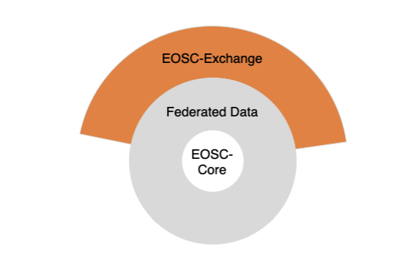
Fig 1: Schematic representation of key elements of the Minimum Viable EOSC, from the EOSC Sustainability Working Group draft FAIR lady report on solutions for a sustainable EOSC.

​Current projects
EOSC is being constructed by a wealth of projects, who converge their outputs into the new iteration of EOSC planned for 2021 and beyond through the EOSC Association, EOSC Future and other efforts. This new iteration is based on the model of a Core and Exchange, and the existence of a legal entity in the EOSC Association. The projects building this vision occur in a number of different strands, which are leading into the future EOSC.
First are the projects which directly construct the core elements of EOSC. These began with EOSCpilot and continued into EOSC-Hub, however other projects exist in this space, including the OpenAIRE project series and eInfraCentral. The GEANT GN project series includes some activities which contribute to EOSC (such as AAI) although the GN projects are broader in scope and objectives than just EOSC. These projects tend to focus on activities which could contribute to EOSC-Core or Exchange, or on mobilising a broad range of actors to contribute to EOSC. In some cases, such as with the OpenAIRE community, they provide horizontal services which may go beyond a strict Core of EOSC but would provide broad benefit and value add over existing infrastructures. This also includes specialist projects like EOSC Enhance which target improvement of the Portal itself.
A second strand include the community cohesion and development projects, including the INFRAEOSC 04 ‘thematic cluster’ projects (which build on ESFRI communities), the INFRAEOSC 5b 'regional cluster’ projects (which build on national initiatives) and numerous other community specific digital research projects from calls that may not be EOSC-specific but are part of the larger EOSC ecosystem. These include calls for new ESFRI communities such as OPERAS-P or projects working on specific topics such as FREYA on PIDs. These projects tend to focus on one community or topic, and bring together new resources supporting that community. They may also create internal services (mini- or community-centric Cores in general) but their greater impact is mobilising and uniting a community to play an active role in EOSC and bringing their services to the EOSC-Exchange.
The third strand are new projects which will be funded under INFRAEOSC 07 which are intended to add resources or capabilities of different types to EOSC. These are intended to ‘increase the service offer of the Portal’, i.e. increase the resources in the EOSC-Exchange. They address distributed computing, data services, scholarly and open access, data spaces and various other services and other resources of broad horizontal interest which enrich the EOSC value proposition.
The table below gives an initial indication of the types of contribution from each project or project type.
Table 1: Project high level contributions to EOSC Elements
Project | Contribution to EOSC-Core | Contribution to EOSC-Exchange
EOSC-Hub | Internal services (from the Hub portfolio) delivering a set of capabilities which support the internal operation of EOSC functions. Cover the majority of the functions expected in the FAIR Lady report to some extent. | Researcher facing services developed through Competence centres and developed Thematic Services. Horizontal (generic) services from e-Infrastructure partners in the project. Services onboarded through EOSC-hub T2.2.
EOSC Enhance | Demand side portal (‘Marketplace’) and supply side portal (‘Provider Portal’). Underlying registry of resources, Provider & Resource profiles (3.0) | Service onboarded from wider community through EOSC onboarding collaboration with EOSC-hub and OpenAIRE. Later, research products to be onboarded.
OpenAIRE Advance | Open Science frameworks required as part of EOSC-Core. | OpenAIRE services onboarded to EOSC-Exchange, largely horizontal added value services around open science, scholarship and research impact.
Thematic clusters (INFRAEOSC 04) | Requirements and feedback for EOSC-Core resources, testing integration of EOSC-Core and community internal services. | Services and other resources (data, publicatsuions, software etc) from thematic communities, either onboarded directly or through connecting thematic community portals and catalogues. General services developed within the clusters that can be generalised to EOSC horizontal added value services.
Regional clusters (INFRAEOSC 05b) | Requirements and feedback for EOSC-Core resources, testing integration of EOSC-Core and community internal services. | Services and other resources (data, publicatsuions, software etc) from regional communities, either onboarded directly or through connecting regional community portals and catalogues. General services developed within the regional or national communities that can be generalised to EOSC horizontal added value services.
New or emerging community projects (e.g. new ESFRIs) | Testing EOSC Core services or adopting them in place of developing their own internal services./ | Community services and other resources that can be onboarded to EOSC Exchange.
INFRAEOSC 07 projects (Invited to Grant Agreement) | Integrating with EOSC Core (required as part of collaboration, and likely required to support accounting for Virtual Access repayment of 07 projects. | Services and other resources related to activity types in 07 projects, which each cover a different horizontal areas, such as compute platform, data infrastructure services, open science servicers etc.. Onboarded to Exchange as horizontal services. Integrated with other horizontal services where possible.
EOSC Future (in negotiation, submitted to INFRAEOSC-03 call) | Refined and evolved set of services and other resources to meet core capabilities, built on top of EOSC-hub and other contributions. | Resources onboarded through EOSC Future onboarding, from partners, from large scale projects with thematic clusters (Test Science Projects) and from wider community.

In this context, the contribution of EOSC-hub is largely in the area of EOSC Core (and more detail on this is provided in alter sections). While it has worked to create, support and integrate thematic services in the Exchange, it is one of several groups doing so, while it is one of a much smaller list of contributors to the basic EOSC-Core services needed to keep EOSC operating​Working groups, EOSC Governance and the EOSC association
The current (Phase I) Governance of EOSC, until the end of 2020, as mandated by the EC in collaboration with the member states, is as follows:
- The EOSC Governance Board is made up of representatives of the Member States and Associated Countries, and provides strategic orientation and oversight of EOSC, and nominates the Executive Board
- The EOSC Executive Board is a group of experts that creates a strategic implementation plan for EOSC operated by the expert Working Groups.
- EOSC Working Groups are chaired by Executive Board members and mobilise experts from the community on specific topics to ensure community input is taken on board in the construction of EOSC.
The EOSC working groups are as follows:
- Landscape: Mapping of the existing research infrastructures which are candidates to be part of the EOSC federation;
- FAIR: Implementing the FAIR data principles by defining the corresponding requirements for the development of EOSC services, in order to foster cross-disciplinary interoperability;
- Architecture: Defining the technical framework required to enable and sustain an evolving EOSC federation of systems;
- Rules of participation: Designing the Rules of Participation that shall define the rights and obligations governing EOSC transactions between EOSC users, providers and operators;
- Skills and Training: Providing a framework for a sustainable training infrastructure to support EOSC in all its phases and ensure its uptake;
- Sustainability: Providing a set of recommendations concerning the implementation of an operational, scalable and sustainable EOSC federation after 2020.
During 2019 and 2020 the outputs of the working groups operated to take input from existing efforts like EOSC-hub and evolve them to broader consensus approaches which then helped shape later work within EOSC-hub on Services and other resources. In particular, in the following ways:
- The Working Group on Sustainability proposed a conceptual framework for the elements of EOSC (Core, Exchange, Federated Data) presented above, and provided a list of proposed capabilities for EOSC-Core. It is also working on business and sustainability models to fund and resource EOSC.
- The Working Group on Rules of Participation has taken input from the practical work of EOSC Hub on collating, describing cataloguing and offering services and other resources. Toward the end of 2020, it is also now publishing draft high level rules, which will influence which resources can be part of EOSC and what conditions they must obey.
- The Working Group on Architecture has offered an architecture and structure for the services and resource types in EOSC-Core, taking input from the Sustainability group and going into considerably more detail. This is then being used to guide the construction of the Core in EOSC Future.
- EOSC Governance has influenced the service and resource approach and roadmaps of EOSC hub, though high-level guidance and orientation. And through mobilisation of expertise through the Working Groups.
EOSC-hub contributed members to the working groups on Architecture and Rules of Participation as well as liaising with or offering input to the other working groups through our partner network and through consultations. The project also participated in the work of the task forces on Persistent Identifiers, on AAI and the EOSC Interoperability framework, which were convened under the Working Groups.
In summer 2020 this work led to the creation of the EOSC Association AISBL in Belgium, with four initial members (GÉANT, CESAER from Belgium, CSIC from Spain, and ICDI from Italy) to be expanded by the end of the year to include most EOSC actors as members. Of the initial members, CSIC is an EOSC-hub partner and ICDI is an Italian federation that includes multiple EOSC-hub partners. This organization and the associated Partnership and Steering boards will provide some federating effort and coordination to the community and be the basis for new models for supporting, resourcing and funding EOSC in future (For late 2023 and beyond).

​The Strategic Research and Innovation Agenda and Multiannual Roadmaps
Two major outputs of the EOSC Governance efforts are the Strategic Research and Innovation Agenda (SRIA) for EOSC, and the EOSC Multiannual Work Plans.
The SRIA provides the strategic overview of EOSC to date, and on many specific topics within EOSC, the current state and future challenges left to address. It is intended to act as a live guiding document for EOSC which will offer input for future strategic initiatives and funding schemes at national and European levels. The SRIA will then drive a series of Multiannual Roadmaps (MARs) which set out the actual steps to be implemented in each period.
The SRIA has been drafted by members of the phase I EOSC Governance, including the members of the Working Groups, and a public consultation with the community was carried out in Summer 2020. EOSC-hub members contributed to multiple sections of the SRIA through various working groups, including sessions of Rules of Participation, User Environments and Resource Provider Environments. The project also coordinated feedback to on the SRIA consultation draft as a project and individually as members of EOSC-hub.
The SRIA is a requirement for the conclusion of the co-programmed partnership with the European Commission. An updated version is expected before the end of 2020. The SRIA and MAR will be major and final outputs of the current period of EOSC governance, ending in 2020 or mid 2021.

EOSC Future
As mentioned in previous sections, the EOSC Future project is a proposal to INFRAEOSC-03 call which is currently in negotiation with the European Commission. EOSC Future is, among other things, the main continuation and sustainability avenue for the outputs of EOSC-hub, including EOSC-hub’s portfolios. EOSC Future is expected to be a 30-month project of around €40million starting from early 2021. In the new EOSC landscape we expect from 2021, it will further develop and more broadly deliver EOSC-Core (much of which will build on work from EOSC-hub, see Section 3), as well as managing the inclusion of resources into EOSC-Exchange though continued direct onboarding of resources, and also through connection with thematic, regional or national community portals and catalogues.
EOSC Future will bring together the major European e-Infrastructure organisations (including EGI, EUDAT, GEANT, OpenAIRE), and the thematic EOSC cluster projects (ENVRI-FAIR, EOSC-life, ESCAPE, PaNOSC and SSHOC). Its structure follows the description of the EOSC-Core and the EOSC-Exchange from the FAIR Lady report. It will continue and expand the work of EOSC-hub and other projects to bridge the gap between EOSC-hub and the point where a sustainable long term model for delivering EOSC-Core under the oversight of the EOSC Association is possible.
For EOSC-hub, uptake by EOSC Future will be the major sustainability and exploitation path for EOSC-hub outputs. EOSC-hub has built the initial version of an EOSC Core and Exchange (which might be called EOSC Alpha) but remains a limited duration project. Following EOSC-hub, EOSC Future will operate not alone, but in parallel with the recently launched EOSC Association, so will have itself an inbuilt path for sustainability in terms of transferring functions to the Association or some orgasisation(s) commissioned by the Association at the conclusion of the project. As such, the main sustainability path for EOPSC-hub is uptake in EOSC Future to carry forward the outputs of the project into the next iteration of EOSC.

​Contribution to EOSC-Core

​The functional needs for an EOSC-Core and the FAIRLady functionalities
The FAIR Lady report, in trying to determine and support the sustainability of EOSC, sets out the proposed contents of EOSC-Core as a list. This list is not one of services or other resources, but rather of EOSC capabilities which must be supported and delivered on by some set of resources. It is similar though to an evolution of the lists seen in the earlier Tinman report. Here we include the names of these functions (in italics, from the FAIR Lady draft) and a sketch these capabilities so that we can subsequently map our available services to them.
A shared open science policy framework is fundamentally a non-technical capability, rather a framework, to drive, encourage and enforce the adoption of open science in the EOSC ecosystem. The FAIRLady mentioned embedding a data compliance framework for open and FAIR data, but we believe this would go beyond that to cover resources other than data, certainly to cover publications, but likely also software and services to some extent. It does however imply compliance with some specific requirements for open science, which are as yet unwritten. We expect these to come from the EOSC Working groups this year, or more likely from a combination of EOSC Future and the EOSC Association next year. EOSC-hub, as a project, already engages on these topics through close collaboration with user communities within he project, with the thematic cluster projects, with OpenAIRE in the EOSC Portal Collaboration and through the EOSC working groups.
An instantiation of the EOSC Interoperability Framework likely makes up the bulk of the technical work implied by the FAIR Lady.
It consists of:
- An Authentication and Authorization Infrastructure (AAI) Interoperability framework should allow the sharing of identity and the assignment of authorization across the EOSC landscape, through connecting existing AAI or encouraging use of shared AAI solutions. Hence credentials from existing communities should allow the access of permitted resources, and allow tracking of usage of resources across the entire EOSC ecosystem.
- A Persistent Identifier System should allow the identification and referencing of resources within EOSC at all levels. It is likely that EOSC will impose a PID policy rather than a single PID system, instead requiring resources to have and publish PIDs, and providing means to resolve PIDs to their sources. It may also include a PID approach to EOSC services to support a system of systems approach among EOSC catalogues.
- An Interoperable Metadata Framework representing consensus on basic or necessary metadata schemas, including profiles for providers and resources. Supporting mining or collection of metadata from across the EOSC ecosystem, and connection between domains such that workflows can also span domains and approaches.
- A Data Access Framework offering Data as a Service, facilitating access to data through ensuring it is in the correct location, format or associated with other required resources. This should support use of the data by communities in support of open science.
- An Open Metrics Framework which allows the monitoring of EOSC, in terms of the Core resources, federated data and EOSC-Exchange services (to some extent).
A Service Management and Access Framework intended to support effective planning, delivery, monitoring and improvement of services. This will likely apply largely to EOSC-Core services, though it may impact EOSC-Exchange services in terms of Portfolio Management and some other processes performed in collaboration with resource providers.
Security policies and procedures to manage, monitor and maintain the security of Services in EOSC Core and support security in the Exchange. This includes security guidance, security audits and coordinated security incident response.

Operational support services which assist use of and integration with the EOSC-Core resources as well as assist providers of EOSC-Exchange resources in integrating with and benefitting from Core resources.
A Web Portal which holds information about EOSC as well as allows access to the registry of resources for both the demand and supply side. This will be one main channel for accessing EOSC, though there are likely to be other portals for specific thematic, regional or national communities. Presumably this will be an evolution of the current EOSC Portal

​The proposed architecture from the EOSC Architecture Working Group
Alongside the work of the Sustainability working group, which looks at EOSC-Core from the point of view of capabilities and frameworks, EOSC Architecture Working Group have taken a more technical approach, considering the functional components necessary to provide a Core of EOSC. These were prepared as part of the Working Group’s internal work and have subsequently been shared with other Working Groups and community members as a way to express the likely contents of EOC-Core, and therefore be able to explain plans for a Minimum Viable EOSC as an initial subset of EOSC-Core They also supported the design of the Core in EOSC Future..
Figures 2 and 3 below show the architecture at a high level and in more detail, going down to individual components or services. These imagine how EOSC-Core should look at the end of the EOSC Future project, though many of the components already exist in some form. Also, the components are all needed, but are not static, so each can exist as an initial, a developed and a more mature or optimised form. The Architecture working group feels that ultimately all will be needed for a valuable EOSC, but some earlier and at a more mature initial level.
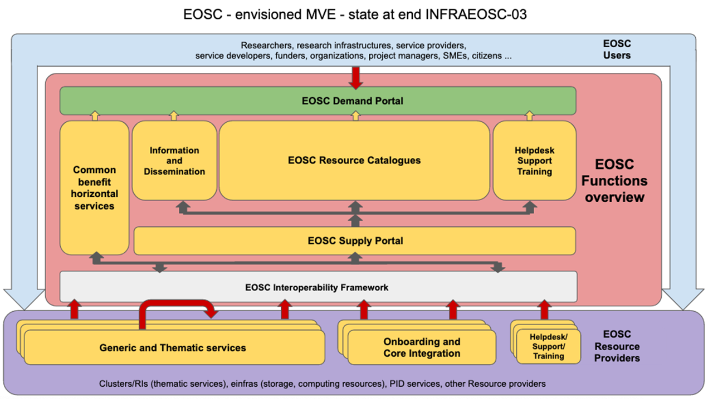Figure 2- a high level EOSC architecture. The Red box comprises EOSC-Core, and the Purple box maps to the services in EOSC-Exchange
Figure 2 shows high level functional areas in the EOSC-Core, which are as follows:

At the heart of EOSC is a set of resource catalogues which include metadata on the many resources available in EOSC. On the demand side, these form part of a demand-facing portal which exposes them to EOSC users (researchers, etc). This demand portal should also include helpdesk and support functions to assist users in benefitting from resources, information on EOSC, and ideally common benefit horizontal services, which may not be absolutely required to have an EOSC-Core, but which bring added value for all actors.
On the supply side, resource providers interact with EOSC using a supply portal, which is based on the guidance, formats and standards of the EOSC Interoperability Framework. Through this, they contribute generic and thematic services via an onboarding mechanism, or integrate their thematic and generic services with element of the Core.
The Onboarding function above is an important one in populating EOSC Exchange, and one which requires considerable human resources in effort and consultancy. It sits somewhat between the Core and Exchange, as it acts to list resources in the registry held in the Core, but the resources are listed as part of the Exchange.

Figure 3 then shows this in a greater level of detail, showing specific services or other components and resources in each functional block.

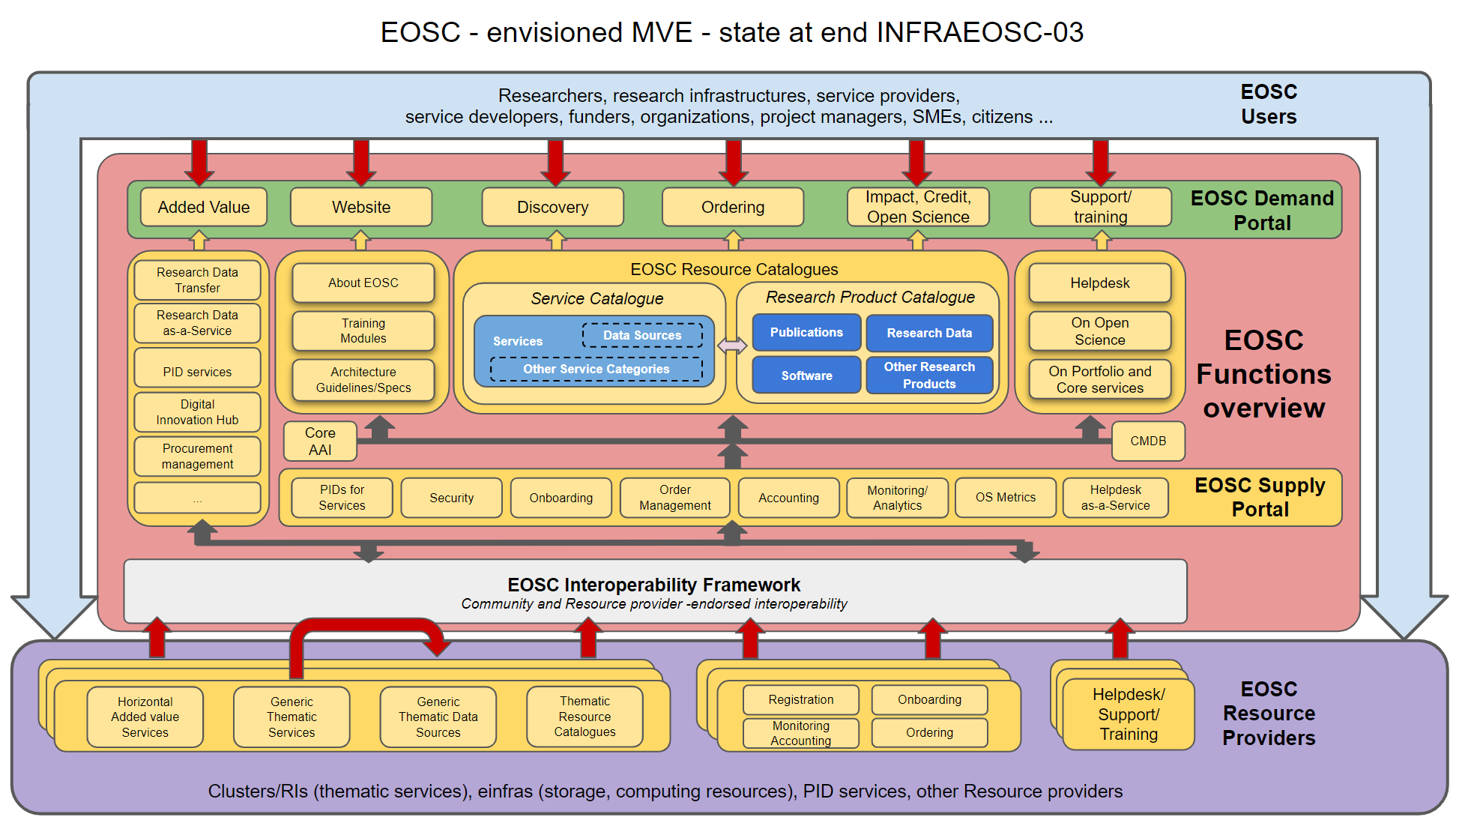
Figure 3 - a more detailed EOSC architecture. The Red box comprises EOSC-Core.

In the centre we still see the EOSC Resource catalogues, but now we differentiate them into at least the Service and Research Products catalogues, with subcategories below those for specific types of each resource category. The two portals, both demand facing and supply facing, now have multiple elements or components covering the different ways they will interact with EOSC. For instance, they include ordering on the demand side and order management on the supply side. Ordering of services or other resources is a function that EOSC clearly could and likely will support, though it will vary depending on the resource type. Services will require permission, configurtation and in some cases payment as aprt fo ordering. Fro data iot is more likely to be simply requesting access, or ‘ordering’ the data together with some services as apart fo a coherent workflow. But this implies quite complex connections to both the supply and demand communities. On the demand side, ordering must be a function built into the portals or interfaces users use (rather than just redirection to the webpage for a resource) while on the supply side there must be channels to transmit orders to suppliers and let them fulfil them. Where possible, these will need to be automated to the greatest extent reasonable, in order to make order fulfilment timely and easy to deliver. These, as with all elements of the interoperability framework and supply portal, rely on EOSC AAI and a Configuration Management system that identifies EOSC-Core configuration items. At this stage we will not examine every element in detail, but in the next section these will be mapped to the services and other resources in the ‘Hub Portfolio’ of EOSC-hub.

​Hub portfolio services
In light of the changes in the EOSC community since the previous deliverable, and the new vision for EOSC-Core, EOSC-hub provides the following overview of the candidate EOSC-Core services (formerly noted as Hub Portfolio Services). This view goes above the technical components to the larger value-generating services we offer, and which we imagine will either continue in or contribute to EOSC-Core in EOSC Future.

Table 2: Hub Portfolio services which may contribute to EOSC-Core.
Hub Portfolio Service | Components and building blocks | Value proposition
EOSC Portal (Including web content, Marketplace, Provider portal, portal metrics)  Provided through the EOSC Portal collaboration together with EOSC Enhance and OpenAIRE Advance | - EOSC Portal Web content (Trust-IT and EOSC Secretariat)  - Provider portal - supply side interface (University of Athens as part of EOSC Enhance)  - EOSC Marketplace - demand side interface (Cyfronet as part of EGI Federation) | Offer providers and users access to a registry of resources which they can contribute to or make use of, alongside information about EOSC. Allow access via the web or via API to onboard or access and consume EOSC resources.
EOSC-hub Helpdesk | - xGUS (KIT)  - GGUS (KIT as part of EGI Federation)  - EUDAT RT(EUDAT) | Offer a channel for support on the components of EOSC-Core that allows users to go through a single point of contact to get assistance.
EOSC-hub AAI | - EGI Check-in (EGI.eu)  - B2ACCESS (EUDAT)  - INDIGO-IAM (INFN as part of Indigo community)  - eduTEAMS (GEANT) | Provide an infrastructure for seamless access and authorisation against EOSC resources based on existing community identities.
EOSC-hub Monitoring | - ARGO (GRNet as part of EGI Federation) | Offer up to date information on the status of EOSC-Core services and EOSC-Exchange services which choose to integrate EOSC monitoring.
EOSC-hub Accounting | - Accounting Portal (EGI.eu)  - Operations Message Broker Network (EGI.eu)  - APEL Accounting Repository (STFC as part of EGI Federation) | Track usage of EOSC-Core resources and resources from the EOSC-Exchange that have chosen to integrate EOSC Accounting. This can support demonstration of usage required for reimbursement of resource provision costs, tracking of activity and impact.
EOSC-hub Configuration Management System | - GOCDB (STFC as part of EGI Federation)  - DPMT (MPCDF as part of EUDAT)  - SVMON (EUDAT) | Manage necessary information on all the elements required to deliver EOSC-Core, and support control of changes to elements supporting EOSC-Core and connection of Core components to other systems from the EOSC community.
EOSC-hub Collaboration & Communication systems | Commercial or open source components deployed by EGI.eu  - Jira  - Confluence  - Indico  - DocDB | Provide platforms needed to facilitate communication and collaboration between the individuals and groups providing EOSC-Core and EOSC-Exchange services
EOSC-hub Order handling system | - EOSC Marketplace - demand side interface (Cyfronet as part of EGI Federation)  - SOMBO (CNRS as part of the EGI Federation) | Capture resource orders from the EOSC Marketplace, manage them and distribute them to providers to allow them to be fulfilled.
EOSC-hub Messaging service | - ARGO Messaging Service | Connect other components of EOSC-Core allowing them to be programmatically connected.

Three additional areas of work are deployed in EOSC-hub, but as human activities rather than technical or IT services. These are crucial functions and map to capabilities required and suggested in the FAIR Lady report, but may or may not be considered Services.

EOSC Service Management System (SMS). A conceptual structure built to allow, support and ensure effective and efficient delivery of EOSC-Core services and any other associated resources integrated with EOSC. Defines policies, processes, procedures roles and responsibilities, and allows for their monitoring and continual improvement.
EOSC-hub Support Services, including training and knowledge bases comprises the expertise, consulting, training courses, training material, Trainer expertise, supporting documentation and other research products that support and enable the other activities in EOSC-Core and their connection and integration with EOSC-Exchange.
EOSC-hub Security policies and security coordination functions are the high-level policies governing IT and information security in EOSC and their application to the Core and Exchange as appropriate. It includes security guidelines, security assessment and audits, and implementation of appropriate security controls.
Some other services have been discussed and are likely to be needed in future but not yet deployed by EOSC-hub. These include:
- Data transfer Services
- PID Assignment
- FAIR Semantic interoperability tools
These three are in fact all also under discussion in the EOSC Working Groups and EOSC Future, so it seems that the work and approach of EOC-hub is well aligned to the larger community view.

While organised as a project activity rather than a resource to be handed over to a longer term EOSC structure, the last key activity it the outreach and promotion of EOSC. Even with an effective EOSC Core and exchange, it is still crucial to have mechanisms which seek new resources to be offered through the exchange, and even more key , to bring research hers to EOSC to benefit from it.

​Mapping the Hub Portfolio services to the EOSC-Core functionalities
The following table maps the EOSC-hub services and functions above to the EOSC Architecture Working Group view and the view presented in the FAIR Lady draft. Blank cells are areas which may be requested or implied by an EOSC Working Group, but are out of scope for the EOSC-hub project.
Table 3 - Mapping services to EOSC Core functionalities.
EOSC-Core area (from WG Architecture) | EOSC-Core component (from WG Architecture) | EOSC-Core capability ( From WG Sustainability / FAIR lady) | EOSC-hub component(s) | EOSC-hub level service (Hub Portfolio)
EOSC Demand Portal | Added Value resource access | A Web Portal |  | EOSC Portal
 | Website | A Web Portal | EOSC Portal web component
 | Discovery | A Service Management and Access Framework,  A Web Portal | EOSC marketplace
 | Ordering | A Service Management and Access Framework,  A Web Portal | EOSC Marketplace
 | Impact, Credit, Open Science | A Web Portal
 | Support / Training | Operational support services,  A Web Portal | Provided through training work packages and competence centres rather than as a service.
EOSC Resource Catalogues | Service Catalogue (Services, Data sources, other service types) | An Interoperable Metadata Framework,  A Web Portal | Resource Database (provided by EOSC-hub and EOSC Enhance) attached to Provider Portal and populating Marketplace | EOSC Portal
 | Research Product Catalogue (Publications, Software, Research Data, Other research product types) | An Interoperable Metadata Framework,  A Web Portal | Resource Database (provided by EOSC-hub and EOSC Enhance) attached to Provider Portal and populating Marketplace | EOSC Portal
Information and Dissemiantion | About EOSC | A Web Portal | EOSC Portal web component | EOSC Portal
 | Training modules | A Web Portal | Provided through training work packages and competence centres rather than as a service
 | Architecture guidelines / specifications | An Interoperable Metadata Framework,  A Web Portal | Provided through EOSC-hub deliverables
Support | Helpdesk | A Service Management and Access Framework,  Operational support services | XGUS (connected to GGUS, EUDAT helpdesk) | EOSC-hub Helpdesk
 | Open science support | A shared open science policy framework
 | Portfolio and core service support | A Service Management and Access Framework,  Operational support services | Provided as EOSC-hub Service Management System, a management framework rather than a typical IT service. | EOSC-hub SMS
Common benefit Horizontal Services | Research Data transfer | A Data Access Framework
 | Research Data as a service | A Data Access Framework
 | PID Services | Persistent Identifier System
 | Digital Innovation Hub | NA | EOSC Digital Innovation Hub | EOSC Digital Innovation Hub
 | Procurement management | A Service Management and Access Framework
 | Other added-value services | NA
Core AAI | Core AAI | Authentication and Authorization Infrastructure (AAI) Interoperability framework,  A Service Management and Access Framework | IAM, Check-In, B2Access | EOSC AAI
Core Configuration management system / database | Core Configuration management system / database | An Interoperable Metadata Framework,  A Service Management and Access Framework | GOCDB, EOSC SMS CMDB | EOSC Configuration Management System
EOSC Supply Portal | PIDs for services | Persistent Identifier System
 | Security coordination | A Service Management and Access Framework | Security Vulnerability Group, Information Security Management process in EOSC SMS | EOSC Security Coordination
 | Onboarding | An Interoperable Metadata Framework,  A Service Management and Access Framework
 | Order Management | An Open Metrics Framework,  A Service Management and Access Framework | SOMBO | EOSC Order Handling System
 | Accounting | An Open Metrics Framework,  A Service Management and Access Framework | APEL | EOSC-hub Accounting
 | Monitoring / Analytics | An Open Metrics Framework,  A Service Management and Access Framework | ARGO | EOSC-hub Monitoring
 | Open Science Metrics | A shared open science policy framework
 | Helpdesk as a Service | A Service Management and Access Framework,  Operational support services | GGUS. XGUS, EUDAT RT | EOSC-hub Helpdesk
EOSC Interoperability Framework |  | An Interoperable Metadata Framework |  | Interoperability guidelines (project documentation not formatted as a service)

This mapping allows us to draw some conclusions about the contribution of EOSC-hub to the coming EOSC-Core and EOSC Future. The project delivers many if not most functionalities required for EOSC-Core, but this does not mean that these are the final or full versions required. We expect that the capabilities described in the FAIR Lady will initially exist in relatively basic versions at first, improving and being refined and added to over time as EOSC further matures. The outputs of EOSC-hub provide a basic set of functionalities to address almost all requirements, though some are missed. Those which EOSC-hub cannot deliver are mostly in areas of projects EOSC-hub collaborates with, such as Open Science capabilities delivered by OpenAIRE, or PIDs delivered by projects such as FREYA. Between EOSC-hub and the other core projects in the current EOSC landscape, the capabilities of EOSC-Core can be reasonably delivered in the near future.
Perhaps most interesting are the capabilities delivered by EOSC-hub but not seen in the other lists. Notable among them are Collaboration & Communication systems, a Messaging Service and Hub/Core support activities.
Collaboration and Communication systems (such as wikis, mailing lists, ticketing systems, document management systems and video conferencing systems) will obviously be required to enable the cooperation needed to deliver EOSC-Core, but in most project contexts, these are considered a project element not a service, but as we transit to a sustainable EOSC landscape, they must be considered. It is possible that these will be provided by EOSC Association AISBL, but in any case need to accommodate a wide variety of actors who must cooperate in delivering EOSC well beyond Association members. It seems likely this capability should extend beyond the association, even if it is operated from there.
A Messaging Service is equally a part of the internal infrastructure connecting other components, and perhaps appears ‘invisible’ in the current view, or perhaps becomes a technical element of the EOSC Interoperability Framework. It allows other elements in the Core to pass data between each other and carries actionable messages to trigger other Core services. The Messaging Service therefore empowers and supports numerous other services.
Probably the most concerning lack in the other views is that of the EOSC-hub Support Services, including training and knowledge bases. While training is addressed in both EOSC-hub and indeed EOSC Future through specific work packages, other forms of support are missing from the Architecture or Sustainability views. Within EOSC-hub, support is delivered through Competence Centres and through the Early Adopter Program. There are plans in EOSC Future for support for integration of Core services, and support for limited specific use cases though the large scale Test Science Projects, but it currently lacks a generic user support function. Experience suggests that while some users may indeed be prepared to adopt off the shelf services, others will need assistance in adapting the services offered to their situation, which is a function not well covered in current plans for EOSC-Core from the working groups and not confirmed as part of the EOSC Future.

​Contributions to the EOSC-Exchange
The second portfolio maintained by EOSC-hub has been the so-called EOSC Service Portfolio, comprising researcher-facing services from the project and from the larger community. This maps directly to the EOSC-Exchange, where users from the research community are offered listing and access to a wealth of thematic and generic services which may empower, improve and support their research practice.
Initially this was intended to be only services coming from EOSC-hub partners and collaborators, but with the opening of EOSC portal it was expanded to be anyone from the wider research community wanting to onboard. The ways onboarding now occurs are covered in the next section, here we give a brief overview of the services onboarded

​Services arising and lessons learnt from EOSC-hub onboarding
From the launch of EOSC Portal in 2018 until August 2020, EOSC-hub published 122 services from the community. These are listed in Annex 1 of this document.
For each service, following a contact from a provider, information was collected in a Service Description Template, covering a provider and a service. The information was then validated by project staff to ensure consistency and quality, and then published to the EOSC Marketplace.
Due to the progressive merger of the efforts of EOSC-hub, EOSC Enhance and OpenAIRE Advance into a shared EOSC Portal and with the catalogue from the former eInfraCentral project, this number, while considerable, does not represent the full list of resources in EOSC portal. This merger began in Summer 2019 and completed in November 2020. Details of the combined portfolio are seen in the next section. Documentation on the process, including the data format uses (the Resource and Provider Profiles) can be found on the EOSC Portal web site.
Beyond the direct work of onboarding, the experience of running an onboarding team from multiple EOSC-hub work packages (WP2, 3, 4) has provided crucial insight into the challenges of drawing together services and other resources from across a wide community. Some of these are offered below. So far, as onboarding has (to date) only covered services rather than data or other research products, the lessons learned all concern services and service related topics. Onboarding of data and other research products is planned for 2021 by the EOSC Enhance project, and we would hope that some of these lessons could have application to data onboarding, as well as likely generating many new lessons.
Onboarding is the lowest tier of integration. As EOSC-hub operates a relatively heavyweight onboarding process, it is not simply a gathering of names into an index, but in fact is already an integration, or rather harmonisation of resources via harmonisation of their metadata. It sets the stage for later and more profound technical integration or process integration by providing a baseline for it, and a conceptual model for describing resources.
Resource providers are less able than expected to describe their resources and benefit from supportive engagement and consultancy. While ultimately quite lengthy, the Provider and Resource profiles (formerly Service Description Templates) would be straightforward to fill in for most commercial service providers. However, based on more than two years of effort onboarding services in EOSC-hub, this is not the case with the largely academic or research based resource providers seen in EOSC. While typically expert in their fields, and often having very interesting services, they may not be familiar enough with the surrounding activities and models to find onboarding simple. In particular they lack knowledge of IT Service Management, on which much of the information requested in onboarding is based. Equally others who have the expertise may be put off by the lengthy nature of the provider and resource profiles and previous somewhat ad-hoc way in which onboarding was performed. Rather than responding to technical bugs in the onboarding process, a lot of time is spent explaining for instance the need for a privacy policy, or defining whether something is several services or a single service with multiple options.
In terms of quantifying the skills and training gap here, we would estimate that only around 25% of the more than 100 providers are able to provide all required information without support. Of the remaining 75%, 50% are able to onboard with some consultancy and active support, and a final 25% need complex engagement and to do internal development (typically on policies) in order to match Rules of Participation and Inclusion criteria.
In future, providing education, training and knowledge transfer on these topics will bring benefit to EOSC, as by increasing the skill level in service management and other related fields, we will improve the resources providers offer through EOSC, and also increase their sustainability, as their costs and benefits will be clearer and easier to monitor and manage.
Automation of verification or validation can support onboarding but only for simpler situations. In validating services, the things which typically cause verification or validation to fail come in two broad categories. The first is simple errors such as information not filled in, or typographical errors in URLs. These can be relatively easily supported with automatic validation to check URLs are correct and available and ensure all fields are filled. The other category is errors in understanding what is requested, or in onboarding of inappropriate providers and resources, and this category is both more time consuming and requires manual validation. For instance, if a URL for terms of service is submitted in the field for a privacy policy, due to a misunderstanding by the provider, it will not be noticed by automated checks, and requires a member of a validation team to click the link and read whether the content is correct. Some of this may be addressed in later projects using machine learning techniques to support more complex automation of validation, but this is not yet available.
Validation can check correctness of requested information but not quality of information. Taking a privacy policy as an example, which is a required element for onboarding a provider or resource, a validator can check whether a privacy policy is provided and whether it appears to be a privacy policy. However we lack the resource to comment on the quality of the privacy policy provided, and indeed a mandate to do so. The only realistic way to support quality of inputs is through providing examples or templates (such as suggesting the WISE/AARC Acceptable Use Policy template) - but this only works where the required information is not present and can be created using a high quality template. EOSC-hub does not have resources to read and comment on all documents or linked information on all resources to make quality improvement suggestions. While it seems unlikely that any central; element of EOSC (such as the EOSC Association AISBL) would take on responsibility for guaranteeing the quality of elements of resource documentation and management, some form of quality mark to highlight well managed and effective services has been frequently discussed. As ever, this will involve balancing the quality EOSC can promise with the effort it has available to manage quality, and the willingness of providers to participate in such quality control. It also depends on the current level of quality int eh community – too stringent demands or criteria could see valuable if less well-described services discouraged or not used due to a lack of some quality mark. Any validation on the quality of content must be very carefully instituted and matched to the general level of maturity of the community and the training and support available to providers, to ensure than such validation encourages quality rather than inhibiting innovation.
Appropriateness of provider or resource is the most complex question and requires the most discussion. While the bulk of cases remain straightforward in terms of appropriateness for onboarding (a national portal for social science research data is typically appropriate, a webstore selling fake handbags is not - both of these being real examples) a number are edge cases. Typically these hinge on whether a service is really targeting EOSC users or not. Many services could be used by members of the research community, but equally have no specificity to it. If EOSC accepts (at this stage) all generic commercial IaaS cloud providers, or generic business online tools like directories of business partners, these will likely drown out the more research targeted services but drawing a line as to what is research specific enough can be highly complex. Likewise the relationship with commercial providers of services and their suitability remains unclear.
Validation generates policy questions which must be answered beyond just the scope of validation. Based on some of the topics listed above and others, onboarding activities, especially validation, generate larger scale questions quite rapidly. These can and should act as input to policy bodies with EOSC-hub, or later EOSC as a whole, as to what approach should be taken. Open questions raised include which languages should be supported, for both onboarding and for the resources themselves, which countries are valid locations for providers, and how and if commercially paid resources are permitted. While one might expect that the Working Group on Rules of Participation may answer some of these questions, in practice their work (while valuable) remains currently at a very high level which does not answer such operational questions. It seems likely that the new policy bodies under the proposed EOSC Future and the EOSC Association will provide bodies which many of these topics can be consulted on or escalated to.

​Overview of resources onboarded to the shared portal registry
Following the completion of the merger of the EOSC Service Portfolio from EOSC-hub with the catalogue from eInfraCentral, EOSC Portal now features a single integrated registry of resources.
The Portal web content offers information on EOSC, including EOSC Governance, policies, use cases and other useful information.
The Provider Portal (Supply portal - providers.eosc-portal.eu ) is a platform to allow resource providers to submit themselves and their resources to the EOSC portal resource registry, based on the Provider Profile version 3.0 (created by EOSC Enhance in collaboration with EOSC-hub and others). This then allows them to submit resources (using the resource profile version 3.0) either via the profile portal web interface, or via API. Records are deposited into a central database. This registry can then be queried via API or accessed over the web via the catalogue search function in the Marketplace.
The Marketplace (Demand portal marketplace.eosc-portal.eu ) is a web platform which exposes EOSC resources to users. They are able to search, browse, explore, compare and order services and other resources via the marketplace. It draws its listing from the registry attached to the Provider Portal, though only offers TRL8 (System complete and qualified) and above services for ordering (TRL 7 - System prototype demonstration in an operational environment- for simply listing).
Following the final merger of the services onboarded by both EOSC-hub, eInfraCentral and EOSC Enhance, the registry currently, in November 2020, contains 281 resources. At present these resources are all services, as this is the only resource type as yet onboarded and supported by the Resource Profiles, though EOSC Enhance will begin to onboard other resources types (such as Research products – data, publications, software etc.) next year. The records on resources in the registry can be accessed through https://marketplace.eosc-portal.eu/.
In terms of function, the distribution of resource categories can be seen in Figure 4, below.

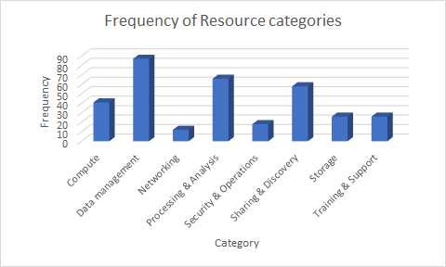
Figure 4: frequency of resource categories in Marketplace
At present, the services are somewhat skewed to providers already engaged with EOSC, which means that eInfrastructures and providers of services of use to all research areas are significantly overrepresented (See figure 5).
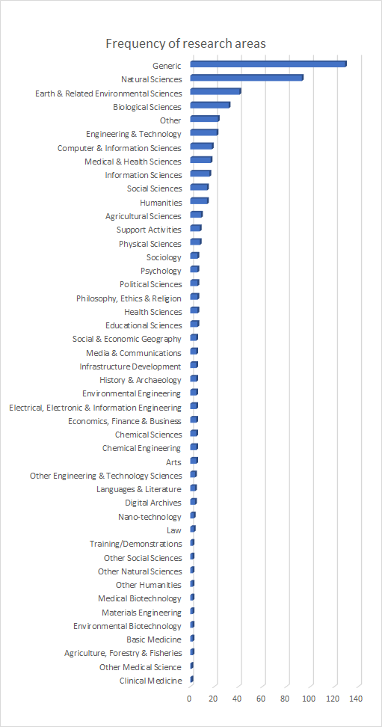
Figure 5 Distribution of Research areas in Marketplace resources
We expect that in future, as more thematic organizations are brought into EOSC and onboard their resources, this distribution will stabilise in a more balanced way.

​Contributions to the governance of EOSC and handover to later projects

In addition to the practical work of populating and managing the portfolio, EOSC-hub has contributed to the governance of portfolios and catalogues in the wider EOSC ecosystem.

​Definition of the EOSC-Core
During the period of EOSC-hub, the project has engaged actively in the many discussions about how EOSC should be formed. It has presented numerous suggestions and contributed to many discussions on the topic, notably the Briefing paper on the Federating Core Governance and Sustainability which was the subject of public consultation and supplemented recently by a Briefing Paper on Provision of Cross-Border Services, which gave further consideration to some of the Shared Resources expected to form part of the EOSC-Exchange. As the community view has evolved, the project has continued to engage on the to pic, in particular though membership and contribution to the work of the EOSC Architecture Working Group, in their work to define the elements of the EOSC-Core and a potential Minimum Viable EOSC. Members of EOSC-hub, working together with those from OpenAIRE generated the initial ideas which became the model of EOSC components presented in section 3.2. The project has worked hard to ensure that the views of the Core contents, while based on a broader consensus, also represent a sufficient set of capabilities to operate EOSC, based on our experience of operating the proto-EOSC represented by EOSC-hub.
This engagement has extended to the contents of a Minimum Viable EOSC (MVE) discussed by the Sustainability Working Group, where once again EOSC-hub participants engaged in discussions between the working groups on Architecture, Sustainability and FAIR in order to further develop ideas on the MVE and contribute to the function list for EOSC-Core presented in drafts of the FAIR lady report.
As a result, the project has been able to ensure definitions of EOSC-Core are realistic and based on real experience deploying a proto-EOSC at scale within EOSC-hub.

​Rules of Participation and inclusion criteria for EOSC-Exchange
EOSC-hub participates in the Rules of Participation (RoP) Working Group to assist the community in determining what commitments and requirements are appropriate or necessary to form an effective EOSC. Through many discussions the group has converged on a minimal rule set that provides limited high level rules and requirements. The current draft of the EOSC Rules of Participation fits well with the work of EOSC-hub to date, however because it is high level, it does not provide operational guidance and procedures which can be used to judge the fit of a provider or resource with EOSC. Given the challenges posed by onboarding, and discussed in section 4.1, such procedures are required to operate an effective onboarding process.
Over time EOSC-hub has developed and improved a set of working inclusion criteria, which can be seen in Annex 2 of this document. These attempt, at least for services, to provide useful operation criteria for inclusion, when used alongside the provider and resource profiles themselves, whose required fields effectively present an additional set of criteria. As other resource types are going to be included in 2021 through the extension of EOSC-hub, through EOSC Enhance or the EOSC Future project, these will be further refined, extended and harmonised with the input of the Rules of Participation and the EOSC Association AISBL.

​Handover to EOSC Future and later projects
EOSC-hub has never been intended to be the final or fully mature structure for EOSC, rather it provides and presents a proto-EOSC, including key functions we might expect in EOSC-Core and a portfolio and catalogue of researcher-facing services as we may expect in the Catalogue. Nonetheless, it is expected to be a major or the major contribution to many aspects of the EOSC-Core and EOSC-Exchange for the next phase of EOSC.
This is facilitated by the EOSC Enhance project, managing the EOSC portal evolution, which overlaps with EOSC-hub and the likely EOSC Future project which continues much of its work though the INFRAEOSC-03 call. While EOSC Enhance only deals with the Portal and related components, this still represents a significant element of EOSC and one where handover to EOSC Future or other projects is much facilitated.
For the rest of EOSC-Core, as shown in the table in section 3.4, the components developed or integrated by EOSC-hub provide most functions required for EOSC-Core and proposed by the Architecture and Sustainability working groups. As EOSC-hub partners have a significant presence in the proposed EOSC Future project, and are slated to be responsible for operation of EOSC-Core-services, we can expect considerable continuity between these efforts, and a significant portion of EOSC-hub ‘hub portfolio’ services to be adopted or integrated as part of EOSC-Core services.
For EOSC-Exchange, the services onboarded by EOSC-hub have already been integrated with others through the work of EOSC Enhance, which will facilitate the handover of the portfolio to EOSC Future. Again, there is significant commonality between partners performing management and onboarding of services to EOSC-Exchange in EOSC-hub and EOSC Enhance with those foreseen to perform this work in EOSC Future, such that a seamless transition of the processes and procedures around onboarding to EOSC Future is fully expected.

- Full list of services onboarded by EOSC-Hub prior to registry merger
The following list comprises 122 services published by EOSC-hub alone to EOSC portal from its launch until August 2020. This does not cover all activity as numerous services were updated one or more times, and numerous other requests were rejected or redirected to other more appropriate venues.

Table 4: Services onboarded to EOSC Service portfolio (EOSC-Exchange) by EOSC-hub alone prior to merged process with EOSC Enhance through EOSC Portal Collaboration Agreement.
Date requested | Date resolved | Service name | Submitting organisation
29/10/2018 10:33 | 11/12/2018 16:32 | GEOSS Web Portal | CNR
29/10/2018 10:47 | 21/01/2019 11:18 | Alien and Invasive Species | CNR
29/10/2018 15:59 | 11/12/2018 16:29 | Virtual Language Observatory (Clarin) | CLARIN - ERIC
07/11/2018 10:48 | 22/01/2019 12:02 | GEP - High-Resolution Change Monitoring for the Alpine Region (part of EO pillar) | Terradue
13/11/2018 18:24 | 11/12/2018 16:30 | PaN Gitlab | DESY Deutsches Elektronen-Synchrotron
13/11/2018 19:06 | 12/12/2018 18:21 | AMBER | WeNMR virtual research community
13/11/2018 19:14 | 12/12/2018 18:15 | CS-ROSETTA | WeNMR virtual research community
13/11/2018 19:16 | 12/12/2018 18:13 | DisVis | WeNMR virtual research community
13/11/2018 19:18 | 12/12/2018 18:16 | FANTEN | WeNMR virtual research community
13/11/2018 19:21 | 12/12/2018 18:21 | HADDOCK | WeNMR virtual research community
13/11/2018 19:24 | 12/12/2018 18:23 | POWERFIT | WeNMR virtual research community
13/11/2018 19:29 | 12/12/2018 18:18 | SpotOn | WeNMR virtual research community
14/11/2018 15:54 | 21/01/2019 11:17 | GEO Discovery and Access Broker | GEOSS - Group on Earth Observation System of Systems
19/11/2018 13:53 | 12/12/2018 18:26 | EODC Data Catalogue Service | EODC
19/11/2018 14:23 | 12/12/2018 18:06 | Sentinel Hub | Sinergise
19/11/2018 14:38 | 12/12/2018 18:24 | MEA Platform (Data access and exploitation service) | EODC
19/11/2018 14:49 | 12/12/2018 18:22 | CloudFerro Data Collections Catalog | EODC
19/11/2018 15:50 | 11/12/2018 18:01 | CloudFerro Data Related Services - EO Finder | http://www.cloudferro.com
19/11/2018 16:26 | 21/01/2019 11:17 | Virtual Collection Registry (CLARIN) | CLARIN - ERIC
19/11/2018 17:12 | 11/12/2018 17:59 | B2FIND | EUDAT
19/11/2018 17:51 | 11/12/2018 16:32 | DARIAH Science Gateway | DARIAH
19/11/2018 18:57 | 14/12/2018 15:29 | CSC ePouta | CSC
19/11/2018 19:00 | 22/01/2019 12:11 | TDS | University of Oslo (UiO)
20/11/2018 10:16 | 08/01/2019 11:28 | ENES Climate Analytics Service | Deutsches Klimarechenzentrum (DKRZ)
20/11/2018 11:20 | 11/12/2018 16:33 | New Particle Formation Event Analysis | ENVRI
20/11/2018 15:41 | 12/12/2018 18:17 | PaN Notebook | DESY Deutsches Elektronen-Synchrotron
20/11/2018 15:51 | 12/12/2018 18:12 | PaN Data | DESY Deutsches Elektronen-Synchrotron
20/11/2018 15:57 | 12/12/2018 18:10 | PaN FaaS | DESY Deutsches Elektronen-Synchrotron
21/11/2018 02:21 | 12/12/2018 18:21 | B2Access | EUDAT
21/11/2018 12:42 | 12/12/2018 18:22 | B2SHARE | EUDAT
21/11/2018 13:42 | 08/01/2019 10:34 | Language Resource Switchboard | CLARIIN
30/11/2018 16:15 | 23/01/2020 14:25 | FAIRsharing | University of Oxford
30/11/2018 16:28 | 31/05/2019 15:55 | Identifiers.org | European Bioinformatics, Institute (EMBL-EBI)
03/12/2018 09:50 | 11/02/2019 12:26 | Robot Benchmark | Cyberbotics Ltd.
13/12/2018 12:47 | 02/04/2019 09:52 | Midas Integration in EOSC-hub | Vilnius University
08/01/2019 16:35 | 08/02/2019 15:30 | Open Telekom Cloud | T-Systems International GmbH
09/01/2019 10:10 | 26/06/2019 15:56 | Infrastructure Manager | GRyCAP-I3M-UPV
09/01/2019 10:32 | 04/09/2019 10:33 | Snap4City | University of Florence, DINFO dept, DISIT Lab
11/01/2019 18:19 | 27/03/2019 10:41 | symbIoTe | PSNC
15/01/2019 15:35 | 17/06/2019 17:01 | DigitalGlobe EarthWatch | DigitalGlobe
23/01/2019 13:20 | 07/02/2019 12:53 | new-particle-formation-event-analysis | NA
23/01/2019 13:21 | 07/02/2019 11:47 | PROMINENCE | NA
25/01/2019 10:14 | 11/07/2019 14:20 | DigitalGlobe GBDX Notebooks | DigitalGlobe
30/01/2019 16:53 | 24/07/2019 10:16 | ALIEN 4 Cloud | NCG-INGRID-PT
01/02/2019 14:20 | 11/03/2019 09:51 | D4Science Visual Media Service VRE | CNR-ISTI
04/02/2019 13:32 | 26/06/2019 15:53 | 100 Percent IT - Trusted Cloud | 100 Percent IT Ltd
18/02/2019 09:20 | 11/07/2019 11:13 | cyverseuk VMs | Earlham Institute
04/04/2019 18:08 | 12/03/2020 13:57 | UBORA | UBORA consortium
10/04/2019 20:35 | 11/07/2019 11:02 | Figshare | Figshare LLP
10/04/2019 21:30 | 23/09/2019 09:44 | Europeana APIs | Europeana Foundation
12/04/2019 09:08 | 18/06/2019 13:02 | Embassy Cloud | EMBL-EMI
30/04/2019 14:33 | 04/09/2019 10:42 | Finnish Social Science Data Archive's (FSD) online data service | Finnish Social Science Data Archive
30/04/2019 14:43 | 24/07/2019 09:58 | Galaxy | University of Freiburg
07/05/2019 11:15 | 07/10/2019 10:10 | IAM | INFN
24/05/2019 16:12 | 28/06/2019 11:15 | DEEPaaS training facility | DEEP-Hybrid-DataCloud consortium
28/05/2019 13:17 | 01/07/2019 16:45 | MetaCentrum Cloud | Institute of Computer Science, Masaryk University
31/05/2019 13:39 | 04/09/2019 10:27 | Jelastic Cloud | Jelastic Cloud Union
06/06/2019 09:34 | 27/05/2020 16:39 | Dissemin | CAPSH
07/06/2019 14:43 | 19/11/2019 12:34 | LEMONADE | Universidade Federal de Minas Gerais (Brazil)
14/06/2019 10:02 | 29/01/2020 10:19 | GUARDOMIC | Koma Nord Sp. z o.o., Idego and PSNC
14/06/2019 10:28 | 08/10/2019 10:11 | DataFurn | Suite5 Data Intelligence, Solutions, AIDIMME
17/06/2019 14:44 | 27/11/2019 09:20 | Argo GDAC | Euro-Argo ERIC by way of Ifremer
03/07/2019 08:44 | 13/12/2019 15:23 | DMPonline | Digital Curation Centre
12/07/2019 13:58 | 08/10/2019 14:16 | NOMAD | Humboldt-University
24/07/2019 11:43 | 07/10/2019 12:37 | Open Science MOOC | Not provided
07/08/2019 11:59 | 28/11/2019 12:53 | EGI Notebookes (Update) | EGI
07/08/2019 12:00 | 19/06/2020 18:05 | EGI Training Infrastructure | EGI
07/08/2019 12:00 | 18/09/2019 17:02 | EGI FitSM Training | EGI
07/08/2019 12:01 | 19/06/2020 18:38 | EGI Online Storage | EGI
07/08/2019 12:02 | 19/06/2020 18:13 | EGI High Throughput Computing | EGI
07/08/2019 12:03 | 19/06/2020 18:31 | EGI Cloud Container Compute | EGI
07/08/2019 12:03 | 19/06/2020 18:24 | EGI Cloud Compute | EGI
07/08/2019 12:03 | 28/11/2019 15:57 | EGI Check In | EGI
07/08/2019 12:04 | 18/09/2019 16:31 | EGI Archive Storage | EGI
07/08/2019 12:05 | 19/09/2019 10:20 | EGI Data Transfer | EGI
07/08/2019 12:05 | 18/09/2019 15:18 | EGI ISO 27001 Training | EGI
07/08/2019 13:24 | 08/10/2019 10:56 | cPouta | CSC - IT Center for Science Ltd., Finland
07/08/2019 13:32 | 08/10/2019 10:58 | rahti | CSC - IT Center for Science Ltd., Finland
08/08/2019 12:58 | 07/10/2019 12:32 | EGI Workload Manager | EGI
09/08/2019 09:44 | 26/06/2020 11:32 | de.NBI Cloud | University of Bielefeld
21/08/2019 13:53 | 07/10/2019 10:16 | CESSDA Data Catalogue | CESSDA ERIC
04/09/2019 16:07 | 13/11/2019 10:25 | VAMDC Query store | VAMDC Consortium
05/09/2019 10:10 | 07/11/2019 09:58 | VAMDC species database | VAMDC Consortium
05/09/2019 10:19 | 07/11/2019 09:56 | VAMDC portal | VAMDC Consortium
04/10/2019 14:30 | 27/11/2019 13:40 | INDIGO PaaS Orchestrator Service | INFN
11/10/2019 14:17 | 12/03/2020 13:59 | LifeWatch Lagunas | University of Granada, Spain, LifeWatch ERIC
11/10/2019 14:39 | 30/06/2020 11:57 | LifeWatch Plant | Institute of Physics of Cantabria IFCA - CSIC LifeWatch ERIC
11/10/2019 14:50 | 24/04/2020 10:37 | LifeWatch GBIF Collections | GBIFes
16/10/2019 17:05 | 24/04/2020 10:33 | LifeWatch GBIF SpeciesLIst | LifeWatch ERIC
16/10/2019 17:06 | 24/04/2020 13:01 | LifeWatch GBIF Species | LifeWatch ERIC
16/10/2019 17:07 | 23/04/2020 09:14 | LifeWatch GBIF SpatialPortal | LifeWatch ERIC
16/10/2019 17:09 | 02/03/2020 13:43 | LifeWatch GBIF Regions | LifeWatch ERIC
16/10/2019 17:10 | 21/02/2020 13:48 | LifeWatch GBIF Occurences | LifeWatch ERIC
16/10/2019 17:12 | 24/04/2020 13:08 | LifeWatch GBIF Images | LifeWatch ERIC
16/10/2019 17:13 | 21/02/2020 13:39 | LifeWatch GBIF eLearning | LifeWatch ERIC
18/10/2019 09:22 | 04/06/2020 14:11 | OpenAIRE Amnesia | OpenAIRE
18/10/2019 09:25 | 27/05/2020 16:30 | OpenAIRE Marine Science community gateway | OpenAIRE
18/10/2019 09:30 | 28/05/2020 10:34 | OpenAIRE Fisheries & Aquaculture community gateway | OpenAIRE
18/10/2019 09:31 | 07/05/2020 12:08 | OpenAIRE Zenodo | OpenAIRE
18/10/2019 09:33 | 28/05/2020 10:49 | OpenAIRE Research Community Dashboard | OpenAIRE
18/10/2019 09:35 | 07/04/2020 12:49 | OpenAIRE Scholexplorer | OpenAIRE
18/10/2019 09:36 | 07/04/2020 13:03 | OpenAIRE Mining service | OpenAIRE
18/10/2019 09:36 | 28/05/2020 10:28 | OpenAIRE Research Graph | OpenAIRE
18/10/2019 09:36 | 27/05/2020 16:21 | OpenAIRE Explore Portal | OpenAIRE
18/10/2019 09:38 | 24/07/2020 11:21 | OpenAIRE Content Provider Dashboard | OpenAIRE
24/10/2019 22:39 | 15/01/2020 16:35 | UT Rocket - HPC batch queue | University of Tartu
29/10/2019 10:08 | 03/02/2020 13:36 | Max - AiiDA lab | MaX project
01/11/2019 17:14 | 23/01/2020 10:20 | da|ra | GESIS Leibniz Institute for the Social Sciences
12/11/2019 10:25 | 31/03/2020 14:20 | EISCAT specific DIRAC instance | EISCAT
04/12/2019 12:34 | 23/04/2020 11:51 | Integration of Remote Sensing service (WP7-Thematic services) | LifeWatch ERIC
06/12/2019 12:22 | 20/07/2020 11:07 | ROR (Research Organization Registry) | Research Organization Registry (ROR)
11/12/2019 09:35 | 31/03/2020 14:16 | Open Knowledge Maps | Open Knowledge Maps
08/01/2020 07:58 | 21/02/2020 12:16 | Knowledge Graph | Shanghai Science and Technology Innovation Resources (SSTIR) Center
29/01/2020 11:20 | 20/02/2020 17:27 | Laniakea@ReCaS | IBIOM-CNR
20/02/2020 12:45 | 04/05/2020 17:14 | Identifiers.org Resolution Service | The European Bioinformatics Institute EMBL-EBI
09/03/2020 10:34 | 20/03/2020 10:20 | e-IRG Knowledge Base | Genias Benelux BV
10/03/2020 15:47 | 20/03/2020 10:03 | OPERAS certification service | OPERAS
12/03/2020 09:40 | 27/05/2020 17:41 | Astro Online Data Analysis at UNIVERSITY OF GENEVA | UNIVERSITY OF GENEVA
19/03/2020 09:50 | 28/04/2020 14:06 | eTDR (European Trusted Digital Repository) | CINES
05/06/2020 10:09 | 20/07/2020 11:03 | APEER is a cloud-based digital microscopy platform | Carl Zeiss Microscopy GmbH
19/06/2020 23:21 | 03/07/2020 10:10 | Identifiers.org Central Registry | EMBL-EBI
14/08/2020 15:47 | 31/08/2020 15:01 | OPERAS Research for society | OpenEdition

- ​Timelines of current EOSC related projects
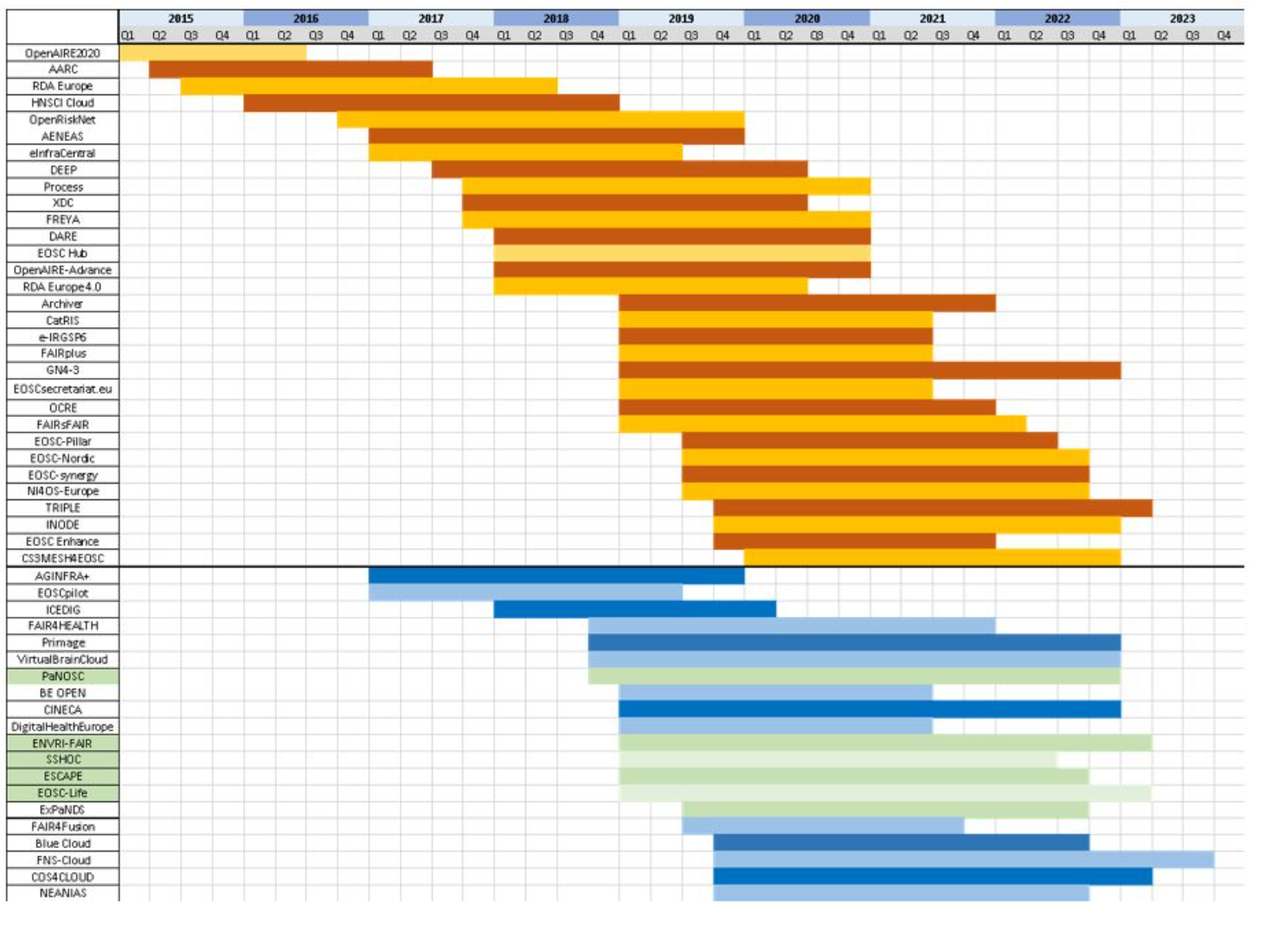

- ​Current EOSC-Exchange inclusion criteria
The following are the current inclusion criteria for providers and resources wishing to onboard to EOSC-Exchange, based on experience in EOSC-hub. It is used by EOSC-hub and EOSC Enhance to assess requests for inclusion from community providers. These are online at https://www.eosc-portal.eu/providers-documentation/eosc-provider-portal-inclusion-criteria
The following criteria are currently used to validate Providers and Resources to be onboarded within the EOSC Service Portfolio. The criteria are still under development by a joint team consisting of partners of EOSC-hub and EOSC Enhance. The EOSC AISBL may define broader criteria, therefore the criteria are subject to change in the future.
- Who can onboard resources to EOSC
  - Resources must be onboarded by a legal entity (although the legal entity may do so on behalf of a project or consortium in which they participate, with the agreement of those groups)
  - Providers onboarding a resource must assert that they are able to ensure the resource is delivered by them or their collaborators and agree to remove resources which are no longer operational or available.
- What resources may be connected to EOSC?
  - Services. At present only services are being onboarded (though this is planned to change in future).
    - It must be an actual service
    - It must be a specific service offered ‘live’ to customers [1]. This may be an IT service, or a human service (e.g. training, consultancy).
    - It may not be a research product, for instance, a document, a dataset or a piece of software [2].
    - The Service must be discrete. It must be available and offer value on its own. It may not be only a feature of a larger service available while already using that service.
    - Services must meet at least one of:
      - The service must be targeted to EOSC and EOSC communities [3].
      - The service must build on or leverage EOSC capabilities to serve some other community.[4]
  - Other research products (Rules and onboarding process pending)
- A provider profile and resource profiles for each resource must be filled, including all required fields.
  - URLs must be Fully Qualified Domain Names (FQDN)
  - Key information must be in English due to the limitations of current project resources (thought this may change in future)
    - The provider and resource profiles must be in English
    - The basic information in the User Interface for the service must be available in English
    - Privacy statements, terms of use and SLA/SLS must be available in English. Other documentation may be in native language only.
    - The Helpdesk must be able to answer queries in English at a minimum.
- Resources must be both available in Europe and available in a European language [5].
- The provider must agree to periodically update data on themselves and their resources to keep it current (to be covered in Provider agreement, TBD)
[1] Filling e.g. the definition according to FitSM-0 - Service: Way to provide value to customers through bringing about results that they want to achieve. Note: In the context of the FitSM standard series, when referring to services, usually IT services are meant. From https://www.fitsm.eu/download/280/ It should not be a generic menu of services from a provider, but the specific services themselves.
[2] A data repository service providing some annotation, tools over the data sets, enhanced features is likely a service. A simple link to a data file is not.
[3] For instance, could be a service from the research community for researchers, or if a commercial service, includes a clear offer targeted at EOSC and research customers which addresses them, rather than be a generic commercial service. One example of the latter is a joint procurement framework targeting EOSC.
[4] For instance, services through the Digital Innovation Hubs which build on EOSC expertise, resources and capabilities to create new, innovative commercial services
[5] See https://europa.eu/european-union/about-eu/eu-languages_en

Solutions for a Sustainable EOSC ] Tinman Report (requires login), see https://www.eoscsecretariat.eu/file/solutionsforasustainableeosc-tinmandraft02dec19pdf
Solutions for a Sustainable EOSC - FAIR lady report, see https://op.europa.eu/en/publication-detail/-/publication/581d82a4-2ed6-11eb-b27b-01aa75ed71a1/language-en/format-PDF/source-175468053
In this case the website www.eosc-portal.eu, the basic web content on it, the registry of EOSC services, EOSC Marketplace and new EOSC provider portal.
ENVRI-FAIR, EOSC-life, ESCAPE, PaNOSC and SSHOC
EOSC-Nordic, EOSC-Pillar, EOSC-synergy, ExPaNDS and NI4OS-Europe.
E.g. the SSH Open Marketplace - see https://www.sshopencloud.eu/ssh-open-marketplace
Descriptions from EOSC Secretariat, see https://www.eoscsecretariat.eu/eosc-working-groups
These are both introduced in the EOSC Partnership Proposal, see https://ec.europa.eu/info/sites/info/files/research_and_innovation/funding/documents/ec_rtd_he-partnership-open-science-cloud-eosc.pdf
The EOSC Portal Collaboration brings together EOSC-hub, OpenAIRE Advance, EOSC Enhance (previously eInfraCentral) to deliver EOSC Portal and the registry and marketplace for services and other resources available there.
The EOSC Portal Collaboration was originally a collaboration agreement between EOSC-hub, eInfraCentral and OpenAIRE Advance, though later eInfracentral concluded and the new agreement instead included EOSC Enhance.
See https://www.eosc-portal.eu/providers-documentation
See https://www.eosc-portal.eu/providers-documentation/eosc-provider-portal-provider-profile
See https://www.eosc-hub.eu/sites/default/files/EOSC-hub%20Briefing%20Paper%20-%20EOSC%20Federating%20Core%20Governance%20and%20Sustainability%20v1.0_0.pdf
See https://www.eoscsecretariat.eu/sites/default/files/draft_eosc_rop_version_0.5_20-10-2020.pdf

