.

e-ScienceTalk

Annual Upgraded Version of the RTM

EU DELIVERABLE: D2.4

Document identifier: | e-ScienceTalk_D2_4_RTM
Date: | 20/6/2013
Work package: | WP2
Lead Partner: | Imperial
Document Status: | DRAFT
Dissemination Level: | PUBLIC
Document Link: | https://documents.egi.eu/document/xx

Abstract
The Real Time Monitor has been upgraded during the course of the third year of e-ScienceTalk and a new version launched to meet D2.4 Annual Upgraded Version of the RTM. This document describes the work carried out on the upgraded version during PY3 as part of this Deliverable.

Copyright notice
Copyright © Members of the e-ScienceTalk collaboration, 2010-2013. See www.e-sciencetalk.eu for details of the e-ScienceTalk project and the collaboration. E-ScienceTalk is a project co-funded by the European Commission as an Support Action within the 7th Framework Programme. E-ScienceTalk began in September 2010 and will run for 33 months. This work is licensed under the Creative Commons Attribution-Noncommercial 3.0 License. To view a copy of this license, visit http://creativecommons.org/licenses/by-nc/3.0/ or send a letter to Creative Commons, 171 Second Street, Suite 300, San Francisco, California, 94105, and USA. The work must be attributed by attaching the following reference to the copied elements: “Copyright © Members of the e-ScienceTalk Collaboration, 2010-2013. See www.e-sciencetalk.eu for details of the e-ScienceTalk project and the collaboration”. Using this document in a way and/or for purposes not foreseen in the licence, requires the prior written permission of the copyright holders. The information contained in this document represents the views of the copyright holders as of the date such views are published.
- Delivery Slip
 | Name | Partner/Activity | Date
From | J. Martyniak | Imperial/WP2 | 20/06/2013
Reviewed by | Moderator:  Reviewers: | Various
Approved by | PMB:
- Document Log
Issue | Date | Comment | Author/Partner
1 | 20/06/2013 | First draft | J Martyniak & N O’Neill / Imperial & QMUL
2
3
- Application area
This document is a formal deliverable for the European Commission, applicable to all members of the e-ScienceTalk project and its beneficiaries and collaborating projects.

- Document amendment procedure
Amendments, comments and suggestions should be sent to the authors.
- PROJECT SUMMARY

Over the last 10 years, the European Commission and governments have invested substantial funds in distributed computing infrastructures. Scientists have access to state-of-the-art computational and data resources located around the world, putting European research into a leading position to address the greatest challenges facing us today, such as climate change, pandemics and sustainable energy. The advent of the European Grid Infrastructure, combined with the blurring of boundaries between grids, clouds, supercomputing networks and volunteer grids, means that a clear consistent source of information aimed at non-experts is now more important than ever, through dissemination projects such as e-ScienceTalk, that cross national boundaries.

Objectives:

- e-ScienceTalk will build on the achievements of the GridTalk project in bringing the success stories of Europe’s e-Infrastructure to policy makers in government and business, to the scientific community and to the general public.

- e-ScienceTalk will work with EGI-InSPIRE and other collaborating projects to expand the scope of the existing GridTalk outputs, and to report on the interactions of grids with e-Infrastructures such as cloud computing and supercomputing.

- The project will explore options for the sustainability of e-ScienceTalk’s products.

- e-ScienceTalk will produce a series of reports aimed at policy makers to disseminate key policy issues underpinning grid and e-Infrastructure development in Europe. The project will also coordinate e-concertation activities.

- The GridCafé, GridCast and GridGuide suite of websites will cover new topics and explore novel web technologies; they will integrate closely with GridPP’s Real Time Monitor, combining live views of grid activity with the human aspects of computing.

- The growing weekly publication, International Science Grid This Week (iSGTW) will bring news and events to the existing and potential e-Science community under a new name of The Digital Scientist.

- EXECUTIVE SUMMARY
xxxxxxxxxxxxx

TABLE OF CONTENTS
1 Introduction 6
1.1 The Real Time Monitor 6
1.2 The GridGuide 7
2 progress in year tWO 9
2.1 Website and logo 9
2.2 Maintenance 9
2.3 User Support 9
2.4 Extending the RTM Functionality 10
2.4.1 GÉANT display 10
2.4.2 Upgrading software 10
2.4.3 CMS data transfers 10
3 Conclusion 12
4 References 13

Introduction

In the first year of the e-ScienceTalk project the GridGuide and Real Time Monitor were upgraded and integrated as described in D2.1 GridGuide Upgraded Integration with the RTM [R1]. The second year focused on improving the content of the GridGuide by expanding the institutes and countries covered while the RTM has incorporated new data sources and infrastructures. There has also been work done on upgrading the code the RTM runs. This is described in D2.3 Annual Upgraded Version of the RTM [R2]. In the third project year, an effort was made to increase the number of sites within the GridGuide to 100. In Q11, a number of new sites were added from both grid-only and grid/e-science sites from around the world, bringing the total to 102.

The current version of the GridGuide is available at http://www.gridguide.org and the Real Time Monitor can be downloaded as a standalone application from http://rtm.hep.ph.ic.ac.uk/ or launched as a Java webstart version. This document describes the work achieved during PY3.

The Real Time Monitor

The RTM is a real time visualisation of activity on the grid computing infrastructure. The High Energy Physics e-Science group at Imperial College London has been developing it since 2002. Initially funded by the UK-based GridPP collaboration, work on the RTM became a part of the e-ScienceTalk project in September 2010. The latest version utilises the NASA World Wind virtual globe, which is based on OpenGL and Java. The RTM overlays the movement of site activity and job transfers onto the 3D globe, giving users the ability to see the current state of the grid infrastructure. It is modularly designed, making it easy to add and change various aspects of the application depending on the demands placed on it.

The application also includes more detailed information about the status of the individual sites on the grid including:

- Current number of jobs running/queued at a site
- The load on a site’s computing elements and workload management systems
- Graphs detailing the work done at the site over various time periods
- Information from the GridGuide about that site, if available

Running the RTM is also relatively straightforward, with no special installation required, on computers with a modern up-to-date operating system. This has widened the use beyond a small community of experts to anyone wanting to look at or discuss the grid infrastructure.

The tools on which the RTM is based are used for more than generating the live visualisations. They also generate important statistic about sites, jobs and virtual organisations, which can be used to help in diagnosing problems or monitoring performance of the infrastructure.

Since becoming a part of the e-ScienceTalk project the RTM development has focused on four areas: the website, maintenance, user support and extending the application’s functionality. This has included input from other areas of the project to help give a fresh look to the application.

In PY3, 54 countries are included in the RTM and the team has visited six events where the RTM has been demonstrated. These included Supercomputing ‘12, EGI Technical Forum 2012 and Community Forum 2013, ISC 2013, the European Conference on Computational Biology and the 9th European Biophysics Congress. Additionally, the RTM was shown at multiple locations for the UK Particle Physics Masterclass series of events.

The GridGuide

GridGuide (www.gridguide.org) is the youngest of the e-ScienceTalk products and gives a human face to the grid, showing the sites and sights of grid computing. Users can listen to podcasts from grid sites worldwide, read about the ongoing work and watch interviews with researchers. As well as giving a visual overview of current grid work, GridGuide enables users to drill down to more detail about an individual scientist’s work and how the grid has produced results. For these reasons, the GridGuide is useful for engaging with policy makers who are able to find out more detail about work going on in their local regions or areas of responsibility, as well as the general public and other scientists.

The GridGuide complements the GridCafé by providing a more in-depth guide to institutions across the globe that are involved in grids and distributed computing. GridGuide has become increasingly interactive and accessible through co-development with the Real Time Monitor (RTM), which shows traffic on the worldwide grid in real time. The current integration with GridGuide allows a visitor to click on a site and view both the technical statistics from the RTM as well as the pages from GridGuide. The RTM is widely used for demonstrating the grid at conferences and events and is an accessible and engaging way to understand more about the grid.

Feedback on GridGuide was gathered through email and one-to-one interviews with science communicators and scientists. The GridGuide map has been cited as a good way of demonstrating what the grid does, and provides a draw for people researching grids and e-Infrastructure in their own locality. E-ScienceTalk has focused its efforts to encourage more interest in the GridGuide site by increasing the number of sites across a wider global area, thereby pushing the site closer to a ‘critical mass’ where content is renewed by grid sites themselves. The content is also reflected in e-ScienceCity’s GridPort, which will increase audience exposure to this valuable resource.

In total there are now 102 sites in the GridGuide, including 21 in North America, 5 in South America, 53 in Europe, 7 in Africa, 9 in Asia and 7 in Oceania. This represents an additional 72 sites since the start of the project, and is 102% of the final target for the project. Of these, 59 of the biggest grid sites (in terms of number grid jobs sent, received and processed) are also currently included in the Real Time Monitor, ensuring that the system focuses on those sites that are most involved in global grid community.

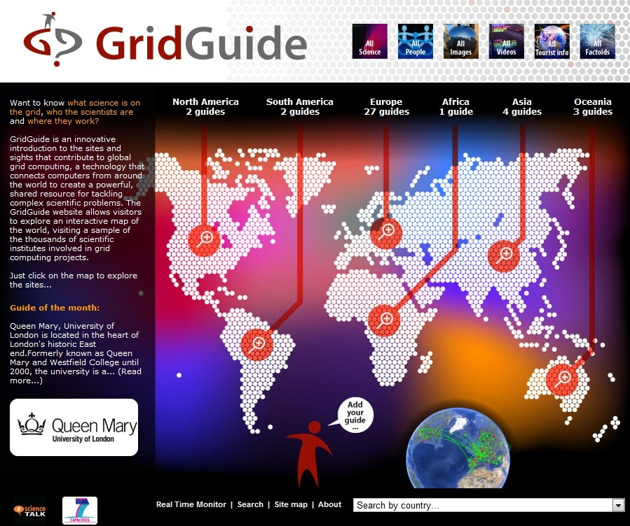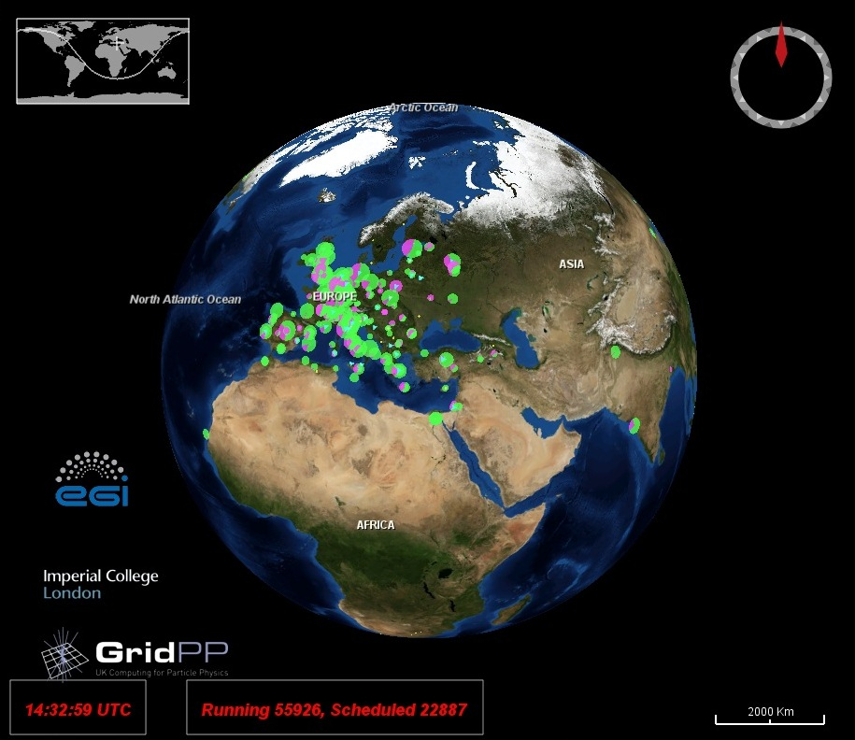

Fig. 1: Screenshot of the GridGuide (left) and Real Time Monitor (right)

progress in year tHREE

Website and logo

In the last 12 months the RTM website has not undergone any major changes.

Maintenance

For the RTM to remain a useful and reliable application it has to monitor two very different areas of technology development. The first is the grid side, where providers and users are still settling on the tools and programmes they are using. The second is the WorldWind code, which is being constantly updated by the developers.

Grid technology is still evolving and sourcing the information about the status of the infrastructure varies from experiment to experiment. During PY1 the RTM integrated the information from the PANDA system used by the ATLAS experiment at CERN (see D2.1 GridGuide Upgraded Integration with the RTM [R1]). During PY2 the middleware used by the majority of sites monitored by the RTM changed subtly and so required some work.

Prior to the start of the e-ScienceTalk project the RTM was upgraded to the latest version of the WorldWind software, this was a major undertaking. Since the start of e-ScienceTalk the RTM has kept abreast of developments of WorldWind and moving to the next full version will be completed during PY3.

User Support

Currently the RTM has a wide range of users, with varying levels of computer literacy. This is in stark contrast to early versions, which were used by a small number of technical users. The RTM website is designed to help the new users, with a dedicated mailing list for “power” users to inform them of new developments. There is also an email address for feature requests, bug reporting and support questions.

In PY3 efforts are being made to develop better communications channels with system admins at Grid Sites, to ensure that new and existing sites on the RTM have the correct data and to stop sites disappearing.

Extending the RTM Functionality

LHC Experiments Data

The addition of new data layers from LHC experiments ATLAS and CMS is underway, but has been put on hold due to work developing a RTM-based exhibition for The Science Museum.

Upgrading software

The latest stable release of NASA WorldWind is 2.0. During PY3 significant work has been carried out to move the RTM over to this latest version of WorldWind, which should be achieved in PM35.
The employs OpenGL 2.0, which should improve stability and performance. The new version is
Also compatible with WebStart on the Mac version of Java. (Java 1.6 originally caused problems with the RTM on the Macintosh platform).

LHC Exhibition at the London Science Museum 2013

During PY2, the UK Science Museum expressed an interest in including the Real Time Monitor in their LHC exhibition, Collider. Collider will open on 13 of November 2013 and run for six months. Janusz Martyniak is working on a number of features that will make the RTM more accessible and visually appealing to the tens of thousands of visitors that will visit the exhibition. This includes technical improvements (e.g. optimising the code and solving issues with the JAVA code for the map), but it also includes some general aesthetic improvements requested by the museum (e.g. a full screen version, a globe that automatically jumps between locations, a recorded offline version, more data sources CMS-Phedex). This should be implemented by the end of the project in time for the exhibition.

Currently the RTM is working in full screen on a Mac thanks to API changes in moves by small circle to decrease judder between point of interest grid sites – rotates at constant latitude. The Science Museum would like to implement a demo that moves between grid site ‘points of interest’ with variable speed.

Conclusion

During PY3, the team worked on improving the amount of information provided by the GridGuide, increasing the overall number of guides but also improving coverage outside Europe. The RTM has been upgraded with software updates and the team has worked on integrating new data sources and infrastructures into the display. The aim for PY3 has been to complete the transfer to the latest version of WorldWind, fully integrate the CMS data transfers, continue to ensure that the application displays up-to-date and accurate information and investigate displaying data from new sources and infrastructures.

References
R 1 | D2.1 GridGuide Upgraded Integration with the RTM  https://documents.egi.eu/document/766
R 2 | D2.3 Annual Upgraded Version of the RTM  https://documents.egi.eu/document/1299
R 3
R 4

