EGI-Engage

Application of the simulation portals for scientific scenario in disaster mitigation
D6.20

Date | 27 February 2017
Activity | WP6
Lead Partner | Academia Sinica
Document Status | DRAFT
Document Link | https://documents.egi.eu/document/3024

Abstract
Demonstrators built by the Disaster Mitigation Competence Centre within the simulation portals.

COPYRIGHT NOTICE
This work by Parties of the EGI-Engage Consortium is licensed under a Creative Commons Attribution 4.0 International License (http://creativecommons.org/licenses/by/4.0/). The EGI-Engage project is co-funded by the European Union Horizon 2020 programme under grant number 654142.
DELIVERY SLIP
 | Name | Partner/Activity | Date
From: | Eric Yen and Simon Lin | Academia Sinica / WP6 | 27/02/2017
Moderated by:
Reviewed by
Approved by:

DOCUMENT LOG
Issue | Date | Comment | Author/Partner
v.1 | 27/02/2017 | Full draft for external review | Eric Yen/AS
...
...
v.n

TERMINOLOGY
A complete project glossary and acronyms are provided at the following pages:
- https://wiki.egi.eu/wiki/Glossary
- https://wiki.egi.eu/wiki/Acronyms

Contents
1 Introduction 6
2 Service architecture 7
2.1 High-Level Service architecture 7
2.2 Integration and dependencies 9
Table 1. Summary of case studies conducted by DMCC 10
2.2.1 Typhoon Haiyan Case Study 10
2.2.2 Malaysia Flood Case Study 13
2.2.3 Long-Distance Forest Fire Dust Transportation Case Study 15
3 Plan for Exploitation and Dissemination 19
4 Future plans 22

Executive summary

Hazard risk estimation and prediction by numerical simulation is the most effective approach for disaster mitigation studies and applications. Exactly like weather forecast today has been playing a vital role in shaping societal decision-making, many critical decisions must be made in advance of potentially disruptive environmental conditions. The primary challenges lie on our knowledge to the earth system and how to achieve reliable and accurate simulations as early as possible. Consequently, Disaster Mitigation Competence Centre (DMCC) is developing innovative simulation models and providing high performance simulation services from historical event studies, based on deeper understandings of target hazards. Meteorological disasters and hydrological disasters which caused principal social-economical losses in Asia Pacific Region in recent years are targeted, such as flood, typhoon, extreme temperature, tsunami, and long-distance dust transportation.

This deliverable describes the three case studies carried out by simulation portals based on deeper understandings of disaster mechanisms. All case studies are supported by the DMCC collaboration framework which consists of the core multi-disciplinary taskforce and the platform. The taskforce covers scientists group, technical group, e-Infrastructure group and user support group. The platform provides the data access, data management, simulation services, and case studies over the regional e-infrastructure.

Through case studies, local communities of the partner countries jointly work with those groups of the core taskforce to build up the simulation facility for the specific disaster type according to the following steps: Identification of case study; Collection of observation data and supporting materials; simulation model development and validation; infrastructure integration and performance tuning; simulation portal development.

DMCC conducted storm surge, flood, and forest fire dust transportation case studies with different partners by the fundamental weather (WRF) and tsunami (COMCOT) simulation models. For the moment, while finishing these case studies, a new storm surge simulation model has developed and the storm surge simulation portal will be implemented over the Asia Pacific regional e-infrastructure. The souring simulation model would be integrated with the flood or excessive rainfall event to specifically understand the risk of target damages if appropriate data is in place in the future. Long-distance dust transportation services will be implemented by a web portal once the current case study of Indonesia is validated by further observation data. All these case studies would be compiled into knowledge base of the DMCC collaboration framework and the simulation could be reproduced for education, training and studies. Besides the simulation facilities, users could also access to observation data, archive of historical events, case studies, and knowledge base. New case studies of different disaster types in different places would be initiated while the collaboration is extended. The DMCC collaboration framework is thus increasing disaster mitigation capability as both the case studies and dissemination activities grows. Disaster mitigation needs continuous investment and improvement and regional collaboration is necessary. The DMCC collaboration framework has paved solid ground of regional collaborations for more and more case studies and the knowledge from those cases by the regional e-Infrastructure.

Introduction

This deliverable describes the three case studies carried out by simulation portals based on deeper understandings of disaster mechanisms. The cases are storm surge, flood, and forest fire dust transportation. All case studies are supported by the DMCC collaboration framework which consists of the core multi-disciplinary taskforce and the platform. The taskforce covers scientists group, technical group, e-Infrastructure group and user support group. The platform provides the data access, data management, simulation services, and case studies over the regional e-infrastructure.

Through case studies, local communities of the partner countries will jointly work with those groups of the core taskforce to build up the simulation facility for the specific disaster type according to the following steps: Identification of case study; Collection of observation data and supporting materials; simulation model development and validation; infrastructure integration and performance tuning; simulation portal development.

All these case studies would be compiled into knowledge base of the DMCC collaboration framework and the simulation could be reproduced for education, training and studies. Besides the simulation facilities, users could also access to observation data, archive of historical events, case studies, and knowledge base. New case studies of different disaster types in different places would be initiated while the collaboration is extended. The DMCC collaboration framework is thus increasing disaster mitigation capability as both the case studies and dissemination activities grows.

As descriptions of the DMCC collaboration framework taskforce members, users of DMCC services include scientists of disaster-related disciplines, ICT engineers of disaster mitigation application supporters, e-Infrastructure providers, as well as users who need to make decisions by the disaster risk prediction information from education, research, as well as independent and government agencies.

Service architecture
The service architecture provides an overview of the key (logical) service components and their dependencies to help better understand the structure and logical as well as technical setup of the service.

High-Level Service architecture
These sections describe how the service is built. If already described in technical documentation please provide link.
Highlight and shortly describe any change on the service architecture introduced by this release.

DMCC investigate in-depth the mechanisms of the selected disaster events and develop the appropriate simulation models to reproduce the processes by case studies. Results of case studies include the simulation facility and simulation web portals as well as shared knowledge base made by the complete materials compiled from the case studies. The collaboration framework aims at becoming an open science platform of disaster mitigation so that all the tools, data, resources and simulation facilities are sharable, and the simulations are reproducible. Furthermore, more case studies would be conducted and the knowledge base and shared resources would be enriched by materials from the new case studies.

DMCC collaboration framework consists of the core multi-disciplinary taskforce and the platform. The taskforce covers scientists group, technical group, e-Infrastructure group and user support group. The platform provides the data access, data management, simulation services, and case studies over the regional e-infrastructure.

Through case studies, local communities of the partner country will jointly work with those groups of the core taskforce to build up the simulation facility for the specific disaster type according to the following steps: Identification of case study; Collection of observation data and supporting materials; simulation model development and validation; infrastructure integration and performance tuning; simulation portal development. The DMCC collaboration framework architecture and case study workflow is depicted in Figure 1.

Leveraging the results of case studies, simulation model could be applied to similar disaster events of the same type at different location with customization. By deeper understandings of the hazards, the simulation models would be more accurate. Growing by the case studies, the simulation facilities would be more useful and robust for complicated or compound disasters.

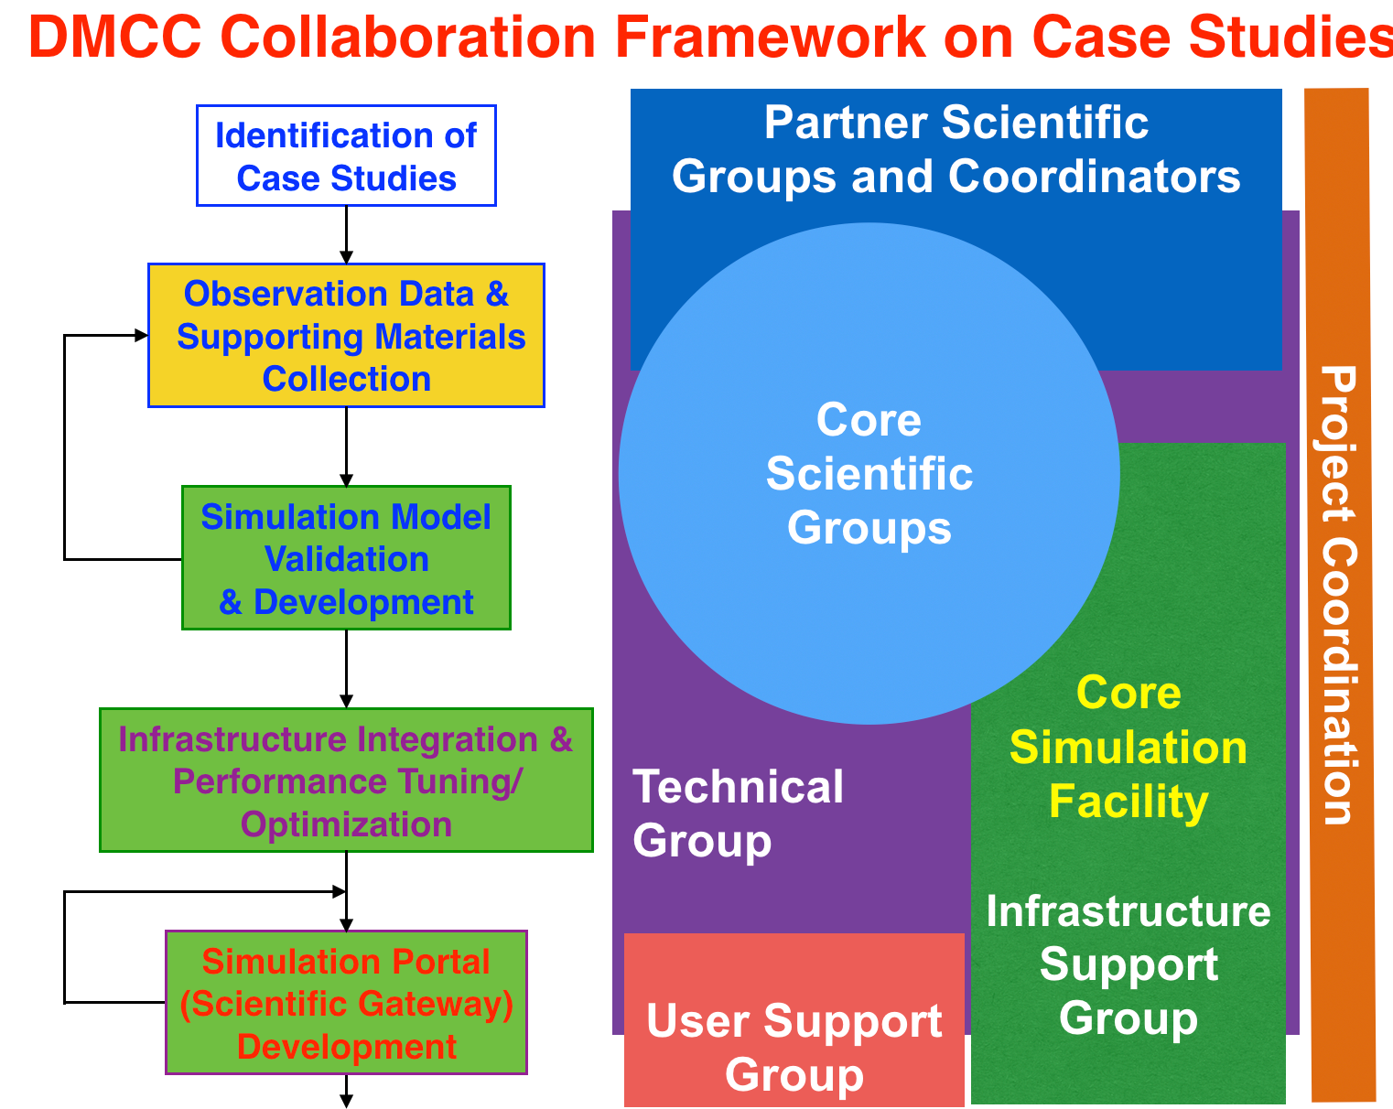
Figure 1. DMCC Collaboration Framework Architecture and Case Study Workflow

In EGI-Engage project, DMCC dedicates to carry out the proposed case studies and verify the collaboration architecture and workflow described above. The synergy of collaborations from user communities (e.g., scientists, information providers, disaster analysts, decision makers), scientist groups, technical groups, infrastructure support groups and user support groups in partner countries could be further exploited by the result case studies, simulation facilities and services, shared knowledge and resources, as well as the future open science platform.

Integration and dependencies
Insert a description and/or visualisation (figure) of the dependencies to other tools.
If already described in technical documentation please provide link.
Highlight and shortly describe any change on the dependencies to other tools introduced by this release.

According to the plan, meteorological disasters and hydrological disasters which caused principal social-economical losses in Asia Pacific Region in recent years are targeted. Weather Research and Forecasting (WRF) model developed by NCAR is used for meteorological event simulation and analysis. gWRF provides the web portal services for numerical weather predication by taking advantages of the regional e-Infrastructure. Cornell Multi-grid Coupled Tsunami Model (COMCOT) model is used for simulations of wave propagation and runup/rundown on coastal regions which is developed by Cornell University. iCOMCOT is the web portal services for COMCOT simulations. DMCC conducted three case studies on three types of disasters in three different partner countries by gWRF and iCOMCOT - storm surge, flood and long-distance forest fire dust transportation, as summarized in Table 1. Through case studies, mechanisms that trigger the hazards were identified. Together with considering whole lifespan of target disaster, the simulation model was enhanced, and the process and parameterization were improved to achieve more accurate simulations. New simulation web portal services for specific disaster type would be developed in the future.

Disaster Event | Type | Partners | Simulation Facility | Future Extension | New Simulation Model and Simulation Portal
Typhoon Haiyan (2013) | Storm Surge | PH, TW | gWRF + modified iCOMCOT |  | Storm Surge simulation system based on the new model is available. The web portal development is underway.
Malaysia Flood (2014-2015) | Flood due to excessive rain | MY, TW | gWRF | Scouring, Landslide | gWRF + Scouring for souring risk estimation is planned.
Forest Fire Dust Transportation (2015) | Dust Transportation | ID, TW | gWRF  (WRF-Chem) | Biomass burning impact analysis | - The same simulation model is applicable to biomass burning impact analysis.  - Long-Distance Dust Transportation Simulation Portal would be developed.

Table 1. Summary of case studies conducted by DMCC

Typhoon Haiyan Case Study

Most of the life and economic losses of typhoon Haiyan (6,340 confirmed fatality and 1,061 missing people, $2.86 billion USD damage) was caused by storm surge induced by typhoon. Accordingly, both the complete life cycle of typhoon and storm surge wave propagation have to be included. A New Storm Surge Model for Typhoon Haiyan by Coupling Atmospheric and Oceanic Models has been developed. Coupled WRF model and in-house COMCOT-based storm surge model incorporating pressure field and wind field analysis were implemented as described in Figure 2. Additionally, to accurately calculate the storm surge characteristics the COMCOT model also incorporates the essential features below.
- Large computational domain is adopted covering the complete typhoon lifecycle and full storm surge propagation extent.
- The global TPXO tidal model is coupled.
- High-resolution storm surge inundation calculation is achieved.
- Support operational storm surge risk estimation by high performance simulation is achieved by the distributed computing infrastructure.

DMCC core scientist group is confident in typhoon forecast for future 48 to 72 hours in terms of track, intensity and pressure. Storm surge simulation thus could be finished in minutes once the weather conditions are available.
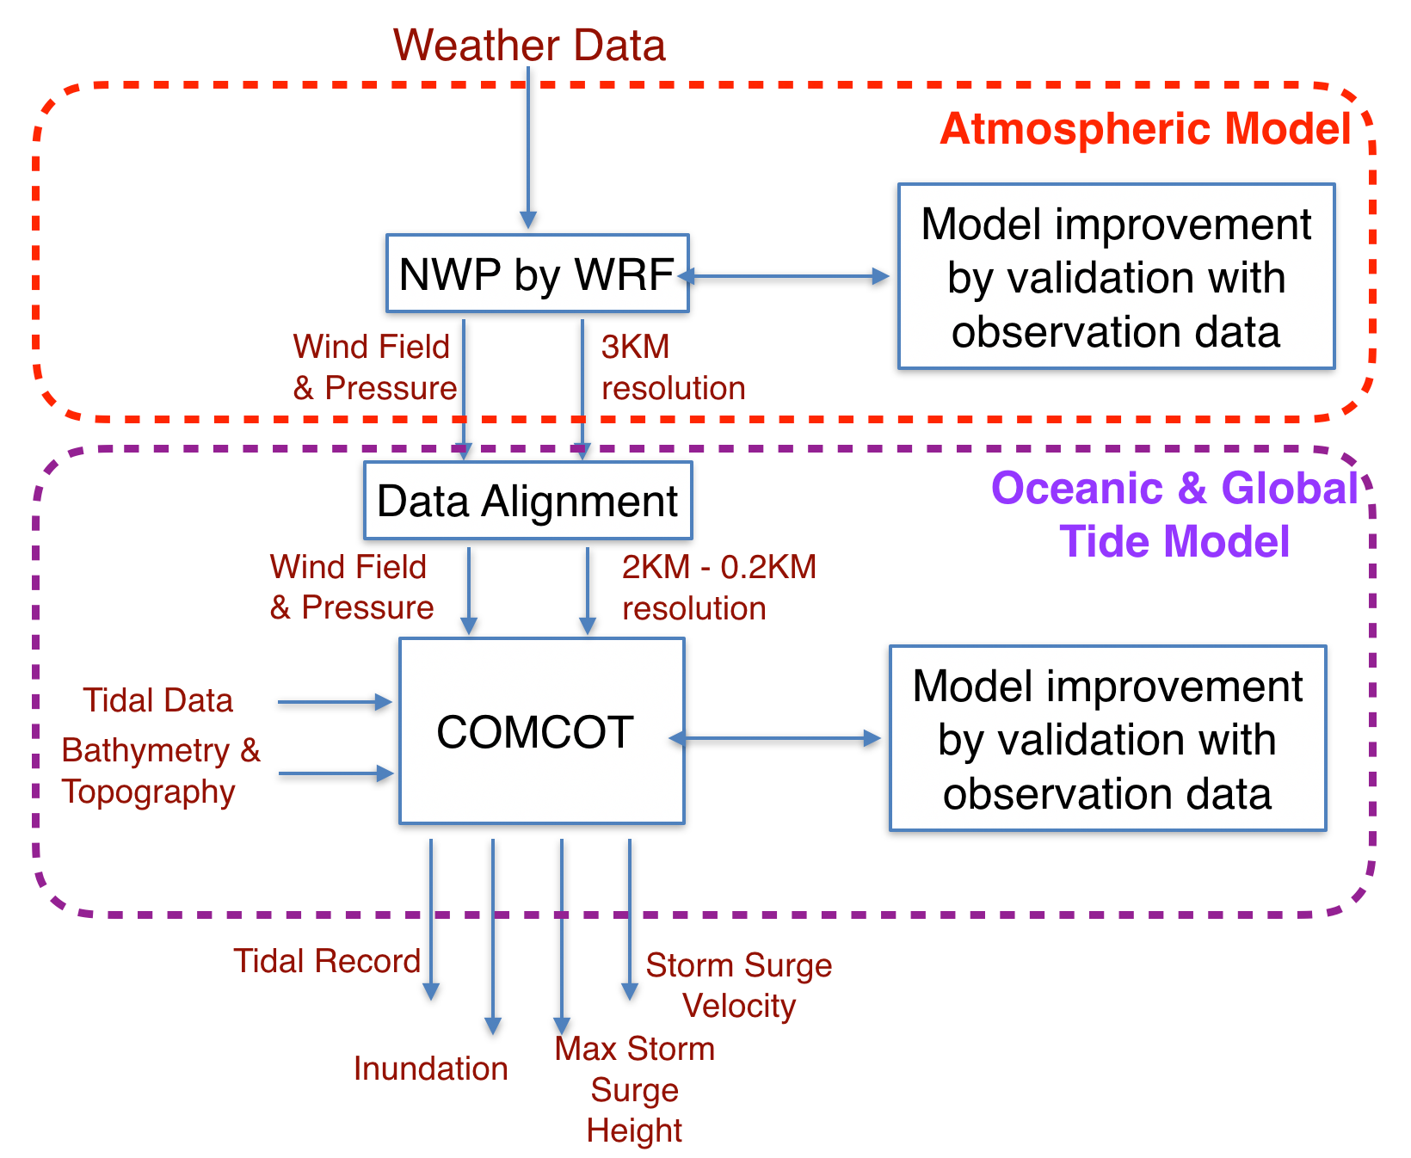
Figure 2. A New Storm Surge Simulation Model for Typhoon Haiyan by Coupling Atmospheric and Oceanic Models

With careful parameterization (especially on the initial condition, boundary condition and resolution) as well as observation data (especially Doppler radar data), the simulation results are very much coincident with the observation as compared by Figure 3(a), 3(b) and 3(c). The track, pressure field and wind field simulations of typhoon Haiyan by DMCC is depicted in Figure 3(d). For such strong typhoon as Typhoon Haiyan, there are still discrepancies in the lowest pressure and highest wind intensity by the current simulation model. Further studies on the physical processes and simulation model will be conducted based on this discovery.

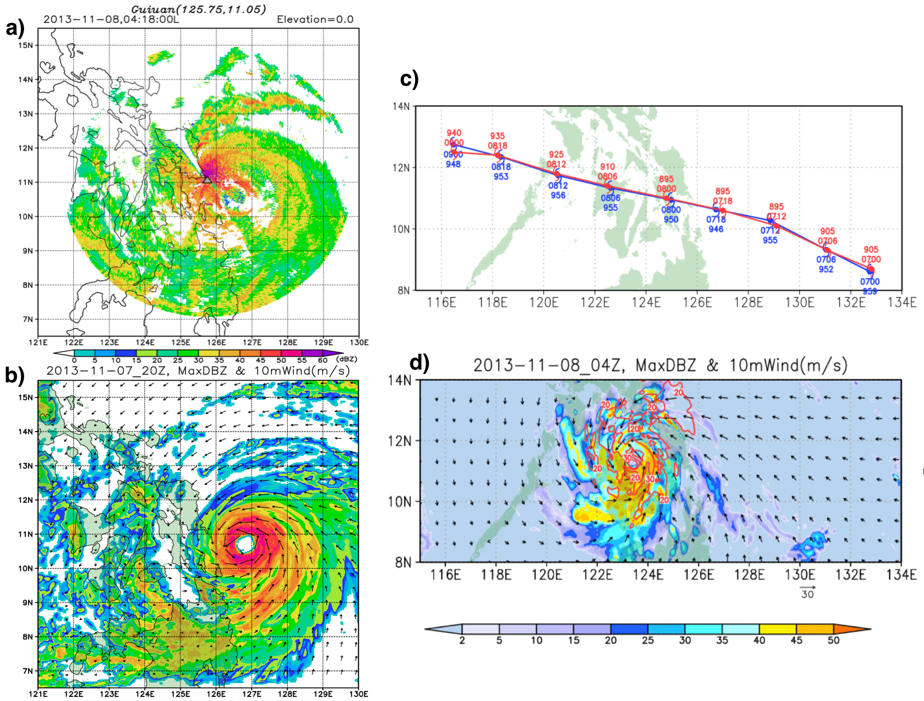
Figure 3. a) Doppler radar data snapshot of Typhoon Haiyan at 18:00, November 8, 2013 (local time). b) WRF simulation result on Typhoon Haiyan of the same time with a). c) Overlaps of Typhoon Haiyan tracks by WRF simulations (blue) and observation (red). d) Wind field and pressure field of WRF simulations on Typhoon Haiyan.

Leveraging the parallelized and optimized nonlinear COMCOT tsunami model, pressure gradient and wind shear stress calculations are included. Furthermore, non-linear interactions among tide, topography and surface friction are also analyzed to attain inundation and runup height. Validated by tidal gauge data, the bias is smaller than 0.1m and root mean square is smaller than 0.6m of storm surge simulations on Typhoon Haiyan by the devised storm surge model. High resolution and high accuracy storm surge propagation simulations on Typhoon Haiyan in offshore regions and in nearshore regions are depicted in Figure 4. The storm surge simulation/model is flexible to utilize to different countries by customized tidal boundary conditions bathymetric characteristics. In the end, a new storm surge simulation web portal will be provided by DMCC.
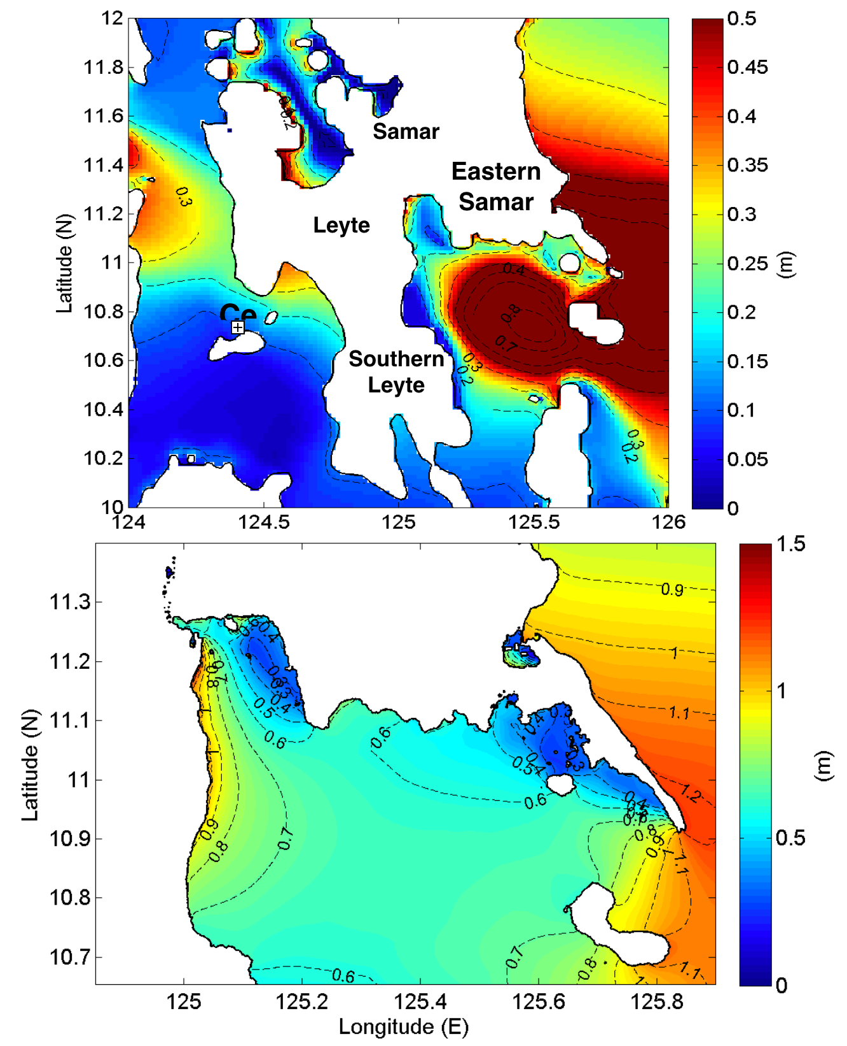
Figure 4. High resolution and high accuracy storm surge propagation simulation on Typhoon Haiyan in offshore regions a) and in nearshore regions b).

Malaysia Flood Case Study

This case study is about the 2014-15 Malaysia flood event during 15 December 23014 and 3 January 2015, 21 people died and more than 250,000 people were displaced from their homes. The economic cost of disaster relief, clean-up, infrastructure loss and rebuilding exceeded 9.4 billion US dollars. This area is subjected to significant large scale and mesoscale interactions, such as: topographic feature induced distribution of deep convection; northeasterly cold surges dominate the low-level circulation patterns; quasi–stationary Borneo vortex; and Madden-Julian Oscillations (MJO) which occurs on intra-seasonal time scales peak amplitude during boreal winter over the Maritime Continent.

In this case, mechanism of the rainfall is mainly dominated by both the southwest monsoon and northeast monsoon which is not unusual. Flood was caused by excessive accumulated rainfall. Formation of the low pressure and its movement affected by the monsoon during the floods period from 12 December, 2014 to 3 January, 2015 was simulated by WRF facility as in Figure 5. Comparison of the weather conditions with the same period of time in 2013 is also provided. Multiple WRF schemes were implemented by gWRF portal facilities and need to verify by observation data which scheme is the best in terms of topographical features of different regions.

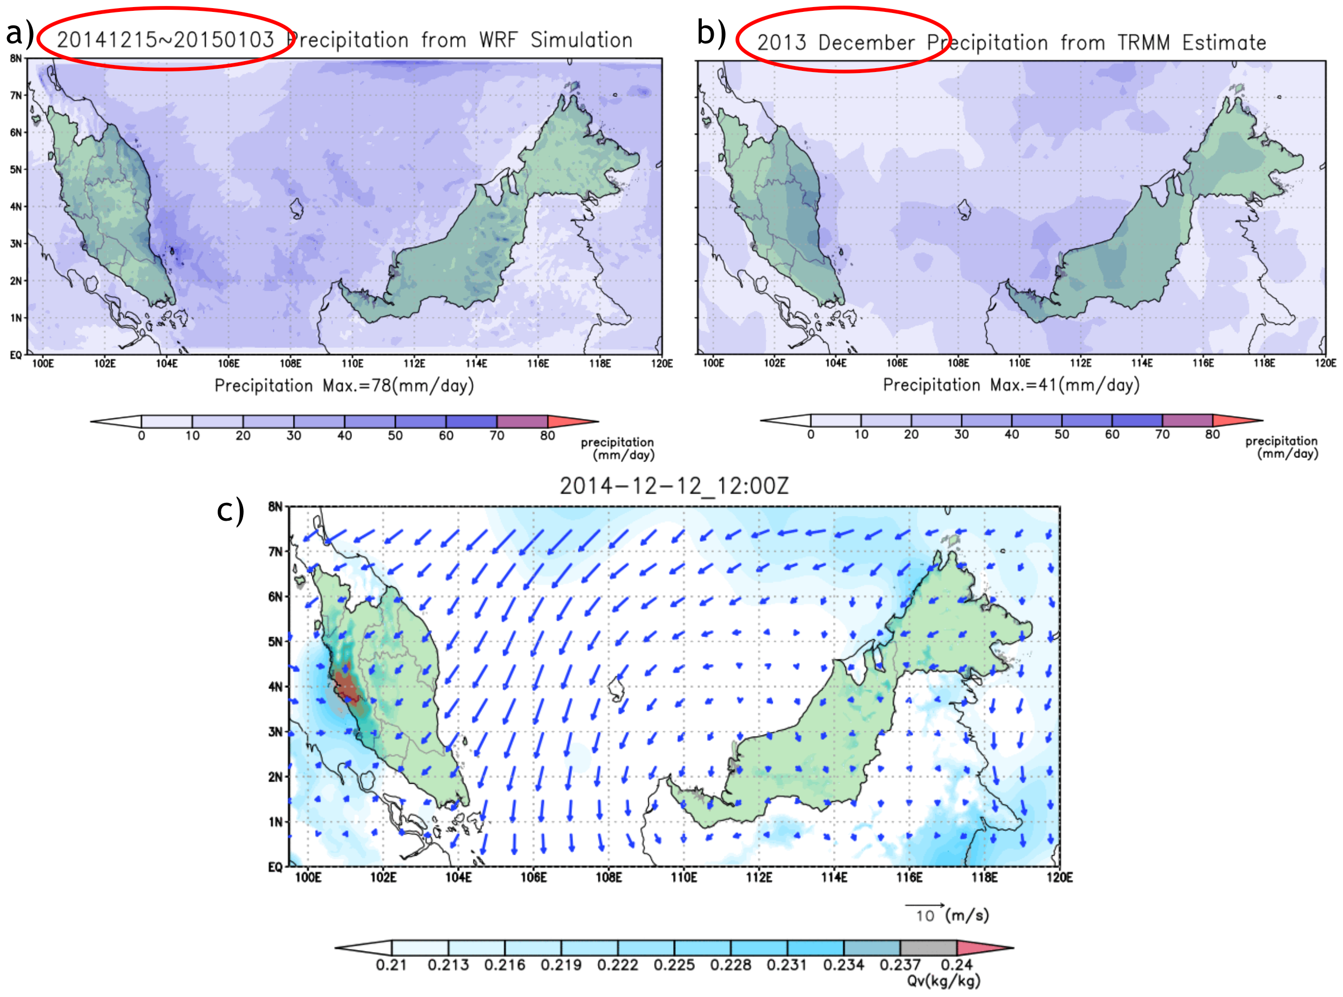
Figure 5. a) WRF simulations on precipitation in Malaysia during 15 December, 2014 and 3 January, 2015 in comparison with the same period of 2013 in b). Wind field simulations was also provided in c).

From the scientific group of Malaysia, it is confirmed that WRF model was able to predict the event considerably well both qualitatively and quantitatively with the right combination of cumulus parameterization as in Figure 6. The combination of Multiscale Kain Fritch for the outer domains and no cumulus scheme at the innermost domain gives the best agreement with the observation in terms of intensity and location. Various aspect of practical predictability examined are dependency of grid resolution, initial and boundary conditions, and cumulus schemes. Initial analysis and cumulus schemes gave large error to the forecast thus reveals the uncertainties in these parameters should be given utmost priority when simulating the event. In the future, the risk of scouring damages and landslides simulations could be integrated in association with excessive rainfall or flood events.

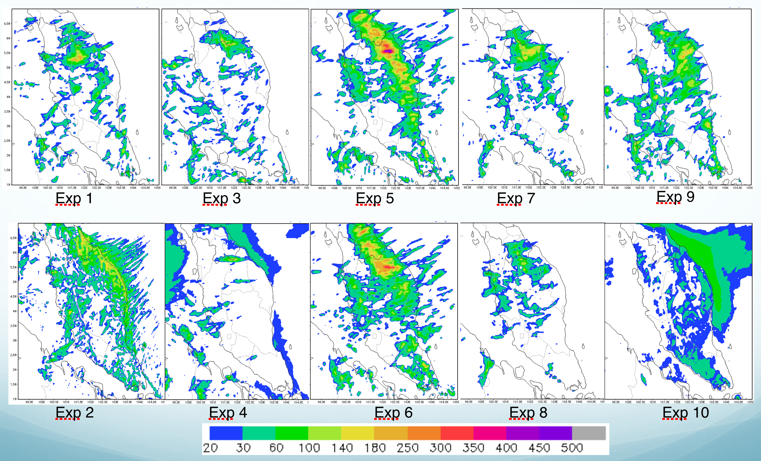
Figure 6. Studies of simulation schemes in capturing the mechanisms of rainfall prediction in WRF.

Long-Distance Forest Fire Dust Transportation Case Study
By using WRF-Chem model in the WRF simulation facility
Biomass burning is the burning of agricultural waste or forest wild fires which causes huge impact on not just local but also regional air quality, biogeochemical cycles, climate and the hydrological cycle. Biomass burning under specific weather conditions contributes a significant amount of air pollutants within a short period of time. During spring and summer (from February to September), fire hotspots dot could be found frequently all over the Indochinese peninsula, Indonesia and India. The biomass-burning aerosols over the Indian Ocean and Asia are one of the critical sources for the formation of atmospheric brown cloud in South Asia. It also has been confirmed to have a significant effect on the ozone concentration in Hong Kong and Taiwan. By improved monitoring on the dust sources and integrating with effective numerical simulation facility, impact of individual aerosol species (such as CO2, PM2.5, PM10, O3) on the climate could be provided. Recent advent of satellite monitoring systems, such as the Along-Track Scanning Radio-meter (ATSR), Advanced Very High Resolution Radiometer (AVHRR), and Moderate Resolution Imaging Spectroradiometer (MODIS), have provided useful information for identifying fire events and the duration of burning as in Figure 7.

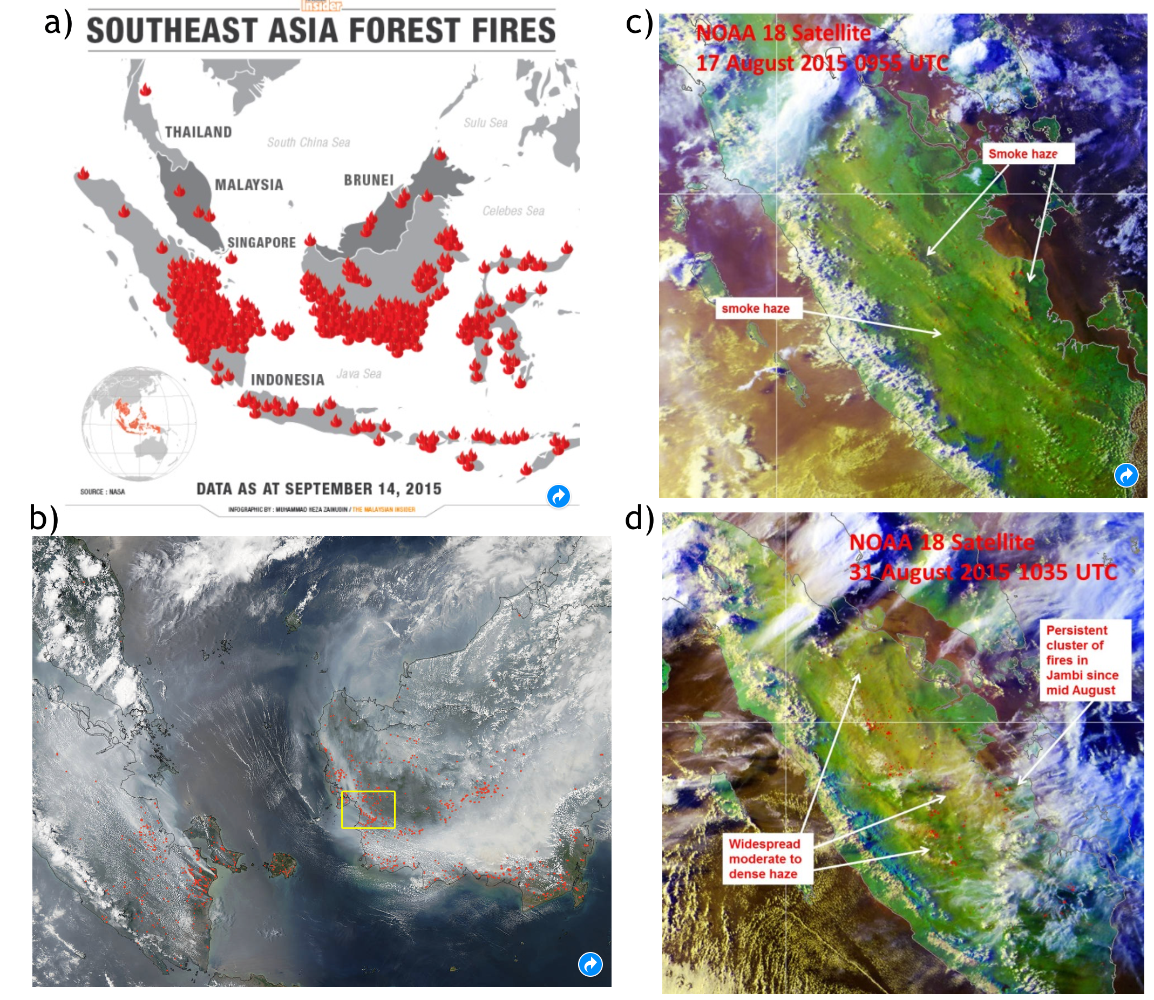
Figure 7. Forest fire hotspots identified from remote sensing surveillance. a) Southeast Asia Forest Fires in 2015 from the Malaysian Insider. b) NASA's Aqua satellite collected this natural-color image with the Moderate Resolution Imaging Spectroradiometer, MODIS, instrument on September 22, 2015. c) NOAA-18 satellite picture on 29 August 2015 shows deterioration of smoke haze situation in Kalimantan. d) NOAA-18 satellite picture on 31 Augusts 2015 shows widespread smoke haze from Sumatra spreading into the Strait of Malacca.

Previous studies of the DMCC core scientific group have already identified that both thermal effect and dynamic forcing resulting from mountain lee-side effect play important roles in enhancing the upward motion of biomass-burning products. Thus, aerosols and pollutants could be uplifted to above 3km and transported by strong westerly winds downwind to Taiwan and even the entire East Asia. Once the forest fire spot is identified from satellite monitoring, numerical modelling provides the effective approach to estimating the impact of individual aerosol species on the radiative forcing and the climate.

This case study analyzed the seasonal variations of CO, O3 and PM10, which are related to biomass-burning emissions from Southeast Asia during the autumn time in 2015.From previous researches we learned that the long-range transport of biomass-burning products to Taiwan is mostly at the elevation of 2000 4000m. To evaluate the amount of pollutants transported from Indochina, a high-altitude sampling site, the Lulin Atmospheric Background Station (LABS) (http://lulin.tw/index_ en.htm) located at Lulin Mountain (23.478N, 120.878E; 2862 m above mean sea level) of central Taiwan was selected for this case study. Measurements of hourly particulate matter with a diameter less than 10 mm (PM), carbon monoxide (CO), ozone (O3) and meteorological parameters such as air temperature and wind field were analysed in this study.

In terms of tracer by WRF-Chem, the linkage between biomass burning in Indonesia and downwind Taiwan is identified and evaluated using the air mass trajectory model and air pollutant transport processes simulated by WRF simulation facility. The online coupled meteorology-chemistry model WRF-Chem (Ver. 3.6) was utilised to study the long-range transport of air masses associated with biomass burning in Indonesia as depicted in Figure 8.
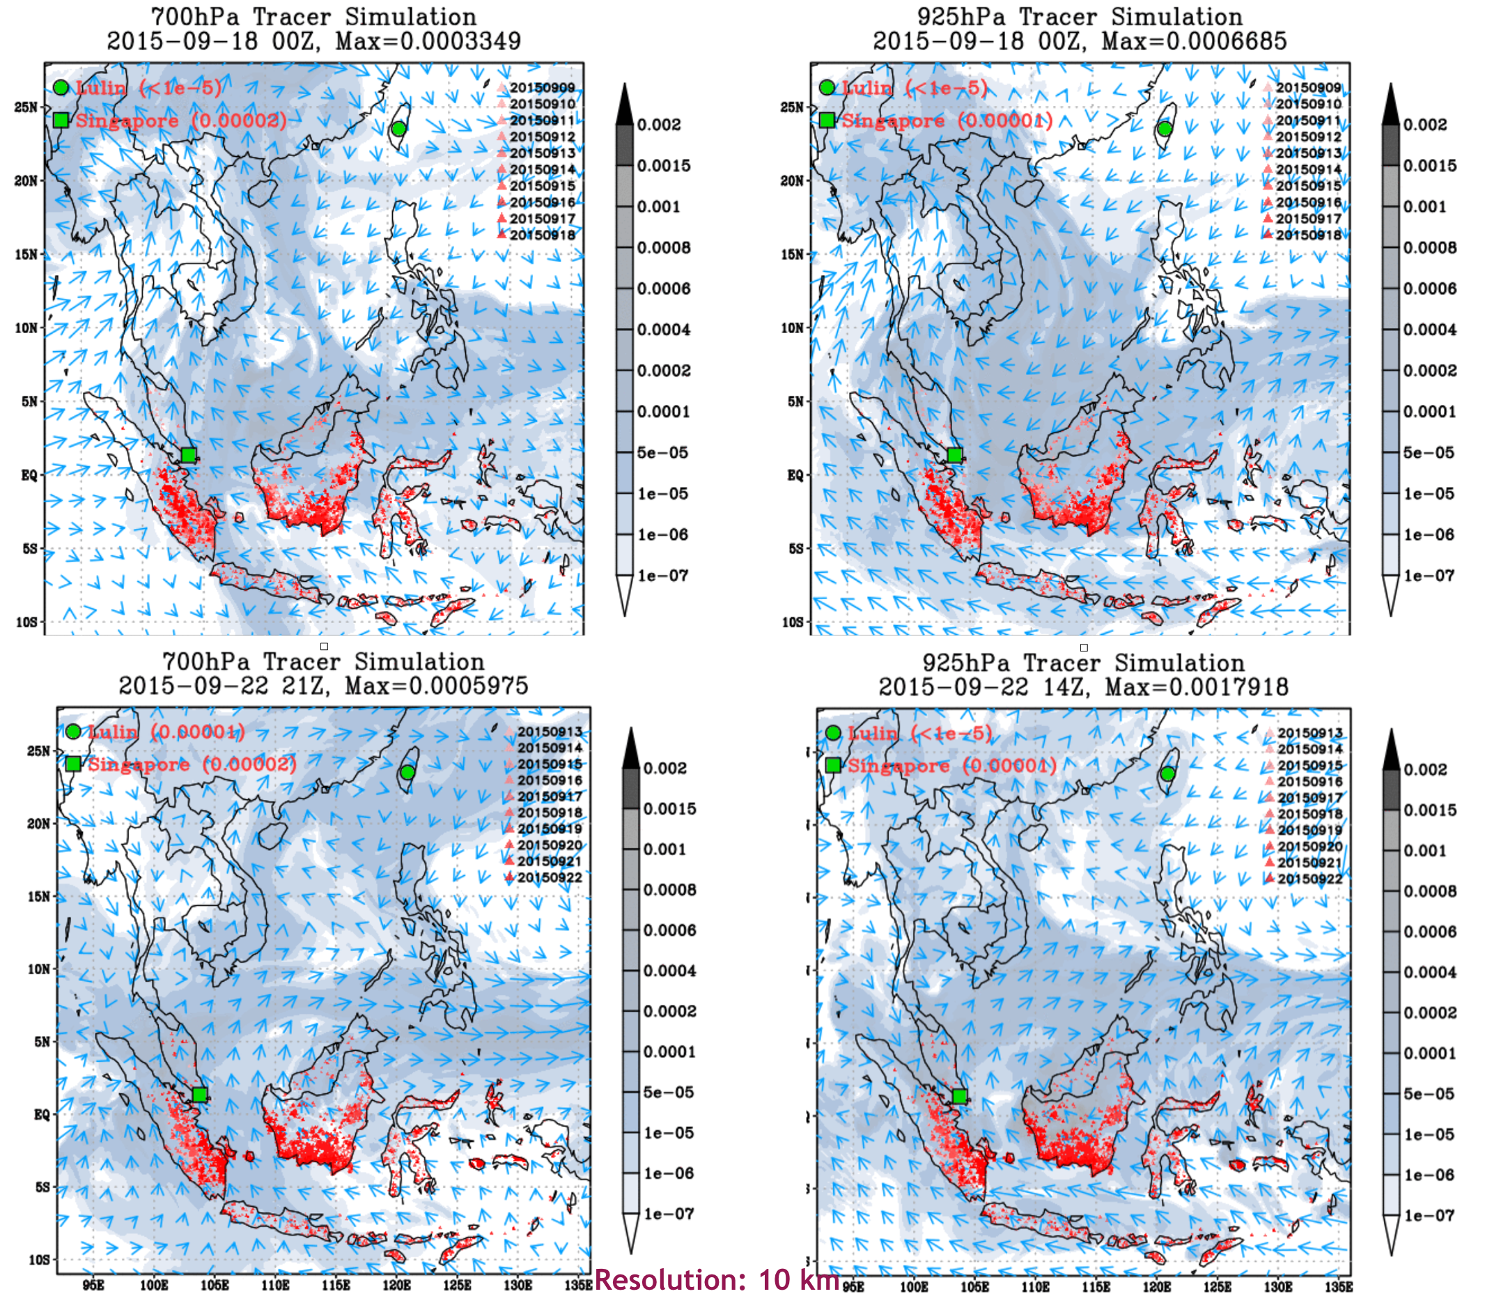
Figure 8. Snapshots of simulations on long-distance dust transport of forest fire burning in Indonesia by WRF simulation facility provided by DMCC during 18-22 September 2015 in 700hPa and 925hPa.

Plan for Exploitation and Dissemination
This section should provide a plan for exploitation and dissemination (PEDR) of the project results documented in this deliverable. If a plan was already provided in an earlier deliverable, then this plan should provide an update. The content will be used to update the catalogue of project results (http://go.egi.eu/egi-engage-results) and to develop an overall PEDR for the whole project. You can create as many tables as the number of results being described.

Name of the result | Enhanced Disaster Mitigation Competence Centre Collaboration Framework
DEFINITION
Category of result | - Policy & Procedure developments: Technical procedures directed at users, service and infrastructure providers (for example to govern access and allocation to resources), policy reports and recommendations, and strategic analysis  - Software & service innovation: Software developments: (e.g.: workflows, Virtual Machines, applications), new software services deployed for the direct benefit of researchers (e.g.: web portals, gateways), e-Infrastructure Commons such as accounting, AAI, and the Federated Cloud platform and the Open Data platform, demonstrators and prototypes.  - Business model innovation: Business and sustainability-related outputs (the EGI Service Marketplace concept, the contribution to the Innovation space for the big data value chain, sustainability plans, pay-for-use models)  - Know-how: Includes all results from fact-finding activities (e.g. surveys, requirement gathering), but also the results from internal exercises (e.g. security challenges) and outputs that can be used for knowledge transfer as training materials.
Description of the result | The deliverable is building the DMCC collaboration framework to conduct case studies, to deeper understand the mechanisms of disasters, to compile knowledge base from case studies, to engage more user communities from Asia Pacific countries, to extend the e-Infrastructure and simulation facilities, to increase capacity of disaster mitigation by better simulations, and to share all tools, data, resources.
EXPLOITATION
Target group(s) | Describe who will use those results. Es: RIs, international research collaborations and the long-tail of science, industry/SMEs, service providers, Funding agencies and decision/policy makers, Standardisation bodies"  Users of DMCC services include scientists of disaster-related disciplines, ICT engineers of disaster mitigation application supporters, e-Infrastructure providers, as well as users who need to make decisions by the disaster risk prediction information from education, research, as well as independent and government agencies. The services are valuable for industries such as risk estimation as well.
Needs | What are the needs of the target groups that the results aims to fulfil?  From the DMCC point of view, collaboration on disaster case studies to enhance the deeper understandings of disasters, simulation facilities and the result knowledge base is first priority. User could make use of the web portals to achieve his own simulations with observation data and knowledge to the mechanism caused the disaster.
How the target groups will use the result? | How the project result will be used? How are you going to achieve the best benefits from the project outcomes? How can you make sure the results they owned are used:  - in further research activities other than those covered by the project concerned  - in developing, creating and marketing a product or process  - in creating and providing a service  - in standardisation activities  Note: The exploitation does not need necessarily to be done by participants, who may prefer to ensure its use by another entity. Such indirect exploitation can be performed by licensing the results or assigning them to third parties, in accordance with the requirements established in the grant agreement "  Regional and multidisciplinary collaborations are of essential importance to disaster mitigation development in Asia Pacific countries. DMCC case studies exemplify how to make best use of the collaborating resources to solve the real problems and benefit the related communities in the world. Problems of DMCC all come from the real needs which are the most effective driving forces striving for the best solutions. As demands have been coming from countries beyond DMCC members, the DMCC collaboration framework has proven to be beneficial and could attract more cases and synergies.  The DMCC collaboration framework is extending this collaborations in both disaster types, the associated impact activities, cooperation groups and countries and the understandings to the sciences. As an open collaboration, community or individual who can contribute to any of those fields is welcomed to join DMCC collaborations. More importantly, the collaboration framework would be extended distributedly in any type of collaborations in different areas supported by the regional e-Infrastructure. Through open science and open service paradigm, the DMCC collaborations would be sustainable and much valuable.
Benefits | What are the expected benefits of the result when this will be used by the target groups?  It is expected to have more and more applications making use of DMCC services to alleviate disaster losses or to gain useful risk estimation to support the mitigations of future disasters. DMCC minimizes the barriers to use the simulation facilities by web portals and provides consulting services by coordinating experts from the region for much accurate simulations based on investigating disaster mechanisms for future events.
How will you protect the results? | Protection of results is indeed essential in Horizon 2020, since an effective exploitation depends on it. Thus, participants must assess the possibility of protecting their results once these are generated. Please, describe what IP protection approach will you put in place for this result. This can range from simple attribution via open source license to full copyright for commercially exploitable results. (For more information you can read “How to manage IP in Horizon 2020: project implementation and conclusion” https://www.iprhelpdesk.eu/sites/default/files/newsdocuments/FS_IP_Management_h2020_implementation_0.pdf  Open collaboration, open platform, open source and open technology are the fundamental strategy of DMCC. The collaboration framework and services are released under CC BY 4.0 license.
Actions for exploitation | Please, describe the concrete actions that need to be executed to make the result reusable by the target group (e.g., for a software, this can include software packaging for distribution, documentation for the installation, etc). Once executed, the target groups should be able to use the results without barriers.  DMCC services and simulation facilities are all designed to be ease-of-use by web portals and all case studies are reproducible in the collaboration framework.
URL to project result | Link where the result will be made available  The DMCC collaboration framework and services will be released in the official EGI-Engage wiki page by end of EGI-Engage.  https://wiki.egi.eu/wiki/EGI-Engage:Competence_centres
Success criteria | What are the success criteria in terms of adoption by the end of the project?  As mentioned before, as demands have been coming from countries beyond DMCC members, the DMCC collaboration framework has proven to be beneficial and could attract more cases and synergies. To accurately simulate the case studies by devised simulation models than other similar simulations is one metrics. The number of uses of simulation portals is naturally the metrics of the web portals.
DISSEMINATION
Key messages | What messages will you tell to the target groups when informing about the results?  With the DMCC collaboration framework, people do not need to tackle disaster mitigation alone. The framework provides open collaborations for an expert of related disciplines to accomplish accurate simulation model based on deeper understandings of the mechanisms behind disasters. The earlier we could achieve accurate risk estimation, the more opportunity we could reduce more losses.
Channels | What channels will you use to deliver the messages to the target?  (e.g. Scientific publications, EGI web site, EGI newsletter, participation in conferences or trade fairs)  Regional collaboration framework such as Asia Pacific Advanced Network (APAN), conferences such as ISGC and IEEE/ACM hosted ones, and scientific publications, EGI web sites, EGI newsletter, etc.
Actions for dissemination | Describe the concrete set of actions that will be put in place to disseminate this project output. When this result is ready, how will you reach to target group to ensure uptake of the result? (You can list the preliminary list of events where you plan to promote the results or material that will be produced or any other concrete actions that will be put in place during the project)  Disseminations at APAN meetings twice a year (usually held in January and August in different Asia countries) and ISGC (usually held in March in Taiwan) have been planned. Scientific groups and major disaster mitigation group a country are the primary user communities to approach at the planned events.
Cost | What is the expected cost of dissemination actions?  Around 8K Euros for a dissemination event in Asia is needed.
Evaluation | How will you evaluate the impact of the dissemination actions?  User communities engaged and case studies invited after each dissemination event is the basic evaluation criteria.

Future plans
Regional and multidisciplinary collaborations are of essential importance to disaster mitigation development in Asia Pacific countries. The DMCC collaboration framework is extending this collaborations in both disaster types, the associated impact activities, cooperation groups and countries and the understandings to the sciences. As an open collaboration, community or individual who can contribute to any of those fields is welcomed to join DMCC collaborations. More importantly, the collaboration framework would be extended distributedly in any type of collaborations in different areas supported by the regional e-Infrastructure. Through open science and open service paradigm, the DMCC collaborations would be sustainable and much valuable. Continuous investment to DMCC efforts is crucial to maintain the momentum and collaborations to move forward and benefit to not just Asia Pacific but also the rest of the world.

gWRF deliverable: https://documents.egi.eu/document/2784
iCOMCOT deliverable: https://documents.egi.eu/document/2784

