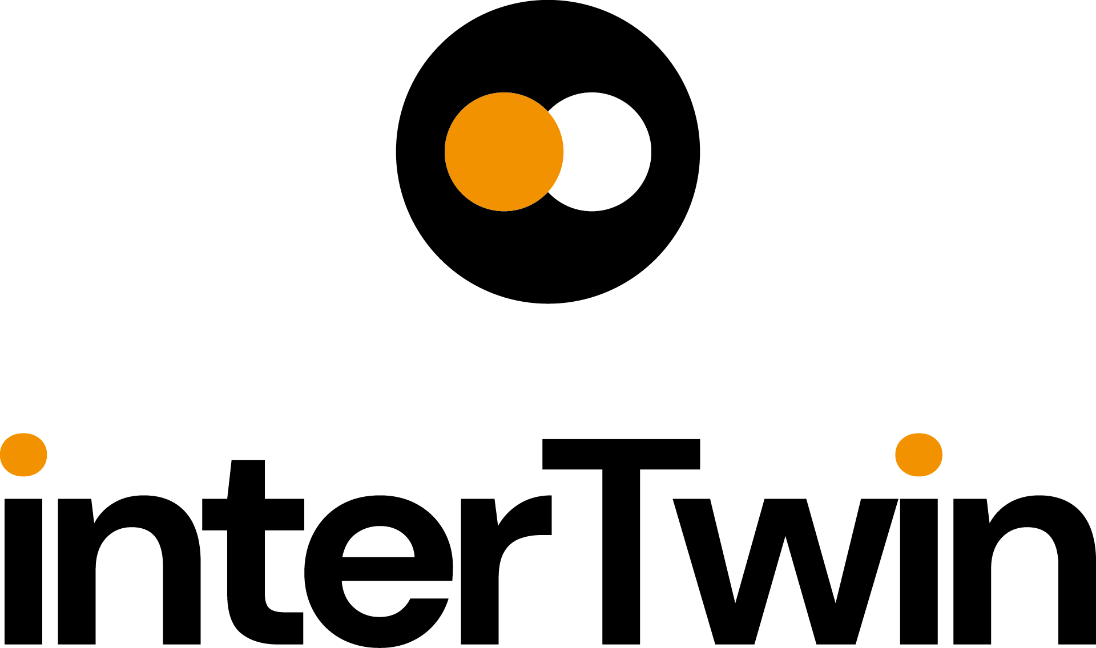

D2.2 Innovation Management and Exploitation Plan
Status: Under EC review
Dissemination Level: public
Abstract
Key Words | Innovation Management, Exploitation, IP Management
interTwin is a project to co-design and implement the prototype of an interdisciplinary Digital Twin Engine (DTE), that enables the implementation of application-specific Digital Twins (DTs).

In this deliverable, the innovation management system and its related plans, processes and procedural activities are outlined in order to ensure the exploitation of the interTwin project in line with the Grant Agreement. The deliverable explains how the context will be assessed, how the results and key exploitable results will be collected and will monitor the related exploitation and business planning activities. Together with communications, dissemination, target groups and project stakeholders will be engaged in order to ensure and maximize the uptake of the project.

This document describes the innovation management system including the main processes, procedures, roles templates and information to be collected, the plan and timeline for doing it and the baseline and initial progress from the initial months. Follow-up progress will be presented in subsequent deliverables D2.4 (M22) and D2.6 (M36)

Document Description
D2.2 Innovation Management and Exploitation Plan
Work Package number WP2
Document type | Deliverable
Document status | Under EC review | Version | 1
Dissemination Level | Public
Copyright Status | This material by Parties of the interTwin Consortium is licensed under a Creative Commons Attribution 4.0 International License.
Lead Partner | EGI
Document link | https://documents.egi.eu/document/3922
DOI | https://doi.org/10.5281/zenodo.8004049
Author(s) | - Xavier Salazar (EGI)
Reviewers | - Björn Backeberg (Deltares)  - Elia Bellussi (EGI)
Moderated by: | - Sjomara Specht (EGI)
Approved by | AMB

Revision History
Version | Date | Description | Contributors
V0.1 | 30/01/2023 | ToC | Xavier Salazar (EGI)
V0.2 | 30/03/2023 | First Draft | Xavier Salazar (EGI)
V0.3 | 11/05/2023 | Second Draft | Xavier Salazar (EGI)
V0.4 | 16/05/2023 | External review
V.05 | 26/05/2023 | Approved by AMB
V1.0 | 02/06/2023 | Final

Terminology / Acronyms
Term/Acronym | Definition
DT | Digital Twin
DTE | Digital Twin Engine
KER | Key Exploitable Result
DoA | Description of Action
GA | Grant Agreement
CA | Consortium Agreement
DestinE | Destination Earth
EEAB | External Expert Advisory Board
EOSC | European Open Science Cloud
ETP4HPC | European Technology Platform For High Performance Computing
EuroHPC | European High-Performance Computing Joint Undertaking
HPC | High-Performance Computing
HTC | High-Troughput Computing
IEG | Innovation and Exploitation Group
IP | Intellectual Property
IPR | Intellectual Property Rights
PEST Analysis | Political, Economic, Social and Technological Analysis
TRL | Technology Readiness Level
TCB | Technical Coordination Board
AMB | Activity Management Board
Terminology / Acronyms: https://confluence.egi.eu/display/EGIG

Table of Contents
1 Introduction 8
1.1 Scope and Purpose 8
1.2 Structure of the document 9
1.3 Framework and Context 9
1.4 Roles and responsibilities 10
1.5 Definitions 11
2 Innovation Management System 17
3 Innovation Management Plan and Main Activities 21
3.1 Market, Technological and Political Context 21
3.2 Capture and Identify Project Results 23
3.3 Exploitation Management 26
4 Innovation Management Processes and Procedures 29
4.1 Market, Technological and Political Context Monitoring 29
Steps 31
4.2 Capture, Identify and Review of Project Results 32
Steps 34
4.3 Exploitation Monitoring 35
Input/Output 36
5 Innovation Management and Exploitation Progress (M6+3) 39
5.1 interTwin Market, Technological and Political Context 39
5.1.1 interTwin Market analysis 39
5.1.2 interTwin Value Chain 40
5.1.3 Liaison with External Stakeholders - Creation of an External Expert Advisory Board 41
5.2 interTwin Project Results 44
5.2.1 interTwin background 44
5.2.2 interTwin main expected outputs and impact 45
5.2.3 Key Exploitable Results 45
5.2.4 Outcomes and Impacts 46
5.3 interTwin Exploitation 47
6 Timeline, Next Steps and Conclusions 50
Annexes 51
Annex 1: Template for Background 51
Annex 2: Template for Project Results 51
Annex 3: Template for Key Exploitable Results 54
Annex 4: Template for Project Innovations 60

Table of Tables
Table 1 - Definitions 11
Table 2 - steps described in ISO 56000 19
Table 3 - collects the EEAB members 42
Table 4 - EEAB expected meetings 43

Table of Figures
Figure 1 - ISO 56000 based Innovation Management System 17
Figure 2 - Main innovation management activities 19
Figure 3 - Generic Segmentation for Market Analysis 22
Figure 4 - Main Activities to understand the market, technological and political context 22
Figure 5 - Innovation Funnel for the Identification of Project 24
Figure 6 - Results Definition and Types. 25
Figure 7 - Types of Exploitation, Paths, and Activities 26
Figure 8 - Procedure for Market, Technological and Political Context Monitoring 29
Figure 9 - Procedure for Identification of Project Results 32
Figure 10 - Procedure for Exploitation Monitoring 35
Figure 11 - interTwin Key Markets 39
Figure 12 - interTwin Value Chain 41
Figure 13 - interTwin Building Blocks 45
Figure 14 - Innovation Management Plan Timeline 50

Executive summary
interTwin is a project to co-design and implement the prototype of an interdisciplinary Digital Twin Engine (DTE), that enables the implementation of application-specific Digital Twins (DTs).

In this deliverable, the innovation management system and its related plans, processes and procedures activities are outlined in order to ensure the exploitation of the interTwin project in line with the Grant Agreement. The deliverable explains how the context will be assessed, how the results and key exploitable results will be collected and will monitor the related exploitation and business planning activities. Together with communications, dissemination, target groups and project stakeholders will be engaged in order to ensure and maximize the uptake of the project.

This document describes the innovation management system including the main processes, procedures, roles templates and information to be collected, the plan and timeline for doing it and the baseline and initial progress from the initial months. Follow-up progress will be presented in subsequent deliverables D2.4 (M22) and D2.6 (M36)

Introduction
interTwin co-designs and implements the prototype of an interdisciplinary Digital Twin Engine (DTE) - an open-source platform based on open standards, that offers the capability to integrate with application-specific Digital Twins (DTs). Its functional specifications and implementation are based on a co-designed interoperability framework and conceptual model of a DT for research - the DTE blueprint architecture. The ambition of interTwin is to create consensus on a common approach to the implementation of DTs that is applicable across the whole spectrum of scientific disciplines that will facilitate developments and interoperability across different DTs.

Scope and Purpose
As part of Work Package (WP) 2 (Innovation Management and Communications), Task T2.1 (led by EGI.eu) deals with Innovation Management and Exploitation. In this deliverable (D2.2), the overall plan for these activities is laid out, in line with communications and dissemination and the project quality and risk management plan.

The activities outlined in this plan address the innovation management system of the project. It includes the description of the plan, the related processes, and procedures, expected activities and the necessary templates to collect the information throughout the execution of the project.

The main aim is to ensure the identification of project results, assess their adequacy to the political, technological and market context and plan the exploitation activities to ensure the results are further developed and taken up beyond the project context or after the end of the project. With the help of T2.2 (Dissemination, Communications and Engagement) it is expected to collect feedback and engage main project stakeholders, to ensure maximum accessibility and reuse of the results and hence to foster project outcomes. How the project results, including the Key Exploitable Results (KER) will be captured, monitored, and exploited, is the subject of this Innovation and Exploitation Plan (D2.2). This deliverable also provides the baseline for the expected results, key exploitable results and exploitation plans as they were foreseen in the Description of Action (DoA) and the initial progress in some of the activities relevant at the initial months.

This plan is designed to be a living document and does not offer final plans/solutions for all the activities of the project at this moment but aims to set the main driving guidelines to work during the project. As such, the Innovation Management plan is stored in the interTwin confluence repository that acts as the platform to store the Progress Register. Hence, as the project evolves, parts of this plan will be updated or amended, depending on the needs. Any needed updates will be included in the corresponding progress report deliverables in M22 (D2.4) and the final report in M36 (D2.6).

Structure of the document
This document contains the innovation management and exploitation plan for the project. The introduction provides the basics of the project including the context and framework, and some important definitions. Section 2 includes the introduction of the innovation management system. Sections 3 and 4 describe the innovation management processes and procedures. Section 5 describes the baseline and actual progress towards the different activities. Finally, section 6 exposes conclusions and the next steps.

Framework and Context
The work to be performed by the Innovation Management plan is described in Task 2.1 of WP2 of interTwin DoA. It entails the definition of an Innovation Management System that,
- Implements and conducts an operational innovation management process that ensures all project results are systematically captured, assessed for exploitation readiness and validated along with an improvement cycle to strengthen them.
- Organises relevant meetings and hands-on workshops (i.e., business models) that will support the complete innovation management lifecycle.
- Coordinates dissemination and exploitation plan, monitoring dissemination effectiveness and potential changing market landscapes, responding to feedback and the potential for new business opportunities.
The main deliverable outputs are:
- D2.2. Innovation Management and Exploitation Plan: This deliverable.
- D2.4 Innovation Management and Exploitation Report and Updated Plan (M20)
- D2.6 Final report on Innovation Management, Exploitation and Sustainability (M36)
This deliverable complements the other deliverables in WP2 referring to the dissemination task
- D2.1. Communication, Dissemination and Engagement Plan
- D2.3. Communication, Dissemination and Engagement Activity Report and Updated Plan
- D2.4. Final report on Communication, Dissemination and Engagement
In those, main target groups, target audiences need to be in line with the main stakeholders. In the middle of the project, dissemination activities will aim to promote the uptake of project results and key exploitable results. At the end of the project, successful exploitation will be turned into success stories.
This deliverable also feeds D1.1 / D1.3 - Quality and Risk Management Plan - as several procedures are described here, together with KPIs and impact metrics needed to track the success of the project.
In order to build and collect the different results a thorough review of all the other deliverables will be done including D1.2 / D1.4 Data Management Plans to understand the Data outputs of the project, and the deliverable from the technical work packages (WP3, WP4, WP5, WP6 and WP7 ) will help to get a full screening of all the building blocks, technologies and services generated during the project.
It is noteworthy to highlight the work related to the interTwin project is bound to the following legal documents:
- Grant Agreement Nr. 1010583836 between the European Commission and the Coordinator (EGI)
- Consortium Agreement between all project partners
Those specific articles and clauses regulate Exploitation, Results, Ownership and joint ownership, Access, and Open Science among others. Some of those have been included in the definitions section.

Roles and responsibilities
An assigned Innovation Manager is responsible for carrying out the activities under the WP2 task within the Project.

The Innovation Manager’s key responsibilities notably include but are not limited to:

- The oversight of all activities related to innovation with the establishment, implementation and operation of an innovation management process that ensures all project results are systematically captured, assessed for exploitation readiness, and validated.
- The organization of the necessary meetings and workshops to support the Parties along the full innovation management lifecycle.
- The support to the definition and maintenance of the project exploitation plan.
- The creation of a register of the results generated by the project that collects, for each, the necessary information on ownership, IPR, access conditions, etc. and to help monitor their compliance with Grant Agreement and Consortium Agreement.
- The resolution of issues related to access and use rights for background and 3rd party assets needed for the implementation and exploitation of the Project
- The monitoring and support of exploitation activities in the context of external collaborations.
- The liaison with the Communication Manager for the dissemination of the results, exploitation outcomes and success stories, and with the necessary Governance Boards and Partners.
- The chairing of the Innovation & Exploitation Group (IEG) and the External Expert Advisory Board (EEAB).

The work towards innovation management will be supported by the Innovation & Exploitation Group (IEG). Main responsibilities of the IEG aim to:

- Support innovation overlaying the ISO standard 56002:2019 processes over the project
- Drive the implementation of the project’s knowledge and protection strategy
- Collect and maintain the information related to project KERs as well as updating and monitoring dissemination and exploitation plan in line with the innovation management task (T2.1). This includes
  - The management of IPR, access rights of the project’s background and foreground
  - The maintenance of information related to dissemination and exploitation activities.
- Give direction and facilitate discussion for capturing opportunities and developing initial technical concept candidates.

Definitions
The keywords "MUST", "MUST NOT", "REQUIRED", "SHALL", "SHALL NOT", "SHOULD", "SHOULD NOT", "RECOMMENDED", “MAY", and "OPTIONAL" in this document are to be interpreted as described in RFC 2119.

Table 1 - Definitions
Definition | Description | Reference
Exploit(ation) | The use of results in further research and innovation activities other than those covered by the action concerned, including among other things, commercial exploitation such as developing, creating, manufacturing, and marketing a product or process, creating, and providing a service, or in standardisation activities | interTwin Grant Agreement
Innovation | A new or changed entity, realising, or redistributing value. An entity is anything perceivable or conceivable, such as a product, service, process, model, method, or a combination of thereof. They can be material, immaterial or imagined. | ISO56000
 | The successful exploitation of new creations (inventions) which can be used to produce tangible benefit, satisfying needs and wants. | Innovation Radar
Innovation management system | Set of interrelated or interacting elements of an Organization / Project to establish strategies, policies and objectives and Processes to achieve those objectives with regard to innovation | ISO56000
Innovation Policy | Intentions and direction of an Organisation as formally expressed by its top management with regard to innovation | ISO56000
Innovation Strategy | Plan to achieve objectives with regard to innovation | ISO56000
Process | Set of interrelated or interacting activities that use inputs to deliver an intended result | ISO56000
Background | Any data, know-how or information — whatever its form or nature (tangible or intangible), including any rights such as intellectual property rights — that is:  - (a) held by the beneficiaries before they acceded to the Agreement and  - (b) needed to implement the action or exploit the results | interTwin Grant Agreement
Results | Any tangible or intangible effect of the action, such as data, know-how or information, whatever its form or nature, whether or not it can be protected, as well as any rights attached to it, including intellectual property rights. | interTwin Grant Agreement
 | What is generated during the project implementation. This may include, for example, know-how, innovative solutions, algorithms, proof of feasibility, new business models, policy recommendations, guidelines, prototypes, demonstrators, databases and datasets, trained researchers, new infrastructures, networks, etc. Most project results (inventions, scientific works, etc) are ‘Intellectual Property’, which may, if appropriate, be protected by formal ‘Intellectual Property Rights | European Commission Horizon Europe Guidelines
Key Exploitable Result | A Key Exploitable Result (KER) is an identified main interesting result (as defined above) which has been selected and prioritised due to its high potential to be “exploited” – meaning to make use and derive benefits- downstream the value chain of a product, process or solution, or act as an important input to policy, further research, or education. | European Commission Horizon Europe Guidelines
Innovation Capacity | Do the project results have the capacity to stimulate further innovations? Does it have the potential to be used in other areas (beyond the project objectives) | Innovation Radar
Innovation Potential | How much benefit (innovation) can the project results potentially deliver | Innovation Radar
Innovation Management | (EC definition) Management of all the activities related to understanding needs with the objective of successfully identifying new ideas and managing them, in order to develop new products and services which satisfy these needs.) | IP Helpdesk
Intellectual Property (IP) | Refers to creations/products of the mind, such as inventions, research & experimentation, or products of creativity. Like physical property, IP is an asset which can be traded (sold, bought, leased, used, or given away), and is protected by law. | IP Helpdesk Glossary
Intellectual Property Rights (IPR) | Is the legal right granted to IP owners to protect their IP, enabling people to earn recognition or financial benefit from what they invent or create. Some common types of IPR are:  - Copyright (Software, written works, engineering drawings…) – it comes into existence automatically upon the creation of the original work  - Patents (Technical inventions) - a monopoly right granted in return for causing the publication of an invention, preventing others to use it without agreement  - Database rights (Creation & arrangement of data) - legal rights that protect the creation & management of data)  - Design rights (Appearance)  - Trademarks  - Confidentiality Agreements (Know-how) | IP Helpdesk Glossary
Ownership of results & Joint Ownership | Results are owned by the beneficiaries that generate them. However, two or more beneficiaries own results jointly if they have jointly generated them and it is not possible to:  - establish the respective contribution of each beneficiary, or  - separate them for the purpose of applying for, obtaining, or maintaining their protection.  The joint owners must agree — in writing — on the allocation and terms of the exercise of their joint ownership (‘joint ownership agreement’), to ensure compliance with their obligations under this Agreement. | interTwin Grant Agreement
Access rights for implementing the action | The beneficiaries must grant each other access — on a royalty-free basis — to background needed to implement their own tasks under the action unless the beneficiary that holds the background has — before acceding to the Agreement:  - informed the other beneficiaries that access to its background is subject to restrictions, or  - agreed with the other beneficiaries that access would not be on a royalty-free basis.  The beneficiaries must grant each other access — on a royalty-free basis — to results needed for implementing their own tasks under the action. | interTwin Grant Agreement
Access rights for exploiting the results | The beneficiaries must grant each other access — under fair and reasonable conditions — to the results needed for exploiting their results.  The beneficiaries must grant each other access — under fair and reasonable conditions — the background needed for exploiting their results unless the beneficiary that holds the background has — before acceding to the Agreement — informed the other beneficiaries that access to its background is subject to restrictions.  Requests for access must be made — unless agreed otherwise in writing — up to one year after the end of the action. Access rights for entities under the same control | interTwin Grant Agreement
Technology Readiness Levels - TRL | - TRL 1 – basic principles observed  - TRL 2 – technology concept formulated  - TRL 3 – experimental proof of concept  - TRL 4 – technology validated in the lab  - TRL 5 – technology validated in relevant environment (industrially relevant environment in the case of key enabling technologies)  - TRL 6 – technology demonstrated in relevant environment (industrially relevant environment in the case of key enabling technologies)  - TRL 7 system prototype demonstration in an operational environment  - TRL 8 – system complete and qualified  - TRL 9 – the actual system is proven in an operational environment (competitive manufacturing in the case of key enabling technologies; or in space) | European Commission Annex G. Grant Agreement
Objectives | The goals of the work performed within the project, in terms of its research and innovation content. These will be translated into the project’s activities. These may range from tackling specific research questions, demonstrating the feasibility of innovation, and sharing knowledge among stakeholders on specific issues. The nature of the objectives will depend on the type of action and the scope of the topic. | European Commission Horizon Europe Guidelines
Outcomes | The expected effects, over the medium term, of projects supported under a given topic. The results of a project should contribute to these outcomes, fostered in particular by the dissemination and exploitation measures (including the uptake, diffusion, deployment, and/or use of the project’s results by direct target groups). Outcomes generally occur during or shortly after the end of the project | European Commission Horizon Europe Guidelines
Impacts | Wider long-term effects on society (including the environment), the economy and science, enabled by the outcomes of R&I investments (long term). It refers to the specific contribution of the project to the work programme's expected impacts described in the destination. Impacts generally occur sometime after the end of the project. | European Commission Horizon Europe Guidelines

Innovation Management System
The objective of Innovation Management in interTwin is to provide a systematic approach to opportunity identification, and validation and turn it into actionable knowledge to enhance the project’s ability to increase the impact of the developed solutions. The opportunities can be related to, but not limited to, the following:
- Capturing demands for new services or new features in existing services (service innovation)
- Tapping into new markets (community outreach)
- Project’s internal activities (e.g., process innovation that makes execution of project’s activities more efficient),
- Interfaces with user and provider communities (e.g., new collaboration models or use cases)
- Interfaces between user communities (e.g., facilitating collaboration between the user communities).
- How to run project activities better (Project innovation)
The Innovation Management System defined in interTwin is based on ISO 56000.
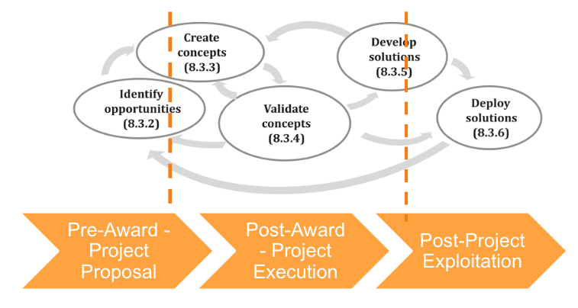
Figure 1 - ISO 56000 based Innovation Management System
Following are the main steps described by the standard:
- Identify Opportunities: This involves identifying opportunities for innovation through analysis of the market, trends, customer needs, and other relevant factors. This step is important to ensure that the innovation efforts are focused on areas with the highest potential for impact and return on investment.
- Create Concepts: Once opportunities have been identified, the next step is to generate ideas and concepts for new products, services, or processes. This involves brainstorming, ideation sessions, and other creative techniques to generate a range of potential concepts.
- Validate Concepts: After generating concepts, the next step is to validate them. This involves evaluating the concepts against criteria such as technical feasibility, market potential, customer needs, and alignment with strategic goals. Validation can be done through methods such as prototyping, market research, and feasibility studies.
- Develop Solutions: Once concepts have been validated, the next step is to develop solutions. This involves designing and engineering the product or service, testing, and refining it, and preparing it for deployment.
- Deploy Solutions: The final step in the innovation management process is to deploy the solutions. This involves launching the product or service in the market, monitoring its performance, and adjusting as necessary.
Those different steps are needed in different phases of the project.
- Pre-Award Phase: The identification of opportunities happens usually during the proposal writing, together with the creation of the necessary concepts for the project to be awarded.
- Post-Award Phase: During the execution phase of the project, opportunities and concepts presented and planned in the proposal are validated and solutions are created. Within the project, there are several iterations that permit new opportunities to be identified and hence create new concepts that were unforeseen during the pre-award phase. These should take into account a bottom-up approach coming from the technical development of the solutions (and their challenges), but also a top-down approach to identify the evolution of the state of the art of the technologies, the state of play of the markets and be able to gather feedback from external stakeholders of the project.
- Post-Project Exploitation: Within Research & Development (R&D) projects expected maturity is reviewed during the execution of the project. Often technologies reach the necessary maturity only after the end of the project. Therefore, appropriate plans for exploitation and sustainability are needed to ensure the take-up and adoption of project results.
The Innovation management plan is built around 3 main activities listed below, to be performed during the project and their corresponding processes and procedures:
- Understanding the Market, Technological and Political Context of the project is crucial to provide the necessary market information to incorporate to the project solutions.
- Capture and identify project results to push technologies and services to the market.
- Prepare, monitor, and update exploitation, business, and sustainability plans in order to ensure the proper uptake of project results to cover expected pathways to impact, while generating the necessary feedback loop back to all other innovation stages of the project.
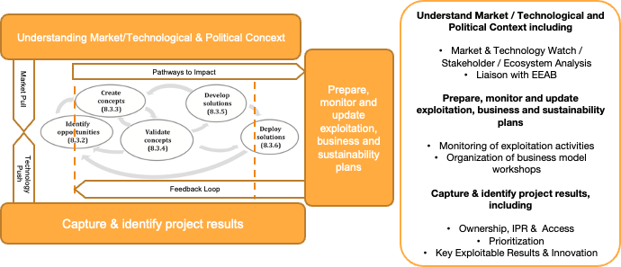
Figure 2 - Main innovation management activities
Those 3 main sets of activities contribute to the different steps described in ISO 56000 as described in table 2:
Table 2 - steps described in ISO 56000
 | Understand Market / Technological and Political Context | Capture & identify project results | Prepare, monitor, and update exploitation, business, and sustainability plans
Identify Opportunities | Understanding market trends, customer needs, can help identify potential opportunities from a market pull perspective | Identification of project results can provide ideas for potential opportunities from a technology push perspective | Feedback loop from exploitation activities can help identify potential new opportunities
Create Concepts | Facilitating the generating concepts that align with market trends and customer needs | Inspiring new concepts based on existing project results, e.g., further developments from missing gaps, technological improvements, etc | Inspiring new concepts for commercialization or further development, such as creation of new services based on project results.
Validate Concepts | Determining feasibility, viability, and desirability based on market context | Providing a baseline for validation and comparison of concepts, based on existing project results | Comparing concepts against project results through testing and prototyping.
Develop Solutions | Ensuring solutions meet customer needs and align with market trends | Inspiring innovative solutions that build upon existing project outcomes. | Exploitation of project results can provide a foundation for developing new solutions or improving existing ones.
Deploy Solutions | Planning deployment strategies ensuring solutions are brought to market effectively. | Identifying opportunities for exploitation based on existing project results | Provide opportunities for deployment, such as licensing or partnerships

In the following sections each of the activities, processes and procedures are described and detailed.

Innovation Management Plan and Main Activities

Market, Technological and Political Context
Understanding the market, technological, and political context is important for identifying opportunities and threats, tailoring project objectives and activities, building partnerships and collaborations, and meeting GA requirements. It can help the project maximize the impact of the results, increase the likelihood of success, and contribute to addressing the expected societal challenges.

In order to do that, a basic market analysis will be performed, expanded, and updated throughout the project. The main objectives of the market analysis are:

- To demonstrate the potential impact of the project: A market analysis helps to identify potential customers, competitors, and market trends relevant to the project. This information can be used to demonstrate the potential impact of the project and its relevance to the market, to ensure the project keeps being meaningful over time.
- To identify potential applications that facilitate the take-up of the project's outcomes. This information will be used to develop the exploitation and business strategy.
- To assess the feasibility of the project: A market analysis can also help to assess the feasibility of the project and its potential to be used after the end of the project. This information is useful to determine whether the project is viable and to identify any potential barriers to adoption.
- To optimise the project's impact by identifying potential users or customers and tailoring the project outcomes to their needs.
- To comply with Horizon Europe requirements: Horizon Europe requires that projects demonstrate the potential for impact and exploitation. A market analysis is a key tool for meeting these requirements and demonstrating the project's potential for success.

Market analysis will tackle not only the main market but will also identify the downstream markets -i.e., infrastructure service providers, market horizontals (i.e., enabling technologies used on top of the infrastructures), market verticals (i.e., application domains) for which the different use cases will be deployed.

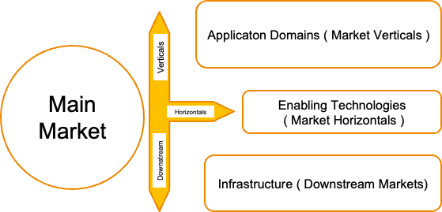
Figure 3 - Generic Segmentation for Market Analysis
Although the scope of the market analysis is expected to be simple, it is essential to understand the evolution of the project context to ensure the relevance and sustainability of the project results over time. In order to assess those trends, a non-exhaustive market and technology watch will be implemented in order to track the most relevant market news from technologies and key stakeholders, policy makers and key documentation (such as roadmaps, policy documents, relevant papers will be shared with the consortium).

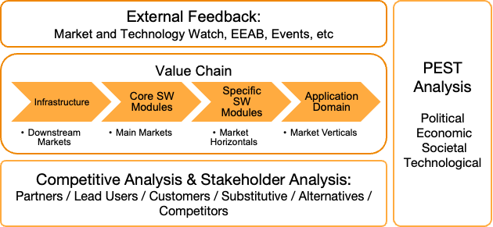
Figure 4 - Main Activities to understand the market, technological and political context

Market Analysis is complemented by a value chain analysis which provides a deeper understanding of the different stages of the results development process and the roles of different stakeholders in creating value. The value chain analysis will help to identify the different activities and actors involved in the creation and delivery of a product or service. For each of the stages lead users, customers, suppliers, substitutive technologies or services, and competitors will be identified. This can provide the basis for a competitive analysis to understand interTwin’s strengths and weaknesses against competitors. This is crucial for planning how to position interTwin’s offering relative to them as an element of the exploitation strategy of the project.

This will facilitate performing a stakeholder analysis in line with the target groups and audiences described in D2.1 Dissemination Plan, describing for each of them the reason for interest, priority, and the expected type of engagement - if we expect them to be informed of the project, for consultation purposes to gather feedback from them or for any further collaboration.

The Market and Technology context will be complemented with a PEST analysis where the political context will be expanded to include regulatory considerations, policy implications, or how governmental initiatives in different regions might impact the Digital Twin market and foster the adoption of Digital Twin technologies in application domains or as part of major European initiatives (e.g., DestinE, EOSC, EuroHPC, ETP4HPC , etc).

Any needed liaison with stakeholders especially to gather relevant feedback, from external sources, such as events, or via the creation of an External Expert Advisory Board to assess the technical implementation, review the blueprint architecture and help along the project in dissemination and exploitation.

Capture and Identify Project Results
Figure 2 depicts a usual innovation funnel to capture results in Horizon Europe Projects. It includes 4 stages:
- Identification of all necessary background, sideground and external know-how, technologies and ideas existing before the beginning of the project needed for the implementation and/or the exploitation of the project.
- Identification of project results and prioritisation of main results.
- Identification of Key Exploitable Results - including the main exploitation paths and business opportunities
- Identification of Project Innovations
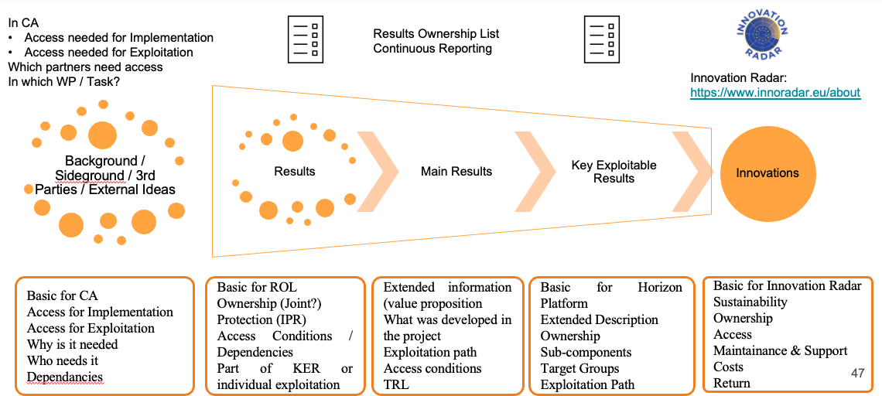
Figure 5 - Innovation Funnel for the Identification of Project
Background needs to be identified during the negotiation of the Consortium Agreement, where every partner needs to indicate the access conditions for implementation and exploitation. Access is governed by Art. 16 of the GA and expanded in the Consortium Agreement. The template for the Background is to be found in Annex 1: Template for Background. Further information that is relevant to the project is to understand why this background is needed, work which activity (under which WP and Task), which other partners needed it and if there are any dependencies with other third-party technologies or expected foreground.
Project Results are generated during the project implementation. This may include, among others, Know-how, Innovative Solutions, Algorithms, Proof of Feasibility, New Business Models, Guidelines, Prototypes, Demonstrators, Databases and Datasets, New Infrastructures, Networks, Research Roadmaps, Policy Recommendations, Reports, Platforms (Collaboration), Skills and Knowledge, Educational Materials, Codes of Conduct, Pre-standards, Prototypes, Software, Publications and Data.
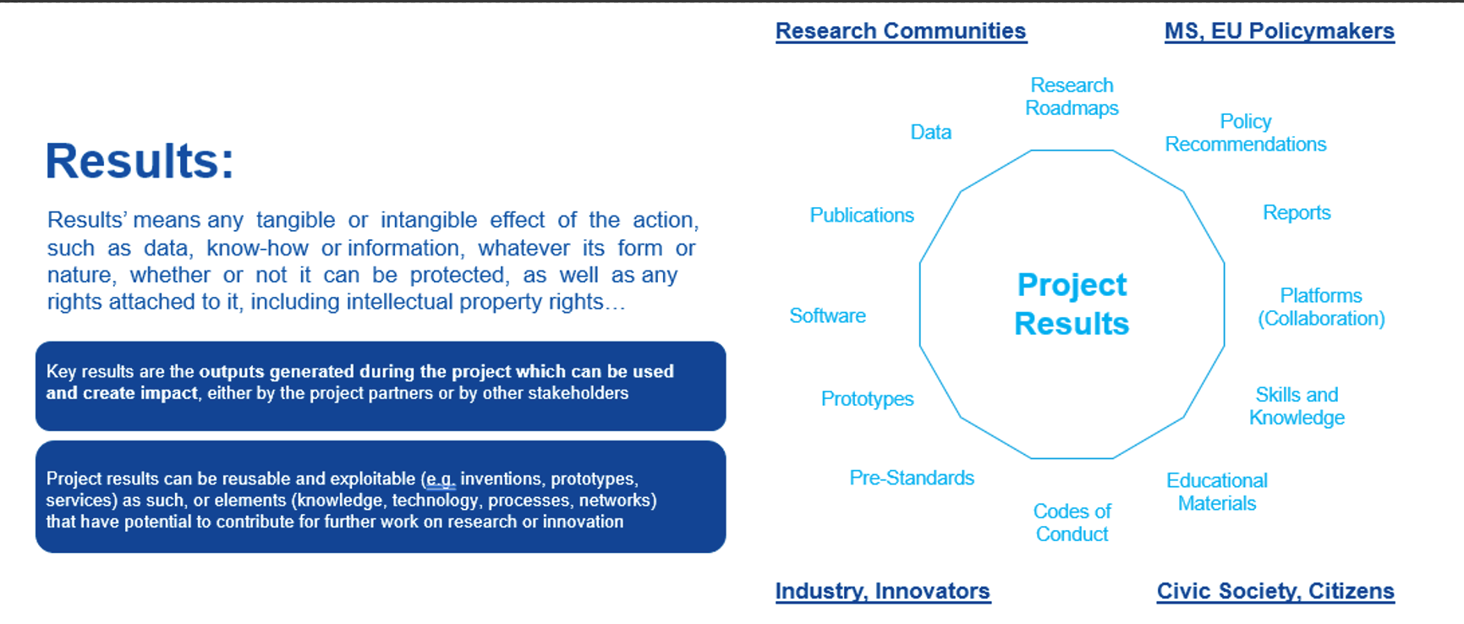
Figure 6 - Results Definition and Types.
Source: Horizon Europe Webinar on Dissemination, Communication and Exploitation
Main Results are the prioritised results by each of the partners because of their exploitation potential. Exploitation may be as part of a project developed technologies and exploited linked to a Key Exploitable Result or exploited directly by the partner from other sources.
Both project results and main results are collected in the results register, as shown in Annex 2: Template for Project Results. Information collected for each of the results is basic to complete the Results Ownership List to be provided as part of the continuous reporting of the participants portal. Key elements to be provided are the ownership of the result, if one or multiple partners, and joint ownership if the corresponding agreement is in place between the owners. Further information needed is the IP protection mechanisms (including associated Intellectual Property Rights), expected access conditions (open or proprietary, under which license), and if there are any dependencies with other third-party technologies or expected foreground or if they are part of a Key Exploitable Result (KER).
Key Exploitable Results (KER) are consortium-level project results from the dissemination and exploitation point of view. They are usually composed of the main set of results of the project. For further refining and consolidating this information, each of the KERs has a "KER champion" assigned to them. The role of the KER champion is to act as the central contact point for all issues that might arise related to KER. The champion also helps to coordinate and encourage the exploitation and dissemination of the KER. The champion also acts as the primary spokesperson for the KER and accepts or suggests changes and improvements of the KER-related documentation, promotional material and plans in collaboration with the different WP2 team members. Each of the KERs are associated with their own exploitation paths to ensure their future uptake after the project.
Annex 3: Template for Key Exploitable Results, shows the template for Key Exploitable Results and includes all the necessary information to upload the KERs to the Horizon Results Platform. In it, an extensive description of the achievements done during the project, TRL level, target groups and expected exploitation paths is to be provided.
Innovations are those KERs and Results that have succeeded in their exploitation efforts and have a higher potential to impact the market and society. Information collected is based on the Innovation Radar methodology from the European Commission, aiming to facilitate the uptake of the main innovations to be showcased on the innovation radar website. The main focus is to provide information on sustainability. Some relevant aspects are Ownership, Access conditions, Maintenance and support, Costs and expected return. The template is provided in Annex 4: Template for Project Innovations.

Exploitation Management
According to the Grant agreement definition, exploitation under the context of a Horizon Europe project is defined as the use of results in further research and innovation activities other than those covered by the action concerned, including among other things, commercial exploitation such as developing, creating, manufacturing, and marketing a product or process, creating, and providing a service, or in standardisation activities

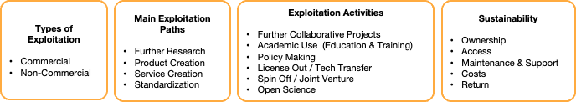
Figure 7 - Types of Exploitation, Paths, and Activities
Hence, exploitation can mean the further use of the results of the project in non-commercial or in commercial settings.

Main exploitation paths as defined in the grant agreement:.

- Further Research: This refers to academic or industrial research conducted within the project that is aligned with the partners' long-term research goals. It is often focused on technologies in the early stages of development (low TRL), those intended for educational purposes. Specific research groups or departments within the partners' organizations are usually responsible for further developing and utilizing the project results internally.

- Service Creation: This involves creating services related to the technologies and knowledge generated in the project, such as software as a service, consulting services, or support services. These services can be offered through service-level agreements or linked to other types of contracts, such as licensing, collaboration, or consortium agreements.

- Product Creation: This is a straightforward path for commercialization, involving developing ready-to-use / ready-for-sale products based on the project results. Product planning includes efforts in documentation, protection, certification, alignment with standards, and marketing, among other things. Creating a well-defined product can also facilitate other exploitation activities, such as technology transfer, licensing, or spin-off creation.

- Standardization Activities: This exploitation path is often overlooked in projects but is crucial for contributing to industrial growth. Standardization activities can involve contributing to the standardization body, which can adopt part of the project-generated knowledge for the creation or the improvement of standards. Another way to work towards standardization is to ensure the alignment of the technologies with existing standards to increase their maturity level and facilitate their uptake. Some open-source projects have become de facto standards, with foundations/organizations supporting the open-source community acting as the standardization body.

Further exploitation activities can be defined on top of or to complement main exploitation paths that can result in the uptake of project results out of the context of the project and contribute to project outcomes

- Further Collaborative Projects: This is essential for bringing technologies to a higher level of maturity or finding early adopters. Collaborative research can take various forms, including follow-up collaboration between project partners, a bilateral collaboration between one partner and external parties, or a joint collaboration between partners and external parties. Collaboration between projects can also occur through the adoption of other parties' technologies, providing them with use cases and test beds, and contributing to increasing their maturity.

- Academic Use/Education and Training: This refers to granting access to project results for academic purposes, which is often overlooked but can have a significant impact on society. The project work can directly contribute to the education of PhD thesis, Master's students or becoming part of high-level university programmes. Disseminating the generated knowledge through master programs and universities ensures that it will be learned and used by future workforces. In addition, seminars, courses, and training can also be valuable and become part of the commercial offerings of project partners.

- Technology Transfer/Licensing: This refers to legal agreements for providing access to project results, which can be proprietary or open source. Proprietary licenses may be limited to specific purposes, sectors, technologies, or uses, with access granted on a commercial or non-commercial basis, for trial and testing or academic/research purposes. Open-source licenses are becoming more common and have different levels of restrictiveness or permissiveness, from copyleft GPL-type licenses to more permissive/academic licenses like BSD, MIT, or Apache.

- Spin-off Creation/Joint Venture: This refers to the creation of spin-offs or joint ventures to exploit the project results, which requires careful preparation following market analysis, business planning, and IP valorisation to detect potential business opportunities. Organizations created can be for-profit or non-profit, such as foundations, associations, or other legal forms.

Within interTwin exploitation paths will be linked to the Key Exploitable Results and to each of the partners. In order to deepen the economic sustainability of the project and the future take-up of the results, two hands-on workshops (e.g., business models) will be organized in the middle and towards the end of the project in order to support the generation of business cases and help to complete innovation management lifecycle.

Innovation Management Processes and Procedures

Market, Technological and Political Context Monitoring
The procedure describes steps to be taken to understand the market, technological and political context part of the Innovation Management Plan of the project.

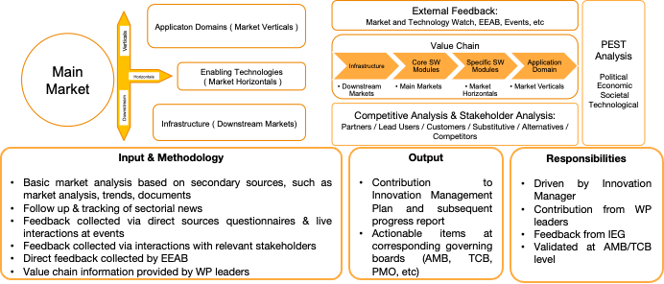
Figure 8 - Procedure for Market, Technological and Political Context Monitoring
The goals of this procedure are:
- Identify relevant markets and their main stakeholders (including users, across the project value chain).
- Gather external feedback including indirect sources, such as documents, news and report and direct sources from any further relevant stakeholders (e.g., Experts, End Users, Policy Makers, Industry representatives, Academics, etc).
- Curate information and turn it into actions to be performed by the project.
- Provide a strong basis for justifying the project relevance and adequacy to all the relevant stakeholders over time and adapt & react to changes and assess the generation of new opportunities.
There are many ways through which gathering external feedback can be done:
- Leveraging knowledge from the project/project partners
  - Desk research and careful analysis of project deliverables, milestones, DoA, project proposal, presentations and other dissemination material generated by the project.
  - From each of the consortium members, WP leaders, and task leaders, in contact with their own ecosystems. Contact can be done by e-mail, one-to-one telcos, during regular periodic meetings with different boards (Activity Management Board (AMB), Technical Coordination Board (TCB), Innovation and Exploitation Group (IEG), etc), in specific workshops, etc.
- Integrating knowledge from external sources
  - Desk research and careful analysis of relevant news, market analysis documents, industrial reports, white papers, scientific papers, presentations, patents, technology roadmaps, etc
  - Organisation of an External Expert Advisory Board
  - Direct feedback gathering at events (structured, semi-structured or informal), interviews, workshops, hackathon, ideathons, etc.,)
  - Online feedback - such as questionnaires, feedback e-mails, etc
- Information gathered is curated and validated by Technical Coordinator and Innovation and Exploitation Group and assessed in the corresponding board meetings (AMB, TCB, IEG, etc) and turned into actions.
Input/Output
Project documentation (such as Consortium Agreement, DoA, Grant Agreement, Deliverables, Milestones, Periodic Reports and WP reports, presentations and other dissemination material generated by the project, etc.) | In
External documentation (such as news, market analysis documents, industrial reports, white papers, scientific papers, presentations, patents, technology roadmaps, etc.) | In
Feedback from WP leaders, task leaders, consortium members and with different boards of the project | In
Feedback from external relevant stakeholders (e.g., Experts, End Users, Policy Makers, Industry representatives, Academics, etc.) by the organization of an External Expert Advisory Board, at events, online, etc. | In
A basic market & technology watch/analysis | Out
Set of actions to be performed by the project | Out
Curated information to can be used for the Results & Exploitation activities | Out
Procedure outputs need be incorporated:
- At the Corresponding Innovation Management Progress Deliverables
- Translated into news Items or social media updates (Twitter / LinkedIn) in case it is relevant
Entities involved in the procedure
- Innovation Manager
- Technical Coordinator
- WP leaders, task leaders
- Consortium members
- Different boards of the project (TCB, AMB, General Assembly (GA), etc)
- Innovation and Exploitation Group
- External relevant stakeholders (e.g., Experts, End Users, Policy Makers, Industry representatives, Academics, etc)
Triggers
It needs to start from the beginning of the project. Market and Technology Watch progress is monitored regularly at the corresponding (AMB, TCB, etc) meetings. EEAB is triggered upon the organisation of F2F meetings. Feedback gathering at Events upon participation at the events.
Several checkpoints and iterations will be needed depending on
- The submission of the deliverables
- The submission of periodic reports/participation at project reviews
- Upon dissemination and communications and exploitation needs

Steps
# | Responsible | Action Action
1 | Innovation Manager | Desktop research and careful analysis of the relevant project and external documentation
2 | Innovation Manager | Create the necessary templates and assign responsibility for filling it among, consortium members, WP leaders, task leaders, and with different boards of the project asking to fill in the necessary information. In case of unclear responsibility, AMB should be consulted.
3 | Innovation Manager | Contact assigned responsible for filling the templates
4 | Assigned Responsible | Fill in the necessary information to the templates
5 | Innovation Manager, Project Coordinator, TCB | Set up & organisation of the EEAB
6 | Innovation Manager, Project Coordinator Dissemination Responsible, Consortium members | Prepare feedback gathering at Events
7 | Innovation Manager | Incorporate as a discussion topic in regular periodic meetings (AMB, TCB, etc.)
8 | Innovation Manager | Curate Information gathered from all the different sources to the Market, Technological and Political Context section of the Innovation Management Progress Register and translate into actions
9 | Technical Coordinator and IEG | Validate information gathered and actions proposed and perform and request any necessary correction from assigned responsible
10 | Project Boards (AMB, TCB, etc) | Decide on the actions to be taken
11 | Innovation Manager | Incorporate Curated Information into the necessary tasks, deliverables and to Communications Officer for News content

Capture, Identify and Review of Project Results
The procedure describes how information about project results is gathered. Though all project results are captured and documented, detailed analysis is limited to a subset of these results which are deemed important.
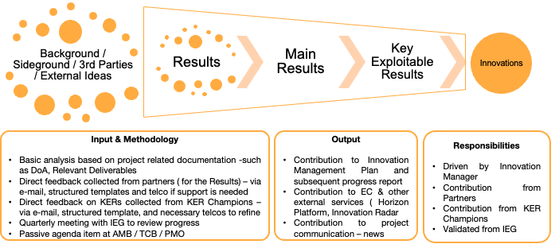
Figure 9 - Procedure for Identification of Project Results
The goals of this process are
- Identify, record, and manage the project results.
- Curate detailed information for a subset of the project results.
- Ensure that innovation developed or enhanced by the project is well-documented.
- Provide a strong basis for all other processes in Innovation Management.
There are many ways through which identification of project results can be done,
- Desktop research and careful analysis of deliverables, milestones, DoA, project proposal, presentations and other dissemination material generated by the project.
- Direct e-mail to each of the consortium members, WP leaders, task leaders, and with different boards of the project
- During regular periodic meetings AMB, TCB, etc
- Through a specific workshop during a Face to Face:
  - Participants: Work Package leader, task leaders (and task members) at a work package level meeting.
  - Duration: 1-hour
  - During Workshop: Explain the objective of the workshop. Explain what project results are and give some examples. Use brainstorming or brainwriting to generate project results related to that work package.
- Results are curated and validated by the project coordinator and Innovation and Exploitation Group
- A combination of all. Desk research can be augmented with a simple 30-minute discussion with work package leaders, individually going through the identified results for their work package and adding, supplementing, or modifying the existing list.
Input/Output
Consortium Agreement, DoA, Grant Agreement | In
Deliverables, Milestones, Periodic Reports and WP reports | In
Discussions with WP leaders, task leaders, consortium members and with different boards of the project | In
A List of Project Results | Out
Curated information for a given Project Result | Out
Collection of results need to be incorporated at
- Corresponding Innovation Management Progress Deliverables
- Continuous Reporting from European Commission
- Translated into News Items for the relevant ones

Entities involved in the procedure
- Innovation Manager
- Technical Coordinator
- WP leaders, task leaders,
- consortium members
- Different boards of the project (TCB, AMB, GA, etc)
- KER Champions
- Innovation and Exploitation Group
Triggers
Although identification of Project Results can happen at any time during the project execution, the earlier the identification takes place the better it is.
This procedure will be triggered at the beginning of the project to understand the baseline for expected project results, and whenever a new project result is identified. It will be continuously monitored at corresponding board meetings (TCB, AMB, GA, etc), and worked during specific workshops.
Several iterations will be needed depending on
- The submission of the deliverables
- The submission of periodic reports
- Upon dissemination and communications and exploitation needs

Steps
# | Responsible | Action
1 | Innovation Manager | Desk research and careful analysis of deliverables, milestones, DoA, project proposal, presentations and other dissemination material generated by the project.
2 | Innovation Manager | Create the necessary templates and assign responsibility for filling it among the KER champions, consortium members, WP leaders, task leaders, and with different boards of the project asking to fill in the necessary information. In case of unclear responsible, AMB should be consulted.
3 | Innovation Manager | Contact assigned responsible for filling the templates
4 | Assigned Responsible | Fill in the necessary information related to the results and send to Innovation Manager
5 | Innovation Manager | Incorporate as a discussion topic in regular periodic meetings (AMB, TCB, etc.)
6 | Innovation Manager | Curate results from information gathered from all the different sources into Project Results section of the Innovation Management Progress Register
7 | Technical Coordinator and IEG | Validate Results information and perform and request any necessary correction from assigned responsible
8 | Innovation Manager | Incorporate Curated Results Information into the necessary deliverables & send information to Project Management Office for European Commission's continuous reporting and to Communications Officer for News content

Exploitation Monitoring
The procedure describes steps to be taken to capture, manage and exploit opportunities in the context of the Innovation Management Plan.
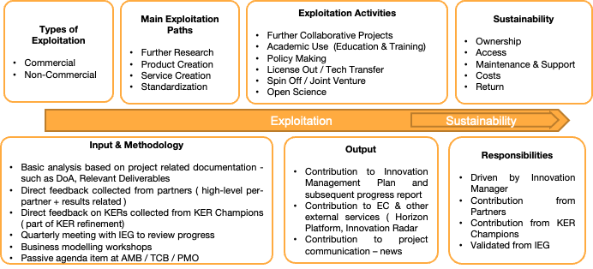
Figure 10 - Procedure for Exploitation Monitoring
Though all project results are captured and documented, detailed analysis is limited to a subset of these results which are deemed important.
The goals of this process are:
- Identify, record, and capture the exploitation opportunities and the related activities
- Curate detailed information for the subset of main project results and in particular the Key Exploitable Results
- Ensure that innovation developed or enhanced by the project is well-documented.
- Provide a strong basis for all other processes in Innovation Management.
There are many ways through which the collection of exploitation opportunities can be done,
- Desk research and careful analysis of deliverables, milestones, DoA, project proposal (and in particular, the exploitation plan), presentations and other dissemination material generated by the project.
- Direct e-mail to each of the consortium members, WP leaders, task leaders, and with different boards of the project
- During regular periodic meetings AMB, TCB, IEG, etc
- Through a specific business prototyping workshop during a F2F or webinar.
  - Participants: Work Package leader, task leaders (and task members) at a work package level meeting.
  - Duration: 1 hour
  - During Workshop: Explain the objective of the workshop. Explain what project results are and give some examples. Use brainstorming or brainwriting to generate project results related to that work package.
- Curated Information for exploitation plans and activities are validated by project coordinator and Innovation and Exploitation Group
- A combination of all. Desk research can be augmented with a simple one-on-one discussion with project partners, work package leaders, individually going through the identified exploitation opportunities and activities and adding, supplementing, or modifying the existing list.

Input/Output
Consortium Agreement, DoA, Grant Agreement | In
Deliverables, Milestones, Periodic Reports and WP reports | In
Discussions with WP leaders, task leaders, consortium members and with different boards of the project | In
List of Project Results, Main results, and Key Exploitable results | In
Curated information on Exploitation Plans and Activities for a given partner, result, and Key Exploitable result | Out
Collection of exploitation activities need to be incorporated at:
- Corresponding Innovation Management Progress Deliverables
- Continuous Reporting from European Commission
- Translated into News Items for the relevant ones
Entities involved in the procedure
- Innovation Manager
- WP leaders, task leaders
- Consortium members
- Different boards of the project (TCB, AMB, GA, etc.)
- KER Champions
- Innovation and Exploitation Group
Triggers
Although identification of Exploitation Plans and Activities can happen at any time during the project execution, the earlier the identification takes place the better it is.
Several iterations will be needed depending on
- The submission of the deliverables
- The submission of periodic reports/participation at project reviews
- Upon dissemination and communications and exploitation needs
Steps
# | Responsible | Action
1 | Innovation Manager | Desk research and careful analysis of deliverables, milestones, DoA, project proposal, presentations and other dissemination material generated by the project.
2 | Innovation Manager | Create the necessary templates and assign responsibility for filling it among the KER champions, consortium members, WP leaders, task leaders, and with different boards of the project asking to fill in the necessary information. In case of unclear responsible, AMB should be consulted.
3 | Innovation Manager | Contact assigned responsible for filling the templates
4 | Assigned responsible | Fill in the necessary information related to the exploitation opportunities and activities related to partners, results, and key exploitable results
5 | Innovation Manager | Incorporate as a discussion topic in regular periodic meetings (AMB, TCB, etc.)
6 | Innovation Manager | Organise a business prototyping workshop to assess and develop the exploitation opportunities and related activities
7 | KER Champions, Consortium Members | Participate to the business prototyping workshops to assess and develop the exploitation opportunities and related activities of each of the KERs and relevant main results
8 | Innovation Manager | Curate collected information from all the different sources on exploitation opportunities and activities into 03. Exploitation Management section.
9 | Technical Coordinator and IEG | Validate collected information on exploitation opportunities and activities
10 | Innovation Manager | Incorporate Curated Exploitation Information into the necessary deliverables & send information to Project Management Office for European Commission's continuous reporting and to Communications Officer for News content

Innovation Management and Exploitation Progress (M6+3)

interTwin Market, Technological and Political Context

interTwin Market analysis
Main market addressed at the interTwin project is the Digital Twins Market. Figure 8 depicts the adjacent market verticals (application domains), horizontals (enabling technologies) and downstream (infrastructure)
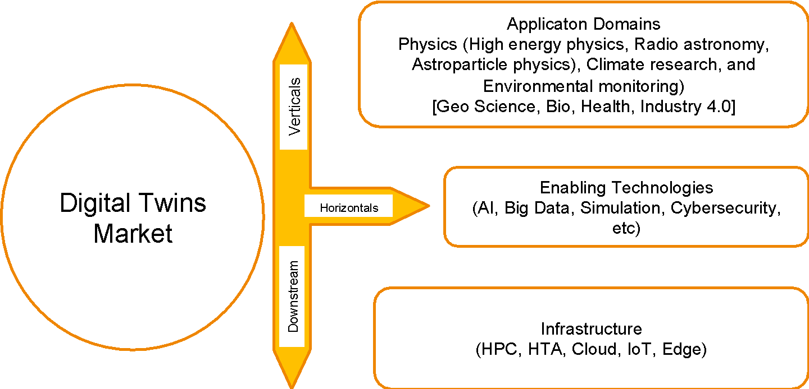
Figure 11 - interTwin Key Markets

The global Digital Twin market size was valued at USD 11.12 billion in 2022 and is expected to grow at a compound annual growth rate (CAGR) of 37.5% from 2023 to 2030, according to a report by Grand View Research. The report also predicts that the market will reach a size of USD 63.2 billion by 2028.

This growth will be boosted by the deployment of enabling technologies for Digital Twins including the Internet of Things (IoT), artificial intelligence (AI), big data analytics, and cloud computing as these technologies are used to collect, analyse, and manage data from physical assets in real-time, creating a virtual replica of the physical asset. Within interTwin AI, Big data technologies play a very relevant role, especially with the simulation needs of the Digital Twins, whereas it takes data from already collected sources hence IoT is not that relevant.

Digital Twins are being adopted commercially across various verticals, including manufacturing, healthcare, aerospace, automotive, energy and utilities, and construction: In the manufacturing sector, they are used to optimize production processes and improve product quality; in healthcare, to simulate patient-specific scenarios to aid in diagnosis and treatment planning among others, in the aerospace industry, to monitor and optimize the performance of aircraft engines; in the automotive industry, to optimize the design and performance of vehicles; in energy and utilities, to monitor and optimize the performance of power plants and other infrastructure; in construction, to improve project management and reduce overall costs.

In general, Digital Twins are also becoming increasingly useful in science because they allow researchers to simulate complex systems in changing environments and predict how they will behave under different conditions while being able to adjust depending on real-time gathered data. This can help researchers optimize their experiments, improve their understanding of complex phenomena, and develop more effective strategies for managing environmental systems. Within interTwin, the main scientific domains addressed are Physics, including High Energy Physics, Radio Astronomy and Astro Particle Physics, Climate research and environmental monitoring.

Overall, the digital twin market is expected to continue to grow as more industries adopt this technology to improve operational efficiency, reduce costs, and enhance product and service quality. As such it is expected to become a key technology for the above-mentioned scientific domains.

In subsequent deliverables, further details on the relevant markets will be expanded.

interTwin Value Chain
As depicted in the figure below, the main steps in the value chain are:

- Infrastructure stands for the federated data and compute resources involved in modelling and simulation tasks, including HPC, HTC, Cloud, Quantum computing resources and Data repository and its Authentication and Authorization Infrastructure (AAI), Orchestration and Federated Data Management.
- Digital Twin Core modules offer horizontal capabilities to facilitate the creation and the operations of data-intensive and compute-intensive DT applications including Workflow composition modules based on big data analytics, AI and Data Fusion, Quality Verification and Real-time data acquisition and procession.
- Digital Twin Thematic Modules are add-ons providing capabilities tailored to the needs of specific groups of applications that can become part of the core modules if they can be in the interest of further communities.
- Application/Scientific Domain are the actual use case implementations of Digital Twins for the different scientific domains of the project

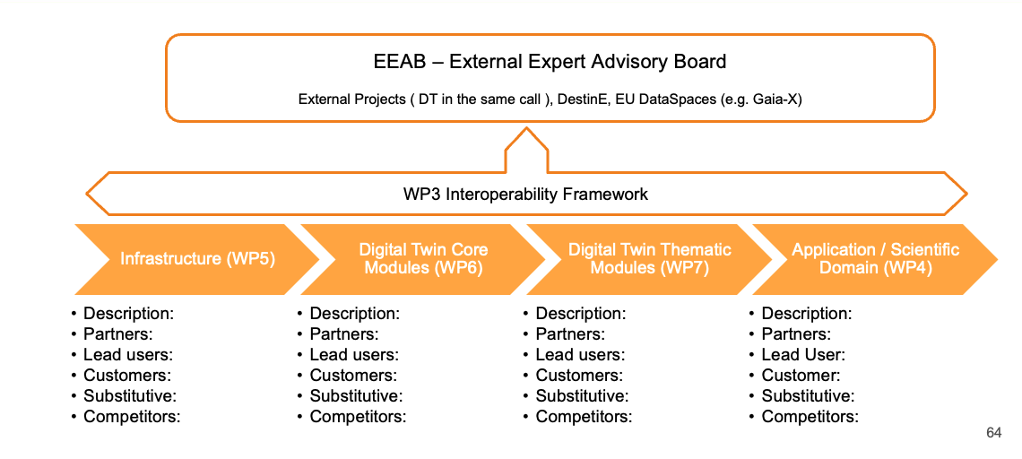
Figure 12 - interTwin Value Chain

In the subsequent innovation management and exploitation progress report deliverables, the whole picture will be expanded to include information of lead users, customers, competitors, etc at each of the stages in the value chain.

Liaison with External Stakeholders - Creation of an External Expert Advisory Board
EEAB has the following main purpose and responsibilities:

- Advises the Technical Coordination Board (TCB) on the project technical architecture and implementation plan. It draws membership from Digital Twin innovators and adopters from different sectors.
- Reviews blueprint architectures relevant to the specific scientific domains of the project (such as Destination Earth)– from an implementation point of view
- Validates and makes sure that what the project is delivering is useful in broader application domains.

EEAB is chaired by the Innovation Manager, will be appointed, and steered by the Technical Coordination Board and is composed of between 5 and 7 Members. Ideally EEAB members should be the same throughout the project, however the TCB may propose new members or substitute members depending on their availability and the technological status and evolution throughout the project.

Key Expertise of the EEAB members includes:

- Experts across the interTwin value chain - Infrastructure, Digital Twin Developers, Application Developers – e.g., Project coordinators or Key Representatives of the rest of Digital Twins Projects in the same interTwin European Commission call: DT-GEO, BioDT, eBRAIN-Health). This is a lightweight, very efficient, and effective way of cross-collaboration between projects.
- End user experts across scientific domains for each of the use cases – e.g., High energy physics, Radio astronomy, Astroparticle physics, Climate research, and Environmental monitoring.
- Experts in adjacent application / scientific domains (other than interTwin), especially those which have already relevant industrial adoption or from the other Digital Twins Projects– such as Industry 4.0, Geo-sciences, Bio or Health.

The type of Expertise expected from EEAB Members is Policy Making, Decision Making or Technical Expertise.

Table 3 - collects the EEAB members
Name | Institution | Project | Key Expertise / Scientific Domain
 | [Industry, SME, Research Institution, Academia, Policy Making] | [DT-GEO, BioDT, eBRAIN-Health, others?] | [High energy physics, Radio astronomy, Astroparticle physics, Climate research, and Environmental monitoring]  [Geo Science, Bio, Health, Industry 4.0]

Main duties of EEAB Members are expected to be as lightweight as possible. EEAB members are highly renowned experts in the community, usually lacking time, and no economic compensation is expected for their contribution – other than covering travel costs.

The main duty will be to provide feedback – to be given during dedicated meetings (F2F or virtual).

- Any necessary material (agenda, executive summaries) will be provided in advance. Any further material – such as deliverables, papers, and presentations can also be provided upon interest.
- During the meetings, EEAB members will be required to provide feedback in specific Q&A (after presentations or on a specific discussion session)
- Minutes from the meeting will be taken by a rapporteur from project representatives and shared with the EEAB members for validation.

In the case of not being able to attend – feedback will be collected by one-on-one interaction (by telco, interview, etc).

Other forms of feedback collection such as survey/semi-structured questionnaire or open-ended questions or sending back a written report could also be considered on project needs and EEAB members availability.

Another support for dissemination and exploitation is to be given on best effort basis

- Dissemination wise - such as providing publishable information from EEAB members for interTwin project website (such as a short CV or publishable quotes along the project), providing content, giving a presentation to the consortium or at an event, participating in public discussion, etc.
- Exploitation wise – becoming early adopter or providing ideas or contacts for early adopters, providing ideas on business models or other potential exploitation activities.

EEAB Members will be proposed by Coordinator or Interested Partners and accepted by the TCB. Official invitations are to be sent by PMO/Project Coordinator/Innovation Manager backed by Proposing Partner. EEAB Members will need to sign a Letter of Intent or accept the Terms of Reference.

EEAB Members will attend 1 meeting per year (3 in total). When possible, meetings will be physical, co-located with flagship events (e.g., at the EGI conference). If not possible, Online meetings will be organized – or any other channels will be used).

Table 4 shows the list of expected meetings:

Table 4 - EEAB expected meetings
Meetings | Timeline | Scope
1st EEAB Meeting – co-located with EGI Conference | Between M9-M12 | Present the early version of the Blueprint deliverable & gather feedback before the review
2nd EEAB Meeting -co-located with TBD | Between M18-M24 | Present a 1st complete picture of the Digital Twin Engine & early version of Use Cases
3rd EEAB Meeting - co-located with TBD | Between M30-M36 | Present final results with a strong focus on end users & potential adopters

Complementary approaches may be used for gathering feedback in the meetings, which include:

- Inviting EEAB Members to take part in whole F2F meeting presentations itself. This enables the project to provide a better understanding of the in-depth status of the project and hence be able to receive better quality feedback. On the other side this approach requires a more time-consuming commitment of the EEAB members (usually 1-2 days) and possibly some parts of the project are not that interesting for the members depending on their expertise.
- Preparing a specific session that includes presentations tailored to the EEAB members (1-2 hours). This is the less time-consuming option for the EEAB members – but it may require previous preparation (providing materials in advance, reading, etc) in order to provide meaningful feedback.
- Preparing a specific consultation meeting for EEAB members – including a whole set of presentations to foster discussion & feedback (half day). This is an in-between solution between the approaches.

Presentations will be open (public) by default – restricted as necessary. Hence, presentations should be public/open (without sharing confidential information). Design & architecture should be open -so it can be taken as a reference. If for any reason it is necessary to present any confidential information – then an NDA would be needed for the EEAB members to be signed. In that case, the coordinator will ensure that a non-disclosure agreement is executed between the consortium and each EEAB member. Its terms shall be not less stringent than those stipulated in the Consortium Agreement, and it shall be concluded no later than 30 days after their nomination or before any confidential information will be exchanged/disclosed.

Travel costs will be covered by the project (taken from the budget to cover other costs from EGI). EEAB members should comply with the reimbursement policies of the EGI.

Feedback collected from EEAB will be translated into actions to be performed by the project. Any decision related to how the feedback is incorporated into the project and the related actions– will follow the corresponding voting rules of the corresponding decision board (TCB for the incorporation of the technical feedback and the General Assembly for any higher-level project decision emerging from the feedback).

Any further external feedback should also be collected at events or by sending out surveys or questionnaires to relevant stakeholders

interTwin Project Results

interTwin background
One of the first duties of the project has been providing support to gather the background information of the partners to feed the consortium agreement. The list has been compiled and stored at the corresponding confluence repository. At the time of writing the deliverable 69 background elements have been spotted. For all of them, the access information for implementation and exploitation has been provided together with the WP under which those elements are needed and the contact person and link for accessing those open elements. 4 partners are not including background.

interTwin main expected outputs and impact
The project objectives and foreseen Key Exploitable Results (KERs) each have their own stakeholder engagement level associated. Here below are the baseline results, KERs, outputs and impacts, as described in the DoA. The KERs will serve as the basis to structure the concrete Exploitation activities proposed further in this plan and in the following iterations (M21 and M36).

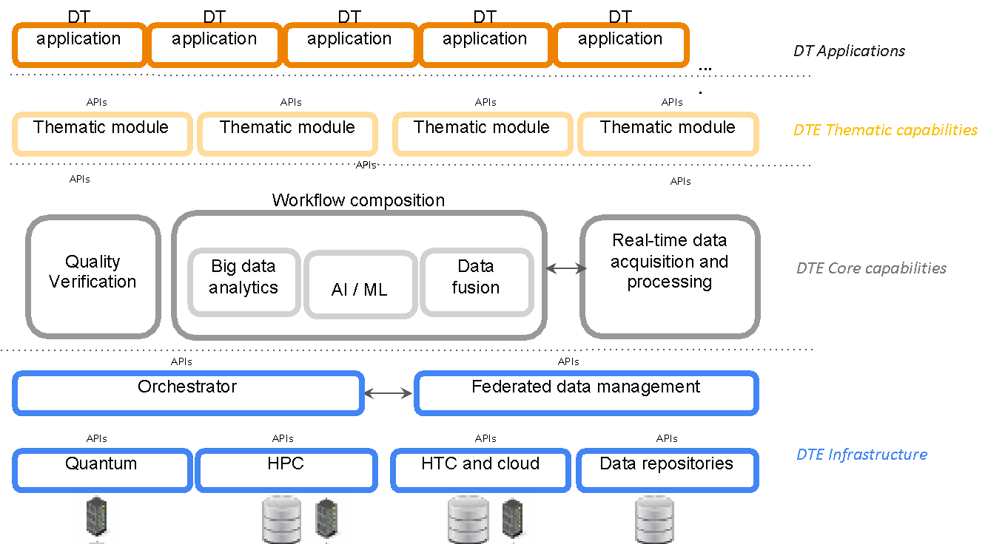
Figure 13 - interTwin Building Blocks

Key Exploitable Results
KER1: Interdisciplinary Digital Twin Engine
A software platform that provides generic and tailored functional modules for modelling and simulation to facilitate the development and deployment of Digital Twins that address scientific problems in different domains.

KER2: Interoperability Framework: Guidelines, Specifications, and Blueprint Architecture
The interTwin interoperability framework aligns technical approaches and foster collaboration in modelling and simulation application development across scientific domains.

KER3: Toolkit for AI workflow and method lifecycle management
AI-based methodologies to extract application sector-specific information from research data at the exabyte-scale level in a real-time manner and increase the efficiency and accuracy of simulation and modelling outputs.

KER4: Quality Framework
Tools for automated quality measures and trust, development of standard quality mapping and indicators for appropriately communicating differences in qualities of inputs and outputs from digital twins, addressing issues such as data and model pedigree, accuracy, and lack of knowledge.

KER5: DTE federated infrastructure integrated with EOSC and EU Data Spaces
Federated distributed compute platform providing access to distributed data and integrating HTC, HPC, Cloud and Quantum Computing capabilities for processing.

KER6: interTwin Open-Source Community
The community of DT application developers, users and operators that is responsible for the design, development, and maintenance of the DTE code base.

The KERs above will contribute to the realisation of interTwin expected outcomes and impacts.

Outcomes and Impacts
Outcome 1: A pre-operational prototype of an interdisciplinary Digital Twin, using a combination of the latest digital technologies, relevant to addressing challenges where multidisciplinary is the defining element of complexity.

Outcome 2: Latest modelling and prediction technologies in several different areas widely serving research communities and supporting the interoperability of data and software, integration, and collaboration.

Outcome 3: Framework to ensure the quality, reliability, and verifiability of the data, information, and outputs of such Digital Twins and to exploit data made available through the Common EU Data Spaces and the EOSC.

Impact 1: Enhanced global competitiveness, technological excellence in a fast-moving environment and wider use of AI in research and enhanced data-based research across Europe.

Impact 2: Opening of new areas of research and development of new industrial applications/products.

Impact 3: Transdisciplinary, cross-fertilisation and a wider sharing of knowledge and technologies between academia and industry.

interTwin Exploitation
KER1: Interdisciplinary Digital Twin Engine
A software platform that provides generic and tailored functional modules for modelling and simulation to facilitate the development and deployment of Digital Twins that address scientific problems in different domains.
Target Groups | Exploitation Path | KER Champion | Protection
Developers  Users  Operators | > Platform-as-a-Service provisioning by the EGI Federation through open access. Onboarded in the EOSC and AI4EU (AI-on-Demand Platform) ecosystems and integrated with EU Data Spaces.  > Software available for download and maintained by the Open Source Community via repository technologies such GitHub. | EGI Foundation | Free and Open Source License

KER2: Interoperability Framework: Guidelines, Specifications, and Blueprint Architecture
The interTwin interoperability framework aligns technical approaches and foster collaboration in modelling and simulation application development across scientific domains.
Target Groups | Exploitation Path | KER Champion | Protection
Developers  Users  Operators | Open access available via multiple channels such as EOSC and AI4EU interTwin managed web pages, ecosystems, and Zenodo. | EGI Foundation | Creative Commons

KER3: Toolkit for AI workflow and method lifecycle management
AI-based methodologies to extract application sector-specific information from research data at the exabyte-scale level in a real-time manner and increase the efficiency and accuracy of simulation and modelling outputs.
Target Groups | Exploitation Path | KER Champion | Protection
Developers  Users  Operators | Available for download and maintained by the Open Source Community via repository technologies such GitHub | EGI Foundation | Free and Open Source License

KER4: Quality Framework
Tools for automated quality measures and trust, development of standard quality mapping and indicators for appropriately communicating differences in qualities of inputs and outputs from digital twins, addressing issues such as data and model pedigree, accuracy, and lack of knowledge.
Target Groups | Exploitation Path | KER Champion | Protection
Developers  Users | Open access available via multiple channels such as interTwin managed web pages, EOSC and AI4EU ecosystems, and Zenodo.  Software available for download and maintained by the Open Source Community via repository tech such as GitHub. | CSIC | Free and Open Source License  Creative Commons

KER5: DTE federated infrastructure integrated with EOSC and EU Data Spaces
Federated distributed compute platform providing access to distributed data and integrating HTC, HPC, Cloud and Quantum Computing capabilities for processing.
Target Groups | Exploitation Path | KER Champion | Protection
Users  Operators | Maintained and managed as part of the EGI Service Catalogue offering policy-based access. (Policy-based: users are granted access based on policies defined by the EGI resource providers or by the EGI Foundation; such policies usually apply to resources being offered with “sponsored use” to meet some national or EU level objective, i.e., a country may offer resources with “sponsored use” to support national researchers involved in international collaborations.)  Service ordering via EOSC Marketplace. | INFN | Free and Open Source License

KER6: interTwin Open Source Community
The community of DT application developers, users and operators that is responsible for the design, development, and maintenance of the DTE code base.
Target Groups | Exploitation Path | KER Champion | Protection
Developers  Users  Operators | Free registration following approval processes guided by open science commons principles. | EODC | Joint Ownership Agreement and Policy

Timeline, Next Steps and Conclusions
This deliverable has described the innovation management system and its related activities, processes, and procedures in order to ensure the exploitation of the interTwin project and recaps the baseline expected results, key exploitable results, and exploitation plans, as described in the DoA. In this section, the execution plan is outlined highlighting when the main deliverables will be submitted, and which activities and main contributions are expected to each of them

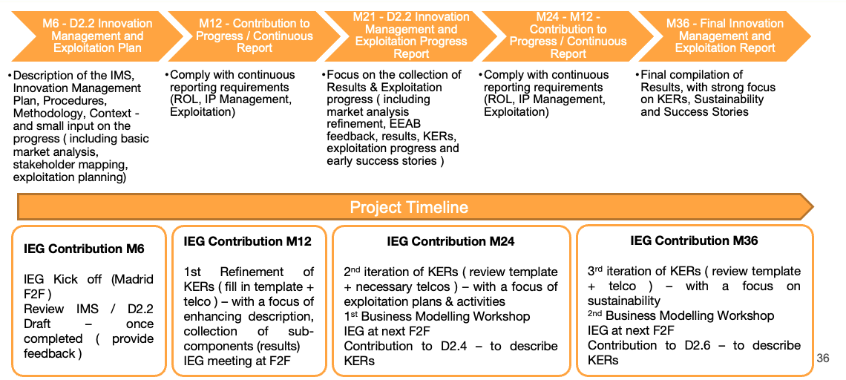
Figure 14 - Innovation Management Plan Timeline

- M6. The D2.2. Innovation Management and Exploitation Plan is outlined. Innovation and Exploitation Group is defined and constituted.
- M12. The 1st iteration of the collection of results, including ownership and IPR information, will be performed in order to contribute to the continuous reporting, and KERs will be refined.
- M21. Major updates in all 3 activities will be presented in the progress report deliverable D2.4 including an expanded market analysis, expected results, collection of EEAB feedback and progress towards exploitation, etc.
- M24. In order to capture and refine exploitation opportunities, the first Business Modelling workshop will be organized in order to upskill project partners and relevant stakeholders so the impact can be maximized. Updated data for the continuous reporting will be provided.
- M36. Final report adding on top of the previous progress D2.4 deliverable - with main focus on final results, exploitation activities and success stories, and the continued feedback of EEAB and other external stakeholders, the 2nd business modelling workshop, etc.

Annexes

Annex 1: Template for Background
According to the Grant Agreement (Article 16.1) Background is defined as “data, know-how or information (…) that is (…) needed to implement the Action or exploit the results”. Because of this need, Access Rights have to be granted in principle, but Parties must identify and agree amongst themselves on the Background for the Project. This is the purpose of this attachment.
NAME OF THE PARTY
As to NAME OF THE PARTY, it is agreed between the Parties that, to the best of their knowledge, the following Background is hereby identified and agreed upon for the Project. Specific limitations and/or conditions, shall be as mentioned hereunder:

Describe Background | Specific restrictions and/or conditions for implementation (Article 16.4 Grant Agreement and its Annex 5, Section “Access rights to results and background”, sub-section “Access rights to background and results for implementing the Action”) | Specific restrictions and/or conditions for Exploitation (Article 16.4 Grant Agreement and its Annex 5, Section “Access rights to results and background”, sub-section “Access rights for exploiting the results”)

Annex 2: Template for Project Results
Description
Name | <Name of the Project Result>
Description | <Describe the result in brief>
URL | <URL(s) to the result>
WPs and Tasks involved | <List all the Work Packages including Tasks involved in generating the result>
Result Type | <Select one of the following>  - Policy Related Results  - Scientific or Technological R&D results (including HW)  - ICT Software Digital Solution  - Other Intangible Results  - Services  - Other
Result Contact Person | <Contact information of the primary contact person for the result>

Impact and Innovation
Innovation | <Describe what is new in the result. How it benefits the users and society in general>
Potential beneficiaries or customer groups | <Describe the potential user groups for the result. For each group describe,  - what is the exploitation/use objective for them? (eg use for further research, use for policy support, etc)?  - What are the main messages you want to deliver?  - What are the best channels to deliver messages?  - How will the target group (when they hear your message and want to use the result(s)) access and use the results, and under what terms (i.e. who do they approach, where is the result located, etc)?>
Geographical Market | <Describe the local or global geographical regions for which the result has been developed primarily>

IPR Information
Are there IPR issues that will limit foreseen use?
IP Background | <Please list all IP components related to the result brought by the partners into the project. This might be reports, software code, etc. There may be several IP components for each result. Don’t forget know-how – which may be delivered as training or consultancy to support use.>  Name Short Description IP Owner Type of protection or licensing action used Protection or licensing actions used
Third-party IPs | <Please list all IP third-party components which IP is owned by organizations outside the project.>  Name Short description IP Owner Type of protection or licensing action used Protection or licensing actions used
IP Sideground | <Please list all IP components which are relevant to the project but produced outside the project by any of the partners during the project’s tenure (providing a summary of the components of this aggregate result)>  Name Short description IP Owner Type of protection or licensing action used Protection or licensing actions used
IP Foreground | <Please list all IP created during the project. Include all the IPs related to components of this result.>  Name Short description Partners Owner & Other Beneficiary(s) involved during the project Related contribution of Partners involved during the project Who will manage the IP (Host/Protect/ Market/Exploit) and under what terms? Confidential Click on YES/NO Foreseen embargo date Type of protection or licensing action used Protection or licensing actions used How costs and revenues will be decided and shared?  Yes No Patents Trademarks Registered designs Utility models Others

Dissemination
Early Adopters | <Briefly describe who are the early adopters>
Dissemination Channels

Annex 3: Template for Key Exploitable Results
Results
Title of result (120 characters) | Ideally, a punchy name that makes sense to someone who hasn’t heard about EOSC, e-Infrastructures or Cloud technologies. Writing acronyms (like EOSC) out might be a good idea.
Message/ Teaser to the potential user (1000 characters) | State what your result is, what it is for, what makes it special in terms of adding value or knowledge, what is your purpose for making it public, and what is your target audience.  Refer to: page "Five_Ws" in Wikipedia
Video/ image section | Upload an image (primary goal: visually attractive item to draw attention and trigger curiosity) or add a link to a YouTube/Vimeo video.
Result Type | Select one from the following list,  - Policy Related Results - Scientific or Technological R&D results (including HW) - ICT Software Digital Solution  - Other Intangible Results - Services - Other
Target Audience | Select max three from the list,  - Others/ No specific audience - Public or private funding institutions - EU and Member State Policymakers  - International Organisations (ex. OECD, FAO, UN, etc.) - Other Actors who can help us fulfil our market potential - Research and Technology Organisations  - Academia/ Universities - Private Investors
Our needs are | Select max three from the list,  - Business partners - SMEs, Entrepreneurs, Large Corporations - Incubators / Accelerators - Marketing Mentoring or Coaching  - Financing Expertise - Technology Transfer Expertise - Legal / IPR advise  - I/we wish to transfer my/our IPR to an interested party - Investor readiness training - Investor introductions  - Business plan development - Expanding to more markets /finding new customers - Executive Training  - Business Angels - Venture Capital - Crowd-funding Equity  - Other type of Investment
We specifically need/ are looking for (600 words) | Freeform description of what the result owners are looking for (more specifically than the selection from the list) from the members of the target audiences selected.

About us
Main project | EC-funded project that was the main contributor
Other related projects | Optional – won’t be visible in the entry
Result Contributors | The partners that contributed to the result.
Owners for exploitation | Partners that will serve as contact points for further exploitation. Less important for open EOSC services (in which case entries would probably imply a commitment to user onboarding and support). In case the business model is based on licensing of IPR, this needs more care (either a single owner or parties to a joint ownership agreement)
Start-up created for further exploitation? | - Yes  - No
Logo | Not applicable unless there’s a start-up in the works

Testimonials
Title | Title of the success story collection (should at least contain material that is not created by the contributors or owners). You can add several entries on this section (click Add information)
Link | URL

Find us on
Description | This could be e.g., homepage or EOSC marketplace entry. As with testimonials, it is possible to add more than one line: homepage + marketplace entry ideal solution.
Link | URL

Results description and influence
Result description (1200 characters) | A more detailed description of the result, freeform.
Business Sector(s)/ Policy Area(s) | Select max three from the list,  Agriculture and rural development Banking and financial services Borders and security Budget Business and industry Climate action  Competition Consumers Culture and media Customs Digital economy and society Economy, finance and the euro  Education and training; Employment and social affairs Energy; Environment EU enlargement European neighbourhood policy Food safety Foreign affairs and security policy  Fraud prevention Home affairs Humanitarian aid and civil protection Institutional affairs International cooperation and development Justice and fundamental rights  Maritime affairs and fisheries Migration and asylum Public health Regional policy Research and innovation Single market  Sport Statistics Taxation Trade Transport Youth
Tags/ Keywords | Recommend that you use keywords to describe the technology, science, sector, content or nature of the result and very importantly, keywords to denote potential uses or applications of your result. Please note that, by default, you will see in your submission form all keywords linked to the main project you had chosen for declaring this result. This is to help you get started. Feel free to remove those keywords irrelevant to this result.

Your result's contribution to Sustainable Development
Contribution to UN Sustainable Development Goals | Select max three from the list,  GOAL 1: No Poverty GOAL 2: Zero Hunger GOAL 3: Good Health and Well-being GOAL 4: Quality Education  GOAL 5: Gender Equality GOAL 6: Clean Water and Sanitation GOAL 7: Affordable and Clean Energy GOAL 8: Decent Work and Economic Growth  GOAL 9: Industry, Innovation and Infrastructure GOAL 10: Reduced Inequality GOAL 11: Sustainable Cities and Communities GOAL 12: Responsible Consumption and Production  GOAL 13: Climate Action GOAL 14: Life Below Water GOAL 15: Life on Land GOAL 16: Peace and Justice Strong Institutions  GOAL 17: Partnerships to achieve the Goal Not Applicable
Radical Innovation Breakthrough? | (Optional) Is it a Radical Innovation Breakthrough?
Are you a member of the 'World Alliance for 1000 Solutions'? | - Yes  - No

Your result's influence on policy
Has your result had, or do you expect it to have a significant influence on policymaking? | - Yes  - No

Other information/data to share
Title (optional, one or more links to further information) | Open access publications, presentations, etc.
Link | URL

Result, Business Maturity and Exploitation Outlook
Result Maturity | TRL Level
Current Stage and Next Steps | More details/justification of the maturity.
Do you already have customers for this result? | - Yes  - No
Number of existing customers | - 1-5  - 6-30  - 31-50  - 51-100  - 101-500  - 501-1000  - >1000
What type of customers/ users do you have? | Select all that are applicable,  Individuals SMEs Big corporations Academia R&T organisations  Public Institutions and Authorities Governments Commerce Manufacturers
Which Business Sectors do your customers mainly come from? | Select all that are applicable,  Agriculture and rural development Banking and financial services Borders and security Budget Business and industry Climate action  Competition Consumers Culture and media Customs Digital economy and society Economy, finance and the euro  Education and training; Employment and social affairs Energy; Environment EU enlargement European neighbourhood policy Food safety Foreign affairs and security policy  Fraud prevention Home affairs Humanitarian aid and civil protection Institutional affairs International cooperation and development Justice and fundamental rights  Maritime affairs and fisheries Migration and asylum Public health Regional policy Research and innovation Single market  Sport Statistics Taxation Trade Transport Youth
Unique value proposition | The unique selling proposition (USP), also called the unique selling point, or the unique value proposition (UVP) in the business model canvas, is the marketing strategy of informing customers about how one's own brand or product is superior to its competitors (in addition to its other values).
Do you have a scalable business model? | For a business model to be scalable, staffing requirements should grow in a strongly sublinear fashion and/or the revenue per customer (or end-user) should remain relatively stable. Grant-based sustainability is usually not scalable, nor is consulting. Franchising, licensing and platform business models can be.
Is your result replicable? | (Judgement call)  - Yes  - No
Please elaborate on the Replicability | Justification for a claim for replicability.
Is your result and your business model sustainable in the long term?
Please elaborate on Sustainability | Justification to claim the solution is sustainable.
Are you targeting geographical markets? | Geographical market areas, or can also be global

Investor Corner
What level of investment (EUR) are you currently looking for? | Levels of funding sought: if a € sum is chosen.

Annex 4: Template for Project Innovations
Innovations
INNOVATION 1 (optional)
1. Title of the innovation
Please enter a meaningful innovation title (between 20 and 200 characters, spaces included). This field will be revealed to the public on the Innovation Radar platform / mobile app.
Tip: This field is key and needs to be strong and clear. If possible, use a ‘for’ clause. Examples of poor versus good innovation titles:
‘Laser Design Platform’ (poor) vs ‘Improved semiconductor laser design platform for RWG (Ridge Wave Guide) laser’’(good)
‘Novel Robot Arm’ (poor) vs ‘Dextrous robotic slave arm for high radiation environments’ (good)
‘Biosensors for diagnosis’ (poor) vs ‘Biosensors capable of breath and saliva monitoring for heart failure diagnosis’ (good)
2. Description of the innovation
Please describe the innovation. Use less than 500 characters, spaces included.
This field will NOT be revealed to the public on the Innovation Radar platform / mobile app
3. This innovation is ...
Under development
Already developed but not yet being exploited
Being exploited
4. Characterise the type of innovation (choose one only)
Significantly improved product
Significantly improved service (except consulting services)
Significantly improved process
Significantly improved marketing method
Significantly improved organisational method
Consulting services
New product
New service (except consulting services)
New process
New marketing method
New organisational method
Other
5. Level of Innovation: What is the level of innovation? (Choose one only)
Some distinct, probably minor, improvements over existing products
Innovative but could be difficult to convert customers
Obviously innovative and easily appreciated advantages to customer
Very innovative
6. How will the innovation be exploited? (Choose one only)
Introduced as new to the market (commercial exploitation)
Only deployed as new to the organisation/company (new internal processes implemented, etc.)
No exploitation planned
If ‘no exploitation planned’ is selected, explain why not:
[insert explanations]
7. Indicate the step(s) in order to bring the innovation to (or closer to) the market
Answer the following grid only if the answer to the previous question is ‘Introduced as new to the market’ (choose only one answer per row)
 | Done or ongoing | Planned | Not planned but needed or desirable | Not planned and not needed
Technology transfer
A partner's research team and business units are both engaged in activities relating to this innovation
Market study
Prototyping in laboratory environment
Prototyping in real-world environment
Pilot, Demonstration or Testing activities
Feasibility study
Launch a start-up or spin-off
Licensing the innovation to a 3rd party
Complying with existing standards
Contribution to standards
Raise capital
Raise funding from public sources
Business Plan
Other (please specify)
If ‘Other’ is selected, please specify what other steps have been done or planned for this innovation:
[insert explanations]
8. Is there a clear ‘owner’ of the innovation in the consortium or multiple owners?
Only for multi-beneficiary projects
One clear owner
Multiple owners
9. Indicate (up to a maximum of 3) key organisation(s) delivering this innovation.
10. Indicate these organisations’ needs to fulfil their market potential
 |  | Organisation 1 | Organisation 2 | Organisation 3
Investor readiness training
Investor introductions
Biz plan development
Expanding to more markets
Legal advice (IPR or other)
Mentoring or Coaching
Partnership with other SME(s)
Partnership with large corporates
Incubation/Start-up accelerator
Executive Training
Other: Standardization efforts
Further developments in a co-design approach through the common project
11. For the private company/companies chosen as one of the 3 ‘key innovators’, will this innovation be used by mainly current or new customers?
Current customers
New customers
12. Market maturity: The market targeted by this innovation is ... (choose one only)
The market is not yet existing, and it is not yet clear that the innovation has the potential to create a new market
Market-creating: The market is not yet existing, but the innovation has clear potential to create a new market
Emerging: There is a growing demand, and few offerings are available
Mature: The market is already supplied with many products of the type proposed
13. Market dynamics: is the market ...?
Answer this question only if the answer to the previous question is ‘mature’.
In decline
Holding steady
Growing
14. Are there other markets for this innovation that the innovators are not yet targeting?
Yes
No
15. Market competition: How strong is competition in the target market?
Patchy, no major players
Established competition but none with a proposition like the one under investigation
Several major players with strong competencies, infrastructure, and offerings
16. When do you expect that such innovation could be commercialised (from today)?
Less than 1 year
Between 1 and 3 years
Between 3 and 5 years
Between 5 and 10 years
More than 10 years
17. Has a trademark been registered for this innovation?
Yes
No
18. Which of the Societal Challenge(s) is/are the innovation relevant to?
Health, demographic change, and well-being
Food security, sustainable agriculture, marine and maritime, Bioeconomy
Secure, clean, and efficient energy
Smart, green, and integrated transport
Climate action, environment, resource efficiency and raw materials
Europe in a changing world - inclusive, innovative, and reflective societies
Secure societies - protecting freedom and security of Europe and its citizens
Not relevant to any Societal Challenge
If ‘not relevant to any SC is selected’ explain why?
[insert explanations]
19. Which of the UN Sustainable Development Goals (SDGs) does this innovation contribute to?
SDG 1 – No Poverty
SDG 2 – Zero Hunger
SDG 3 – Good Health and Well-being
SDG 4 – Quality Education
SDG 5 – Gender Equality
SDG 6 – Clean Water and Sanitation
SDG 7 – Affordable and Clean Energy
SDG 8 – Decent Work and Economic Growth
SDG 9 – Industry, Innovation, and Infrastructure
SDG 10 – Reducing Inequity
SDG 11 – Sustainable Cities and Communities
SDG 12 – Responsible Consumption and Production
SDG 13 – Climate Action
SDG 14 – Life Below Water
SDG 15 – Life On Land
SDG 16 – Peace, Justice, and Strong Institutions
SDG 17 – Partnerships for the Goals
Not relevant to any SDG
If ‘not relevant to any SDG is selected’ explain why?
[insert explanations]
20. Does this innovation have a potential to address climate mitigation or climate adaptation?
Climate mitigation potential: The innovation addresses the causes of climate change (i.e., it can reduce and curb greenhouse gas emissions)
Climate adaptation potential: The innovation can reduce vulnerability to the harmful effects of climate change
Mitigation potential
Not applicable for this innovation
Adaptation potential

General
How do you consider the project's performance in terms of innovation?
Performing below my expectations
Meeting my expectations
Exceeding my expectations
Highly exceeding my expectations
Does the innovator engage end-users organisations? |  |  |  |  | (Yes/No)
If ‘Yes’ to the previous question, are the end-users in the consortium? |  |  |  |  | (Yes/No)
If ‘Yes’ to the previous question; please indicate which project participant(s) are end-users and what their key contribution is
 | Providing Ideas | Testing | Validation | Deployment | Not an end-user
Participant A
Participant B
Participant C
If ‘No’ to the previous, please indicate which types of organisations outside the consortium are engaged with and what is their key input as a user?
 | Providing Ideas | Testing | Validation | Deployment | Not consulted
Potential procurer of innovation (Public sector)
Potential procurer of innovation (Private sector)
Citizen Group
NGO
Regulator
Policy Maker
Other

IPR & Exploitation
Are there IPR issues within the consortium that could compromise the ability of the organisation(s) to exploit new products/solutions/services, internally or in the marketplace? | (Yes/No)
Which are the external bottlenecks that compromise the ability of project partners to exploit new products, solutions, or services, internally or in the marketplace?
Regulation
Skills in the wider workforce
Standards
Financing
Trade issues (between MS, globally)
IPR
Others
Indicate how many patents have been applied for by the project
How would you rate the level of commitment of relevant organisation(s) to exploit the innovation?
Very low
Low
Average
High
Very High
Please indicate the one participant (excluding large enterprises) that the panel considers to be the most impressive in terms of innovation potential within the context of the innovations identified
(Insert name of participant)
Please provide concrete recommendations for the project to improve its innovations and their potential to deliver impact in - or close to - the marketplace.
(Insert recommendation)
Hypothetically but honestly, would you invest your own money in any innovation developed by this project? | (Yes/No)
Please indicate the participant(s) from which a woman is in a position of leadership (such as Principal Investigator / Work Package Leader) for this project:
(Insert name of participant)

https://datatracker.ietf.org/doc/html/rfc2119
https://www.iso.org/standard/68221.html
https://www.innoradar.eu/methodology
https://ec.europa.eu/info/funding-tenders/opportunities/docs/2021-2027/horizon/guidance/programme-guide_horizon_en.pdf
https://www.innoradar.eu/methodology
https://intellectual-property-helpdesk.ec.europa.eu/regional-helpdesks/european-ip-helpdesk/europe-glossary_en
https://ec.europa.eu/research/participants/data/ref/h2020/wp/2014_2015/annexes/h2020-wp1415-annex-g-trl_en.pdf
https://www.iso.org/standard/68221.html
https://digital-strategy.ec.europa.eu/en/policies/destination-earth
https://eosc.eu/sria-mar
https://eurohpc-ju.europa.eu/system/files/2023-04/21.03.23%2016h30%20-%20Paving%20the%20Path%20for%20Digital%20Twins%20in%20HPC.pdf
https://www.etp4hpc.eu/tci-use-cases.html#twins
https://ec.europa.eu/research/participants/docs/h2020-funding-guide/other/event210609.htm
https://ec.europa.eu/info/funding-tenders/opportunities/portal/screen/opportunities/horizon-results-platform
https://www.innoradar.eu/
https://www.grandviewresearch.com/industry-analysis/digital-twin-market
https://confluence.egi.eu/display/interTwin/1.+Background (restricted to Consortium members)
interTwin Project Objectives
interTwin Key Exploitable Results

