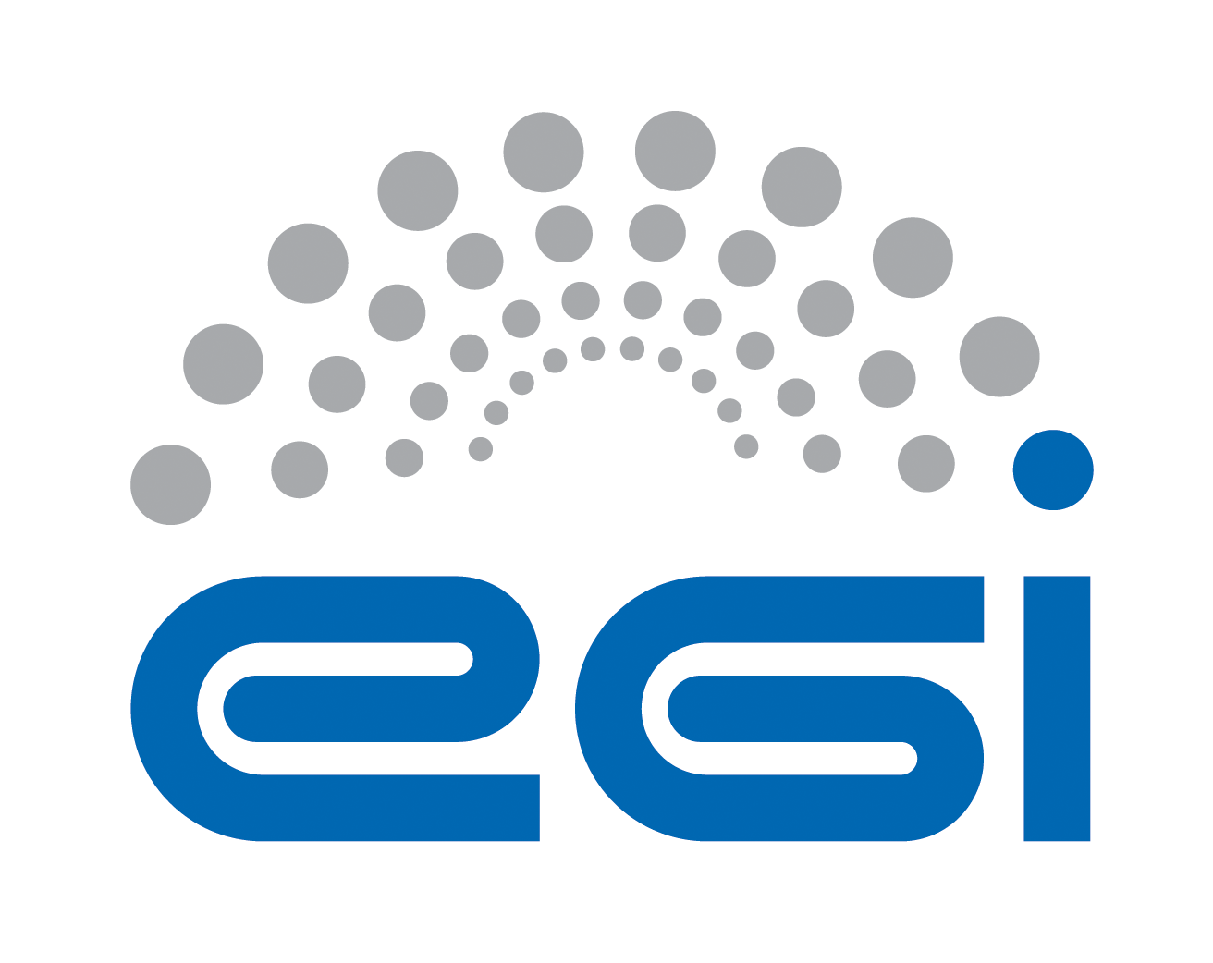
Acceptable Use Policy and Conditions of Use

Document identifier | EGI-SPG-AUP-V3
Document Link | https://documents.egi.eu/document/3600
Last Modified | 30/06/2020
Version | 3
Policy Group Acronym | SPG
Policy Group Name | Security Policy Group
Contact Person | David Kelsey / STFC
Document Type | Security Policy
Document Status | Approved
Approved by | EGI Foundation Executive Board
Approved Date | 28/05/2020

TABLE OF CONTENTS
1 introduction 5
2 ACCEPTABLE USE POLICY AND CONDITIONS OF USE 6
3 REFERENCES 7

COPYRIGHT NOTICE
This work by the EGI Foundation is licensed under a Creative Commons Attribution 4.0 International License (http://creativecommons.org/licenses/by-nc-sa/4.0/). Other Sources / Attribution / Acknowledgements: “The WISE Baseline Acceptable Use Policy and Conditions of Use, used under CC BY-NC-SA 4.0, by members of the WISE Community SCI Working Group (version 1.0.1 25 Feb 2019). In turn that was based on “EGI Acceptable Use Policy and Conditions of Use”, used under CC BY-NC-SA 4.0. The research leading to the earlier WISE Baseline AUP received funding from the European Community’s Horizon2020 Programme under Grant Agreement No. 730941 (AARC2).
AUTHORS LIST
 | Name | Partner/Activity/Organisation/Function | Date
From | David Kelsey on behalf of EGI SPG | STFC/SPG Chair | 05/05/2020

DELIVERY SLIP
 | Body | Date
Reviewed by: | EGI OMB | 21/03/2019 &  07/05/2019
Reviewed by: | EGI UCB | 17/07/2019
Reviewed by: | EGI Foundation Executive Board | 12/05/2020
Approved by: | EGI Foundation Executive Board | 28/05/2020

DOCUMENT LOG
Issue | Date | Comment | Author/Partner
V2.9 | During 2019  28/02/2020 | New version from EOSC-hub work, wide consultation with EOSC-hub, EGI OMB, EGI UCB in collaboration with AARC2.  New version (V3) to replace EGI document #2623 (V2). This is the new EGI AUP based on the WISE Baseline AUP V1. The new document number is #3600. | David Kelsey/STFC
V2.9.1 | 05/05/2020 | Changes following discussion with SPG | David Kelsey/STFC
V3 | 30/06/2020 | Review and approval by EGI Foundation Executive Board | David Kelsey/STFC

TERMINOLOGY
A complete project glossary is provided at the following page: https://wiki.egi.eu/wiki/Glossary_V2
APPLICATION AREA
This document is a formal EGI policy or procedure applicable to all participants and associate participants, beneficiaries and Joint Research Unit members, as well as its collaborating projects.
POLICY/PROCEDURE AMENDMENT PROCEDURE Reviews and amendments should be done in accordance with the EGI “Policy Development Process” (https://documents.egi.eu/document/169).

introduction
This policy is effective from 01/06/2020 and replaces an earlier version of this document [R1]. This policy is one of a set of documents that together define the Security Policy [R2]. This individual document must be considered in conjunction with all the policy documents in the set.

The clauses of this AUP apply equally to use of any AAI access service and to use of all its connected Services, from now on collectively referred to as "Services", as augmented by any specific terms to which adherence is required during enrolment in any Virtual Organisation. The AUP text must be shown to all users of the EGI infrastructure and their acceptance of the terms and conditions recorded.

ACCEPTABLE USE POLICY AND CONDITIONS OF USE

This Acceptable Use Policy and Conditions of Use (“AUP”) defines the rules and conditions that govern your access to and use (including transmission, processing, and storage of data) of the resources and services (“Services”) as granted by the EGI Federation, and the Virtual Organisation to which you belong, for the purpose of meeting the goals of EGI, namely to deliver advanced computing services to support researchers, multinational projects and research infrastructures, and the goals of your Virtual Organisation or Research Community.

- You shall only use the Services in a manner consistent with the purposes and limitations described above; you shall show consideration towards other users including by not causing harm to the Services; you have an obligation to collaborate in the resolution of issues arising from your use of the Services
- You shall only use the Services for lawful purposes and not breach, attempt to breach, nor circumvent administrative or security controls.
- You shall respect intellectual property and confidentiality agreements.
- You shall protect your access credentials (e.g. passwords, private keys or multi-factor tokens); no intentional sharing is permitted.
- You shall keep your registered information correct and up to date.
- You shall promptly report known or suspected security breaches, credential compromise, or misuse to the security contact stated below; and report any compromised credentials to the relevant issuing authorities.
- Reliance on the Services shall only be to the extent specified by any applicable service level agreements listed below. Use without such agreements is at your own risk.
- Your personal data will be processed in accordance with the privacy statements referenced below.
- Your use of the Services may be restricted or suspended, for administrative, operational, or security reasons, without prior notice and without compensation.
- If you violate these rules, you may be liable for the consequences, which may include your account being suspended and a report being made to your home organisation or to law enforcement.
The administrative contact for this AUP is: operations@egi.eu
The security contact for this AUP is: abuse@egi.eu
The privacy statements (e.g. Privacy Notices) are located either at: https://egi.eu/privacy-policy/ or are presented to the user accessing a Service having its own Privacy Notice.

REFERENCES
R 1 | (Old version) Grid Acceptable Use Policy: https://documents.egi.eu/document/2623
R 2 | Approved EGI Security Policies: https://wiki.egi.eu/wiki/SPG:Documents

