EGI-InSPIRE

Execution Plan

EU MILESTONE: MS102

Document identifier: | EGI-MS102-v2
Date: | 21/02/2011
Activity: | NA1
Lead Partner: | EGI.eu
Document Status: | Final
Dissemination Level: | PUBLIC
Document Link: | https://documents.egi.eu/document/358

Abstract

The Execution Plan provides an overview of the allocation of staff to tasks in the EGI-InSPIRE project across the partners. This report describes the process of producing both the Execution Plan and its implementation in the Project Progress Tracking (PPT) tool through their evolution from Project Quarters PQ1 to PQ3.

- Copyright notice
Copyright © Members of the EGI-InSPIRE Collaboration, 2010. See www.egi.eu for details of the EGI-InSPIRE project and the collaboration. EGI-InSPIRE (“European Grid Initiative: Integrated Sustainable Pan-European Infrastructure for Researchers in Europe”) is a project co-funded by the European Commission as an Integrated Infrastructure Initiative within the 7th Framework Programme. EGI-InSPIRE began in May 2010 and will run for 4 years. This work is licensed under the Creative Commons Attribution-Noncommercial 3.0 License. To view a copy of this license, visit http://creativecommons.org/licenses/by-nc/3.0/ or send a letter to Creative Commons, 171 Second Street, Suite 300, San Francisco, California, 94105, and USA. The work must be attributed by attaching the following reference to the copied elements: “Copyright © Members of the EGI-InSPIRE Collaboration, 2010. See www.egi.eu for details of the EGI-InSPIRE project and the collaboration”. Using this document in a way and/or for purposes not foreseen in the license, requires the prior written permission of the copyright holders. The information contained in this document represents the views of the copyright holders as of the date such views are published.
- Delivery Slip
 | Name | Partner/Activity | Date
From | C Bitoune | EGI.eu / NA1 | 06/02/2011
Reviewed by | Moderator: Richard McLennan  Reviewers: Claire Devereux | EGI.eu/ NA3  STFC | 17/02/2011
Approved by | AMB & PMB |  | 17/02/2011
- Document Log
Issue | Date | Comment | Author/Partner
1 | 06/02/2011 | First draft | C Bitoune/EGI.eu
2 | 14/02/2011 | Second draft | C Bitoune/EGI.eu
3 | 19/02/2011 | Final draft | C Bitoune/EGI.eu
- Application area
This document is a formal deliverable for the European Commission, applicable to all members of the EGI-InSPIRE project, beneficiaries and Joint Research Unit members, as well as its collaborating projects.
- Document amendment procedure
Amendments, comments and suggestions should be sent to the authors. The procedures documented in the EGI-InSPIRE “Document Management Procedure” will be followed:
https://wiki.egi.eu/wiki/Procedures
- Terminology
A complete project glossary is provided at the following page: http://www.egi.eu/results/glossary/.
- PROJECT SUMMARY

To support science and innovation, a lasting operational model for e-Science is needed − both for coordinating the infrastructure and for delivering integrated services that cross national borders.

The EGI-InSPIRE project will support the transition from a project-based system to a sustainable pan-European e-Infrastructure, by supporting ‘grids’ of high-performance computing (HPC) and high-throughput computing (HTC) resources. EGI-InSPIRE will also be ideally placed to integrate new Distributed Computing Infrastructures (DCIs) such as clouds, supercomputing networks and desktop grids, to benefit user communities within the European Research Area.

EGI-InSPIRE will collect user requirements and provide support for the current and potential new user communities, for example within the ESFRI projects. Additional support will also be given to the current heavy users of the infrastructure, such as high energy physics, computational chemistry and life sciences, as they move their critical services and tools from a centralised support model to one driven by their own individual communities.

The objectives of the project are:

- The continued operation and expansion of today’s production infrastructure by transitioning to a governance model and operational infrastructure that can be increasingly sustained outside of specific project funding.
- The continued support of researchers within Europe and their international collaborators that are using the current production infrastructure.
- The support for current heavy users of the infrastructure in earth science, astronomy and astrophysics, fusion, computational chemistry and materials science technology, life sciences and high energy physics as they move to sustainable support models for their own communities.
- Interfaces that expand access to new user communities including new potential heavy users of the infrastructure from the ESFRI projects.
- Mechanisms to integrate existing infrastructure providers in Europe and around the world into the production infrastructure, so as to provide transparent access to all authorised users.
- Establish processes and procedures to allow the integration of new DCI technologies (e.g. clouds, volunteer desktop grids) and heterogeneous resources (e.g. HTC and HPC) into a seamless production infrastructure as they mature and demonstrate value to the EGI community.

The EGI community is a federation of independent national and community resource providers, whose resources support specific research communities and international collaborators both within Europe and worldwide. EGI.eu, coordinator of EGI-InSPIRE, brings together partner institutions established within the community to provide a set of essential human and technical services that enable secure integrated access to distributed resources on behalf of the community.

The production infrastructure supports Virtual Research Communities (VRCs) − structured international user communities − that are grouped into specific research domains. VRCs are formally represented within EGI at both a technical and strategic level.

- EXECUTIVE SUMMARY

The Execution Plan provides an overview of the allocation of staff to tasks in the EGI-InSPIRE project across the partners. This report describes the process of producing both the Execution Plan and its implementation in the Project Progress Tracking (PPT) tool through their evolution from Project Quarters PQ1 to PQ3.

In the Description of Work, the Members’ activity was planned to be identified at Project Milestone PM2. During PQ1 the EGI.eu office focused on establishing contact with the partners in order to populate the Execution Plan and to ensure coherence between the work plan and the resources. This information was used to populate PPT which was used at the start of PM3 (July 2010) to record the staff effort within their particular tasks in PM1 and PM2.

During PQ1, mapping of the staff resource to tasks did not reach the expected level because of the delay in signing the Grant Agreement. This GA was not yet available in PQ1 due to further verifications being required by the Commission to validate the Joint Research Units (JRUs). Until it was signed, some partners were unable to recruit or confirm contracts with staff, and due to their internal procedures were explicitly unable to allocate staff to work on a particular project. This Execution Plan has now been finalised in PQ3, based on the established agreement between the work plan and the actual resources now recruited to the Project.

This report describes:

1. Execution Plan build up
2. Project Progress Tracking (PPT) tool
3. Evolution of the Execution Plan from PQ1 to PQ3

TABLE OF CONTENTS
1 Execution plan Build up 6
2 Project Progress Tracking (PPT) 8
3 Evolution From PQ1 to PQ3 10
4 Execution Plan 13
5 Conclusions 14
6 References 15

Execution plan Build up
The Execution Plan provides details of the staff assigned by each partner to each task and the reporting lines. The first batch of information was collected by Work package leaders and set-up by the Project Director in June 2010 (PM2).

The following template was sent to the partners’ contact for every Work-package and every task, along with appropriate instructions on how to complete the document:
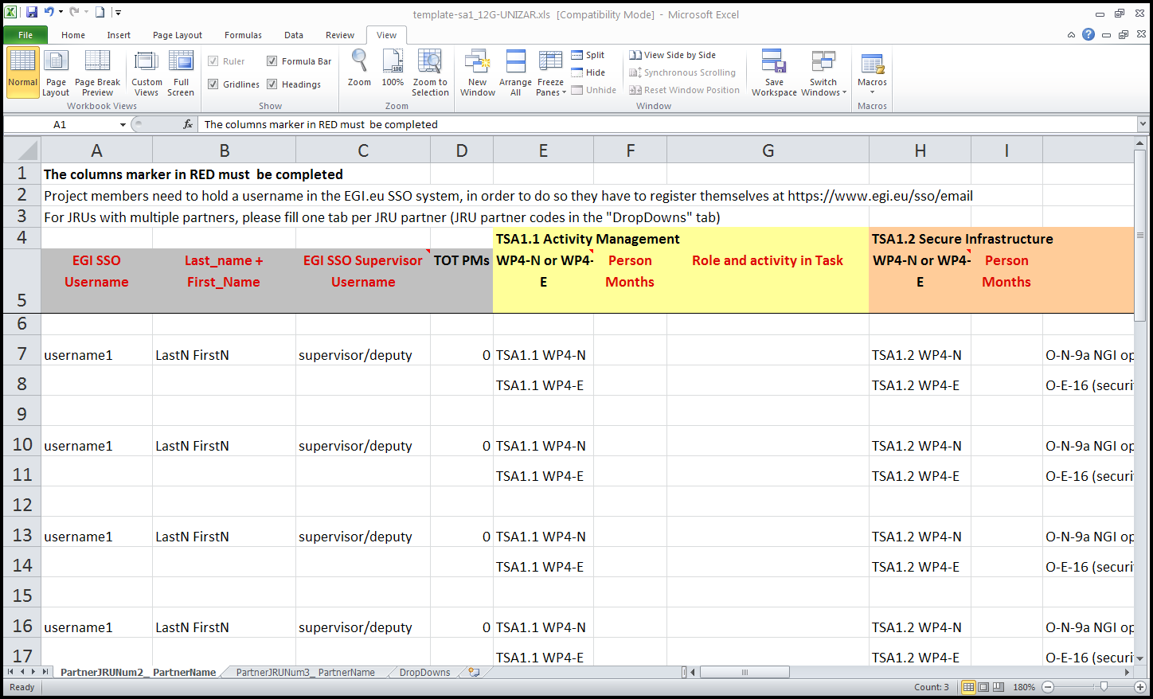
Figure 1: Execution Plan Template
The columns marker in RED must be completed
Project members need to hold a username in the EGI.eu SSO system, in order to do so they have to register themselves at https://www.egi.eu/sso/email
For JRUs with multiple partners, please fill one tab per JRU partner (JRU partner codes in the "DropDowns" tab)

This process has been repeated several times to ensure that the activity of each partner was coherent with the committed work plan of the project. Initially the activity was recorded at the level of the member in the Execution Plan (see the above template – Figure 1). The data were then checked against the efforts per task committed in the project plan (at the level of the partner).
Once validated, this information was implemented in the database of the Project Progress Tracking tool (see Section 2). An online form was created for every project member to enable them to record their activity for each task in their timesheet.
The Execution Plan records activity at the level of each staff member, compared to the internal organisation of the partner. In PPT, the database of resources committed by a partner to a task should match with the effort plans recorded in the Consortium Agreement.
This double process ensures that the partners’ data are pre-validated by the Work-package leader, who is in direct contact with the partner, and prevents the member from mistakenly declaring their activity (e.g. charging under the wrong task). Further details on the PPT tool can be read in the following section.

Project Progress Tracking (PPT)

The PPT tool is hosted by CERN and is used by the EGI-InSPIRE project, and other EC projects such as EMI, to track the work of its members across the different work packages and tasks. It manages the online completion of timesheets across the partners.
The working plan of the project is registered per partner and per task. For each task a list of involved partners and the corresponding staff resource is maintained in the database (see Figure 2).
Figure 2: Task view within PPT showing active partners
The data collected in the Execution Plan are then transferred into PPT. A member form is created for every user (see Figure 3). A combination of information is used to define the activities that the user can report their efforts to. Each member has a supervisor assigned in PPT, who is responsible for validating the member’s declaration, his/her working period, etc.

The member is identified and authenticated using his/her EGI Single Sign On (SSO) ID. This is a single username and password allocated by the EGI.eu IT support services. It ensures that every member is has a unique ID and can be recognised by PPT.
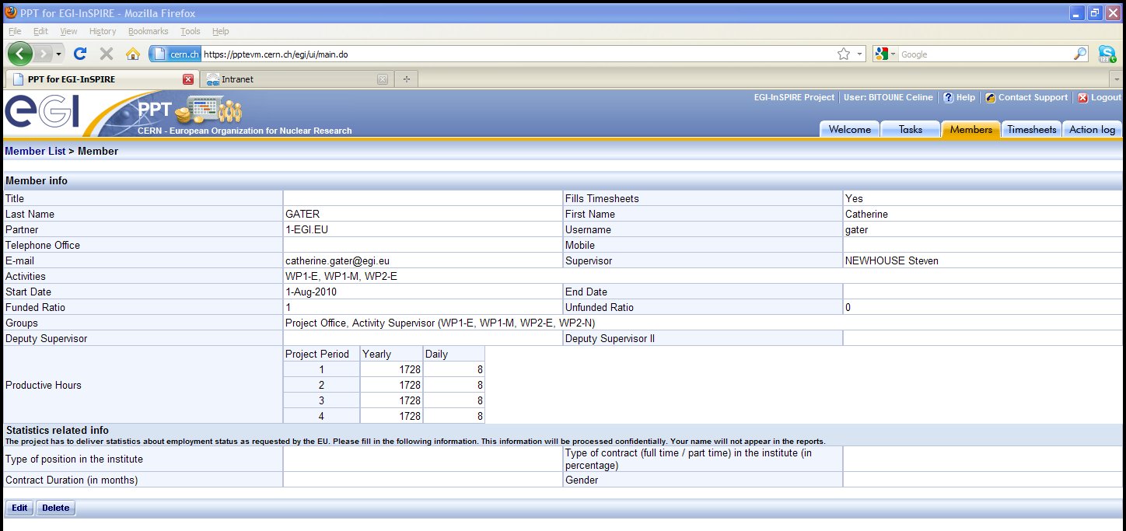
Figure 3: Project member view in PPT
To meet EGI-InSPIRE project requirements the reporting procedure has changed from the previous EGEE-III project, where effort was reported as partly funded, partly unfunded. In PPT all EGI-InSPIRE project effort is declared as funded. The particular refunding ratio of each task grouping (see Table 1) is then applied to the total person months recorded in the timesheets at the end of the quarter.

Table 1: Reimbursement rates for different work packages
Activity | EC Contribution | NGI Contribution | EGI.eu Contribution
EGI Global Task (e.g. WP4-E) | 25% | 50% | 25%
NGI International Task (e.g. WP3-N) | 33% | 67% | N/A
General Tasks (e.g. WP6-G) | 40% | 60% | N/A

The costs estimate is calculated from the PPT tool by using the average person month of the partner (as defined for the budget tables – see example in Table 2) and the number of working hours applicable to the partner. Given that this information is accurate, the cost estimates are aligned with the project funding scheme. This also enables EGI.eu as coordinator to report costs funded by the European Commission grant, those funded by the NGI and those funded by EGI.eu on behalf of the NGIs.

Table 2: Typical partner costings report taken from PPT
Partner Effort |  |  | Project Period 1
Activity | Task | TR | Worked PM Funded | Committed PM | Achieved PM | Eligible Cost Estimate | Estimated Funding
WP2-N | TNA2.2N | 33% | 1,5 | 1,0 | 153% | 15.823 € | 5.222 €
WP3-N | TNA3.2N | 33% | 0 | 1,0 | 0% | 0 | 0
WP4-E | TSA1.8E | 50% | 2,5 | 2,9 | 86% | 25.515 € | 12.757 €
WP4-N | TSA1.5N | 33% | 0,1 | 0,5 | 20% | 1.010 € | 333 €
WP6-G | TSA3.2.4 | 40% | 4,6 | 3,0 | 153% | 47.396 € | 18.958 €
Total: |  |  | 9 | 8 | 4 | 89.744 € | 37.271 €

Evolution From PQ1 to PQ3

As explained in the Introduction the EGI-InSPIRE activities have ramped up during the initial months of the Project due to a number of factors, discussed in greater detail in the Quarterly Reports. [R1, R2]

As a result, staff have continued to be recruited to the Project after the early months, which explains why the number of members registered in the Execution Plan was at its lowest level in PQ1 (see chart below) and has increased since.

Partners and JRUs total 135 institutes, of which 93 receive an EU contribution (partners and JRUs). The other institutes, including the Asia Pacific partners, do not receive funding. None of these institutes have registered their members into PPT as they are not reporting any funded effort, but their staff are registered in the SSO in order to access other project resources. Their activities are recorded in the management reports and for the Asia Pacific partners in an annual report.

Table 3 shows the evolution of the number of (funded) Partners and JRUs, and the number of people per partner, who have been registered in PPT during each quarter. These figures should be compared to the total number of institutes which receive funding, i.e. 93.

Table 3: Growth of partner engagement during the project
Period | PPT Member | Partners & JRUs | Effort delivered by the project against plan
PQ1: May-July 2010 | 372 | 65 | 71 %
PQ2: Aug-Oct 2010 | 494 | 82 | 88 %
PQ3: Nov 2010 - Jan 2011 | 583 | 87 | 93 %

The evolution of member registrations reflects the capacity of the Network in terms of resources from the start of the project. For example in May 2010 only 65 out of 93 Funded Partners were able to record effort towards the Project’s Description of Work (DoW). It is important to note that this data changed rapidly during PQ2 with the completion of the summer holidays period and after the Grant Agreement had been released by the Commission and signed by EGI.eu.

Six partners and JRUs are not yet registered into the system and thus do not declare efforts. These are EMBL and five JRUs (28-UWAR and 28-Politechnika Wroclawska, 40-PNPI, 51-INCAS and 51-UPB). The situation with these partners is being monitored by the Project Management Board.

The workplan of EGI-InSPIRE totals 9192 PMs⁽¹⁾, of which 1018 shall be delivered by the Asia Pacific partners. The remaining 8174 PMs are distributed across 7 work-packages. The analysis below (see Figure 4) has been conducted to get an overview of the distribution of the active members per work-package from PQ1 to PQ3. The percentages are calculated out of the total number of funded PMs, i.e. excluding the Asia Pacific PMs, for which the effort reporting is not reviewed through monthly timesheets and thus is not managed through PPT.

- The figure has slightly increase from the 9170 PMs reported in the tables of the DoW. This comes from the latest fine tuning which occurred during the implementation of the Consortium Agreement.

Figure 4: Percentage of Committed vs. Planned effort for each work package

WP1, WP2, WP4, WP5 and WP7 are operational; the missing person months allocated by the partner versus the committed plan varies of +/- 6 %. This is an acceptable variation justified by the on-going fine tuning managed by the Partners.

Further investigation is required for WP3 and WP6. In WP3 the contacts made by the project are steadily increasing and should fully reach their committed efforts by the end of Year 1. WP3 effort consists of central teams (with significant effort over the project) and activities taking place within the NGIs to engage with the central team (small amounts of effort). The significant central effort has been assigned whereas the small amounts of effort within many of the partners continue to be identified. Identifying and recording this effort has been a challenge. Verification is currently in process to control Partners’ involvement and take corrective actions if necessary. The situation of the Partners in this work package is as follows:

No resource commitments have been planned yet for:
- UPT, 31 PMs;
- IIAP NAS RA, 6 PMs;
- IPP-BAS, 8 PMS.
- GRNET and IASA, 47 PMs (WP3-E tasks);
- VU, 22 PMs;
- UWAR, 17 PMs;
- and UK NGI, 28 PMs;

Then the following Partners have partly allocated the committed effort:
- LIP has only allocated 30PMs out of the 40PM planned in both N and E activities;
- CSC could still allocate 14 PMs (out of 24 PMs);
- INFN has missed 12 PMs out of 40PMs;

And finally, UPVLC (Spanish JRUs) has allocated double PMs in TNA3.4N, compared to the plan (24 PMs);

In WP6 732 PMs have been allocated over the first 3 years of the project. The major missing efforts come from EMBL, INFN-SPACI, CNRS-CEA and CIEMAT. One-third of the missing person months are due to EMBL being inactive since the start of the project. A further 45% of missing efforts result from a gap in the resource allocated from INFN that is being seconded to CERN through the CERN fellowship process. The appointment for these staff is still underway. The remaining efforts from CNRS-CEA and CIEMAT (25%) will be adjusted as soon as the recruitment process is completed.

Table 4: Effort delivered for each work package during the project to date
Work packages | PQ1 (%) | PQ2 (%) | PQ3 (%) | Project TOTAL  (excl Asia Pacific) | Project TOTAL
WP1 | 46% | 93% | 99% | 321 | 321
WP2 | 57% | 73% | 90% | 705 | 812
WP3 | 43% | 63% | 79% | 960 | 1379
WP4 | 66% | 77% | 94% | 4638 | 5130
WP5 | 95% | 94% | 94% | 503 | 503
WP6 | 52% | 69% | 79% | 732 | 732
WP7 | 106% | 106% | 106% | 315 | 315
 |  |  | TOTAL | 8174 | 9192

Execution Plan

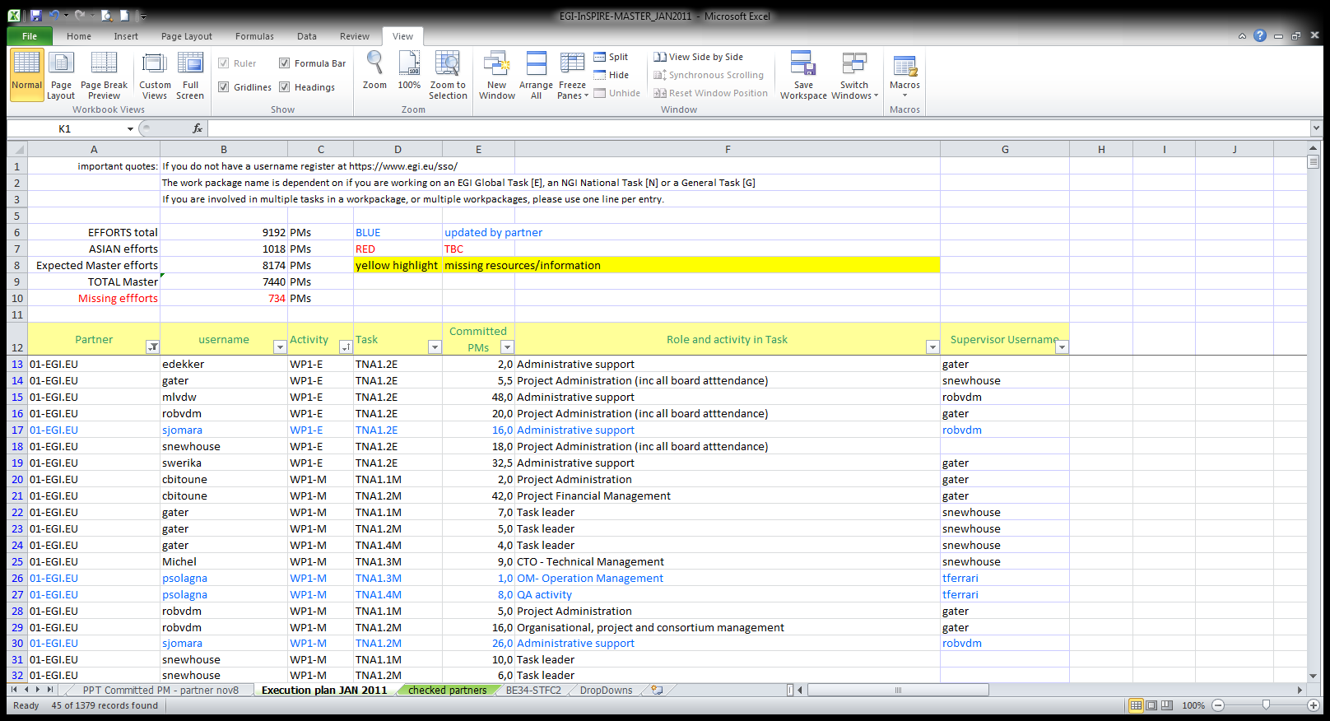
The full Execution Plan (see sample below) can be found on the wiki page of the Project Administration Committee [R3]. It is updated on a regular basis as it evolves according to the staff situation of our partners. It will be reviewed entirely after the closure of Year 1. Any resulting underspending of Year 1 planned efforts may be carried forward and spread over the remaining three years of the project.

Further investigation on the best option to keep this Execution Plan in line with our initial commitments will be made following the first review.

Conclusions
The Execution Plan is a living document that records across the consortium which individual at each Partner is working on a particular task. This information is reflected in the PPT tool that allows the consortium to monitor via timesheets the delivery of effort to particular tasks. Any differences between the expected and committed effort are reviewed at least quarterly. Alongside this process task leaders monitor their activity and report issues to the work package leaders and the project management. Deviations (unexpected over or under reporting) are understood and managed as needed. This document has provided an overview of the process that has taken place to establish the Execution Plan, the document itself will continue to adapt during the course of the Project as staff change.

At this stage in the Project the un-assigned effort that is concentrated with particular partner in particular tasks has been identified and is being monitored. Some partners have failed to engage at all in the project to date (EMBL & UPT) while some JRU members in Poland, Russia and Romania have not committed their allocated effort. Attempts are being made to obtain their engagement before the end of year 1.

References
R 1 | MS105 Quarterly Report PQ1 May 2010 – July 2010  https://documents.egi.eu/document/156
R 2 | MS106 Quarterly Report PQ2 August 2010 – October 2010  https://documents.egi.eu/document/248
R3 | EGI-InSPIRE Project Administration Committee  https://wiki.egi.eu/wiki/Project_Administration_Committee

