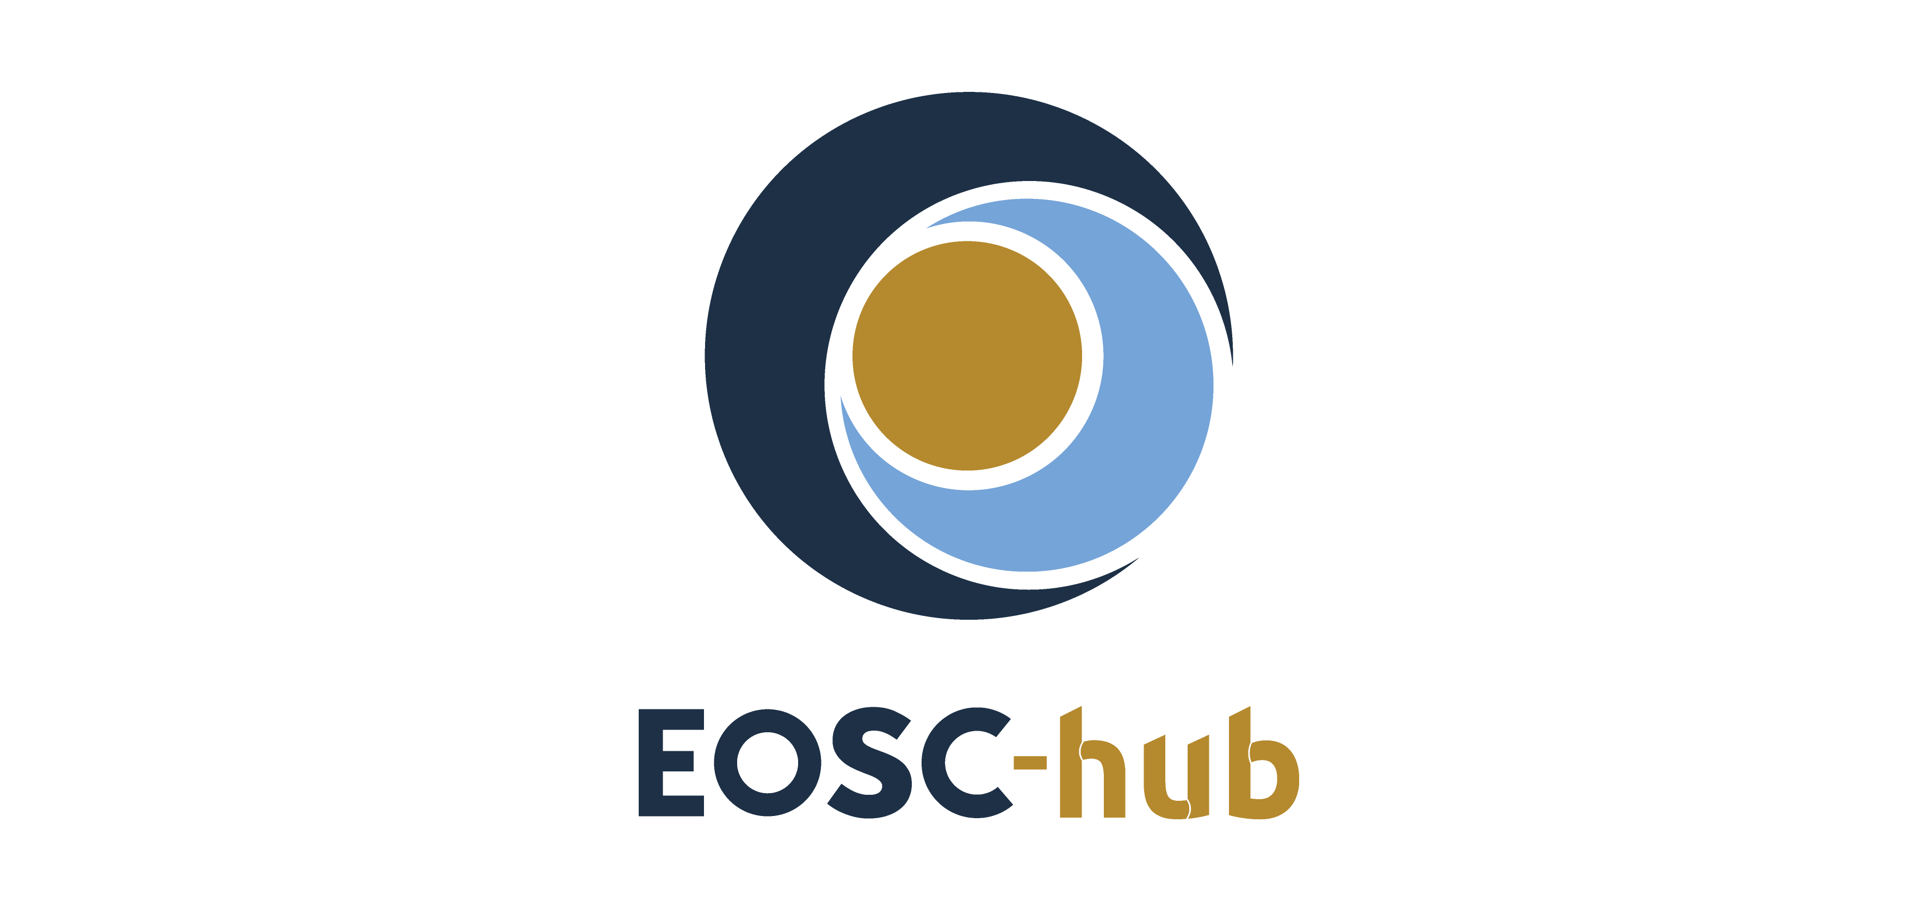

D3.4 Final report on dissemination and exploitation of project results
Lead Partner: | EGI Foundation
Version: | 1
Status: | FINAL
Dissemination Level: | Public
Document Link: | https://documents.egi.eu/document/3710

Deliverable Abstract
This document provides a final report on the key exploitable results, including aspects such as the definition, value proposition, IP management, exploitation path and dissemination activities and adoption.

COPYRIGHT NOTICE
This work by Parties of the EOSC-hub Consortium is licensed under a Creative Commons Attribution 4.0 International License (http://creativecommons.org/licenses/by/4.0/). The EOSC-hub project is co-funded by the European Union Horizon 2020 programme under grant number 777536.
DELIVERY SLIP
Date | Name | Partner/Activity | Date
From: | Matti Heikkurinen  Roksana Wilk  Małgorzata Krakowian  Owen Appleton  Pavel Weber  John Kennedy  Elisa Cauhé  Dale Robertson  Giacinto Donvito  Giuseppe La Rocca  Gergely Sipos  Debora Testi | EGI Foundation  CYFRONET  EGI Foundation  EGI Foundation  KIT  MPCDF  EGI Foundation  JISC  INFN  EGI Foundation  EGI Foundation  CINECA | 13/04/2021
Moderated by: | Malgorzata Krakowian | EGI Foundation/WP1
Reviewed by: | Debora Testi  Smitesh Jain | CINECA  EGI Foundation | 07/04/2021  09/04/2021
Approved by: | AMB

DOCUMENT LOG
Issue | Date | Comment | Author
v.0.1 | 25/01/2021 | Table of Contents | Matti Heikkurinen
v.0.2 | 10/03/2021 | KER descriptions imported/refined | Matti Heikkurinen, Roksana Wilk, Małgorzata Krakowian, Owen Appleton, Pavel Weber, John Kennedy, Elisa Cauhé, Dale Robertson, Giacinto Donvito, Giuseppe La Rocca
v.0.3 | 25/03/2021 | Chapter 4 contents, refinements; review version | Gergely Sipos, Debora Testi, Matti Heikkurinen
v.0.4 | 09/04/2021 | Review | Debora Testi  Smitesh Jain
v.1 | 13/04/2021 | Final | Matti Heikkurinen

TERMINOLOGY
https://wiki.eosc-hub.eu/display/EOSC/EOSC-hub+Glossary
Terminology/Acronym | Definition
DIH | Digital Innovation Hub
EOSC | European Open Science Cloud
IP | Intellectual Property
IPR | Intellectual Property Rights
KER | Key Exploitable Result
RoP | Rules of Participation
SMS | Service Management System

Contents
1 Introduction 8
1.1 Relationship with the other deliverables and documents 8
1.2 Project results, Intellectual Property and Intellectual Property Rights 9
2 Summary of the EOSC-hub Innovation Management approach 11
2.1 ​KER Champion role 11
2.2 ​Broadening the set of results managed 12
2.3 ​Definition of the Results and result types 12
2.4 ​Value proposition 13
2.5 ​IP Management principles 13
2.6 Overall exploitation and dissemination approach 14
2.7 Branding as a mechanism for encouraging adoption 15
2.8 ​Target audiences 16
3 Key Exploitable Results: Exploitation and Dissemination 18
3.1 ​KER 1. EOSC Portal and Marketplace 18
3.2 ​KER 2. EOSC Service Management System (SMS) 22
3.3 ​KER 3. EOSC Rules of Participation (ROP) 26
3.4 ​KER 4. Internal Services in the Hub Portfolio 28
3.5 ​KER 5. External Services in the EOSC Service Portfolio 33
3.6 KER 6. EOSC Digital Innovation Hub (DIH): Platform for Industrial Collaborations with EOSC 37
3.7 KER 7. Business and sustainability models for services and the hub 41
3.8 KER 8. Interoperability and integration guidelines 44
3.9 KER 9. Training courses and material 47
4 ​Competence Centres and Thematic Services 51
4.1 Competence centres 51
4.2 ​Thematic Services 61
5 Conclusions and future work 76
5.1 Further evolution of the Innovation Management as a concept 77
5.2 Potential Best Practices 77
Appendix I. KER Champions 78
Appendix II. KER 4 components 79
Appendix III. KER 5 integration components 81

Executive summary
The innovation management approach and the conceptual models underlying it have remained largely stable since the end of the first half of the project. The second half of the project applied and optimised them in a turbulent environment. The global pandemic necessitated some changes in the working practices and required developing new ways to disseminate and promote project results. The evolution of the EOSC landscape introduced new opportunities and challenges for the project. The three-month extension of the project lifetime allowed the project to address the challenges and seize the opportunities for sustained service provision of the EOSC-hub results. However, due to the EOSC Future project launch delay, some of the details may change with the evolving EOSC-Core service.
This document is released simultaneously with a wide range of other final deliverables presenting the project achievements in detail. Hence, this document aims to be a relatively concise summary of the project’s high-level aspects that supported the exploitation and dissemination of the results. There are unavoidable overlaps with the material in the other deliverables. Still, consistent attempts have been made to limit these to what is necessary to make this document readable on its own. Chapter 1.1 includes a list of other deliverables and the specific parts of this document they provide more details on. The section contains some reflections related to the project results and the degree they can be captured as formal IP or IPR. In an open platform project such as EOSC-hub, the community's goodwill and awareness, familiarity, and network effects unavoidably play a crucial role in creating the impact. This is in clear contrast to projects aiming to solve a single challenge (or a known set of challenges). The project results that can be protected likely capture a more significant proportion of the value generated.
As noted above, the primary approach for Innovation Management did not change dramatically during the second half of the project. The exception was formalising the “KER Champion” role as a single contact point or information broker in all aspects of the Key Exploitable Results. This rule was very useful in streamlining and clarifying the communications and decision making within the project and is included as part of the lessons learned and topics for further study of the project. Linking innovation management more closely with the other project processes and presenting the lessons learned in the framework of the recently published ISO 56 000 standards family were also seen as potentially fruitful areas of further study.
A lot of effort was spent developing a coherent and consistent approach to “EOSC branding” of the project results. EOSC-hub played a role of a pilot case in this area, with the activities having an impact on the EOSC branding guidelines published by the EOSC Secretariat in April 2020. In general, branding and trademarking were identified as tools that would support capturing of types of project result that are not directly protectable by the traditional IPR mechanisms. As the formalisation of the EOSC brand will be completed, this kind of use of trademarking and branding will undoubtedly become feasible mechanisms to support the capture and exploitation of the results of the EOSC-core and EOSC Exchange.
All of the results described in this document will be further developed in ways that are linked to the evolving EOSC ecosystem. Thus, we hope this deliverable will serve not only as a final summary of EOSC-hub project results but also as a useful reference document for a broad range of future activities that are building the common EOSC innovation ecosystem!

Introduction
This deliverable presents the project’s Key Exploitable Results (KERs) and the process used in defining them, their value propositions and aspects related to dissemination and exploitation (including IPR-related issues). As the landscape surrounding the project has evolved dramatically during the project’s lifetime, the deliverable will also include some updates to the analysis presented in the deliverable D3.3.
The primary exploitation channel of the project - the EOSC ecosystem - underwent parallel evolutionary processes during the activities covered by this document. Thus, the approaches used to capture value propositions of the KERs, dissemination approaches, models for adoption and IP strategies are summarised. For more detailed information related to the rationale for choosing particular KERs and the exploitation roles and approaches, the deliverable D3.3 remains the primary reference.

Relationship with the other deliverables and documents
This deliverable has the role of summarising and presenting in a systematic manner results that are described in more detail in other final deliverables of the project. The deliverables of specific importance are:
- D2.5 and D12.3, presenting the background of the KER7 (business and sustainability models for services and the hub)
- Deliverable D5.6 includes the KER 4 (Internal services in the hub portfolio, chapter 3.4 of this document) background in detail
- Deliverable D6.5 presents the external, horizontal services integrated to the EOSC-hub marketplace as KER 5 (External Services in the Hub Portfolio, Chapter 3.5 of this document)
- Deliverable D7.5 presents the results related to the thematic services part of KER 5 (Chapters 3.5 and 4.2 of this document) in more detail.
- Deliverable D8.2 presents the results of the Competence centres (Chapter 4.1 of this deliverable) in detail.
- Deliverable D9.4, presenting the KER6 (EOSC Digital Innovation Hub) results and their background.
- Deliverable D10.7, presenting the KER 8 (KER8. Interoperability and Integration guidelines) background in detail.
- Deliverable D11.5, presenting KER 9 (KER9. Training courses and material ) background in detail.

The goal of this deliverable is to be as self-contained as possible while at the same time minimising the overlap with these other, more in-depth deliverables.
For each of the project results, the promotional and outreach activities that played a key role in achieving the exploitation successes are described. For readability reasons, detailed records of all the dissemination activities are not included in the deliverable but made available separately on the project website.

Project results, Intellectual Property and Intellectual Property Rights
The latter period of the project was characterised by several fundamental changes, both in the EOSC landscape and in the world surrounding it. The vision of the future EOSC has become clearer with the establishment of the EOSC Foundation (EOSC AISBL) as a permanent legal entity responsible for EOSC governance. However, the details have not been fully settled: for example, when writing this document, EOSC Foundation is still in the bootstrap phase. Similarly, the projects tasked to take the results of the EOSC-related projects forward towards sustained service provision have been launched only recently. At the same time, the plans related to funding models of this sustained service provision are also shifting: the potential move from the grants-based approach to procuring services will have a fundamental impact on the collaboration patterns of the service providers in the EOSC ecosystem. Thus, with a slight hyperbole, we could say that at the moment, we know quite well who will take the project results forwards. However, the details of this “destination” as well as the “means of transportation” are at least not fully known.
The global upheaval caused by the COVID-19 pandemic has also shaped the working practices and decision-making processes of the EOSC-hub consortium in dramatic ways. The final year of the project proceeded using online collaboration as the primary mechanisms for discussions ranging from technical details to principles of governance. The speed of organisational learning and innovation that was necessary in order to fulfil the original working plan was breath-taking. However, while remembering and mourning for the human suffering caused by the pandemic, we should also acknowledge its role as a trigger for innovation and reflection on the purpose and role science and research can play in society. In EOSC-hub context, COVID triggered a vast array of results that fit in the intangible and abstract part of the definition of the word “results” used in the Grant Agreement:

‘Results’ means any (tangible or intangible) output of the action such as data, knowledge or information — whatever its form or nature, whether it can be protected or not — that is generated in the action, as well as any rights attached to it, including intellectual property rights.

During the last year of the project, the consortium generated vast amounts of knowledge related to ways to overcome limitations of remote collaboration. Gradually, this triggered a development (and tacit co-design) of working practices and understanding that - in some cases - may have made the collaborations more efficient than before. Overall, the last year of the project generated numerous intangible results that shaped the culture of the project and the EOSC ecosystem surrounding it. While these results are impossible to protect or even capture in a satisfactory manner It is likely that results in this “ephemeral category” will play an important role in the future EOSC. The ability to build and maintain trust both within the EOSC Core and Exchange teams and in their relationships with growing numbers of user and resource communities in a virtual context is a Key Result of the project. However, transferring the result to a new context for exploitation cannot happen through an installation script or a licensing agreement. Thus, in its current form we cannot consider this organisational learning a Key Exploitable Result.
Hence, the focus of this document is on the more tangible forms of project results, typically linked to Intellectual Property: service definitions and instantiations, requirement gathering and co-developing documented working practices that allowed better and better alignment between project and its key stakeholders. As discussed in the deliverable D3.3, this IP forms a subset of the project results. An even smaller subset of this intellectual property can be formally protected by Intellectual Property Rights. For the most part of the shared core-components, the primary purpose of the IPR management is to encourage as broad adoption of the results as possible through the use of open licenses that reduce the perceived risks related to uptake and adoption of the technical solutions of the project.
But it is worth to reiterate that in most cases the part of the project results that can be protected using IPR mechanism is only a small subset of the overall result that tends to include aspects such as mutual, tacit understanding of the goals of the collaborating partners, social capital and familiarity with the solutions and research challenges they target.

Summary of the EOSC-hub Innovation Management approach
While the EOSC overall vision has been relatively stable throughout the project lifetime, many of the details and approaches related to the implementation have undergone changes, sometimes quite dramatic ones. Some of these changes have been catalysed by EOSC-hub efforts, with some of the KERs either forming parts of the EOSC as it is understood today or providing crucial support components for the EOSC ecosystem. In general, the innovation management approach has focused on aligning and communicating the project results in a way that they can be integrated into EOSC in a way that seems consistent from the user perspective.
For this reason, a lot of the effort was dedicated to clarifying the branding of the project results. These actions were, to a large degree, triggered by the recommendation in the project review of EOSC branding of main building blocks of the project. This required active engagement with the relevant parts of the EOSC governance as well as an internal reflection of the role branding would play in creating a cohesive environment from the user perspective.
In the end, the promotion of branding was one of the areas where the linking of the project’s quality processes, and innovation management was identified as an area where synergies were realised. The branding-related tracking and communication could - as part of the process - also complement the execution of monitoring the execution of the project’s compliance processes.
In terms of the DoA definition of the innovation management goals, evolution of the project’s environment made focusing on dissemination, exploitation and communication of the KERs the priority of the activity. The due diligence related to IPR and further validation of the KER definitions were performed, but the effort was focused based on the importance of the results from the exploitation point of view.

​KER Champion role
As the role of KERs as a tool for communicating the project results and supporting their exploitation became clearer, it became obvious that the project needed a single contact point with an overview of the technical, engagement, IP and exploitation plan aspects of the KERs. In addition, especially when it came to communication aspects of the KERs, it was important to identify an individual with a mandate to rapidly “sign off” or approve final versions of dissemination materials and other aspects of the communication activities.
For this reason, the project developed a “KER Champion” role and appointed nine project staff members to coordinate the communication and dissemination activities of the KERs. The role accepted by the AMB in September 2020 was defined as:
“Helping to coordinate and encourage exploitation and dissemination of the KER. The champion would act as the primary spokesperson for the KER and would accept or suggest changes and improvements of the KER-related documentation, promotional material and plans in collaboration with the different WP3 team members.”
The acute need for this role was the development of the public KER descriptions on the EOSC-hub website, where the visual representation, drafting summary text and determining the optimal linking with more technical information and other supporting material required the involvement of several staff members from the dissemination team. A single contact point was crucial in streamlining the necessary communication steps.
However, the role was extremely useful also for the overall exploitation of the project results overall. Even in cases where the KER mapped almost directly with the WP structure of the project, the role clarified the decision-making process and allowed for a less centralised communication between the KER champions and dissemination support staff.

​Broadening the set of results managed
An in-depth analysis of project results was also extended more systematically to other result types: Competence centres and thematic services supported by the project. While the thematic services are covered by a KER, each of the thematic forms an autonomic innovation ecosystem, typically linked to a research community that has its own dissemination and exploitation strategies and channels. The same holds true for the competence centres that are even more heterogeneous and independent in nature. Both of these result sets represent indirect paths to EOSC integration with the thematic communities playing a key role in their continued integration in the EOSC ecosystem.
The results related to the thematic services and competence centres are summarised in chapter 4 and presented in detail in dedicated deliverables.

​Definition of the Results and result types
The basic project result types defined in deliverable D3.3 were deemed sufficient for the purposes of this final report. The primary result categories are as follows:
- Software
- Services
- Technical specifications
- Policies and procedures
- Documents and reports
- Business models
- Skills
- Brands
- Other
In some specific cases, the document includes additional information related to results in order to make it easier to position them in terms of further exploitation and adoption.

​Value proposition
The deliverable D3.3 defined the overall exploitation goal of the project as “continued EOSC service provision by the follow-up activities”. The prerequisites for this were:
- Reliable and efficient service delivery, and
- Awareness of the value of the service by the key stakeholders.

This basic principle still holds true. In terms of the reliability and efficiency of service delivery, the role of some of the KERs has become more important, either through technical developments (EOSC Portal and Marketplace) or to broader engagement and awareness of the importance of the result, e.g. through cross-project collaborations and engagement with the EOSC Governance (e.g. Rules of Participation and EOSC Service Management System).
However, the overall awareness-raising and communication efforts related to the project results has played an equally important role. The analysis and refinement of the concept and its communication have allowed the project to articulate the KERs and their roles in a concise and concrete manner. One of the visible results of this process are the KER descriptions on the project website that are aimed at the part of the general public that is interested in IT Services and research, but with no previous experience or knowledge related to EOSC. While these communication tools and efforts undoubtedly have an important role as contributions to the EOSC ecosystem, the systematic analysis of the value KERs provide has likely played an important role in ensuring that the project’s contributions have been picked up by the EOSC-related follow-up activities.

​IP Management principles
As discussed in section 3.3 of the deliverable D3.3, the primary goal of the IPR management of the project is to “minimise the risk of IP-related service disruptions for the EOSC-hub project and future long-term structures under EOSC Governance which would operate a hub”. Thus, the principles of the IP management adopted by the project are very much in line with the mid-project assessment:
- IP and IPR are linked to most of the project’s results but represent a very small part of the value they bring.
- The impact of IPR generated by the project cannot be separated from the future service provision.
- Most of the IPR linked to project results is automatically protected by copyright protection.
- The project considered trademarking approaches to brand some of the project results (especially the EOSC-DIH), and also to structure the underlying IP and protect key parts by associating them with IPR (e.g. skills, that cannot be protected directly) in a way that would support the overall EOSC branding. However, due to the lack of clarity of formal trademarking of the primary EOSC brand itself, these plans needed to be abandoned.
- Since most of the partners do not generate revenue from licensing of their IPR, the only practical enforcement method related to copyright is open licensing (in line with the clauses in the consortium agreement).

Thus, the key focus of the IP management was ensuring that the future service provision based on the project results would be possible. The extension of the project lifetime allowed the project to manage this also in practice, with the handover of the services happening between projects that were running in parallel (or negotiating the details of the launch, in case of the EOSC Future).

Overall exploitation and dissemination approach
As the group of KERs and major project results had stabilised by the middle of the project, the dissemination and exploitation could focus on optimisation of the presentation of KERs and their components. In terms of exploitation through take-up by the follow-up activities, KERs served as a conceptual framework that streamlined the discussions related to similar components and services. All and all, the consistent use of KERs to explain the project's contributions to EOSC very likely facilitated the common understanding of the EOSC architecture. In the end, mapping of KERs to EOSC Core and Exchange parts of the EOSC Sustainability Working Group’s “FAIRlady document” was straightforward, as the “Hub operator” and EOSC Core had almost one-to-one mapping with each other.
EOSC-hub was also proactively supporting the work of the EOSC working groups. This engagement is described in detail in chapter 7 of the deliverable D3.5. To summarise, the project was actively engaging in the work of four of the six working groups:
- Architecture: Defining the technical framework required to enable and sustain an evolving EOSC federation of systems;
- Rules of participation: Designing the Rules of Participation that shall define the rights, obligations governing EOSC transactions between EOSC users, providers, and operators;
- Sustainability: Providing a set of recommendations concerning the implementation of an operational, scalable, and sustainable EOSC federation after 2020.
- Skills and Training: Providing a framework for a sustainable training infrastructure to support EOSC in all its phases and ensure its uptake;
This engagement has obviously played an important role in the dissemination and exploitation of several of the project KERS, especially Interoperability and Integration guidelines (chapter 3.8), Rules of Participation (chapter 3.3), Business models and sustainability models for services and the hub (chapter 3.7) and training courses and material (chapter 3.9).
In addition to these formal activities, the project adopted a continuous engagement and testing of concepts with the current and new stakeholders. For example, the project’s engagement and collaboration with the OCRE project allowed sharing and validating the observations and insights related to business models directly with a project engaged in Cloud service procurement.

Branding as a mechanism for encouraging adoption
As part of the mid-project review, it was noted that the project should initiate branding of its results in a way that would demonstrate integration with EOSC. The project expanded considerable effort in clarifying the scope and correct use of the EOSC brand, contributing to the development of the EOSC Branding Guidelines that were published 1st April 2020.
The meaning of the Branding Guidelines was discussed within the project’s AMB meetings in detail, ensuring that the approach was clear. As a summary, the approach was based on:
- Adding EOSC logo to the user interface of the service
- Maintaining the original visual identity of the services
- Ensuring that the other project results had an IPR regime that allowed EOSC branding later on. In the case of the EOSC-hub deliverables, this was accomplished by the CC-BY 4.0 license, that allows changing the layout (including logos) freely, as long as the original license statement is retailed.

​Co-Branding of the results
The work package leaders of the WPs with “user facing” components were the primary contact points for the co-branding activities. Each of them informed and promoted the opportunity to co-brand the results with the EOSC logo to show integration with the overall initiative. In general, the attitudes towards this initiative were very positive. However, there were some pragmatic issues and limitations with the implementation:
- Digital Innovation Hub pilots, where the EOSC is not the primary market for the results generated
- Competence centres that represented hubs for major research communities, with activities that extend considerably beyond the EOSC (or ICT in general) scope
- General purpose services integrated into the EOSC-hub, but used widely outside this context
However, all the services that were integrated into the EOSC-hub marketplace (and thus into the EOSC Marketplace) have been co-branded through their marketplace entries. In addition, ECAS, WeNRM and EISCAT 3D took up the opportunity to add the EOSC logo to the user interfaces.

Dedicated, co-branded results
As noted above, some of the general-purpose services were difficult to co-brand directly. These services tended to have a broad user base that is not limited to EOSC context. After careful analysis, it was noted that in some cases direct co-branding of these broadly exploited services might cause confusion, even representing a potential risk to the EOSC brand. The risk would be non-negligible in cases an end-user encounters EOSC logo without any background or context, especially as part of a routine process with some privacy or security implications. Thus, it was deemed better to create a dedicated instance with the EOSC Co-Branding under the “eosc-portal.eu” domain for the following services:

Service | Address of the co-branded version
Marketplace | https://marketplace.eosc-portal.eu/
Monitoring | argo.eosc-portal.eu
Order management | https://opsportal.eosc-portal.eu/sombo
Metrics portal | https://opsportal.eosc-portal.eu/metricsEOSC/
Helpdesk | helpdesk.eosc-portal.eu
AAI | http://aai.eosc-portal.eu/
CMDB | https://gocdb.eosc-portal.eu/portal/

These services and their role in the emerging EOSC core are presented in more detail in chapter 2 of the deliverable D5.6.

​Target audiences
While the landscape surrounding EOSC-hub shifted dramatically during the project’s lifetime, the analysis of the communities with interest and capability to take the project results further remained valid. The D3.3 analysis of the exploitation roles was summarised as follows:

Table 1: Exploitation roles used to assess the value proposition of the KERs
EOSC Exploitation Role | Proposed definition
Researchers and Research Communities | Performing or organising research (scientific or otherwise) in the context of EOSC. Consuming research services and benefiting from research data. Can include academic, public sector, profit and non-profit research.
Service providers | Providing services which support researchers and research communities. Includes IT, Human and other services. Can include academic, public sector, profit and non-profit services.
EOSC Hub Operators | Operating a ‘Hub’ function for some level of EOSC structure, whether it is a central ‘Hub’ (i.e. the Federating Core of EOSC), a regional or thematic Hub. Involves some combination of, listing, exposing, federating or integrating a number of Service providers in support of Researchers and research Communities. Typically acts in support of agendas set by national or European policy makers.
Enterprise | Acting to further their corporate goals, typically growth and maximisation of profit by interacting with EOSC.
Education and support for eScience activities | A cross-cutting role that can be taken by those taking on other roles, when they are providing education and training of members of the border EOSC community in any capacity.

In some of the exploitation plans the “EOSC Hub Operators” has been used interchangeably with “EOSC Core”. While the “EOSC Core” is a specific instance of the “Hub Operator” role defined earlier, these terms could be considered as synonyms in the scope of this deliverable.
The high-level role definition does not seem to require updates even in the context of service providers, despite the discussions related to complementing grant-based approaches for service provision with procurement mechanisms in the future. While the procurement mechanism would mean shifting to contractual arrangements that are more in line with the for-profit sector practices, the “service provider” exploitation role was not tied to the non-profit business model or grant-based service provision.

Key Exploitable Results: Exploitation and Dissemination

​KER 1. EOSC Portal and Marketplace
The EOSC Portal and Marketplace - which have developed into joint efforts with EOSC Enhance project - support the resources discovery and access in EOSC. As described in the 2019 EOSC Portal collaboration agreement (concluded in 2019 with the representatives of the EOSC-hub, OpenAIRE-Advance and eInfraCentral project consortia) this KER includes: “technical components, intangible assets and contractual arrangements that make it possible to provide the service that facilitates the access and use of the EOSC assets. The contractual arrangements include - but are not limited to - the rights to administer the IP addresses and IT infrastructure making accessing the EOSC Portal possible”.

Key benefits for EOSC
Thanks to this KER, it will be possible to operate a scalable and well-managed EOSC portal and marketplace with a growing service portfolio and with a transparent governance model. From the researcher point of view, the benefits include the ability to:
- Discover and compare multiple resources and services such as scientific outputs, applications, data management, compute services and thematic services;
- Order EOSC resources;
- Find guidance on how to access the resources integrated to EOSC. Access them seamlessly if they incorporate open access policy
- Organise resources of interest and resource orders into logical blocks in EOSC Marketplace Projects to reflect a common scientific purpose and gain EOSC expert support for the created Marketplace Project;
- Access services and resources using a common authentication/authorisation process;
- Pick up on best practices and practical examples featuring research communities, making the most of EOSC;
- With access to datasets and services from a variety of sources make previously not possible connections and apply new techniques and algorithms to research.
- Provide feedback about services and information to contribute to building the EOSC service portfolio.

From the service provider point of view, the benefits are based on the ability to:
- Publish, share and advertise services and resources to a wider user base;
- Get statistics about access requests and customer feedback;
- Get a free online platform where providers can manage service requests, interact with users and provide support to them, and agree the most suitable service levels;
- Allow users to authenticate with existing credentials to access services;
- Demonstrate that the services meet EOSC quality standards.
- Identify future service offerings.

The importance of the EOSC Portal as the primary, pan-European entry point to the EOSC ecosystem is going to grow dramatically as the scope of the EOSC resources grows. Naturally, this activity does not preclude the reuse of the portal components by third parties. In fact, the anticipated growth of volume and diversity of use of the components is likely to speed up the maturing process of future versions considerably.

Result type | Software, services
URL | https://www.eosc-hub.eu/key-exploitable-results/eosc-portal-and-marketplace (documentation)  https://github.com/cyfronet-fid/marketplace (MP software repository)
Key innovation | Support for federated service ecosystem: service discovery and access to market
Target audiences | Service Providers, Researchers and Research Communities, Enterprise
Key benefit (for the audiences) | Large, diverse and well-managed marketplace with transparent governance model.  ● The service providers will see increased interest in their services with user requirements that better match the specific offering  ● Researchers can compare solutions and reuse their credentials and knowledge related to EOSC service access with different providers  ● The Enterprise can lower the marketing and transaction costs considerably compared to targeting individual research institutes or researchers.
IPR approach | Outlined as part of the collaboration agreement involving the eInfraCentral and OpenAIRE-Advance projects. Brand protection plans are in place, software components licensed under Apache, GPL and LGPL licensed, other components protected by copyright, typically licensed under creative commons. The IPR ownership and licensing strategy will be reviewed periodically in scope of the activities of the projects further involved in the development of this KER.
Exploitation strategy | The key exploitation strategy was based on deploying the portal and marketplace as a shared EOSC resource, based on EOSC branding.
Key communication and dissemination activities | The key communication and dissemination events ensuring the successful exploitation of the KER were:  - EOSC Launch event, Introduction of the EOSC Portal, Vienna, Austria 23-11-2018  - EOSC-hub Week 2019, Why joining EOSC, Prague, Czech Republic, 11-04-2019  - Building Open Science in Europe: The road ahead for the EOSC community and the EU Member States, Developing the EOSC portal for the benefits of the user communities, Tallin, Estonia, 20-06-2019  - EOSC-hub week 2020, Service Onboarding: Future vision, online  - EOSC-hub week 2020, New EOSC Portal functionalities, online
Engagement activities | The primary cross-project collaboration agreements were:  - Collaboration Agreement defining the contributions of EOSC-hub, OpenAIRE-Advance and partners of the eInfraCentral project for the technical development, maintenance, daily operations and communication activities related to the EOSC Portal service components (September 2019)  - EOSC Portal Collaboration Agreement between EOSC-hub / EOSC Enhance / OpenAIRE Advance defining, among other things, data models and operational aspects of onboarding processes (September 2020)  In addition to these high-level activities, the success of the KER relied on seamless collaboration with key stakeholder groups: end users, scientific communities, service providers, operators of thematic marketplaces etc.

User friendly materials (video tutorials) to get to know the EOSC Portal better, with its key functionalities and highlights, can be found in the portal under this link:
https://eosc-portal.eu/using-the-portal

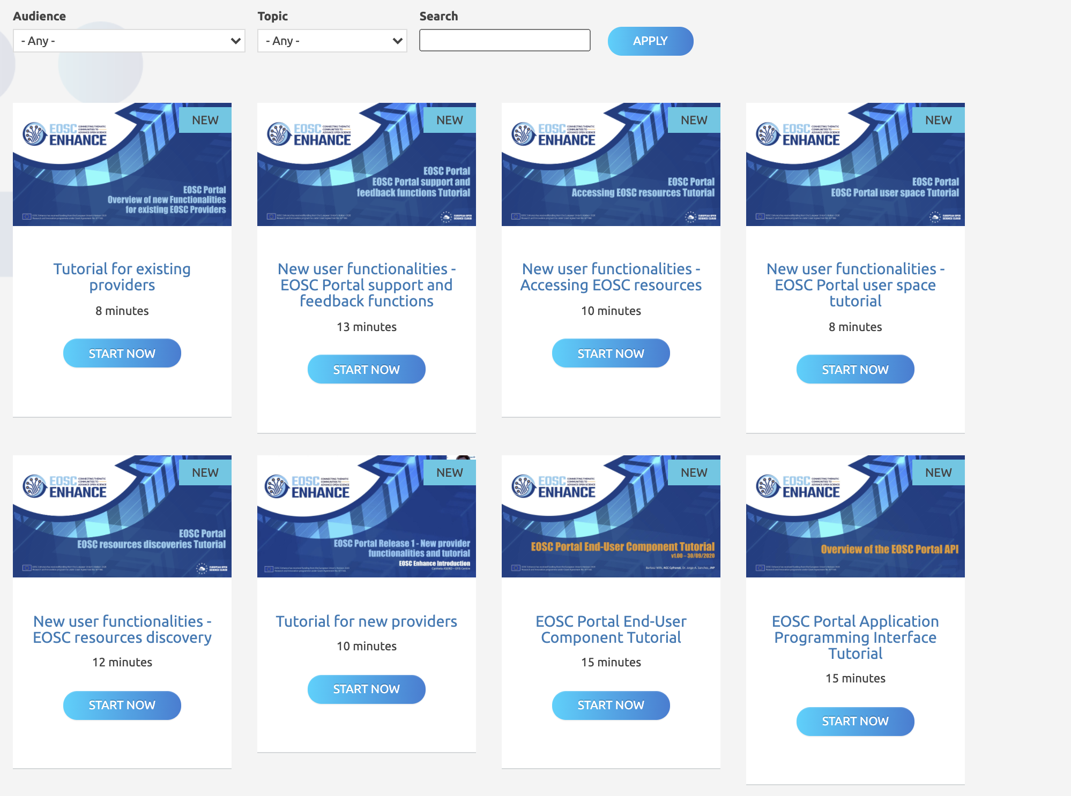
Figure 1: The Portal and Marketplace training resource collection on the EOSC portal website
Also the Portal itself implements functionalities aimed at high-level user experience, so the Portal is easy to use and self-explanatory (tips, pop-ups, tours for newly introduced functionalities etc.)
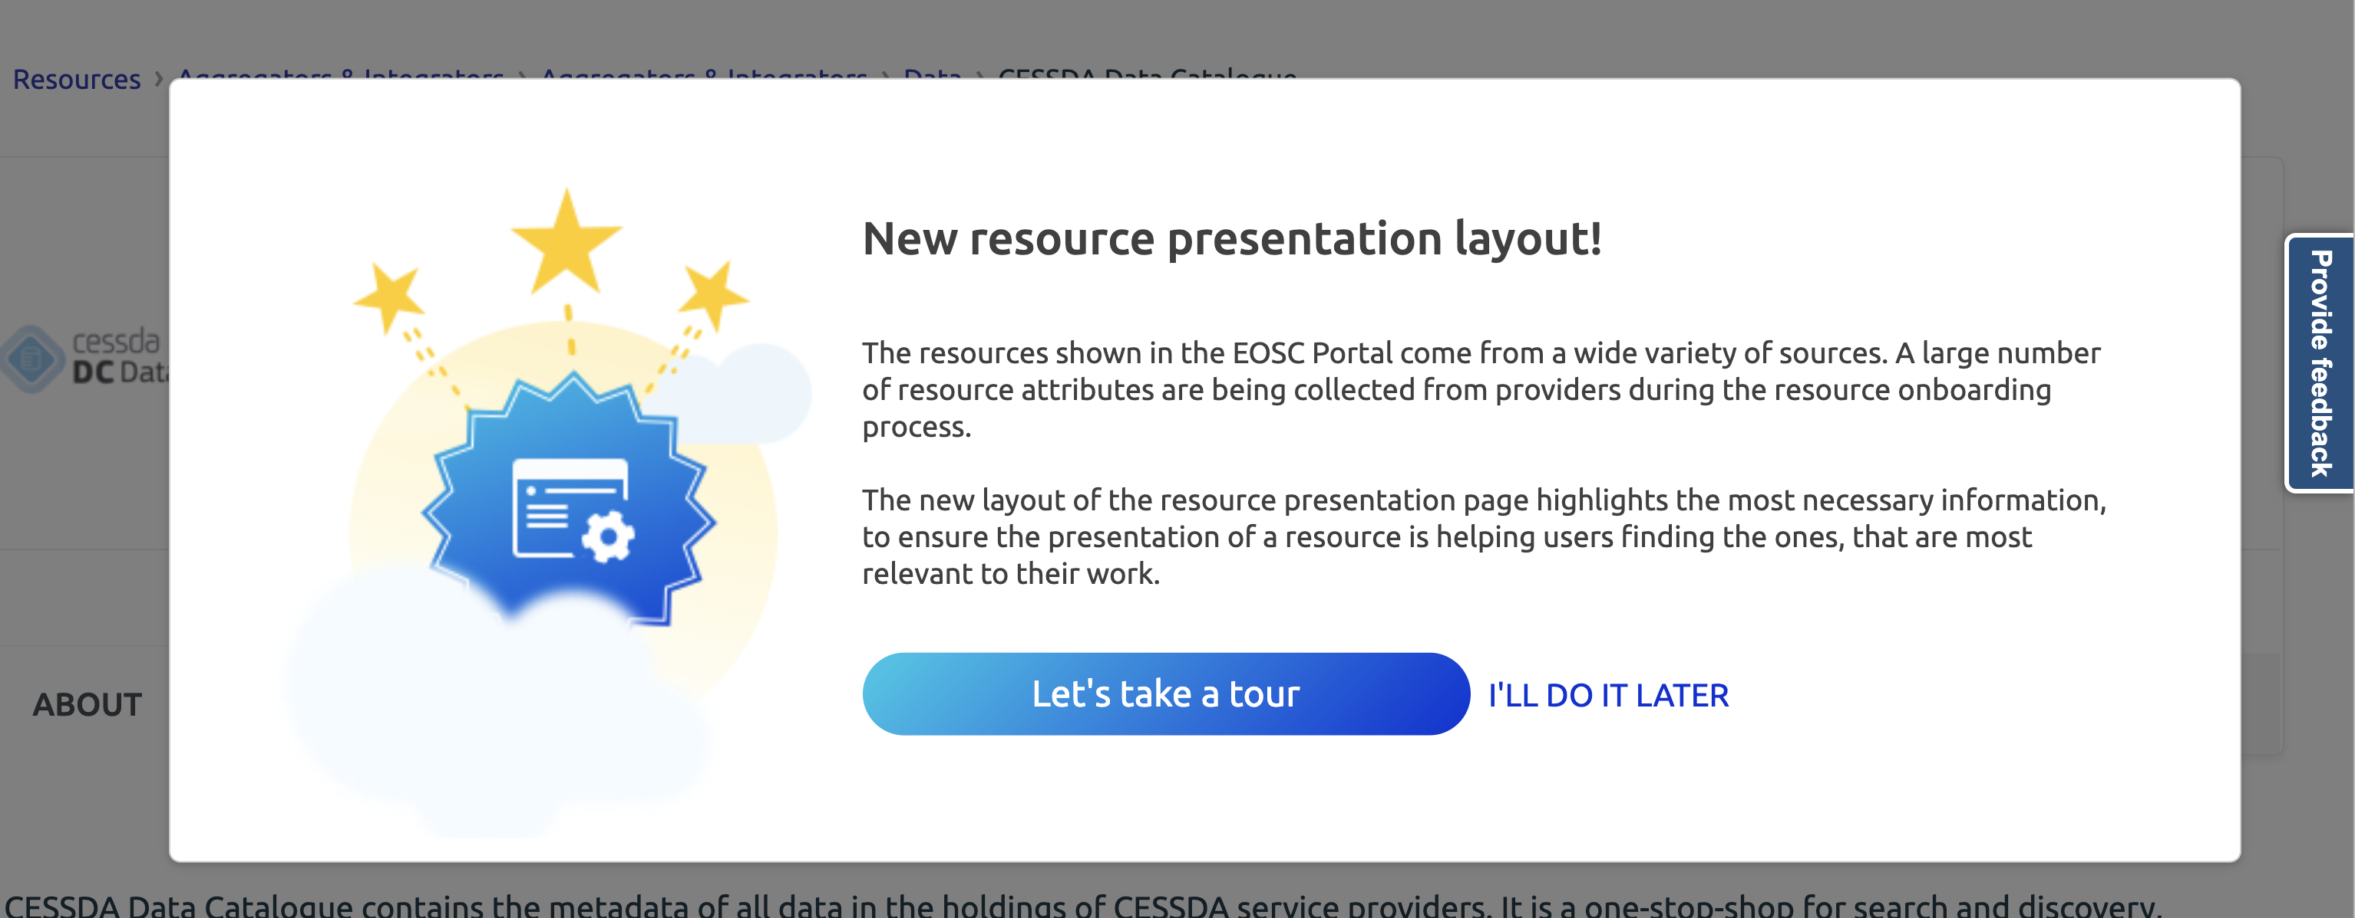
Figure 2: An example of context-specific popup help text

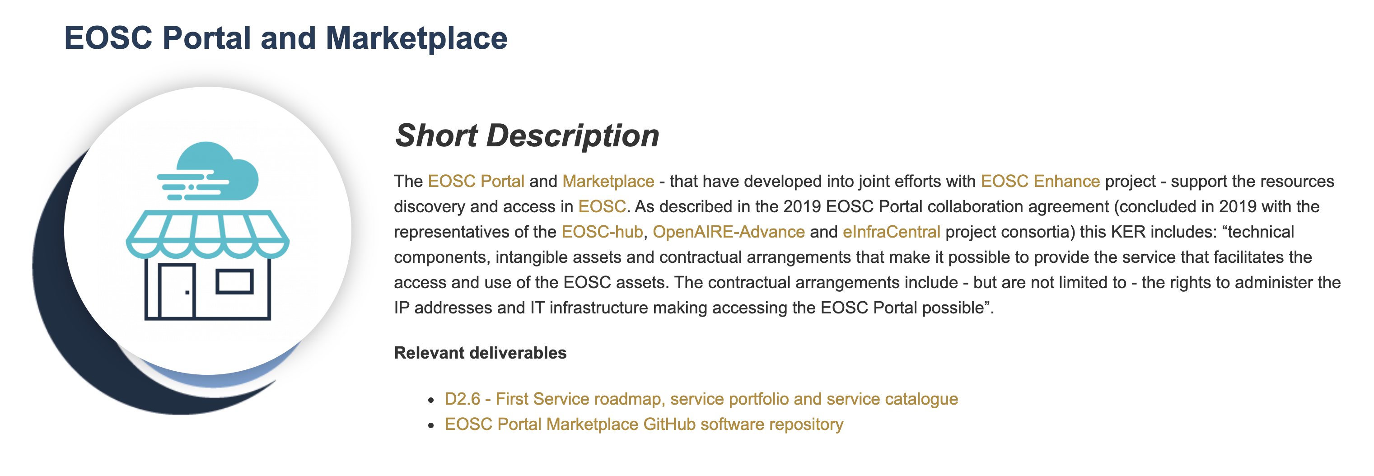
Figure 3: Public description of the EOSC Portal and Marketplace KER providing summary and links to background material (including project deliverables)

Use and impact after EOSC-HUB
The EOSC Portal will continue to serve EOSC users (researchers / providers / operation team members / founders etc) after the conclusion of the EOSC-hub project. Moreover, it will be further developed in the forthcoming EOSC Future project. It will go beyond the Minimum Viable Product phase to support the growth of EOSC and acknowledge new EOSC competences and use-cases. An expansion of EOSC Portal capabilities is foreseen especially in the areas of professional resource discovery and delivery (supporting both supply and demand side of the process):
- significant expansion of the EOSC resource portfolio and catalogue;
- evolution of the resource discovery including the integration with external, thematic catalogues;
- inclusion of resource allocation process, EOSC interoperability framework, user-centric resource monitoring and accounting;
- improvements on customer relationship management functionalities etc.

The focus on the EOSC user perspective and a use of UX design methods will be maintained, so all of the developed functionalities will keep user experience in its centre. Incorporation of the AI techniques will be one the factors contributing to this goal. Also, by widening the scope of statistics components, EOSC governance will gain new relevant data regarding the EOSC development.

​KER 2. EOSC Service Management System (SMS)
EOSC-hub defines and implements the EOSC IT service management system (ITSM), i.e. the activities performed by service providers to plan, deliver, operate and control services offered to customers. These activities are directed by policies and are structured and organised by processes and procedures.
EOSC-hub implements best practices based on the lightweight standard, FitSM, regarding the service planning, delivery, operation and control of the services in the service catalogue.
The scope of the Service Management System is primarily all services contributing to creation and delivery of the hub. The hub is a set of services essential to provide the core functionality for EOSC like: helpdesk, monitoring, accounting, order management etc.

Key benefits for EOSC
The key benefits of the SMS are:
- To ensure robust and resilient service delivery of services within the hub to the EOSC federated infrastructure;
- To facilitate communication between customer and providers by introducing single point of contact (helpdesk, marketplace etc.);
- To disseminate and share service delivery best practices among providers;
- To facilitate alignment of service management activities of all of the service providers, supporting different levels of integration with the centralised services;
- To integrate the services provided by the different providers into the common marketplace and monitoring frameworks in a way that provides value for EOSC.

Result type | Policies and procedures for service management
URL | https://eosc-hub.eu/key-exploitable-results/eosc-service-management-system-sms
Key innovation | Comprehensive, coherent and standards-based set of procedures and processes to manage the complete life cycle of services in a complex environment. A service that is managed by the EOSC-hub SMS will have a known status, contact points for user support and for resolving problems and security incidents in a reliable, consistent manner - even in cases where the service consists of components that are provided by different service providers.
Target audiences | EOSC Core and thematic portal/marketplace operators
Key benefit (for the audiences) | Ensure robust and resilient service delivery in a federated infrastructure with different types of many-to-many relationships between users, providers and customers.
IPR approach | The template collection that will make implementing a similar SMS system will be made available under CC-BY 4.0 license.  The underlying standard (FitSM) is licenced under Creative Commons. The EOSC-hub specific procedure descriptions (project internal use) are protected by copyright, with a standardised copyright notice mentioning the project and EC grant number.  The contents of the SMS are not public but are intended to be available to future Hub Operators, so will be packaged as much as possible at the project conclusion for later uptake. This will be largely a set of documents with a CC-BY license, including templates relating to policies, processes, procedures, role descriptions, reports and records.
Exploitation strategy | The EOSC-hub SMS has already been used as a foundation of the service management systems of several EOSC-related projects (such as EOSC-enhance, EGI-ACE and so on). The upcoming EOSC Future will be the primary exploitation channel for the KER
Key communication and dissemination activities | SMS has been an implicit part of practically all project communications related to service onboarding or operations of the portal and marketplace. Some of the key events were:  - Presentation and panel “EOSC service provider onboarding: Why joining the EOSC portal?” during the EOSC-hub week 2019 (November 2019, Prague, Czech Republic) with 60 participants  - Presentation “Onboarding to EOSC: Current status and Future Issues” during the EOSC Symposium (November 2019, Budapest, Hungary) with 200 participants covering most of the EOSC related projects  - Several presentations during the EOSC-hub week 2020 (online event, approximately 800 registered participants, sessions typically with 150 participants)
Engagement activities | The primary formal, cross-project collaboration mechanisms were based on the same agreements as KER 1:  - Collaboration Agreement defining the contributions of EOSC-hub, OpenAIRE-Advance and partners of the eInfraCentral project for the technical development, maintenance, daily operations and communication activities related to the EOSC Portal service components (September 2019)  - EOSC Portal Collaboration Agreement between EOSC-hub / EOSC Enhance / OpenAIRE Advance defining, among other things, data models and operational aspects of onboarding processes (September 2020)

In general, the SMS system has been seen as a valuable component in service integration in several EOSC-related projects. EOSC-hub has been adopted or served as an inspiration of the approaches of several projects, for example EOSC-Synergy, EOSC-Enhance, TRIPLE and so on.
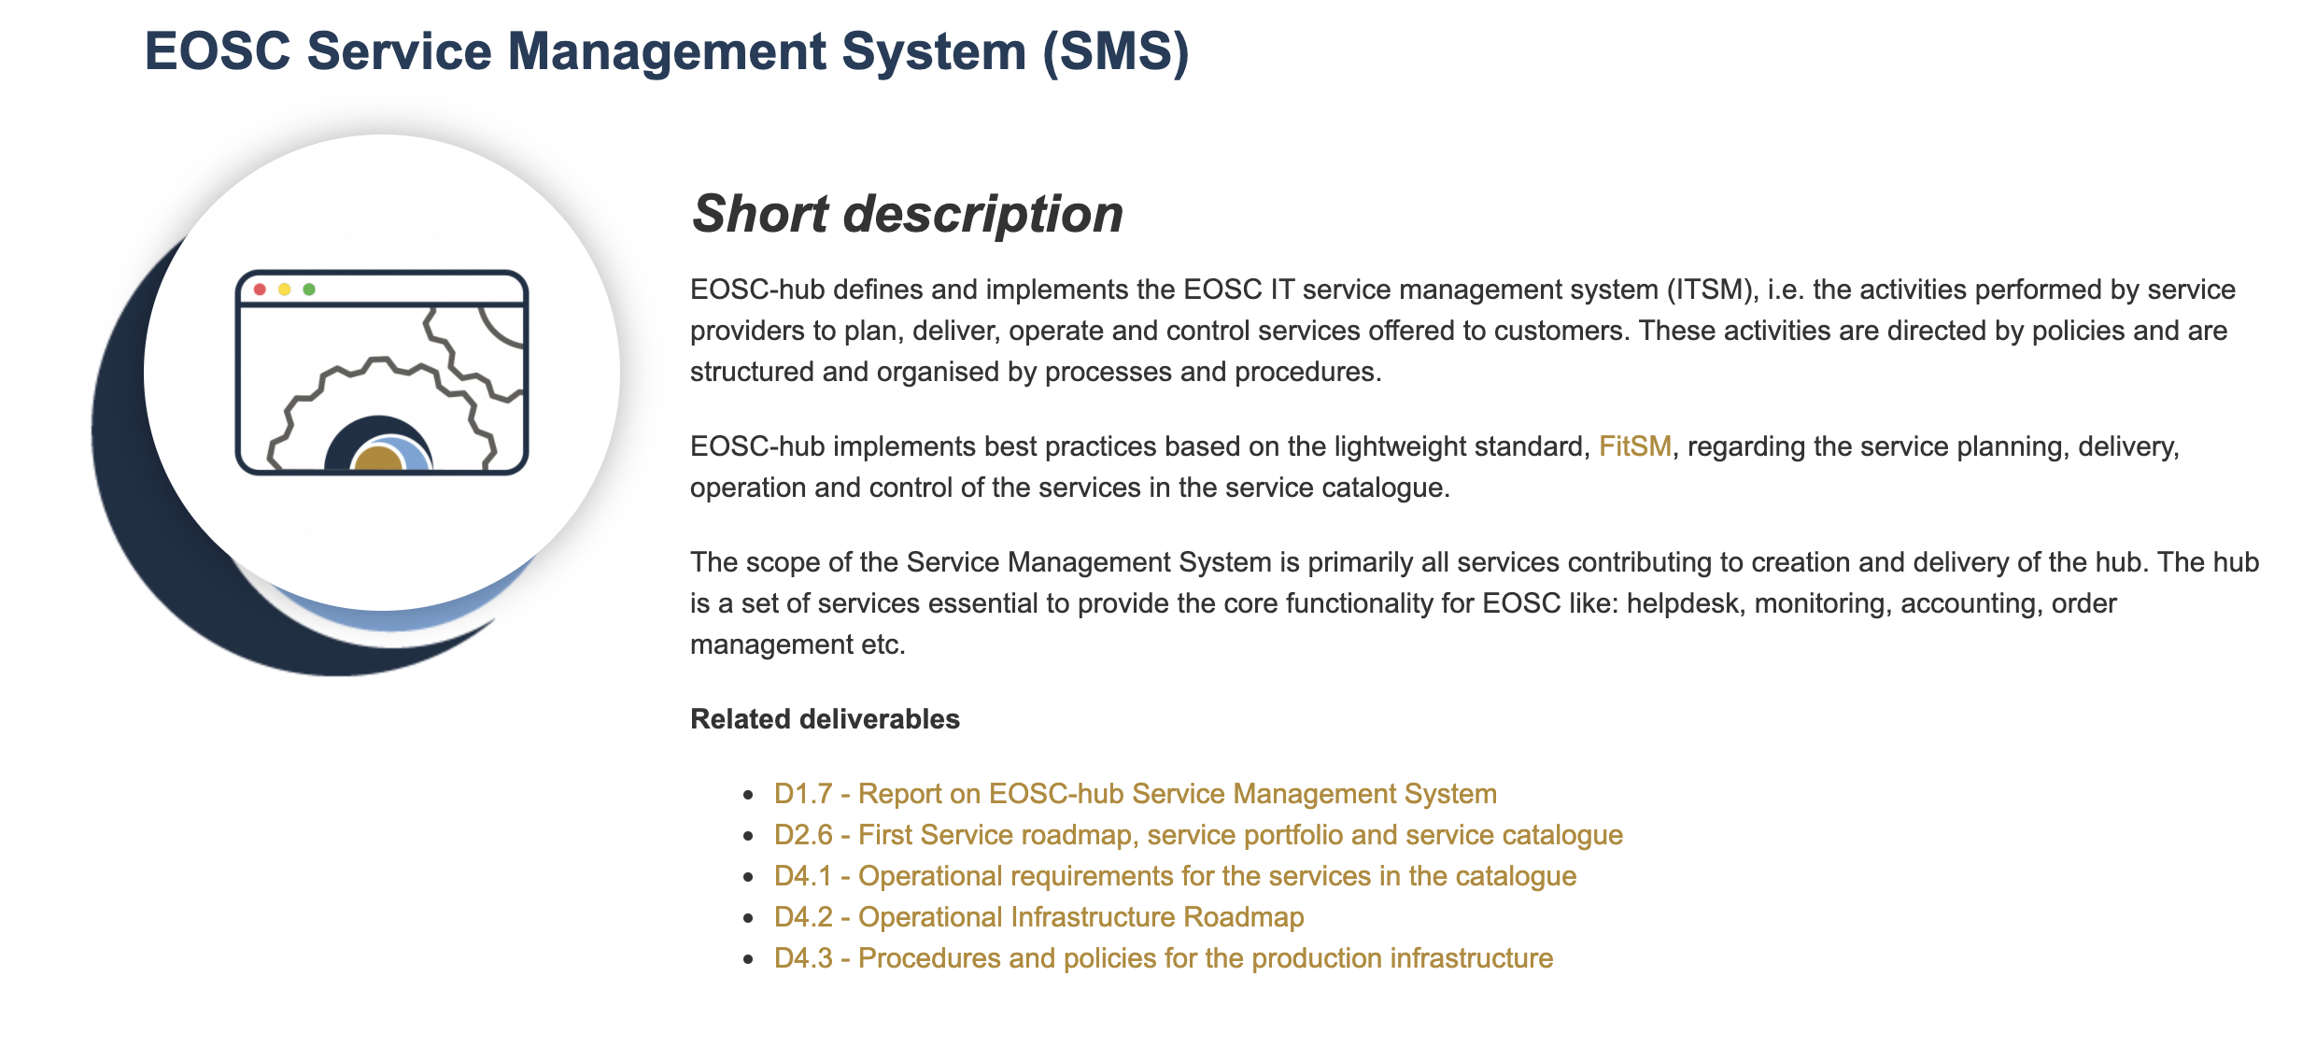
Figure 4: Public description of the SMS KER providing summary and links to background material (including project deliverables)

Use and impact after EOSC-HUB
The EOSC Service Management System has already made an impact by creating a prototype SMS for the provision of EOSC core services under a unified management system. It will be further adopted and managed by EOSC Future. EOSC SMS as a result of EC funded projects can be used as an example for others how to set up a management system considering federated aspects.

​KER 3. EOSC Rules of Participation (ROP)
The KER provides a framework of policies of what should be included or integrated in the EOSC. The KER provided important contributions to the EOSC Governance Working Group on Rules of Participation which published its initial RoP at the end of 2020 and has been further developed based on this foundation. The high-level policies of the KER provide important parameters defining the scope of EOSC by specifying the kinds of behaviour and types of entities that are necessary for optimal functioning of EOSC.
The high-level policies are complemented by the concrete processes and procedures which can be implemented, refined and monitored. These processes and procedures can and will evolve based on the demands of the day-to-day business of populating EOSC with valuable providers and resources. The result of this is a live set of EOSC Inclusion Criteria which are included with the other Provider Documentation as part of EOSC Portal.
These are developed based on several years of experience forming and populating EOSC resource portfolios, and now in collaboration with the EOSC Enhance and OpenAIRE Advance projects. In order to further extend the reach of these rules and criteria, they are also now discussed in an open manner with representatives from other projects, including thematic and regional clusters.
A comprehensive and coherent set of rules and policies for service providers to onboard services and make them discoverable and accessible through the EOSC Portal.
Key benefits for EOSC
RoP makes it as easy as possible to bring new service providers into the EOSC ecosystem while ensuring the quality and compliance of the overall services and building and maintaining the trust of the users and user communities. Practical inclusion criteria translate RoP into actionable procedures which can be used by onboarding teams to repeatedly assess and support applications to join EOSC.
Result type | Policies and procedures for service management
URL | https://eosc-hub.eu/key-exploitable-results/eosc-rules-participation-rop
Key innovation | Comprehensive and coherent set of rules for the onboarding team and for the service providers to onboard services into and make them discoverable and accessible through the EOSC Service Catalogue and Marketplace.
Target audiences | EOSC Core, Service Providers
Key benefit (for the audiences) | Make it as easy as possible to bring new service providers into the EOSC ecosystem while ensuring the quality and compliance of the overall services and building and maintaining the trust of the users and user communities
IPR approach | CC-BY 4.0
Exploitation strategy | The primary contributions have been included in the EOSC RoP version published by the EC. The RoP will be further developed by EOSC-related follow-up activities and projects, primarily EOSC Future.  The responsibility for further development of the EOSC RoP has been formally handed over to the EOSC Association in March 2021.
Key communication and dissemination activities | The key communication path was through the EOSC RoP working group, with the project providing continuous feedback since the initial engagement with the group (presentation in July 2019 WG meeting). The importance of the KER was promoted in an article “Opening the floodgates for open science” (June 2019, Science Business).  The EOSC Rules of Participation were published in January 2021.
Engagement activities | The primary engagement mechanisms were active collaboration and contributions to the work of the EOSC Rules of Participation working group (described in detail in the deliverable D3.5)

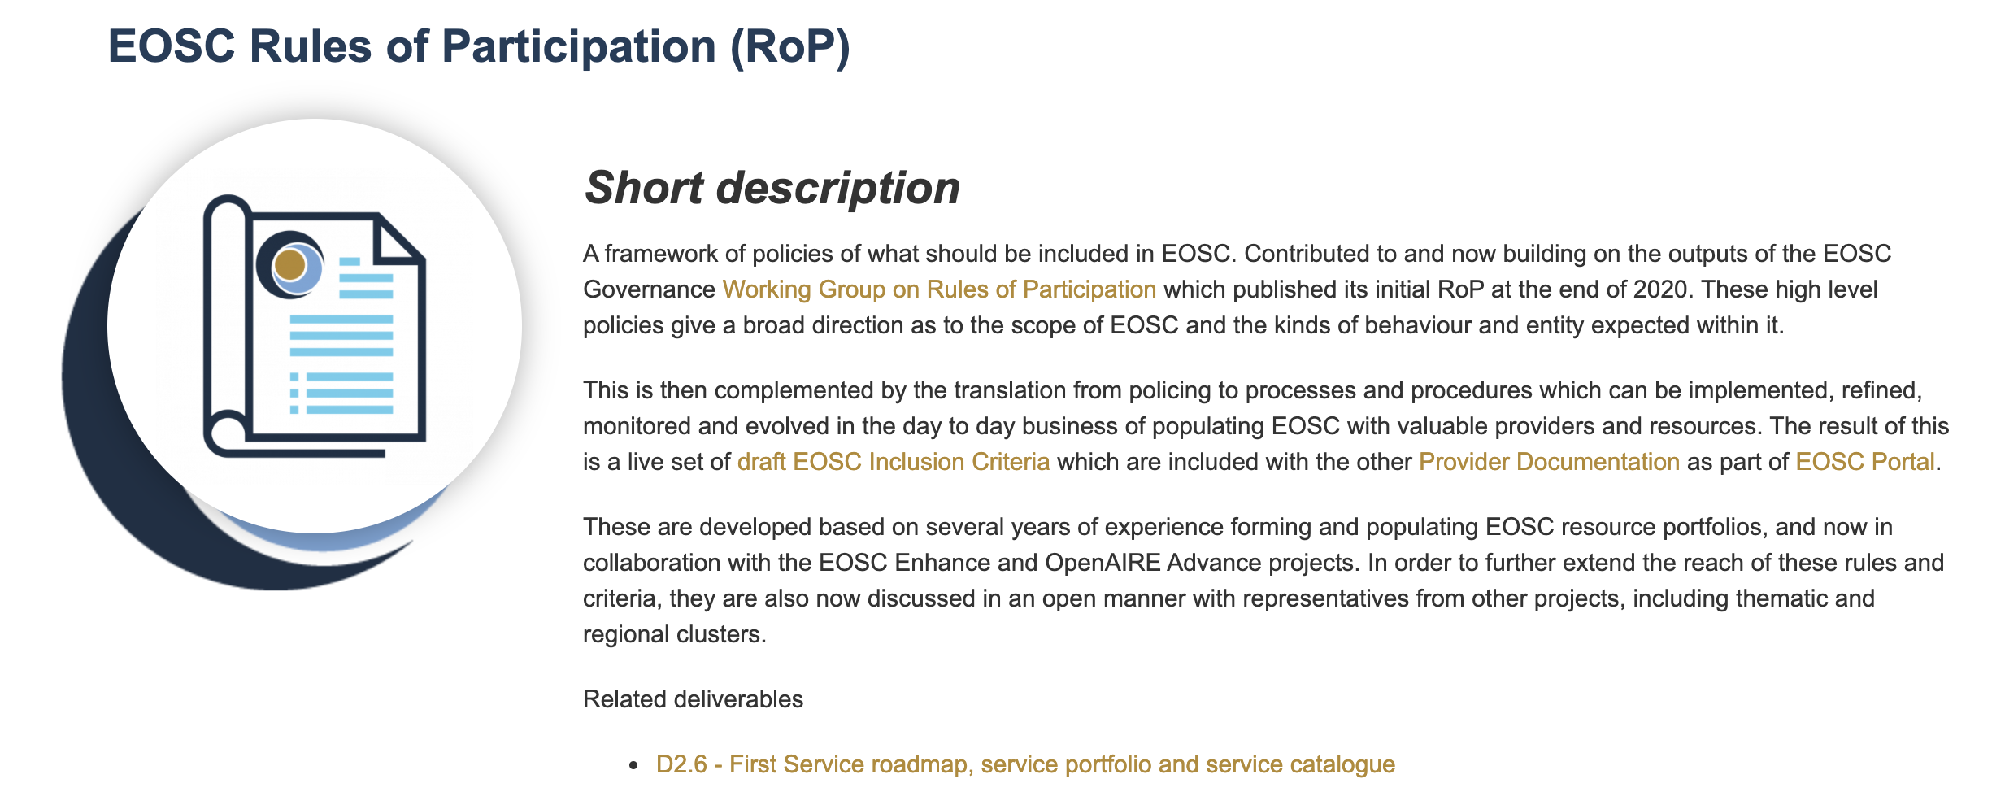
Figure 5 : Public description of the RoP KER providing summary and links to background material (including project deliverables)

Use and impact after EOSC-HUB
The work on RoP from EOSC-hub has already formed a significant input for the Working Group on Rules of Participation, and as a set of practical inclusion criteria is adopted and evolved by the EOSC Enhance project and will be further managed by EOSC Future.

​KER 4. Internal Services in the Hub Portfolio
The Internal Services provide basic enabling services for EOSC access and operation, such as access control or accounting, and offer common and standard interfaces to shared tools for basic services that need to be aligned in order to provide consistent user experiences. Internal services in the Hub Portfolio are one of the key elements of the EOSC federating core.
Key benefits for EOSC
This common toolset enables the integration of services into the EOSC ecosystem. This is a prerequisite for the function of the hub as a federating core, as a mature implementation of the tools will streamline the processes of the EOSC Hub Operators. For the service providers, the KER provides tools to access several user communities through the Hub by integrating their services into a single service interface (instead of several community-specific ones). The common services are targeting adoption by the permanent EOSC services and their importance will be increased by the growth of the number of users and the value delivered through EOSC. The reuse of individual components by third parties is also encouraged.

Result type | Software and services
URL | https://eosc-hub.eu/key-exploitable-results/internal-services-hub-portfolio
Key innovation | Set of service interfaces providing basic enabling services for EOSC access with standardised interfaces and common approach to support and documentation
Target audiences | EOSC Core, Service Providers
Key benefit (for the audiences) | This KER provides a common toolset for integrating services to the EOSC ecosystem. This is a prerequisite for the function of the hub as a federating core, and a mature implementation of the tools will streamline the processes of the EOSC Core Operators (provided by activities - such as EOSC Future - that take over or expand the service integrator role of EOSC-hub). For the service providers, the KER provides tools to access several user communities through the hub by integrating their services to a single service API (instead of several community-specific ones)
IPR approach | Tools supporting the KER are licensed under a number of different open-source licenses. This ensures that irrespective of ownership, the software is available to EOSC in the future. Some of the services rely on databases that may fall under sui generis database protection.  The specific technical outputs related to this KER are listed in Appendix II of this deliverable, and the detailed IPR approach of each component is documented in Appendix I of deliverable D5.6.
Exploitation strategy | The KER has been used (wholly or in parts) by other EOSC-related projects, such as EOSC-Enhance and are candidate services to be provided by EOSC Future. Some of the services belonging to KER are being used by additional projects (e.g. ARGO monitoring, AMS and B2ACCESS are being used in DICE project and several components in EGI-ACE)  It should be noted that some of the services - such as AAI or Monitoring have become commonly used, general-purpose components that have been exploited in a wide range of projects, also beyond the EOSC context. As noted in section 2.7.2 of this deliverable, in some cases specific steps have been needed in order to deal with these successfully exploited services.
Key communication and dissemination activities | Due to the multifaceted nature of the KER, aspects of it were presented in numerous events. Some of the key activities were:  - Presentation and training session “The EOSC-hub proposal for the EOSC AAI”, EOSC-hub Week 2018 (April 2018, 50 participants)  - Presentation “AARC Blueprint Architecture and its evolution – towards the EOSC AAI for research communities”, ESFRI RIs and EOSC Workshop (January 2019, 100 participants)  - Presentation “EOSC-hub AAI Service Architecture”, Digital Infrastructures for Research 2018 event (October 2018, 300 participants)  - News item “The ARGO Service Monitoring Service has a pilot integration with the EOSC Portal”, EOSC-hub website, March 2020  - Presentation “Federating Core Proposals” during EOSC symposium 2019  However, it should be noted that the internal services are typically mentioned as mechanisms and advantages for any presentation discussing EOSC integration.
Engagement activities | The engagement approach was based primarily on bilateral, strategic consultations with key developers in the community to ensure technical alignment and shared sense of ownership

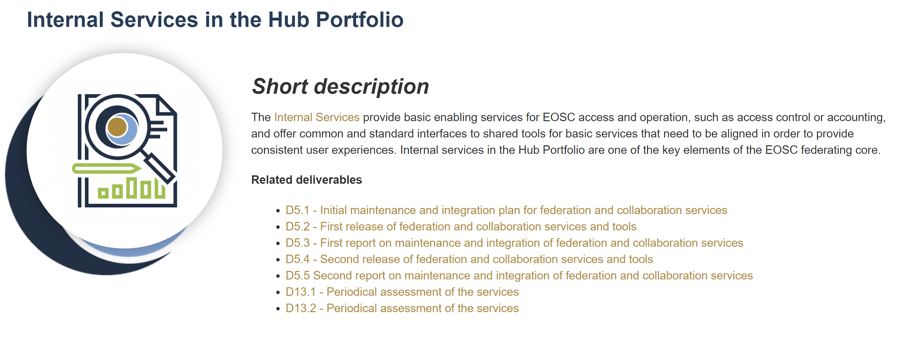
Figure 6: Public description of the Internal Services in the Hub Portfolio KER providing summary and links to background material (including project deliverables)

Use and impact after EOSC-hub
The Internal Services components of the KER are used in several projects that continue building the EOSC ecosystem (as reported in the table above). They will continue playing an important enabling role in the future EOSC Core and Exchange initiatives, paving the way towards the sustainable EOSC. The following table presents the contributions of the components to the future EOSC activities:

Hub Portfolio Service | Components and building blocks | Value proposition
Technical services implementing the EOSC Portal KER  (Including web content, Marketplace, Provider portal, portal metrics) | ● EOSC Portal Web content (Trust-IT and EOSC Secretariat)  ● Provider portal - supply side interface (University of Athens as part of EOSC Enhance)  ● EOSC Marketplace - demand side interface (Cyfronet as part of EGI Federation) | As KER 1: Offer providers and users access to a registry of resources which they can contribute to or make use of, alongside information about EOSC. Allow access via the web or via API to onboard or access and consume EOSC resources.
EOSC-hub Helpdesk | ● xGUS (KIT)  ● GGUS (KIT as part of EGI Federation)  ● EUDAT RT(EUDAT) | Offer a channel for support on the components of EOSC-Core that allows users to go through a single point of contact to get assistance.
EOSC-hub AAI | ● EGI Check-in (EGI.eu)  ● B2ACCESS (EUDAT)  ● INDIGO-IAM (INFN as part of Indigo community)  ● eduTEAMS (GEANT) | Provide an infrastructure for seamless access and authorisation against EOSC resources based on existing community identities.
EOSC-hub Monitoring | ● ARGO (GRNET as part of EGI Federation) | Offer up to date information on the status of EOSC-Core services and EOSC-Exchange services which choose to integrate EOSC monitoring.
EOSC-hub Accounting | ● Accounting Portal (EGI.eu)  ● Operations Message Broker Network (EGI.eu)  ● APEL Accounting Repository (STFC as part of EGI Federation) | Track usage of EOSC-Core and Exchange resources that have chosen to integrate EOSC Accounting. Support demonstrating usage required for reimbursement of resource provision costs, tracking of activity and impact.
EOSC-hub Configuration Management System | ● GOCDB (STFC as part of EGI Federation)  ● DPMT (MPCDF as part of EUDAT)  ● SVMON (EUDAT) | Manage necessary information on all the elements required to deliver EOSC-Core, and support control of changes to elements supporting EOSC-Core and connection of Core components to other systems.
EOSC-hub Collaboration & Communication systems | Commercial or open-source components deployed by EGI.eu  ● Jira  ● Confluence  ● Indico  ● DocDB | Provide platforms needed to facilitate communication and collaboration between the individuals and groups providing EOSC-Core and EOSC-Exchange services
EOSC-hub Order handling system | ● EOSC Marketplace - demand side interface (Cyfronet as part of EGI Federation)  ● SOMBO (CNRS as part of the EGI Federation) | Capture resource orders from the EOSC Marketplace, manage them and distribute them to providers to allow them to be fulfilled.
EOSC-hub Messaging service | ● ARGO Messaging Service | Connect other components of EOSC-Core allowing them to be programmatically connected.

The deliverable D2.7 presents more details of the KER 4 and KER 5 services and their role in future EOSC service provision.

​KER 5. External Services in the EOSC Service Portfolio
EOSC provides a "one-stop-shop" for a range of services and solutions to speed up the research process of the disciplines and enable cross-disciplinary collaboration and reuse of tools and results. It encourages the sharing of the research tools and data between different research groups - also across disciplines. The services in the EOSC Service Portfolio have different application areas and sustainability models. However, independently of the details of the approaches, the EOSC Service Portfolio will support them by making the discovery of the services easier and reducing the effort needed to adopt them. Together with the EOSC Portal and Service Management System, the KER provides an intuitive, comprehensive and robust set of services to researchers.
Key benefits for EOSC
As the number of research activities and groups supported by EOSC grows, the possibility to easily search, request and re-use research services will become more and more important. Consistent metadata will be crucial for efficient service discovery (either by the researchers themselves or in collaboration with different helpdesk services). Providing an intuitive interface to the service lifecycle information will be of equal importance, especially when considering the long-term repeatability of EOSC-supported research.
Result type | Services
URL | https://eosc-hub.eu/key-exploitable-results/external-services-eosc-service-portfolio
Key innovation | Larger number of high-quality, interoperable services for faster and higher quality research results.
Target audiences | Researchers and research communities
Key benefit (for the audiences) | EOSC provides a "one-stop shop" for a range of services and solutions to speed up the research process of the disciplines and enable cross- disciplinary collaboration and reuse of tools and results. Integrating these external services to EOSC encourages sharing of the research tools and data between different research groups - also across disciplines.  The services can be categorised into common/horizontal - or Core - services that are grouped into six categories:  - Data Discovery and Access  - Federated Compute  - Processing and Orchestration  - Data and Metadata Management  - Data preservation  - Sensitive Data Services  And Thematic services that are primarily focused on the research challenges of specific research communities, but EOSC integration will also encourage cross-pollination between research communities.  The integration steps of these services are described in detail in the deliverable D6.5, while section 4.3 of this document and the deliverable D7.5 will provide more details related to the thematic services.
IPR approach | Each of the services accessible through the marketplace has its own IPR approach (ranging from the public domain to proprietary software) and terms and conditions for use (within the constraints of the KER 3, Rules of Participation). The components from the Hub Portfolio (internal services) which are offered for integration by external services in the EOSC Service portfolio integration are also offered under a range of open licences.  The EOSC-integration related work consists of developments or adaptations made to over 50 open-source components (listed in Appendix III of this deliverable), each of them released under an OSI-approved open -source license.
Exploitation strategy | Thematic and horizontal services integrated by the KER have their own sustainability models and strategies  Further development of the EOSC integration has been taken over by the INFRAEOSC-07 projects.
Key communication and dissemination activities | The key channels for communication and dissemination were based on the events organised and participated by the horizontal and thematic service providers. The dissemination activities related to thematic services are described in chapter 4.2 of this document. Most of the common services have a slide deck describing the key aspects of the component in the service description pages.
Engagement activities | Engagement activities were based on a common approach, aimed at bringing diverse communities of service providers into contact with and onboarded in EOSC. The activities were based on a dedicated contact person (or persons) responsible for specific horizontal or thematic services. Overall, the integration activities were driven by community requirements.

​
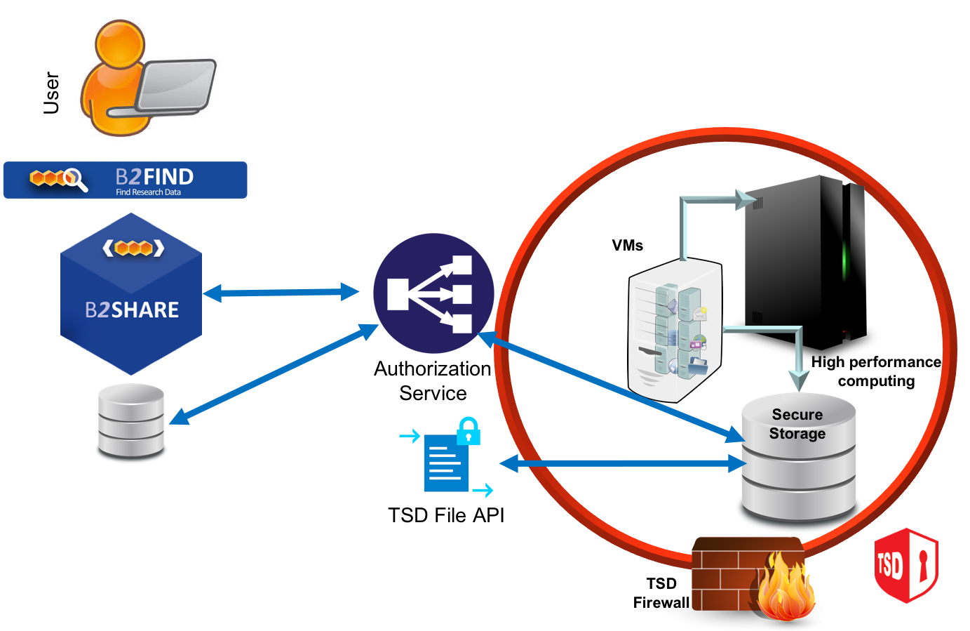
Figure 7: An example of an external Core service: Secure-B2SHARE integration
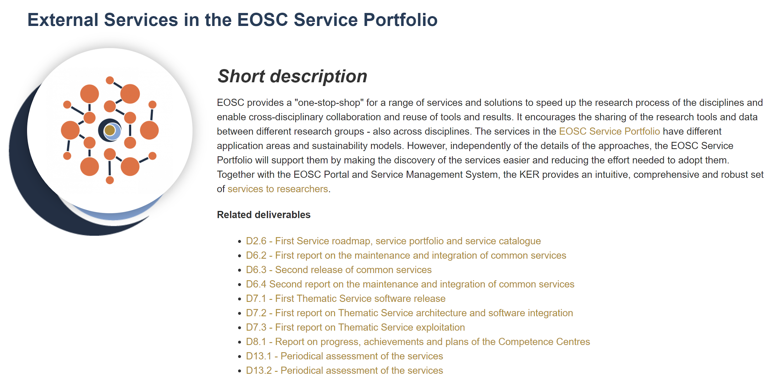
Figure 8: Public description of the External Services in the EOSC Service Portfolio KER providing summary and links to background material (including project deliverables)

​Use and impact after EOSC-hub
Each of the thematic services have their own communities focused on sustainability and further development of the services and their impact within the thematic communities. The trans-disciplinary use supported by EOSC will be further supported by the INFRAEOSC-07 projects. For details, see section 4.2 that discussed the approaches taken by each of the thematic services.

KER 6. EOSC Digital Innovation Hub (DIH): Platform for Industrial Collaborations with EOSC
EOSC DIH related activities of the project are described in detail in a separate deliverable (D9.4). The following text is intended as a concise overview, highlighting the key issues related to innovation management, dissemination and exploitation.
The KER provides a clear interface for commercial innovation that can be supported by EOSC as part of the broader European Digital Innovation Hub landscape (such as free access trials). It is a multi-dimensional mechanism that allows research e-Infrastructures to support business organisations to stimulate innovation, as well as helping start-ups, SMEs, and other innovative actors to tap into the academic world both in accessing knowledge as well as technical services. The final goal of the EOSC DIH is to create a one-stop-shop that brings IT services, research data, technology and expertise into a single place to support innovation in the industry to become more competitive. EOSC DIH offers several public-private collaboration models around piloting and co-design of new services (proof-of-concept work, performance testing, etc.), technical access to different “as a Service” resources (HPC/HTC/Cloud computing, storage, data management and higher-level services), training and support (Technical consultancy, service management, commercialisation) and visibility, using the DIH as a networking tool to expand beyond local markets.
Key benefits for EOSC
EOSC DIH allows lowering the initial investments (time and effort) for identifying/accessing services and developing/testing new products and services as well as increasing visibility and networking opportunities at European level. It will be continued as an activity in the context of EOSC and the wider network of Digital Innovation Hubs. In the long run, it can provide a formalisation of the knowledge and expertise into procedure descriptions, standardised consulting offerings or certification schemes.
Result type | Software and services, business models
URL | https://eosc-hub.eu/key-exploitable-results/eosc-digital-innovation-hub-dih-platform-industrial-collaborations-eosc
Key innovation | Single contact point with a flexible engagement mechanism supporting flexible collaboration models with industry. The collaboration models can be categorised as:  - Piloting & Co-Design  - Technical Assets  - Training & Support  - Visibility  This categorisation will help finding the optimal combination of approaches that suits the needs of the specific DIH project.
Target audiences | Enterprise, mainly SMEs and start-ups with low resources or investment on R&D
Key benefit (for the audiences) | Test before invest approach: Lowers initial investment (time and effort) for identifying/accessing services and developing/testing new products and services as well as increasing visibility and networking opportunities on a European level
IPR approach | Each of the business pilot contacts retain the ownership of their own background IPR and the adaptations made to the proprietary code with the support of DIH. The EOSC-hub services are provided primarily using the standardised interfaces to the EOSC services; thus, DIH does not have an impact on the IPR situation of the EOSC software.
Exploitation strategy | As noted in the previous deliverable, the DIH is sustained through “Continued activity in the context of EOSC and the wider network of digital innovation hubs. In the long-run: formalisation of the knowledge and expertise into procedure descriptions standardised consulting offerings or certification schemes.”  At the time of writing this deliverable - pending the start of the EOSC Future project - EOSC-DIH continues as an organic, self-sustained activity based on a Terms of Reference (ToR) document signed by the partners involved in the DIH activity. The EOSC Future plans expand the EOSC-hub based DIH by keeping on collaborating with private sector entities, in particular with SMEs to stimulate an ecosystem of innovation and knowledge transfer that fosters the development of commercial services to continuously cover the needs of EOSC users. Sectors covered in the past by the DIH range from artificial intelligence and machine learning, agriculture, FAIR data, blockchain, environment, security to sports and this is only expected to increase during the life of EOSC Future.
Key communication and dissemination activities | Specific website and branding were launched in 2020, to be aligned with EOSC. The website is online and can be accessed at https://eosc-dih.eu/  Specific social media profiles in Twitter and LinkedIn with regular activity  https://twitter.com/eosc_dih?lang=en  https://www.linkedin.com/company/eosc-digital-innovation-hub/about/  Some of the dissemination activities are the following:  - Participation in EOSC related events  - EOSC hub week, April 2019  - EOSC hub week, April 2020  - Participation in DIH related events  - Digitising European Industry Stakeholder Forum, Nov 2019  - Participation in EC related events  - ICT 2018, December 2018  - Participation in industry related events and fairs  - IT Future Expo, September 2019  Webinars for the EOSC DIH community  - Webinar on Marketing and Communication (May 2019)  - Webinar on Business Internationalisation (June 2019)  - Webinar on Intellectual Property Rights (October 2019)  - Webinar on Technology Transfer Models (September 2020)  - Webinar on Growth Marketing and Communication (October 2020)  - Webinar on Funding for Innovation: programmes and opportunities (November 2020)  Business publication with the pilots (2019 and 2020 edition) can be download here: https://eosc-dih.eu/visibility/  A complete description of communication activities are covered in the D9.4 Joint Digital Innovation Hub Final Results and Sustainability Plan.
Engagement activities | The exploitation of the KER has used strategic partnerships and collaborations systematically as a way to increase its impact. Some of the highlights include:  - Partnerships with projects and DIH networks have been established to extend / complement the service offers and to collaborate in the promotion of both side initiatives. These partnerships were captured under MoU, one pagers or Letters of Interest. Established partnerships are collected in the EOSC DIH webpage: https://eosc-dih.eu/partnerships/  - Individual contacts with companies in events and fairs, promoting the options for collaborating and running pilots in the DIH. The promotion of the open call should be highlighted, where multiple channels were used for the dissemination activities and a webinar was organised. A total of 16 companies applied for the open call, 6 of them were selected. Thanks to all the engagement activities, in addition to these companies and those involved in the initial pilots, more than 30 companies have been in contact with the DIH.  - EOSC-DIH has proactively promoted funding opportunities - also beyond the mechanisms EOSC-hub had direct control over - to the SME community. In addition to directly benefiting the SMEs involved with the DIH, it also ensures that when the innovation hub publishes a targeted call for projects the information reaches the broadest possible range of innovative SMEs.

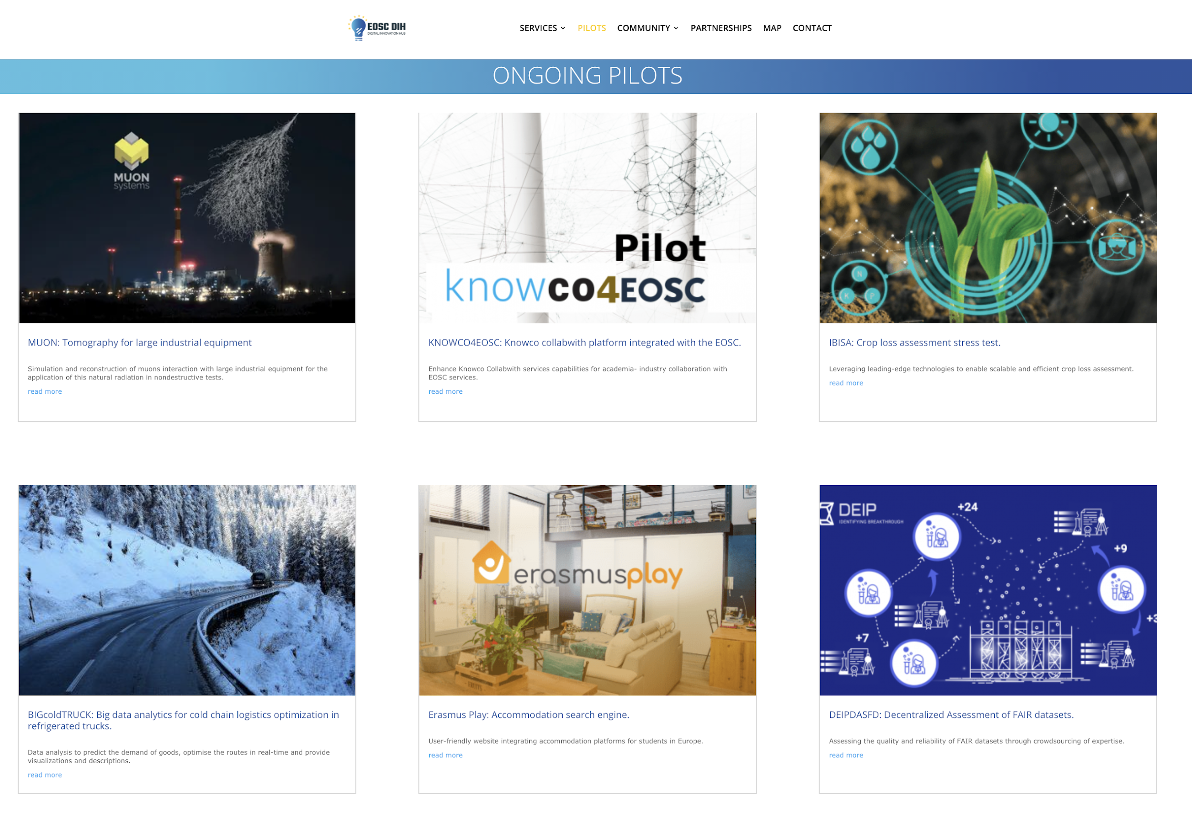
Figure 9: Some of the ongoing pilots on the EOSC-DIH website

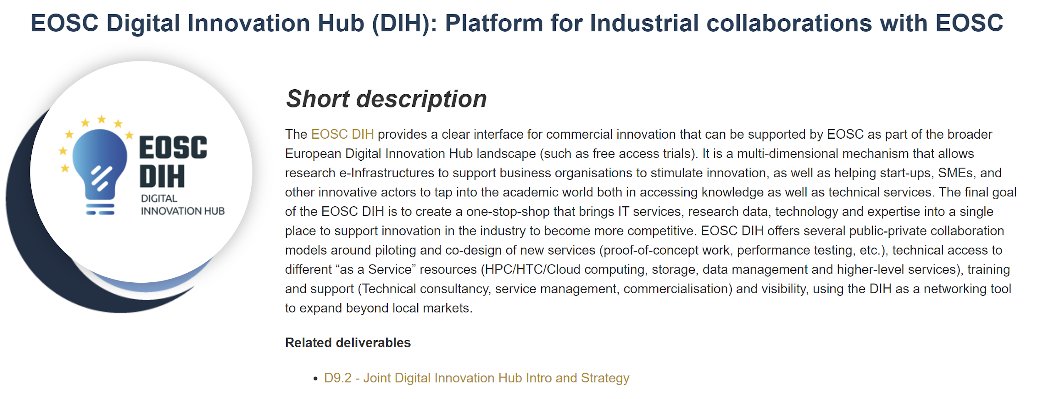
Figure 10: Public description of the EOSC Digital Innovation Hub KER providing summary and links to background material (including project deliverables)

​Use and impact after EOSC-HUB
The EOSC DIH will be followed up by EOSC Future project as the mechanism to centralise the multiple innovation and business collaboration initiatives around the EOSC. The experience and knowledge generated working with companies on the business pilots would be used as input for the EOSC Governance for defining the innovation agenda of the EOSC and how to align it to major European initiatives.
In addition, the cross-border nature of the EOSC DIH allowed the generation of external collaboration with other European Digital Innovation Hubs (EDIHs), links that have been defined as “DIH corridors” by the European Commission. The EOSC DIH will establish new corridors to cooperate with other EDIHs by complementing their technical offer which will imply a wider impact of the EOSC outside the research context.

KER 7. Business and sustainability models for services and the hub
The knowledge this KER brings together is described in more detail in the deliverables D2.5 and D12.3. The deliverable D2.5 charts the overall sustainability options of EOSC delivery, while D12.3 is focused on the specific issues related to procurement and cost recovery models of a broad range of e-Infrastructure services.
Business and Sustainability models are crucial for long-term planning of EOSC. In addition to grounding the discussions about finances, they also provide foundations for ensuring the trust of users and user communities in the continued delivery of services. This KER provides a definition for the planned “EOSC Federating Core”, including a cost assessment, a proposed value proposition for the EOSC, evaluation of procurement and service delivery models applicable to different EOSC scenarios, and consideration of issues related to cross-border service provision and cross-sectoral VAT compliance.

Key benefits for EOSC
By proposing a definition of the EOSC Federating Core, this KER provides a basis for determining the costs and possible business models required to provide the EOSC and permits identification of the importance of “Shared Resources” - services and scientific products of pan-European relevance which are developed by a given discipline but used more broadly by external user communities and additional disciplines. By providing recommendations on procurement frameworks and supporting business models, and on ways in which the EOSC can support the delivery of Shared Resources such as cross-border storage and compute services in Europe, this KER points the way towards further activities required to deliver an EOSC which adds value for users and resource providers. Clear and intuitive business models will increase flexibility, lower barriers to entry and reduce compliance costs in service provision and consumption by the EOSC stakeholders and are thus important inputs to EOSC sustainability planning. This KER contributes to the work of EOSC policy bodies, in particular to the EOSC Sustainability Working Group and EOSC Architecture Working Group.

Result type | Business models, documents and reports
URL | https://eosc-hub.eu/key-exploitable-results/business-and-sustainability-models-services-and-hub
Key innovation | Contributing to adaptation and alignment of business and sustainability models to support integration of traditional and emerging EOSC stakeholder groups into a shared innovation ecosystem
Target audiences | Service providers, EOSC Core
Key benefit (for the audiences) | Increased flexibility, lowered barriers of entry and reduced compliance costs in service provision and consumption by the EOSC stakeholders
IPR approach | Documents and deliverables published under CC-BY 4.0 license
Exploitation strategy | The KER provided input to the follow-up projects, and EOSC WGs. The documents produced have been deposited in repositories, however the key to further exploitation is continued involvement of the community members brought together by EOSC-hub in the future activities related to EOSC sustainability
Key communication and dissemination activities | The key communication and dissemination activities targeting broader EOSC community were:  - “Business models and procurement” session during the EOSC-hub week (20th May 2020) with approximately 60 participants  - “EOSC Business model recommendations” webinar in the EOSC-hub webinar series (15th September 2020) with approximately 50 participants  - Open webinar/consultation event related to EOSC business models and procurement (31st March 2021) with over 30 EOSC experts and decision makers.
Engagement activities | EOSC-hub-OpenAIRE Advance Collaboration: joint production of two documents:  White Paper: Common Vision for EOSC, Service Provision, and Role in the EOSC Governance, which presented a concise position paper identifying the necessary alignment processes between the EOSC Governance and EOSC-hub and OpenAIRE-Advance.  Aligned Roadmap for Service Positioning and Sustainability Within EOSC, presenting an aligned roadmap of steps towards alignment of EOSC-hub and OpenAIRE services within the EOSC.  Discussions with FREYA project around the role and position of PIDs in the EOSC, in the context of the EOSC-hub-FREYA MoU.

Business and sustainability models address complex issues which lie at the heart of the EOSC, the relationships and trust between its involved stakeholders, and the risks and opportunities it presents. Numerous business models are possible, and likely to be deployed simultaneously. Sustainability too has numerous facets. The complexity and multi-faceted nature of the issues involved means that business and sustainability models are therefore strongly influenced by developments in the EOSC landscape, particularly policy at EU and member state levels.
Key success factors are transparency, clarity and timeliness relating to key decisions pivotal to the EOSC’s funding.

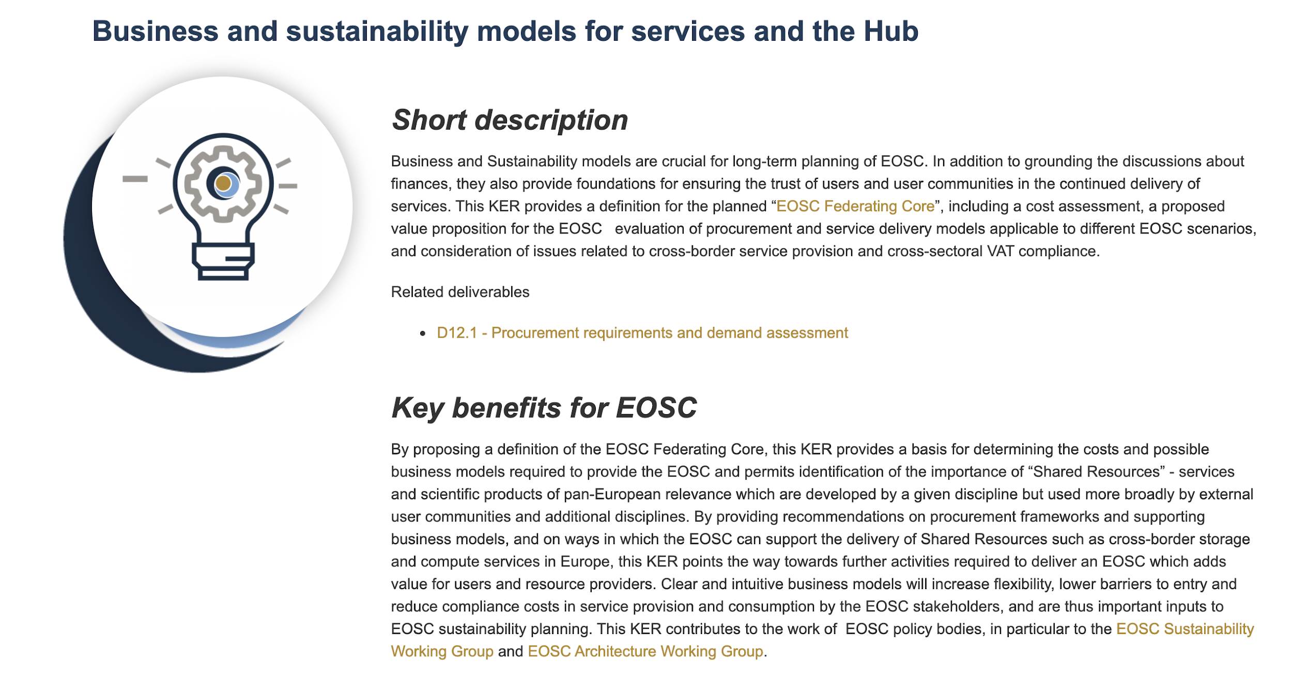
Figure 11: Public description of the KER on the EOSC-hub website

​Use and impact after EOSC-HUB
Proposals and recommendations from this KER have provided input to:
- Sustainability Working Group FAIR Lady Report “Solutions for a Sustainable EOSC”
- Architecture Working Group View on the Minimal Viable EOSC
and have informed the preparation of the INFRAEOSC-03 project proposal expected to provide the EOSC-Core in the next phase of the implementation of the EOSC. Discussion of Business and Sustainability Models will continue in the EOSC Partnership governance bodies, the EOSC Association, in the EC and member states, and in the service providers themselves.

KER 8. Interoperability and integration guidelines
Interoperability and Integration guidelines, defining the high-level architecture for basic EOSC technical functions and promoting EOSC standards and APIs, will facilitate access to services, lower barriers to integrating and composing services and promote the usage of services between adjacent communities.
Key benefits for EOSC
EOSC services ‘compliant’ with the interoperability and integration guidelines will offer well-established and documented interfaces for usage and integration, based on well-known standard or APIs, facilitating (1) their exploitation from user communities willing to create new scientific services that could rely on well-established and documented interfaces for the integration (e.g. a community creates a new scientific workflow reusing EOSC federation and common services, like AAI, accounting, etc.) and (2) the combined usage of EOSC services, indeed the adoption of well-known standards and interfaces will very-likely reduce the cost to integrate services (e.g. two accounting infrastructures can be made easily interoperable if they use the same standard usage record format, in such case accounting data extracted from them can be merged and presented in a unique view). As a consequence, less mature or small scientific communities can leverage on EOSC services for a series of IT functions and focus on their scientific work, access to scientific services will be open to new communities thanks to the documented interfaces and new scientific workflows can be created combining existing applications.

Result type | Technical specifications, policies and procedures for FAIR data management and security, documents and reports
URL | https://eosc-hub.eu/key-exploitable-results/interoperability-and-integration-guidelines
Key innovation | A concise and easily adopted set of technical guidelines allowing technical integration of solutions to EOSC system
Target audiences | Service providers, Enterprise
Key benefit (for the audiences) | Minimising the technical design and development effort needed to access to EOSC services market
IPR approach | The document is released under the CC-BY 4.0 license
Exploitation strategy | The KER has provided foundations of the interoperability and integration activities of several EOSC-related project, such as EOSC-Synergy, EOSC-Pillar, EOSC-Nordic, ExPaNDS, NI4OS.
Key communication and dissemination activities | The technical interoperability documentation has served as reference material in a broad range of communication activities. Some of the key activities ensuring the uptake of the KER have been:  - “Service Interoperability: moving towards a common framework” - presentation and panel discussion in the EPOS IP Final Event: EPOS practical solutions to Data Interoperability & FAIRness. September 2019, 100 participants from a scientific community  - News articles on the EOSC-hub website, for example: “Ensuring long-term access to EOSC resources: PIDs as a service” (June 2020) and “EOSC-hub and OpenAIRE join forces with EOSC Enhance to collaborate on boosting the EOSC Portal” (June 2020)
Engagement activities | EOSC-hub has been instrumental in the EOSC Architecture working group discussions to identify the elements and in developing the architecture diagrams.  The recommendation “trust based open access” in the joint statement with ESFRI science clusters and several e-Infrastructures could be seen as a result of the sustained engagement and also as an endorsement of the approach consolidated in the KER.

Short description of lessons learned key success factors and links to more detailed material (D3.5 will have the full list of talks etc)

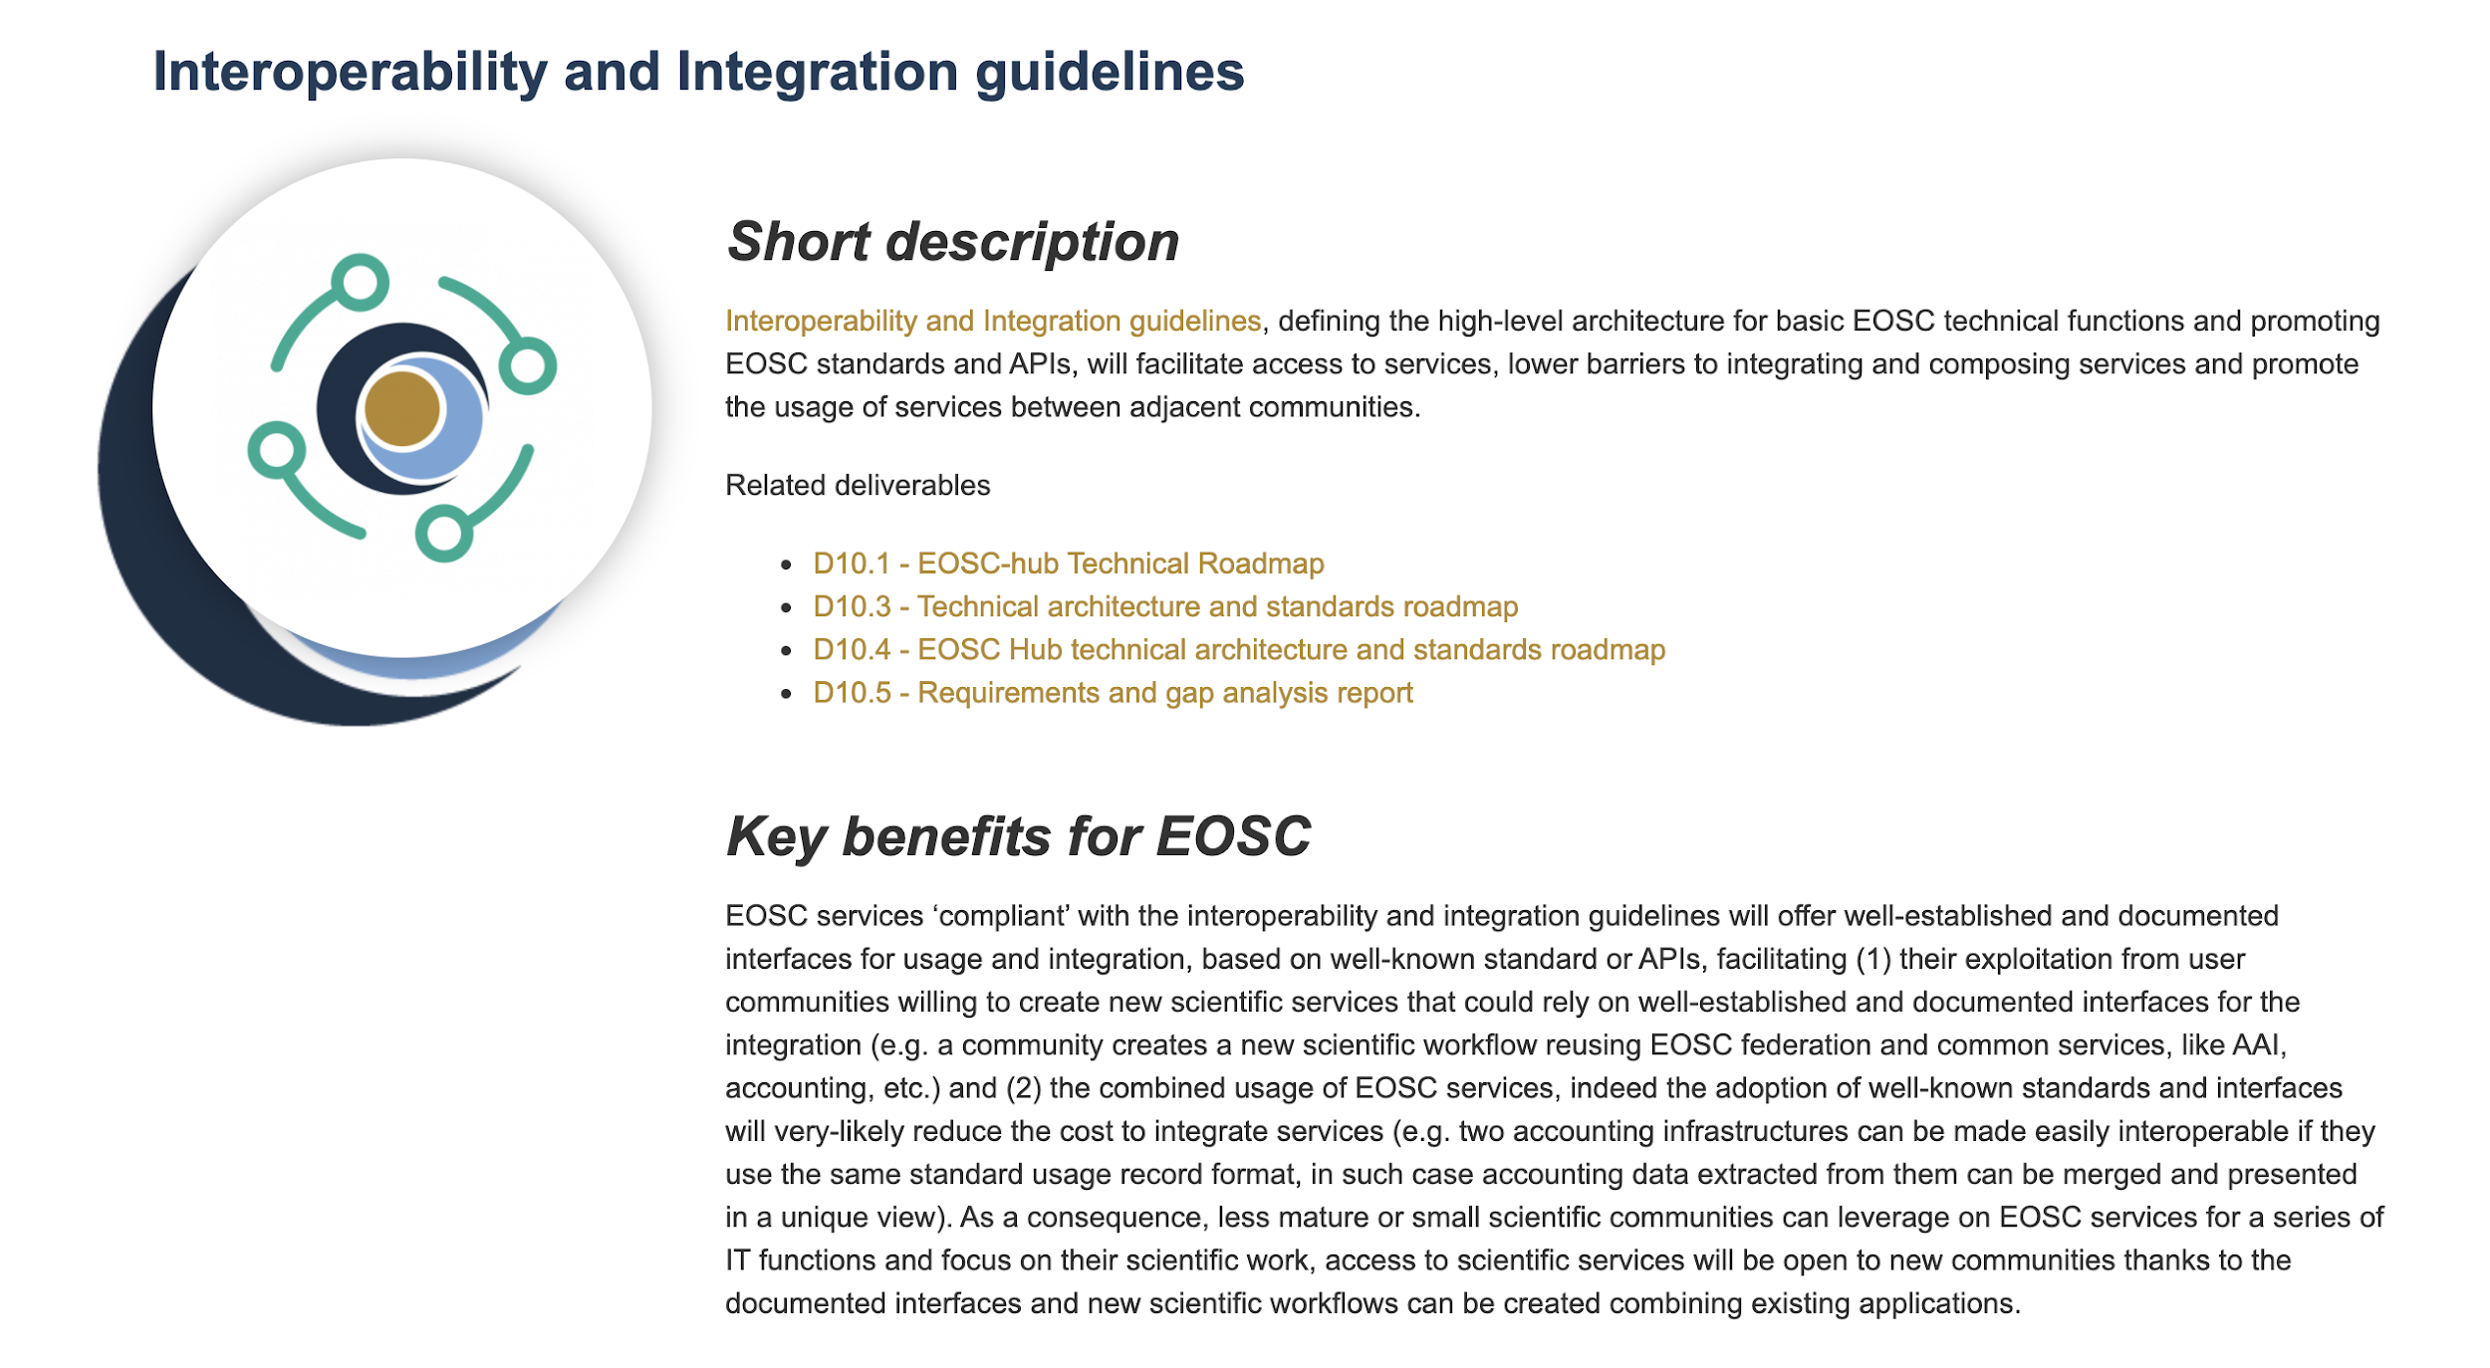
Figure 12: Public description of the KER on the EOSC-hub website

​Use and impact after EOSC-HUB
The Interoperability and integration guidelines have been used by a large number of related projects that continue beyond the EOSC-hub project itself to make their services EOSC-compatible. This is already happening, for example, in the EOSC regional projects funded under the INFRAEOSC 5b call. Moreover, the interoperability standards will be maintained and further developed by the upcoming EOSC Future project.

KER 9. Training courses and material
The training courses and material encompass a large variety of project results. They range all the way from common and federated services for supporting the whole research life cycle, domain-specific trainings to target the needs of data providers and data scientists and advanced training on higher-level compo-sable and PaaS services to consultancy building on training events (such as workshops focused on applying the FitSM standard in the specific circumstances in the client organisations, or helping research communities to develop a sound Data Management Plans) aiming to stimulate the knowledge transfer, foster the use of digital infrastructures and promote the uptake of Open Science paradigm. The sound training programme delivered by the project aimed to stimulate the establishment of a “knowledge network” of expertise and help researchers from different scientific disciplines to better integrate advanced digital services, tools and data to achieve excellence in science, research and innovation.
Training services are tailored to optimally fit the requirements of the diverse audience EOSC needs to reach, ranging from service providers who might benefit from technical assistance on using, integrating and providing services in EOSC to individual researchers possibly encountering the e-Infrastructures for the first time, enabling a smooth integration into EOSC ecosystem and maximising the benefits.
In terms of topics, the training courses and material cover all of the other KERs as well as most of the individual project results. Curation of this material by linking the training activity closely with the other developments of the project is a critical part of the project’s outreach activities.
Key benefits for EOSC
Training and support activities will play a key role in creating awareness of services and resources, augmenting skills and adapting organisational practices needed as prerequisites of full participation in the EOSC ecosystem. In the long run, the demand for training and related services will increase dramatically through the extension of the user base beyond the initial group of early adopters. This increased demand can be managed through synergy and collaborations with other EOSC-related projects. These activities complement training efforts of collaborating projects like OpenAIRE-Advance and FAIRsFAIR that look into the ‘Open-ing’ and into the ‘FAIR-ification’ of science, and the efforts of EOSC Enhance from early 2020 to pull together fundamental training on EOSC. Furthermore, the continuous involvement in the EOSC-wide Training Coordinators’ Community of Practice will ensure that the lessons learned, and best practices developed in the EOSC-hub training context will be available in the broader EOSC landscape.

Result type | Documents and reports
URL | https://eosc-hub.eu/key-exploitable-results/training-courses-and-material (documentation)  https://eosc-hub.eu/training-material (training database)
Key innovation | Rich set of tools, consulting models and material that make it possible to provide training services tailored to optimally fit the needs of the diverse audience EOSC needs to reach.
Target audiences | Users, research communities, EOSC service providers.
Key benefit (for the audiences) | Smooth integration into the EOSC ecosystem, maximising the benefits. Encourage uptake of the solutions integrated to EOSC (discovery, perceived maturity).
IPR approach | Multifaceted – most of the material is openly available, licensing approach differs on a case-by-case basis. The training material can be searched and filtered based on the licensing approach, e.g. to find training material licensed under creative commons, Apache or MIT licenses. The database making searching the training material and displaying it on the website could be protected under the sui generis database rights.
Exploitation strategy | All the documentation is licensed under CC-BY in order to ensure that future initiatives have sufficient IPR rights to curate and further improve the available material.
Key communication and dissemination activities | - Towards cultural change in data management – data stewardship in practice (Workshop), 24/05/2018  - The EOSC-hub training catalogue and financial procedure to support trainers (Webinar), 23/10/2018  - The European Open Science Cloud (Lecture), 28/11/2018  - Training on the EOSC-hub Data Platforms for data processing and solutions for publishing and archiving scientific data (PART I/II), 09/04/2019  - The ascent of Open Science and the European Open Science Cloud, presentation, 05/12/2019  - Training workshop in EOSC, 26-28/02/2020  - Training sessions during the EOSC-hub week, 20/05/2020  Dissemination articles/news:  - How to make your data Open and FAIR, EOSC-hub Magazine, Issue no. 2, Oct 2018  - OPENCoastS and EOSC-hub, EOSC-hub Magazine, Issue no. 3, March 2019  - The new EOSC-hub training catalogue has just been released! EOSC-hub Magazine, Issue no. 6, June 2020  - Open Science in action with EGI Notebooks and Zenodo (news), 08/06/2020  - Outreach and Training activities for the seismological community, EOSC-hub Magazine, Issue no.7, Feb. 2021
Engagement activities | - MoU between EOSC-hub and FREYA  - MoU between EOSC-hub and the FAIRsFAIR

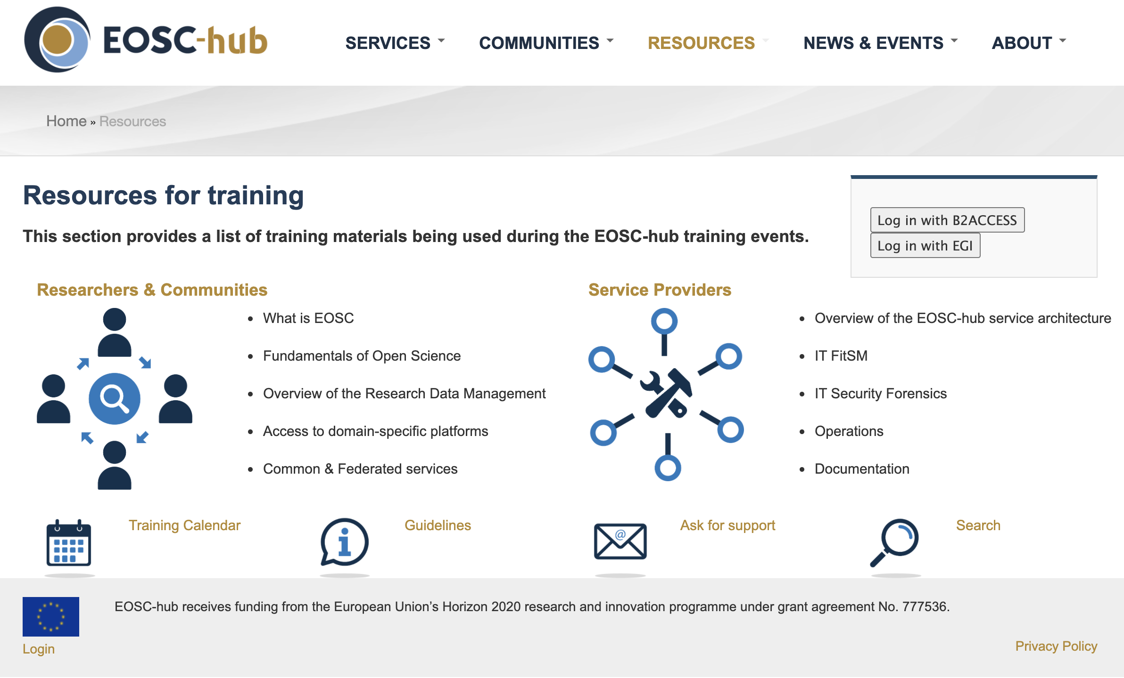
Figure 13: The training resource main page on EOSC-hub website
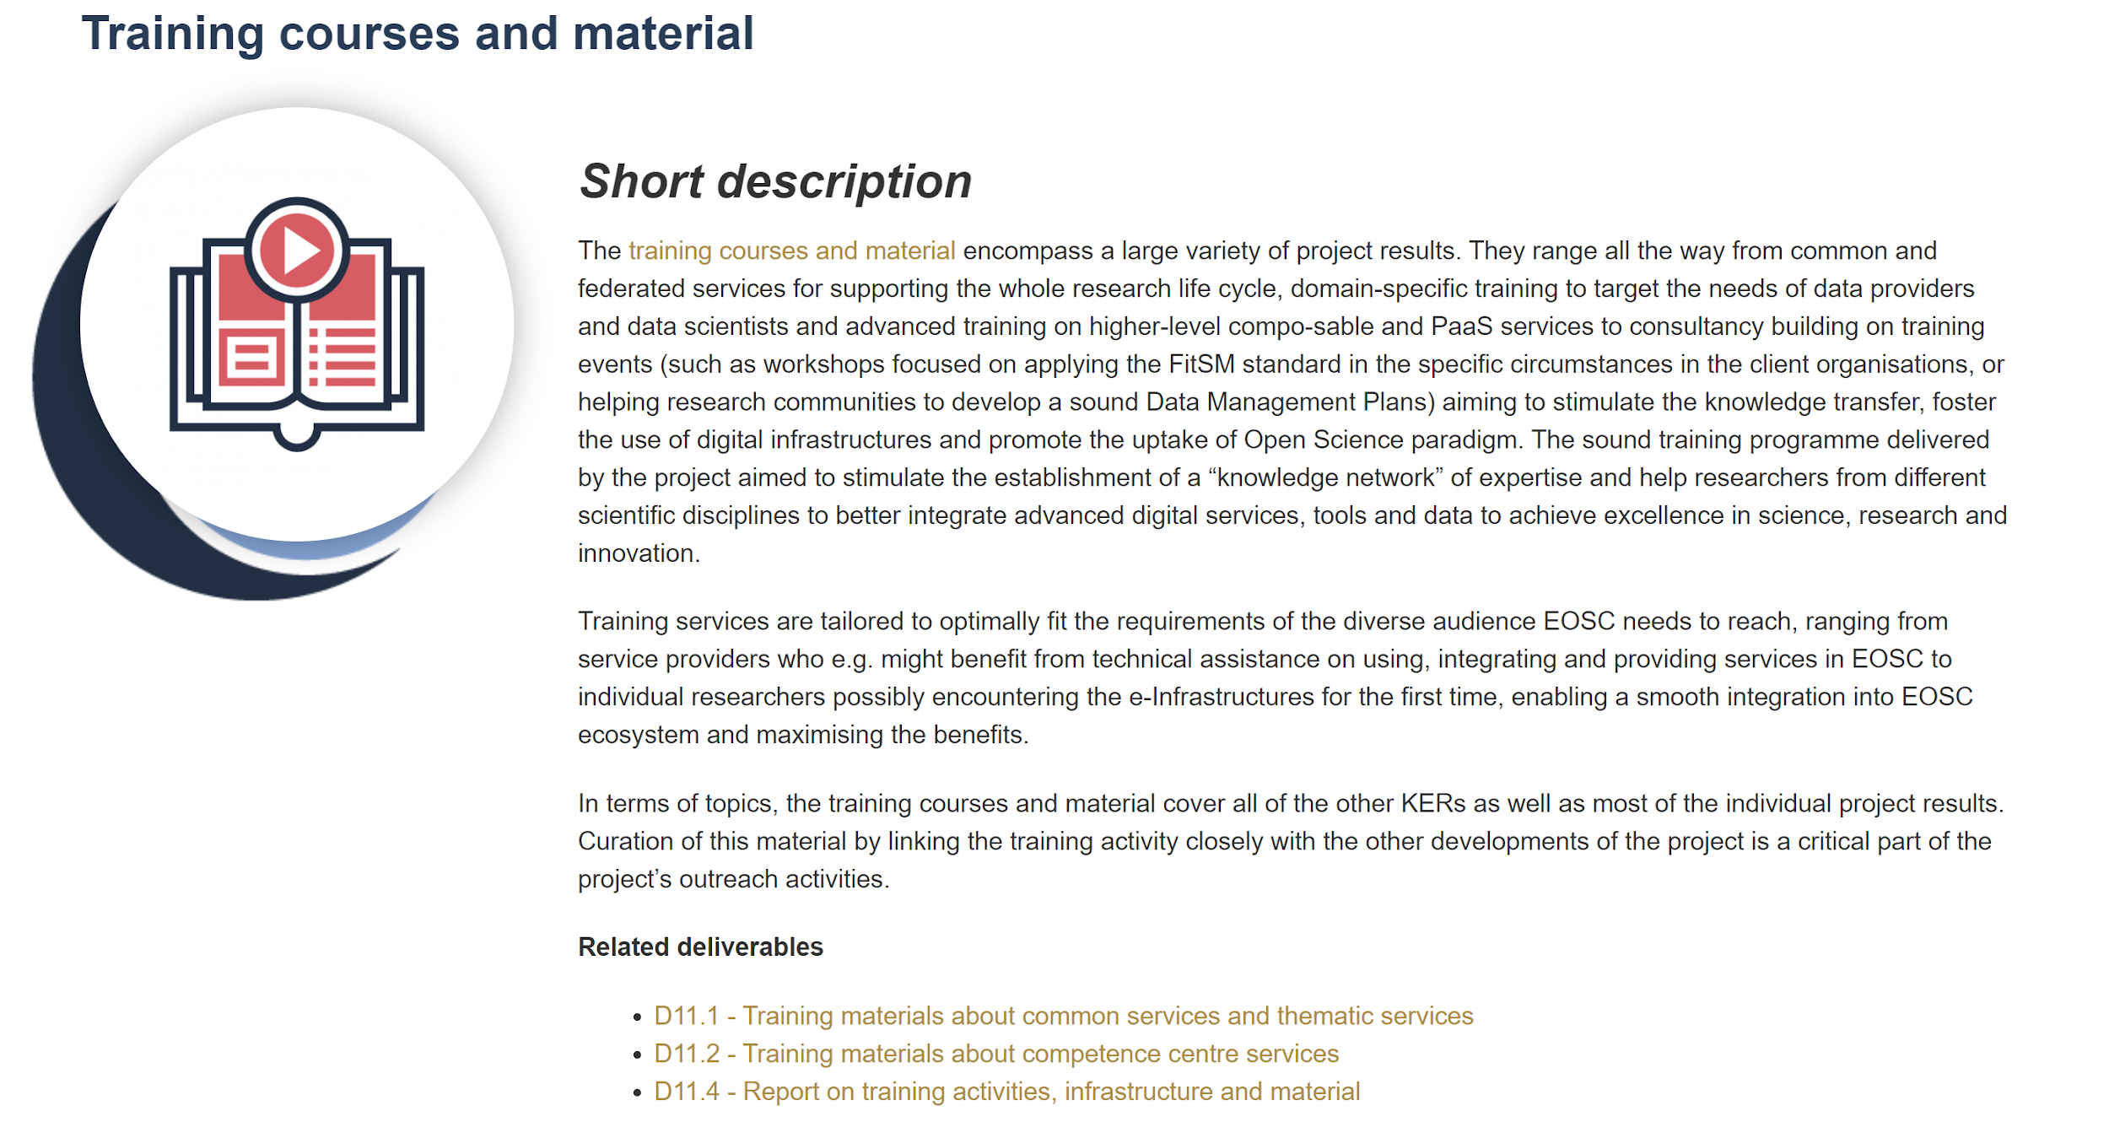
Figure 14: Public description of the Training courses and material KER providing summary and links to background material (including project deliverables)

​Use and impact after EOSC-HUB
Most of the KER components are tied to the EOSC portal and its future development, and EOSC-hub has ensured that the future activities have sufficient IPR rights to curate and further develop this resource.

​Competence Centres and Thematic Services

Competence centres
The competence centres are discussed in detail in the deliverable D8.2, but for convenience they are summarised here for concise reference.

​Elixir
​Name of the result | ELIXIR AAI integration and institutional clouds in EOSC Portal (CESNET, CSC, EBI)
​Result type | Software, services
​URL | https://eosc-hub.eu/research-communities/elixir
​Key innovation | Allow ELIXIR cloud and data providers to share cloud compute and storage capacity to replicate and share reference datasets with each other and with their users.
​Groups the innovation would be beneficial to | Researchers and research communities
​Key benefit (for the audiences) | Enables the staging of 'ELIXIR Core Data Resources' to the cloud sites on-demand and allows application providers to deploy containerised community/reference applications to any of the federated cloud sites.
​Sustainability: source of funding or revenue | Part of the ELIXIR overall sustainability strategy (ECP components will be integrated and expanded to broader group of ELIXIR services)
​IPR situation | RDSDS-Server: Apache 2.0  ELIXIR AAI is based on PERUN software (2-clause BSD license)
​Estimated launch date for external users | Available
​WPs involved | WP8
Key dissemination steps | - Plenary presentation at 8th Global Alliance for Genomics and Health (GA4GH) meeting (September 30th, 2020)  - “WP3 Update - Data Discovery and Transfer Service and Application in COVID-19” at the Elixir All hands meeting (June 16th, 2020)
​Future dissemination and exploitation paths and actions | Through ELIXIR collaboration, supported in the follow-up projects

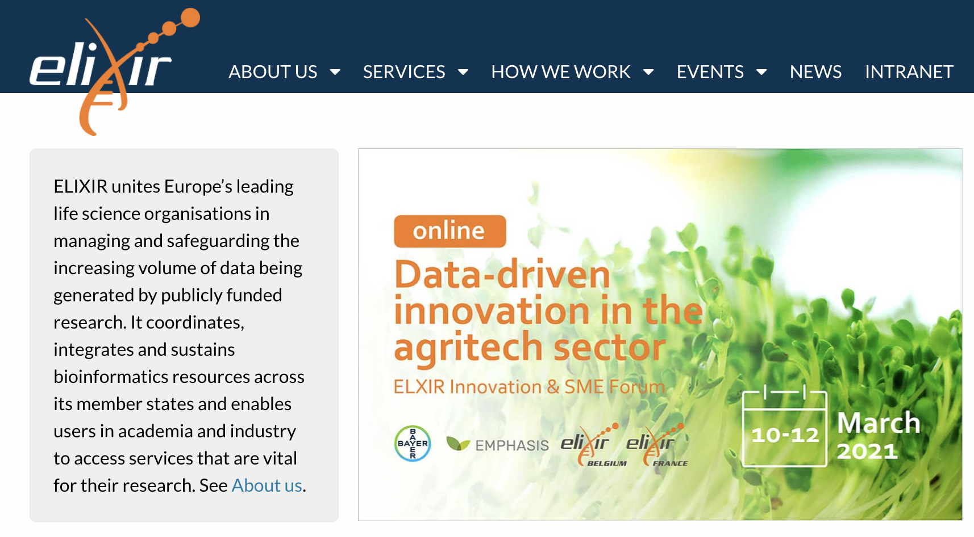
Figure 15: Elixir homepage

Fusion
​Name of the result | PROMINENCE service
​Result type | Software, services
​URL | https://marketplace.eosc-portal.eu/services/prominence
​Key innovation | Adapt the EOSC services to the needs of the fusion community
​Groups the innovation would be beneficial to | Research communities, researchers
​Key benefit (for the audiences) | Simplified storage access: OneData has been installed successfully and data replication was performed and evaluated between CEA and PSNC. Testing of the B2SAFE technology is ongoing.  Computing part the CC has containerised versions of the standard ITER Modelling and Analysis System (IMAS) software, making it ready for deployment on EOSC-hub computational resources.  Prominence: opportunistic use of cloud resources
​Sustainability: source of funding or revenue | Adoption by EUROfusion being discussed
​IPR situation | The EOSC-hub developments use the licensing approach of the components adapted for the fusion community. Prominence components licensed under Apache 2.0.
​Estimated launch date for external users | Available
​WPs involved | WP8
Key dissemination steps | Announcement on the EOSC-hub website (August 2019)
​Future dissemination and exploitation paths and actions | Engagement with Fusion community
​

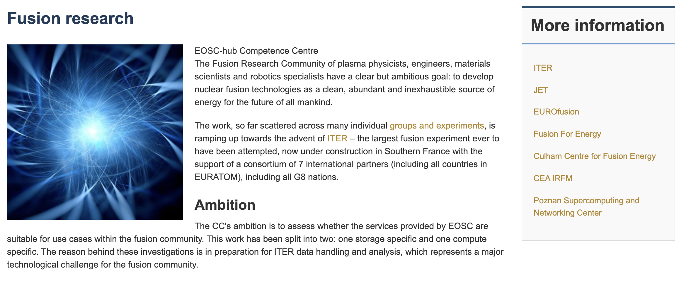
Figure 16: The Fusion research homepage collecting information related to project’s contributions to the fusion research community

Marine
​Name of the result | ARGO floats data discovery
​Result type | Community support (competence centre)  Software and services (Marine Data Analytics Platform)
​URL | https://marketplace.eosc-portal.eu/services/argo-floats-data-discovery
​Key innovation | Tools and resources to facilitate improvements of the understanding of global ocean changes.
​Groups the innovation would be beneficial to | Researchers and research communities
​Key benefit (for the audiences) | Repeatable, easily discoverable solutions that allow researchers document and share their workflows and tools.
​Sustainability: source of funding or revenue | The Euro-Argo tools have been adopted and further refined by the BlueCloud H2020 project. SeaDataNet WebODV application will be deployed on the EGI cloud infrastructure in the context of the EGI-ACE project
​IPR situation | The Euro-Argo and SeaDataNet services will continue to be made freely available.
​Estimated launch date for external users | Available
​WPs involved | WP8
Key dissemination steps
​Future dissemination and exploitation paths and actions | ARGO float discovery service was included in the work plan of the BlueCloud H2020 project. BlueCloud involves CSC and IN2P3 (the hosting nodes of the service), so the operation is secured there until the end of September 2022.

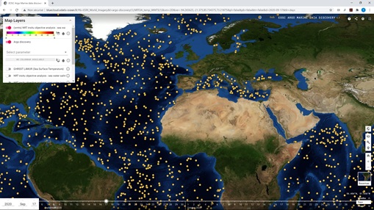
Figure 17: The user interface of the Argo floats data discovery service onboarded to EOSC

EISCAT 3D
​Name of the result | EISCAT Data Access Portal
​Result type | Community support (centre)  Software and services (technical solutions)
​URL | https://marketplace.eosc-portal.eu/services/argo-floats-data-discovery
​Key innovation | Fine-grained access control based on federation of identify providers facilitating global collaboration coupled with integration with EOSC marketplace and resources
​Groups the innovation would be beneficial to | Researchers and research communities
​Key benefit (for the audiences) | More systematic approach to data access and processing across the broader thematic community, improvements in quality of services and software
​Sustainability: source of funding or revenue | EISCAT 3D results have acted as background of the EISCAT’s involvement in EGI-ACE and PITHIA-NRF projects.
​IPR situation | Components used by EISCAL 3D:  DIRAC: GPL 3.0  PERUN: BSD 2-clause license  RCIAM (EGI Check-in): Apache 2.0
​Estimated launch date for external users | Available
​WPs involved | WP8
Key dissemination steps
​Future dissemination and exploitation paths and actions | The result generated by the EOSC-hub project will contribute to a broad range of EISCAT related activities, including EISCAT_3D, ENVRI-Fair, EGI-ACE, PITHIA-NRF as well as operations and developments funded by national contributions.
​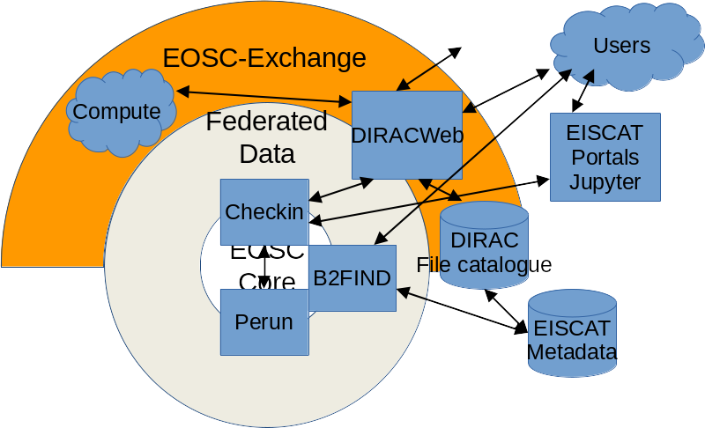
Figure 18: EISCAT 3D components in the EOSC architecture

EPOS-ORFEUS
​Name of the result | EPOS-ORFEUS Service validation
​Result type | Community support (centre)  Software and services (technical solutions)
​URL | https://www.eosc-hub.eu/research-communities/epos-orfeus-competence-center
​Key innovation | Pre-production quality, modular software platform that can be deployed at data centres to support solid-Earth science community (especially Seismology)
​Groups the innovation would be beneficial to | Researchers, research communities
​Key benefit (for the audiences) | Streamlined workflow supporting federated identity services
​Sustainability: source of funding or revenue | EOSC-hub results taken up by EPOS ERIC and the ENVRI-FAIR and EOSC Future projects
​IPR situation | Components:  - RCIAM (EGI Check-in): Apache 2.0  - Jupyter Notebooks: 3-Clause BSD License
​Estimated launch date for external users | Available
​WPs involved | WP8
Key dissemination steps
​Future dissemination and exploitation paths and actions | The AAI system will be maintained in production by GFZ, serving the EPOS community and beyond. Webinars/meetings are planned with the international federation of seismology to use this as an international standard (e.g. FDSN standard) for data access.

Radioastronomy
​Name of the result | LOFAR Science Products
​Result type | Community support (centre)  Software and services (technical solutions)
​URL | https://www.eosc-hub.eu/research-communities/radio-astronomy-competence-center
​Key innovation | Lower the technological barriers for adoption of EOSC services and resources for the Radio Astronomical community
​Groups the innovation would be beneficial to | Researchers, research communities
​Key benefit (for the audiences) | Support researchers in finding, accessing, managing, and processing data produced by the International LOFAR Telescope
​Sustainability: source of funding or revenue | Part of the framework of the SDC Program coordinated by the Netherlands Institute for Radio Astronomy (ASTRON). Some of the services will be provided as EGI-ACE virtual access services
​IPR situation | Components:  - RCIAM (EGI Check-in): Apache 2.0  - B2SHARE: GPL-2.0  - B2HANDLE: Apache License 2.0
​Estimated launch date for external users | EOSC onboarding planned during 2021
​WPs involved | WP8
Key dissemination steps
​Future dissemination and exploitation paths and actions | The achieved results will be built upon in follow-up projects (including EGI-ACE) through which a LOFAR data processing service will be offered to the science community. The result will be included in the ASTRON Science Data Center (SDC) programme (formed in 2020).

ICOS-eLTER
​Name of the result | ICOS validated solutions
​Result type | Services, community support
​URL | https://www.eosc-hub.eu/research-communities/icos
​Key innovation | Test and integrate EOSC services into ICOS and eLTER tools
​Groups the innovation would be beneficial to | Researchers, research communities
​Key benefit (for the audiences) | Automating raw data down sampling for ICOS analysis tools, Cloud-based data validation framework for eLTER
​Sustainability: source of funding or revenue | The results have been adopted by the ICOS RI and as background in the eLTER PLUS project
​IPR situation | ICOS - GPL-3.0  eLTER - freely available for the community (no explicit license)
​Estimated launch date for external users | Available
​WPs involved | WP8
Key dissemination steps
​Future dissemination and exploitation paths and actions | ICOS: The system developed will be used by ICOS, the global fluxnet database and be open for the user community. There is already strong interest from the South-African ecosystem infrastructure SAEON into the data processing system.  eLTER: The development of the prototype into a fully operational and functional service will be continued throughout the eLTER PLUS project.

​Disaster Mitigation Competence Centre plus (DMCC+)
​Name of the result | iCOMCOT Portal
​Result type | Service (community support)
​URL | https://www.eosc-hub.eu/research-communities/disaster-mitigation-competence-centre-plus-dmcc
​Key innovation | Test and integrate EOSC services into portals for analysing natural hazards and their impact
​Groups the innovation would be beneficial to | Researchers, research communities
​Key benefit (for the audiences) | Flexible use of Cloud resources for broad range of applications to reduce disaster risk
​Sustainability: source of funding or revenue | Regional international collaborations, continued support in the context of the EGI-ACE project
​IPR situation | N/A
​Estimated launch date for external users | EOSC onboarding planned for 2021
​WPs involved | WP8
Key dissemination steps | DMCC+ meetings have been organised in conjunction with the annual International Symposium on Grids and Clouds conferences, typically with joint workshops with the broader environmental informatics community.
​Future dissemination and exploitation paths and actions | The regional collaborations on disaster mitigation in Asia extend beyond EOSC-hub, based on the foundations laid by the DMCC+. Extension to space-based resource federation and applications will be prototyped in the coming years in the context of the EGI-ACE project. Capacity building for dealing with more complex scenarios such as multi-hazards and compound hazards will be included in future case studies.

​Thematic Services
The thematic services represent a specific category of major project results that are presented in more detail in the deliverable D7.4 and D7.5. The key aspects of these success stories are presented here for quick reference.

​CLARIN
​Name of the result | Virtual Language Observatory (VLO)  Virtual Collection Registry (VCR)  Language Resource Switchboard (LRS)
​Result type | Services
​URL | VLO:  https://vlo.clarin.eu  https://marketplace.eosc-portal.eu/services/virtual-language-observatory  VCR:  https://collections.clarin.eu  https://marketplace.eosc-portal.eu/service/virtual-collection-registry  LRS:  https://switchboard.clarin.eu;  https://marketplace.eosc-portal.eu/services/language-recource-switchboard
​Key innovation | User friendly and easy access to services for language research.
​Groups the innovation would be beneficial to | Researchers, research communities
​Key benefit (for the audiences) | The services provide a framework to describe and reuse existing metadata blueprints.
​Sustainability: source of funding or revenue | The service will be further sustained and developed as part of the CLARIN ERIC activities. Improvements will also be supported thanks to the participation in the EC funded projects SSHOC and EOSC Future.
​IPR situation | GPLv3
​Estimated launch date for external users | Available
​WPs involved | WP7
Key dissemination steps | - The blog and video on CLARIN services in EOSC.  - Online training session in March 2020 on the topic of connecting language processing tools to the Language Resource Switchboard.  - Presentations at EOSC events
​Future dissemination and exploitation paths and actions | The thematic services will be further supported and developed by CLARIN ERIC. Additional improvements will be ensured through CLARIN's participation in the SSHOC project and in the EOSC Future project.

DODAS
​Name of the result | DODAS
​Result type | Software, services
​URL | http://dodas-iam.cloud.cnaf.infn.it/  https://marketplace.eosc-portal.eu/services/dynamic-on-demand-analysis-service-dodas-portal
​Key innovation | Flexible Cloud PaaS platform with enhanced support for federated cloud solutions
​Groups the innovation would be beneficial to | Researcher, Service Providers, Research Communities
​Key benefit (for the audiences) | EOSC-hub added or improved features that provide a common interface to monitoring, AAI, service deployment across heterogeneous, federated IaaS resources
​Sustainability: source of funding or revenue | The service will also be operated and further developed as part of the EGI-ACE project and the national INFN-Cloud initiative.
​IPR situation | Apache License Version 2.0
​Estimated launch date for external users | Available
​WPs involved | WP7
Key dissemination steps | - 2 presentations at CHEP 2019  - Dedicated technical lectures and hands-on sessions on clouds, and related scientific services, were also presented during the CODATA-RDA schools in 2019 and 2020 and during the “Multiscale, Machine learning and QSAR (MM-QSAR) Methods applied to biomolecules” schools in 2020 as part of the Elective course Master in Theoretical Chemistry and Computational Modelling (EMTCCM).
​Future dissemination and exploitation paths and actions | The DODAS Thematic Service will keep operating under the EGI-ACE project in order to deliver compute and data analysis capabilities to the scientific communities. Moreover, DODAS will continue its support to the adopter in the context of the INFN-Cloud National project.

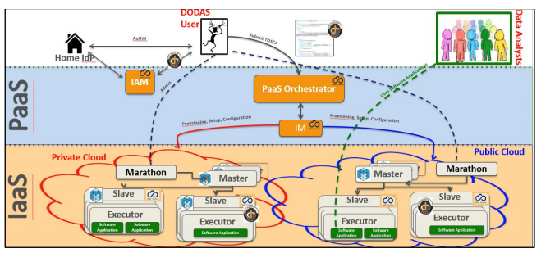
Figure 19: High level schema of the DODAS architecture

​ECAS
​Name of the result | ENES Climate Analytics Service (ECAS)
​Result type | Service
​URL | https://www.eosc-hub.eu/services/ENES%20Climate%20Analytics%20Service  https://marketplace.eosc-portal.eu/services/enes-climate-analytics-service
​Key innovation | Community-specific, FAIR Jupuyter notebook for executing and sharing research workflows, paradigm shift with a strong focus on data intensive analysis and server-side approaches
​Groups the innovation would be beneficial to | Research communities, climate modelling community, direct downstream usage communities
​Key benefit (for the audiences) | ECAS enables scientific end-users to perform data analysis experiments on large volumes of multidimensional data by exploiting a server-side, PID-enabled, and parallel approach and aiming to improve reusability of data and workflows (FAIR approach).
​Sustainability: source of funding or revenue | Solution picked up by the EOSC-Pillar project, to be continued as an EGI-ACE service
​IPR situation | The ECAS/Ophidia component code is available on GitHub under GPLv3 license; additional components for ECAS (Docker workflow components) available under BSD license; ECAS-B2SHARE Python client available under MIT license. Other components are available on GitHub (no explicit license)
​Estimated launch date for external users | Available
​WPs involved | WP7
Key dissemination steps | - Training on ECAS during the "EUDAT CDI - PRACE Summer School on managing scientific data from analysis to long term archiving”, Trieste, Italy, 27 September 2019  - Online Training on Data Analytics: How to skip high-volume data transfer and access free computing resources for your CMIP analyses, Online, 8-9 March 2021
​Future dissemination and exploitation paths and actions | Additional training courses (also as virtual and online events) with the aim of addressing new use cases coming from other research communities.  Inter-thematic-service collaboration and joint training events to explore and define possible common approaches.  Integration with new compute backends at individual sites, in the context of the IS-ENES compute service portfolio.
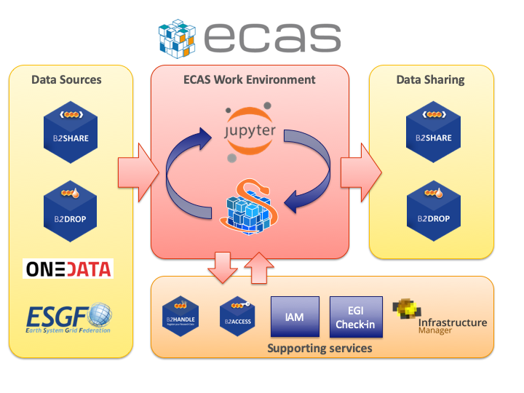
Figure 20: ECAS software architecture

GEOSS
​Name of the result | GEO Discovery and Access Broker (GEO DAB)  Virtual Laboratory (VLab)
​Result type | Software, services
​URL | GEO DAB:  https://www.geodab.net/  https://marketplace.eosc-portal.eu/services/geo-dab  VLab:  https://essilab.wixsite.com/vlab
​Key innovation | Cross-disciplinary, multi-platform data access, processing and knowledge discovery suite for Earth Observation data.
​Groups the innovation would be beneficial to | Researchers, research communities
​Key benefit (for the audiences) | Simplified access to data, models and the execution platforms to process them
​Sustainability: source of funding or revenue | CNR-IIA team (leader of the GEOSS TS) applied as Early Adopter for the EGI-ACE project where the use of EOSC for the described services will be continued and enhanced.
​IPR situation | GEO DAB and VLab are now free for use for educational, research and public services. It is planned to release in the future an open-source community edition.
​Estimated launch date for external users | Available
​WPs involved | WP7
Key dissemination steps | - During the last GEO Plenary meeting in Canberra (November 2019), the developed demo was widely shown at the EC booth during the entire meeting,  - Demonstrated also at the EuroGEO side event and during the plenary session
​Future dissemination and exploitation paths and actions | CNR-IIA team (leader of the GEOSS TS) applied as Early Adopter for the EGI-ACE project where the use of EOSC for the described services will be continued and enhanced.

​OPENCoastS
​Name of the result | OPENCoastS
​Result type | Service
​URL | http://opencoasts.lnec.pt/index_en.php  https://opencoasts.ncg.ingrid.pt/  https://marketplace.eosc-portal.eu/services/opencoasts-portal
​Key innovation | A user-friendly web portal allows users to set up forecast systems of several flow options for ocean circulation in their coastal region of interest (barotropic, wave and current interaction, baroclinic flows).
​Groups the innovation would be beneficial to | Coastal Researchers and research communities, Coastal authorities, consulting companies, coastal recreation companies, general public
​Key benefit (for the audiences) | User-friendly and simple access to numerous modelling tools and services, hiding the complexity of forecast systems and guaranteeing the computational resources for the daily simulations through EOSC
​Sustainability: source of funding or revenue | Made available as a service in any EGI High-Throughput compute cluster (part of the EGI Federation sustainability strategies). Further integration work will be undertaken in the EGI-ACE project. Future consulting services for dedicated training events and to set up the computational grids needed for the service.
​IPR situation | OPENCoastS: Apache License Version 2.0  The public repository is being created in GitHub. The link will be available in opencoasts.lnec.pt
​Estimated launch date for external users | Available
​WPs involved | WP7
Key dissemination steps | The full list of events is available at (including ppts and recordings):  http://opencoasts.lnec.pt/index_en.php#eventos  The full list of publications is available at:  http://opencoasts.lnec.pt/index_en.php#publicacoes  Key dissemination events:  - Reference paper: A. Oliveira, A.B. Fortunato, J. Rogeiro, J. Teixeira, A. Azevedo, L. Lavaud, X. Bertin, J. Gomes, M. David, J. Pina, M. Rodrigues, P. Lopes, OPENCoastS: An open-access service for the automatic generation of coastal forecast systems, Environmental Modelling & Software, 2019, 104585,ISSN1364-8152, https://doi.org/10.1016/j.envsoft.2019.104585.  - Reference online tutorial (includes ppts and recordings in YouTube): 2nd OPENCoastS e-Tutorial: build your forecast for all circulation choices (27-29 January 2021): http://opencoasts.lnec.pt/index_en.php#eventos
​Future dissemination and exploitation paths and actions | OPENCoastS has grown from a national service to a service with a worldwide community of over 300 users from 61 countries, and applications in 5 continents. The operation of the service and user support will continue under the EGI-ACE H2020 project and its expansion to water quality forecasts and hindcast simulation will also be achieved in that project.

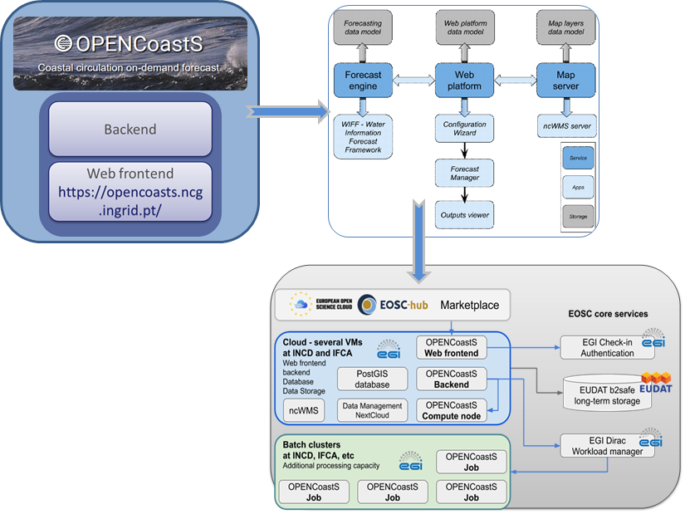
Figure 21: OPENCoastS architecture

WeNMR
​Name of the result | WeNMR
​Result type | Software, services
​URL | https://www.eosc-hub.eu/services/WeNMR%20suite%20for%20Structural%20Biology  https://marketplace.eosc-portal.eu/services/amber-based-portal-server-for-nmr-structures-amps-nmr  https://marketplace.eosc-portal.eu/services/disvis-web-portal-6eab178c-9bc5-4c62-b7ce-aeeb18d5cba9  https://marketplace.eosc-portal.eu/services/fanten-finding-anisotropy-tensor  https://marketplace.eosc-portal.eu/services/haddock2-4-web-portal  https://marketplace.eosc-portal.eu/services/spoton-c5db8fd5-a546-4342-8bae-2b2b4777b67e  https://marketplace.eosc-portal.eu/services/powerfit-web-portal-b8ddee6c-78f5-43d8-a5a2-9e3b7f1cb24e
​Key innovation | User-friendly access to complex computational workflows and tasks in the structural biology field
​Groups the innovation would be beneficial to | Researchers, research communities
​Key benefit (for the audiences) | The WeNMR portals allow inexperienced and experienced structural biologists to make use of state-of-the-art software for their research while benefiting from the computational infrastructure through EOSC
​Sustainability: source of funding or revenue | Software development continues as a community effort, EOSC service provision planned as part of the EGI-ACE project
​IPR situation | Haddock software remains property of University of Utrecht (commercial licenses available). The EOSC integration is based on DIRAC4EGI service (software available under GPL 3.0 license)
​Estimated launch date for external users | Available
​WPs involved | WP7
Key dissemination steps | The WeNMR services and associated software have been presented at numerous conferences and workshops, reaching a wide audience. Training courses have been organized among others under INSTRUCT-ERIC and EMBO.
​Future dissemination and exploitation paths and actions | The WeNMR user community has been and is still steadily growing, reaching over 21000 users worldwide from over 120 countries. In the current COVID pandemic, the services have seen more than a doubling of active users and usage over the last year. Software development of HADDOCK, the most used services, is supported among others by the BioExcel Center of Excellence. The operation of the services and user support will continue under the EGI-ACE H2020 project.
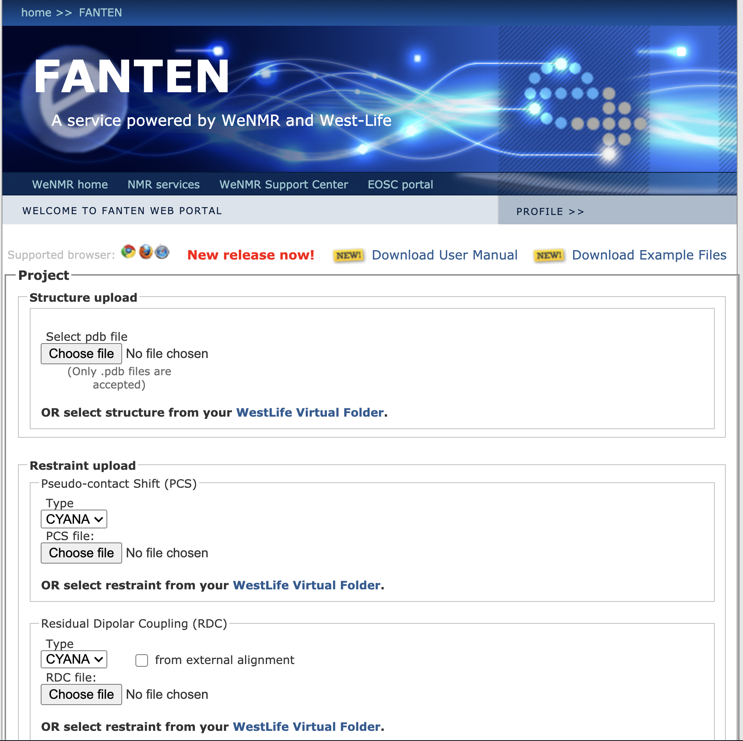
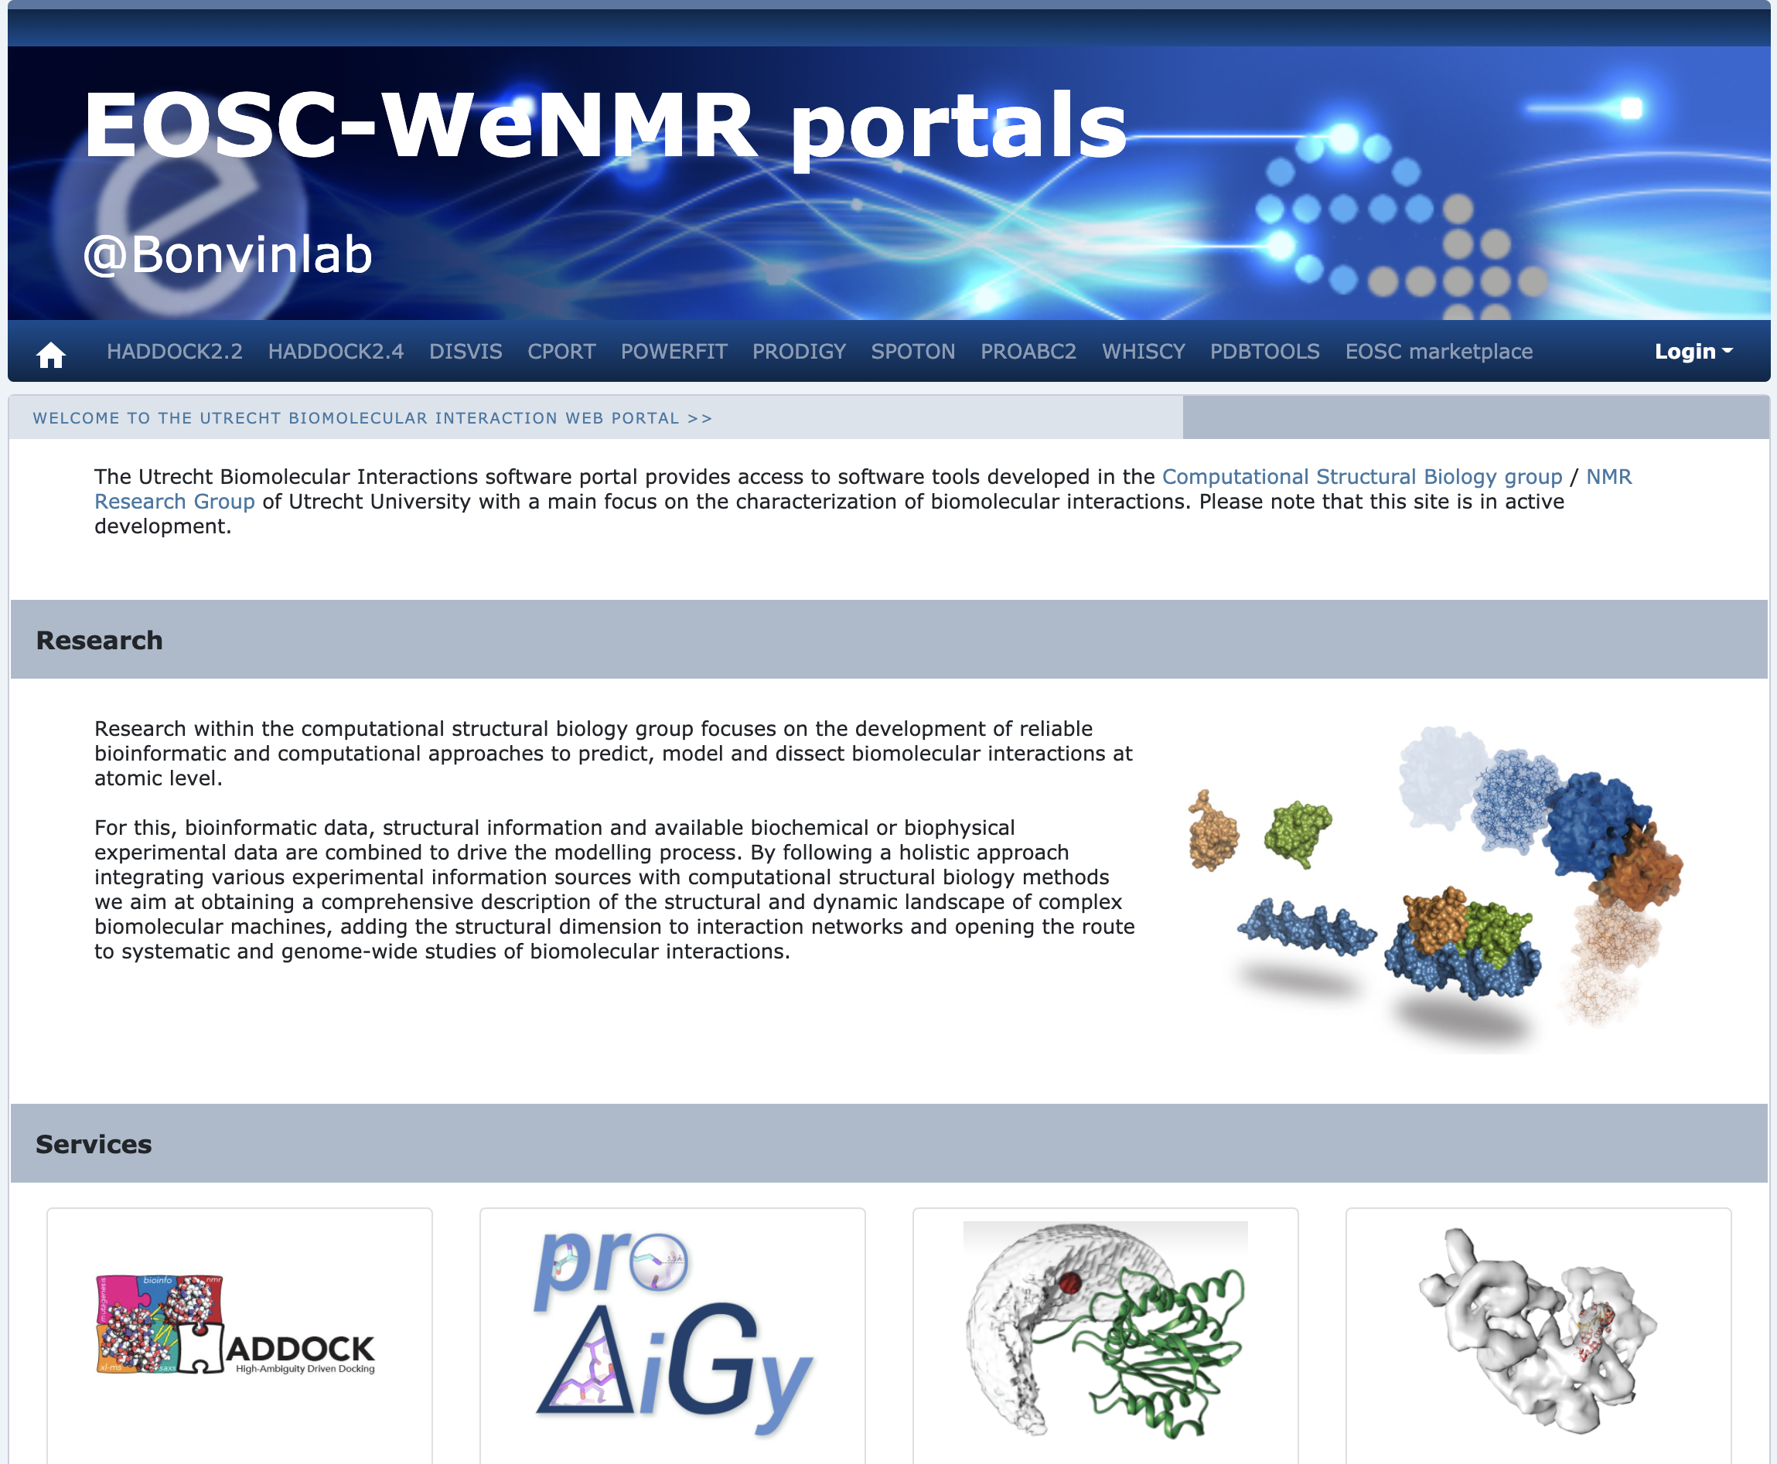
Figure 22: Front ends of the Utrecht WeNMR portals (https://wenmr.science.uu.nl) (left) and of the FANTEN web portal in Florence (right)

EO Pillar
​Name of the result | EO Pillar
​Result type | Services
​URL | https://www.eosc-hub.eu/keywords/eo-pillar  Specific services links:  - https://marketplace.eosc-portal.eu/services/cloudferro-data-related-services-eo-browser  - https://marketplace.eosc-portal.eu/services/gep-eo-services-for-earthquake-response-and-landslides-analysis  - https://marketplace.eosc-portal.eu/services/eodc-data-catalogue-service  - https://marketplace.eosc-portal.eu/services/cloudferro-data-related-services-eo-finder  - https://marketplace.eosc-portal.eu/services/eodc-jupyterhub-for-global-copernicus-data  - https://marketplace.eosc-portal.eu/services/cloudferro-infrastructure  - https://marketplace.eosc-portal.eu/services/cloudferro-data-collections-catalog  - https://marketplace.eosc-portal.eu/services/sentinel-hub  - https://marketplace.eosc-portal.eu/services/gep-eo-services-for-earthquake-response-and-landslides-analysis  - https://marketplace.eosc-portal.eu/services/rasdaman-eo-datacube
​Key innovation | To provide access to different services established in the field of Earth Observation (EO).
​Groups the innovation would be beneficial to | Researchers and research communities
​Key benefit (for the audiences) | Intuitive and efficient tools for geohazard analysis
​Sustainability: source of funding or revenue | Some services are going to be supported as part of EOSC-Future.  For others, funding opportunities are being explored.
​IPR situation | Different licenses for the individual components
​Estimated launch date for external users | Available
​WPs involved | WP7
Key dissemination steps
​Future dissemination and exploitation paths and actions | Integrated to EOSC-Marketplace for future exploitation

DARIAH
​Name of the result | DARIAH Science Gateway
​Result type | Software, services
​URL | https://www.eosc-hub.eu/services/DARIAH%20Science%20Gateway  https://marketplace.eosc-hub.eu/49-dariah
​Key innovation | A centralized portal for various Digital Arts and Humanities services connected with the EGI AAI with easy integration of new services
​Groups the innovation would be beneficial to | Researchers, research communities (especially in Digital Arts and Humanities fields)
​Key benefit (for the audiences) | Support resource discovery and sharing across a broad range of disciplines
​Sustainability: source of funding or revenue | Continued development will be undertaken in the projects DARIAH RI is involved in
​IPR situation | A mix of GPL 2.0, GPL 3.0 and Apache 2.0 licensed software components
​Estimated launch date for external users | Available
​WPs involved | WP7
Key dissemination steps | In general, the DARIAH Thematic Service has been actively promoting its services and participated in a variety of outreach and exploitation activities. This includes common channels like Twitter, but also blogs and websites related to the Digital Arts and Humanities.
​Future dissemination and exploitation paths and actions | SSHOC project took up results and findings from the DARIAH Thematic Service (and its predecessor, the EGI-Engage DARIAH Competence Centre) and evolved them further into a rich, integrated service portfolio for the Digital Arts & Humanities within EOSC.

LifeWatch
​Name of the result | LifeWatch tools
​Result type | Service, software
​URLs | https://www.eosc-hub.eu/keywords/lifewatch  - Plant Classification (IFCA-CSIC):  https://marketplace.eosc-portal.eu/services/lifewatch-eric-plants-identification-app  - Remote monitoring and smart sensing (IFCA-CSIC):  https://marketplace.eosc-portal.eu/services/remote-monitoring-and-smart-sensing  - Glacier Lagoons of Sierra Nevada (University of Granada):  https://marketplace.eosc-portal.eu/services/lagunas-de-sierra-nevada-glacier-lagoons-of-sierra-nevada  - GBIF.ES services:  https://marketplace.eosc-portal.eu/services/e-learning-platform-of-gbif-spain  https://marketplace.eosc-portal.eu/services/gbif-spain-occurrence-records  https://marketplace.eosc-portal.eu/services/gbif-spain-collections-registry  https://marketplace.eosc-portal.eu/services/gbif-spain-images-portal  https://marketplace.eosc-portal.eu/services/gbif-spain-regions-module  https://marketplace.eosc-portal.eu/services/gbif-spain-spatial-portal  https://marketplace.eosc-portal.eu/services/gbif-spain-species-portal
​Key innovation | Onboarding a range of LifeWatch RI related tools and services to EOSC marketplace
​Groups the innovation would be beneficial to | Researchers, research communities, citizen scientists
​Key benefit (for the audiences) | Easy discovery of the research and citizen science tools related to LifeWatch
​Sustainability: source of funding or revenue | Each of the integrated tools have their own sustainability approach, typically linked to LifeWatch ERIC
​IPR situation | Described in detail in D7.5. A mix of open-source licenses and openly accessible services.
​Estimated launch date for external users | Available
​WPs involved | WP7
Key dissemination steps | Promoted through EOSC marketplace and through LifeWatch channels
​Future dissemination and exploitation paths and actions | Through LifeWatch ERIC

Conclusions and future work
A multifaceted, multi-stakeholder project such as EOSC-hub will almost always face challenges related to the definition of Key Exploitable Results. This is evident when looking at the diversity of the project’s KERs: some of them can be distilled into a single document, while in other cases the KER consists of a large number of independent results. In the latter case, these results contain a large amount of background or sideground.
The analysis of the EOSC as an innovation ecosystem based on a platform model (as discussed in the deliverables related to KER 7) might partially explain this. The core of the platform is ideally as concise and “lean” as possible, providing a set of interfaces and services that minimise the friction of transactions between resources and users integrated to the platform. In contrast, a set of external services integrated to EOSC should be as rich as possible, providing the user community with choices that match their preferences and previous expertise. The value of EOSC will also increase as a function of potential interactions between these components, not only through the link with the EOSC core and the pathways to users it provides.
A complementary approach to evaluating the project results based on their ability to act as catalysts for innovation would be to look at the maturity of the component and the role definition. For example, using a simplified Kano Model, we could split KERs into “dissatisfiers” and “delighters”. A mature core component (such as the Rules of Participation - RoP) provides certain preconditions for innovation and impact. But even if the component is perfectly designed and executed, the “user satisfaction” will reach the level of indifference and absence of negative attitudes. Any kind of failure in this kind of KER will be seen as a major failure. In general, once the clarity and maturity of a KER reaches a certain level, further improvements are likely to have only a minor positive impact on the perceived innovation potential (even though in the case of RoP it forms a prerequisite for practically all EOSC-based innovation. In contrast, the (perceived and real) innovation potential based on the services and user communities sharing the EOSC platform is based on the “delighter” model. At the moment, the ability to link user communities and compute/data resources together across national and organisational boundaries is still seen as newsworthy and an inherently positive thing. Increasing the number of participants increases the perceived value (and innovation potential) in a super linear fashion, and due to the perceived novelty challenges in some specific cases are seen as something to be expected. The occasional struggles in some specific circumstances may even serve as reminders of the importance of the work.
Taking these impact modelling approaches as complementary tools in the definition of KERs and their value propositions could make it easier to define the results and their dissemination and exploitation strategies. However, on both cases the dynamics of the situation should be kept in mind: even the most fundamental, mature aspects of EOSC may need to be re-examined due to reasons mentioned in section 1.2. And when applying the Kano model, it is important to keep in mind that “delighters” will evolve into “dissatisfiers” very quickly, which means that the positioning of a KER will need to be reassessed at least periodically.

Further evolution of the Innovation Management as a concept
Innovation Management is, in general, a relatively recent field of study and practice. In addition to the evolution of the theoretical framework itself, the interpretation of the concept is not uniform. In some cases, continuous improvement activities are considered to be fully within the scope of innovation management while it is also possible to find interpretations where Innovation Management and Intellectual Property Management are used interchangeably.
With the publication of the ISO 56 000 standards family, the theoretical framework is becoming more well-defined. However, especially in the collaborative project context, further reflections and models for interpreting and implementing innovation management are needed.

Potential Best Practices
During the project lifetime, the following aspects of Innovation Management were identified as areas for further analysis and development:
- Links with management processes. Most of the EOSC projects operating structures similar to the hub built by EOSC-hub will have a process-based approach to the activities. Innovation Management should be more closely linked with these processes, both from an opportunity identification point of view (e.g. user and provider interactions) as well as from benefiting from synergies (e.g. with quality and risk management that also needs to deal with IPR and branding issues).
- Minimising the overhead: Innovation Management and result capture should focus on performing analysis and collecting information that cannot be derived from other sources. For example, in case of IPR issues, software repositories should already contain the information and automating the collection of this information should reduce overhead and allow shifting effort from monitoring to the definition of IPR strategies.
- KER champions: assign earlier, expand to other results: the role of KER champion showed great promise in the EOSC-hub project. In future activities, assigning the roles immediately after the KER is captured should further reduce the overhead.
- KER Champions
KER | Champion
KER1. EOSC Portal and Marketplace | Roksana Wilk, Cyfronet
KER2. EOSC Service Management System | Malgorzata Krakowian, EGI
KER3. EOSC Rules of Participation | Owen Appleton, EGI
KER4. Internal Services in the Hub Portfolio | Pavel Weber, KIT
KER5. External Services in the Hub Portfolio | John Kennedy, MCDF
KER6. EOSC Digital Innovation Hub (DIH) | Elisa Cauhé, EGI
KER7. Business and sustainability models for services and the Hub | Dale Robertson, JISC
KER8. Interoperability and Integration guidelines | Giacinto Donvito, INFN
KER9. Training courses and material | Giuseppe La Rocca, EGI

- KER 4 components

EUDAT B2ACCESS | https://b2access.eudat.eu
 | https://github.com/unity-idm/unity
EUDAT B2ACCESS | https://github.com/EUDAT-B2ACCESS/b2access-unitytheme
EGI Checkin | https://aai.egi.eu/
 | https://github.com/rciam
 | https://github.com/EGI-Foundation/simplesamlphp-module-themeegi
 | http://www.eduteams.org
 | https://wiki.geant.org/display/eduTEAMS
 | https://github.com/IdentityPython/
 | https://spaces.at.internet2.edu/display/COmanage/Home
 | https://github.com/hexaaproject
 | https://github.com/CESNET/perun
 | https://github.com/CESNET/perun-services
 | https://github.com/CESNET/perun-wui
 | https://github.com/indigo-iam/iam
 | https://perun.egi.eu/
 | https://perun-aai.org/
WATTS | https://watts-prod.data.kit.edu
WATTS | https://watts-prod.data.kit.edu/docs/user/index.html
 | https://github.com/watts-kit/
EGI RCauth | https://wiki.nikhef.nl/grid/RCauth.eu_and_MasterPortal_documentation
 | https://github.com/rcauth-eu
EGI RCauth | http://pilot-ca1.rcauth.eu/
EGI RCauth | https://rcauth.eu/
EOSC-hub Marketplace | https://marketplace.eosc-portal.eu
EOSC-hub Marketplace | https://wiki.eosc-hub.eu/display/EOSC/Marketplace
EOSC-hub Marketplace | https://github.com/cyfronet-fid/marketplace
EOSC-hub SPMT | https://spmt.eosc-hub.eu
EOSC-hub SPMT | https://grnet.github.io/agora-sp/
EOSC-hub SPMT | https://github.com/grnet/agora-sp-admin
EOSC-hub Monitoring | https://github.com/grnet/agora-probes
EOSC-hub SPMT | https://github.com/grnet/agora-catalogue-react-view
EGI OperationsPortal | http://operations-portal.egi.eu
EGI OperationsPortal | https://gitlab.in2p3.fr/opsportal/sf3
EGI GocDB | https://goc.egi.eu
EGI GocDB | https://wiki.egi.eu/wiki/GOCDB
EGI GocDB | https://github.com/GOCDB/gocdb
EUDAT DPMT | https://dp.eudat.eu
EUDAT DPMT | https://github.com/EUDAT-DPMT
 | https://easydmp.eudat.eu
 | https://www.sigma2.no/content/easydmp
EUDAT EasyDMP | https://github.com/hmpf/easydmp
EUDAT EasyDMP | https://gitlab.eudat.eu/dmp/eestore
EUDAT SVMON | https://svmon.eudat.eu
EGI APEL | http://apel.github.io/
EGI APEL | https://github.com/apel/ssm
EGI APEL | https://github.com/apel/apel
EUDAT ACCT | https://accounting.egi.eu/
 | https://github.com/cesga-egi/accounting
EGI Argo Monitoring | http://argo.egi.eu
 | https://github.com/ARGOeu/argo-messaging
 | http://argoeu.github.io
 | https://github.com/ARGOeu/
 | https://github.com/CESNET/pakiti-server
 | https://github.com/CESNET/secant
 | https://bestpractical.com/download-page
EOSC-hub Helpdesk | https://helpdesk.eosc-hub.eu
EGI AppDB | https://appdb.egi.eu/
EGI AppDB | https://github.com/iasa-gr
EUDAT Software Repo (GitLab) | https://gitlab.eudat.eu
EGI Software Repo | http://repository.egi.eu/
EGI Software Repo | http://repository.egi.eu/about
 | https://trac.iasa.gr/trac/egi-repo/
EOSC-hub EOSC-Portal | https://eosc-portal.eu/
EUDAT Helpdesk | https://helpdesk.eudat.eu
EUDAT Helpdesk | https://www.eudat.eu/contact-support-request

- KER 5 integration components

INDIGO IAM | GitHub - indigo-iam/iam: INDIGO Identity and Access Management Service
EGI DATAHUB | EGI DATAHUB – Sign-in – Onezone
EGI DATAHUB | onedata · GitHub
EUDAT B2FIND | Welcome - B2FIND
EUDAT B2FIND | GitHub - EUDAT-B2FIND/ckanext-b2find: B2FIND extension for CKAN
EUDAT B2FIND | GitHub -  EUDAT-B2FIND/md-ingestion: Ingestion (including OAI harvesting, semantic  mapping (see repo 'md-mapping') and uploading to CKAN ) of metadata in  the B2FIND portal
EUDAT B2STAGE | B2STAGE - EUDAT
EUDAT B2STAGE | GitHub - EUDAT-B2STAGE/B2STAGE-GridFTP: B2STAGE service core code for EUDAT project: iRODS-DSI
EUDAT B2STAGE | GitHub - EUDAT-B2STAGE/http-api: RESTful HTTP-API for the B2STAGE service inside the EUDAT project
EUDAT B2DROP | EUDAT B2DROP
EUDAT B2DROP | EUDAT-B2DROP · GitHub
EGI Cloud Compute | EGI | Cloud Compute
EGI Cloud Compute | GitHub - EGI-Foundation/fedcloud-vmi-templates: Virtual Machine Image of EGI Fedcloud
EGI Cloud Compute | GitHub - EGI-Foundation/cloud-info-provider: EGI Cloud Information System Provider
EGI Cloud Compute | GitHub - IFCA/caso: cASO is an OpenStack Accounting extractor
EGI Cloud Compute | GitHub - IFCA/keystone-voms: Keystone VOMS authentication module
EGI Cloud Compute | GitHub - the-cloudkeeper-project/cloudkeeper: EGI AppDB <-> CMF synchronization utility
EGI Cloud Compute | GitHub - the-cloudkeeper-project/cloudkeeper-one: OpenNebula backend for Cloudkeeper
EGI Cloud Compute | GitHub - the-cloudkeeper-project/cloudkeeper-os: OpenStack backend for cloudkeeper
EGI Cloud Compute | GitHub - the-rocci-project/keystorm: Federated authentication component for rOCCI-server
EGI Cloud Compute | GitHub - ARGOeu/nagios-plugins-fedcloud
EGI Cloud Compute | GitHub - IASA-GR/appdb-core: Applications Database core
EGI Cloud Compute | GitHub - IASA-GR/appdb-is-publisher: AppDB Information System (IS) publisher module
EGI Cloud Compute | GitHub - the-oneacct-export-project/oneacct-export: Exporting OpenNebula accounting data
EGI Cloud Container Compute | EGI | Cloud Container Compute
EGI Cloud Container Compute | GitHub - grycap/ansible-role-kubernetes: Ansible role to install a Kubernetes cluster
EGI DIRAC | EGI-Prod - DIRAC
EGI DIRAC | GitHub - DIRACGrid/DIRAC: DIRAC Grid
EGI Online Storage | EGI | Online Storage
STORM | GitHub -  italiangrid/storm: StoRM (STOrage Resource Manager) is a light,  scalable, flexible, high-performance, file system-independent storage  manager service (SRM) for generic disk based storage system, compliant  with the standard SRM interface version 2.2.
EGI High Throughput Compute | EGI | High-Throughput Compute
CVMFS | CernVM File System | cernvm.web.cern.ch
GitHub -
indigo-dc/udocker: A basic user tool to execute simple docker containers
in batch or interactive systems without root privileges
CVMFS | GitHub - cvmfs/cvmfs: The CernVM File System
 | Heat-Translator - OpenStack
 | GitHub - openstack/heat-translator: Translate non-heat templates to Heat Orchestration Template.
 | GitHub - indigo-dc/heat-translator: Translate non-heat templates to Heat Orchestration Template.
Infrastructure Manager | Infrastructure Manager | GRyCAP | UPV
Infrastructure Manager | GitHub - indigo-dc/im: Infrastructure Manager (TOSCA support)
INDIGO PaaS Orchestrator | GitHub - indigo-dc/orchestrator: The INDIGO PaaS Orchestrator
CMDB | cmdb/CHANGELOG.md at master · indigo-dc/cmdb · GitHub
SLA Manager | GitHub - indigo-dc/slam: Indigo SLA Manager
Indigo FutureGateway | Future Gateways (Programmable Scientific Portal) | INDIGO DataCloud
Indigo FutureGateway | FutureGatewayFramework · GitHub
Indigo FutureGateway | GitHub - tzok/fg-docker-compose: A docker-compose configuration for FutureGateway
GitHub -
indigo-dc/indigo-parent: A parent project with common configuration for
indigo-dc/indigoclient and indigo-dc/indigokepler
Indigo FutureGateway | GitHub -  tzok/eosc-futuregateway: An ansible-container project which builds  docker images containing FutureGatewayFramework services
EUDAT B2HANDLE | B2HANDLE - EUDAT
EUDAT B2HANDLE | GitHub - EUDAT-B2SAFE/B2HANDLE: B2Handle Python library for interaction with Handle services
EUDAT B2HANDLE | GitHub - EUDAT-B2SAFE/PYHANDLE: Python library for HANDLE system https://eudat-b2safe.github.io/PYHANDLE/
EUDAT B2HANDLE | GitHub - EUDAT-B2SAFE/B2HANDLE-HRLS: Provides a Java servlet for local Handle System reverse-lookups and searching.
ARGO | STATUS REPORT
EUDAT B2SAFE | GitHub - EUDAT-B2SAFE/B2SAFE-core: B2SAFE service core code for EUDAT project
EUDAT B2SAFE | GitHub - EUDAT-B2SAFE/pam-oauth2: OAuth2 pam module
EUDAT B2SAFE | GitHub - EUDAT-B2SAFE/B2SAFE-DPM: Repository for the EUDAT data policy manager application
EUDAT B2SHARE | B2SHARE
EUDAT B2SHARE | GitHub - EUDAT-B2SHARE/b2share: B2Share software for the EUDAT CDI services.
LOFAR CWL | https://git.astron.nl/eosc/prefactor3-cwl
LOFAR CWL | https://git.astron.nl/EOSC/lofar-cwl
LOFAR CWL | https://git.astron.nl/EOSC/ontologies
EUDAT eTDR | EUDAT-eTDR@CINES
EUDAT B2NOTE | https://b2note.eudat.eu/

https://eosc-hub.eu/EOSC-hub_dissemination_complete.xlsx
While some ad hoc reflection and analysis naturally took place, the rapid evolution of the working practices would have benefited from a systematic anthropological research and analysis. Unfortunately, this was beyond the scope of the project and attempting to secure additional resources for such studies was not feasible due to the increased workload in the early stages of the pandemic.
OSI-approved open-source licenses for software components, Creative Commons for documents.
Access and use of background and side ground; capture, assessment and protection of results; and dissemination, exploitation and communication measures
Linked to the page https://eosc-hub.eu/eosc-hub-key-exploitable-results
This autonomic nature of the results is the reason the group of competence centres were not considered to form a KER. The support provided to them is driven more by the demand and overall community engagement and is not focused on a distinct set of services that will be integrated to the EOSC.
https://eosc-hub.eu/eosc-hub-key-exploitable-results
Categories used in D3.3: Software, Services, Technical specifications, Policies and procedures, Documents and reports, Business models, Skills, Brands, Other
Exploitation roles in D3.3: Researchers and Research Communities, Service providers, EOSC Hub Operators, Enterprise, Education and support for eScience activities.
Online event with approximately 800 participants.
Categories used in D3.3: Software, Services, Technical specifications, Policies and procedures, Documents and reports, Business models, Skills, Brands, Other.
Exploitation roles in D3.3: Researchers and Research Communities, Service providers, EOSC Hub Operators, Enterprise, Education and support for eScience activities.
https://op.europa.eu/en/publication-detail/-/publication/a96d6233-554e-11eb-b59f-01aa75ed71a1
Categories used in D3.3: Software, Services, Technical specifications, Policies and procedures, Documents and reports, Business models, Skills, Brands, Other.
Exploitation roles in D3.3: Researchers and Research Communities, Service providers, EOSC Hub Operators, Enterprise, Education and support for eScience activities.
https://op.europa.eu/en/publication-detail/-/publication/d96b59b8-70fd-11eb-9ac9-01aa75ed71a1/language-en/format-PDF/source-191673829
https://op.europa.eu/en/publication-detail/-/publication/a96d6233-554e-11eb-b59f-01aa75ed71a1/language-en/format-PDF/source-184432576
Categories used in D3.3: Software, Services, Technical specifications, Policies and procedures, Documents and reports, Business models, Skills, Brands, Other.
Exploitation roles in D3.3: Researchers and Research Communities, Service providers, EOSC Hub Operators, Enterprise, Education and support for eScience activities.
Categories used in D3.3: Software, Services, Technical specifications, Policies and procedures, Documents and reports, Business models, Skills, Brands, Other.
Exploitation roles in D3.3: Researchers and Research Communities, Service providers, EOSC Hub Operators, Enterprise, Education and support for eScience activities. To be reviewed
Linked to the page https://eosc-hub.eu/services
Gathering of community requirements was a joint activity of WP6 and WP10.
Categories used in D3.3: Software, Services, Technical specifications, Policies and procedures, Documents and reports, Business models, Skills, Brands, Other
Exploitation roles in D3.3: Researchers and Research Communities, Service providers, EOSC Hub Operators, Enterprise, Education and support for eScience activities.
The ToR is included in the deliverable D9.4 as Annex V.
Categories used in D3.3: Software, Services, Technical specifications, Policies and procedures, Documents and reports, Business models, Skills, Brands, Other.
Exploitation roles in D3.3: Researchers and Research Communities, Service providers, EOSC Hub Operators, Enterprise, Education and support for eScience activities.
Additional, specific target audiences include EC, Member States (policy makers), other funders and EOSC Association.
https://www.eosc-hub.eu/eosc-hub-week-2020/agenda/business-models-procurement
https://indico.egi.eu/event/5220/
Categories used in D3.3: Software, Services, Technical specifications, Policies and procedures, Documents and reports, Business models, Skills, Brands, Other.
Exploitation roles in D3.3: Researchers and Research Communities, Service providers, EOSC Hub Operators, Enterprise, Education and support for eScience activities.
https://www.eosc-hub.eu/news/eosc-hub-supports-e-infrastructures-and-science-clusters-joint-statement
Categories used in D3.3: Software, Services, Technical specifications, Policies and procedures, Documents and reports, Business models, Skills, Brands, Other.
Exploitation roles in D3.3: Researchers and Research Communities, Service providers, EOSC Hub Operators, Enterprise, Education and support for eScience activities.
https://confluence.egi.eu/download/attachments/23233414/MoU_FREYA_EOSC-hub_signed.docx.pdf?version=1&modificationDate=1595914544443&api=v2
https://confluence.egi.eu/download/attachments/23233414/EOSC-hub_FAIRsFAIR_MoU.pdf?version=1&modificationDate=1594652167997&api=v2
https://eosc-hub.eu/news/new-service-agreement-serve-fusion-community
https://github.com/ECAS-Lab
https://github.com/indigo-dc/dariah-repository
https://en.wikipedia.org/wiki/Kano_model
As a concrete, recent example of this: a virtual background in an online conferencing system was a delighter in early 2020 when it was launched into the commodity market. Today it would likely be impossible to launch a standalone, paid online conferencing system without the feature, and users are becoming more and more demanding of the quality of the implementation.

