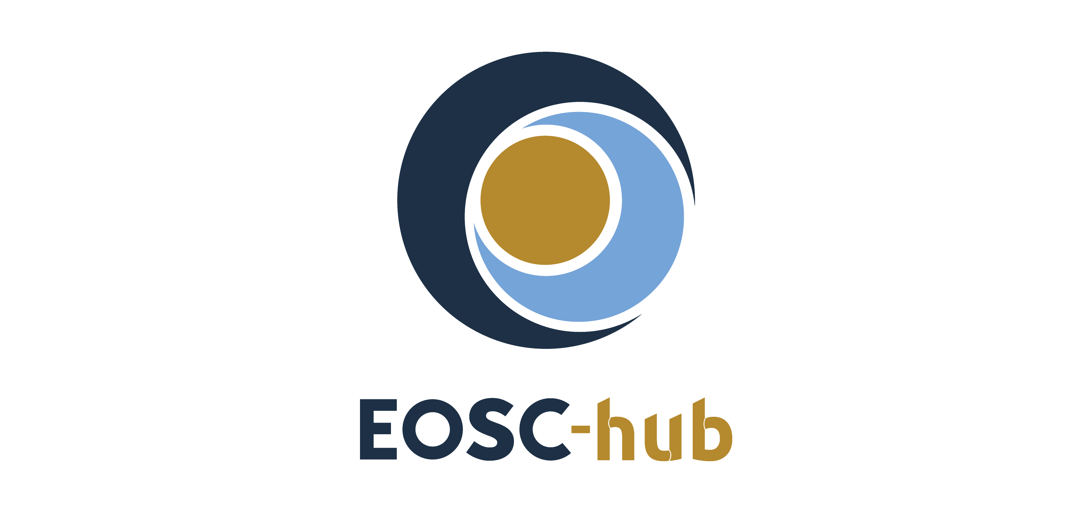

D11.4 Report on training activities, infrastructure and material
Lead Partner: | EGI Foundation
Version: | 1
Status: | FINAL
Dissemination Level: | Public
Document Link: | https://documents.egi.eu/document/3557

Deliverable Abstract
This document provides a second training activity report for WP11. It also includes a short report about the training contents developed by the different stakeholders involved in the project, and the status of the resources and technical services that were provided for supporting the organization and the delivery of training activities. With the entering in the second part of the project, and the progressively integration of the domain-scientific platforms and pilots in the EOSC ecosystem, WP11 will play an important role to improve skills and knowledge among researchers and service operators by delivering specialised training events. The strategy adopted WP11 to intensify the organization and delivery of training activities to support the research needs of the stakeholders involved in the project will be also presented as outlook in the plans.

COPYRIGHT NOTICE
This work by Parties of the EOSC-hub Consortium is licensed under a Creative Commons Attribution 4.0 International License (http://creativecommons.org/licenses/by/4.0/). The EOSC-hub project is co-funded by the European Union Horizon 2020 programme under grant number 777536.
DELIVERY SLIP
Date | Name | Partner/Activity | Date
From: | Giuseppe La Rocca,  Yin Chen | EGI Foundation / WP11 | 9.01.2020
Moderated by: | Małgorzata Krakowian | EGI Foundation
Reviewed by: | Anabela Oliveira,  Shaun de Witt | LNEC  UKAEA
Approved by: | AMB

DOCUMENT LOG
Issue | Date | Comment | Author
v0.1 | 24.10.2019 | Initial ToC | Giuseppe La Rocca/EGI Foundation
v0.2 | 27.11.2019 | Additional contributions added | Giuseppe La Rocca/EGI Foundation,  Yin Chen/EGI Foundation,  René van Horik/DANS-KNAW  Sy Holsinger/EGI Foundation
V1 | 09.01.2020 | Integrate feedback from reviewers | Giuseppe La Rocca,  Yin Chen/EGI Foundation

TERMINOLOGY
https://wiki.eosc-hub.eu/display/EOSC/EOSC-hub+Glossary

Contents
1 Introduction 5
2 The training strategy adopted in EOSC-Hub 6
2.1 Training activities in EOSC-hub 7
3 Status of the training infrastructure 19
4 Training materials available in EOSC-Hub 21
4.1 Services for Supporting FAIR principles 21
4.2 Training contents developed by the Thematic Platforms 21
4.3 Training contents about Common and Federated Services 23
4.4 IT Service Management System training contents 24
4.5 IT Security Forensics training contents 24
4.6 Training materials developed by the Competence Centres 25
5 Recommendations 26
6 Conclusions and plans 27
7 APPENDIX I - TRAINING EVENTS 29

Executive summary
This document reports on the status of the training activities coordinated by WP11 during the reporting period. This report also contains a list of training contents developed by the different stakeholders involved in the project and made available through the EOSC-hub training registry. An update about the status of the training infrastructure, with a list of the resources offered for supporting training activities, is also provided.
In the context of the EOSC-hub project, WP11 aims to provide a “knowledge hub”, composed by experts and service providers at local and national levels. Overall, the aim of this “knowledge network” of experts is to raise awareness about the available resources and services developed by the project and help researchers from all disciplines to have easy, integrated and open access to the advanced digital services, scientific instruments data, to achieve excellence in science, research and innovation. From a technical perspective this distributed team will be created involving experts within and from outside the consortium to deliver specialized training and technical support in different areas spanning from: common and other federated services, research data management, federated service management, to domain-specific training events for data providers and data scientists (e.g.: bioinformatics, marine, radio astronomy, seismology, language, earth observation, structural biology, coastal analysis, climate, high-energy physics, arts and humanities).
After the first part of the project, most of the selected Thematic Services completed the integration of their domain-scientific platforms in the EOSC ecosystem and, in collaboration with WP11, they started to deliver specific training events to target their end-users and increase the user base. Few of them reported minor organizational issues and delays in recruiting internal staff to work in the project and, consequently, training activities were postponed in the second half of the project. A report about the specialized training events delivered, and the new training contents developed by the most active Thematic Services is presented in this second summary report. According to the DoA, most of the selected Competence Centres completed their piloting activities during the first part of the project and few of them will be registered in the EOSC Portal Marketplace as Thematic Services. Training activities from the involved Competence Centres will intensify during the second half of the project.

Introduction
WP11 designed and delivered a sound training programme to stimulate the establishment of a distributed knowledge network of experts aimed at promoting the adoption of services published in the EOSC-hub service catalogue and facilitate their adoption. Training courses covered topics like IT Security Forensics, Cloud computing, Data platforms for data processing and solutions for publishing and archiving scientific data, EOSC AAI solutions, PaaS solutions, applications on demand platform and domain specific training events. The training programme also aimed to enhance the capability to make research data FAIR (Findable, Accessible, Interoperable, Reusable) by creating data management plans.
This document is a report about the training activities to sustain the needs of the different stakeholders involved in the project.
The present document is organized in 5 different sections.
- Section 2 provides background information about the training strategy and activities delivered by WP11 during the reporting period. The full list of training events is reported in Appendix I.
- Section 3 reports on the status of the training infrastructure and the resources allocated to facilitate the organization and the delivery of training events.
- Section 4 provides an initial list of training contents developed by WP11 in collaboration with other members involved in the project (WP5, WP6, WP7 and WP8). All the training contents are publicly available and can be downloaded from the EOSC-hub Training Registry.
- Section 5 outlines the recommendations collected during the implementation of the training plan.
- Finally, session 6 draws some conclusions and provides an outlook to plans.

The training strategy adopted in EOSC-Hub
To define and coordinate the annual training plans and support research activities of the communities involved in the EOSC-hub project, WP11 relied on the collaboration with other WPs involved in the project (see Fig.1).

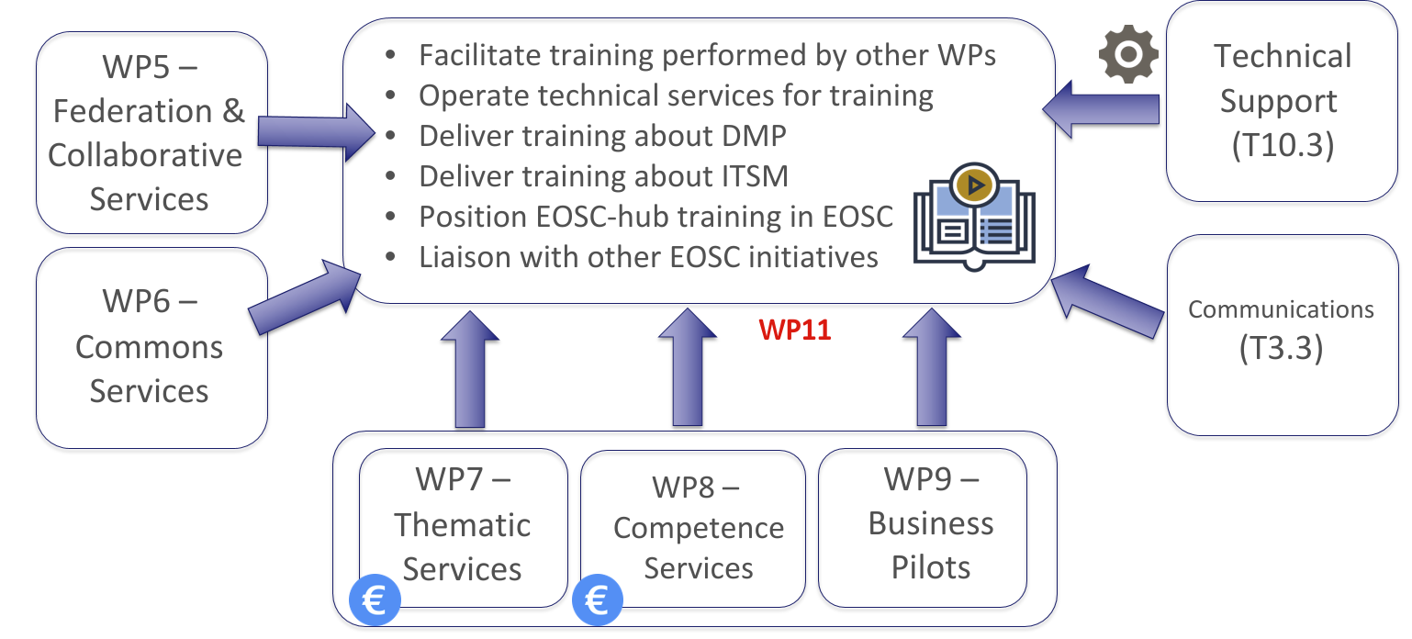
Fig. 1. Interaction between WP11 and other EOSC-hub WPs
From WP7, WP8 and WP9 WP11 collects the training needs that, every year, will feed into the annual training plan. WP7 and WP8 members are officially involved in WP11 activities. To provide a sound training programme WP7 and WP8 members are officially involved in WP11 activities. The budget (quantified in few PMs) allocated to the EOSC-hub Thematic Services (WP7) and Competence Centres (WP8) is used to support the organisation and the delivery of specialized domain-specific training activities and create new training modules. For this reason, WP7 and WP8 members received a budget for helping WP11 to deliver specialized training events and create new contents.
For other members not directly involved in WP11, such as WP5 and WP6, a dedicated budget was allocated to cover travel costs of external trainers and contribute to the WP11 training activities. The procedure to support the travel costs of trainers of WP5 and WP6 members is documented in the PROC07. From a technical perspective, WP5 experts provide support to enable the use of federated identities to authenticate and authorise users, while WP6 experts contribute developing documentation and providing support about the common services of the catalogue that will support the entire research lifecycle. If necessary, additional support can also be provided by WP10.3 to produce documentation about new services, or new features, to address new customer’s requirements. Lastly, WP11 will also rely on the technical support provided by WP3.3 to promote the organization of training events and disseminate results coming from WP11 activities.

To raise awareness about the available services and resources offered to researchers from all disciplines to have easy, integrated and open access to the advanced digital services, scientific instruments and data, WP11 adopted the training strategy described in Fig. 2.

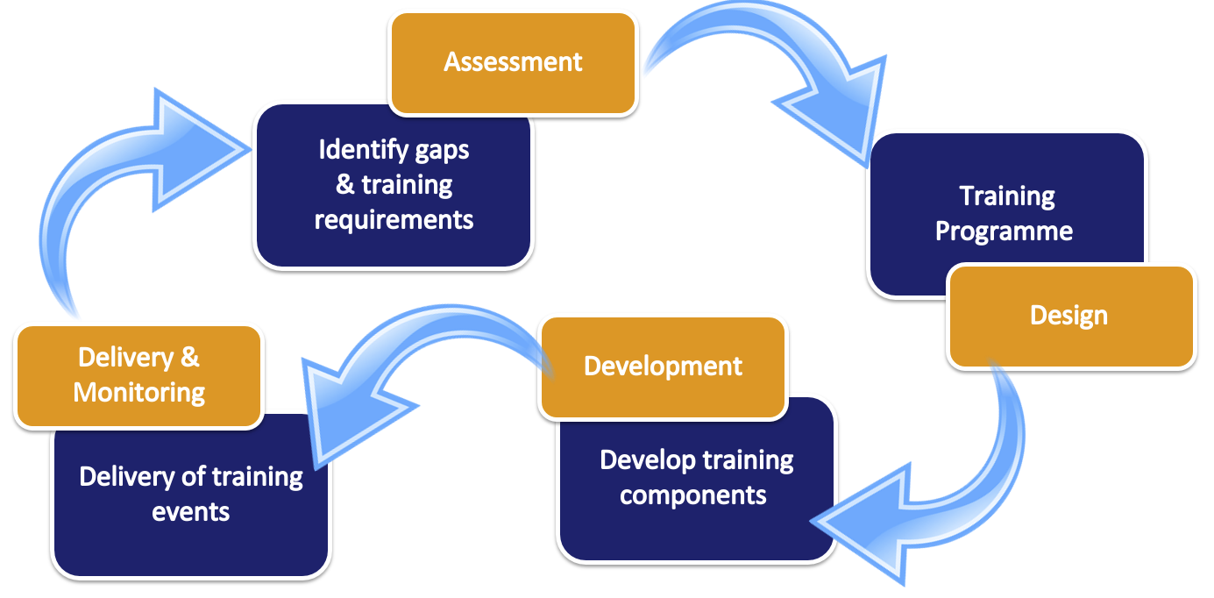
Fig. 2. Training strategy adopted in EOSC-hub

The training strategy starts collecting training needs from the selected Thematic Services, Competence Centres and Business pilots involved in the project. The assessment of all these requirements will feed into the design of the annual training programme that will be coordinated by WP11. This is a live document that can be updated anytime according to the new requirements coming from the stakeholders.
The design of the annual training programme will trigger, if necessary, the development of training contents to be used. For this WP11 will rely on the technical support of WP5 and WP6. In order to continuously improve the training delivery, WP11 will also collect feedback to identify possible follow-up to monitor the training offered.

Training activities in EOSC-hub
To stimulate the establishment of a “knowledge hub” of experts and raise awareness about the available services and resources, the training programme delivered by WP11 covers the following 5 main areas:
- Training on Data Management Planning (DMP);
- IT Federated Service Management training events to learn the fundamentals of IT Service Management processes;
- Training contents about Common and Federated services for supporting scientific activities of Thematic Services (TSs), Competence Centres (CCs) and research communities;
- IT Security Forensics training;
- Domain-specific training for data providers and data scientists.
More details about the training activities delivered in each of these 5 areas are reported in the next sections.

Training activities on Data Management Planning
EU projects financed by the Horizon 2020 Work Programme are required to develop a Data Management Plan (DMP). From a technical perspective, a DMP describes the data management life cycle for the data to be collected, processed and/or generated by the project. As part of making research data findable, accessible, interoperable and re-usable (FAIR), a DMP should include information on:
- the handling of research data during and after the end of the project,
- what data will be collected, processed and/or generated,
- which methodology and standards will be applied,
- whether data will be shared/made open access, and
- how data will be curated and preserved (including after the end of the project).
The activities in relation to research data management, initiated by T11.2, are aimed at “advocacy, guidance and disciplinary support for researchers and support staff” (as stated in the DoW). During the reporting period, the activities were mainly aimed at explaining the rationale for the creation of DMPs and pointing at tools to facilitate the development of proper DMPs (e.g. by providing training at the EOSC-hub week targeted at Competence Centers, Thematic Services and other initiatives in the EOSC-hub project). Currently 8 Competence Centers active in WP8 of the EOSC-hub project have created (and updated) DMPs for the research data sets they have generated or collected.
Next to the training available for all stakeholders in EOSC-hub, a couple of “on demand” events were held in which, for a specific target group or organisation, background information on DMPs was given as well as practical guidance on how to create DMPs. Three “on demand” training events were: (1) a training on DMP as part of the PRACE days aimed at management of HPC data, (2) a training on DMP for high volume data provided by the supercomputer centre in Barcelona, and (2) a training on the use of EUDAT services as part of a DMP instructions for data supporters in Denmark and a workshop as part of the “grant-week” of the Royal Netherlands Academy of Sciences.
Overall, the feedback on the training from the participants of these training sessions was positive. In the feedback forms most participants rated the events as “good” or higher. Another observation is that familiarity with RDM is wide ranging within the group of participants. Often some people are already familiar with RDM while others get introduced for the first time. During the preparation of the training event we tried to anticipate the expected familiarity with the topic.

For the second half of the project, the T11.2 strategy is to organize joint events with other EOSC-related projects such as: OpenAIRE-Advance (aimed at open science), FREYA (aimed at supporting persistent identifiers), RDA Europe (aimed at promoting the activities and outcomes of the RDA in Europe) and FAIRsFAIR (aimed at promoting FAIR data, services and training). As part of the Collaboration Agreement with the OpenAIRE-Advance project, EOSC-hub contributed to the organization of a total of 18 training events on Data Management Planning and the publication of the story “How to make your data Open and FAIR" in the 2nd issue of the EOSC-hub magazine. By the time of writing this report, the Collaboration Agreement with the FAIRsFAIR project is in preparation. To date, more than 700 participants attended training events jointly organized by EOSC-hub and OpenAIRE-Advance.
Based on the feedback of the training events organized so far, and the evaluation of the EOSC landscape, T11.2 intends to focus future training events on domain protocols for DMPs (also called “Data Domain Protocols” (DDP). Science Europe has taken the initiative for the international alignment of research data management (RDM) policies among research funding organisations in Europe. In a nutshell, the aim of the initiative was to develop a set of core requirements for DMPs as well as a list of criteria for the selection of trustworthy repositories where researchers can store their data for sharing. The background and value of DDPs is communicated at a couple of occasions, such as the RDA plenary (WG on RDM) in October 2019 in Helsinki and the EOSC-symposium in Budapest in November 2019.
The core requirements for Data Management Plans address all scientific disciplines in general terms. By creating generic, or “blueprint” DMPs, for a domain discipline or community, the process of DMP writing for researchers, and the evaluation of research proposals by research funders, can be simplified. Such DDPs for Social Sciences, Art and Humanities, Life Sciences, etc. share for each domain similar data collection and processing methods and can serve as a norm for individual researchers. The idea is that if a researcher complies with the norms and standards of his or her field, only deviations need to be explained or refinements to be added to the individual researcher’s DMP. A DMP template, based on the core requirements, has been developed that can be used to create domain protocols.
The main advocacy activities organized by T11.2 were workshops and meetings with the purpose to explore how existing infrastructures can work together and understand how to deliver services that support the creation of FAIR research outputs. A tangible result of these activities in 2019 is the white paper “Recommendations for Services in a FAIR data ecosystem”, a common result of EOSC-hub, OpenAIRE, FREYA, RDA Europe and FAIRsFAIR. This joint collaboration will continue also during the second part of the project.

To conclude, it can be observed that the role and relevance of a DMP is increasingly acknowledged by the international research community. Tools are available to create DMPs and data management planning is an important component of the Open Science paradigm to create FAIR data. Webinars and other events were organised around the Open Science paradigm and EOSC-hub intends to contribute to these focussing on DMPs, with an emphasis on domain protocols for data management. Additional events will be organized in the second half of the project.
The number of training events organized and delivered by T11.2 is monitored by the project
specific metric M11.2:
MetricID | Definition | Baseline | Value M06 | Value M12 | Value M24 | Target PY2
M11.2 | Number of DMP events  organized | 0 | 5 | 9 | 18 | 5
Table 1 - WP11 metric for T11.2

The full list of DMP training, advocacy and support events jointly organized by EOSC-hub and the OpenAIRE-Advance projects are reported in Appendix I.

IT Federated Service Management training activities
One of the main objectives of the project is to develop and operate a Service Management System (SMS) for EOSC. To ensure that there was a clear understanding of all the IT Service Management (ITSM) concepts, terminology and activities to be/being carried out to plan, deliver, operate and control all EOSC-hub services, WP11 focuses on the preparation, and delivery, of FitSM training events to all EOSC-hub project partners and collaborators. FitSM is a freely available and lightweight standard aimed at enabling effective IT service management in the broadest range of organisations.
The FitSM training and certification scheme is composed of three different levels: Foundation, Advanced and Expert courses as described in Fig. 3.

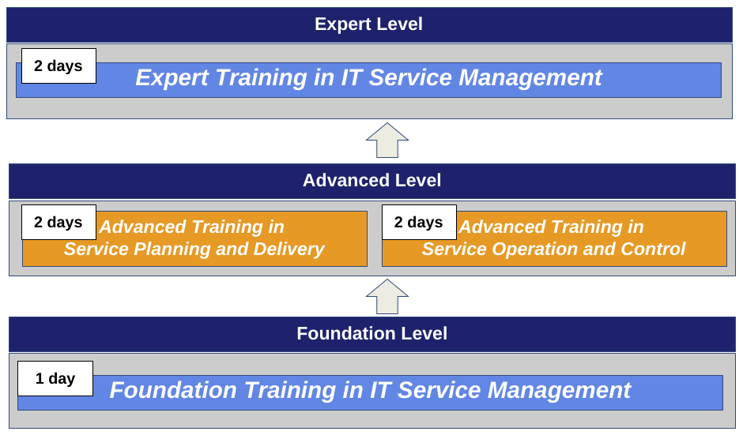
Fig. 3. FitSM training and certification scheme in EOSC-hub

During the first part of the project, WP11 focused more on the organization of Foundation level courses to train as many task leaders and WP coordinators as possible. Most of these events were co-located at major events. During the 1-day Foundation level courses, project members were introduced to IT Service Management, the FitSM approach with its 14-process model and 85 requirements as well as other standards and frameworks on the market. Starting in June 2019, WP11 extended its offer organising 2 Advanced level courses (Service Planning and Delivery; Service Operation and Control) for those who had completed the Foundation courses.
During the Advanced courses, the initial 14 FitSM processes were provided in more detail, extended into how to set up and manage the individual processes as well as how to monitor and evaluate the implementation success and identify areas of improvement. The 8 most strategic processes were introduced during the Service Planning and Delivery (SPD) advanced course, while the 6 more operational ones were presented in the Service Operation and Control (SOC) advanced courses. Another round of advanced courses was organized by WP11 in November 2019. Additional advanced courses will be organized in the first half of 2020.
Those completing both advanced level courses are eligible for the Expert level course. The plan is to organize at least 1 Expert level course before the end of the project. In the 2-day Expert level course, participants will be given more details in the different standards and frameworks, particular emphasis on methods and real-world examples of implementation and improvement of ITSM and look at common problems such as process interfaces and the challenges of organisational change.
To support FitSM training events and trainer costs for other training related events, WP11 was allocated a dedicated budget of 25K€, of which the majority was earmarked to support the organization of the targeted 15 FitSM training courses. This includes the costs of the FitSM certification exams charged by the third-party certification authorities (ICO-Cert and APMG) as well as logistical costs (e.g. room, catering).
During the reporting period (PM1-24), WP11 organized a total of 16 FitSM related training events of which:
- 8 Foundation level certificates (1 course partially supported by the EOSCpilot project)
- 4 Advanced level (2 SPD + 2 SOC)
- 4 Webinars (2 for EOSC-hub task leaders; 2 for external communities)
Total participants trained to date are 151 with 139 successfully receiving FitSM certification. 10 of the 13 WP Managers and more than half of the attendees were task leaders.
The breakdown of the budget, after the organization of 13 physically attended events receiving financial support (excluding webinars), is reported in Table 2.
 | Total  Budget | Consumed Budget | Remaining Budget | # of Events Supported
Trainer Travel | €5,750 | €1,000 | €4,750 | 1
FitSM Certifications | €20,000 | €17,658 | €2,342 | 12
Total Budget | €25,750 | €18,658 | €7,092 | 13

Table 2. Training support budget after the second reporting period

Over the first two years of the project, training activities focused on the spreading of all the IT Service Management (ITSM) concepts, terminology and activities to operate and control all EOSC-hub services. These training activities contributed to the design and implementation of the EOSC-hub Service Management System whose initial maturity was assessed during the first internal audit which took place in March 2019 with a second audit scheduled for the first half of 2020. Second half training courses have been expanded to include participants from the EOSC related projects that have recently started (i.e. EOSC-Nordic, EOSC-Synergy). Discussions are ongoing for running courses in 2020 (i.e. Advanced, Expert, EOSC-hub week, NI4OS).
The majority of training courses have been full based on the recommended size of ~15 participants per course but have had several exceptions with some courses ranging between 17 and 21 participants. Co-location of Foundation courses with major EOSC related meetings and conferences has been strategic in not only increasing participation, but in reducing costs and ensuring the right audience as well.
The number of FitSM training events organized and delivered by T11.3 is monitored by the project specific metric M11.3:

MetricID | Definition | Baseline | Value M06 | Value M12 | Value M24 | Target PY2
M11.3 | Number of FitSM training events delivered during the project | 0 | 7 | 8 | 16 | 14
Table 3 - WP11 metric for T11.3

The full list of IT Federated Service Management training events organized by WP11 is reported in Appendix I.

Training activities about Common and Federated services
EOSC-hub services were classified in the following categories:
- Common services (baseline) of the catalogue will support the entire research data lifecycle from creation to processing, analysis, preservation, access and reuse. These services include the HTC, cloud compute, storage, data management and other specialised services from local, regional and national digital infrastructure in Europe.
- Federated services allow the use of federated identities to authenticate and authorise users and support the operations and the management of EOSC services.
- Collaborative services will enable the research community to discover and share research objects like scientific applications, pipeline and virtual appliances, which provide research environments with integrated data, software and processing resources.
In task T11.4, different training events were organized by WP11 for helping, respectively, the Thematic Services to vertically integrate with the EOSC common components, and the Competence Centres to integrate the generic services (aka "EOSC-hub common services") available in the EOSC-hub service catalogue to run proof-of-concepts and develop new pilot services. These activities contributed to facilitate the co-design and co-develop of new services for the targeted scientific communities. Training requirements from TSs and CCs were collected in collaboration with WP7 and WP8 coordinators.
During the first part of the project, most of the TSs and CCs raised the interest to integrate the federated authentication AAI, interact with the cloud compute and data infrastructures, and use advanced solutions to orchestrate the provisioning of resources. In regard to this need, WP11 organized meetings with the experts of the following different areas: AAI, Cloud Compute, Storage and PaaS Orchestrator. In terms of participation, the events best attended were the ones where the technical aspects to integrate the different AAI solutions proposed by EOSC-hub were introduced.
The overall goals of these meetings were twofold:
- invite technical experts of the different areas to introduce the solution provided by the project, and
- prepare, in collaboration with WP10 technical support, a technical roadmap for helping research communities to integrate EOSC core services with the different platforms and service pilots.
To monitor the implementation of the agreed roadmaps, periodic meetings were organized by WP7 and WP8 leaders. Additional events to report updates on these areas were co-located during important project events. Among them, during the 2nd. EOSC-hub week, held in Prague, a full day training was organized by WP11 on the following topics:
- AAI: service providers interested to be federated in EOSC received an update about the status of the EOSC AAI and its roadmap. A recent update about the status of the EOSC-hub AAI framework was also provided during one of the last WP8 task leaders meeting.
- Orchestration: an overview about the solutions implemented both at the level of IaaS, PaaS and SaaS within the projects: INDIGO-DataCloud, eXtreme DataCloud (XDC) and DEEP-HybridDataCloud was provided.
- Data platforms: researchers received updates about the solutions offered by the project for data processing, publishing and archiving of scientific data following the FAIR principles.
Additional requests, collected during the reporting period, concern the need to make any research outcomes (including publications, data, physical samples, and software) publicly accessible in digital format with no or minimal restriction. To facilitate the uptake of the Open Science principles, WP11 promoted the use of new collaborative solutions such as: the Jupyter Notebooks (a web-based interactive computational environment for creating Jupyter notebook documents), GitHub and Zenodo (for the sharing of the work), Digital Object Identifiers (DOIs) and Binder (for reproducibility) in different events (see Fig.4).

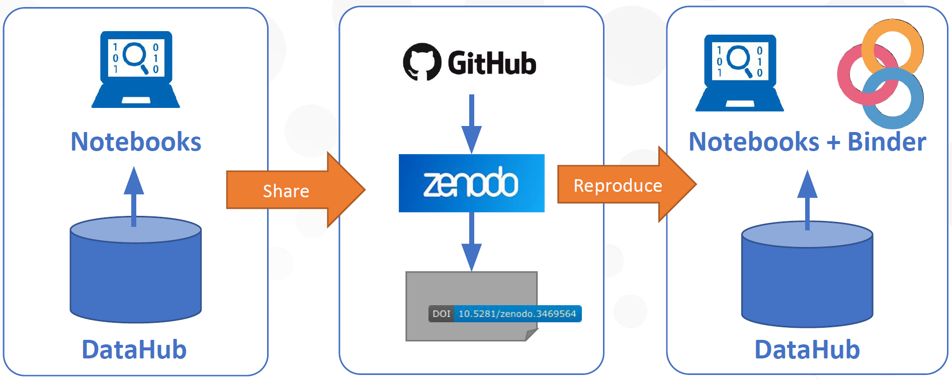
Fig. 4 - Reproducible and discoverable analysis with EOSC services

Training materials and hands-on sessions contributed to demonstrate how data scientists can extend the principles of openness to the whole research cycle entailing a systemic change to the way science and research is done. Additional events on this topic will also be organized during the second part of the project.
Particular attention was also dedicated to support the day-by-day work of a small group of researchers not involved in long-running collaborations. To facilitate access to cloud computing platforms a webinar was organized, in collaboration with the Polytechnic University of Valencia (UPV), to introduce the Elastic Cloud Computing Cluster (EC3) framework for helping researchers to automatically deploy virtual clusters over multi-clouds. The recent integration of the EC3 framework with the HNSciCloud vouchers to access commercial cloud providers provided by Exoscale allows users to boost the execution of long-running jobs that normally take months to complete can be accomplished in a matter of days. This allows researchers to get results much quicker and to increase the amount of information gained by the analyses (see Fig. 5).

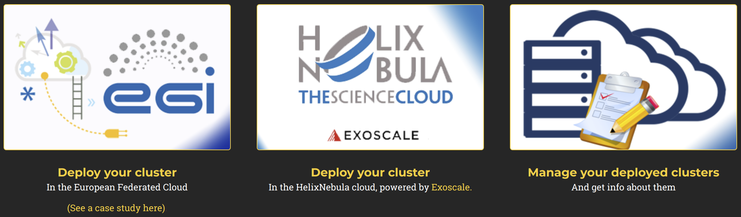
Fig. 5 - Deployment of a virtual cluster with the EC3 portal
Different training events were organized during the reporting period for helping, respectively, the Thematic Services to vertically integrate with the EOSC common components, and the Competence Centres to integrate the generic services (aka "EOSC-hub common services") available in the EOSC-hub service catalogue to run proof-of-concepts and develop new pilot services. These activities contributed to facilitate the co-design and co-develop of new services for the targeted scientific communities. In terms of participation, obviously, the events best attended were the ones where the technical aspects to integrate the different AAI solutions proposed by EOSC-hub were introduced. By the time of writing this report, the interoperability with the three different AAI solutions provided by the project is still an open issue. For this reason, additional updates related to the AAI topic will be provided during the third year of the project.

Training events on Common and Federated services | # Participants
22 events organized | 420 participants were trained
Table 4 - Events and participants

The number of training events on common and federated services organized and delivered by T11.4 is monitored by the project specific metric M11.4 (see next section). The full list of training on Common and Federated services organized by WP11 is reported in Appendix I.

IT Security Forensics training activities
In total, WP11 organized 4 IT Security Forensics training events. During these events participants received an introduction on the basic forensics’ techniques needed to successfully respond to the simulated attacks. The intended audience for these events included: system administrators, security contacts and service providers who operate services for Open Science. To date, more than 100 participants attended the IT Security Forensics training events organized by WP11 in collaboration with WP4.4.

The number of training events on common, security forensics and federated services organized and delivered by T11.4 is monitored by the project specific metric M11.4:

MetricID | Definition | Baseline | Value M06 | Value M12 | Value M24 | Target PY2
M11.4 | Number of training events on common, security forensics and  Federated services | 0 | 4 | 13 | 20 | 20
Table 5 - WP11 metric for T11.4

The full list of IT Security Forensics training events organized by WP11 is reported in Appendix I.

Domain-specific training activities for data providers and data scientists
One of the main objectives of WP11 is to deliver training events in different areas including: domain-specific training events for: bioinformatics, marine, radio astronomy, seismology, language, earth observation, structural biology, coastal analysis, climate, high-energy physics, arts and humanities). With the progressive integration of the EOSC-hub services in the thematic platforms and pilots, WP11, in collaboration with the selected Thematic Services (TSs) started to organize specialised training events to facilitate the promotion and the uptake of new core data resources with the aim to reach a wider user base. During the reporting period, most of the Thematic Services involved in WP7 reached a high level of maturity by enabling federated authentication mechanisms for their end-users and used resources and services from different infrastructures to promote the Open Science principles.
Below is a summary of the training accomplished in the 1st year:
- DODAS organized the 2nd International PhD School on Open Science Cloud and the International Schools on Open Science Cloud. The DODAS framework was also introduced during the Virgo Winter School of Computing and during the EGI Conference 2019. Before the end of this reporting period INFN will also organize a DODAS hack-fest for helping user communities to integrate new scientific use cases through the adoption of the DODAS thematic service.
- 6 specialized training events on the ENES Climate Analytics Service were organized by ECAS (DKRZ, CCMC) during the period. The target audience of these events were researchers interested in using ECAS for data analysis.
- For the Coastal Science community, LNEC, LIP, UNICAN and CNRS-UR organized 4 training events and a video tutorial to demonstrate how the OPENCoastS service can be used to create coastal forecast systems. During these training events it was introduced OPENCoastS, an innovative and free platform to generate forecast systems on demand based on the use of a coastal modelling suite that uses triangular elements grids. A total of 145 participants from 14 different countries attended the training events. The detailed presentation of the OPENCoastS service was accepted for publication in the Environmental Modelling & Software journal last October.
- WeNMR organized 10 training events for structural biology researchers and to introduce the WeNMR services. One additional event was organized to target the INSTRUCT community.
- ELIXIR organized 2 training events on AAI for their users.
- CLARIN co-organised the IEEE Workshop on Big Data Governance and Metadata and Management (2018) and produced a docker container for the CLARIN metadata hackathon.
- ICOS organized training activities for the ICOS Ecosystem Thematic Centres.
- EISCAT_3D prepared training materials for the EISCAT data portal developed in the Competence Center and organized the International EISCAT Radar School.
- EPOS-ORFEUS introduced the new AAI framework for European Integrated Data Archive infrastructure (EIDA) developed by the Competence Centres during the EGU 2019 conference. An internal training, to introduce the latest functionalities of the DMPilot-RuleManager framework to data centres operators at KNMI, was also organized.
- Radio-Astronomy training activities focused on the raising of awareness about EOSC, EOSC infrastructure, and RACC service development among the LOFAR user community, and the training of developers of LOFAR processing software. A total of 4 events were organized by the Competence Centre during the reporting period.
- Disaster Mitigation CC organized a series of master classes and a total of 8 events to introduce the DMCC+ simulation facilities.
In conclusion, a total of 38 domain-specific training events were organized during the reporting period. Additionally, 7 more events were organized to support external communities such as: CODATA-RDA, CORBEL, ENVRIplus, INSTRUCT, NGSchool, VIRGO and advanced courses for PhD students at universities. To date, more than 870 participants attended domain-specific training events.
Overall, the training events organized by ECAS, OPENCoastS and WeNMR were the most attended by users. The training programmes developed by these thematic platforms contributed to increase the knowledge on topics of relevance for the target communities. The sharing of knowledge within these communities also contributed to the increase in the number of new users accessing and using the thematic platforms developed during the project. During the second part of the project, inter-thematic-service collaboration to build new integrated scenarios or support new scientific communities will also be explored by ECAS and OPENCoastS. In terms of support to new scientific communities, DODAS is already collaborating with the Virgo community.
The full list of domain-specific training for data providers and data scientists organized by WP11 is reported in Appendix I.

Status of the training infrastructure
To facilitate the organization and the delivery of specialised training events for improving skills and knowledge among researchers and service operators, an initial set of resources, tools and services were provided by WP11.

The current status of the training resources allocated for supporting training activities include:
- A cloud-based infrastructure provided by EGI. In order to guarantee high-quality services offered to end-users, EGI agreed on an Operational Level Agreements (OLAs) with 5 cloud providers of the EGI Federation. Based on this agreement the cloud providers are offering resources for operating a cloud-based training infrastructure. This cloud-based infrastructure was also used to organize training events to target the need of communities outside the project (e.g. ENVRIplus, CODATA-RDA, NGSchool and some universities courses for PhD students).
- A B2SHARE instance for supporting training activities was also provided. More resources will be allocated depending on users' needs.

Additional services and tools provided by WP11 also include:
- A document template to collect feedback from participants to EOSC-hub training events. Online versions of this template based on SurveyMonkey or GoogleForm are also available.
- A document template to report the main training outcomes, and open issues to the WP11 coordinator.
- 2 GoToMeetings virtual rooms, each allowing 50 simultaneous connections, and 1 AdobeConnect virtual room for max. 200 participants.
- An indico agenda to register new events.
- A Cloud Marketplace with a list of virtual appliances and software repositories pre-configured for training events.
- A calendar of training events and material.
- User guides on how to register a new event and upload training material in the EOSC-hub registry.

If necessary, additional resources, services and tools will be allocated to cope with the demanding needs of the involved communities.

Training materials available in EOSC-Hub
WP11 set up an EOSC online training registry where members of the project can publish training events and upload training materials. The registry is also available for external users, scientific communities and other EOSC related projects (e.g. FREYA). All the training material published in this training registry will contribute to improve skills and knowledge among scientific researchers and service operators.
Several EOSC-hub project members already started to populate the training registry uploading new training materials (e.g.: Docker containers, Jupyter notebooks, user’s documentation, videos, etc.) to support the research activities of the communities involved in the project. This training registry also contains documentation about the Commons and Federated services collected in collaboration with WP5 and WP6, modules used during the organization of IT Security Forensics, IT Service Management Systems training events, and documentation to enhance the capability to make research data FAIR by creating data management plans.
The full list of training materials developed by the different stakeholders are reported in the next sections.

Services for Supporting FAIR principles
In response to the increasing need of research communities to perform data analysis experiments on large volume of data, and produce reusable results following FAIR principles, WP11 also organized training events to demonstrate how EOSC-hub services can be used to meet the data management requirements of research communities, manage and preserve their research data and be compliant with the FAIR principles. In regard to this topic, we report the webinar organized to demonstrate how scientific communities can use the EOSC services for managing active research data (i.e. data transfer, storage, and sharing) and for preserving final research data (i.e. data archiving and publishing). During the webinar, a brief overview of the EUDAT Services and the data life cycle was also given.

Training contents developed by the Thematic Platforms

CLARIN
Overall, the CLARIN Thematic Service makes digital language resources available to scholars, researchers, students and citizen-scientists from all disciplines, especially in the humanities and social sciences. During the reporting period the T7.1 organized a metadata hackathon during the IEEE Workshop on Big Data Governance and Metadata and Management (BDGMM 2018). For the event a Docker container that allowed users to quickly set up a private instance of the Virtual Language Observatory (VLO) and to import some datasets into it was prepared. The Docker container configuration is available in the training registry.

DODAS
In the context of the T7.2 were produced training materials to introduce DODAS - the platform to automate the process of provisioning, creating, managing and accessing a pool of heterogeneous computing and storage resources - during the SOSC18 school, and the Virgo School of Computing. Additional training materials were also produced for the third International School on Open Science School (SOSC 2019).

ECAS
During the reporting period the CMCC and DKRZ has set up a GitHub project to store all the developments, workflows, notebooks, and training material related to the ENES Climate Analytics Service. These Jupyter notebooks were used during the 7 training events organized by the T7.3.

GEOSS
The GEO Discovery and Access Broker (GEO DAB) is a key component of the GEOSS platform, developed by EOSC-hub task T7.4. GEO DAB is a brokering framework that interconnects hundreds of heterogeneous and autonomous supply systems (the enterprise systems constituting the GEO metasystem) by providing mediation, harmonization, transformation, and QoS capabilities. Documentation on GEO DAB was provided and is available in the training material section of EOSC-hub website.

OPENCoastS
During the reporting period, this Thematic Service developed a video tutorial to showcase how to use the service to create coastal forecast systems. Additional training materials, including the OPENCoastS user manual and all slides from the training events, were produced and made available to the attendees for the 4 international training events. During these events the main advantage of using the forecast service, with e-Infrastructures and core services, to support user-oriented engineering platforms to address coastal research and management needs was presented. All these training materials are available in the training registry.

WeNMR
During the reporting period, several training contents were developed by T7.6 for demonstrating the use of the WeNMR portals and train PhD students and post-doctoral fellows in the use of advanced computational methods for the investigation of metal-binding biological systems. In addition, to demonstrate the use of DISVIS, POWERFIT and HADDOCK web servers for predicting the structure of a large biomolecular assembly from cross-linking data and low resolution cryo-EM data T7.6 created dedicated training materials. These materials were used in all the training events organized during the reporting period.

EO Pillar
Training and dissemination activities for T7.7 will start during the second half of the project. During the first part of the project T7.7 focused on the integration of GEP High-Resolution Change Monitoring for the Alpine Region and GEP EO Services for Earthquake Response and Landslides Analysis services in the EOSC Portal Marketplace. In addition, an online training tutorial to use both services was also produced by Terradue.

DARIAH
During the reporting period the Thematic Service was mostly involved with the integration with EOSC services. For this reason, dissemination and training activities for T7.8 will start during the second half of the project.

LifeWatch
This Thematic Service experienced some delay in recruiting staff working on the project. According to the new work-plan, project activities will start from M19 to M36.

Training contents about Common and Federated Services
A total of 21 technical materials and documentations about the available common and federated services made available by the project for supporting scientific activities of TS, CCs and research communities (T11.4), and domain-specific training for data providers and data scientists (T11.5) are published in the EOSC-hub training registry.
This also includes the documentation and a video, developed in collaboration with WP6, to enable transparent data access between the EGI and the EUDAT infrastructures. The main data management components adopted by the two infrastructures are respectively: EGI-DataHub based on Onedata platform for EGI and B2SAFE/B2STAGE based on iRODS for EUDAT.
The number of training materials collected by WP11 is monitored by the project specific metric M11.5:
MetricID | Definition | Baseline | Value M06 | Value M12 | Value M24 | Target PY2
M11.5 | Number of training materials delivered to target date providers and data scientists linked to Thematic Services and Competence Centres | 0 | 13 | 103 | 250+ | 115
Table 6 - WP11 metric for T11.5

IT Service Management System training contents
To support the implementation of a new Service Management System for EOSC-hub based on the lightweight FitSM standard, official training materials were used.

IT Security Forensics training contents
The EOSC-hub proposes a new vision to data-driven science, where researchers from all disciplines have easy, integrated and open access to the advanced digital services, scientific instruments, data, knowledge and expertise they need to collaborate to achieve excellence in science, research and innovation. From a technical perspective, since each service provider adopts different security policies and performs different activities to prevent security incidents, this requires the development of harmonized policies and procedures, to ensure consistent and coordinated security operations across all the services provided in the catalogue.
During the 4 IT Security Forensics training events organized, WP11 developed materials for system administrators, security contacts and service providers who operate services for Open Science. During these events participants received an introduction on the basic forensic techniques needed to successfully respond to the simulated attacks. More than 90 participants attended the IT Security Forensics training events. Training materials developed for supporting IT Security Forensics events are available in the EOSC-hub training registry.

Training materials developed by the Competence Centres

ELIXIR
Training materials about AAI were created by this CC for different target audiences. These training contents were created to target developers and administrators of services that wanted to integrate with the ELIXIR AAI for users' authentication and authorisation,.

Fusion
A training documentation for helping scientific communities to exploit idle cloud resources for running containerized workloads was developed by the Fusion CC.

EISCAT_3D
Training materials were also developed by the EISCAT_3D CC to support the organization of the International EISCAT Radar School. A user guide to access the DIRAC portal for EISCAT data is also available.

EPOS-ORFEUS
The Competence Centre developed a new slide-deck to outline the new Authentication and Authorization for European Integrated Data Archive Infrastructure (EIDA).

Recommendations
In order to further improve the training activities coordinated by WP11, and determine their effectiveness to reach the target objectives stated in the DoA, participants of workshops and training events were asked to provide recommendations, feedback and suggestions on different areas. As part of the training strategy described in Fig.2, the collected feedback will help trainers to focus on moving forward and further improve the training delivery of upcoming events.
By the time of writing of this report, the full list of recommendations and suggestions collected by trainers involved in EOSC-hub training activities are summarized below:
- Provide clear guidelines for helping different stakeholders to improve the awareness about the available services and resources for supporting Open Science.
- Offer training material that fulfil needs for domain-focused examples, suitable for a variety of organisations and roles concerned.
- Provide more practical examples during ITSM Foundation courses.
- Pay more attention to research data management by means of the creation and functions of data management plans (DMPs) (also in the form of “data domain protocols” that are core components of DMPs aimed at specific disciplines).
- Provide a list of criteria for the selection of trustworthy repositories where researchers can store their data for sharing.
- Provide solutions for sensitive data.
- Offer solutions for Copernicus data processing.
- Provide solutions to enable big data analytics.
- Provide more practical examples during the IT security forensics training sessions.

All these recommendations will be considered by WP11 during the organisation of future training activities.

Conclusions and plans
In this document, a report of all the training activities conducted during the reporting period, the status of the available infrastructure and the list of training materials developed and published in the EOSC-hub training registry is presented. To support the organization and the delivery of EOSC-hub training events several computing, and data providers agreed to operate a training infrastructure and allocate resources in fair share-like mode for a fixed time period. Additional resources will be allocated, upon request, depending on users' needs. Through the cloud marketplace, the cloud-based training infrastructure is configured with general-purpose and domain-specific Virtual Appliances (VAs) that participants can use during the specific lab sessions to run initial tests and start to get familiar with the solutions made available by the project. This portfolio of VAs was recently extended by the CMCC and DKRZ teams with a new big data software stack for helping scientific communities to run analytics workflows with the ECAS/Ophidia framework. During the reporting period, these training resources were successfully used to organize focused events aiming at introducing the common services proposed by the project, support the CLARIN Thematic Service metadata hackathon, promote the uptake of the Open Science principles using new collaborative solutions (e.g. Jupyter notebooks, Zenodo and Binder technology), and contribute to target the needs of external research communities. Guidelines and best practices were also provided for helping trainers involved in WP11 to create an effective training programme as well as support and advocacy events. Regarding training activities, one of the main objectives of the project was to consolidate and expand a distributed network of experts to:
- improve skills and knowledge among researchers and service operators, and
- deliver specialized training events for the communities involved in different scientific areas such as: bioinformatics, marine, radio astronomy, seismology, language, earth observation, structural biology, coastal analysis, climate, high-energy physics, arts and humanities.

During the reporting period WP11 organized and delivered a total of 92 training events spanning from: IT Service Management, Data Management Planning, IT Security Forensics, training on Commons and Federated services and an initial set of domain-specific training in collaboration with the Thematic Services involved in the project. More than 2100 participants were trained, and more than 250 training modules were published in the training registry. In terms of training materials WP11, in collaboration with other project members, collected and made available user's documentations, service manuals, jupyter notebooks, Docker containers, videos, GitHub repositories and other modules produced during the running events to target the needs of the different stakeholders. All these materials can be accessed through the EOSC-hub training registry. Following the recommendations received during the first project review, the structure of this training registry will be further enhanced next year. The available modules will be re-organized in order to improve user's experience creating and clear “learning paths” driving the interest of single researchers and scientific communities and service providers will be created.
Overall, the qualitative metrics measured during the training events were very positive. As reference, we report below the feedback from survey collected by IT Federated Service Management training activities. More than 95% of participants were very satisfied about the information provided during the training events. They found the courses very useful and they would take part in another FitSM training in the future if having the opportunity (see Figure 6 below). Specifically, the majority liked the process structure of the standard, which was complemented by active discussions as well as the quality and knowledge of the trainers, which makes the course more enjoyable.

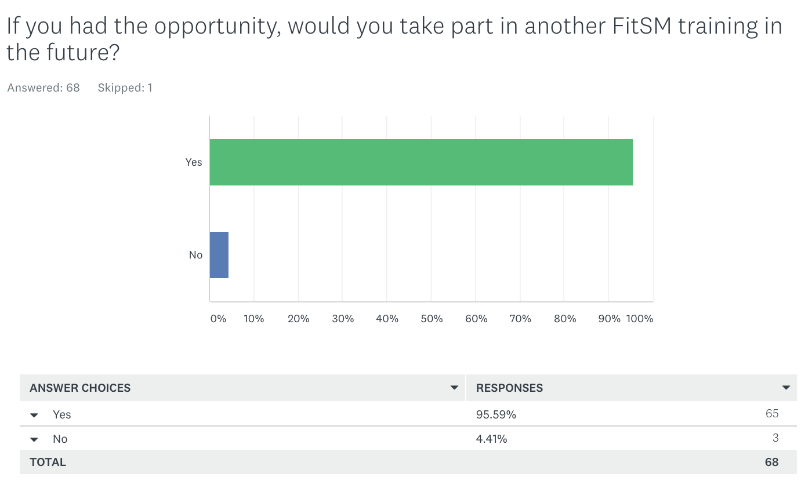
Fig. 6 - Feedback from ITSM training activities

During the third year of the project, we plan to intensify the organisation of training events on common and federated services and domain-specific training events. To contribute to the development and the operation of a Service Management System (SMS) for EOSC, additional IT Federated Service Management training courses will be organized in the first half of 2020. Those completing both advanced level courses are eligible for the Expert level course. The plan is also to organize at least 1 Expert level course before the end of the project. In the 2-day Expert level course, participants will be given more details in the different standards and frameworks, particular emphasis on methods and real-world examples of implementation and improvement of ITSM and look at common problems such as process interfaces and the challenges of organisational change.

APPENDIX I - TRAINING EVENTS
The full list of training events delivered by WP11 during the reporting period is summarized below. This list also includes additional events to support the training needs of external research communities including: CODATA-RDA, CORBEL, ENVRIplus, INSTRUCT, NGSchool, VIRGO and university courses for PhD students.

Date | Event title
8-9/01/2018 | Organization of FitSM Foundation training event during the EOSC-hub KoM
06/02/2018 | FitSM webinar for CORBEL
18-23/02/2018 | INSTRUCT training course: Advanced methods for the integration of diverse structural data, Florence IT
02/2018 | 2 individual FitSM process grouping webinars for task leaders - CONFM
19/03/2018 | Environmental Computing Workshop@ISGC2018
20/03/2018 | Towards cross infrastructure Operational Security in EOSC-hub
20/03/2018 | Lightweight Service Management for Research Infrastructures: The FitSM Approach
19-20/03/2018 | 1st. EOSC-hub Technical talk on storage solutions
28/03/2018 | Disaster Mitigation Workshop @APAN45
19/04/2018 | IEEE Workshop on Big Data Governance and Metadata and Management (BDGMM ’2018) co-organized by CLARIN
19-20/04/2018 | 1st ECAS training event: Training for scientific users on usage of the ECAS integrated service (as far as integrated at this point, cf. integration plan)
24/04/2018 | FitSM Foundation training event during the EOSC-hub week
18/04/2018 | EOSC-hub - OpenAIRE-Advance Webinar for national entities (NGIs and NOADs)
19-20/03/2018 | Training about RDM during the EOSC-week in Malaga
15/05/2018 | Webinar on how to manage your data to make them Open and FAIR (in cooperation with the OpenAIRE-Advance project)
24/05/2018 | Towards cultural change in data management- data stewardship in practice
22-23/05/2018 | FitSM Foundation Training - 22-23 May – Amsterdam (jointly organized with the EOSCpilot project)
30/05/2018 | Data Management Plan Fundamentals
04/06/2018 | How to make training FAIR
15/06/2018 | 2nd. EOSC-hub technical talk on AAI
21/06/2018 | 3rd. EOSC-hub technical talk on: Clouds, container and orchestration
25/06/2018 | 2018 UNIDATA workshop
09-13/07/2018 | International Summer School “Data Management in Environmental & Earth Science Infrastructures: Theory & Practice”
08/08/2018 | 3rd Masterclass on Disaster Mitigation @APAN46
06-17/08/2018 | CODATA-RDA Summer School 2018
17/08/2018 | Training of “EUDAT Tools” (Part of “Train-the-Trainer: Exploring tools for FAIR data”)
10/09/2018 | ELIXIR AAI Training
11-14/09/2018 | OPENCoast training event at IMUM 2018 workshop
13/09/2018 | ECAS training in 3rd ENES Workshop on Workflows funded by ESiWACE
17-21/09/2018 | Second International PhD School on Open Science Cloud
16-23/09/2018 | NGSchool 2018
24-28/09/2018 | 3rd Int'l Summer School on Data Science (SSDS 2018)
10/10/2018 | Planning early, following through: Data Management Planning in the EOSC
11/10/2018 | FitSM Foundation Training, Lisbon (DI4R co-location)
11/10/2018 | IT Security Management (ISM) in EOSC-hub: policies and global trust
23/10/2018 | EOSC-hub WP11 Train the Trainer Webinar
07-08/11/2018 | The VIRGO Winter School
06/12/2018 | Data Privacy and Sensitive Data Services
13/12/2018 | OPENCoastS e-Tutorial: from processes knowledge to on-demand circulation forecasts
12-15/02/2019 | How to apply bioinformatics to metalloproteins
20/02/2019 | Disaster Mitigation WG Meeting@APAN47
19/03/2019 | The EGI Notebooks for interactive analysis of data using EGI storage and compute services
31/03/2019 | Security Workshop at ISGC2019
31/03/2019 | Environmental Computing Workshop@ISGC2019
01-02/04/2019 | EBI Hinxton - Joint Instruct-ERIC/CAPRI Workshop on Integrated Modelling of Protein-Protein Interactions
02/04/2019 | EGI Jupyter Notebooks Tutorial @ISGC 2019
09/04/2019 | FitSM Foundation Training (EOSC-hub week)
10/04/2019 | Data Analysis made easy with the ENES Climate Analytics Service (ECAS)
12/04/2019 | Training on the EOSC-hub Data Platforms for data processing and solutions for publishing and archiving scientific data (PART I)
12/04/2019 | Training on the EOSC-hub Data Platforms for data processing and solutions for publishing and archiving scientific data (PART II)
12/04/2019 | Federation and automate deployment solutions based on the development of INDIGO-DataCloud, Deep-HybridDataCloud, eXtreme-DataCloud
12/04/2019 | Training on the EOSC-hub AAI: the service provider perspective
12/04/2019 | Services to support FAIR data (Part 1 of Workshop series)
12/04/2019 | Building the EPOS-ORFEUS Competence Center in EOSC-hub
24/04/2019 | Services to support FAIR data (Part 2 of Workshop series)
06/05/2019 | JupyterHub deployment: hands-on training
06-08/05/2019 | EPOS Seismology Meeting 2019
07/05/2019 | Service Security Challenge 2019 - Forensics and debrief at the EGI conference 2019
09/05/2019 | FitSM Foundation Training (EGI Conference 2019)
16/05/2019 | The EC3 portal in the EGI Applications on Demand service: how to create virtual elastic clusters on the EGI Federation
20-23/05/2019 | LOFAR Science 2019
21-22-24-28/05/2019 | Introduction to ECAS for Data Science and Learning
04/06/2019 | Course offered for the PhD program in Civil, Chemical and Environmental Engineering. Curriculum in Wind Science and Engineering A.Y. (2018/2019) (XXXIV cycle)
17-19/06/2019 | FitSM Advanced SPD - Service Planning and Delivery
17-20/06/2019 | ELIXIR All Hands Meeting 2019
19-21/06/2019 | FitSM Advanced SOC - Service Operation and Control
23-28/06/2019 | Synergy of experiment and computation in quantitative systems biology
27/06/2019 | CompBioMed: EUDAT services for FAIR Data Management
01-05/07/2019 | BioExcel summer school on biomolecular simulations
08-13/07/2019 | EMBO course on Integrative Structural Biology at Institut Pasteur
24/07/2019 | HADDOCK On Information-Driven Modelling Of Biomolecular Complexes – DSxWORKSHOP
24/07/2019 | Disaster Mitigation Collaboration Meeting @APAN48
12-17/08/2019 | International EISCAT Radar School
05-16/08/2019 | CODATA-RDA Summer School 2019
19/08/2019 | UND Training @MM
05-06/09/2019 | OBS Data Training Course 2019
03-04/09/2019 | FitSM Foundation Training at Espoo
16-20/09/2019 | EBI/EMBL Hinxton - Structural Bioinformatics course
16-20/09/2019 | SOSC 2019: International School on Open Science Cloud
16-20/09/2019 | "Hands-on" OPENcoastS training at the 14th Silusba conference
17/09/2019 | Services to support FAIR data (part 3 of Workshop series)
19/09/2019 | Workshop (2.5 hours) on DMP for managing high data volumes.
23-27/09/2019 | Summer School on managing scientific data from analysis to long term archiving
27/09/2019 | Introduction to Jupyter and EGI notebooks + hands-on session
21-24/10/2019 | MedCoast conference: Presentation/hands-on session on opencoasts
24-31/10/2019 | NGSchool 2019: Machine Learning for Biomedicine
03-09/11/2019 | fEMBL Hamburg, Germany - EMBO practical course on Practical Integrative Structural Biology
14/11/2019 | EOSC-hub AAI update @ the WP8 Task Leader meeting
18-20/11/2019 | FitSM Advanced training in Service Planning and Delivery (SPD)
20-22/11/2019 | FitSM Advanced training in Service Operation and Control (SOC)
25/11/2019 | UND Project Training in Bangladesh
26/11/2019 | EOSC DMP Monitor
25-28/11/2019 | Istanziazione e utilizzo di batch system on demand su infrastrutture cloud
28-29/11/2019 | FitSM Foundation Training (EOSC Symposium)
29/11/2019 | Open Science and Research Results Exploitation: friends or foes?
04/12/2019 | Reproducible big data analytics with Jupyter notebooks and Binder technology
Table 7. Training events organized during the second reporting period

See: https://www.eosc-hub.eu/training-material
See: https://confluence.egi.eu/display/EOSC/PROC07+Allocating+financial+support+for+trainers+to+attend+f2f+events
See the DMP-online tool at: https://dmponline.dcc.ac.uk/
See: D1.5 Data Management Plan” and “D1.6 Data Management Plan (update) at: https://www.eosc-hub.eu/deliverables
See: https://eosc-hub.eu/training-event/data-management-plan-fundamentals-0
See: https://eosc-hub.eu/training-event/training-%E2%80%9Ceudat-tools%E2%80%9D-part-%E2%80%9Ctrain-trainer-exploring-tools-fair-data%E2%80%9D
See: https://eosc-hub.eu/news/how-make-your-data-open-and-fair
See: https://doi.org/10.5281/zenodo.3585741
See: https://www.scienceeurope.org/wp-content/uploads/2018/12/SE_RDM_Practical_Guide_Final.pdf
“Recommendations for Services in a FAIR data ecosystem”, see: https://doi.org/10.5281/zenodo.3585741. Link to Blog with background information: https://www.openaire.eu/blogs/2019-09-30-12-46-02
See: https://ico-cert.org/en/fitsm
See: https://apmg-international.com/
See: https://wiki.eosc-hub.eu/display/EOSC/1st+Internal+Audit%3A+11-15+March+2019
See: https://www.eosc-hub.eu/events/eosc-hub-week-2019
See: https://eosc-hub.eu/training-event/wp8-task-leaders-meeting
See: https://www.indigo-datacloud.eu/
See: http://www.extreme-datacloud.eu/
See: https://deep-hybrid-datacloud.eu/
See: https://github.com/
See: https://zenodo.org/
See: https://mybinder.org/
See: http://www.upv.es/index-en.html
See: https://eosc-hub.eu/training-event/ec3-portal-egi-applications-demand-service-how-create-virtual-elastic-clusters-egi
See: https://www.hnscicloud.eu/
See: https://www.exoscale.com/
See: https://wiki.egi.eu/wiki/Training_infrastructure
See: https://trng-b2share.eudat.eu/
See: https://documents.egi.eu/public/ShowDocument?docid=3296
See: https://www.surveymonkey.com/r/RXC6QSH
See: https://docs.google.com/forms/d/14CgvI7O5JJArcMggY7xG4bj6oePdnHdqXiMH4U-O9k4/edit
See: https://appdb.egi.eu/
A virtual appliance is a pre-configured virtual machine image, ready to run on a hypervisor.
See: https://eosc-hub.eu/training-event/compbiomed-webinar-9-eudat-services-fair-data-management
See: https://bigdatawg.nist.gov/bdgmm2018.html
See: https://eosc-hub.eu/clarin-hackathon-track-ieee-bdgmm-workshop-march-2018-berlin
See: https://eosc-hub.eu/training-event/sosc-2018-second-international-phd-school-open-science-cloud
See: https://eosc-hub.eu/training-event/virgo-computing-school
See: https://eosc-hub.eu/training-event/socs-2019-third-international-school-open-science-school
See: https://github.com/ECAS-Lab/
See: https://eosc-hub.eu/training-event/ecas-training-3rd-enes-workshop-workflows-funded-esiwace
See: https://www.eosc-hub.eu/training-material/geo-discovery-and-access-broker-geo-dab
See: https://eosc-hub.eu/training-material/opencoasts-platform-video-tutorial
See: https://eosc-hub.eu/training-material/opencoasts-user-manual
See: https://eosc-hub.eu/training-material/haddock24-basic-protein-protein-docking-tutorial
See: https://eosc-hub.eu/training-event/how-apply-bioinformatics-metallo-proteins
See: https://eosc-hub.eu/training-material/integrative-modelling-apo-rna-polymerase-iii-complex-ms-cross-linking-and-cryo-em
See: https://www.eosc-hub.eu/training-material/eo-pillar-services-geohazards-thematic-exploitation-platform
See: https://eosc-hub.eu/training-material/transparent-data-movement-egi-eudat
See: https://datahub.egi.eu
See: https://onedata.org
See: https://eudat.eu/services/b2safe
See: https://eudat.eu/services/b2stage
See: https://irods.org/
See: https://www.fitsm.eu/downloads/
See: https://eosc-hub.eu/training-events?title=&field_involved_eosc_hub_ts_cc_ot_tid=IT+Security+training+for+VM+operators&field_format_tid=All
See: https://eosc-hub.eu/training-material/training-integration-openid-connect-services-elixir-aai
See: https://eosc-hub.eu/training-material/elixir-aai-training
See: https://eosc-hub.eu/training-material/enabling-htc-hpc-applications-opportunistically-across-private-academic-and-public
See: http://www.sgo.fi/Events/RS2019/
See: https://eiscat.se/wp-content/uploads/2019/06/DIRAC-instruction.pdf
See: https://eosc-hub.eu/training-material/federated-aai-eida-services
See: https://appdb.egi.eu/
See: https://en.wikipedia.org/wiki/Virtual_appliance
See: https://ecaslab.cmcc.it/web/home.html
See: https://wiki.eosc-hub.eu/display/EOSC/Guidelines+and+Best+Practises+on+Training+Delivery
See: http://www.codata.org/working-groups/research-data-science-summer-schools
See: https://www.corbel-project.eu/home.html
See: https://www.envriplus.eu/
See: https://instruct-eric.eu/
See: https://ngschool.eu/index.php
See: http://www.virgo-gw.eu/

