EGI.eu
OLA Performance Report

Title | EGI.eu OLA – CatchAllServices performance report
Provider | GRNET
Service | CatchAllServices
Produced by | Kostas Koumantaros  kkoum@grnet.gr  Site Operations Manager
Audience | EGI.eu Operations  operations@egi.eu
Purpose | Report on performance of the service
Period | 1/5/2015 – 31/10/2015
Related agreements | EGI.eu-OLA- CatchAllServices -v1.doc
Document Link: | https://documents.egi.eu/document/2170
- Copyright notice
Copyright © EGI.eu. This work is licensed under the Creative Commons Attribution-NonCommercial-NoDerivs 3.0 Unported License. To view a copy of this license, visit http://creativecommons.org/licenses/by-nc/3.0/ or send a letter to Creative Commons, 171 Second Street, Suite 300, San Francisco, California, 94105, USA.
The work must be attributed by attaching the following reference to the copied elements: “Copyright © EGI.eu (www.egi.eu). Using this document in a way and/or for purposes not foreseen in the license, requires the prior written permission of the copyright holders. The information contained in this document represents the views of the copyright holders as of the date such views are published.

This report is based on a template that forms part of the FitSM family – a lightweight standard for IT Service Management that supports federated infrastructures. For more information on FitSM visit www.fitsm.eu or contact info@fitsm.eu. The template this document is based on was licensed with a Creative Commons Attribution 4.0 International License.

This report is based on FitSM Template: Report v0.2

TABLE OF CONTENTS
1 Effort 3
2 General overview of Activity in the period 3
3 Performance againSt Service Targets 3
4 Issues arising in the period 5
5 Measures planned 6
6 Foreseen activities and changes 6

Effort
Due to the introduction of two new Registration authorities and surge in new certificates requests the effort for this period is 1.5PMs.

General overview of Activity in the period
DTEAM VO Membership Management: The DTEAM VOMS service is replicated across two geographically separated regions. These are defined under the GRIDOPS-CATCHALL service group on GOCDB.

Catch All Certification Authority: During the reporting period two new Registration Authorities have been established. These are:

- Swiss RA (university of Bern)
- Terradue RA (Italy)

With respect to the catch-all services (VOMS, MyProxy, LFC, WMS, and top-level BDII) no significant issues have been reported during the reporting period.

With respect to the site certification portal no significant issues have been reported during the reporting period.

Performance againSt Service Targets

The following table summarizes the numbers of certificates issued and revoked by the EGI Catch-all CA during the reporting period:

Certified Entity Type | Certificates issued | Certificates revoked
Personal | 26 | 3
Server | 25 | 0
Robot | 4 | 0
Total | 55 | 3

Below is the distribution of certificates per institute served by the catch all CA service:

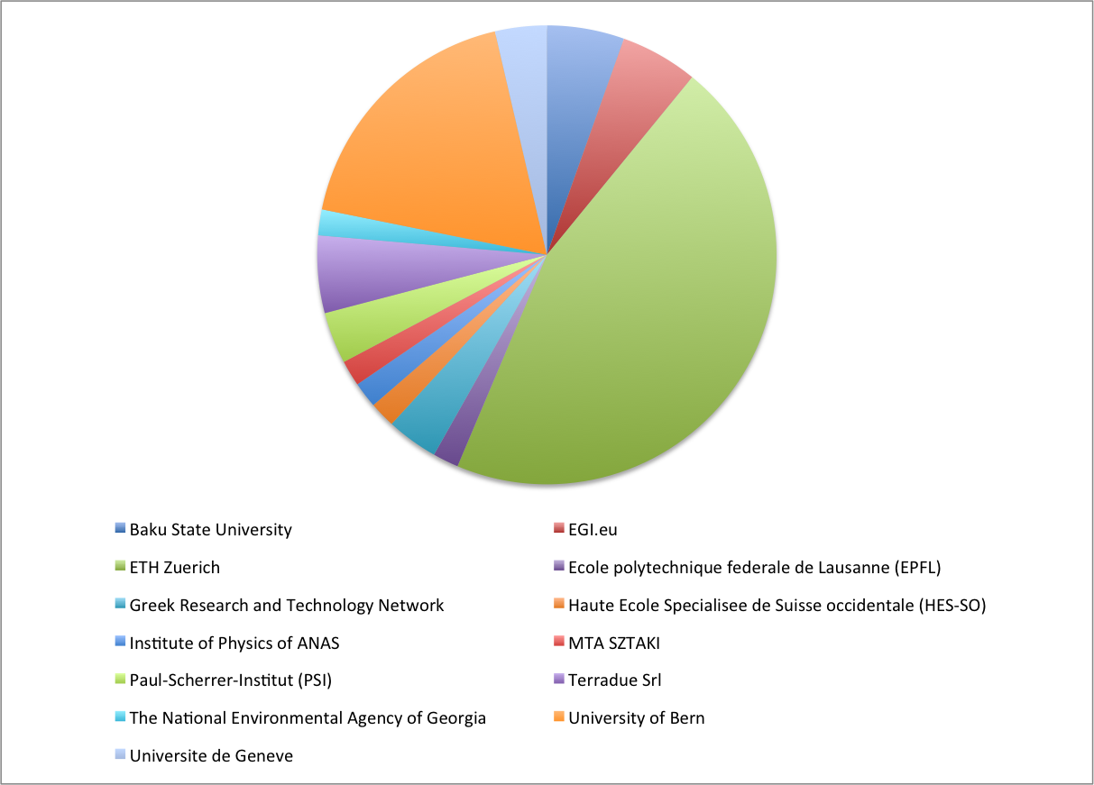

Through the Catch all WMS service the following VOs are supported:
- alice
- atlas
- biomed
- cms
- compchem
- drihm.eu
- dteam
- env.see-grid-sci.eu
- esr
- hgdemo
- meteo.see-grid-sci.eu
- nwchem.vo.hellasgrid.gr
- ops
- ops.vo.egee-see.org
- see
- seegrid seismo.see-grid-sci.eu
- vo.complex-systems.eu

On the Catch-all LFC service the following regional/local VOs are supported:
- digitalmedia.vo.eu-egee.org
- gr-sim
- vo.complex-systems.eu
- vo.grid.auth.gr

On the catch all VOMS service the following VOs are supported:
- dteam
- long-tail.egi.eu
- see
- vo.complex-systems.eu

The following table shows performance against targets:

Service level parameter | Target | M1 average | M2 average | M3 average | M4 average | M5 average | M6 average
Availability | - | - | 99.99 | 100 | 100 | 99.98 | 99.98
Reliability | - | - | 99.99 | 100 | 100 | 99.98 | 99.98
Note that the profile metric results for May 2015 do not exist.

Issues arising in the period

The following GGUS tickets were handled during the reporting period:

113337: Implement support for new VO in dteam VOMS
115282: VO afigrid.cl has requested some help to setup a VOMS Server.
114195: VO training.egi.eu has requested some help to setup a VOMS Server.
115076: Provide support regarding user subsctiption to dteam voms
114879: Provide support regarding user account in dteam vo
114701: Provide support regarding user membesrhip in dteam vo
113922: Update dteam group manager entry for NGI_IT

As a result of ticket 113337 the following VO has been added on the Catch all VOMS service pair:
- long-tail.egi.eu

Additionally the vo.complex-systems.eu and see VOs have been added to the catch all service pair due to the retirement of the voms.grid.auth.gr service.

Measures planned
No special measures are needed.

Foreseen activities and changes
- Regular application of system and service updates.

