EGI-InSPIRE

NGI International Task Review

EU MILESTONE: MS116

Document identifier: | EGI-MS116-V6.doc
Date: | 21/03/2012
Activity: | NA1
Lead Partner: | EGI.eu
Document Status: | FINAL
Dissemination Level: | PUBLIC
Document Link: | https://documents.egi.eu/document/963

Abstract
The National Grid Infrastructures (NGIs) undertake a number of specific tasks within EGI in areas such as operations, user support, dissemination and policy that interface with the central coordination provided by EGI.eu. This report provides a self-assessment of the current services from an NGI perspective. The individual contributions provided by the NGIs through a wiki page have been analysed and summarized in this report. Each service follows a standardised structure to include a service description, service assessment, and an aggregated score.

- Copyright notice
Copyright © Members of the EGI-InSPIRE Collaboration, 2010-2014. See www.egi.eu for details of the EGI-InSPIRE project and the collaboration. EGI-InSPIRE (“European Grid Initiative: Integrated Sustainable Pan-European Infrastructure for Researchers in Europe”) is a project co-funded by the European Commission as an Integrated Infrastructure Initiative within the 7th Framework Programme. EGI-InSPIRE began in May 2010 and will run for 4 years. This work is licensed under the Creative Commons Attribution-Noncommercial 3.0 License. To view a copy of this license, visit http://creativecommons.org/licenses/by-nc/3.0/ or send a letter to Creative Commons, 171 Second Street, Suite 300, San Francisco, California, 94105, and USA. The work must be attributed by attaching the following reference to the copied elements: “Copyright © Members of the EGI-InSPIRE Collaboration, 2010-2014. See www.egi.eu for details of the EGI-InSPIRE project and the collaboration”. Using this document in a way and/or for purposes not foreseen in the license, requires the prior written permission of the copyright holders. The information contained in this document represents the views of the copyright holders as of the date such views are published.
- Delivery Slip
 | Name | Partner/Activity | Date
From | Steven Newhouse et al | EGI.eu/NA1 | 19/03/2012
Reviewed by | AMB | EGI.eu | 10/03/2012
Approved by | AMB & PMB |  | 11/04/2012
- Document Log
Issue | Date | Comment | Author/Partner
ToC | 11/01/2012 | Table of Contents | Steven Newhouse, Sergio Andreozzi, Sy Holsinger/EGI.eu
1 | 24/02/2012 | First draft based on from NGI contributions | Sy Holsinger/EGI.eu, et al.
2 | 27/04/2012 | NGI scores added | Sy Holsinger/EGI.eu
3 | 03/03/2012 | Second draft with assessment analysis | Sy Holsinger/EGI.eu, et al.
4 | 09/03/2012 | Final version for external review | Sy Holsinger/EGI.eu
5 | 11/03/2012 | Initial comments and feedback | Steven Newhouse/EGI.eu
6 | 19/03/2012 | Revised version from external review | Sy Holsinger/EGI.eu
- Application area
This document is a formal deliverable for the European Commission, applicable to all members of the EGI-InSPIRE project, beneficiaries and Joint Research Unit members, as well as its collaborating projects.
- Document amendment procedure
Amendments, comments and suggestions should be sent to the authors. The procedures documented in the EGI-InSPIRE “Document Management Procedure” will be followed:
https://wiki.egi.eu/wiki/Procedures
- Terminology
A complete project glossary is provided at the following page: http://www.egi.eu/about/glossary/.
- PROJECT SUMMARY
To support science and innovation, a lasting operational model for e-Science is needed − both for coordinating the infrastructure and for delivering integrated services that cross national borders.
The EGI-InSPIRE project will support the transition from a project-based system to a sustainable pan-European e-Infrastructure, by supporting ‘grids’ of high-performance computing (HPC) and high-throughput computing (HTC) resources. EGI-InSPIRE will also be ideally placed to integrate new Distributed Computing Infrastructures (DCIs) such as clouds, supercomputing networks and desktop grids, to benefit user communities within the European Research Area.

EGI-InSPIRE will collect user requirements and provide support for the current and potential new user communities, for example within the ESFRI projects. Additional support will also be given to the current heavy users of the infrastructure, such as high energy physics, computational chemistry and life sciences, as they move their critical services and tools from a centralised support model to one driven by their own individual communities. The objectives of the project are:

- The continued operation and expansion of today’s production infrastructure by transitioning to a governance model and operational infrastructure that can be increasingly sustained outside of specific project funding.
- The continued support of researchers within Europe and their international collaborators that are using the current production infrastructure.
- The support for current heavy users of the infrastructure in earth science, astronomy and astrophysics, fusion, computational chemistry and materials science technology, life sciences and high energy physics as they move to sustainable support models for their own communities.
- Interfaces that expand access to new user communities including new potential heavy users of the infrastructure from the ESFRI projects.
- Mechanisms to integrate existing infrastructure providers in Europe and around the world into the production infrastructure, so as to provide transparent access to all authorised users.
- Establish processes and procedures to allow the integration of new DCI technologies (e.g. clouds, volunteer desktop grids) and heterogeneous resources (e.g. HTC and HPC) into a seamless production infrastructure as they mature and demonstrate value to the EGI community.
The EGI community is a federation of independent national and community resource providers, whose resources support specific research communities and international collaborators both within Europe and worldwide. EGI.eu, coordinator of EGI-InSPIRE, brings together partner institutions established within the community to provide a set of essential human and technical services that enable secure integrated access to distributed resources on behalf of the community.

The production infrastructure supports Virtual Research Communities (VRCs) − structured international user communities − that are grouped into specific research domains. VRCs are formally represented within EGI at both a technical and strategic level.
- EXECUTIVE SUMMARY
The National Grid Infrastructures (NGIs) undertake a number of specific tasks within EGI in areas such as operations, user support, dissemination and policy that interface with the central coordination provided by EGI.eu. This report provides a self-assessment of the current NGI services from an NGI perspective. The individual contributions provided by the NGIs through a wiki page and survey have been analysed and summarized in this report.
Feedback from the NGIs was generally positive with very constructive feedback for improvements to be made. Issues still remain in gathering information and feedback from all of the NGIs. However, many of the activities are progressing well with most of the objectives being reached, especially in areas with more effort is available. A few comments were around improving communication of policy activities and suggestions of providing briefing documents that could be adapted for local NGI activities and for better access to materials to support dissemination. Efforts will continue in areas around gathering case studies and generating subject specific printed materials as well as increasing awareness around the tools and processes that are available to them – namely the AppDB, Training Marketplace, and Requirements Tracker.
Operational activities have continued to see active participation from medium and large NGIs; however, participation from smaller or new NGIs needs improvement. In general, emerging NGIs could benefit from a technical support action to allow them to get familiarity with technologies, tools and procedures and to gradually gather expertise about grid service configuration and administration. In addition, procedures and tools need to be extended to allow for a gradual and easier integration into the production infrastructure, so that resource centres and the NGI international tasks can be tested first and then improved to bring them to production level. This is the activity roadmap of SA1 for PY3. The overall level of security provided during PQ5, PQ6 and PQ7 has been good and the whole framework of tools for security monitoring will continue to be further enhanced.
Since the formation of the NGI International Liaison (NIL) network and the set-up of the Virtual Teams, there has been more success in engaging NGIs to collaborate around an individual focused task.
Overall, this report provided an opportunity to assess the progress of the activities being carried out by the NGIs and offered a mechanism for understanding the current issues as well as potential improvements for continuous evolvement as a project, organisation and ecosystem.

TABLE OF CONTENTS
1 Introduction 6
2 External Relations 7
2.1 Policy Development 7
2.2 Dissemination 8
3 User Services 11
3.1 Requirements Gathering 11
3.2 Application Database 11
3.3 Training 12
3.4 Consultancy 13
4 Operations and Tools 14
4.1 Infrastructure and Tools 14
4.1.1 NGI Monitoring Infrastructure 14
4.1.2 Accounting Infrastructure 14
4.1.3 NGI Helpdesk 15
4.2 Grid Services 15
4.2.1 Core Grid Services for VOs 15
4.2.2 Staged Rollout 16
4.2.3 Gathering Middleware Requirements 17
4.3 Support 18
4.4 Operations and Coordination 19
4.4.1 Grid Oversight (ROD) 19
4.4.2 Service Level Management 21
4.4.3 Security Management 21
4.4.4 Operations Management 22
5 Conclusions 23
6 NGI Contributions 24
6.1 Non-operations tasks 24
6.1.1 Summary of NGI Scores 24
6.2 Operations Tasks 24
6.2.1 Summary of NGI Effort Spent 24
6.3 Non-respondent NGIs 25
7 References 26

TABLES AND FIGURES
Table 1: Summary of NGI Scores (non-operations tasks) 24
Table 2: Effort spent for SA1 Int’l tasks, as reported by NGIs in the survey 25

Figure 1: Distribution of core middleware services deployed (source: GOCDB) 16
Figure 2: Number of deployed service instances in staged rollout, grouped by NGI 17
Figure 3: Overall status of middleware requirements submitted by NGIs during 2011 18
Figure 4: Number of tickets opened and median solution time (days), per country 19
Figure 5: ROD average monthly workload 20
Figure 6: ROD quality metric (monthly average) 20

Introduction
This report provides an assessment of the NGI international tasks that take place within the EGI-InSPIRE project and the services provided by the NGIs. EGI-InSPIRE targets the project’s effort focusing primarily on the tasks taking place within NA2 (Policy & Dissemination), NA3 (User Support) and SA1 (Operations).
Each service follows a standardised structure to include a service description, service assessment, and an aggregated score or spent effort. Section 6 offers a list of participating NGIs regarding operations activities and non-operational activities, which includes a summary of the individual scores provided by the NGIs and summary table of the effort recorded in order to carry out the operational activities. The wiki page for individual responses can be found at [R1].
The NGIs were asked to use the following scoring scheme to assign numerical scores to their own services on the basis of the overall level of satisfaction judged by the service provider:
- 0 = not applicable
- 1 = An unacceptable level of service was delivered
- 2= A level of service that was below expectations was delivered
- 3= An acceptable service level has been delivered
- 4= A level of service that exceeded expectations was delivered, but there is scope for even further improvement.
- 5= An excellent service has been delivered that should be considered as best practice
Regarding the NGI operational tasks, the NGIs were requested to estimate the overall cost in person months per year of each task run by the NGI instead of a self-assessment. This choice was motivated by the fact that SA1 metrics are available for many of the tasks to quantitatively estimate performance. Service cost estimation is useful information for future planning of NGI sustainability and for the definition of future business models.
The report concludes with a brief conclusions section.

External Relations

Policy Development
Description: Local policy development activities are integrated with those taking place within the EGI.eu Strategy and Policy Team [R2] that support the development of policies and procedures at a European level. It is the local partner who implements policies and procedures on a local level. Therefore, most of the NGIs responsibilities include developing EGI policies and procedures by participation in EGI policy groups, implementing EGI policies and procedures, communicating with national governments and national research councils about policy priorities for the DCIs, establishing agreements with Resource centres, and drafting national policies and procedures that are in alignment with EGI ones.
Efforts from the local level have also been around trying to establish relations with national policy makers and active lobbying to persuade them to form national e-Infrastructure development programmes for sustainable development of all e-Infrastructure components. The importance is to inform national authorities that national funding is the key element for receiving complementary European level support.

Assessment: Overall feedback from the NGIs has been generally positively, varying based on available effort in the area. Some NGIs have been participating in policy development on a best effort basis where there is no funding for this activity, providing feedback to both technical and non-technical policy and procedures and establishing agreements with Resource Centres. Several other NGIs are aligning EGI procedures and procedures where consistent with relevant local regulation.
Though the output from the policy activities is of high quality, it is relatively low in quantity, reflecting the level of effort available. Quality depends on the input of individuals involved and despite the consultation procedures in place it is not clear that all policies are given sufficient scrutiny. It was felt that it could sometimes be difficult to find time to review policies in depth. The intention or purpose of some policies, while clear to the authors, may not be clear to the readers/reviewers.
Other efforts have also been around trying to establish relations with national policy makers and active lobbying to persuade them to form national e-Infrastructure development programmes for sustainable development of all e-Infrastructure components. The importance is to inform local authorities that national funding is the key element for receiving complementary European level support. For example, Macedonia was successful in convincing the government for the essence of Grid in modern e-Science, thus receiving a grant of 1M euros, and successfully purchased a new HPC cluster with 1000 CPU Cores. Turkey has established an Advisory Board responsible to study e-Infrastructure policies for Turkey and consider the important directions and recommendations including EGI.eu. Moldova organises a national e-Infrastructure policy event every year with participation of high-level ministerial representatives. At these events, the NGIs presenting information on current status and perspectives of National Grid Infrastructure and services development, common European view and requirements for Grid development, approaches and policies promoted by EGI. The use of GridTalk GridBriefings was mentioned for preparing materials for the national ministry of sciences.
Other NGIs are more involved in policy activities contributing on a variety of levels and consider the service outcome of a good quality. NGIs have participated developing strategic policies in EGI bodies such as the Council, EGI-InSPIRE Project Management Board (PMB), as well as internal policy activities in EGI policy groups such as the Security Policy Group (SPG) and Operations Management Board (OMB) and external policy activities such as active participation in the EUGridPMA and IGTF bodies. Only one NGI, Finland, viewed policy related issues as a staffing problem and hopes to remedy this over the next year.

NGI Aggregate Score: 3
Overall, the NGIs gave a satisfactory review of the policy activities along with suggestions for improving it. There is still a certain level of fragmentation throughout the community focusing on individual efforts, this needs to move more towards a joint community perspective with more contacts at the ESFRI level and with government authorities coupled with the implementation of national funding programmes.
There also needs to be clearer scheduling and assignment of policy editing and review (and record effort against such tasks) to avoid clashes between editing/reviewing and quarterly reports, etc. Call for interest in policy writing (as for Virtual Teams) is needed in order to get interested people involved early, rather than at the ‘final call’ stage.
EGI.eu has to more closely interrelate with NGIs to support their contacts with national policy makers and to formulate special messages to them with argumentation of necessity of national support for sustainable Grid infrastructure operation and development. This is especially true for those Eastern European states where there were no previous national e-Infrastructure initiatives. This includes more tightly coupled interaction with EGI.eu with feedback and recommendations that are expected to enhance national policies within the same alignment.
Finally, policy activities are positively viewed by the European Commission, but it is sometimes unclear how the interaction with NGIs are taking place. There seems to be policy uncertainties on the side of the people responsible for infrastructures in Europe, and at the national level. On the one hand, European and national policy makers support the NGIs and EGI concept, but they continue funding computing resources without any apparent coordination for each user community. There is a need to work more closely with the European Commission and the national authorities to understand what are the needs and what is expected from EGI and the NGIs. One of the possible ways to improve would be more provide clarity in the EC and national policy documents.

Dissemination
Description: NGIs promote their work and that of EGI to their local national audiences. Therefore, while EGI.eu coordinates the external liaison functions at a European level, NGIs are focused on dissemination and liaison at the regional and national level. NGIs also provide EGI representation at local and regional events. NGIs active on the international front are considered to represent themselves, but are of course free to propose coordination of any international activities with EGI.eu. NGIs report news stories and interesting user community events in their local area to the central EGI.eu team for further dissemination. They also get involved by providing people to be at these events. In addition, some of the NGI dissemination activities include publicising local success stories in suitable media, creating materials for various audiences (from politicians to scientists), writing up success stories, pointing potential users in the right direction, etc.

Assessment: The key message that comes across from the NGI’s self-assessments is that the situation with regards to the funding of dissemination and communication activities varies widely. Some NGIs reported having the resources to be very active during the second year of the project. This included NGI-CZ, who concentrated on websites and news feeds, mailing lists, newsletters and direct outreach to communities. NGI-FR hosted the EGI Technical Forum in Lyon, co-located with a French Grid Day, and they provided staff for the local organising committee, supported by the team at EGI.eu.
NGI-HU, NGI-LT, NGI-CRO, NGI-MD, NGI-MARGI and others focused activities on events, including training, with NGI-HU establishing a regular series of NGI events, the e-ScienceCafé Roadshow. The team produced a leaflet and poster for the event in collaboration with e-ScienceTalk, and this was also advertised through the International Science Grid This Week and the EGI Inspired newsletter. NGI-LT took part in several scientific festivals and presented at user-oriented scientific seminars. NGI-HR and NGI-SK focused on holding national annual meetings to keep researchers up to date with national progress and issues, as well as the general progress of EGI. NGI-CRO also produced monthly status updates, including operations actions and usage statistics per institute.
For NGI-UK, a national dissemination program was funded in April 2011, SeIUCCR [R8], which allowed the UK to be very strong in this field. The good working relationship between the NGS and GridPP projects has led to the NGI-UK meeting and exceeding outreach targets. At an international level, they have helped EGI to develop case studies and roadshow ideas from their national initiatives and many dissemination stories have been cross-pollenated from NGS/GridPP and EGI.
Other NGIs report having less effort available for communication, and therefore see a lower level of impact from their work. NGI-FI was without a communications officer from PQ5 to PQ8, but expects to recommence dissemination activities in Year 3. NGI-IE dissemination effort was also very limited and has had low impact. They consider the current level of national funding to be inadequate, and while the activity is sustained at current levels, this will make it difficult to increase their impact. NGI-IE is considering sustainability plans and in future would like to give greater prominence to outreach in strategy and plans. NGI-IT also reported that they have almost no effort available for dissemination, so it is difficult to make an assessment of the results.
Looking ahead, the NGIs have a number of aims for communications for Year 3. NGI-CZ’s aim for the next year of the project is to make their materials more attractive visually. NGI-FR will be consolidating its activities from PY2 and reviewing the website. Others, such as NGI-HU, would like to work on more joint activities nationally, instead of individual actions, while conversely NGI-MD wants to encourage take-up of national schemes at an institutional level. NGI-IE has expressed a wish to distribute EGI.eu’s marketing material nationally, which is an option also available to other NGIs, as all materials are available to download and print, to distribute electronically, or as templates to be translated into local languages.
According to NGI-IT, NGIs probably need help in negotiations with companies for licensed products accessed via grid, and other NGIs are also interested in engaging industry. A Virtual Team for exchanging experiences on this would be welcomed. With SA3 closing at the end of PY3, NGIs such as NGI-LT are also exploring how EGI may help heavy user communities and NGI-PT want to reach out to users directly. NGI-CH has a good understanding of their user communities, as they have fine-grained control over which resources are allocated to which users, something that is not generally the case across EGI as a whole. NGI-MD suggests setting up a portal for events and dissemination materials in the same model as the AppDB, and the EGI events calendar, wiki and news feed could help to fill this purpose. Many would like to make their NGI itself better known outside the EGI community and to communicate more about the added value of EGI and its impact on society, an idea which is being pursued through the series of videos, ‘Stories from the Grid’.
Some NGIs have also picked up on the unevenness of engagement in and funding for dissemination activities. They would like to see that all NGIs have a good understanding of their portfolio of users, hold annual meetings and report regularly. While we gather dissemination activities, events and publications through the quarterly project reports and metrics, it would be beneficial to see more a more regular, systematic sharing of experiences, meetings and case studies. Some of this sharing can be done through the central team, in the normal process of gathering use cases and news stories for the website, press releases, social media channels and publications from the NGIs, which are then disseminated back to all NGIs. However, communication between the NGIs should not be solely through the central team but should take a more peer-to-peer approach.
There are a number of tools available to the NGIs to help focus and share their dissemination activities. These include the wiki page, the EGI blog and the bi-annual meetings. Experience has shown that the wiki pages tend to be underused, even when their availability is advertised - it is another overhead for already busy people to post material here. Face-to-face meetings have been held in a number of formats at EGI events over the first 2 years, whether as conference sessions with invited speakers, as face-to-face internal NA2 meetings or in a forum style based around discussion and lightning talks. Again, experience shows that with one or two exceptions, these meetings tend to be poorly attended, due to inevitable clashes in the programme, since the NGI contacts often have 2 or 3 roles, including dissemination. However, since the formation of the NILs network and the set-up of the Virtual Teams, we have had more success in engaging NGIs to collaborate around an individual focused task i.e. populating the website. In PY3, the central team will aim to facilitate further NGI tasks around specific dissemination activities that will be of benefit to all NGIs – gathering case studies, generating subject specific printed materials such as brochures or posters, and representation of EGI at user focused events.
NGI Aggregate Score: 3.5

User Services

Requirements Gathering
Description: While new requirements are gathered centrally, the collection of new requirements starts with the NGIs and EIROs. They have the contacts with the users and operations staff that are using or operating the EGI resources on a daily basis and can identify issues that need to be resolved.

Assessment: Reaching potential users and getting feedback from them on existing and on missing services is mentioned as a challenge by some of the NGIs. The recently setup of a CRM system and institutional contacts added to it by EGI.eu will hopefully improve the situation, giving clearer directions to NGIs for who to talk to and what to ask when they wish to map out interest for e-Infrastructure use in their country. No other major issue was mentioned; most of the low scores are caused by not knowing about some existing features of the RT system, gadget, and wiki.
The EGI.eu User and Community Support Team – in collaboration with technology providers in TCB – finalised the processes around communicating and managing requirements between user communities and product teams. The process has been documented and a succinct summary of the whole requirement workflow has been made available alongside with open and solved user requirements through the EGI webpage [R9]. During the second year 31 user requirements [D10] were resolved by this process. These include 3 MPI and 2 high-level topics that were flagged as priority by the User Community Board. 22 additional requirements are still in the TCB process, at various stages:
- The delivery of ‘documentation about WMS recommended configuration’ (a topic considered as priority by the UCB in 2010) was already delayed twice, and it is now promised to come as part of EMI-2 release.
- 3 requirements (1 of them is a UCB priority topic) are under evaluation by the TCB since February.
- 3 UCB topics and 1 ‘normal’ requirement were endorsed by TCB and are waiting for technology providers to accept as item they want to implement.
- 1 UCB topic and 3 ‘normal’ requirements will be submitted to the next TCB to be held in April.
- 6 requirements have been identified as bugs through the EGI Helpdesk, Technology providers are currently assessing the cost of fixing these in future releases.
- 4 other requirement are still under investigation by the helpdesk support, to decide whether these relate to bugs, or missing features.
NGI Aggregate Score: 3

Application Database
Description: The Application Database [R3] provides a mechanism for users to discover which applications are in use, or are being ported to use the production infrastructure. NGI staff has a vital role to play in adding new entries and keeping entries up to date as they work with their respective user communities.
Assessment: Keeping the registered entities up to date is mentioned as the biggest challenge by quite a few NGIs. There is a clear need and scope to improve AppDB in this respect. (e.g. sending email reminders to users to check and update application/tool/personal profiles). Such actions will be added to the next phase of development.
Some of the answers/scores are controversial or misleading. Sometimes a good assessment score is combined with no recorded use of AppDB. (e.g. Croatia gave a mark of 5 but has neither a tool nor an application registered in AppDB). In other cases the scores evaluates the NGI’s own performance in using the system instead of the quality of the service itself. (e.g. Czech NGI gave a low score because they use a local registry instead of the EGI AppDB.)
Several useful feedback for further development were suggested:
Italy:
- Aggregation per institution of ported applications and publications.
- Write APIs to synchronise EGI AppDB with similar, regional databases. (Note by author: This feature will be implemented later this year.)
- A way to store similar application with slightly different names without replicating them.
Finland & Ireland:
- AppDB should have links to documents that describe who can make use of the applications and how the application can be downloaded / launched. (Note by author: This is already possible through custom links, but their use is not checked. So this is a request asking for more ‘quality control’ of the registered entries.)
France:
- Possibility to add keywords meaning, ‘we use it’ as NGI or as scientific community, to show how widely the tool or the application is widely used. As time is going information could be out-of-date, so update mechanism is needed for this.
Netherlands:
- AppDB could benefit from purge and clean up. EGI could adopt core applications.
NGI Aggregate Score: 3

Training
Description: Many NGIs are able to provide generic or specific training courses to help user communities use EGI resources. The Training Marketplace [R4] provides a means of enabling the coordination that NGIs need to do locally in collaboration with other NGIs to support particular user communities.

Assessment: EGI has focussed its efforts on developing and promoting the Training Marketplace as a mechanism to support the NGIs in their own coordination and delivery of training locally and at an international level. The EGI forums represent an ideal opportunity for partners to deliver training to support for international communities and services should they wish to.
There was a spectrum of responses regarding the Training Marketplace. However, what this spectrum reveals is the lack of a clear ‘best practice’ for using the Training Marketplace. The optimum use (as described by ES) is to centralise information about training activities and then filter back for your region (e.g. ES, UK) and then create a gadget to be used locally. Some commented on the duplication of data (CZ, FR) but this indicates a misunderstanding which suggests that better information and guidance is needed to support NGIs and others in using the service (as ES recognised). There may be scope for an improved API to automate or at least mechanise the synchronisation of training-related material. Promoting the service to others outside of EGI – even commercial organisations – was suggested (by the UK - developers of the service). A number of partners report limited use of the service but for different reasons. For some it was the lack of training events being run in their country (IE), for others it was limitations of the service itself (GR, PT, TR) and even non-participation in the work package (HU). There were a number of suggestions for specific improvements: better search functionality (PT, RS), ordering by rating (IT) and a calendar for future events (HU). There were also suggestions for content, which of course partners are able to provide themselves. Content suggestions included material on solving common problems on the grid (CZ, LT) and just more up to date material (MK, RS). Material to support the training of trainers was also mentioned (NL, MD).
NGI Aggregate Score: 3

Consultancy
Description: The staff within NGIs represents an excellent source of local expertise for new users or new sites wishing to make use of e-Infrastructure. This expertise can be disseminated through training, but more frequently requires in depth one-on-one work with particular applications or user groups.

Assessment: The aggregate score of 3 for consultancy activity from the NGIs belies the breadth of activity that has taken place and also can be explained by the way NGIs approach support that they give to national research communities. Furthermore, not all partners have formal involvement in the WP (e.g. HU) but do offer consultancy to users. The earlier point relates to the fact that a country’s resources are both a constituent of EGI and a national resource such is the nature of federation. For some, such as CZ, IE, FI, LT, MD and ES there has been a good amount of consultancy provided. Others have not undertaken much consultancy but would like to be able to do more (HU, RS). There were a few comments suggesting that the split of moving support to SA1 caused confusion (PT) and about the boundaries of what defines consultancy in an EGI context (UK). This, of course is why the split was made, to oblige partners to differentiate (at a cost centre level) between support as in repeat tasks (something isn’t working, a repeatable process needs to be better documented) and original and unique activities particularly with communities or users new to the grid.
The new Virtual Team model was mentioned (FR, UK) as it starts to deliver results that will be beneficial in this area. Onsite visits were mentioned (FI) as a mechanism to reach out to new users although this could be considered outreach rather than consultancy but that depends on the context. MK and TR are two of the few to report interaction with a commercial organisation. The ESFRI projects have also started to take shape and draw upon the NGIs for expertise and so offer an important area for increased consultancy (PT and UK). Overall, it is worth noting that in addition to the above there are other countries (IS) that are not completely sure what consultancy means in this context. This and other ambiguities should be resolved.
NGI Aggregate Score: 3

Operations and Tools
Between December 2011 and January 2012, a survey dedicated to operations related tasks was circulated among the NGIs asking to provide an assessment regarding the international tasks being carried out. NGIs have not been requested to rate the quality of services delivered, but to assess the manpower needed to run the international tasks [R5].
In total 21 NGIs answered to the survey: Czech Republic, Georgia, Serbia, Portugal, Hungary, Germany, Italy, Poland, Slovakia, Croatia, Ireland, Bosnia Herzegovina, The Netherlands, Moldova, Israel, UK, Turkey, Hungary, Switzerland, Finland and Spain.
The paragraphs about the individual tasks report the median effort spent, with the minimum and maximum values reported in the survey. To calculate the minimum values NGIs reporting 0 have been omitted considering that – with 0 spent effort – no service was delivered. All the efforts reported are available in Table 2.

Infrastructure and Tools

NGI Monitoring Infrastructure
Description: The EGI Monitoring Infrastructure is distributed and is responsible for running periodic functionality checks. Results are stored and displayed locally through NGI portals and are collected centrally at an EGI-level to provide an overall view of the EGI Resource Infrastructure status.

Assessment: The EGI distributed monitoring infrastructure requires every NGI to deploy a SAM service to monitor the sites that belong to the national infrastructure. Currently there are 26 SAM instances deployed by the NGIs, of which 5 instances are responsible for monitoring multiple national infrastructures.
Three NGIs have deployed VO specific SAM instances, for regional VOs and international VOs, while other NGIs reported the deployment of monitoring tools for VO services and other regional tools in the list of priorities.
A full set of probes for the Globus and UNICORE services has been integrated in the SAM release, however, they are not yet included in the profiles used to calculate site availability nor in the set of probes that generate alarms in the Operational Dashboard.
The possibility to deploy multiple SAM instances as high availability configuration has been included in the SAM package in September 2011, therefore, during PY3, the NGIs will evaluate this option to improve the reliability of their monitoring infrastructure.
Median Effort Spent during last year: 3.5PM (Min: 1.2; Max: 25)

Accounting Infrastructure
Description: Each Resource Centre collects Usage Records. Depending on the customisable set-up chosen by the NGI, the data gathered can be directly published in the central databases, or alternatively can be persistently stored at an NGI level and summarised for publication at an EGI level. NGIs are responsible of the validation of the data gathered and to supervise the record publication process to make sure that records are regularly collected centrally.
Assessment: The overall situation of the accounting infrastructure has not changed significantly in the past year. The delay of the release of the regional APEL repository (expected for this year) prevented the NGIs - who were not already using a customised regional accounting system - to deploy their regional accounting system. This is a priority for at least one NGI.
One NGI out of the 13 NGIs who answered to the survey reported an activity of validation for the accounting data published in the central repository.
Median Effort Spent during last year: 1.5 PMs (Min: 0.5; Max: 15)

NGI Helpdesk
Description: An NGI support system that is fully integrated with the central instance, GGUS, is often required to support local users and Resource Centre administrators. This is typically required by medium and large NGIs. For small-scale NGIs operating a limited number of Resource Centres, the local support system can be simply implemented centrally through a dedicated support unit.

Assessment: All the NGIs are currently integrated in the EGI helpdesk. Only Russia has not yet transitioned to an NGI-like support unit and is still being supported by the ROC_Russia SU.
The current deployment scenario of regional helpdesk solutions reflects the data in the previous milestone: 9 NGIs are interfacing the EGI helpdesk with their own system; three of them are using xGUS. In the survey, two NGIs reported the deployment of a local helpdesk system integrated with GGUS as a priority.
Median Effort Spent during last year: 1.1 PMs (Min: 0.4; Max: 6)

Grid Services

Core Grid Services for VOs
Description: Core middleware services for user information discovery, authentication, workflow management, file cataloguing, etc., are often provided by NGIs to support users and the local Infrastructure Services. The actual set of services operated can vary, and depends on the scale of the NGI and on the number of VOs supported.

Assessment: The core grid services are operated by NGIs according to the needs of the VOs (both national and global) supported by their Operations Centre. The core middleware services considered in this document are the WMS (Workload Management Service - 183 instances); Top-BDIIs (Top Level Information System Cache - 109 instances); VOMS (VO Membership Service - 67 instances); and LFC (Central File Catalogues - 39 instances). Figure 1 shows the distribution of the services across the NGIs; more than half of the services instances are deployed by five NGIs: IT, CERN, FR, DE, ES and UK.
Many NGIs reported the deployment of some high availability solutions for the most critical core services. To help NGIs in this task, best practices documents for the high availability of services like Top-BDII, WMS and VOMS have been produced as shared effort of several NGIs throughout 2011. Starting from September 2011 availability reports have been generated by EGI in order to collect the availability performances of the Top-BDII instances operated by the NGIs and to be used by the resource centres as default instances in the configuration of the grid services.
Median Effort Spent during last year: 4 PMs (Min: 1; Max: 31)
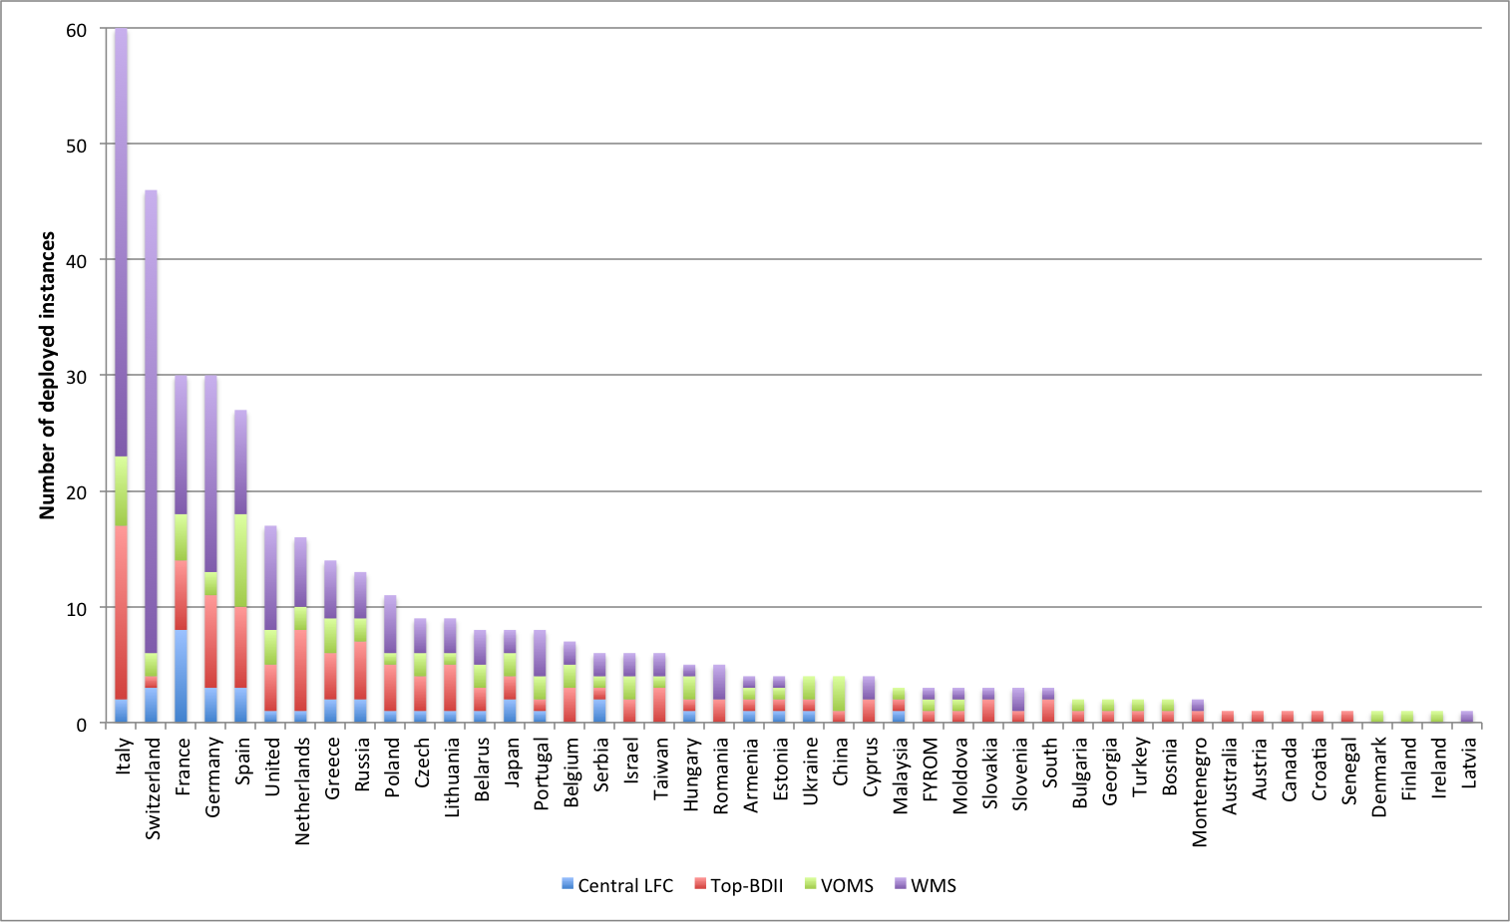
Figure 1: Distribution of core middleware services deployed (source: GOCDB)

Staged Rollout
Description: While EGI.eu is responsible of the coordination and supervision of the process, individual Resource Centres are requested to participate as early adopters to staged rollout for proper verification of new deployed software releases in the production infrastructure.

Assessment: The staged rollout infrastructure includes 58 sites committed as Early Adopters (EA) for one or more components. In the last quarter (PQ7), 18 EAs have been actively contributing to the staged rollout of new components releases.
The EAs currently committed provide good coverage for the components released by the main technology providers – EMI and IGE – and the SAM framework, including the Nagios probes. Many products have multiple EA teams; about 60% of the products have at least two EAs committed. Not all of the committed sites are responsive at the same level, and happens that even for components with multiple EAs, only one staged rollout is actually performed.
In the last two quarters, the staged rollout activities of the gLite 3.2 components slowed upon the end of the standard support due to security updates, which are now provided only for the gLite releases. Starting from April 2012, with the release of EMI-2, staged rollout will have to again deal with two major releases (EMI-1 and EMI-2) and multiple operating system platforms. All EMI products will be released for SL5 and SL6, and a significant subset of them will be distributed also for Debian6. In the coming year, the resources for staged rollout need to be steered to prioritise the OS platforms and components required by the NGIs. Many NGIs reported the deployment of UMD components, replacing gLite versions, as a priority for 2012.
Median Effort Spent during last year: 3PM (Min: 1; Max: 7.5) - includes all staged rollout activities conducted during PY2.

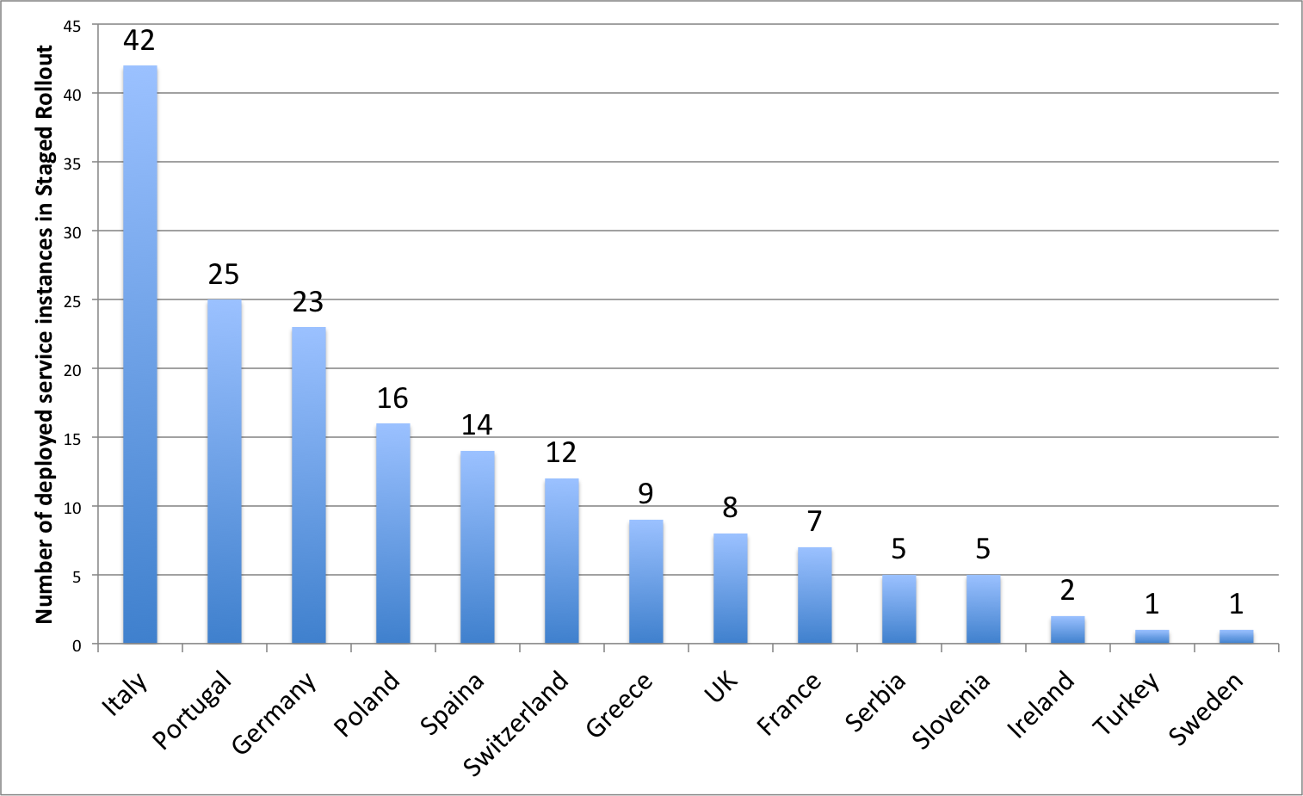
Figure 2: Number of deployed service instances in staged rollout, grouped by NGI

Gathering Middleware Requirements
Description: While new operations requirements are gathered centrally, the collection of new operational requirements starts in the NGIs/EIROs and the Resource Centres. Requirements are periodically gathered and assessed by the Operations Management Board [R6].

Assessment: Requirements about the deployed middleware and the operational tools are periodically collected by the NGI among their resource centres and the operations community. The requirements gathering process has been improved during the last year, but the changes affected only the communications workflow between EGI and the technology providers. The requirements submission process for NGIs did not change, keeping the RT system [R7] as the main tool used for this task.
Figure 3 shows the status of the requirements submitted during 2011, excluding the last campaign run in December, for which the requirements have not yet been processed by the technology providers. 20 out of 40 submitted requirements have been accepted by the technology providers. Only 3 requirements were not accepted with 17 still in the clarification process. At the end of December 2011, 18 additional requirements have been submitted both for middleware (analysed and prioritised by OMB) and for operational tools (analysed by OTAG). Several NGIs expressed concerns about RT, due to the complexity of its search engine: browsing through the requirements catalogue is not easy, in particular when navigation is required across different types of requirements (i.e. from user communities and operations).
Median Effort Spent during last year: 0.5 PMs (Min: 0.1; Max: 6)

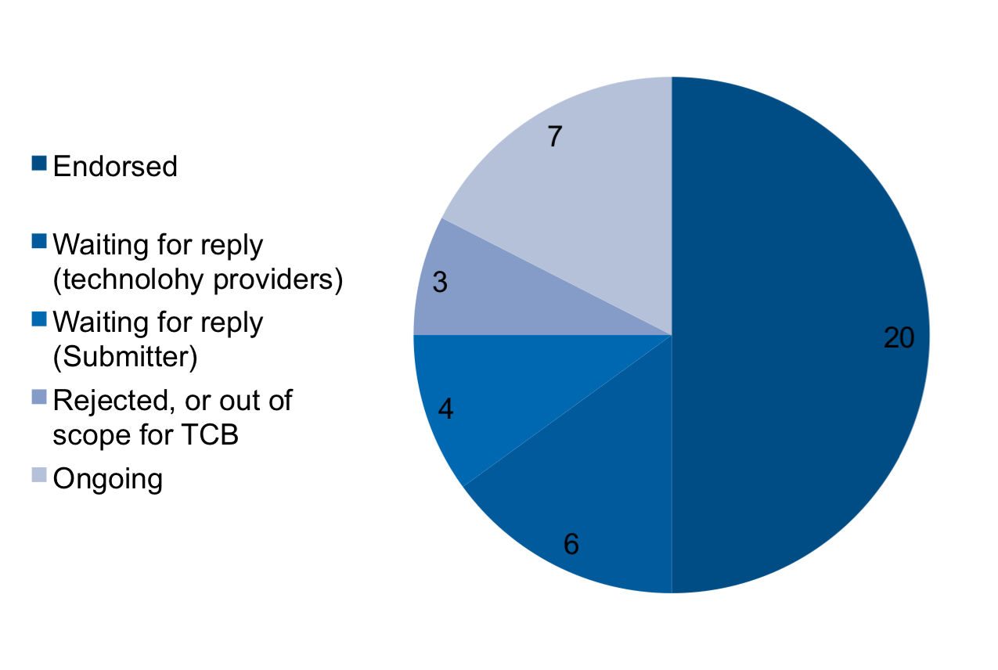
Figure 3: Overall status of middleware requirements submitted by NGIs during 2011

Support
Description: EGI.eu coordinates and supervises operations and network support activities provided by the individual NGIs to ensure that operational issues are properly handled at both Resource Centre and NGI level. It is also responsible of handling of Resource Centre suspension in case of operational issues. First level support, Ticket Process Management (TPM), is through the EGI helpdesk support issues are routed through to NGI support teams. Some of these requests may be related to specific support units but other issues relating to e-Infrastructure usage will require human intervention either from the operational or user support aspect.
Second level support, Deployed Middleware Support Unit (DSMU), provides technical support for incidents around operative grid middleware. Processing support tickets assigned by TPM, the DMSU assesses whether the described incident can be mitigated by changing middleware configuration or deployment. In conjunction with 3rd level expert support provided by Technology Providers, the DMSU assesses whether the reported incident constitutes a persistent software problem that requires fixing through software update cycles. Inhabiting this pivotal position within the grid middleware related support infrastructure, the DMSU is empowered to actively assign and maintain prioritisation of patch development and publication in software updates.

Assessment: As reported in paragraph 3.1.3, 9 NGIs run a local helpdesk system. While the support for the central EGI helpdesk is a global task carried out by EGI.eu, NGI are responsible for carrying out the support activities related to the tickets submitted directly to the local helpdesk.
Support is delivered to both resource centre administrators and users. NGIs reported that the support to regional VOs, to the local users and to the site administrators of resource centres that are either under certification or recently integrated in the infrastructure (who are less familiar with the NGI procedures and middleware services) is a considerable fraction of the activities for this task. Several NGIs reported that maintaining and improving, where needed, the quality of support is a priority for the current year.
The chart in Figure 4 shows the number of tickets handled by the NGIs' support units during the three quarters of PQ5-PQ7, and the median solution time. The number of the tickets assigned to the NGIs' support units increases with the number of Resource Centres and their size. These statistics do not include operational tickets that are opened through the Operations Dashboard directly to site administrators in case of alarms. More information about those tickets is provided in Section 4.4.1.
Median Effort Spent during last year: 4 PMs (Min: 0.5; Max: 48) – includes 1st and 2nd level support.
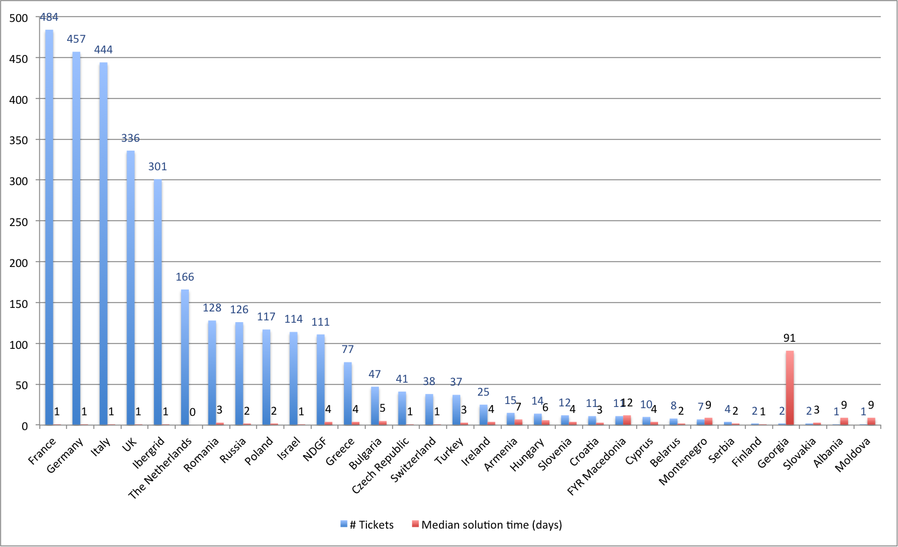
Figure 4: Number of tickets opened and median solution time (days), per country

Operations and Coordination

Grid Oversight (ROD)
Description: The Regional Operations team is responsible for detecting problems, coordinating the diagnosis and monitoring the problems through to resolution. It monitors sites in their region, and reacts to problems identified by the monitors, either directly or indirectly, provides support to Resource Centre administrators as needed, contributes to the knowledge base and provides informational flow to oversight bodies in cases of non-reactive or non-responsive Resource Centres.

Assessment: Grid operations oversight activities include the detection and coordination of the diagnosis of problems affecting the regional infrastructure until their resolution, and the daily operation of the operations at Resource Provider and Resource Centre level.
One NGI reported reducing the response time to problems as a priority for the 2012.
The chart in Figure 5 shows the NGIs’ Regional Operator on Duty (ROD) average monthly workload, which is the sum of all the items the ROD team has to deal with in a month. These items can be either alarms in the Operations Dashboard older than 24h or any ROD ticket generated through the operations dashboard [R11].
The chart in Figure 6 shows the percentage of Operational Dashboard alarms closed to ‘OK’ status. The values are the arithmetic means calculated over quarters PQ5-PQ6-PQ7. Alarms should be closed only when the problem is solved. There are only a few cases where an alarm can be closed in ‘non OK’ status, (e.g. second test run is successful, but the result is not correctly propagated to the dashboard, therefore the dashboard shows the alarm in a ‘error’ status, while it is actually in an 'ok' status). A ROD team scores a high percentage in this metrics when active support is provided, and alarms are properly handled and closed only when the issue is solved.
The average quality performance of the ROD teams was consistently above 90% in the last three quarters.
Median Effort Spent during last year: 6 PMs (Min: 0.1; Max: 39)
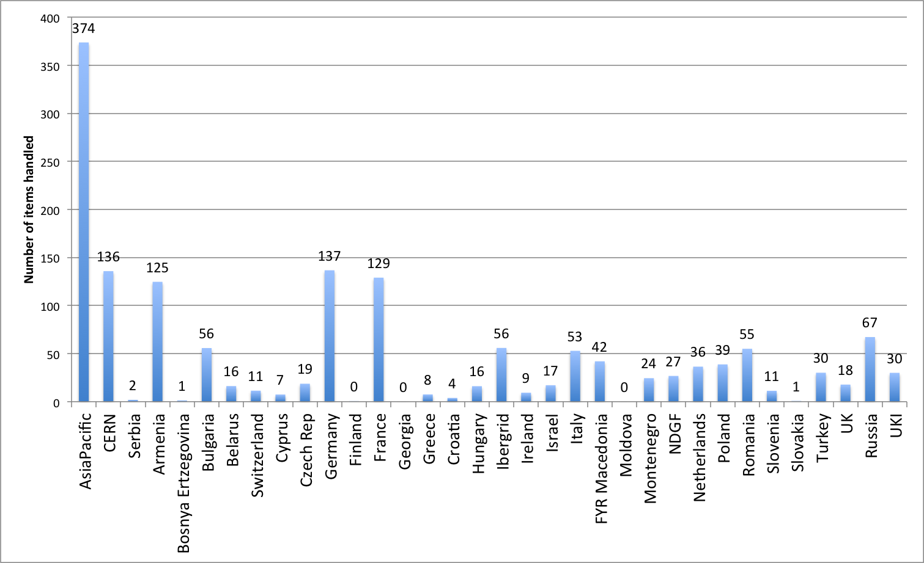
Figure 5: ROD average monthly workload
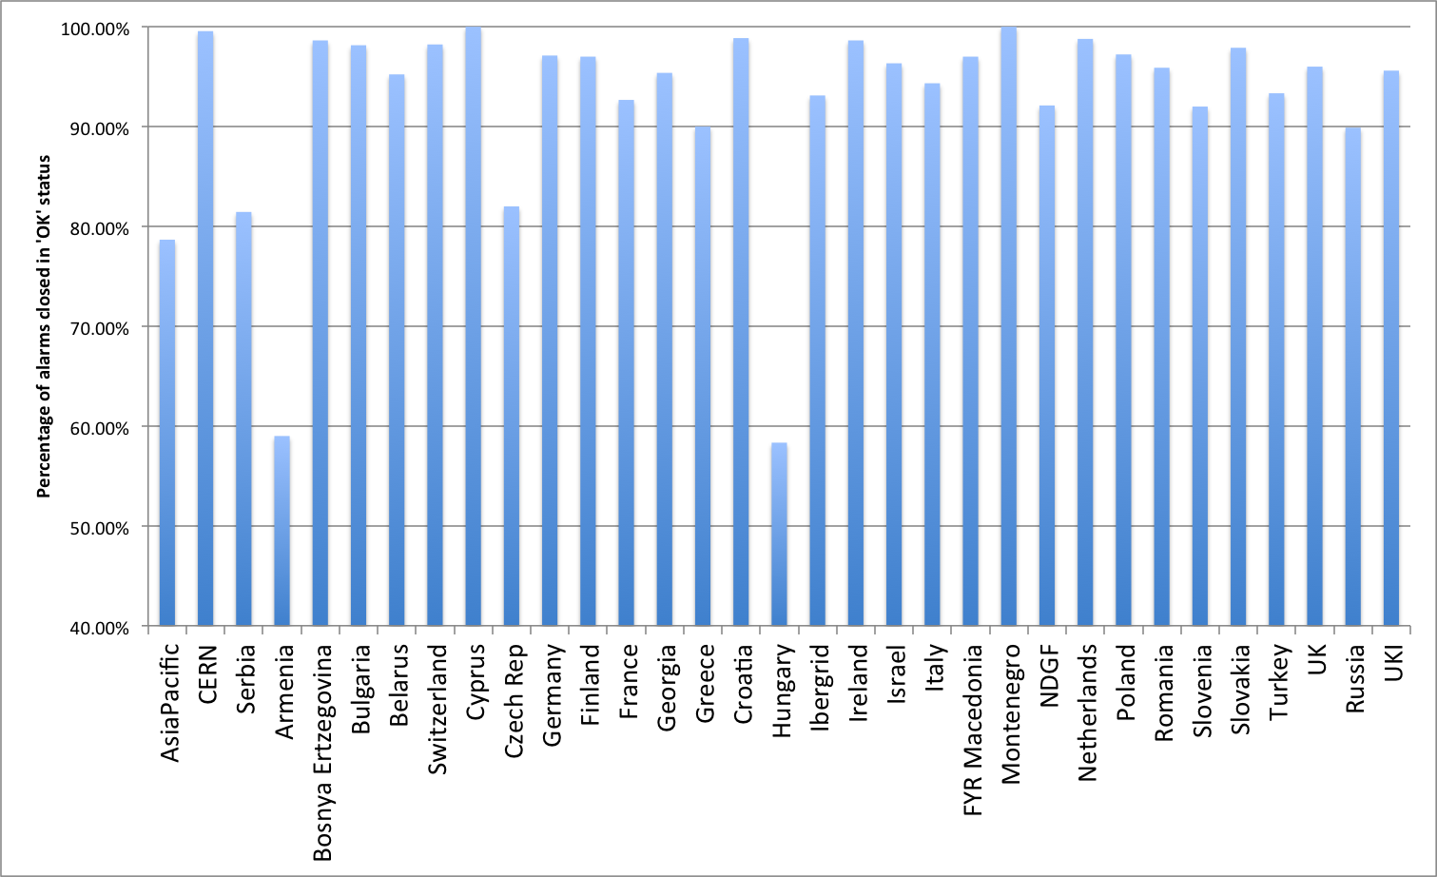
Figure 6: ROD quality metric (monthly average)

Service Level Management
Description: NGIs are responsible of supervising the levels of services delivered both at a Resource Centre level for the services providing access to resources and at an NGI level for collective services provided by the NGIs, adhering to the requirements of the Resource Centre Operational Level Agreement (OLA) and the Resource infrastructure Provider OLA.

Assessment: The service level management activity aims to ensure that the quality of service delivered meets the service target levels agreed in the OLA. The resource centres part of the EGI production infrastructure scored, in the project quarters PQ5-PQ6-PQ7, an average availability of 94.41% and a reliability of 95.34%.
Many NGIs reported as a top priority for the current year the improvement of the level of service delivered or, if satisfied, maintain the current availability performance. This requires a dedicated support action that includes: the extension of the current availability/reliability reporting framework, the periodic assessment of performance for a larger number of NGI core services, the provisioning of guidelines and best practices on how to configure services in high-availability or load balanced mode. All these actions are in the SA1 roadmap for 2012.
One NGI reported the establishment of Service Level Agreements (SLA) with the supported virtual organisations as a priority for the current year. To facilitate this process for the NGIs and the VOs, during 2012 a template for SLA between Resource infrastructure Provider and Virtual Organization will be made available.
Various NGIs scored low performance during PQ5, PQ6 and PQ7. A support programme was defined in collaboration with the Greek NGI, so that those NGIs could receive technical support about software installation and configuration, and operations tasks and procedures.
Several NGI provided core middleware services need consolidation in terms of performance delivered.
Median Effort Spent during last year: 1 PMs (Min: 0.1; Max: 18)

Security Management
Description: NGIs contribute to software vulnerability assessment and to internal Computer Security Incident Response activities, and are responsible for appointing a security officer and providing security support to their Resource Centre administrators.
Assessment: The activities for this international task are focused both at a regional level and at the EGI level. At the regional level, the main activities are: to enforce the security policies and procedures and to handle the security issues, such as security incidents or software vulnerabilities.
NGIs are also requested to participate in security related groups e.g. the security policy group.
NGIs and resource centres security activities performed well, with almost all of the sites promptly reacting to the request to patch security vulnerabilities. Over the last three quarters (PQ5, PQ6 and PQ7) there was one case of a site being suspended for security reasons.
Median Effort Spent during last year: 2 PMs (Min: 0.5; Max: 6)

Operations Management
Description: NGIs are responsible for coordinating internal operational activities and to participate to the OMB for coordination at the EGI level.

Assessment: The attendance to the main operations policy body, the Operations Management Board (OMB) and the technical grid operations meeting is stable, though several small NGIs are not attending them regularly. The attendance slightly improves for the F2F meetings held within the main EGI events. A support programme was implemented to fund participation of members of small NGIs under consolidation to the EGI User Forum and Technical Forum events.
Some NGIs reported the improvement of some operations management aspects such as improving communications with site administrators to better coordinate middleware deployment, attracting new partners to provide resources for the NGI as new resource centres and rationalising operation activities to improve the integration between EGI resources and national resources.
Median Effort Spent during last year: 1 PMs (Min: 0.1; Max: 24)

Conclusions
Overall feedback from the NGIs has been generally positive with very constructive feedback for improvements to be made. Issues still remain in gathering information and feedback from all of the NGIs. However, many of the activities are progressing well with most of the objectives being reached, especially in areas with more effort is available. For example, some NGIs have been participating in policy development on a best effort basis, however, the output of the activities has been of high quality, simply relatively low in quantity, reflecting the level of effort available. A few comments where around improving communication of policy activities and suggestions of providing briefing documents that could be adapted for local NGI activities.
Another key message that comes across from the NGI self-assessments is that the situation with regards to the funding of dissemination and communication activities varies widely. Some NGIs reported having the resources to be very active during the second year of the project. Since the formation of the NGI International Liaison (NIL) network and the set-up of the Virtual Teams, there has been more success in engaging NGIs to collaborate around an individual focused task. In PY3, the central team will aim to facilitate further NGI tasks around specific dissemination activities that will be of benefit to all NGIs, which will also respond to specific NGI requests for access to materials to support dissemination. These efforts will be dedicated to areas around gathering case studies, generating subject specific printed materials such as brochures or posters.
Medium and large NGIs have actively contributed to operations meetings and to the OMB. However, participation from smaller or new NGIs needs improvement. Participation at face-to-face meetings was facilitated with a dedicated funding support programme. In general, emerging NGIs are in need of a technical support action to allow them to get familiarity with procedures and to gradually gather expertise about grid software configuration. In addition, procedures and tools need to be extended to allow for a gradual and easier integration into the production infrastructure, so that resource centres and the NGI international tasks can be tested first and then improved to bring them to production level. During PY3, this action will be discussed with the team responsible for EGI Grid Oversight. The expected tangible results of this action will be a smoother integration with new emerging infrastructures, the improvement of the availability of the services already provided in production by emerging NGIs and the improvement of the quality of support services offered by NGIs. The overall level of security provided during PQ5, PQ6 and PQ7 is good and the whole framework of tools for security monitoring will be further enhanced in PY3. Participation of Resource Centres to software early adoption is also expanding.
A final general conclusion that can be drawn from the survey is around many of the NGIs still not knowing the tools and processes that are provided to them from TNA2.5 (previously TNA3.4) and expect more dissemination to happen about these tools – namely the AppDB, Training Marketplace, Requirements Tracker/tracking. An internal training session (i.e. in a webinar format) could be jointly organised by TNA2.2, TNA2.4 and TNA2.5 to change this situation, ensuring it is attractive and enticing for both NGIs and users.
This report has provided an opportunity to assess the progress of the activities being carried out by the NGIs and has allowed for a pragmatic approach to understanding the current issues as well as potential improvements for continuous evolvement as a project, organisation and ecosystem.

NGI Contributions

Non-operations tasks

Summary of NGI Scores
NGI | Dissemin. | Policy Dev. | Req. Gathering | AppDB | Training Marketplace | Consultancy
Croatia | 5 | 5 | 5 | 5 | 5 | 5
Czech Republic | 4 | 3 | 3 | 2 | 3 | 3
Finland | 3 | 2 | 3 | 3 | 2 | 4
France | 4 | 3 | 3 | 4 | 3 | 2
Greece | 4 | 3 | 3 | 4 | 2 | 3
Hungary | 3 | 3 | 2 | 3 | 4 | 3
Ireland | 2 | 3 | 3 | 3 | 3 | 3
Israel | -- | 3 | 3 | 3 | 4 | 2
Italy | -- | 3 | 5 | 3 | 4 | 3
Lithuania | 4 | 1 | 3 | -- | 4 | 3
Macedonia | 3 | 3 | 3 | -- | -- | 3
Moldova | 4 | 4 | 3 | 3 | 5 | 4
Netherlands | -- | -- | 3 | 3 | -- | 5
Portugal | 3 | 4 | 3 | 3 | 3 | 4
Serbia | 5 | 5 | 5 | 4 | 3 | 3
Slovakia | 4 | 3 | 3 | -- | 3 | 3
Spain | 2 | 3 | 3 | 3 | 4 | 4
Switzerland | 3 | -- | 2 | 3 | -- | 4
Turkey | 4 | 5 | 3 | 2 | 2 | 4
United Kingdom | 5 | 4 | 4 | 3 | 5 | 3
Avg. | 3.56 | 3.24 | 3.16 | 3.06 | 3.38 | 3.32
Mode | 4 | 3 | 3 | 3 | 3 | 3
Median | 4 | 3 | 3 | 3 | 3 | 3
Table 1: Summary of NGI Scores (non-operations tasks)

Operations Tasks

Summary of NGI Effort Spent
Country | Monitoring Infrastructure | Accounting Infrastructure | Helpdesk | Core Grid Services | Staged Rollout | Requirements Gathering | 1st and 2nd Level Support | Grid Oversight | Service Level Management | Security Management | Operations Management
Bosn-Herz | 3.0 | 1.0 | 1.0 | 2.0 | 1.0 | 0.5 | 2.5 | 1.0 | 1.0 | 2.0 | 1.5
Croatia | 25.0 | 6.0 | 0.0 | 12.0 | 4.0 | 0.0 | 6.0 | 14.0 | 2.0 | 2.0 | 0.0
Czech Republic | 6.0 | 1.0 | 3.0 | 2.0 | 1.0 | 1.0 | 9.0 | 1.0 | 0.5 | 6.0 | 1.0
Finland | 3.0 | 2.0 | 1.0 | 3.0 | 4.0 | 1.0 | 4.0 | 4.0 | 2.0 | 3.0 | 1.0
Georgia | 2.0 | 1.0 | 1.5 | 1.0 | 1.0 | 1.5 | 1.0 | 1.0 | 1.0 | 1.0 | 2.0
Germany | 18.0 | 6.0 | 6.0 | 12.0 | 6.0 | 1.0 | 6.0 | 18.0 | 6.0 | 6.0 | 3.0
Hungary | 18.0 | 0.0 | 6.0 | 20.0 | 0.0 | 0.0 | 10.0 | 10.0 | 18.0 | 4.0 | 0.0
Hungary | 1.2 | 0.6 | 2.0 | 2.0 | 0.0 | 0.0 | 4.0 | 0.0 | 6.0 | 0.0 | 0.0
Ireland | 3.0 | 1.0 | 0.5 | 3.7 | 4.0 | 0.1 | 2.5 | 2.0 | 0.2 | 4.5 | 0.1
Ireland | 3.0 | 0.0 | 0.0 | 6.0 | 0.0 | 0.0 | 0.5 | 0.0 | 0.5 | 1.0 | 1.0
Italy | 15.0 | 15.0 | 6.0 | 12.0 | 3.0 | 1.0 | 6.0 | 39.0 | 12.0 | 3.0 | 1.0
Macedonia | 4.0 | 1.5 | 1.0 | 3.5 | 1.5 | 1.0 | 2.5 | 6.0 | 1.0 | 1.5 | 0.0
Moldova | 2.5 | 0.5 | 0.4 | 1.0 | 1.0 | 0.2 | 2.5 | 0.1 | 0.5 | 0.5 | 0.3
Netherlands | 2.8 | 1.5 | 1.5 | 8.5 | 3.3 | 0.0 | 3.3 | 14.5 | 0.0 | 4.3 | 0.0
Poland | 15.0 | 3.5 | 1.2 | 4.4 | 7.5 | 0.4 | 1.2 | 11.2 | 4.4 | 3.4 | 1.6
Portugal | 4.0 | 2.0 | 0.0 | 8.0 | 2.0 | 0.2 | 8.0 | 5.0 | 1.0 | 2.0 | 0.8
Serbia | 2.0 | 2.0 | 1.0 | 5.0 | 3.0 | 1.0 | 6.0 | 12.0 | 1.0 | 2.0 | 1.0
Slovakia | 5.0 | 0.0 | 0.0 | 3.0 | 0.0 | 0.1 | 4.0 | 6.0 | 0.1 | 1.6 | 0.2
Spain | 12.0 | 3.0 | 6.0 | 12.0 | 6.0 | 6.0 | 6.0 | 12.0 | 12.0 | 3.0 | 24.0
Switzerland | 3.0 | 0.0 | 1.0 | 0.0 | 1.0 | 0.2 | 0.7 | 1.0 | 0.0 | 2.0 | 0.8
Turkey | 3.0 | 2.0 | 2.0 | 3.0 | 3.0 | 1.0 | 2.0 | 12.0 | 1.0 | 2.0 | 2.0
UK | 8.0 | 8.0 | 6.0 | 31.0 | 6.0 | 1.0 | 48.0 | 3.0 | 1.0 | 6.0 | 12.0
TOTAL | 158.5 | 57.6 | 47.1 | 155.1 | 58.2 | 17.2 | 135.6 | 172.8 | 71.2 | 60.7 | 53.3
Table 2: Effort spent for SA1 Int’l tasks, as reported by NGIs in the survey

Non-respondent NGIs

- Albania
- Armenia
- Belarus
- Belgium
- Bulgaria
- Cyprus
- Denmark
- Latvia
- Montenegro
- Norway
- Romania
- Russia
- Slovenia
- Sweden

References
R 1 | NGI Int’l Task Review Wiki - https://wiki.egi.eu/wiki/NGI_International_Task_Review_MS116
R 2 | EGI Policy Page - https://www.egi.eu/policy/
R 3 | EGI Applications Database - http://appdb.egi.eu/
R 4 | EGI Training marketplace - http://www.egi.eu/user-support/training_marketplace/
R 5 | Operations Survey - http://go.egi.eu/op-survey-ngi-intl-tasks-2012
R 6 | EGI Operations Management Board (OMB) - https://www.egi.eu/policy/groups/Operations_Management_Board_OMB.html
R 7 | Requirements Tracking Tool - http://rt.egi.eu
R 8 | SeIUCCR project - http://www.ngs.ac.uk/seiuccr/home
R 9 | User requirements and process - http://www.egi.eu/user-support/getting_help
R 10 | Solved user requirements - https://wiki.egi.eu/wiki/Solved_user_requirements
R 11 | Grid operations oversight / Operations Support Metrics -  https://wiki.egi.eu/wiki/Grid_operations_oversight/OperationsSupportMetrics

