MoU – Milestone Report

M5.2: IGE Accounting Mechanisms

Document Link | https://documents.egi.eu/document/<DOCID>
Report by | Steve Crouch, IGE
Contributors | John Robinson, IGE
Last Modified | 05/07/2011
Version | 1.1
Due Date | 01/07/2011
Delivery Date | 05/07/2011
MoU URL | To be added by the EGI.eu Policy Development Team
RT Ticket URL | To be added by the EGI.eu Policy Development Team

Abstract
This document describes the accounting mechanisms needed to record service usage provided via IGE software components, as well as future work currently under discussion. This functionality is targeted at the Operations.Accounting EGI capability described in the EGI UMD Roadmap, and will be provided through the Grid-SAFE accounting software.

TABLE OF CONTENTS
1 Introduction 3
2 Grid-SAFE: Current Status and Future Work 4
2.1 Introduction 4
2.2 Standards Support 4
2.3 Architecture 4
2.4 Implementation 6
2.5 Building, Deployment and Configuration 6
2.6 Testbed Availability 6
2.7 Grid-SAFE Availability 7
2.7.1 Source Code 7
2.7.2 Packaging 7
2.7.3 Documentation 7
3 References 8
Appendix A Numbered appendices 9
A.1 Appendix level 2 9
A.1.1 Appendix level 3 9

Introduction
This document describes the accounting mechanisms needed to record service usage provided via IGE software components, as well as future work currently under discussion. This functionality is targeted at the Operations.Accounting EGI capability described in the EGI UMD Roadmap[R 1], and will be provided through the Grid-SAFE accounting software[R 2]. Its primary audience is the EGI operations team.

Grid-SAFE: Current Status and Future Work

Introduction
The Grid-SAFE software was developed at EPCC as part of a UK JISC project[R 3], which ran from September 2008 - June 2010. It built open standard support into the existing EPCC SAFE software as well as providing a distributed web portal interface and usage reporting mechanisms. More information on Grid-SAFE can be found in the documentation[R 4].
IGE is working closely with the Grid-SAFE developer Stephen Booth.

Standards Support
At the moment, Grid-SAFE fully supports UR v1.0[R 5], although has been designed to allow easy support for extended/other versions of UR as required. IGE is tracking, and will participate in, the developments of the EMI Compute[R 6] group in this area, with the aim of converging on a common UR format. A preliminary analysis has uncovered no major problems with adopting the current proposed UR format from this group.

In terms of supporting RUS (i.e. [R 7]), Grid-SAFE has adopted a subset of this specification called RUPI[R 8] (Resource Usage Publishing Interface), which just focuses on the publishing aspects of RUS, and a draft for this specification has been submitted to the RUS WG[R 9]. Preliminary support for RUQI (Resource Usage Querying Interface) exists, but is not currently described in a specification (although it is inferred that this is essentially the RUS aspects dealing with querying such a service) . A known risk with the RUS-WG group is that at present, the group has no active chair and group activity is currently low to non-existent.

Architecture
Architecturally, Grid-SAFE can be illustrated thus:

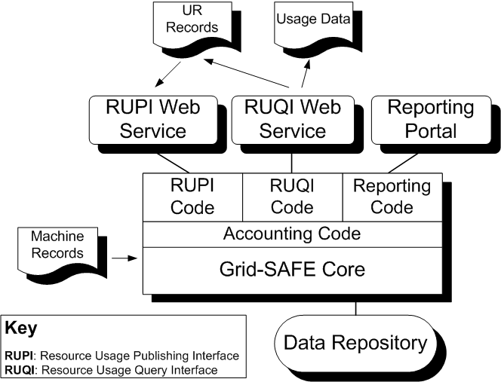

The core components are as follows:

- WebAcct: The web accounting portal. Allows usage records presented in multiple formats to be persistently stored in a relational database. Once stored, complex reports detailing the records may be generated in multiple formats. A web based interface is presented to allow multiple users to upload records and generate reports. This code base also comes with a command line tool to allow scripts access to most functions without going through the web interface.

- SafeRupi: An implementation of the Resource Usage Publishing Interface (RUPI) specification being developed by the RUS working group, a part of the Open Grid Foundation. This component allows usage records represented in the OGF Usage Record format to be uploaded and stored using the Grid-SAFE software framework. Any client which adheres to the RUPI specification may use this service to publish usage information.

- SafeRupi: An implementation of a Resource Usage Query Interface. This is an additional web-services interface allowing a Grid-SAFE data repository to be queried programatically over the network. This is intended to allow complex distributed accounting solutions to be built out of the Grid-SAFE components.

The general architecture of Grid-SAFE has been designed to be easily extensible. For example, the development and inclusion for different UR parsers is a very useful and adaptable extensibility feature, and is support many evolving or stable UR record formats simultaneously.

Implementation
Grid-SAFE is a Java-based web service, and to date has been tested on the following platform:

Provider | Product | Version
Apache | HTTP Server | 2.2
Apache | Tomcat | 5.5
Apache | Ant | 1.7
Apache | Axis | 2
Oracle | MySQL | 5.0
Oracle | Java JDK | 6

Building, Deployment and Configuration
Documentation for these aspects can be found at [R 4]. In general, the documentation is in need of updating and will be addressed in a future IGE development cycle in 2012. However, this section does provide a brief overview of the tasks required to set up a working installation.

Prerequisites for installation of Grid-SAFE consist of Java, an Apache HTTP Server (optional), Apache Tomcat and an Oracle MySQL server. For installation of SafeRupi, Apache Axis2 is also required to be installed to Tomcat.

Prior to building Grid-SAFE, a set of properties files need to be configured for the service, database, logging and any extensions. Partial instructions for these are available[R 12]. Building is accomplished by simply running Apache Ant.

Installation of the Grid-SAFE core web application to Tomcat is achieved through Apache Axis2's deployment mechanism. Following installation, the properties files can be further configured to meet the needs of the deployment.

Testbed Availability
IGE are working with the Grid-SAFE developer to complete the Grid-SAFE configuration on the IGE testbed installation which should be completed in the short term, with the aim to provide external access to the IGE testbed for testing by EGI and related personnel. The Grid-SAFE developer is currently assisting us directly with this aspect. IGE will provide updates on progress to the EMI JRA1 Compute and EGI Globus Integration Taskforce mailing lists as they occur.

Grid-SAFE Availability

Source Code
Previously, source code on the official SourceForge Grid-SAFE project website was missing the RUPI functionality, but this has since been achieved by automatically synchronising his own development CVS with the SourceForge Grid-SAFE project's CVS, so all code should now be on SourceForge and will be regularly updated. IGE are in the process of verifying this: IGE will firstly check existence of the previously missing code, then validate the code to ensure it's complete and functional as expected. IGE will provide updates on progress to the EMI JRA1 Compute and EGI Globus Integration Taskforce mailing lists as they occur.

Packaging
The binary packaging of Grid-SAFE into IGE releases may be addressed in a future IGE development cycle in 2012, as IGE prioritisation dictates. However, the developer is already working with us to provide a set of sensible configuration defaults to minimise the effort of achieving a working deployment; aiming for a working solution-out-of-the-box which can be readily configured as desired.

Documentation
Documentation can found at [R 4], but as has been noted, the documentation requires some revision. Depending on IGE prioritisation, this may be addressed in a future IGE development cycle in 2012.

References
R 1 | The EGI D5.2 UMD Roadmap:  https://documents.egi.eu/public/ShowDocument?docid=272
R 2 | The Grid-SAFE accounting software:  http://gridsafe.sourceforge.net/index.html
R 3 | The Grid-SAFE Project  http://www.epcc.ed.ac.uk/projects/grid-safe  http://www.jisc.ac.uk/whatwedo/programmes/eresearch/gridsafe.aspx
R 4 | Grid-SAFE documentation  http://gridsafe.sourceforge.net/Documentation/GridSafeDocumentation/index.html
R 5 | OGF Usage Record v1.0  http://www.gridforum.org/documents/GFD.98.pdf
R 6 | EMI Compute Accounting group  https://twiki-beta.cern.ch/twiki/bin/view/EMI/ComputeAccounting
R 7 | Resource Usage Service draft specification  http://forge.ggf.org/sf/go/doc7965?nav=1
R 8 | Resource Usage Publishing Interface (RUPI)  http://forge.ggf.org/sf/go/doc15577?nav=1
R 9 | Resource Usage Service Working Group (RUS-WG)  http://forge.ggf.org/sf/projects/rus-wg
- Numbered appendices
- Appendix level 2
- Appendix level 3
- Appendix level 4
- Appendix level 5

